ASSIGNMENT SHEETS

Activity 5 outcome 3

Refractive index of a perspex block

Apparatus
Ray box and single slit, 12 V power supply, semi-circular perspex block, sheet of white paper, protractor.
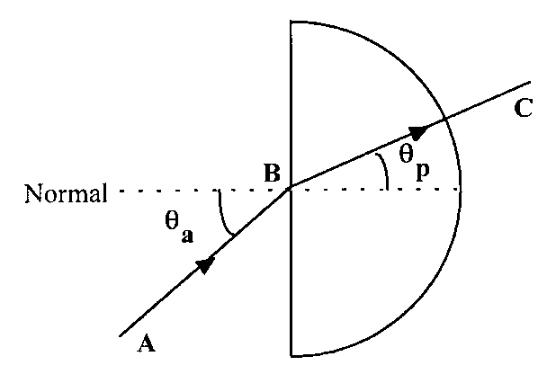

Instructions
- Place the block on the white paper and trace around its outline. Draw in the normal at the midpoint B.

- With incident angle θ_{a} = 10°, measure the angle θp, the refracted angle in the perspex.

- Repeat for the other values of incident angle.

- Use an appropriate format to determine the refractive index of the perspex block.

Activity 6

Critical angle of a perspex block

Aim
Measurement of the critical angle θ_{c} of a perspex block.

Apparatus
Ray box and single slit, 12 V power supply, semicircular perspex block, sheet of white paper, protractor.

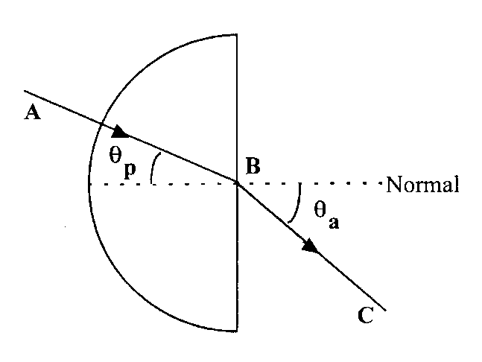

Instructions
- Place the block on the white paper and trace around its outline. Draw in the normal at the midpoint B.

- Draw a line representing the angle θ_{p} = 10°, the line AB in the diagram above.

- Direct the raybox ray along AB and mark in the point C where the ray emerges.

- Draw a line representing the refracted ray, the line BC in the diagram above.

- Measure the angle θ_{a}, the refracted angle in air.

- Use an appropriate format to record your results.

- Repeat for other values of incident angle θ_{p}.

- Determine the critical angle θ_{c} for this perspex block.

Activity 7 outcome 3

Variation of light intensity with distance from a point source of light

Apparatus
12 V power supply, 12 V lamp, light detector and meter, metre stick.

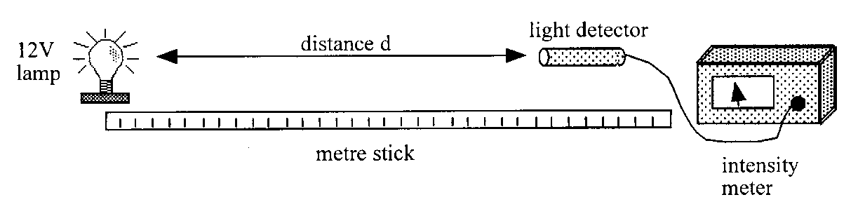

Instructions
- Darken the room. Place the light detector a distance from the lamp.

- Measure the distance from the light detector to the lamp and the intensity of the light at this distance.

- Repeat these measurements for different distances between detector and lamp.

- Plot a graph of light intensity against distance from the lamp.

- Consider this graph and your readings and use an appropriate format to find the relationship between the light intensity and distance from the lamp.

Activity 15 outcome 3

Measurement of the half-value thickness of lead for γ-rays

Apparatus
Geiger-Muller tube, counter, radioactive source, lead absorbers.

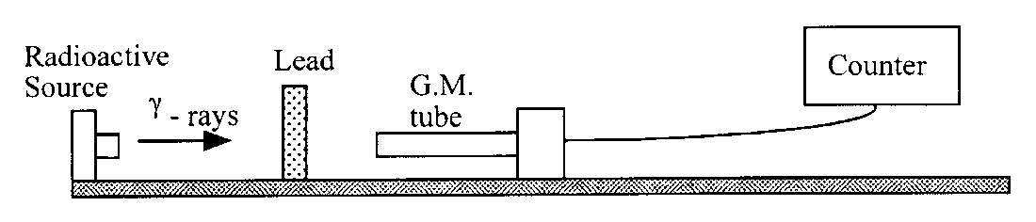

Instructions
- Determine the background count rate.

- With the radioactive source in position, record the count rate with no absorber, paying due attention to safety requirements.

- Place a piece of lead of unknown thickness between the source and detector.

- Record the measurements of count rate and thickness of lead absorber.

- Repeat using lead absorbers of different known thickness.

- Use an appropriate format to determine the half-thickness of lead.

Note
For use as an Outcome 3 assessment, the student must actively participate in the experiment.

Due attention must be paid to safety requirements and age restrictions.

