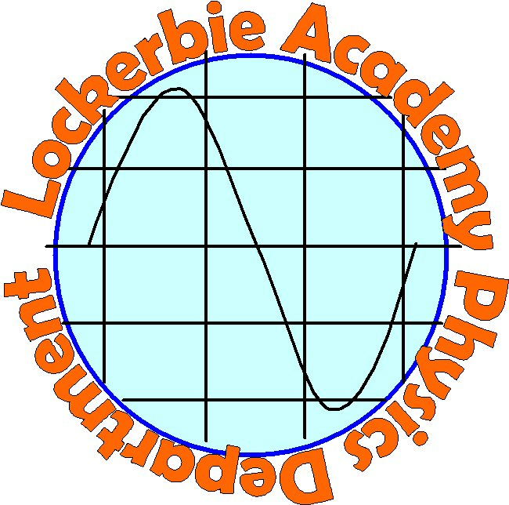
4

NAME:

CLASS:

TEACHER:

This is your third S3 Physics Unit and for this unit we hope to explore the universe. We know that some of you have a keen interest in Space and so we do not wish you to go over material that you have already covered. Some of you may have forgotten about things that you knew at primary school so we are going to give you a little quiz to find out what you know. Do not feel worried if you cannot do any of the questions, either take a guess or miss it out.

You will notice that each question has a space to answer it twice. Do not worry about this at the moment. Only fill in one box for each question.

If you need more space use lined paper, staple it to the back but clearly label the question number and put your name on it.

If you are particularly interested in a question please place a tick in the “Interest?” column next to the question. If you dislike a question put a cross in the “Interest?” column next to the question. If you have no strong feelings one way or the other, please leave the column blank.
RISK ASSESSMENT: YOU MUST NEVER LOOK DIRECTLY AT THE SUN AT ANY TIME, EITHER WITH THE NAKED EYE OR THROUGH BINOCULARS OR A TELESCOPE. THE SUN’S RAYS WILL CERTAINLY DAMAGE YOUR EYES. YOU MAY EVEN BE PERMANENTLY BLINDED! IF IN DOUBT SEEK ADVICE.

Earth and Space Quiz
Interest ?
LEVEL A
- Label the pictures A to F.
 | 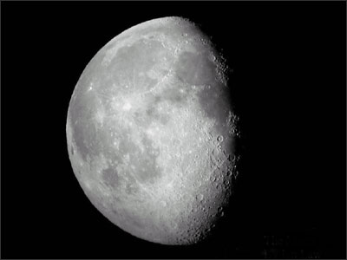
A= | B=
A= | B=
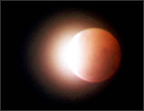 | 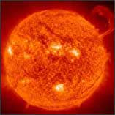
C= | D=
C= | D=
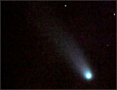 | 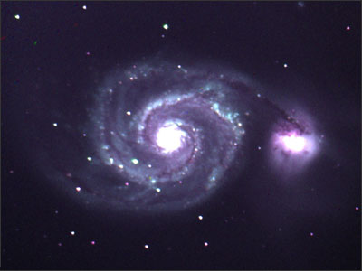
E= | F=
E= | F=

Interest?
- A constellation is a group of stars that make a pattern. Ancient astronomers named patterns after people, goods and animals.

Label the following constellations
 | 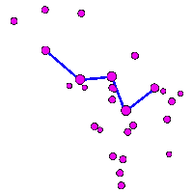
A= | B=
A= | B=
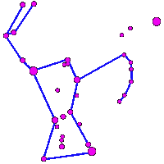 | 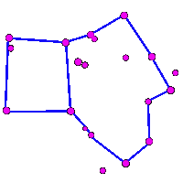
C= | D=
C= | D=
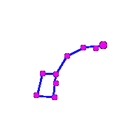 | 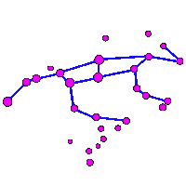
E= | F=
E= | F=

- Which letter represents the correct reason why we have day and night?
Interest ?
  - The Sun goes behind a hill
  - The Earth spins in front of the Sun
  - The Earth goes around the Sun once a day
  - The Sun goes around the Earth once a day
  - The Moon covers the Sun
  - Clouds cover the Sun
  - Other (give a reason)________________________

Correct answer is ________ Correct answer is ________

- Which letter gives the correct reason for the Seasons?

  - Changes in the plants and trees cause the seasons
  - The Sun moves to the other side of the Earth
  - The Sun is further away
  - Heavy winter clouds stop heat from the Sun
  - A cold planet takes heat from the Sun
  - The angle of the Earth as it rotates.
  - Other (give a reason) ________________________

Correct answer is ________ Correct answer is ________

- Below is a diagram of the Earth, mark the position of the Sun with a X, and label which half of the Earth has DAYTIME and which has NIGHTIME.
Interest ?

- This diagram shows the position of the sun in the sky at different times and seasons.
West
South
East
1
2
3
4
5
6
7
8
Horizon

Complete this table entering the correct number to match the time of year and time of day.

Time of day | Time of year | 1st Answer | 2nd Answer
Dawn (sunrise) | Summer
Dusk (sunset) | Winter
Midday | Winter
Midday | Summer

LEVEL B
Interest ?
- From the pictures shown below label the seasons.
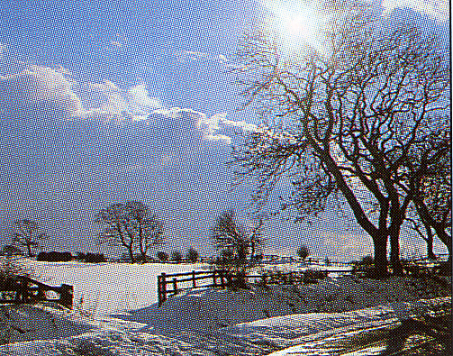
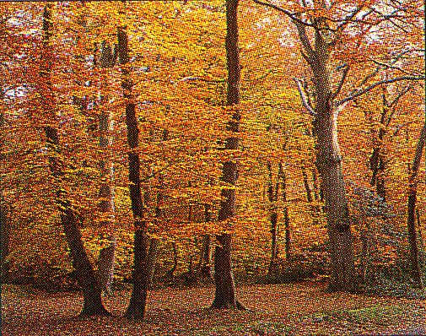
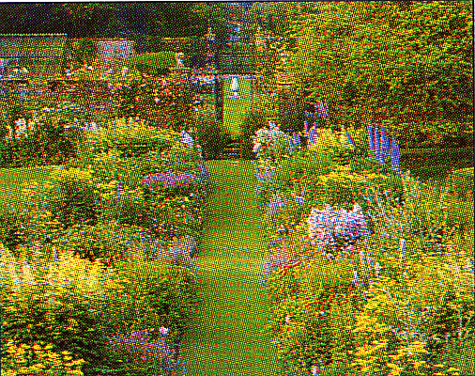
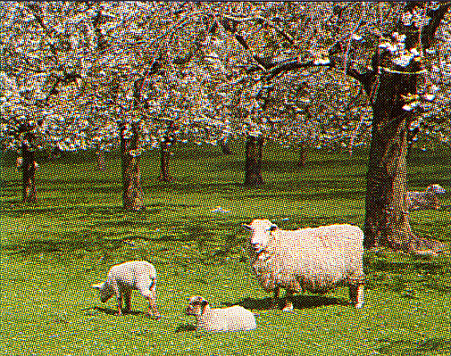

Label the phases of the moon in the table below.
Interest
?
Moon Phase | New  Moon | Waxing  Crescent | First  Quarter | Waxing  gibbous | Full  Moon | Waning  gibbous | Last  Quarter | Waning  Crescent
Label | A | B | C | D | E | F | G | H

Phase of Moon | Answer  1 | Answer 2 | Phase of Moon | Answer 1 | Answer 2
 | E

- Decide whether the following statements are true or false. Write T for True or F for False in the box.
Interest ?
STATEMENT | 1  T/F | 2  T/F
The Sun is the largest planet in our Solar System
The Earth turns once every 365 days
An eclipse of the Sun is caused when the moon passes directly between the Earth and the Sun
The tilt of the Earth’s axis causes the four seasons
When it is Winter in Britain it is Summer in Australia
When it is day in the Northern Hemisphere it is night in the Southern Hemisphere
Shadows in the winter are longer than shadows in Summer at the same time of day.
The days are always short and cold at the North Pole
The Moon shines with Sun’s reflected light
The Moon can often be seen in the daytime

Month | Answer 1 | Answer 2
January | E
February
May
August
November
- Look at the information in the table below. Match the information to the month of the year in the next table.

Month | Air Temperature  ºC | Rainfall  mm | Windspeed  m/s
A | 4.9 | 163 | 1.6
B | 3.0 | 72 | 2.0
C | 13.1 | 74 | 1.4
D | 11.3 | 36 | 1.4
E | 2.3 | 49 | 1.8

Answer table
LEVEL C + E
Interest
?
- Label the diagram below, make it as detailed as you can.
  - Is this an accurate diagram? Explain your answer.
LEVEL C
Interest
?
- The Earth is the only planet in our solar system where water is found as a liquid. Some planets contain ice and some have no water at all, can you suggest a reason for this?

Answer 1
Answer 2

- Match the description with the term. Place them in order of size with the smallest as Number 1

1 | Natural satellite that orbits a planet.
2 | A basic building block of the universe that includes stars, star clusters, clouds of gas, dust and interstellar molecules.
3 | Very hot sphere of glowing gas which vary in size
4 | The main component of a solar system
5 | Sum total of everything that exists.
6 | Is one or more suns surrounded by orbiting planets
7 | A relatively large body rotating in an elliptical orbit around the sun.

Name | Description number round 1 | Description number round 2 | Size (smallest No. 1)
Universe
Sun
Star
Planet
Moon
Galaxy
Solar System
LEVEL D
Interest
?
- What would be the effect on the motion of the Earth if the Sun suddenly vanished?
Answer 1
Answer 2

- What evidence is there to show we are moving around the Sun and not the Sun moving around the Earth?
Answer 1
Answer 2

- Match the meaning with the term.
1 | Condition felt whilst in free-fall.
2 | A measure of the amount of matter in an object measured in kilograms
3 | The force of gravity pulling an object towards the centre of the Earth measured in Newtons
4 | When you are accelerating to Earth at the acceleration due to gravity
5 | The size of the force of gravity on 1 kg.

Name | Description number round 1 | Description number round 2
Mass
Weight
Gravitational Pull
Weightlessness
Free-fall

LEVEL E
Interest
?
- Using your knowledge of the Earth, Sun, and moon explain:
  - day and night
Answer 1
Answer 2

  - which way the Earth must be rotating for us in Scotland
Answer 1
Answer 2

  - a month
Answer 1
Answer 2

  - a year
Answer 1
Answer 2

  - a leap year
Interest?
Answer 1
Answer 2

- Match the size of the gravitational pull with the planets.

Size of the Gravitational Pull (N/kg)
9.8
26.4
3.8
11.5
1.6

Planet | size of gravitational pull  round 1 | size of gravitational pull  round 2
Jupiter
Saturn
Earth
Mars
Moon (Lunar)

- Give an approximate year for the following events
Interest
?

Event | Answer 1  Year | Answer 2 Year
the first spaceflight
the first person in space
the first animal in space
the first woman in space
the first person to land on the moon
the first Britain in space
the launch of the Hubble telescope
the first Space Shuttle launch
the Challenger disaster

- Answer the following questions.
  - What was the first living animal to go into space?
First Answer | Second Answer

  - What happened to the above animal?
First Answer | Second Answer

  - Who was the first man in space?
First Answer | Second Answer

  - What is the difference between a cosmonaut and an astronaut?
First Answer | Second Answer

  - Who first set foot on the moon?
First Answer | Second Answer

  - What famous words did he speak when he touched down?
First Answer | Second Answer

  - Who was the first Britain in Space?
First Answer | Second Answer

  - Who was the first woman in space?
First Answer | Second Answer

- For the next few questions write on A4 paper and stick it to the back of the sheets if there is anything you wish to write. Put your name on the paper.
Give a meaning to each of the terms below
  - Comet
  - Meteorites
  - Meteors
  - Asteroids
  - Black holes
Interest
?

LEVEL F
- What do you know about any of the following?

  - The Doppler Effect
  - Red shift
  - A singularity
  - The Big Bang theory
  - The expanding or shrinking universe

- Match the moons to the planets
Moon | Titan | Titania | Dione | Io | Deimos
Europa | Mimas | Oberon | Umbriel | Ganymede | Iapetus
Ariel | Miranda | Callisto | Phobos | Enceladus | Triton
 |  |  |  |  | Charon

Moons | Planet
Moons | Earth | Mars | Jupiter | Saturn | Neptune | Uranus | Pluto

Moons | Planet
Moons | Earth | Mars | Jupiter | Saturn | Neptune | Uranus | Pluto

- The following are probes and satellites sent out by humans. Can you give any details about where they were sent, when they were launched and their role.
Interest
?
Satellite/Probe
Cassini/ Huygen
Hubble telescope
Galileo
Giotto probe
Voyager
Mars Global Surveyor

WELL DONE YOU MADE IT THIS FAR!

