Higher Dynamics
Past Paper Questions
Book 1

Contents
Forces pg 2-18
Linear Motion pg 19-28
Momentum and Impulse pg 29-54
Forces
1. |  | A car of mass 900 kg pulls a caravan of mass 400 kg along a straight horizontal road with an acceleration of 2·0 m s⁻².  coupling
 |  | 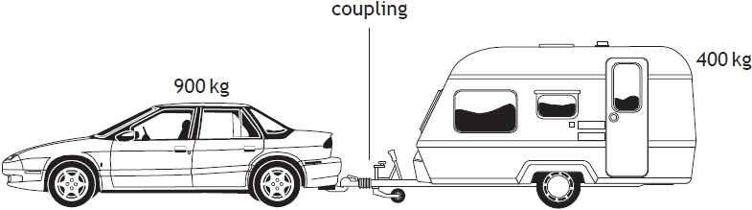  900 kg | 400 kg
 |  | Assuming that the frictional forces on the caravan are negligible, the tension in the coupling between the car and the caravan is
 | A  B  C  D  E | 400 N  500 N  800 N  1800 N  2600 N.
2. |  | A helium filled balloon of mass 1·5 kg floats at a constant height of  100 m. The gravitational field strength at this height is 9·8 N kg⁻¹.  The upthrust on the balloon is
 | A  B  C  D  E | 0 N  1·5 N  14·7 N  150 N  1470 N.

3. |  | A box of mass 10 kg rests on an inclined plane. The component of the weight of the box acting down the incline is 50 N. A force of 300 N, parallel to the plane, is applied to the box as shown.  300 N
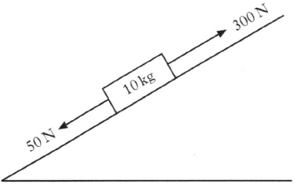
10 kg
50 N
The box accelerates at 10 m s⁻² up the plane.
The size of the force of friction opposing the motion of the box is
 | A  B  C  D  E | 50 N  100 N  150 N  200 N  250 N.
4. |  | A force of 180 N is applied vertically upwards to a box of mass 15 kg.  180 N
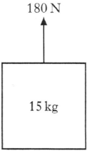
15 kg
 |  | Assuming that the gravitational field strength is 9·8 N kg⁻¹, the acceleration of the box is
 | A  B  C  D  E | 2·2 m s⁻²  7·6 m s⁻²  9·8 m s⁻²  12·0 m s⁻²  19·6 m s⁻².

5. |  | A box is pulled along a level bench by a rope held at a constant angle of 40º to the horizontal as shown.  100 N
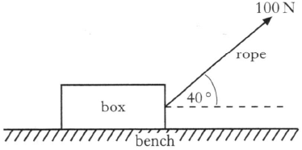
rope
bench
box
40º
A constant force of 100 N is applied to the rope.
The box moves a distance of 10 m along the bench.
The work done on the box by the rope is
 | A  B  C  D  E | 100 J  643 J  766 J  839 J  1000 J.
6. |  | A car of mass 1200 kg pulls a horsebox of mass 700 kg along a straight, horizontal road. They have an acceleration of 2·0 m s⁻².  700 kg
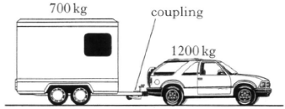
1200 kg
coupling
 |  | Assuming that the frictional forces are negligible, the tension in the coupling between the car and the horsebox is
 | A  B  C  D  E | 500 N  700 N  1400 N  2400 N  3800 N.

7. |  | A person stands on bathroom scales in a lift. The scales show a reading greater than the person’s weight.  The lift is moving
 | A  B  C  D  E | upwards at constant velocity  downwards at constant velocity  downwards and accelerating  downwards and decelerating  upwards and decelerating.
8. |  | A person stands on a weighing machine in a lift. When the lift is at rest, the reading on the machine is 620 N. The lift now descends and its speed increases at a constant rate. The reading on the machine
 | A  B  C  D  E | is a constant value higher than 620 N  is a constant value lower than 620 N  continually increases from 620 N  continually decreases from 620 N  remains constant at 620 N.
9. |  | Two boxes on a frictionless horizontal surface are joined together by a string. A constant horizontal force of 12 N is applied as shown.
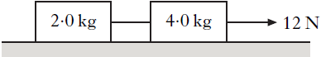
2·0 kg
4·0 kg
12 N
 |  | The tension in the string joining the two boxes is
 | A  B  C  D  E | 2·0 N  4·0 N  6·0 N  8·0 N  12 N.

10. |  | A skydiver of total mass 85 kg is falling vertically.
 |  | 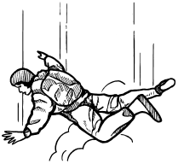
At one point during the fall, the air resistance on the sky diver is 135 N.
The acceleration of the skydiver at this point is
 | A  B  C  D  E | 0·6 m s⁻²  1·6 m s⁻²  6·2 m s⁻²  8·2 m s⁻²  13·8 m s⁻².
11. |  | A box of weight 120 N is placed on a smooth horizontal surface.  A force of 20 N is applied to the box as shown.  20 N
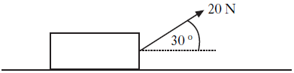
30º
The box is pulled a distance of 50 m along the surface.
The work done in pulling the box is
 | A  B  C  D  E | 500 J  866 J  1000 J  6000 J  6866 J.

12. |  | A rocket of mass 200 kg accelerates vertically upwards from the surface of a planet at 2·0 m s⁻².  The gravitational field strength on the planet is 4·0 N kg⁻¹.  What is the size of the force being exerted by the rocket’s engines?
 | A  B  C  D  E | 400 N  800 N  1200 N  2000 N  2400 N
13. |  | A box is placed on a horizontal surface.  A force of 15 N acts on the box as shown.
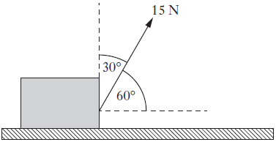
15 N
60º
30º
 |  | Which entry in the table shows the horizontal and vertical components of the force?
 | A  B  C  D  E
  Horizontal component (N) | Vertical component (N)
  15 sin 60º | 15 sin 30º
  15 cos 60º | 15 sin 30º
  15 sin 60º | 15 cos 60º
  15 cos 30º | 15 sin 30º
  15 cos 60º | 15 sin 60º

14. |  | Two blocks are linked by a newton balance of negligible mass.  The blocks are placed on a level, frictionless surface. A force of 18·0 N is applied to the blocks as shown.
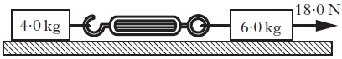
18·0 N
6·0 kg
4·0 kg
 |  | The reading on the newton balance is
 | A  B  C  D  E | 7·2 N  9·0 N  10·8 N  18·0 N  40·0 N.
15. |  | The mass of a car is 900 kg. The car is being towed at a steady speed of 4·0 m s⁻¹. The tow rope breaks and the car travels a further 6·0 m in a straight line before coming to rest.  The magnitude of the average unbalanced force acting on the car while coming to rest is
 | A  B  C  D  E | 600 N  1200 N  1350 N  3600 N  5400 N.
16. |  | A person stands on bathroom scales in a lift.  The scales show a reading greater than the person’s weight.  The lift is moving
 | A  B  C  D  E | upwards with constant speed  downwards with constant speed  downwards with increasing speed  downwards with decreasing speed  upwards with decreasing speed.

17. |  | A box of mass m rests on a slope as shown.
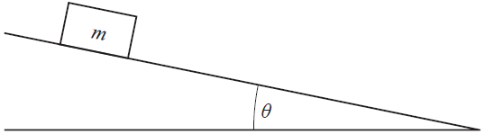
θ
m
 |  | Which row in the table shows the component of the weight acting down the slope and the component of the weight acting normal to the slope?
 | A  B  C  D  E
  Component of weight acting down the slope | Component of weight acting normal to the slope
  mg sinθ | mg cosθ
  mg tanθ | mg sinθ
  mg cosθ | mg sinθ
  mg cosθ | mg tanθ
  mg sinθ | mg tanθ
18. |  | A block of wood slides with a constant velocity down a slope. The slope makes an angle of 30º with the horizontal as shown. The mass of the block is 2·0 kg.  2·0 kg
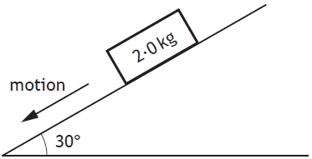
motion
30º
 |  | The magnitude of the force of friction acting on the block is
 | A  B  C  D  E | 1·0 N  1·7 N  9·8 N  17·0 N  19·6 N.

19. |  | A block is resting on a horizontal surface.  A force of 24 N is now applied as shown and the block slides along the surface.  24 N
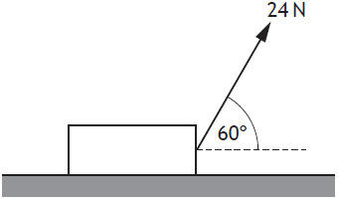
60º
The mass of the block is 20 kg.
The acceleration of the block is 0·20 m s⁻².
The force of friction acting on the block is
 | A  B  C  D  E | 4·0 N  8·0 N  12 N  16 N  25 N.
20. |  | A person stands on a weighing machine in a lift. When the lift is at rest, the reading on the weighing machine is 700 N.  The lift now descends and its speed increases at a constant rate.  The reading on the weighing machine
 | A  B  C  D  E | is a constant value higher than 700 N  is a constant value lower than 700 N  continually increases from 700 N  continually decreases from 700 N  remains constant at 700 N.

21. |  | A block of mass 6·0 kg and a block of mass 8·0 kg are connected by a string.  A force of 32 N is applied to the blocks as shown.

32 N
6·0 kg
8·0 kg
A frictional force of 4·0 N acts on each block.
The acceleration of the 6·0 kg block is
 | A  B  C  D  E | 1·7 m s⁻²  2·0 m s⁻²  2·3 m s⁻²  2·9 m s⁻²  5·3 m s⁻².
22. |  | Four masses on a horizontal, frictionless surface are linked together by strings P, Q and R.  A constant force is applied as shown.
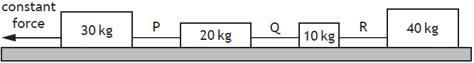
10 kg
Q
constant force
R
P
40 kg
20 kg
30 kg
 |  | The tension in the strings is
 | A  B  C  D  E | greatest in P and least in Q  greatest in P and least in R  greatest in R and least in Q  greatest in R and least in P  the same in P, Q and R.

Forces; Linear Motion
23. | (a) | A box of mass 18 kg is at rest on a horizontal frictionless surface.  A force of 4·0 N is applied to the box at an angle of 26º to the horizontal.  4·0 N
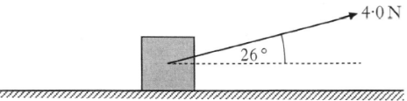
26º
 |  | (i) Show that the horizontal component of this force is 3·6 N. | 1
 |  | (ii) Calculate the acceleration of the box along the horizontal surface. | 3
 |  | (iii) Calculate the horizontal distance travelled by the box in a time of 7·0 s. | 3
 | (b) | The box is replaced at rest at its starting position.  The force of 4·0 N is now applied to the box at an angle of less than 26º to the horizontal.  4·0 N
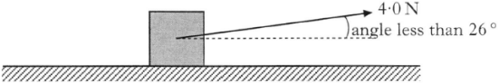
angle less than 26º
 |  | The force is applied for a time of 7·0 s as before.  Describe how the distance travelled by the box compares with your answer to part (a)(iii).  You must justify your answer. | 2

Forces; Linear Motion
24. |  | A van of mass 2600 kg moves down a slope which is inclined at 12º to the horizontal as shown.
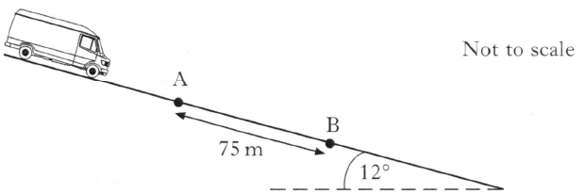
Not to scale
B
A
12º
75 m
 | (a) | Calculate the component of the van’s weight parallel to the slope. | 2
 | (b) | A constant frictional force of 1400 N acts on the van as it moves down the slope.  Calculate the acceleration of the van. | 4
 | (c) | The speed of the van as it passes point A is 5·0 m s⁻¹.  Point B is 75 m further down the slope.  Calculate the kinetic energy of the van at B. | 4

Forces; Linear Motion
25. |  | A fairground ride consists of rafts which slide down a slope into water.
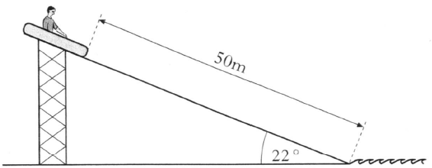
50 m
22º
 |  | The slope is at an angle of 22º to the horizontal. Each raft has a mass of 8·0 kg. The length of the slope is 50 m.
 |  | A child of mass 52 kg sits in a raft at the top of the slope. The raft is released from rest. The child and raft slide together down the slope into the water. The force of friction between the raft and slope remains constant at 180 N.
 | (a) | Calculate the component of weight, in newtons, of the child and raft down the slope. | 2
 | (b) | Show by calculation that the acceleration of the child and raft down the slope is 0·67 m s⁻². | 2
 | (c) | Calculate the speed of the child and raft at the bottom of the slope. | 3
 | (d) | A second child of smaller mass is released from rest in an identical raft at the same starting point. The force of friction is the same as before.  Describe how the speed of this child and raft at the bottom of the slope compares with the answer to part (c).  Justify your answer. | 2

Forces
26. |  | A car is travelling along a straight, level road. The brakes are then applied and the car comes to rest in a distance of 50 m.
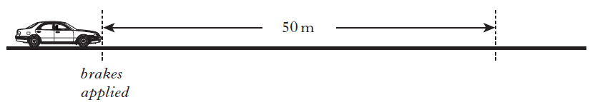
brakes
applied
50 m
The work done in stopping the car is 75 kJ and the average external frictional force exerted on the car is 300 N.
The total mass of the car and driver is 1100 kg.
 | (a) | Calculate the average force exerted by the brakes on the car. | 4
 | (b) | A second car of smaller total mass is travelling at the same speed along the same road. Its brakes are applied and it stops in the same distance of 50 m.  The same average external frictional force is exerted on this car compared to that of the original car.  Describe how the value of the average braking force on this car compares to that of the original car.  You must justify your answer. | 2

Forces; Vector Diagrams
27. |  | A spacecraft has a mass of 3520 kg and is descending vertically towards the surface of a moon.
 |  | 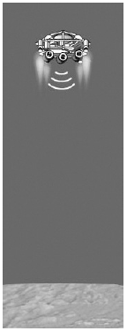
 |  | During the descent the average gravitational field strength for this moon is 1·25 N kg⁻¹.
 | (a) | When the spacecraft is at a height of 2·00 x 10³ m it has a vertical velocity of 90·0 m s⁻¹. Rocket engines exert a constant force on the spacecraft to reduce its speed.
This causes the speed of the spacecraft to be 0 m s⁻¹ at a height of
20·0 m.
 |  | Calculate the average vertical force exerted by the rocket engines during this descent. | 4
 | (b) | At this height of 20·0 m the spacecraft is kept stationary by the rockets while a rover vehicle is lowered at a constant speed towards the surface of the moon.  cords
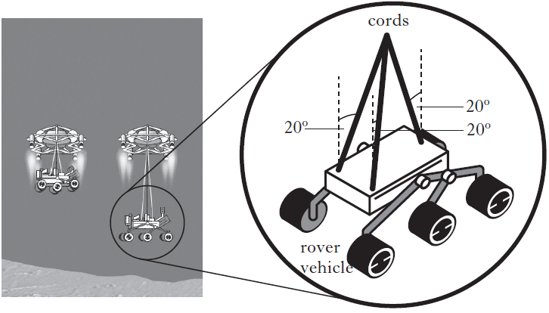
vehicle
rover
20º
20º
20º
 |  | The rover vehicle has a weight of 1380 N.  There are three cords supporting the rover as it descends.  At one instant, the angle between each cord and the vertical is 20º.  Show that the tension in each cord is 490 N at this instant. | 2

Forces; Motion Graphs
28. |  | A crate of mass 40·0 kg is pulled up a slope using a rope.
 |  | The slope is at an angle of 30º to the horizontal.
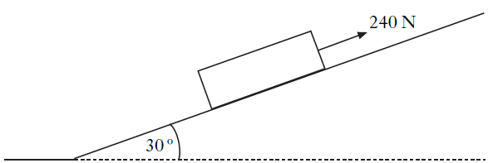
240 N
30º
 |  | A force of 240 N is applied to the crate parallel to the slope.
 |  | The crate moves at a constant speed of 3·0 m s⁻¹.
 | (a) | (i) Calculate the component of the weight of the crate acting parallel to the slope. | 2
 |  | (ii) Determine the frictional force acting on the crate. | 1
 | (b) | As the crate is moving up the slope, the rope snaps.  The graph shows how the velocity of the crate changes from the moment the rope snaps.  velocity / m s⁻¹
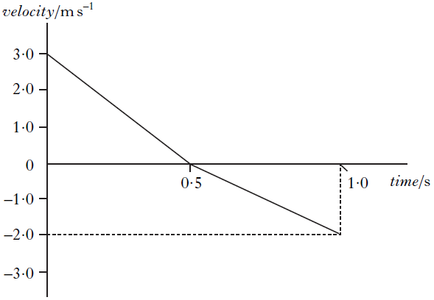
-2·0
-3·0
-1·0
0
1·0
2·0
3·0
1·0
0·5
time / s
 |  | (i) Describe the motion of the crate during the first 0·5 s after the rope snaps. | 1

28. | (b) | (continued)
 |  | (ii) Copy the axes shown below and sketch the graph to show the acceleration of the crate between 0 and 1·0 s.  Appropriate numerical values are also required on the acceleration axis.  acceleration / m s⁻² | 2
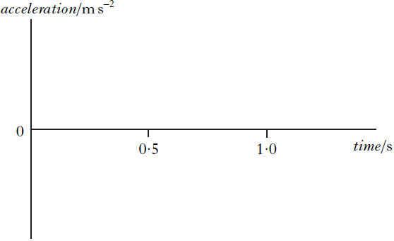
0
time / s
1·0
0·5
 |  | (iii) Explain, in terms of the forces acting on the crate, why the magnitude of the acceleration changes at 0·5 s. | 2

Linear Motion
1. |  | A helicopter is descending vertically at a constant speed of 3·0 m s⁻¹. A sandbag is released from the helicopter. The sandbag hits the ground 5·0 s later.
 |  | What was the height of the helicopter above the ground at the time the sandbag was released?
 | A  B  C  D  E | 15·0 m  49·0 m  107·5 m  122·5 m  137·5 m
2. |  | An object has a constant acceleration of 3 m s⁻². This means that the
 | A  B  C  D  E | distance travelled by the object increases by 3 metres every second  displacement of the object increases by 3 metres every second  speed of the object is 3 m s⁻¹ every second  velocity of the object is 3 m s⁻¹ every second  velocity of the object increases by 3 m s⁻¹ every second.
3. |  | The total mass of a motorcycle and rider is 250 kg. During braking, they are brought to rest from a speed of 16·0 m s⁻¹ in a time of 10·0 s.
 |  | The maximum energy which could be converted to heat in the brakes is
 | A  B  C  D  E | 2000 J  4000 J  32000 J  40000 J  64000 J.

4. |  | A car of mass 1000 kg is travelling at a speed of 40 m s⁻¹ along a race track. The brakes are applied and the speed of the car decreases to  10 m s⁻¹.
 |  | How much kinetic energy is lost by the car?
 | A  B  C  D  E | 15 kJ  50 kJ  450 kJ  750 kJ  800 kJ
5. |  | A train accelerates uniformly from 5 m s⁻¹ to 12·0 m s⁻¹ while travelling a distance of 119 m along a straight track. The acceleration of the train is
 | A  B  C  D  E | 0·50 m s⁻²  0·70 m s⁻²  1·2 m s⁻²  7·0 m s⁻²  14 m s⁻².
6. |  | A boat is moving at a speed of 6·0 m s⁻¹. The boat now accelerates at 3·0 m s⁻² until it reaches a speed of 12 m s⁻¹.
 |  | The distance travelled by the boat during this acceleration is
 | A  B  C  D  E | 6·0 m  18 m  30 m  36 m  54 m.

7. |  | A car is travelling at 12 m s⁻¹ along a straight road. The car now accelerates uniformly at -1·5 m s⁻² for 6·0 s.
 |  | The distance travelled during this time is
 | A  B  C  D  E | 18 m  45 m  68 m  72 m  99 m.
8. |  | A car accelerates uniformly from rest. The car travels a distance of 60 m in 6·0 s. The acceleration of the car is
 | A  B  C  D  E | 0·83 m s⁻²  3·3 m s⁻²  5·0 m s⁻²  10 m s⁻²  20 m s⁻².
9. |  | A car is moving at a speed of 2·0 m s⁻¹.  The car now accelerates at 4·0 m s⁻² until it reaches a speed of 14 m s⁻¹.  The distance travelled by the car during this acceleration is
 | A  B  C  D  E | 1·5 m  18 m  24 m  25 m  48 m.

Linear Motion; Oscilloscopes and A.C. Supplies
10. |  | A train of mass 7·5 x 10⁵ kg is travelling at 60 m s⁻¹ along a straight horizontal track.
 |  | 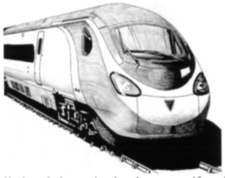
 |  | The brakes are applied and the train decelerates uniformly to rest in a time of 40 s.
 | (a) | (i) Calculate the distance the train travels between the brakes being applied and the train coming to rest. | 3
 |  | (ii) Calculate the force required to bring the train to rest in this time. | 3
 | (b) | Part of the train's braking system consists of an electrical circuit as shown in the diagram.  resistor
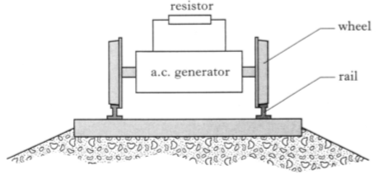
a.c. generator
wheel
rail
While the train is braking, the wheels drive an a.c. generator which changes kinetic energy into electrical energy. This electrical energy is changed into heat in a resistor. The r.m.s. current in the resistor is
2·5 x 10³ A and the resistor produces 8·5 MJ of heat each second.
 |  | Calculate the peak voltage across the resistor. | 4

Linear Motion; Band Theory and Conductivity; Practical Circuits
11. |  | To test the braking system of cars, a test track is set up as shown.  data-logger
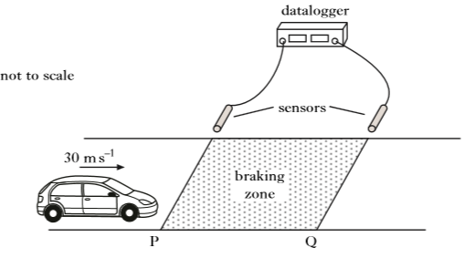
not to scale
30 m s⁻¹
Q
P
braking zone
sensors
 |  | The sensors are connected to a data-logger which records the speed of a car at both P and Q.
 |  | A car is driven at a constant speed of 30 m s⁻¹ until it reaches the start of the braking zone at P. The brakes are then applied.
 | (a) | In one test, the data-logger records the speed at P as 30 m s⁻¹ and the speed at Q as 12 m s⁻¹. The car slows down at a constant rate of  9·0 m s⁻² between P and Q.  Calculate the length of the braking zone. | 3
 | (b) | The test is repeated. The same car is used but now with passengers in the car. The speed of P is again recorded as 30 m s⁻¹.  The same braking force is applied to the car as in part (a).  State how the speed of the car at Q compares with its speed at Q in part (a).  Justify your answer. | 2

11. |  | (continued)
 | (c) | The brake lights of the car consist of a number of very bright LEDs.  An LED from the brake lights is forward biased by connecting it to a  12 V car battery as shown.  12 V
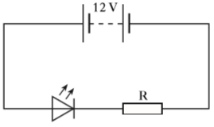
R
 |  | The battery has negligible internal resistance.
 |  | (i) Explain, in terms of charge carries, how the LED emits light. | 2
 |  | (ii) The LED is operating at its rated values of 5·0 V and  2·2 W.  Calculate the value of resistor R. | 4

Linear Motion; Vector Diagrams
12. | (a) | A gymnast of mass 40 kg is practising on a trampoline.
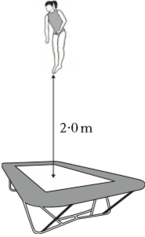
2·0 m
 |  | (i) At maximum height the gymnast's feet are 2·0 m above the trampoline.  Show that the speed of the gymnast, as she lands on the trampoline, is 6·3 m s⁻¹. | 2
 |  | (ii) The gymnast rebounds with a speed of 5·7 m s⁻¹.  Calculate the change in momentum of the gymnast. | 3
 |  | (iii) The gymnast was in contact with the trampoline for 0·50 s.  Calculate the average force exerted by the trampoline on the gymnast. | 3

12. |  | (continued)
 | (b) | Another gymnast is practising on a piece of equipment called the rings. The gymnast grips two wooden rings suspended above the gym floor by strong, vertical ropes as shown in Figure 1.
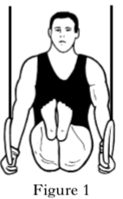
Figure 1
 |  | He now stretches out his arms until each rope makes an angle of 10º with the vertical as shown in Figure 2.
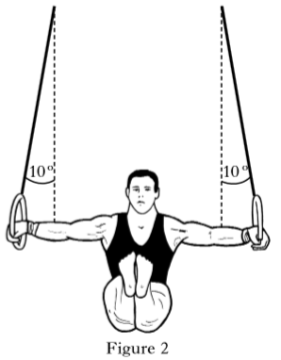
10º
10º
Figure 2
 |  | Explain why the tension in each rope increases as the gymnast stretches out his arms. | 2

Linear Motion; Forces
13. |  | A car is travelling at a constant speed of 15 m s⁻¹ along a straight, level road. It passes a motorcycle which is stationary at the roadside.  0·0 m s⁻¹
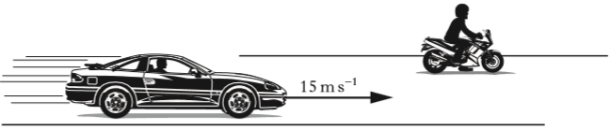
15 m s⁻¹
 |  | At the instant the car passes, the motorcycle starts to move in the same direction as the car.
 |  | The graph shows the motion of each vehicle from the instant the car passes the motorcycle.
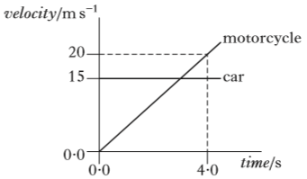
velocity / m s⁻¹
20
15
0·0

0·0

time / s
4·0
car
motorcycle
 | (a) | Show that the initial acceleration of the motorcycle is 5·0 m s⁻². | 2
 | (b) | Calculate the distance between the car and the motorcycle at 4·0 s. | 4
 | (c) | The total mass of the motorcycle and rider is 290 kg. At a time of 2·0 s the driving force on the motorcycle is 1800 N.
 |  | (i) Calculate the frictional force acting on the motorcycle at this time. | 4
 |  | (ii) Explain why the driving force must be increased with time to maintain a constant acceleration. | 2

Linear Motion; Doppler Effect
14. |  | A student is on a stationary train.
 |  | The train now accelerates along a straight level track.
 |  | The student uses an app on a phone to measure the acceleration of the train.
 |  | 
 | (a) | The train accelerates uniformly at 0·32 m s⁻² for 25 seconds.
 |  | (i) State what is meant by an acceleration of 0·32 m s ⁻². | 1
 |  | (ii) Calculate the distance travelled by the train in the  25 seconds. | 3
 | (b) | Later in the journey, the train is travelling at a constant speed as it approaches a bridge.
 |  | 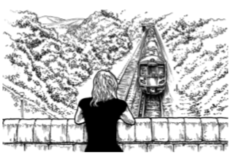
 |  | A horn on the train emits sound of frequency 270 Hz.
 |  | The frequency of the sound heard by a person standing on the bridge is 290 Hz.
 |  | The speed of sound in air is 340 m s⁻¹.
 |  | (i) Calculate the speed of the train. | 3
 |  | (ii) The train continues to sound its horn as it passes under the bridge.  Explain why the frequency of the sound heard by the person standing on the bridge decreases as the train passes under the bridge and then moves away.  You may wish to use a diagram. | 1
Momentum and Impulse
1. |  | The momentum of a rock of mass 4 kg is 12 kg m s⁻¹.  The kinetic energy of the rock is
 | A  B  C  D  E | 6 J  18 J  36 J  144 J  288 J.
2. |  | A rocket of mass 5·0 kg is travelling horizontally with a speed of  200 m s⁻¹ when it explodes into two parts. One part of mass 3·0 kg continues in the original direction with a speed of 100 m s⁻¹. The other part also continues in this same direction. Its speed is
 | A  B  C  D  E | 150 m s⁻¹  200 m s⁻¹  300 m s⁻¹  350 m s⁻¹  700 m s⁻¹.
3. |  | A cannon of mass 1200 kg fires a cannonball of mass 15 kg at a velocity of 60 m s⁻¹ East.  60 m s⁻¹
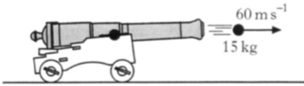
15 kg
 |  | Assuming the force of friction is negligible, the velocity of the cannon just after firing is
 | A  B  C  D  E | 0 m s⁻¹  0·75 m s⁻¹ East  0·75 m s⁻¹ West  6·0 m s⁻¹ East  6·0 m s⁻¹ West.

4. |  | A golf ball, initially at rest, is hit by a club. The graph of the force of the club on the ball against time is shown.  force / kN
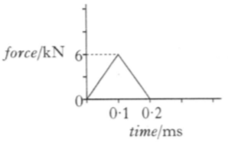
0
0·2

0·1
time / ms
6
A different type of golf ball of the same size and mass is now hit with the same club. This ball moves off with the same velocity as the first ball.
Which graph shows the force of the club on the second ball against time?
 | A | 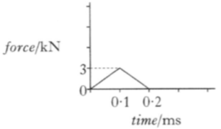  time / ms  12  3  0  0·2  0·1  force / kN | D | 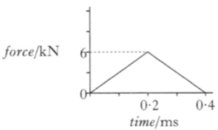  time / ms  12  6  force / kN  0  0·4  0·2
 | B | 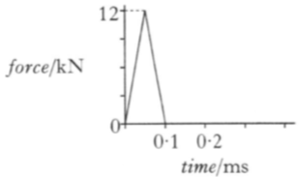  time / ms  12  0  0·2  0·1  force / kN | E | 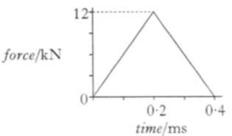  time / ms  0  0·4  0·2  force / kN
 | C | 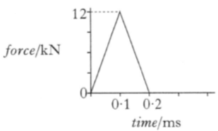  time / ms  0  0·2  0·1  force / kN

5. |  | Car X is designed with a "crumple-zone" so that the front of the car collapses during impact as shown.
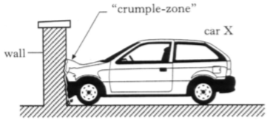
car X
"crumple-zone"
wall
 |  | A similar car, Y, of equal mass is built without a crumple-zone. In a safety test both cars are driven at the same speed into identical walls before coming to rest after colliding with the walls.
 |  | Which of the following statements is/are true during the collisions?
 |  | I The average force on car X is smaller than that on car Y.
 |  | II The time taken for car X to come to rest is greater than that for car Y.
 |  | III The change in momentum of car X is smaller than that of car Y.
 | A | I only
 | B | I and II only
 | C | I and III only
 | D | II and III only
 | E | I, II and III
6. |  | A golfer hits a stationary ball of mass 5·0 x 10⁻² kg with a golf club. The ball leaves the tee with a velocity of 80 m s⁻¹. The club is in contact with the ball for a time of 0·10 s.
 |  | The average force exerted by the club on the ball is
 | A  B  C  D  E | 6·25 x 10⁻⁴ N  0·025 N  0·4 N  4 N  40 N.

7. |  | A vehicle of mass 0·1 kg is moving to the right along a horizontal friction-free air track. A vehicle of mass 0·2 kg is moving to the left on the same track.
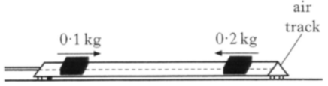
0·2 kg
0·1 kg
track
 |  | The vehicles collide and stick together.
 |  | Which of the following quantities is/are always conserved in collisions?
 |  | I The total momentum
 |  | II The total kinetic energy
 |  | III The total energy
 | A  B  C  D  E | I only  II only  I and II only  I and III only  II and III only
8. |  | Two trolleys travel towards each other in a straight line as shown.
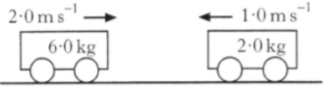
6·0 kg

2·0 kg

1·0 m s⁻¹

2·0 m s⁻¹

 |  | The trolleys collide. After the collision the trolleys move as shown below.
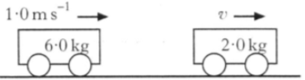
6·0 kg

2·0 kg

v
1·0 m s⁻¹

 |  | What is the speed v of the 2·0 kg trolley after the collision?
 | A  B  C  D  E | 1·25 m s⁻¹  1·75 m s⁻¹  2·0 m s⁻¹  4·0 m s⁻¹  5·0 m s⁻¹

9. |  | A mass of 2 kg slides along a frictionless surface at 10 m s⁻¹ and collides with a stationary mass of 10 kg.
before impact
2 kg

10 kg

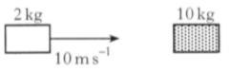
10 m s⁻¹
 |  | After the collision, the 2 kg mass rebounds at 5 m s⁻¹ and the 10 kg mass moves off at 3 m s⁻¹.
after impact
10 kg

2 kg

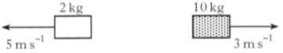
5 m s⁻¹
3 m s⁻¹
 |  | Which row in the following table is correct?
Momentum of system | Kinetic energy of system | Type of collision
conserved | conserved | elastic
conserved | not conserved | inelastic
conserved | not conserved | elastic
not conserved | not conserved | inelastic
not conserved | not conserved | elastic

10. |  | The graph shows the force acting on an object of mass 5·0 kg.
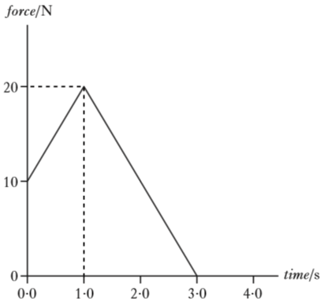
4·0
3·0
2·0
1·0
0·0
20
10
0
time / s
force / N
 |  | The change in the object's momentum is
 | A  B  C  D  E | 7·0 kg m s⁻¹  30 kg m s⁻¹  35 kg m s⁻¹  60 kg m s⁻¹  175 kg m s⁻¹.

11. |  | A cannon of mass 2000 kg fires a cannonball of mass 5·00 kg.  The cannonball leaves the cannon with a speed of 50·0 m s⁻¹.  The speed of the cannon immediately after firing is
 | A  B  C  D  E | 0·125 m s⁻¹  8·00 m s⁻¹  39·9 m s⁻¹  40·1 m s⁻¹  200 m s⁻¹.
12. |  | Momentum can be measured in
 | A  B  C  D  E | N kg⁻¹  N m  N m s⁻¹  kg m s⁻¹  kg m s⁻².
13. |  | The graph shows the force which acts on an object over a time interval of 8 seconds.  force / N
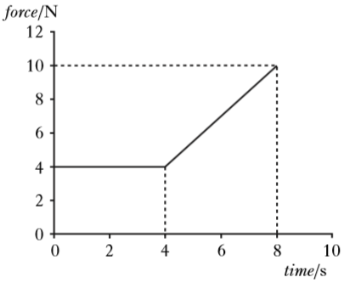
10
8
6
4
2
0
time / s
12
10
8
6
4
2
0
 |  | The momentum gained by the object during this 8 seconds is
 | A  B  C  D  E | 12 kg m s⁻¹  32 kg m s⁻¹  44 kg m s⁻¹  52 kg m s⁻¹  72 kg m s⁻¹.

14. |  | A shell of mass 8·0 kg is travelling horizontally with a speed of 100 m s⁻¹. It explodes into two parts. One part of mass 3·0 kg continues in the original direction with a speed of 200 m s⁻¹.  The other part also continues in this same direction. Its speed is
 | A  B  C  D  E | 25 m s⁻¹  40 m s⁻¹  67 m s⁻¹  200 m s⁻¹  250 m s⁻¹.
15. |  | A 2·0 kg trolley travels in a straight line towards a stationary 5·0 kg trolley on a frictionless surface as shown.  0 m s⁻¹  4·0 m s⁻¹
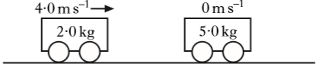
5·0 kg
2·0 kg
The trolleys collide. After the collision the trolleys move as shown below.
v
1·0 m s⁻¹
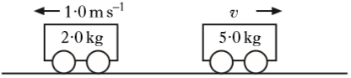
5·0 kg
2·0 kg
 |  | What is the speed v of the 5·0 kg trolley after the collision?
 | A  B  C  D  E | 0·4 m s⁻¹  1·2 m s⁻¹  2·0 m s⁻¹  2·2 m s⁻¹  3·0 m s⁻¹.

16. |  | Two trolleys travel towards each other in a straight line along a frictionless surface.
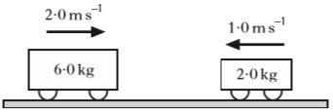
2·0 kg
6·0 kg
1·0 m s⁻¹
2·0 m s⁻¹
 |  | The trolleys collide. After the collision the trolleys move as shown below.
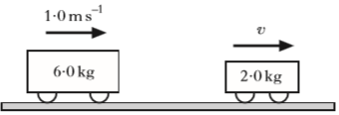
6·0 kg
2·0 kg
v
1·0 m s⁻¹
 |  | Which row in the table gives the total momentum and the total kinetic energy after the collision?
 | A  B  C  D  E
  Total momentum/  kg m s⁻¹ | Total kinetic energy/  J
  10 | 7·0
  10 | 13
  10 | 20
  14 | 13
  14 | 7·0
17. |  | The diagram shows the masses and velocities of two trolleys just before they collide on a level, frictionless bench.  0 m s⁻¹  6·0 m s⁻¹
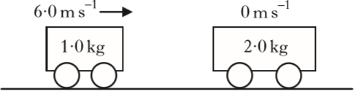
2·0 kg
1·0 kg
After the collision, the trolleys move along the bench joined together.
How much kinetic energy is lost in this collision?
 | A  B  C  D  E | 0 J  6·0 J  12 J  18 J  24 J

18. |  | A cannon of mass 2·0 x 10³ kg fires a cannonball of mass 4·0 kg.  The cannon moves backwards on firing with a speed of 0·05 m s⁻¹.  The speed of the cannonball immediately after firing is
 | A  B  C  D  E | 2·50 x 10⁻² m s⁻¹  25·0 m s⁻¹  99·8 m s⁻¹  100·2 m s⁻¹  400 m s⁻¹.
19. |  | The graph shows how the force acting on an object of mass 15·0 kg varies with time.  force / N
5·0
4·0
3·0
2·0
0·0
time / s
40
20
0
 |  | The change in momentum of the object is
 | A  B  C  D  E | 10 kg m s⁻¹  60 kg m s⁻¹  70 kg m s⁻¹  80 kg m s⁻¹  120 kg m s⁻¹.

20. |  | A student makes the following statements about elastic and inelastic collisions.
I In an elastic collision kinetic energy is conserved but momentum is not conserved.
II In an inelastic collision both kinetic energy and momentum are conserved.
III In an inelastic collision momentum is conserved but kinetic energy is not conserved.
 |  | Which of the statements is/are correct?
 | A  B  C  D  E | I only  II only  III only  I and II only  I and III only
21. |  | The graph shows the force which acts on an object over a time interval of 4·0 seconds.  force (N)
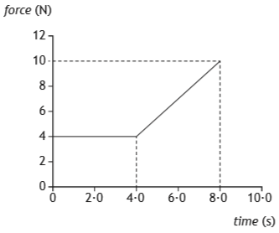
time (s)
5·0
4·0
3·0
2·0
1·0
0
600
500
400
300
200
0
100
 |  | The change in momentum of the object during this 4·0 seconds is
 | A  B  C  D  E | 1000 kg m s⁻¹  1100 kg m s⁻¹  1400 kg m s⁻¹  2000 kg m s⁻¹  2800 kg m s⁻¹.

22. |  | A student makes the following statements about an elastic collision.
I Total momentum is conserved.
II Total kinetic energy is conserved.
III Total energy is conserved.
 |  | Which of these statements is/are correct?
 | A  B  C  D  E | I only  II only  I and II only  I and III only  I, II and III

Momentum and Impulse; Linear Motion
23. |  | The apparatus shown below is used to test concrete pipes.  15 kg mass
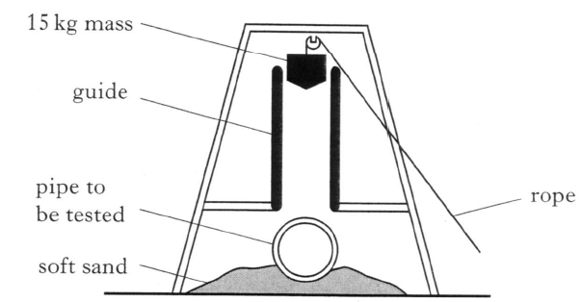
soft sand
pipe to be tested
guide
rope
 |  | The 15 kg mass is at rest. When the rope is released, the 15 kg mass is dropped and falls freely through a distance of 2·0 m on to the pipe.
 | (a) | In one test, the mass is dropped on to an uncovered pipe.
 |  | (i) Calculate the speed of the mass just before it hits the pipe. | 3
 |  | (ii) When the 15 kg mass hits the pipe the mass is brought to rest in a time of 0·02 s.  Calculate the the average unbalanced force on the pipe. | 3
 | (b) | The same 15 kg mass is now dropped through the same distance on to an identical pipe which is covered with a thick layer of soft material.
 |  | Describe and explain the effect this layer has on the size of the average unbalanced force on the pipe. | 2
 | (c) | Two 15 kg masses, X and Y, shaped as shown, are dropped through the same distance on to identical uncovered concrete pipes.
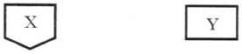
Y
X
 |  | When the masses hit the pipes, the masses are brought to rest in the same time.
 |  | State which of the two masses causes more damage.
 |  | Explain your answer in terms of pressure. (National 5 question) | 2

Momentum and Impulse; Particle Accelerators
24. |  | Beads of liquid moving at high speed are used to move threads in modern weaving machines.
 | (a) | In one design of machine, beads of water are accelerated by jets of air as shown in the diagram.
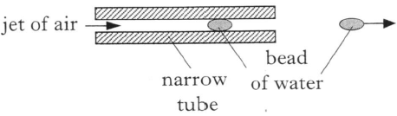
narrow
tube
jet of air
bead
of water
 |  | Each bead has a mass of 2·5 x 10⁻⁵ kg.
When designing the machine, it was estimated that each bead of water would start from rest and experience a constant unbalanced force of
0·5 N for a time of 3·0 ms.
 |  | (i) Calculate:  (A) the impulse on a bead of water;  (B) the speed of the bead as it emerges from the tube. | 3  3
(ii) In practice the force on a bead varies.
The following graph shows how the actual unbalanced force exerted on each bead of water varies with time.
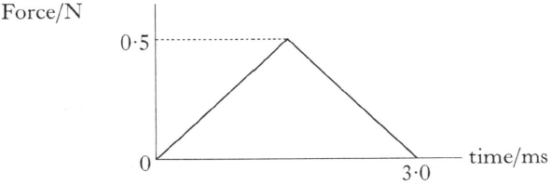
force / N
time / ms
3·0
0
0·5
 |  | Use information from this graph to show that the bead leaves the tube with a speed equal to half of the value calculated in part (i)(B). | 3
 | (b) | Another design of machine uses beads of oil and two metal plates X and Y.  The potential difference between these plates is 5·0 x 10³ V.  Each bead of oil has a mass of 4·0 x 10⁻⁵ kg and is given a negative charge of 6·5 x 10⁻⁶ C.  The bead accelerates from rest at plate X and passes through a hole in plate Y.  +5·0 x 10³ V  0 V
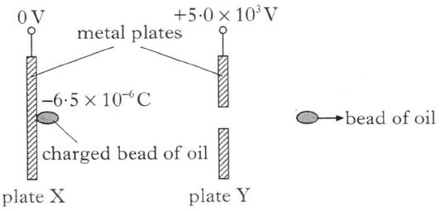
-6·5 x 10⁻⁶ C
bead of oil
plate Y
plate X
charged bead of oil
metal plates
 |  | Neglecting air friction, calculate the speed of the bead at plate Y. | 4
Momentum and Impulse
25. | (a) | A space vehicle of mass 2500 kg is moving with a constant speed of 0·50 m s⁻¹ in the direction shown. It is about to dock with a space probe of mass 1500 kg which is moving with a constant speed in the opposite direction.  0·50 m s⁻¹
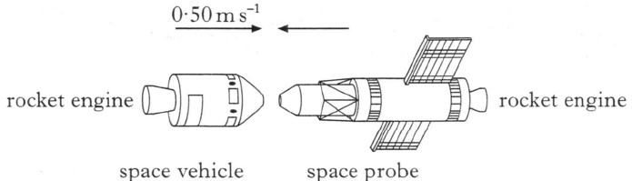
rocket engine
rocket engine
space vehicle
space probe
After docking, the space vehicle and space probe move off together at 0·20 m s⁻¹ in the original direction in which the space vehicle was moving.
0·20 m s⁻¹
 |  | 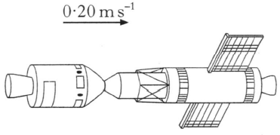
 |  | Determine the speed of the space probe before it docked with the space vehicle. | 3
 | (b) | The space vehicle has a rocket engine which produces a constant thrust of 1000 N. The space probe has a rocket engine which produces a constant thrust of 500 N.
 |  | The space vehicle and space probe are now brought to rest from their combined speed of 0·20 m s⁻¹.
 |  | (i) State which rocket was switched on to bring the vehicle and probe to rest. | 1
 |  | (ii) Calculate the time for which this rocket engine was switch on. You may assume that negligible mass of fuel was used during this time. | 3
 | (c) | The space vehicle and probe are to be moved from their stationary position at A and brought to rest at position B, as shown.
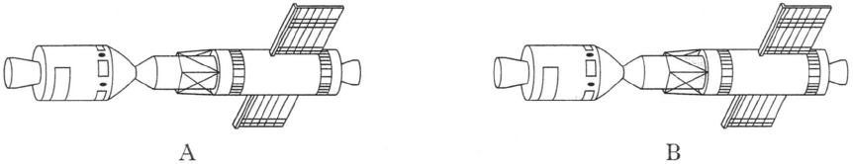
B
A
 |  | Explain clearly how the rocket engines of the space vehicle and the space probe are used to complete this manoeuvre.  Your explanation must include an indication of the relative time for which each rocket engine must be fired.  You may assume that a negligible mass of fuel is used during this manoeuvre. | 1
Momentum and Impulse
26. |  | A force sensor is used to investigate the impact of a ball as it bounces on a flat horizontal surface. The ball has a mass of 0·050 kg and is dropped vertically, from rest, through a height of 1·6 m as shown.
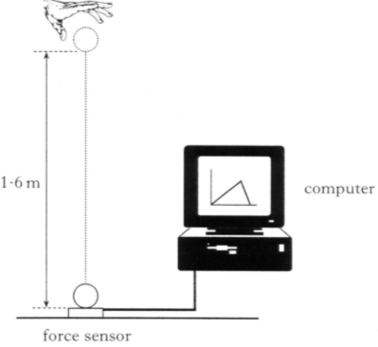
computer
1·6 m
force sensor
 | (a) | The graph shows how the force on the ball varies with time during the impact.  force / N
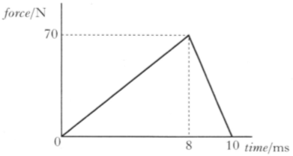
70
8
0
10
time / ms
 |  | (i) Show by calculation that the magnitude of the impulse on the ball is 0·35 N s. | 2
 |  | (ii) State the magnitude and direction of the change in momentum of the ball. | 1
 |  | (iii) The ball is travelling at 5·6 m s⁻¹ just before it hits the force sensor.  Calculate the speed of the ball just as it leaves the force sensor. | 3
 | (b) | Another ball of identical size and mass, but made of a harder material, is dropped from rest and from the same height onto the same force sensor.  Sketch the force-time graph exactly as shown above and, on the same axes, sketch how the force on the harder ball varies with time.  Numerical values are not required but you must label the graph clearly. | 2
Momentum and Impulse
27. |  | The apparatus shown is set up to investigate collisions between two vehicles on a track.  vehicle  B  vehicle  A  motion sensor
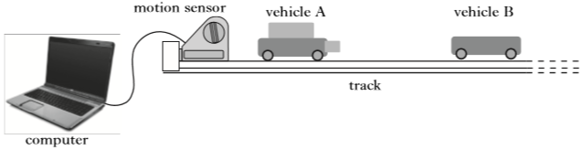
track
computer
The mass of vehicle A is 0·22 kg and the mass of vehicle B is 0·16 kg.
The effects of friction are negligible.
 | (a)  velocity / m s⁻¹ | During one experiment the vehicles collide and stick together. The computer connected to the motion sensor displays the velocity-time graph for vehicle A.
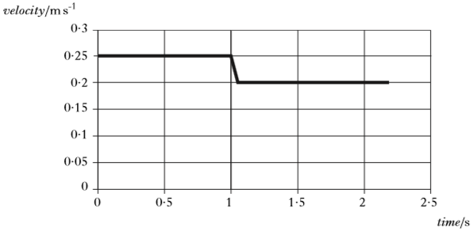
time / s
0·30
0·25
0·20
0·15
0·00
0·10
0·05
0·0
0·5
1·0
1·5
2·5
2·0
 |  | (i) State the law of conservation of momentum. | 1
 |  | (ii) Determine the velocity of vehicle B before the collision. | 3
 | (b) | The same apparatus is used to carry out a second experiment.  In this experiment, vehicle B is stationary before the collision.  Vehicle A has the same velocity before the collision as in the first experiment.  After the collision, the two vehicles stick together.  State whether their combined velocity is less than, equal to, or greater than that in the first collision.  Justify your answer. | 2
Momentum and Impulse
28. |  | An experiment is set up to investigate the motion of a cart as it collides with a force sensor.  motion sensor  force sensor
 | wires to computer |   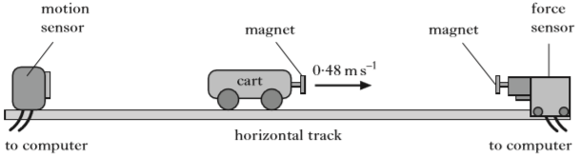  wires to computer  horizontal track  0·48 m s⁻¹  magnet  magnet
 |  | The cart moves along the horizontal track at 0·48 m s⁻¹ to the right.
 |  | As the cart approaches the force sensor, the magnets repel each other and exert a force on the cart.
The computer attached to the force sensor displays the following force-time graph for this collision.
magnitude of force / N
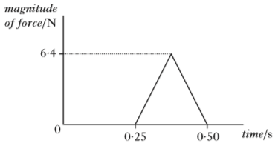
0·50
0·25
0
6·4
time / s
The computer attached to the motion sensor displays the following velocity-time graph for the cart.
velocity / m s⁻¹
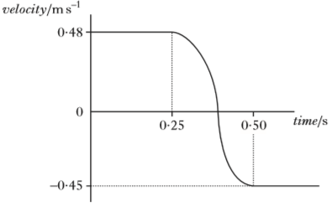
time / s
0·25
0·50
-0·45
0
0·48

28. |  | (continued)
 | (a) | (i) Calculate the magnitude of the impulse on the cart during the collision. | 3
 |  | (ii) Determine the magnitude and direction of the change in momentum of the cart. | 1
 |  | (iii) Calculate the mass of the cart. | 3
 | (b) | The experiment is repeated using different magnets which produce a greater average force on the cart during the collision. As before, the cart is initially travelling at 0·48 m s⁻¹ to the right and the collision causes the same change in its velocity.  Copy the force-time graph shown and, on the same axes, draw another graph to show how the magnitude of the force varies with time in this collision.  Numerical values are not required but you must label each graph clearly. | 2

Momentum and Impulse; Linear Motion
29. |  | The force applied by a seat belt on a crash test dummy is being investigated. The crash test dummy is placed in a car.
 |  | The car then travels along a test track at a speed of 13·4 m s⁻¹, collides with a wall and comes to rest.
 |  | 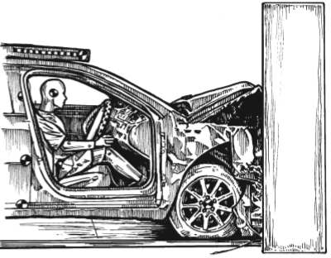
 | (a) | State the law of conservation of linear momentum. | 1
 | (b) | The total mass of the car and dummy is 1200 kg.  Calculate the change in momentum of the car and dummy in the collision. | 3
 | (c) | The crash test dummy has a mass of 75 kg and is wearing a seat belt.  During the collision, the dummy travels a distance of 0·48 m while coming to rest.  Calculate the average force exerted on the dummy by the seat belt. | 4

Momentum and Impulse
30. |  | Interactions between objects can be analysed using the law of conservation of momentum.
 | (a) | An experiment is set up to verify that momentum is conserved when two vehicles explode apart.
 | frictionless track | 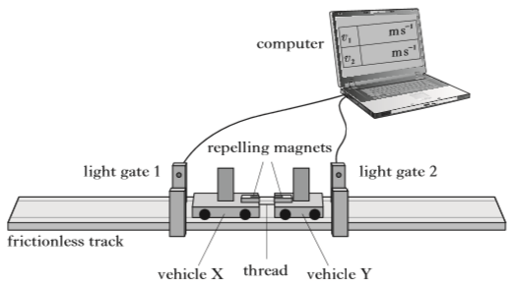  computer  light gate 2  light gate 1  repelling magnets  vehicle Y  thread  vehicle X
 |  | Initially, both vehicles are stationary on the horizontal track and are held together by a thread.  The thread is cut and the force between the magnets pushes the vehicles apart.  The computer then displays the speed of each vehicle as it passes through a light gate.  The following data is recorded:  Mass of vehicle X = 0·70 kg  Mass of vehicle Y = 0·30 kg  Speed of vehicle X through light gate 1 = 0·51 m s⁻¹  Speed of vehicle Y through light gate 2 = 1·19 m s⁻¹  Use this data to show that momentum is conserved in this interaction. | 3

30. | (b) | In a second experiment, a block of wood of mass 0·20 kg is suspended from the ceiling by thin cords of negligible mass.  A dart of mass 0·050 kg is thrown at the stationary block of wood.  Just before the dart hits the block it is travelling horizontally at a velocity v.  The dart sticks into the block.  The dart and block then swing to a maximum height of 0·15 m as shown.  After  Before
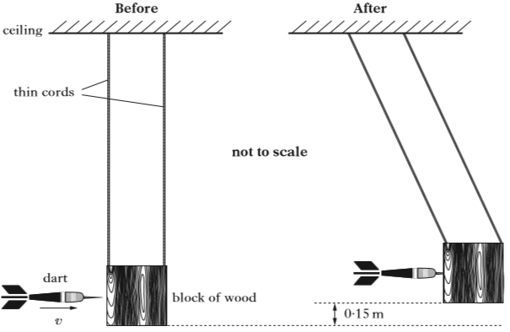
block of wood
dart
not to scale
ceiling
thin cords
v
0·15 m
 |  | (i) Use conservation of energy to show that the velocity of the dart and block just after the collision is 1·7 m s⁻¹. | 2
 |  | (ii) Determine the velocity of the dart just before it hits the block. | 3
 |  | (iii) The experiment is repeated.  Just before it hits the block, the dart is travelling with the same velocity as in (b)(ii).  This time the dart bounces backwards off the block.  Explain why the block now swings to a greater vertical height. | 2

Momentum and Impulse
31. |  | During a hockey match a penalty is awarded.  This gives a player a free hit at a stationary ball with only the goalkeeper between the player and the goal.
 |  | 
 |  | The mass of the ball is 0·16 kg.
The hockey stick is in contact with the ball for 0·020 s.
The speed of the ball immediately after impact is 39 m s⁻¹.
 | (a) | (i) Calculate the average force exerted by the stick on the ball. | 3
 |  | (ii) Sketch a graph showing how the force exerted by the stick on the ball varies with time during the impact.  Numerical values are not required on the axes. | 1
 | (b) | The ball is replaced by a second ball with the same mass and dimensions as the first ball. However, the material of the second ball is softer.
 |  | The speed of this second ball immediately after being struck by the hockey stick is also 39 m s⁻¹.  On the graph sketched for (a)(ii), draw another graph to show how the force exerted on this second ball varies with time.  You must label each graph clearly. | 2

Momentum and Impulse; Motion Graphs
32. |  | A student sets up an experiment to investigate collisions between two trolleys on a long, horizontal track.
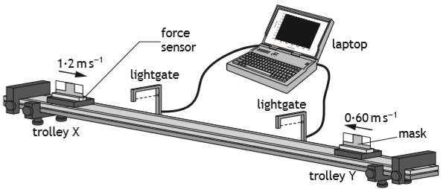
trolley Y
0·60 m s⁻¹
force
sensor
trolley X
laptop
light gate
light gate
1·2 m s⁻¹
mask
The mass of trolley X is 0·25 kg and the mass of trolley Y is 0·45 kg.
The effects of friction are negligible.
In one experiment, trolley X is moving at 1·2 m s⁻¹ to the right and trolley Y is moving at 0·60 m s⁻¹ to the left.
The trolleys collide and do not stick together. After the collision, trolley X rebounds with a velocity of 0·80 m s⁻¹ to the left.
 | (a) | Determine the velocity of trolley Y after the collision. | 3
 | (b) | The force sensor measures the force acting on trolley Y during the collision.  The laptop displays the following force-time graph for the collision.  4·5
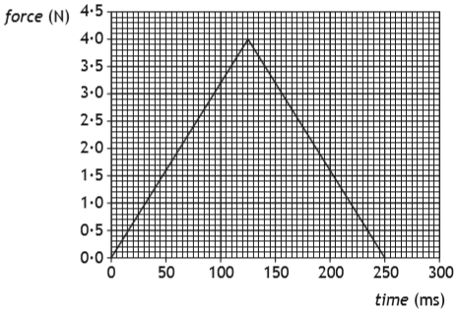
force (N)
4·0
3·5
3·0
2·5
2·0
1·5
1·0
0·5
300
250
200
150
100
50
0
time (ms)
0·0
 |  | (i) Determine the magnitude of the impulse on trolley Y. | 3
 |  | (ii) Determine the magnitude of the change in momentum of trolley X. | 1
 |  | (iii) Sketch a velocity-time graph to show how the velocity of trolley X varies from 0·50 s before the collision to 0·50 s after the collision.  Numerical values are required on both axes. | 3
Momentum and Impulse
33. |  | The following apparatus is set up to investigate the law of conservation of linear momentum.
 | frictionless track | 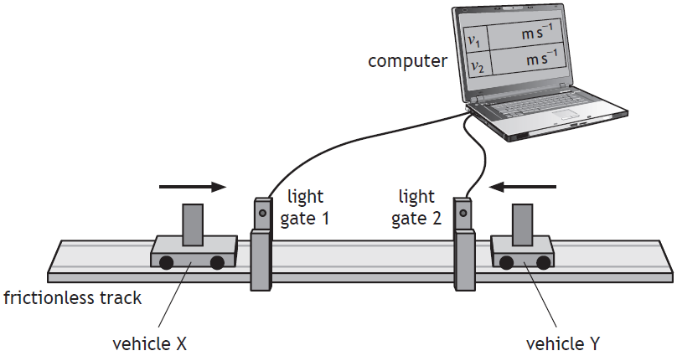  vehicle Y  vehicle X  light gate 2  light gate 1  computer
 |  | In one experiment, vehicle X is travelling to the right along the track and vehicle Y is travelling to the left along the track.
 |  | The vehicles collide and stick together.
 |  | The computer displays the speeds of each vehicle before the collision.
 |  | The following sets of data are recorded:
Mass of vehicle X = 0·85 kg
Mass of vehicle Y = 0·25 kg
Speed of vehicle X before the collision = 0·55 m s⁻¹
Speed of vehicle Y before the collision = 0·30 m s⁻¹
 | (a) | State the law of conservation of linear momentum. | 1
 | (b) | Calculate the velocity of the vehicles immediately after the collision. | 3
 | (c) | Show by calculation that the collision is inelastic. | 4

Momentum and Impulse; Uncertainties
34. |  | A white snooker ball and black snooker ball travel towards each other in a straight line on a frictionless surface.  The white ball and the black ball each have a mass of 0·180 kg.  Just before the balls collide head-on, the white ball is travelling at  2·60 m s⁻¹ to the right and the black ball is travelling at 1·80 m s⁻¹ to the left.

2·60 m s⁻¹
1·80 m s⁻¹
 |  | After the collision, the black ball rebounds with a velocity of 2·38 m s⁻¹ to the right.
 | (a) | (i) Determine the velocity of the white ball immediately after the collision. | 3
 |  | (ii) The collision between the balls is inelastic.  State what is meant by an inelastic collision. | 1
 | (b) | A student carries out an experiment to measure the average force exerted by a cue on a ball.  push switch  motion sensor
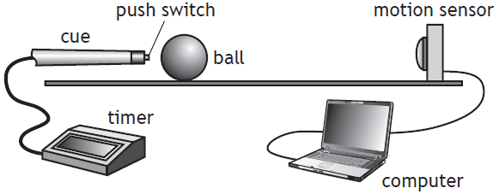
timer
cue
ball
computer
 |  | The cue hits the stationary ball.  The timer records the time the cue is in contact with the ball.  The computer displays the speed of the ball.  The results are shown.  Time of contact between the cue and the ball = (0·040 ± 0·001) s  Speed of the ball immediately after contact = (0·84 ± 0·01) m s⁻¹  Mass of the ball = (0·180 ± 0·001) kg  (i) Calculate the average force exerted on the ball by the cue.  An uncertainty in this value is not required. | 3
 |  | (ii) Determine the percentage uncertainty in the value of the average force on the ball. | 2
Momentum and Impulse
35. |  | A student sets up an experiment to investigate a collision between two vehicles on a frictionless air track.
 | motion sensor | 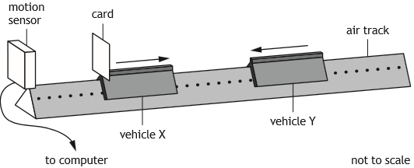  not to scale  wire to computer  vehicle Y  vehicle X  air track  card
 |  | Vehicle X of mass 0·75 kg is travelling to the right along the track.
Vehicle Y of mass 0·50 kg is travelling to the left along the track with a speed of 0·30 m s⁻¹.
The vehicles collide and move off separately.
A computer displays a graph showing the velocity of vehicle X from just before the collision to just after the collision.
0·60
velocity (m s⁻¹) |  | 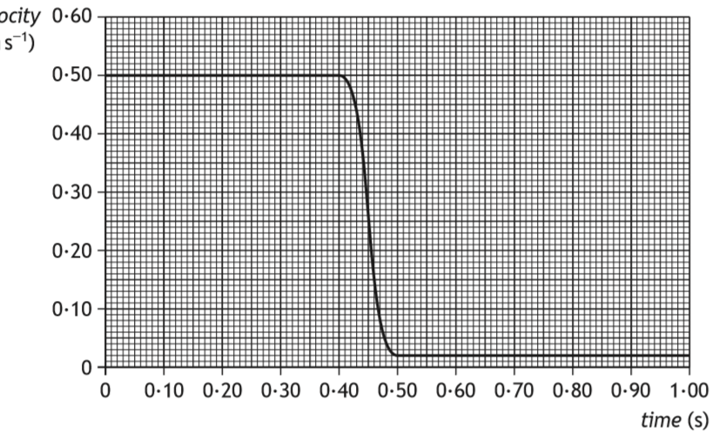  time (s)  1·00  0·90  0·80  0·70  0·60  0·50  0·40  0·30  0·20  0·10  0·00  0·00  0·10  0·20  0·30  0·40  0·50
 | (a) | Show that the velocity of vehicle Y after the collision is 0·42 m s⁻¹. | 2
 | (b) | Determine the impulse on vehicle Y during the collision. | 3
 | (c) | Explain how the student would determine whether the collision was elastic or inelastic. | 2

