Higher Dynamics
Past Paper Questions
Book 2

Contents
Motion Graphs pg 2-16
Projectile Motion pg 17-31
Vector Diagrams pg 32-42
Motion Graphs
1. |  | The following velocity-time graph describes the motion of a ball dropped from rest and bouncing several times.  P  velocity
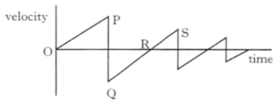
time
S
R
Q
0
 |  | Which of the following statements is/are true?
I The ball hits the ground at P.
II The ball is moving upwards between Q and R.
III The ball is moving upwards between R and S.
 | A  B  C  D  E | I only  II only  III only  I and II only  I and III only
2. |  | Which of the following velocity-time graphs best describes a ball being thrown vertically into the air and returning to the thrower's hand?  velocity  velocity
 | A | 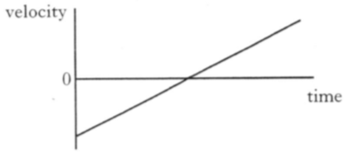  0  time  velocity | D  velocity | 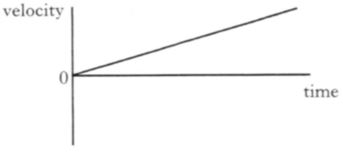  0  time
 | B | 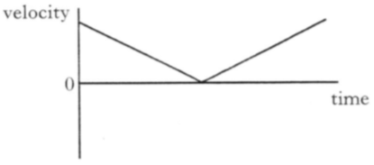  0  time  velocity | E | 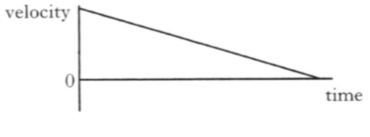  time  0
 | C | 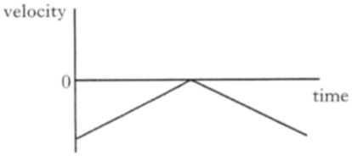  0  time

3. |  | A vehicle is travelling in a straight line.  Graphs of velocity and acceleration against time are shown below.  Which pair of graphs could represent the motion of the vehicle?  acceleration  velocity
 | A | 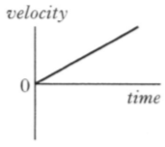  time  velocity  0 | 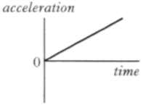  time  acceleration  0
 | B | 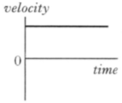  time  velocity  0 | 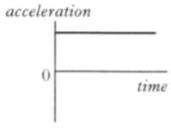  time  acceleration  0
 | C | 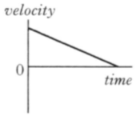  time  velocity  0 | time  acceleration  0
 | D | 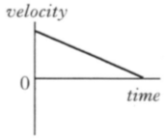  time  0 | 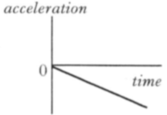  time  0
 | E | 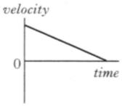  time  velocity  0 | 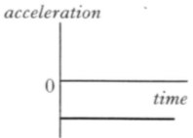  time  acceleration  0

4. |  | An object starts from rest and accelerates in a straight line.  The graph shows how the acceleration of the object varies with time.
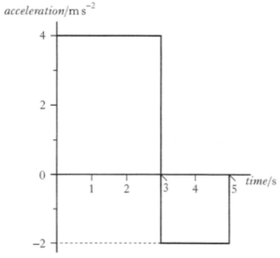
time (s)
acceleration (m s⁻²)
5
4
3
2
1
-2
0
2
4
 |  | The object's speed at 5 seconds is
 | A  B  C  D  E | 2 m s⁻¹  8 m s⁻¹  12 m s⁻¹  16 m s⁻¹  20 m s⁻¹.
5. |  | A ball is thrown vertically upwards and falls back to Earth. Neglecting air resistance, which velocity-time graph represents its motion?  v  v
 | A | 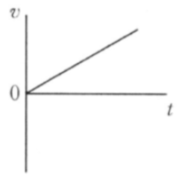  0  t  v | D  v | 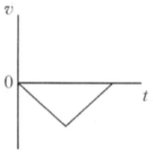  0  t
 | B | 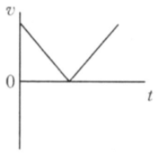  0  t  v | E | 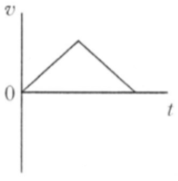  t  0
 | C | 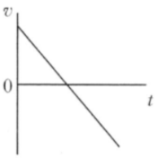  0  t

6. |  | The following velocity-time graph represents the vertical motion of a ball.
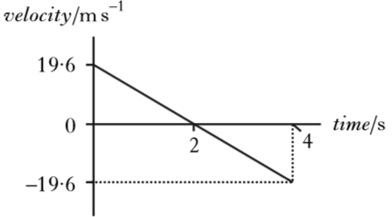
velocity / m s⁻¹
time / s
4
2
19·6
-19·6
0
Which of the following acceleration-time graphs represents the same motion?
acceleration / m s⁻²
 | A | 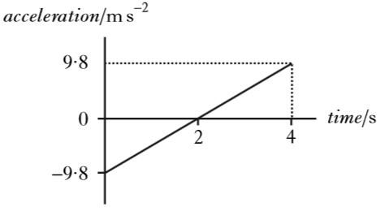  -9·8  0  9·8  time / s  4  2
 | B | 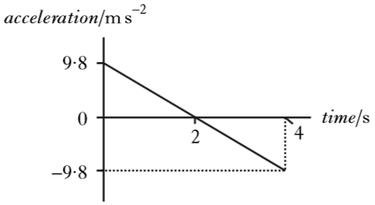  4  2  -9·8  0  9·8  acceleration / m s⁻²  acceleration / m s⁻²  time / s
 | C | 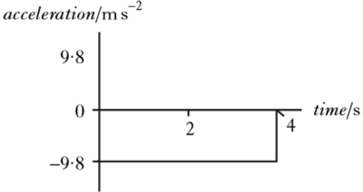  4  2  -9·8  0  9·8  time / s
 | D | 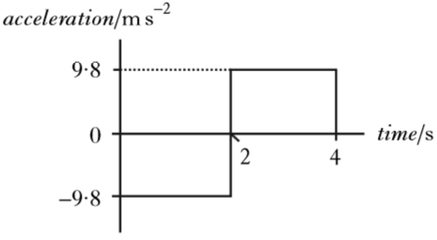  4  2  -9·8  0  9·8  acceleration / m s⁻²  time / s
 | E | 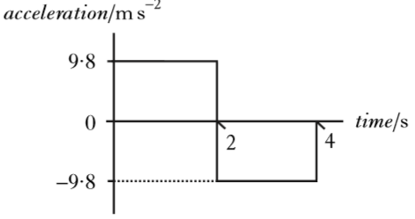  4  2  -9·8  0  9·8  acceleration / m s⁻²  time / s

7. |  | The graph shows how the acceleration, a, of an object varies with time, t.  a
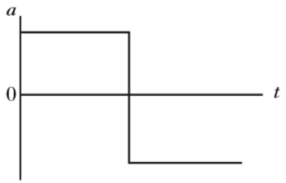
0
t
Which graph shows how the velocity, v, of the object varies with time,
t ?
v
 | A | 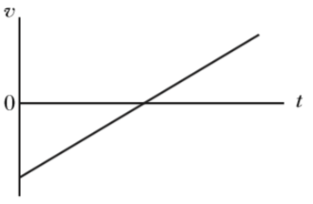  0  t  v
 | B | 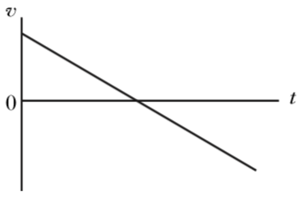  0  t  v
 | C | 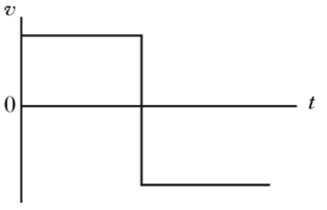  0  t  v
 | D | 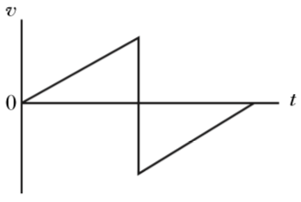  0  v  t
 | E | 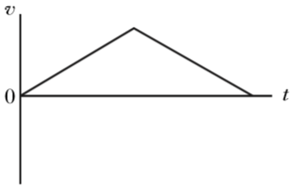  0  t

8. |  | A vehicle is travelling in a straight line at a constant velocity. It then slams on its brakes before coming to rest.  Graphs of velocity and acceleration against time are shown from the moment the vehicle's brakes are applied until it comes to rest.  Which pair of graphs could represent the motion of the vehicle?
 | A | 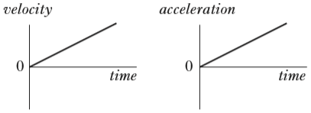  acceleration  0  0  time  time  velocity
 | B | 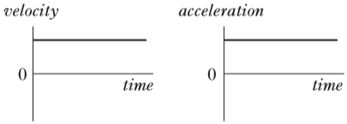  acceleration  0  0  time  time  velocity
 | C | 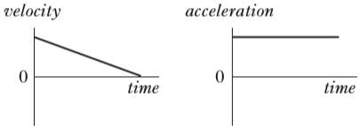  acceleration  0  0  time  time  velocity
 | D | 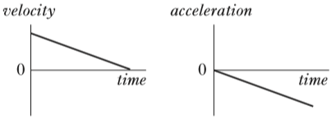  acceleration  0  0  time  time  velocity
 | E | 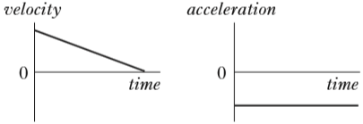  acceleration  0  0  time  time  velocity

9. |  | A trolley travels along a straight track.  The graph shows how the velocity v of the trolley varies with time t.  v
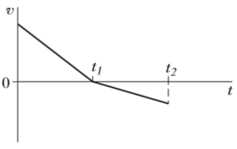
0
t₁
t₂
t
Which graph shows how the acceleration a of the trolley varies with time t ?
a
 | A | 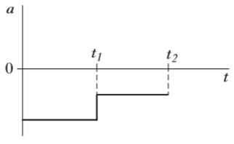  0  a  t  t₂  t₁
 | B | 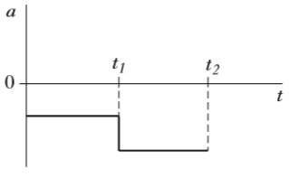  0  a  t  t₂  t₁
 | C | 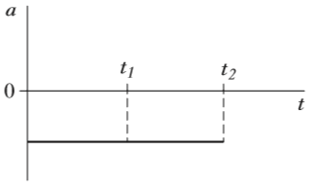  0  a  t  t₂  t₁
 | D | 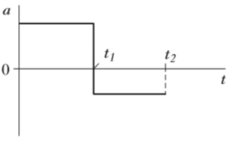  0  a  t  t₂  t₁
 | E | 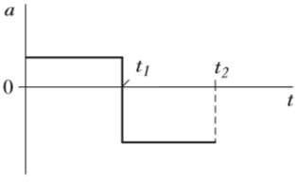  0  t  t₂  t₁

10. |  | An object starts from rest and accelerates in a straight line.  The graph shows how the acceleration of the object varies with time.
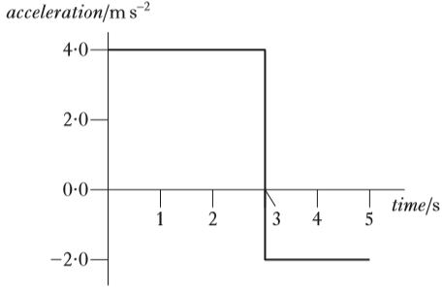
0
-1·5
3·0
1·5
10
8
6
4
2
acceleration / m s⁻²
time / s
 |  | The speed of the object at 10 seconds is
 | A  B  C  D  E | 1·5 m s⁻¹  12 m s⁻¹  18 m s⁻¹  24 m s⁻¹  30 m s⁻¹.
11. |  | A ball moves down a frictionless slope from X to Y.
 | X | 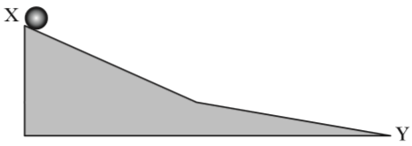  Y
Which graph shows how the acceleration a of the ball varies with time t as it moves down the slope?
a
a
 | A | 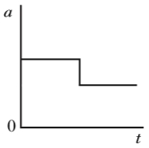  0  t  a | D | 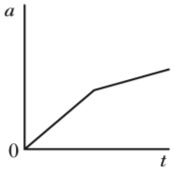  0  t  a
 | B | 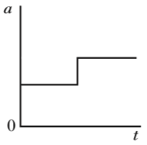  0  t  a | E | 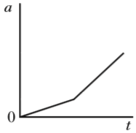  0  t
 | C | 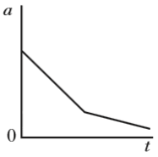  0  t

12. |  | The graph shows how the vertical speed of a skydiver varies with time.  Q  P
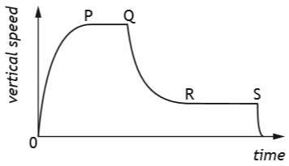
S
R
0
time
vertical speed
 |  | A student uses information from the graph to make the following statements.
 |  | I The acceleration of the skydiver is greatest between P and Q.
 |  | II The air resistance acting on the skydiver between Q and R is less than the weight of the skydiver.
 |  | III The forces acting on the skydiver are balanced between R and S.
 |  | Which of these statements is/are correct?
 | A  B  C  D  E | I only  II only  III only  I and II only  I, II and III
13. |  | The graph shows how the velocity of an object varies with time.  10
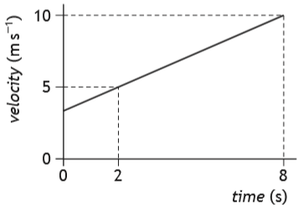
velocity / m s⁻¹
time / s
8
2
0
5
0
 |  | The acceleration of the object is
 | A  B  C  D  E | 0·83 m s⁻²  1·2 m s⁻²  2·5 m s⁻²  5·0 m s⁻²  6·0 m s⁻².

14. |  | A ball is dropped from rest and allowed to bounce several times.
The graph shows how the velocity of the ball varies with time.
velocity
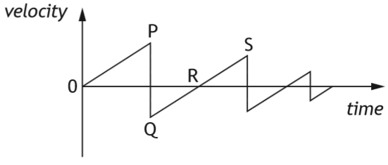
time
P
S
R
Q
0
 |  | A student makes the following statements about the ball.
 |  | I The ball is at its highest point at time 0.
 |  | II The ball is moving downwards between R and S.
 |  | III The ball hits the ground at R.
 |  | Which of these statements is/are correct?
 | A  B  C  D  E | I only  II only  III only  I and II only  I and III only
15. |  | The graph shows how the speed v of a car varies with time t.
v (m s⁻¹) |  | 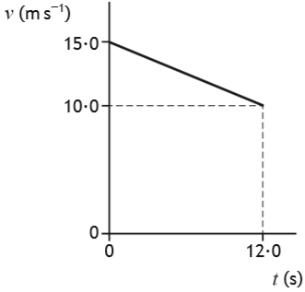  12·0  0·0  0·0  10·0  15·0  t (s)
 |  | The average speed of the car during the 12·0 s is
 | A  B  C  D  E | 1·25 m s⁻¹  2·08 m s⁻¹  2·50 m s⁻¹  7·50 m s⁻¹  12·5 m s⁻¹.

16. |  | A car accelerates from rest along a straight level road.  The acceleration of the car is constant.  Which pair of displacement-time (s-t ) and acceleration-time (a-t ) graphs represent the motion of the car?  a  s
 | A | 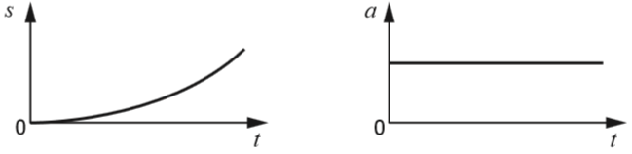  a  s  t  t  0  0
 | B | 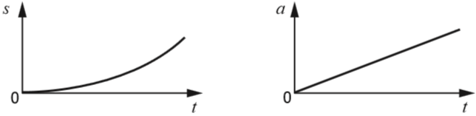  a  s  t  t  0  0
 | C | 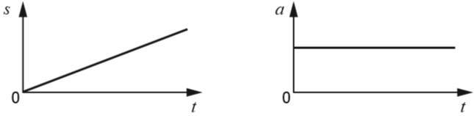  a  s  t  t  0  0
 | D | 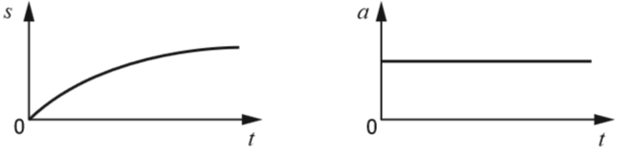  a  s  t  t  0  0
 | E | 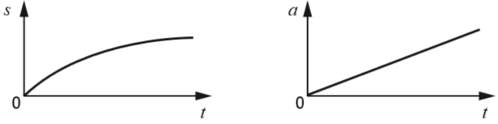  t  t  0  0

Motion Graphs; Linear Motion; Uncertainties; Momentum and Impulse
17. |  | A basketball is held below a motion sensor. The basketball is released from rest and falls onto a wooden block. The motion sensor is connected to a computer so that graphs of the motion of the basketball can be displayed.  motion sensor
 | basketball | 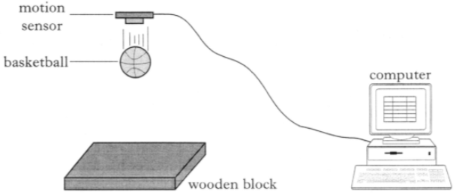  wooden block  computer
 |  | A displacement-time graph for the motion of the basketball from the instant of its release is shown.
 | displacement / m | 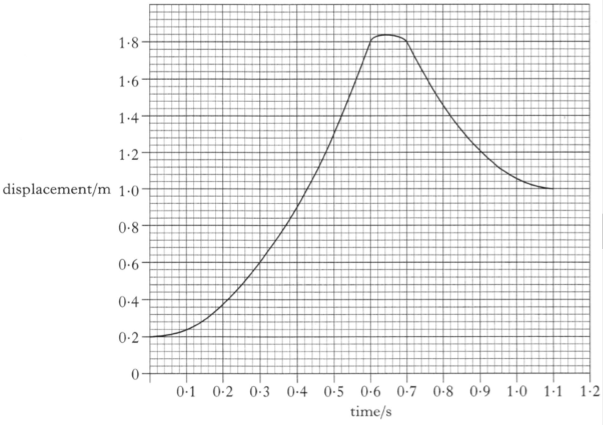  time / s  1·2  1·1  1·0  0·9  0·8  0·7  0·6  0·5  0·3  0·4  0·2  0·1  0·0  0·0  1·8  1·6  1·4  1·2  1·0  0·8  0·2  0·6  0·4
 | (a) | (i) State the distance between the motion sensor and the top of the basketball when it is released. | 1
 |  | (ii) Determine how far the basketball falls before it hits the wooden block. | 1
 |  | (iii) Show by calculation that the acceleration of the ball as it falls is 8·9 m s⁻². | 2

17. |  | (continued)
 | (b) | The basketball is now dropped several times from the same height. The following values are obtained for the acceleration of the basketball.
 |  | 8·9 m s⁻² 9·1 m s⁻² 8·4 m s⁻² 8·5 m s⁻² 9·0 m s⁻²
 |  | Calculate:
 |  | (i) the mean of these values; | 1
 |  | (ii) the approximate random uncertainty in the mean. | 2
 | (c) | The wooden block is replaced by a block of sponge of the same dimensions. The experiment is repeated and a new graph is obtained.
 |  | Describe and explain any two difference between this time graph and the original graph. | 2

Motion Graphs; Momentum and Impulse
18. |  | A student carries out an experiment with a tennis ball and a motion sensor connected to a laptop.  motion sensor
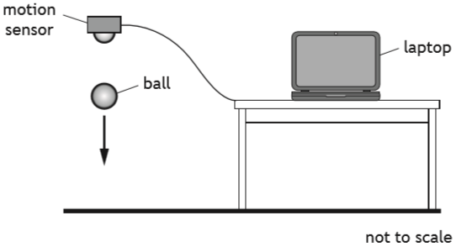
not to scale
laptop
ball
 |  | The ball is released from rest below the motion sensor.
The graph shows how the vertical velocity v of the ball varies with time t , from the moment the ball is released until it rebounds to its new maximum height.
v (m s⁻¹)
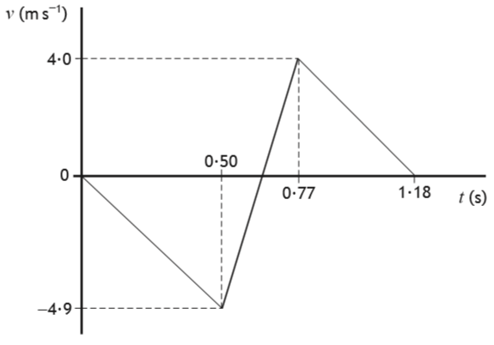
t (s)
1·18
0·77
0·50
-4·9
4·0
0
 | (a) | Using information from the graph
 |  | (i) show that the initial acceleration of the ball is -9·8 m s⁻². | 2
 |  | (ii) determine the height from which the ball is released. | 3
 | (b) | The mass of the ball is 57·0 g.
 |  | (i) Determine the magnitude of the change in momentum of the ball during the bounce. | 3
 |  | (ii) Determine the magnitude of the average force exerted by the ball on the ground during the bounce. | 3

18. |  | (continued)
 | (c) | Copy and complete the sketch graph of acceleration a against time t for the ball, between 0 s and 1·18 s after it is released.
 |  | Numerical values are not required on the acceleration axis.  a (m s⁻²) | 2
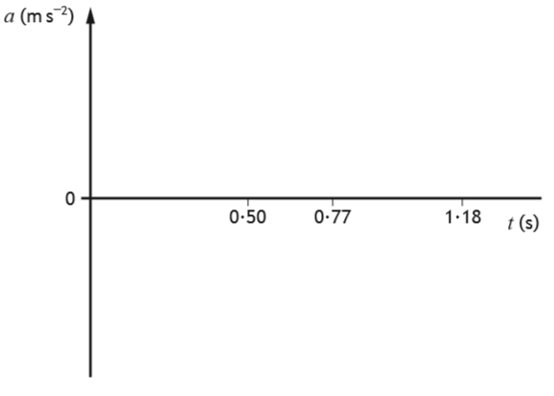
0
t (s)
1·18
0·77
0·50

Projectile Motion
1. |  | A stuntman on a motorcycle jumps a river which is 5·1 m wide. He lands on the edge of the far bank, which is 2·0 m lower than the bank from which he takes off.
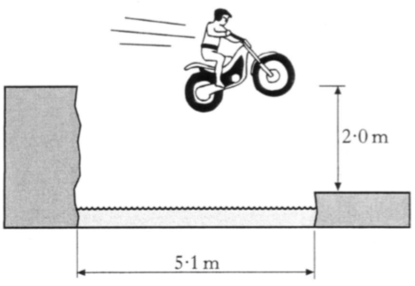
5·1 m
2·0 m
 |  | His minimum horizontal speed at take-off is
 | A  B  C  D  E | 2·0 m s⁻¹  3·2 m s⁻¹  5·5 m s⁻¹  8·0 m s⁻¹  9·8 m s⁻¹.
2. |  | A javelin is thrown at 60º to the horizontal with a speed of 20 m s⁻¹.
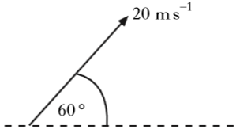
60º
20 m s⁻¹
The javelin is in flight for 3·5 s.
Air resistance is negligible.
The horizontal distance the javelin travels is
 | A  B  C  D  E | 35·0 m  60·6 m  70·0 m  121 m  140 m.

3. |  | A golfer strikes a golf ball which then moves off at an angle to the ground. The ball follows the path shown.
 |  | 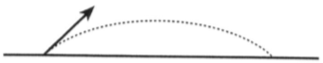
 |  | The graphs below show how the horizontal and vertical components of the velocity of the ball vary with time.
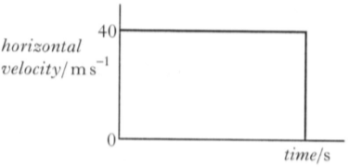
horizontal component of velocity
(m s⁻¹)
time / s
0
40
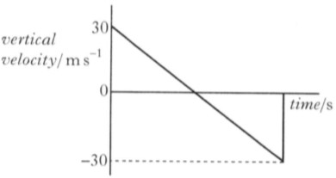
vertical component of velocity
(m s⁻¹)
time / s
-30
0
30
 |  | What is the speed of the ball just before it hits the ground?
 | A  B  C  D  E | 10 m s⁻¹  30 m s⁻¹  40 m s⁻¹  50 m s⁻¹  70 m s⁻¹

4. |  | A stone is thrown at 50º to the horizontal with a speed of 15 m s⁻¹.
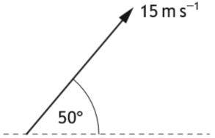
15 m s⁻¹
50º
 |  | Which row in the table gives the horizontal component and the vertical component of the initial velocity of the stone?
 | A  B  C  D  E
  Horizontal component (m s⁻¹) | Vertical component (m s⁻¹)
  15 sin 50 | 15 cos 50
  15 cos 50 | 15 sin 50
  15 cos 50 | 15 sin 40
  15 cos 40 | 15 sin 50
  15 sin 50 | 15 cos 40
5. |  | A golfer strikes a golf ball, which then moves off at an angle to the ground. The ball follows the path shown.
 |  | 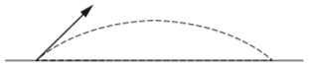
The graphs show how the horizontal component of the velocity v_{h} and the vertical component of the velocity v_{v} of the ball vary with time t.
v_{v} (m s⁻¹)
 | v_{h} (m s⁻¹) | 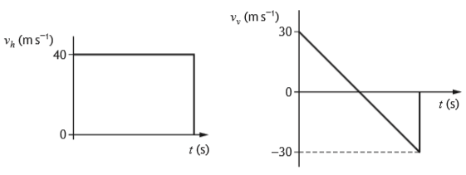  t (s)  t (s)  -30  0  30  0  40
 |  | The maximum height the golf ball reaches is
 | A  B  C  D  E | 1·53 m  45·9 m  81·6 m  91·8 m  128 m.
Projectile Motion
6. |  | At a funfair, a prize is awarded if a coin is tossed into a small dish. The dish is mounted on a shelf above the ground as shown.
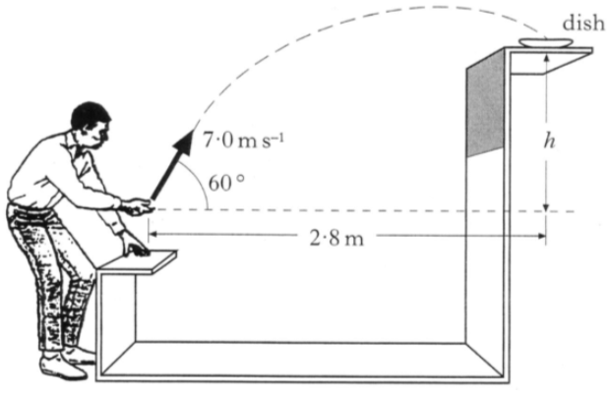
2·8 m
7·0 m s⁻¹
60º
h
dish
A contestant projects the coin with a speed of 7·0 m s⁻¹ at an angle of 60º to the horizontal. When the coin leaves his hand, the horizontal distance between the coin and the dish is 2·8 m. The coin lands in the dish.
The effect of air friction on the coin is negligible.
 | (a) | Calculate:
 |  | (i) the horizontal component of the initial velocity of the coin; | 1
 |  | (ii) the vertical component of the initial velocity of the coin. | 1
 | (b) | Show that the time taken for the coin to reach the dish is 0·8 s. | 2
 | (c) | Calculate the height, h, of the shelf above the point where the coin leaves the contestant's hand. | 3
 | (d) | State how the value of the kinetic energy of the coin when it enters the dish compares with the kinetic energy of the coin just as it leaves the contestant's hand.  Justify your answer. | 2

Projectile Motion
7. |  | A basketball player throws a ball with an initial velocity of 6·5 m s⁻¹ at an angle of 50º to the horizontal. The ball is 2·3 m above the ground when released.
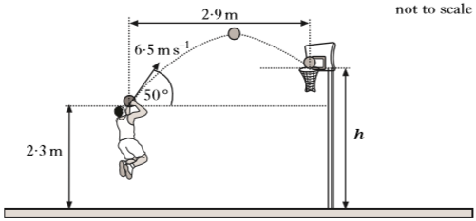
not to scale
h
6·5 m s⁻¹
50º
2·9 m
2·3 m
The ball travels a horizontal distance of 2·9 m to reach the top of the basket.
The effects of air resistance can be ignored.
 | (a) | Calculate:
 |  | (i) the horizontal component of the initial velocity of the ball; | 1
 |  | (ii) the vertical component of the initial velocity of the ball. | 1
 | (b) | Show that the time taken for the ball to reach the basket is 0·69 s. | 2
 | (c) | Calculate the height h of the top of the basket. | 4
 | (d) | A student observing the player makes the following statement.  "The player should throw the ball with a higher speed at the same angle. The ball would then land in the basket as before but it would take a shorter time to travel the 2·9 metres."
 |  | Explain why the student's statement is incorrect. | 2

Projectile Motion
8. |  | A student investigates the motion of a ball projected from a launcher.
The launcher is placed on the ground and a ball is fired vertically upwards.
The vertical speed of the ball as it leaves the top of the launcher is
7·0 m s⁻¹.
The effects of air resistance can be ignored.
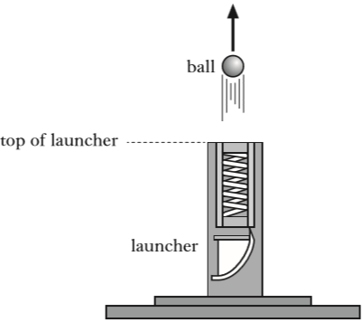
launcher
top of launcher
ball
 | (a) | (i) Calculate the maximum height above the top of the launcher reached by the ball. | 3
 |  | (ii) Show that the time taken for the ball to reach its maximum height is 0·71 s. | 2

8. |  | (continued)
 | (b) | The student now fixes the launcher to a trolley. The trolley travels horizontally at a constant speed of 1·5 m s⁻¹ to the right.  The launcher again fires the ball vertically upwards with a speed of  7·0 m s⁻¹.
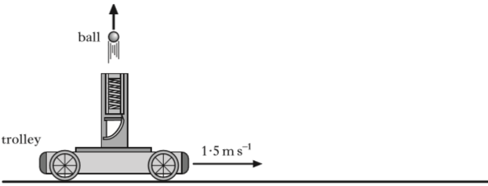
1·5 m s⁻¹
trolley
ball
 |  | (i) State the velocity of the ball after 0·71 s. | 1
(ii) The student asks some friends to predict where the ball will land relative to the moving launcher. They make the following statements.
Statement X: The ball will land behind the launcher.
Statement Y: The ball will land in front of the launcher.
Statement Z: The ball will land on top of the launcher.
 |  | Which of the statements is correct?  You must justify your answer. | 2

Projectile Motion
9. |  | A golfer hits a ball from point P. The ball leaves the club with a velocity v at angle of θ to the horizontal.  The ball travels through the air and lands at point R.  Midway between P and R there is a tree of height 10·0 m.
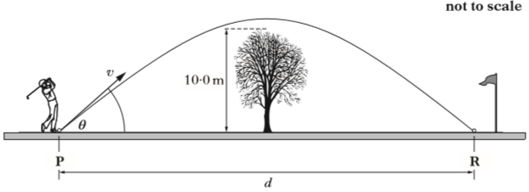
d
v
not to scale
R
P
θ
10·0 m
 | (a) | The horizontal and vertical components of the ball's velocity during its flight are shown.
 | horizontal velocity / m s⁻¹ | 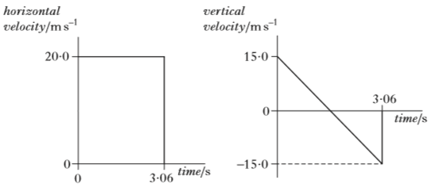  time / s  time / s  vertical velocity / m s⁻¹  3·06  3·06  0  -15·0  0  15·0  0  20·0
 |  | The effects of air resistance can be ignored.
 |  | Calculate:
 |  | (i) the horizontal distance d ; | 3
 |  | (ii) the maximum height of the ball above the ground. | 3
 | (b) | When the effects of air resistance are not ignored, the golf ball follows a different path.  State whether the ball is more or less likely to hit the tree.  You must justify your answer. | 2

Projectile Motion; Vector Diagrams
10. |  | A tennis player strikes a ball at a height of 2·5 m above the ground.  The ball leaves the racquet travelling horizontally at 24 m s⁻¹.  It travels through the air and hits the ground at point X on the other side of the net.  24 m s⁻¹
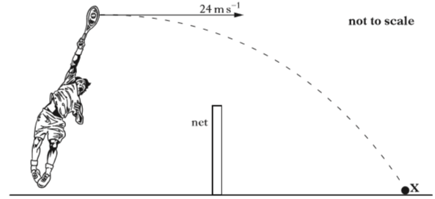
not to scale
X
net
 |  | The effects of air resistance can be ignored.
 | (a) | The ball takes 0·50 s to travel to the net.  Calculate the height of the ball above the ground at this time. | 4
 | (b) | Calculate the vertical velocity of the ball as it reaches the ground at X. | 3
 | (c) | By scale drawing, or otherwise, calculate the velocity of the ball as it hits the ground at X. | 4

Projectile Motion
11. |  | The shot put is an athletics event in which competitors "throw" a shot as far as possible. The shot is a metal ball of mass 4·0 kg. One of the competitors releases the shot at a height of 1·8 m above the ground and at an angle θ to the horizontal. The shot travels through the air and hits the ground at X. The effects of air resistance are negligible.
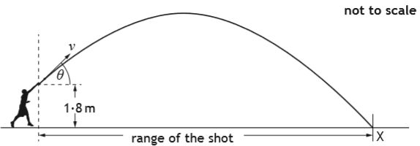
not to scale
X
range of the shot
1·8 m
v
θ
The graph shows how the release speed of the shot v varies with the angle of projection θ.
16
 | release speed (m s⁻¹) | 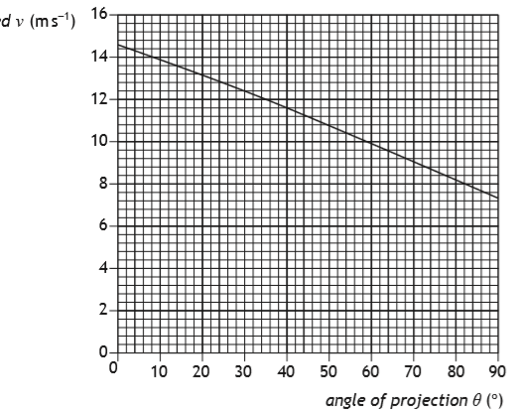  angle of projection θ (º)  90  80  70  60  50  40  30  10  20  0  0  2  4  6  8  10  12  14
 | (a) | The angle of projection for a particular throw is 40º.
 |  | (i) (A) State the release speed of the shot at this angle. | 1
 |  | (B) Calculate the horizontal component of the initial velocity of the shot. | 1
 |  | (C) Calculate the vertical component of the initial velocity of the shot. | 1
11. |  | (continued)
 |  | (ii) The maximum height reached by the shot is 4·7 m above the ground. The time between release and reaching this height is 0·76 s.
 |  | (A) Calculate the total time between the shot being released and hitting the ground at X. | 4
 |  | (B) Calculate the range of the shot for this throw. | 3
 | (b) | Using information from the graph, explain the effect of increasing the angle of projection on the kinetic energy of the shot at release. | 2

Projectile Motion
not to scale
12. |  | 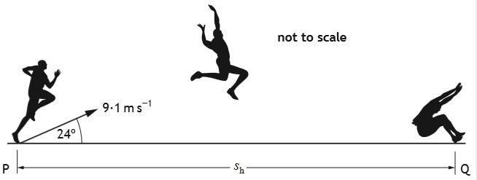  Q  P  s_{h}  24º  9·1 m s⁻¹
 |  | An athlete takes part in a long jump competition. The athlete takes off from point P with an initial velocity of 9·1 m s⁻¹ at an angle of 24º to the horizontal and lands at point Q.
 | (a) | Calculate:
 |  | (i) the vertical component of the initial velocity of the athlete; | 1
 |  | (ii) the horizontal component of the initial velocity of the athlete. | 1
 | (b) | Show that the time taken for the athlete to travel from P to Q is 0·76 s. | 2
 | (c) | Calculate the magnitude of the horizontal displacement s_{h} between points P and Q. | 3
 | (d) | The graph shows how the horizontal displacement of the athlete varies with time for this jump when air resistance is ignored.  displacement (m)
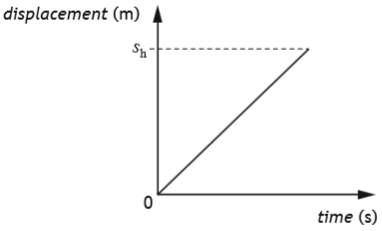
0
s_{h}
time (s)
 |  | Copy the graph and then add a line to the graph to show how the horizontal displacement of the athlete varies with time when air resistance is taken into account.  The original and new line should both be labelled. | 2

Projectile Motion
13. |  | A ball is thrown vertically upwards.  The ball is above the ground when released.  5·6 m s⁻¹
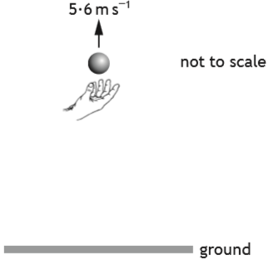
not to scale
ground
 |  | The graph shows how the vertical velocity of the ball varies with time from the instant it is released until just before it hits the ground.
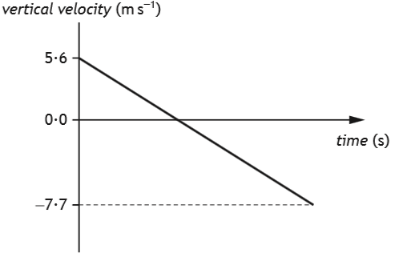
vertical velocity (m s⁻¹)
-7·7
5·6
0
time (s)
 |  | The effects of air resistance can be ignored.
 | (a) | (i) Calculate the time taken for the ball to reach its maximum height. | 3
 |  | (ii) Calculate the distance the ball falls from its maximum height to the ground. | 3

13. |  | (continued)
 | (b) | The ball is now thrown vertically upwards from the same height with a greater initial vertical velocity.  Copy the graph below and then add a new line to the graph to show how the vertical velocity of the ball varies with time from the instant it is released until just before it hits the ground.  The effects of air resistance are negligible.  Additional numerical values on the axes are not required.  The original and new line should both be labelled. | 3
 | vertical velocity (m s⁻¹) | 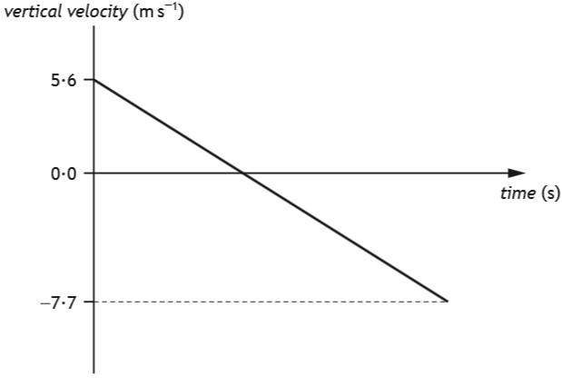  5·6  0  -7·7  time (s)

Projectile Motion
14. |  | During a school funfair, a student throws a wet sponge at a teacher. The sponge is thrown with an initial velocity of 7·4 m s⁻¹ at an angle of 30º to the horizontal.  The sponge leaves the student's hand at a height of 1·5 m above the ground.  not to scale
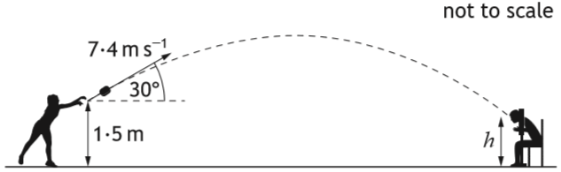
h
1·5 m
7·4 m s⁻¹
30º
The sponge hits the teacher.
The effects of air resistance can be ignored.
 | (a) | (i) Calculate:
 |  | (A) the horizontal component of the initial velocity of the sponge; | 1
 |  | (B) the vertical component of the initial velocity of the sponge. | 1
 |  | (ii) Calculate the time taken for the sponge to reach its maximum height. | 3
 |  | (iii) The sponge takes a further 0·45 s to travel from its maximum height until it hits the teacher.  Determine the height h above the ground at which the sponge hits the teacher. | 4
 | (b) | The student throwing the sponge makes the following statement.  "If the sponge is thrown with a higher speed at the same angle from the same height then it would take a shorter time to hit the teacher in the same place."  Explain why the student's statement is incorrect. | 2

Vector Diagrams
1. |  | A woman walks 12 km due North. She then turns round immediately and walks 4 km due South. The total journey takes 4 hours.  Which row in the following table gives the correct values for her average velocity and average speed?
 | A  B  C  D  E
  Average velocity | Average speed
  4 km h⁻¹ due N | 4 km h⁻¹
  4 km h⁻¹ due N | 2 km h⁻¹
  3 km h⁻¹ due N | 4 km h⁻¹
  2 km h⁻¹ due N | 4 km h⁻¹
  2 km h⁻¹ due N | 3 km h⁻¹
2. |  | The diagram below show the resultant of two vectors.
 |  | 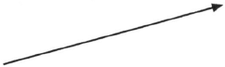
 |  | Which of the diagrams below shows the vectors which could produce the above resultant?
 | A | 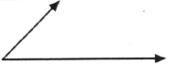
 | B | 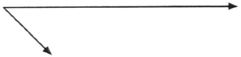
 | C | 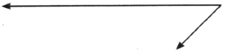
 | D | 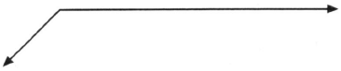
 | E | 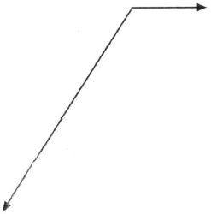

3. |  | A car travels from X to Y and then from Y to Z as shown.
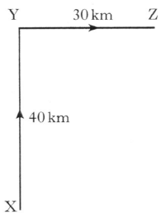
30 km
Z
Y
X
40 km
 |  | It takes one hour to travel from X to Y. It also takes one hour to travel from Y to Z.
 |  | Which row in the following table shows the magnitudes of the displacement, average speed and average velocity for the complete journey?
 | A  B  C  D  E
  Displacement  (km) | Average speed  (km h⁻¹) | Average velocity  (km h⁻¹)
  50 | 35 | 25
  70 | 35 | 25
  50 | 35 | 35
  70 | 70 | 50
  50 | 70 | 25

Vector Diagrams
4. | (a) | State the difference between scalar quantities and vector quantities. | 1
 | (b) | During a tall ships race, a ship called the Admiral passes a marker buoy X and sails due West (270). It sails on this course for 0·5 hours at a speed of 10·0 km h⁻¹, then changes course to 20º West of North (340). The Admiral continues on this new course for 1·5 hours at a speed of 8·0 km h⁻¹ until it passes marker buoy Y.
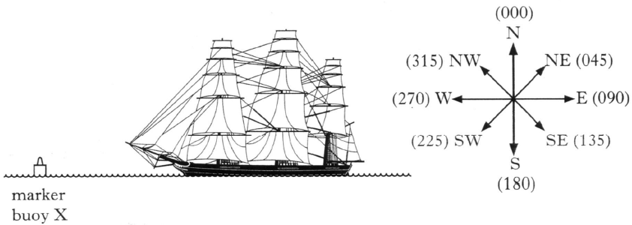
(000) N
(180) S
(135) SW
(225) SW
(090) E
(270) W
(045) NE
(315) NW
marker
buoy X
 |  | (i) Show that the Admiral travels a total distance of 17 km between marker buoys X and Y. | 2
 |  | (ii) By scale drawing or otherwise, find the displacement from marker buoy X to marker buoy Y. | 4
 |  | (iii) Calculate the average velocity, in km h⁻¹, of the Admiral between marker buoys X and Y. | 3
 | (c) | A second ship, called the Lootin, passes marker buoy X 0·25 hours after the Admiral and sails directly for marker buoy Y at a speed of 7·5 km h⁻¹.  Show by calculation which ship first passes marker buoy Y. | 2

Vector Diagrams
5. |  | A “giant catapult” is part of a fairground ride.
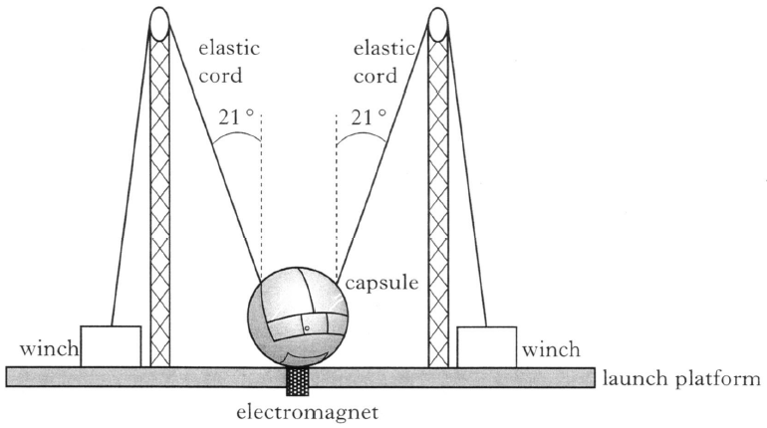
launch platform
21º
21º
elastic
cord
elastic
cord
electromagnet
winch
winch
capsule
Two people are strapped into a capsule. The capsule and the occupants have a combined mass of 236 kg.
The capsule is held stationary by an electromagnet while the tension in the elastic cords is increased using the winches.
The mass of the elastic cords and the effects of air resistance can be ignored.
 | (a) | When the tension in each cord reaches 4·5 x 10³ N the electromagnet is switched off and the capsule and occupants are propelled vertically upwards.
 |  | (i) Determine the vertical component of the force exerted by each cord just before the capsule is released. | 2
 |  | (ii) Calculate the initial acceleration of the capsule. | 4
 |  | (iii) Explain why the acceleration of the capsule decreases as it rises. | 2
 | (b) | Throughout the ride the occupants remain upright in the capsule.  A short time after release the occupants feel no force between themselves and the seats.  Explain why this happens. | 1

Vector Diagrams
6. |  | Competitors are racing remote control cars. The cars have to be driven over a precise route between checkpoints.
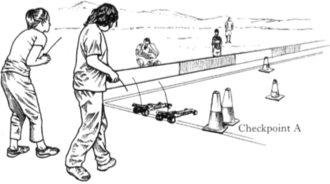
Checkpoint A
Each car is to travel from checkpoint A to checkpoint B by following these instructions.
"Drive 150 m due North, then drive 250 m on a bearing of 60º East of North (060)."
Car X takes 1 minute 6 seconds to follow these instructions exactly.
 | (a) | By scale drawing or otherwise, find the displacement of checkpoint B from checkpoint A. | 4
 | (b) | Calculate the average velocity of car X from checkpoint A to checkpoint B. | 3
 | (c) | Car Y leaves A at the same time as car X.  Car Y follows exactly the same route at an average speed of 6·5 m s⁻¹.  Determine which car arrives at checkpoint B first. | 2
 | (d) | State the displacement of checkpoint A from checkpoint B. | 1

Vector Diagrams; Forces
7. |  | A helicopter is flying at a constant height above the ground. The helicopter is carrying a crate suspended from a cable as shown.
 |  | 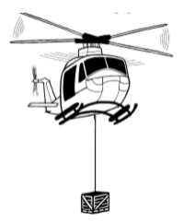
 | (a) | The helicopter flies 20 km on a bearing of 180 (due South). It then turns on to a bearing of 140 (50º South of East) and travels a further 30 km.  The helicopter takes 15 minutes to travel the 50 km.
 |  | (i) By scale drawing or otherwise, find the resultant displacement of the helicopter. | 4
 |  | (ii) Calculate the average velocity of the helicopter during the 15 minutes. | 3
 | (b) | The helicopter reaches its destination and hovers above a drop zone.
 |  | (i) The total mass of the helicopter and crate is 1·21 x 10⁴ kg.  Show that the helicopter produces a lift force of 119 kN. | 2
 |  | (ii) The helicopter now drops the crate which has a mass of 2·30 x 10³ kg. The lift force remains constant.  Describe the vertical motion of the helicopter immediately after the crate is dropped.  Justify your answer in terms of the forces acting on the helicopter. | 2

Vector Diagrams
8. |  | Two cyclists choose different routes to travel from point A to a point B some distance away.
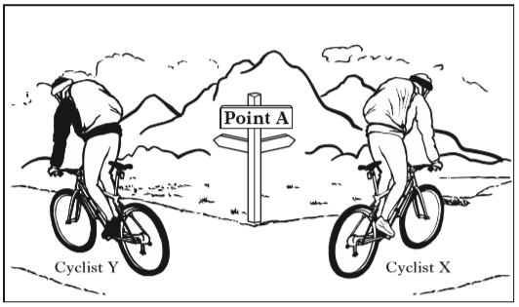
Cyclist X
Cyclist Y
 | (a) | Cyclist X travels 12 km due East (bearing 090). He then turns onto a bearing of 200 (20º West of South) and travels a further 15 km to arrive at B. He takes 1 hour 15 minutes to travel from A to B.
 |  | (i) By scale drawing or otherwise, find the displacement of B from A. | 4
 |  | (ii) Calculate the average velocity of cyclist X for the journey from A to B. | 3
 | (b) | Cyclist Y travels a total distance of 33 km by following a different route from A to B at an average speed of 22 km h⁻¹.
 |  | (i) State the displacement of cyclist Y on completing this route. | 1
 |  | (ii) Calculate the average velocity of cyclist Y for the journey from A to B. | 4

Vector Diagrams
9. |  | A powerboat is used to pull a parascender at a constant speed and height.  force exerted by the parasail
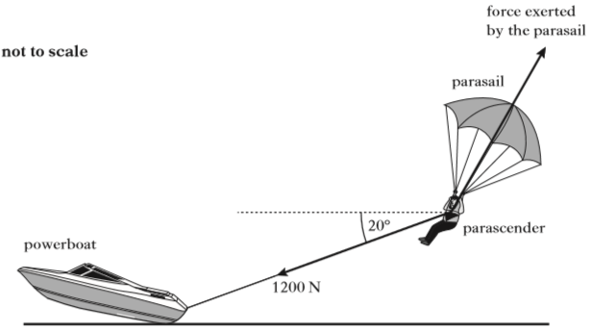
not to scale
20º
parascender
1200 N
powerboat
parasail
The weight of the parascender is 900 N.
A rope exerts a force of 1200 N on the parascender at an angle of 20º to the horizontal.
Another force is exerted on the parascender by the parasail.
 | (a) | The resultant force acting on the parascender is 0 N.
 |  | (i) State what is meant by the resultant of a number of forces. | 1
 |  | (ii) By scale drawing or otherwise, determine the magnitude and direction of the force exerted on the parascender by the parasail. | 4
 | (b) | The parascender releases the rope and initially rises higher.  Explain, in terms of the forces acting, why the parascender rises. | 2

Vector Diagrams; Practical Circuits
10. |  | An internet shopping company is planning to use drones to deliver packages.
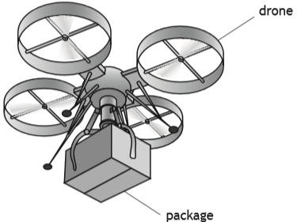
package
drone
 | (a) | During a test the drone is hovering at a constant height above the ground.  The mass of the drone is 5·50 kg.  The mass of the package is 1·25 kg.
 |  | (i) Determine the upward force produced by the drone. | 3
 |  | (ii) The package is now lowered using a motor and a cable.  A battery supplies 12 V across the motor. The resistance of the motor is 9·6 Ω.  Calculate the power dissipated by the motor. | 3
 |  | (iii) While the package is being lowered the cable breaks and the package drops to the ground.  The upward force produced by the drone remains constant.  Describe the vertical motion of the drone immediately after the cable breaks.  Justify your answer. | 2

10. |  | (continued)
 | (b) | To carry a package with a greater mass two drones are used as shown.

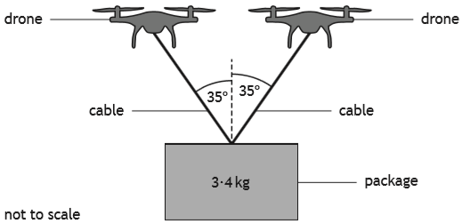
3·4 kg
not to scale
package
35º
35º
cable
cable
drone
drone
 |  | The drones are hovering at a constant height above the ground.  The mass of the package suspended from the two drones is 3·4 kg.  Determine the tension in each cable. | 4

Vector Diagrams
11. |  | A student abseils down the outside of a building using a rope.  X
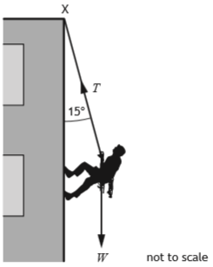
T
15º
W
not to scale
The mass of the student is 55 kg.
The rope, of negligible mass, is attached to a fixed point X at the top of the building.
The rope makes an angle of 15º to the building.
 | (a) | Calculate the weight W of the student. | 3
 | (b) | Determine the tension T in the rope. | 3
 | (c) | As the student abseils down the building the angle the rope makes with the building decreases.  State whether the tension in the rope increases, decreases or stays the same.  Justify your answer. | 2

