Uncertainties
No. | CONTENT
1. | Uncertainties
1a) | I can identify that all measurements of physical quantities are liable to uncertainty which I can express in absolute or percentage form.
i | State what you must be aware of, whenever you are making a measurement.  All measurements are liable to uncertainty, ie you can never be sure that what you are measuring is the exact, true value.
ii | Is there any measurement that you can make that is not liable to uncertainties? Explain your answer.  You can never complete a measurement without uncertainties but you can reduce their effect. All measurements are liable to uncertainty so you cannot make a measurement without one, but choosing the best equipment, repeating measurments and looking for systematic uncertainties and then quantifying your uncertainties is the best you can do.
iii | State any uncertainties that can arise when using a stopwatch to time 10 swings of a pendulum.  - reaction time in starting and stopping the stopwatch  - counting correctly to 10  - knowing exactly that one swing is a full cycle and not a half a cycle  - Stopping the watch at exactly the right time  - making sure that you start the release at 0 and don’t count the release as 1 given you a measurement of 9 swings.  - ensuring the pendulum swings back and forth and not in circles  - does air resistance prevent the string from making 10 swings  - ensuring the the pendulum is taut and not loose
iv | Explain why a ruler should not be used to measure the width of a tennis ball.  A ruler has an end point and doesn’t start from zero at the edge. You can only estimate the value by sight by lying the ball over the ruler, ensuring one end is against the zero mark and looking down by sight. Using a set of callipers to measure the diameter of a tennis ball will reduce your reading uncertainty.
v | State the difference between accuracy and precision and give an example of each.  Accuracy is how close a measured value is to a standard/ known/ true value.  Precision refers to the closeness of two or more measurements to each other.  These are independent of each other, in making measurements you should aim for high accuracy and high precision  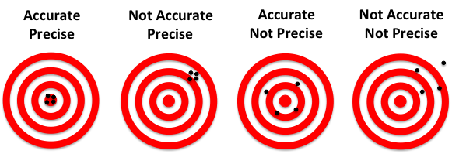  https://www.dnasoftware.com/our-products/copycount-qpcr-analysis-copynumber/precision-and-accuracy/
vi | An experiment is carried out to measure the wavelength of red light from a laser.  The following values for the wavelength are obtained.  Calculate the mean value for the wavelength and the approximate random uncertainty in the mean.  $$mean=\frac{x}{n}=\frac{650+640+635+648+655}{5}=\frac{3228}{5}=646 nm$$  Do not quote your mean to more sig fig than your measurements  $$R=\frac{R_{max}-R_{min}}{n}=\frac{655-635}{5}=4 nm$$  $$646 ±4 nm$$
  650 nm | 640 nm | 635 nm | 648 nm | 655 nm
1b) | I can quantify and recognise scale reading, random and systematic uncertainties in a measured quantity.
i | Explain the terms:  - Scale reading uncertainty  Scale reading uncertainty is a measure of how well an instrument scale can be read. In general, instruments with small unit divisions have a reduced uncertainty.  Random uncertainty  Random uncertainties occur when an experiment is repeated and slight variations occur. Random uncertainties can be reduced by taking repeated measurements.  - Systematic uncertainty  Systematic uncertainties occur when readings taken are all either too small or all too large. They can arise because of a calibration error or poor experimental design or procedure.
ii | Calculate the percentage uncertainty in the following measurement.  0 10 20 30 40 50  $$Reading≈37,$$  $$1 scale division=10, analogue device \frac{1}{2} scale division=5,$$  $$Percentage uncertainty=\frac{5}{37}×100= 14 \%$$  $$37 ±14\%$$
iii | State an example of a
  random uncertainty | systematic uncertainty
  e.g  - fluff on a trolley wheel,  - a gust of wind  - an uneven surface  - changes in temperature / pressure/ light level during repeated measurements | e.g  - A worn metre stick not being exactly a metre,  - incorrectly zeroed meters, scales etc  - a slow running clock  - a resistance in a circuit not being accounted for
iv | SQA Higher Paper 1994  During an experiment to measure the specific heat capacity of a liquid the relationship $VIt=mc∆T$ is used
  The following quantities are measured  V= 12.0 ± 0.1 V  I = 4.2 ± 0.1 A  t =300 ± 1s  m=500± 2 g  ΔT = 15 ± 1 °C | $$V=\frac{0.1}{12}=0.8\%$$  $$I=\frac{0.1}{4.2}=2 \%$$  $$t=\frac{1}{300}=0.3\%$$  $$m=\frac{2}{500}=0.4\%$$  $$T =\frac{1}{15}=7\%$$ | Which quantity will contribute the largest uncertainty to the final answer for the specific heat capacity, c?  A Voltage  B Current  C Time  D mass  E temperature difference
v | 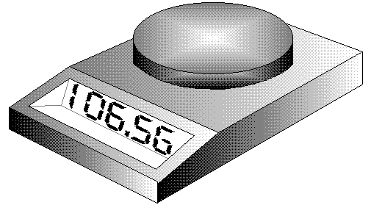  Calculate the scale reading uncertainty in the top pan balance measurement shown in the diagram.  $$m=\frac{0.01}{106.56}×100\%=0.009\%$$
vi | Calculate the scale reading and percentage uncertainty in each of the thermometers readings.  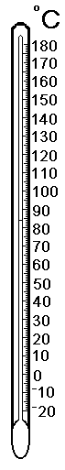  $$T =\frac{0.5}{85}×100\%=0.6\%, T=85C ±0.6\%$$  $$T=\frac{0.5}{44}×100\%=1\%, T=44C ±0.6\%$$
vii | A group of students was measuring the mass of paperclips using a butchart balance in order to find the mass of one paper clip.  The results have been plotted on the graph below:  - Explain how this graph indicates a likely systematic effect in these readings.  - State a likely cause of this systematic uncertainty.  - Estimate the systematic effect in these readings.  - Determine the mass of one paperclip.
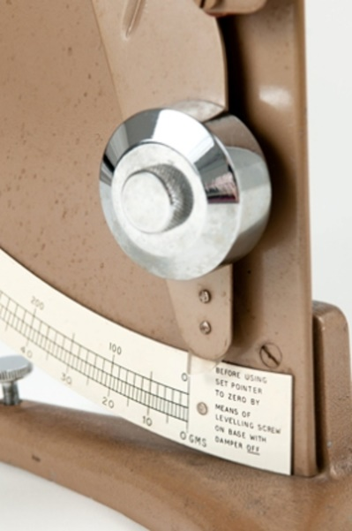
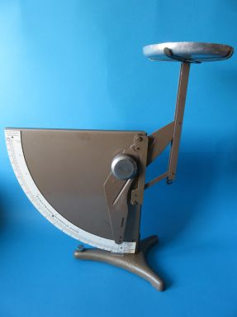
- It is likely that there is a systematic uncertainty. This is indicated as the points form a straight line but the graph does not go through the origin as would be expected.
- The most likely cause of this is that the balance was not zeroed or the balance was balanced before the pan was added to the top (see the diagrams below)
- The systematic uncertainty is about -5g looking at the intercept of the graph.

- The gradient of the graaph would equal the mass of one paperclip in this case 0.9 g (as y=0.9x-5) or check. There is a point that crosses the line at 40 paperclips = 30 g. When the zero error is included thhis point should be 40 paperclips = 35 g. So one paperclip = 35/40=0.875 g (ie the gradient)
1c) | I can express uncertainties in absolute or percentage form
i | A pupil uses light gates and a suitably interfaced computer to measure the acceleration of a trolley as it moves down an inclined plane.  The following results were obtained:  Calculate the mean valve of the acceleration and the corresponding random uncertainty.  $$mean=\frac{x}{n}=\frac{5.16+5.24+5.21+5.19+5.20+5.20+5.17+5.19}{8}$$  $$mean=\frac{41.56}{8}=5.20 {ms}^{-2}$$  Do not quote your mean to more sig fig than your measurements  $$R=\frac{R_{max}-R_{min}}{n}=\frac{5.24-5.16}{8}=0.01{ms}^{-2}$$  $$5.20 ±0.01 {ms}^{-2}$$
  acceleration (m s⁻²) | 5.16 | 5.24 | 5.21 | 5.19 | 5.20 | 5.20 | 5.17 | 5.19.
ii | Calculate the percentage uncertainties for the following absolute readings:  NB Uncertainties are generally quoted to 1 sig fig.  a) (4.65 ± 0.05) V b) (892 ± 5) cm c) (1.8 ± 0.4) A  d) (2.87 ± 0.02) s e) (13.8 ± 0.5) Hz f) (5.2 ± 0.1) m.
  $\frac{0.05}{4.65}×100 \% = 1\%$ | $$\frac{5}{892}×100 \%=0.6\%$$ | $$\frac{0.4}{1.8}×100 \%=20\%$$
  $\frac{0.02}{2.87}×100 \% = 0.7\%$ | $$\frac{0.5}{13.8}×100 \%=4\%$$ | $$\frac{0.1}{5.2}×100 \%=2\%$$
iii | Calculate the mean time, random uncertainty and percentage uncertainty for the following readings:  0.8 s, 0.6 s, 0.5 s, 0.6 s, 0.4 s.
1d) | I know how random uncertainties arise.
i | State how random uncertainties arise.
Ii | State the units for the approximate random uncertainty. The units of approximate random uncertainty are the same as the units from which the measurement was taken.
1e) | I can explain scale reading.
I | Explain the term scale reading uncertainty.
ii | State the usual scale reading uncertainty in an analogue device.
iii | State the usual scale reading uncertainty in a digital device.
iv | Calculate the scale reading uncertainties in each of the measurements above.
v | 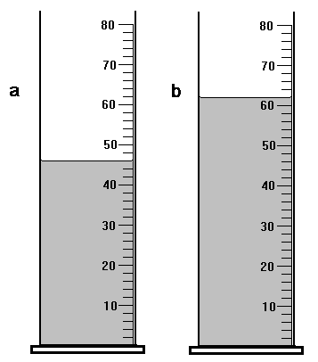  Calculate the scale reading uncertainties in each of the measuring cylinder volumes.  Quote is as reading ± uncertainty.-
vi | For each of the following scales, write down the reading and estimate the uncertainty.
vii | Manufacturers of resistors state the uncertainty in their products by using colour codes.  Gold - 5 % accuracy. Silver - 10 % accuracy.  Calculate the possible ranges for the following resistors for each colour.  a) 1 k Ω b) 10 k Ω c) 22 Ω
viii | 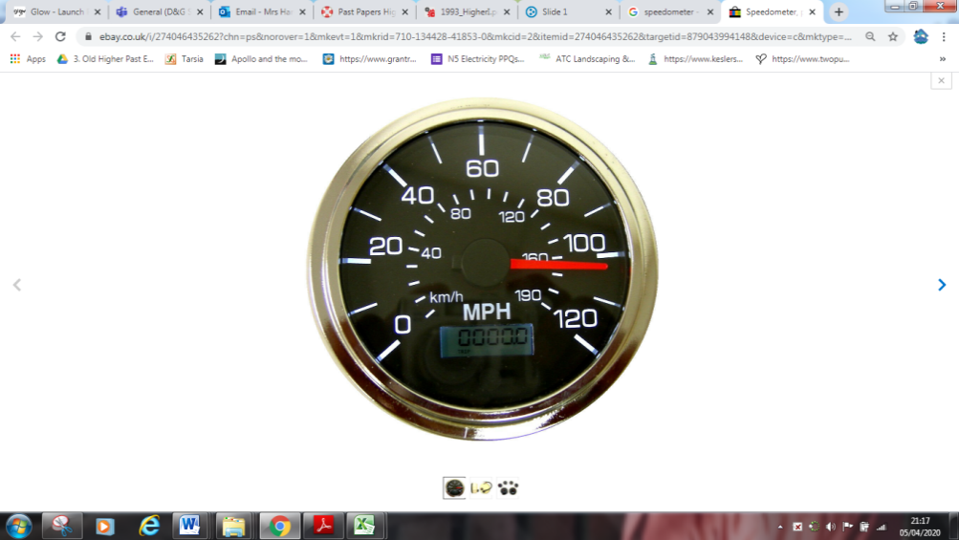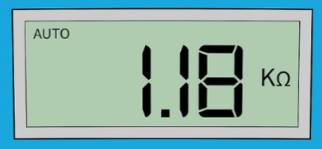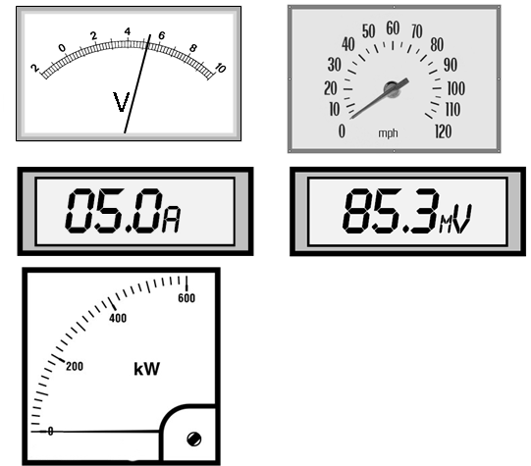  Determine the scale reading uncertainty and the percentage uncertainty in these measurements.  0  Figure 1 obviously not from UK roads!
1f) | I can state how random uncertainties can be reduced.
i | Give examples on how random uncertainties can be reduced.
ii | State what you must do to mitigate random uncertainties arising from your experiment.
1g) | I can explain how systematic uncertainties occur
i | Explain how systematic uncertainties occur
ii | Give examples of how systematic uncertainties occur
1h) | I can recognise possible causes of systematic uncertainties.
i | State the effect systematic uncertainties have on experimental results.
ii | 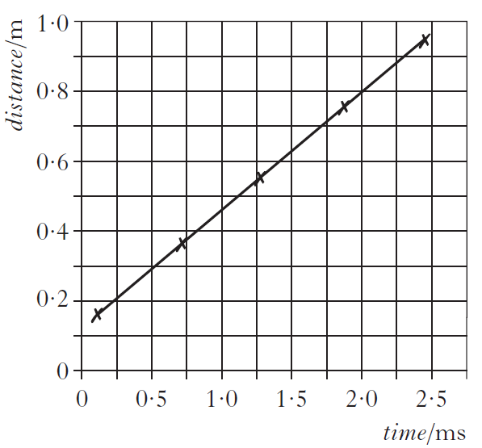  A student makes measurements of the time taken for sound to travel various distances in air.  The measurements are used to produce the following graph.  The student makes the following statements.  I The graph proves that the distance travelled is directly proportional to the time taken.  II The graph indicates that there is a systematic uncertainty in the measurements.  III The speed of sound can be calculated from the gradient of the graph.  Sketch the graph and copy out the correct statement(s)
iii | A National 5 pupil is investigating the relationship between the length of a wire and its resistance using the following arrangement:  The graph of her results shows the expected straight line but it does not pass through the origin:  - State the resistance of zero centimetres of any wire  - State why the graph does not pass through the origin  - State what these results in the graph give as the resistance of one metre of wire.
        - Zero ohms since zero centimetres of wire does not exist and neither does its resistance.
        - The graph shows that there is resistance in the circuit when the length of wire being measured is zero. Thus there must be something else in the circuit besides the wire that is resisting the current.
        - A possible explanation lies in the fact that there is opportunity for corrosion to set in on bare wires. Thus when we come to join them, the junction is not as clean as it should be and has a measurable resistance. This is what we call “contact resistance” and is a likely candidate for the extra resistance shown on the graph at the origin. A physicist often gives banana plugs a little twist as they are inserted into their terminals in an attempt to wipe off any such blemishes and so reduce the contact resistance.
iv | Some first year pupils have completed a practical work in which they weighed handfuls of equal sized marbles. The results they presented to their teacher are shown below.  (a) What is the mass of a single marble according to either Fred or Jane?  (b) What is the mass of a marble according to Mickey?  (c)Show that Mickey’s balance has not been adjusted to zero at the start and is reading 0.6 g too much.
  NAME | No. of Marbles | Mass /g
  FRED | 5 | 6.5
   | 17 | 22.1
   | 9 | 11.7
   | 11 | 14.3
   | 20 | 26
  MICKEY | 13 | 17.5
   | 15 | 20.1
   | 4 | 5.8
   | 8 | 11
   | 18 | 24
  JANE | 8 | 10.4
   | 19 | 24.7
   | 4 | 5.2
   | 12 | 15.6
   | 3 | 3.9
Dividing the mass by the number of marbles gives us the mass of one marble. In the case of Fred or Jane, and the single result, or the average of either set all show the same answer of 1.3g.
(b) Mickey’s individual results give,
17.5 ÷ 13 = 1.35g
20.1 ÷ 15 = 1.34g
5.8 ÷ 4 = 1.45g
11 ÷ 8 = 1.38g
24 ÷ 18 = 1.33g
Since these are all different, we normally quote their average value, which is 6.82 g ÷ 5 = 1.36g.
(c) This is most easily done using a graph of mass against number of marbles.
The line intercepts the mass axis at 0.6g which shows that zero marbles have a mass of 0.6g. Thus all other mass readings will be 0.6g too high.
You can work it out from the table of results using simultaneous equations.
f we make the zero error equal to X grammes and the mass of one marble equal to Y grammes then Mickey’s first two results gives us.
Subtract (1) from (2) to get
Put this value of Y into (1)

v | A pupil uses an electronic thermometer to measure the temperature of water in a thermos flask after fixed amounts of energy have been added. Her results are:  - Plot a graph of temperature against energy added.  - Calculate the temperature actually reached when 200,000 J of energy are added.  - Describe the experimental error you think she has made in this experiment.
  Energy added  ( x 10 ⁴ J) | Temperature of water (ºC)
  5 | 9.9
  10 | 24.8
  15 | 39.6
  20 | 54.5
  25 | 69.4
1i) | I know the mean of a set of repeated measurements is the best estimate of the ‘true’ value of the quantity being measured.
i | Find the absolute uncertainty in the following readings.
  Speed /ms ^{–1} | 0.97 | 0.92 | 1.07 | 1
- State the error made when recording the above results.
- Correct this error by re-writing out the table.
Find the mean in these measurements and the approximate random uncertainty in the mean value.
ii | State the best measurement we can hope for when making measurements.
1j) | I know that when systematic uncertainties are present they offset the mean value
i | Draw a diagram illustrating the effects of a systematic error in a set of results.
ii | State the effect of systematic uncertainties on the mean value.
iii | State any way(s) to identify systematic uncertainties arising in experiments.
1k) | I know when mean values are used; the approximate random uncertainty should be calculated.
i | When taking measurements repeat measurements should be taken, explain why this is done.
ii | Explain how to find the approximate random uncertainty in a set of measurements.
iii | State how you should express your final answer for this measurement.
1l) | I can correctly calculate, use and identify uncertainties during data analysis.
i | Calculate the percentage error in these results.
  Time/s | 1.58 | 1.55 | 1.59 | 1.56 | 1.56 | 1.58
ii | A set of temperature measurements are made by a student as shown below.  80·5 °C, 80·3 °C, 80·4 °C, 81·7 °C, 81·3 °C, 80·1 °C, 81·4 °C, 80·8 °C  Calculate the mean value of the readings and the random uncertainty in the mean.
iii | A student sets up the apparatus in the diagram to measure the average acceleration of a model car as it travels between P and Q  For one run, the following measurements were recorded along with their estimated uncertainty.  clock 1 reading = 0.23 s ± 0.01 s  clock 2 reading = 0.12 s ± 0.01 s  stopwatch reading = 0.95 s ± 0.20 s  length of car = 0.050 m ± 0.002 m  distance PQ = 0.30 m ± 0.01 m  The measurement which gives the largest percentage uncertainty is the  - reading on clock 1  - reading on clock 2  - reading on the stopwatch  - length of the car  - distance PQ.
iv | Measurements are made of the time taken for 5 similar stones to drop down a well. The recorded times are as follows  2.57 s 2.61 s 2.47 s 2.46 s 2.49 s  Calculate  - The mean value of the time of fall;  The random error in the mean value
v | A student makes five separate measurements of the diameter of a lens.  These measurements are shown in the table.  The approximate random uncertainty in the mean value of the diameter is  - 0.1mm  - 0.2mm  - 0.3mm  - 0.4mm  - 0.5mm.
  Diameter of lens/mm | 22.5 | 22.6 | 22.4 | 22.6 | 22.9
vi | SQA Revised Higher 2012  A group of students carries out an experiment to find how the horizontal range of a ball depends on the angle of launch, θ.  They use a projectile launcher as shown.  The results are shown in the table.  - Using square ruled paper, draw a graph of these results.  - Use your graph to estimate the angle of launch that produces the maximum range of the ball.  - Using the same apparatus, the students now wish to determine more precisely the angle of launch that produces the maximum range. Suggest two improvements to the experimental procedure that would achieve this.  - Describe further experimental work that could be carried out to investigate another factor that may affect the horizontal range of a projectile.
  Angle of launch, θ (°) | Range (m)
  20 | 1·55
  30 | 1·64
  40 | 1·63
  50 | 1·43
  60 | 1·18
  70 | 0·95
1m) | I can correctly calculate, use and identify uncertainties during data analysis.
i | A student is using an electronic top pan balance to measure mass during an experiment. She discovers that the readings are all consistently too high. State the name of this type of uncertainty and suggest a reason for the uncertainty.
ii | Calculate the percentage scale reading uncertainty in this line.
iii | The manufacturer of a resistor claims that it is accurate to ± 0·5 Ω. State the name applied to this type of uncertainty.
iv | Eight students in a class measure the temperature of the room. They obtain the following results.  21·9 °C 21·8 °C 21·4 °C 22·3 °C 22·1 °C 22·1 °C 21·5 °C 22·3 °C  (a) State the type of uncertainty represented by a range of results.  (b) (i) Calculate the mean value for these results.  (ii) Calculate the random uncertainty in the mean.
v | The following results were obtained from an experiment.  distance = 1.00 ± 0.01 m, time = 0.16 ± 0.02 s  Calculate the speed from these results and express it in the form final value ± uncertainty.
vi | SQA Higher 2010  An experiment is carried out to measure the time taken for a steel ball to fall vertically through a fixed distance using an electronic timer.  (a) The experiment is repeated and the following values for time recorded.  Calculate:  (i) the mean value of the time;  (ii) the approximate random uncertainty in the mean value of the time.
  0·49 s | 0·53 s | 0·50 s | 0·50 s | 0·55 s | 0·51 s.
vii | A pupil wishes to measure the amount of energy stored in a 5 μF capacitor which is charged to a p.d. of 10 V. She discharges the capacitor through the heating coil which is immersed in a small quantity of oil. The energy stored in the capacitor is calculated using the equation1  $$E=cm∆T$$  $$E stored in the capacitor=c \left(oil\right)×mass (oil)×∆T$$  - State the assumption made by the pupil in using this equation  By considering the energy stored in the capacitor, explain why the measurement of the rise in temperature of the oil is likely to be extremely inaccurate.
viii | SQA 2016  A student uses the apparatus shown to investigate the force of friction between the wheels of a toy car and a carpet.  The toy car is released from rest, from a height h. It then travels down the ramp and along the carpet before coming to rest. The student measures the distance d that the car travels along the carpet. The student repeats the procedure several times and records the following measurements and uncertainties.  Mass of car, m : (0·20 ± 0·01) kg  Height, h : (0·40 ± 0·005) m  (a) (i) Calculate the mean distance d travelled by the car.  (ii) Calculate the approximate random uncertainty in this value.
  Distance, d : | 1·31 m | 1·40 m | 1·38 m | 1·35 m | 1·41 m
Ix | SQA Higher 2009  Golf clubs are tested to ensure they meet certain standards.  In one test, a securely held clubhead is hit by a small steel pendulum. The time of contact between the clubhead and the pendulum is recorded.  The experiment is repeated several times.  The results are shown.  (i) Calculate:  (A) the mean contact time between the clubhead and the pendulum;  (B) the approximate absolute random uncertainty in this value.  (ii) In this test, the standard required is that the maximum value of the mean contact time must not be greater than 257 μs. Does the club meet this standard? You must justify your answer.
  248 μs | 259 μs | 251 μs | 263 μs | 254 μs
x | SQA Higher 2005  A student uses the apparatus shown to measure the average acceleration of a trolley travelling down a track.  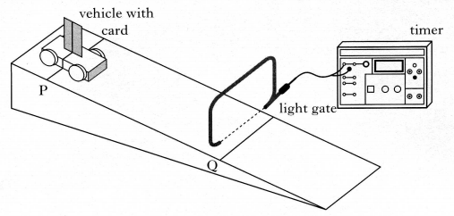  The line on the trolley is aligned with line P on the track. The trolley is released from rest and allowed to run down the track. The timer measures the time for the card to pass through the light gate.  The procedure is repeated a number of times and the results shown below.  - Calculate:  - the mean time for the card to pass through the light gate.  - The approximate absolute random uncertainty in this value.  - The length of the card is 0.020 m and the distance PQ is 0.60 m  Calculate the acceleration of the trolley (a uncertainty I this value is not required).
  0.015 s | 0.013 s | 0.014 s | 0.019 s | 0.017 s | 0.018 s
1n) | I know that when an experiment is being undertaken and more than one physical quantity is measured, the quantity with the largest percentage uncertainty should be identified and this may often be used as a good estimate of the percentage uncertainty in the final numerical result of an experiment.
i | The experimental arrangement shown below is used to measure the speed of an air rifle pellet.  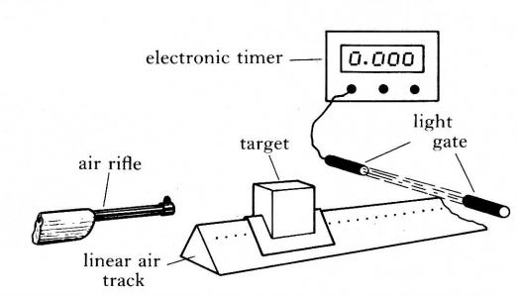  The speed of the pellet is calculated from the equation  $$speed of pellet=\frac{final mass of target ×speed of target}{mass of pellet}$$  The results from one experiment are  Final mass of the target = (2.00 ± 0.02) kg  Mass of pellet = (10.0 ± 0.5) g  Speed of target = (0.50 ± 0.01) ms⁻¹  Which of the following gives a good estimate of the percentage error in the calculated speed of the pellet?  - 1 %  - 2 %  - 3 %  - 5 % As this is the greatest % uncertainty in one measurement  - 8 %
ii | A vehicle runs down a slope as shown.  The following results are obtained.  angle of slope, θ = 15.0 ± 0.5°  length of card on top of vehicle, d = 0.020 ± 0.001 m  time for card to pass light gate 1,t₁ = 0.40 ± 0.01 s  time for card to pass light gate 2,t₂ = 0.25 ± 0.01 s  time for vehicle to travel between the light gates,t₃ = 0.50 ± 0.01 s  - Which quantity has the largest percentage uncertainty?  - State the overall uncertainty is finding the relationship between acceleration and angle of the slope.
iii | A ball is dropped several times from the same height.  A student records the following times for the ball to reach the ground.  Calculate the mean time for the ball to reach the ground and the approximate random uncertainty in this mean.
  1·15 s | 1·13 s | 1·09 s | 1·13 s | 1·05 s
1o) | I can express the numerical result of an experiment in the form final value ±uncertainty.
i | Here are two measurements of the circumference of a ball made by tying a string round it and then measuring the length of the string.  44.6cm, 39cm.  (a)What is the average measurement?  (b)What would you calculate as the average error if the actual circumference of the ball were known to be 42cm?  (c) Here are two more results: 40cm, 44.2cm  (i) What is the new average measurement of the circumference?  (ii) What is your new average for the error in its measurement?  (d) Here are five more results. Just using these results calculate the new average circumference and the average error in its measurement.  43.5cm, 41.2cm, 42.8cm, 39.6cm, 42.9cm
(a)

(c)
$$\text{approximate random unce}\text{rtainty} = \frac{\text{maximum - minimum}}{\begin{aligned}&n \\ &\overline{\begin{aligned}&mean \\ &=\frac{3.9}{5} \\ &\overline{42.0}\end{aligned}}\end{aligned}} \\ = \frac{\text{0.78}}{\text{42.0}}$$$=\text{ 42.0 }±\text{ 0.02 cm}$
(d)

ii | SQA Higher 2002  A basketball is dropped several times from the same height. The following values are obtained for the acceleration of the basketball  Calculate:  - the mean of these values;  - the approximate random uncertainty in the mean.
  8.9 ms⁻² | 9.1 ms⁻² | 8.4 ms⁻² | 8.5 ms⁻² | 9.0 ms⁻²
iii | SQA 2007 Higher  An experiment to determine the wavelength of light from a laser is shown.  A second order maximum is observed at point B.  (b) Distance AB is measured six times.  The results are shown.  (i) Calculate:  (A) the mean value for distance AB;  (B) the approximate random uncertainty in this value.  (ii) Distance BC is measured as (270 ± 10)mm.  Show whether AB or BC has the larger percentage uncertainty.  (iii) The spacing between the lines on the grating is 4.00 × 10⁻⁶ m.  Calculate the wavelength of the light from the laser.  $$mλ = d sinθ$$  Where m=no. of order of maxima, λ = wavelength, d= distance between the  Express your answer in the form  wavelength ± absolute uncertainty
  1.11m | 1.08m | 1.10m | 1.13m | 1.11m | 1.07m

Units Prefixes and Scientific Notation
No | CONTENT
2. | Units, prefixes and scientific notation
2a) | I know the units for all of the physical quantities used in this course.
I | State the 7 base quantities from which all other quantities are derived.
Ii | State the SI units for the following physical quantities  a) length, b) mass, c) acceleration, d) velocity, e) energy, f) charge.
2b) | I can use the prefixes: pico (p), nano (n), micro (μ), milli (m), kilo (k), mega (M), giga (G) and tera (T).
I | Express the following in scientific notation.  a) 50mA, b) 0.3nF, c) 200s d) 45μF e) 5000 GJ
Ii | Express the following in scientific notation in SI units.  a. 12 gigahertz 12 GHz  b. 4.7 megohms 4.7 MΩ  c. 46 kilometres 46 km  d. 3.6 millivolts 3.6 mV  e. 0.55 milliamps 0.55 mA  f. 25 microamps 25 µA  g. 630 nanometres 630 nm  h. 2200 picofarads 2200 pF
Iii | Calculate the volume in cubic metres of a cuboid with sides of length 10 cm, 5.5 cm and 2.55 cm respectively.
Iv | A leaf of mass 0.1g feels a frictional force of 948μN as it falls from a tree. Determine its acceleration as it falls. Include a free body diagram of the leaf.
2c) | I can give an appropriate number of significant figures when carrying out calculations. (This means that the final answer can have no more significant figures than the value with least number of significant figures used in the calculation).
I | 68122500J of energy are used by a heater in 136245s. Calculate the power output of the heater.
Ii | From the graph determine the distance travelled
Iii | A force of 1N is applied to a 3 kg mass determine the acceleration this produces
Iv | A pupil measures the current through a resistor as 0.250 A and the voltage across it is 2.00 V. Calculate the resistance of the resistor.
V | Calculate the energy released when 0.500 kg of water (c = 4180 Jkg⁻¹ °C⁻¹) lowers its temperature by 5 °C.
Vi | Calculate the power of a heater that uses 1200J of energy in 212.5 seconds?
vii | Calculate the area of a triangle in square metres if its base is 25 cm and its height 12 cm.
viii | Calculate the acceleration of a car that changes its speed by 34.5ms⁻¹ in a time of 5 s.
Ix | Calculate the speed of sound from the results below:  Explain the difference in your values.
  Distance (m) | Time(s) | Speed (ms⁻¹)
  1000 | 3
  1000.00 | 3
  1000.00 | 3.00
  1000 | 3.0
X | How much work must be done to increase the potential of a charge of  6·4 × 10 ⁻⁷ C by 560 V (W = QV).
2d) | I can use scientific notation when large and small numbers are used in calculations.
I | Show by calculation the magnitude of a light year.
Ii | put the following into kΩ MΩ, GΩ or TΩ as required:
  a) 5000 Ω | b) 10000 Ω |  | c) 3000000 Ω |  | d) 600000 Ω | e) 340 Ω
  f) 3 x 10⁵ Ω | g) 4 x l0⁴ Ω |  | h) 9 x 10¹³ Ω |  | i) 8.4 x 10⁷ Ω | j) 3.56 x 10⁸ Ω
  k) 98 x 10⁵ Ω |  | l) 740 x l0¹¹ Ω
Iii | Astronomers use the following relationship to determine the distance, d, to a star.  For a particular star the following measurements are recorded:  apparent brightness, F = 4·4 × 10⁻¹⁰ W m⁻²  luminosity, L = 6·1 × 10³⁰ W  Based on this information, the distance to this star is  A 3·3 × 10¹⁹ m  B 1·5 × 10²¹ m  C 3·7 × 10³⁶ m  D 1·1 × 10³⁹ m  E 3·9 × 10³⁹ m.

