ee
Using Excel 2016 in AH
Using Hooke’s Law & the Pendulum to Practice Graphing

January 1, 2020
WWW.mrsphysics.co.uk
J A Hargreaves

Using Excel to make Tables & Plot Graphs
Here are a couple of Youtube videos about using Excel, some of the uses are more for Business and Admin than Science but it gives some ideas for how to use Excel, a very powerful tool.
https://www.youtube.com/watch?v=rwbho0CgEAE
https://www.youtube.com/watch?v=k1VUZEVuDJ8


Symbol for Excel 2016

If you are working from school go to the MENU bar and open EXCEL. If you are online you will need to log into GLOW, click to the school page, which is the symbol on the launchpad.
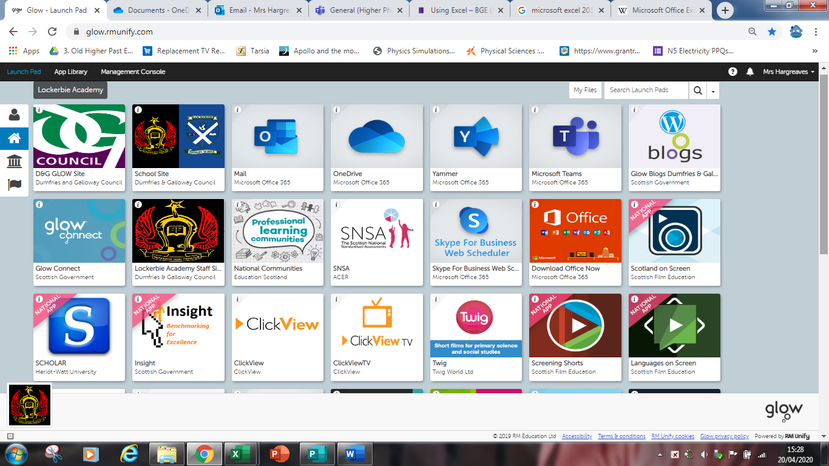

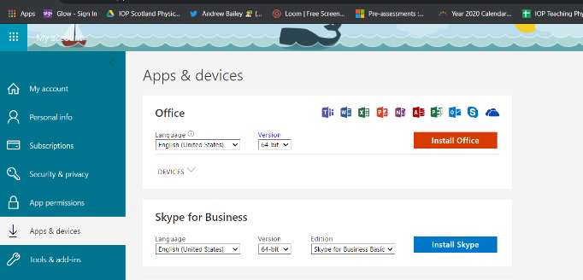
Downloading Excel
You might need to download the package, to get access to Excel. . All GLOW users are entitled to download this for free. You will only need to do this once and it ought to then be available on your machine. Please let teacher’s know if you are unable to do this. Look for the Office icon, you’ll probably need to scroll down the list for the tile. Click on this tile and it will ask if you want to download Microsoft office. On my computer I had to download the 32-bit package.
Click on Install Office. You only need do this once on any machine. It is then downloaded.

Opening Excel
Open Excel in the Microsoft Office Folder Introduction to Excel 2016 . This will be in your start menu. To be able to do all the things we need you to do you need to open this in the app and not just the browser.
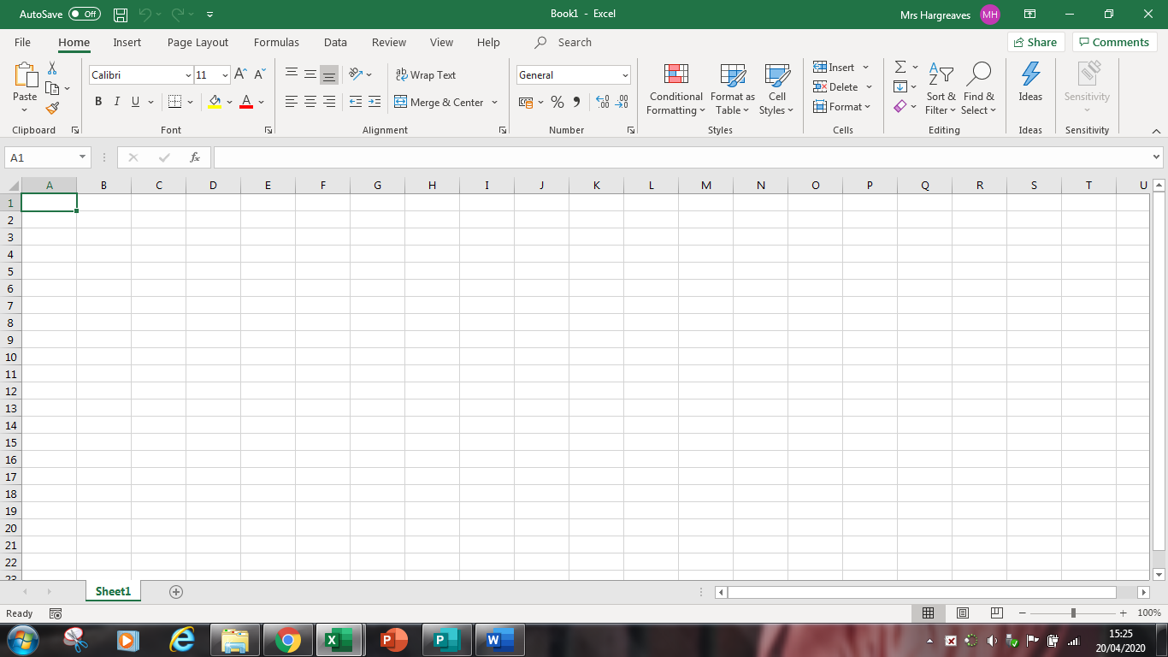
Active cell
Name box
Formula bar
Column letter
Row number
Sheet tab
Office button
Ribbon
cells

On the ribbon bar there are some Launch Buttons (see below) which gives access to more menus.
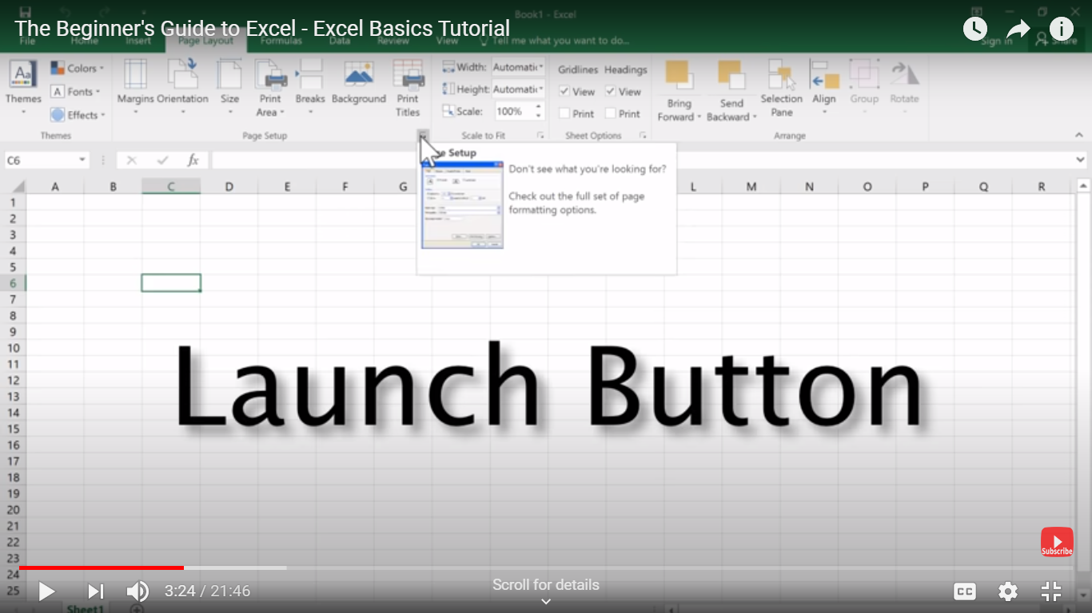

Reference to the terms in Excel 2016
Active cell
The cell with the black outline. Data are always entered into the active cell.

Column letter
Columns run vertically on a worksheet and each one is identified by a letter in the column header, eg the first column is column A. I think there is an infinite number of columns, but I’ve never got to the end.

Formula bar
Located above the worksheet, this area displays the contents of the active cell. It can also be used for entering or editing data and formulas.

Name box
Located next to the formula bar, the Name box displays the cell reference or the name of the active cell.

Ribbon
The ribbon is the strip of buttons and icons located above the work area in Excel 2007. The ribbon replaces the menus and toolbars found in earlier versions of Excel.

Row number
Rows run horizontally in an Excel 2016 worksheet and are identified by a number in the row header.

Sheet tab
Switching between worksheets is done by clicking on the sheet tab at the bottom of the screen. The sheets will usually contain just one experimental set of data.

Office button
Clicking on the Office button displays a drop-down menu containing a number of options, such as Open, Save, and Print. The options in the Office button menu are very similar to those found under the File menu in previous versions of Excel.

Save the document
- Before you start save your work with a sensible name, one that you will be able to find again. Note where you save it and the date in your jotter. It is recommended that you save the file with your name Science class, HOOKES law and date ie
MrsH2_6Hookes Law 2020 02 21.You must check where you’ve saved your document as about 30% of students can’t find their document next week.

Entering Data
Entering data, whether text or numerical, into a spreadsheet is a three-step process. The steps are:

- Click on the cell where you want the data to go.
- Type your data into the cell.
- Press the Enter key on the keyboard or click on another cell with the mouse.
NB It is VITAL when entering numerical data (numbers) that you don’t enter the units after it as Excel can then not pick this up as a number but text and you wont be able to plot a graph, see the image below!

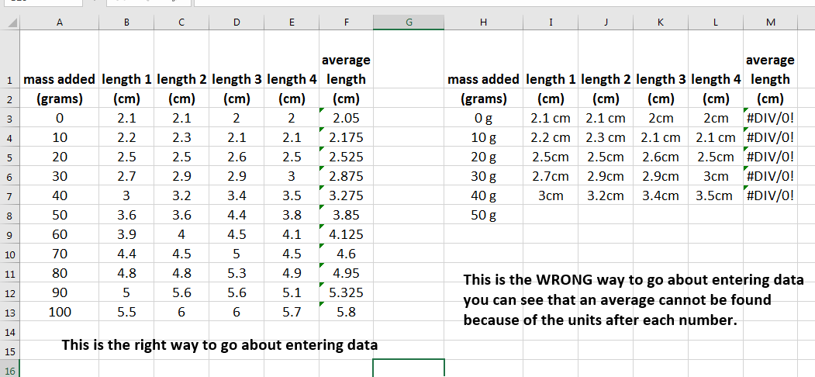

If you make a mistake, the Esc key cancels the data entry. As in all Microsoft products, pressing Ctrl-Z will undo the last process.

So let’s get entering the data.

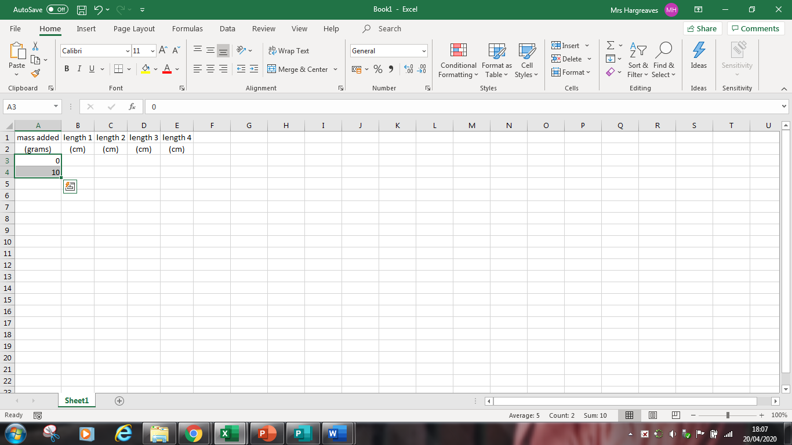
First put in headings on each column, one for mass on the end and then length of the spring.
Put in the first 2 numbers. Move the white cross to the bottom right of the lower box. When it turns to a small black cross drag it down. It will add 10 or 100 (depending on boxes 1 and 2) to each line

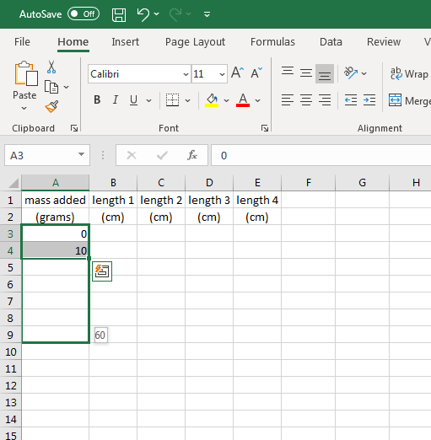

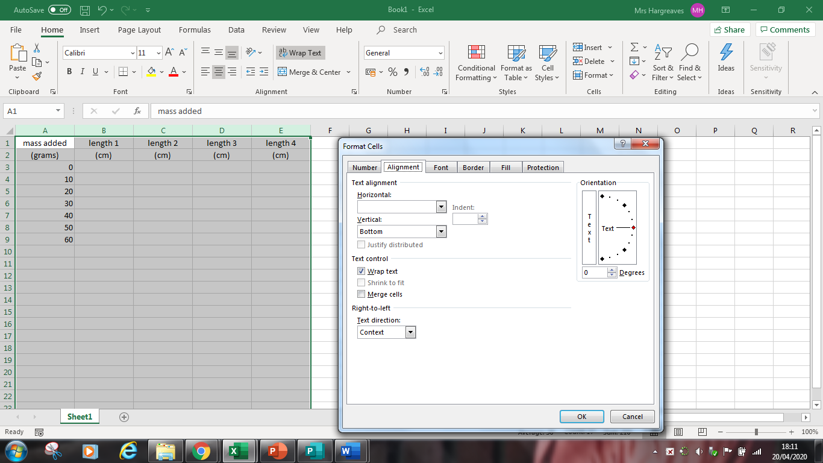
If your headings take up too much space across a cell then wrap text. Do this by ⇒HIGHLIGHT THE COLUMNS go to HOME⇒ FORMAT ⇒ FORMAT CELLS⇒ and then click on ALIGNMENT and tick the box marked WRAP TEXT. Another way of doing this is to highlight the columns go to the edge until the black cross changes to a up and down line and a horizontal arrow and then drag or double click.

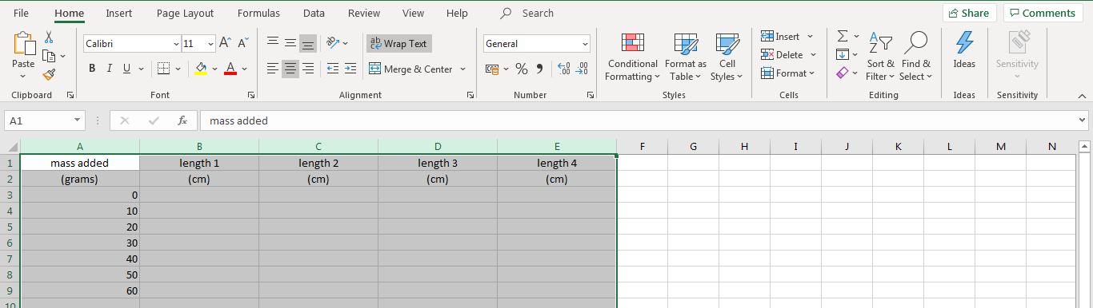

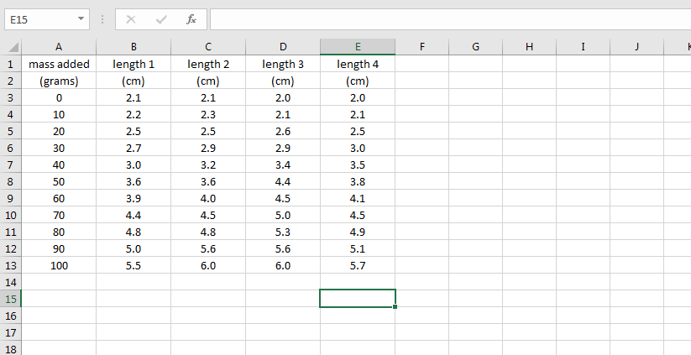
Don’t forget to add units in the headings. If the units are the same, you can drag the cell across the page to copy the text like you did with the numbers.

Averaging your results
You don’t need to get your calculator out Excel will do it for you. Firstly type in a heading in the cell that says average length (cm) or (mm)

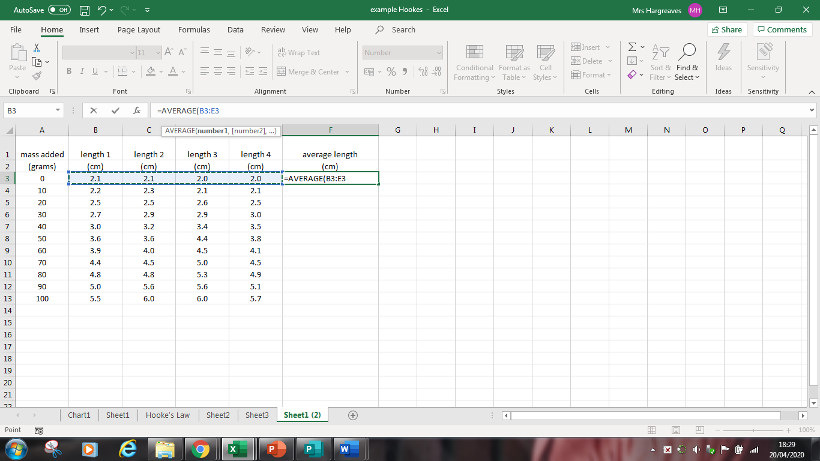
To get an average type in
=average(then holding down the SHIFT key and drag the mouse across the cells you want to average). Put brackets around the cells as above.
Dragging the black cross down will average each line. Make sure your average column has the wrap text box clicked.

You want to subtract the value that is in this box from each reading so either write the equation
={CELL}-value
Or ={CELL}-B$3
The B3 is the cell and the $ is that it is always this cell and not the one below or to the right
Moving the cursor to the bottom right to get the little black cross and dragging it across the sheet will copy the formula for each column. Check that it is given you what you want!
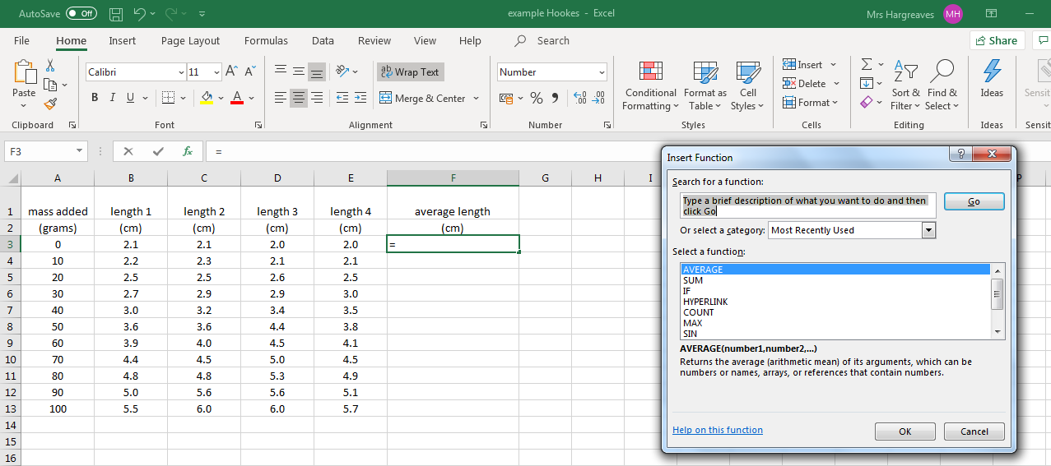
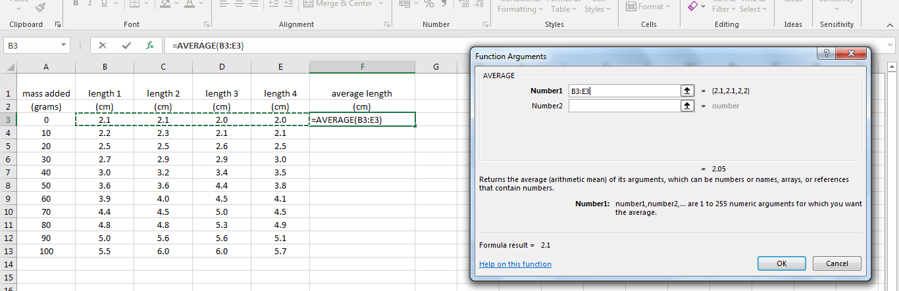
Or to get an average use the formula bar click fx Find the average button in the select a function box and click OK. You then get the numbers that you want to average so either drag across the boxes as before or write the range using B3:E3 (ie the first and last cell that you want to average). Then click OK. Always use this method if your spelling isn’t great

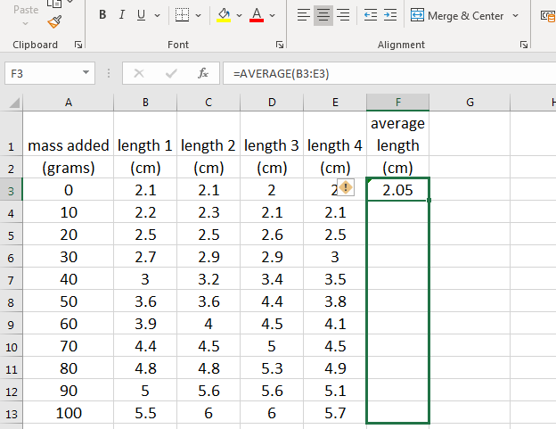
Once you’ve put in ENTER at the end of the formula you can copy the formula for the whole column. Moving the cursor to the bottom right to get the little black cross and dragging it down the sheet will copy the formula for each column. Check that it is giving you what you want that is the average length for that mass!

Remember a mean average should be greater than the smallest number in the range and smaller than the largest number in your range. For example in row 3 the values are 2.1, 2.1, 2, 2 so the average should be greater than 2 and less than 2.1 this is seen in the answer of 2.05.

If you want to see the formula that you’ve added in you can push the SHIFT and the ¬ key (the one under the escape button) and it will show you the formula. Repeating this will turn it off.
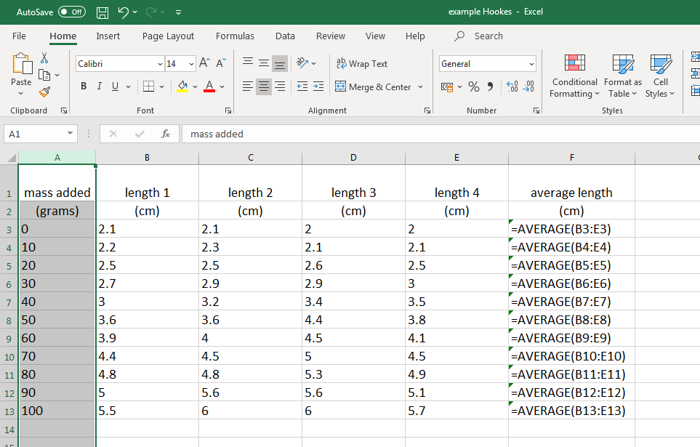
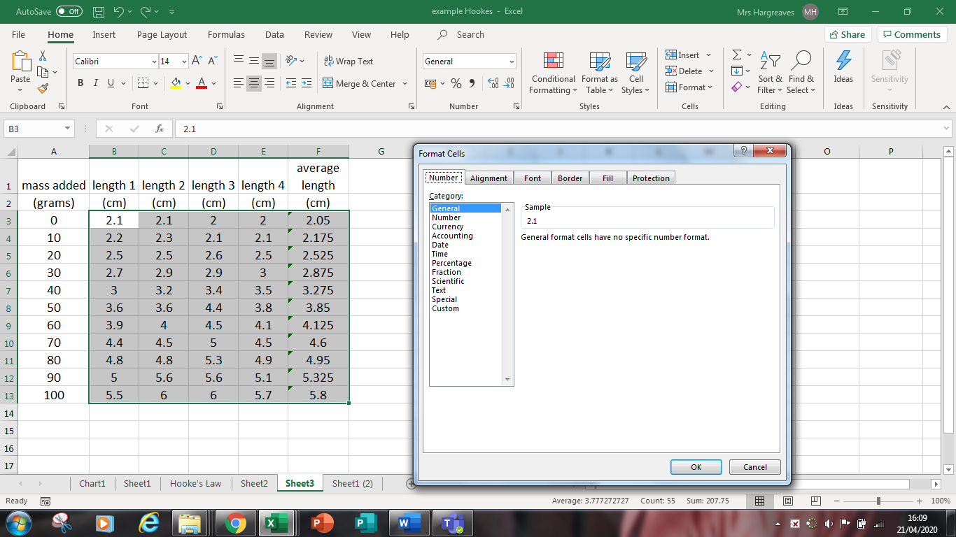
We need to get all of your answers to 1 decimal place as the averages and numbers look a mess and are incorrect. Highlight the boxes that you need to change. This will be all of the length measurements
Go to the HOME box click on FORMAT. Click on FORMAT CELLS. Click on NUMBER and select 1 decimal place

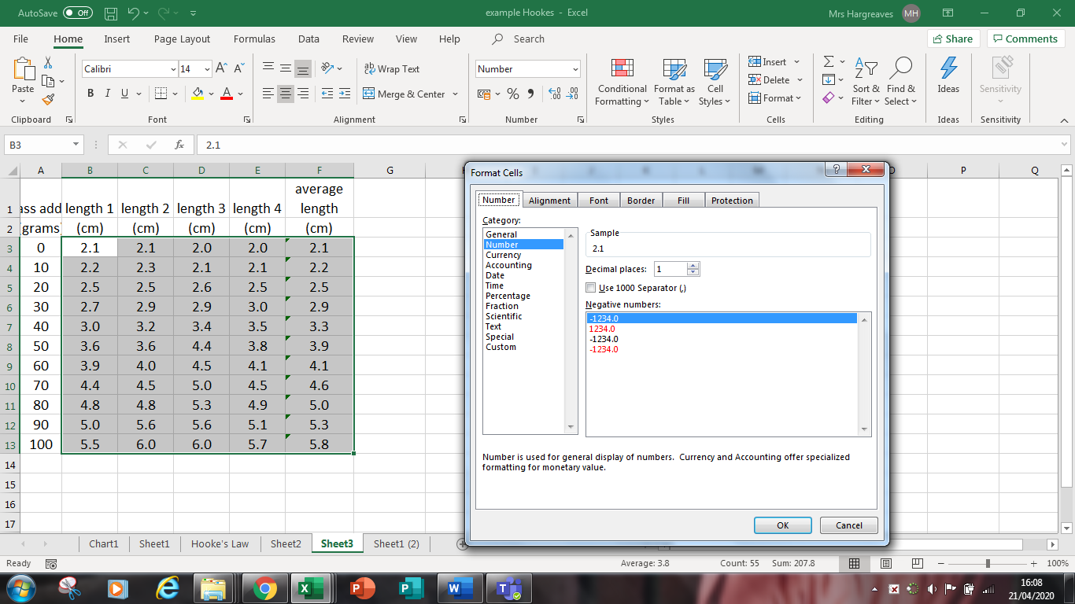
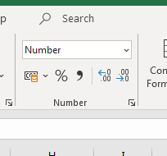
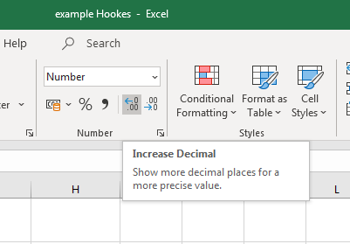
Or a new feature in 2016 is the increase and decrease decimal places. You might need to do both buttons as some values are 1 decimal place and some are 0 decimal places.

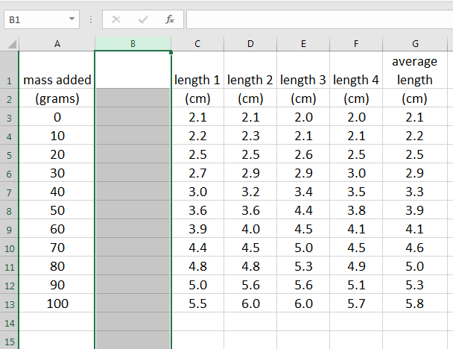
Adding columns
We now need to record the force. This is the force of gravity or weight. To link between mass and weight you need to divide the mass in grams by 100 in your table
So firstly we need to add in a column.
Click on Home Page and then on Column B. On the ribbon bar is a group called cells. If you click on insert cell or insert column in sheet it should add in an additional column before the current column B pushing the results for length 1 and all the other columns one place to the right.
.
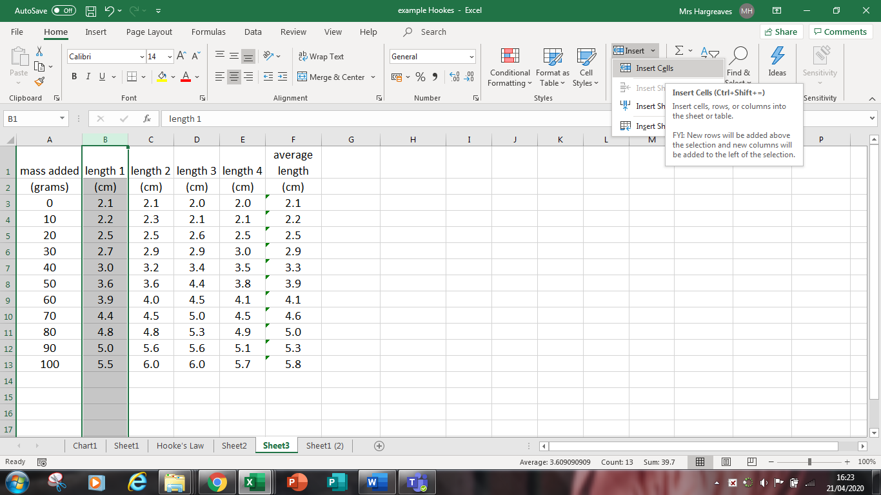
Click on Home Page and then on Column B. Along the top is an insert button. Click inset column This will generate a new column into which we can add a formula

ADDING FORMULAE
To add in the formula, always start with an = sign
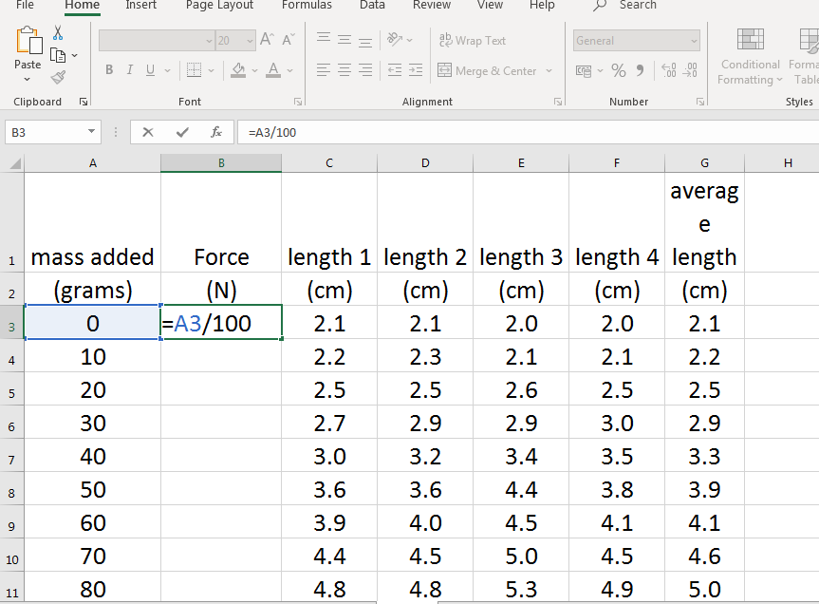
Type in the title and unit, Force and (N)
To find the force we need to divide our mass values in g by 100 (more on this later)
To add the formula type
= {click on the cell}/100 and then hit return.
Or type =A3/100
Drag the box down from the small black cross again and this will copy down the formula

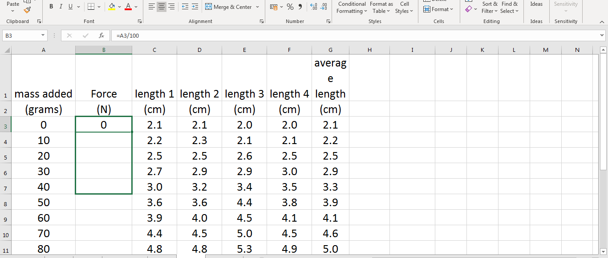
Drag the box down from the small black cross again and this will copy down the formula

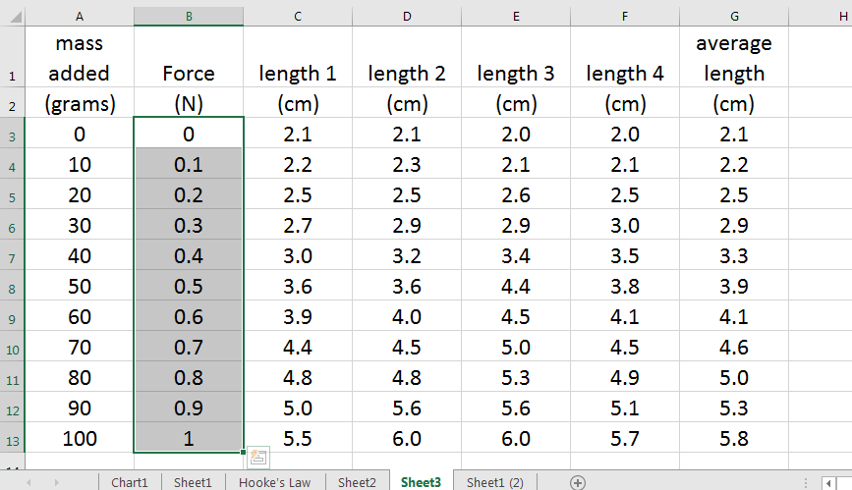
Go back and change the number of decimal places to 1 (see if you can do it without looking back at the notes)

Finding the Extension
The extension of the spring is how much it has stretched from its original position. This is the length of the spring when no load/ mass/ force/ weight was added. This means we want to take the average mass from the first row from the average mass in all the other rows.
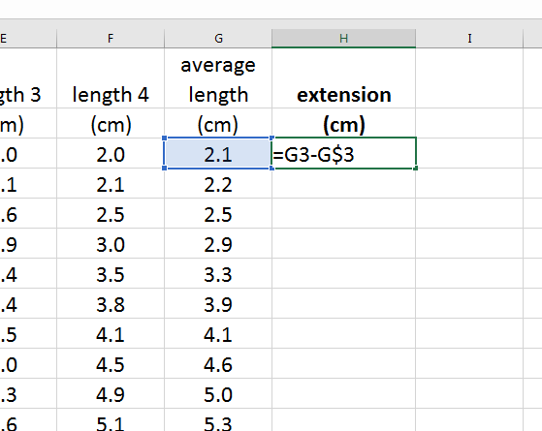
Type in the title and unit, Extension and (cm) or (mm) depending on what unit you measured in.
To add the formula type
= {click on the cell with the length of the spring with 0 force} then put in a subtract symbol and then click in the cell again with the average length for 0 N Force.
If we copy this formula down it will assume we wont to take the number from itself and will give us an extension of 0 all the way down. To show that we want to take the number in that cell from all the others you need to type in a $ between the second column number and the row number. Do this in the formula bar shown

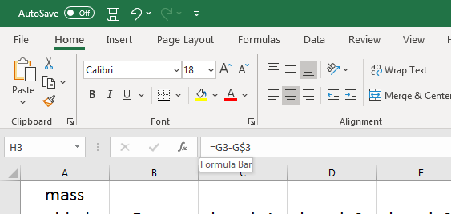
Drag down using the small black cross as you have done before and you ought to get the length of the spring subtracted from the length of the spring with various masses on the end.
mass added | Force | length 1 | length 2 | length 3 | length 4 | average length | extension
(grams) | (N) | (cm) | (cm) | (cm) | (cm) | (cm) | (cm)
0 | 0 | 2.1 | 2.1 | 2.0 | 2.0 | 2.1 | 0.0
10 | 0.1 | 2.2 | 2.3 | 2.1 | 2.1 | 2.2 | 0.1
20 | 0.2 | 2.5 | 2.5 | 2.6 | 2.5 | 2.5 | 0.5
30 | 0.3 | 2.7 | 2.9 | 2.9 | 3.0 | 2.9 | 0.8
40 | 0.4 | 3.0 | 3.2 | 3.4 | 3.5 | 3.3 | 1.2
50 | 0.5 | 3.6 | 3.6 | 4.4 | 3.8 | 3.9 | 1.8
60 | 0.6 | 3.9 | 4.0 | 4.5 | 4.1 | 4.1 | 2.1
70 | 0.7 | 4.4 | 4.5 | 5.0 | 4.5 | 4.6 | 2.6
80 | 0.8 | 4.8 | 4.8 | 5.3 | 4.9 | 5.0 | 2.9
90 | 0.9 | 5.0 | 5.6 | 5.6 | 5.1 | 5.3 | 3.3
100 | 1.0 | 5.5 | 6.0 | 6.0 | 5.7 | 5.8 | 3.8

There are several ways to make your table look better but somethings you shouldn’t do.
Do NOT
- make the background brightly coloured as this uses too much ink when printed
- use a huge font, this uses too much paper and your table might not fit on one page.
- use a font that is hard to read. The standard font that is being adopted is Trebuchet MS but there are other clear fonts too.

Finalising the Table
You can also highlight the text and put a border around the numbers as this makes it easier to read across the line. Don’t make it too fancy and use all the printer ink when you come to print it out; it is not how Scientists lay out their work.

See some of the hints and tips below, but make sure your name is on the page you print out. The best way to do this is in the header or footer.

Adding Borders to the table
Highlight the data in your table that requires a grid
Go to the HOME tab in the bar at the top, and then click on the
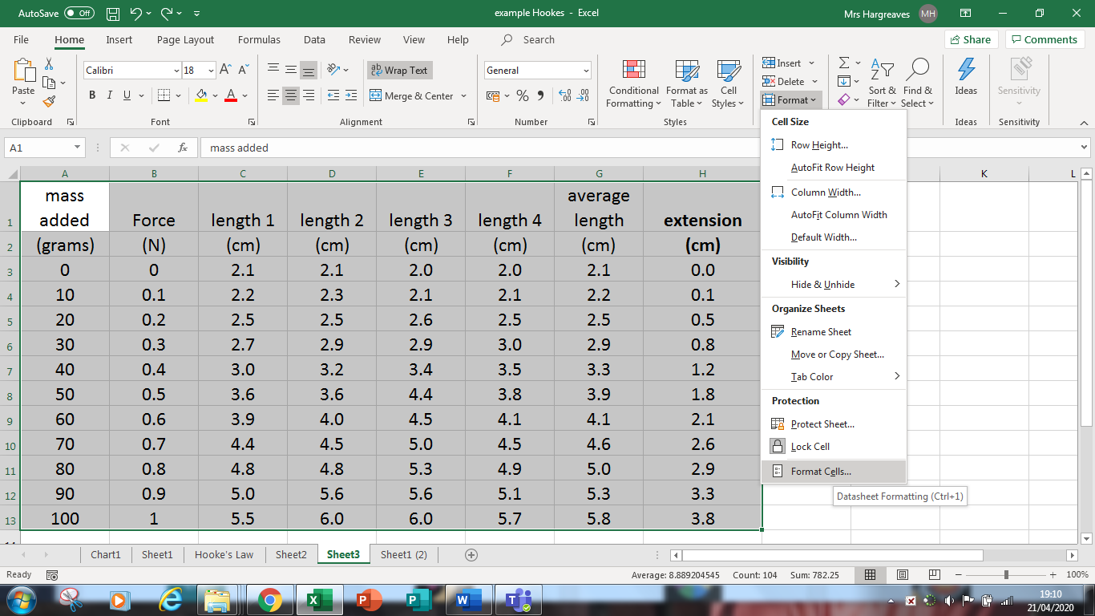

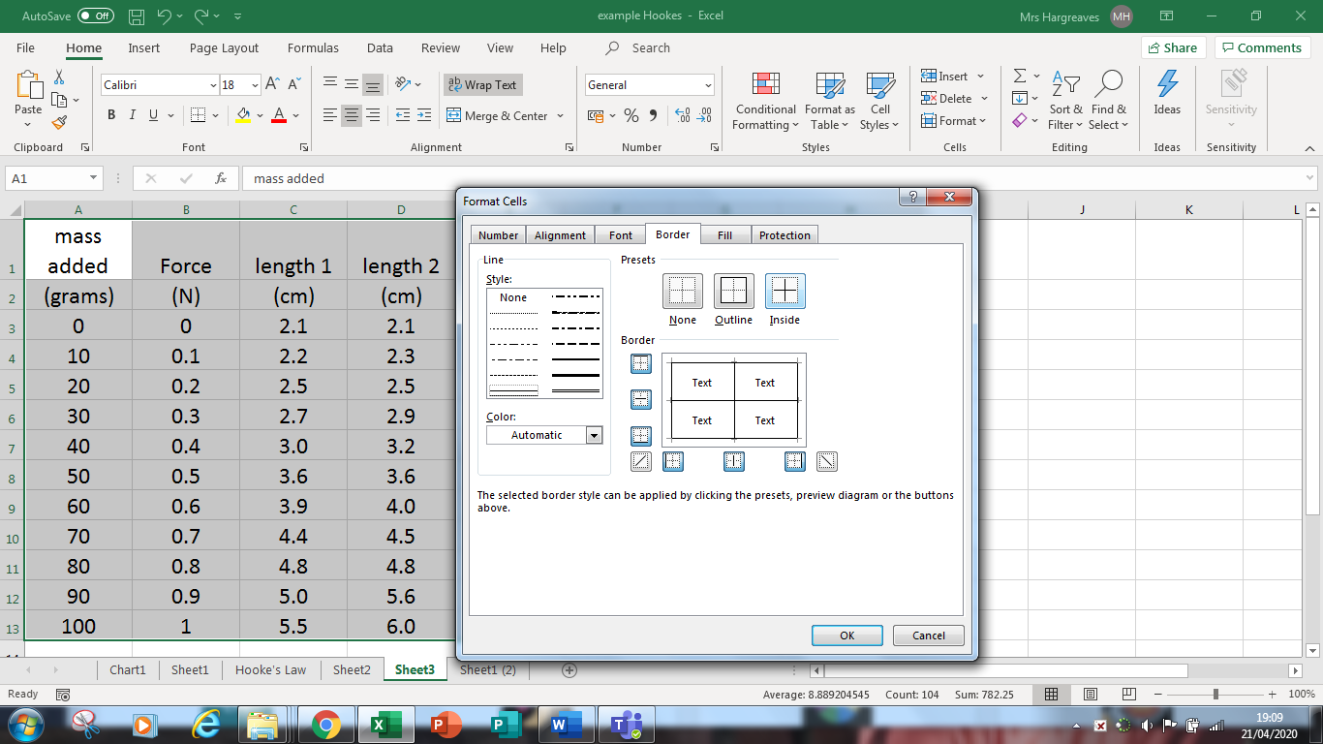
MERGE CELLS
We can make the table look neater by merging all the headings that represent Length.
Highlight the lengths, and I’d include the average one. On the home tab ribbon you’ll find a merge and centre
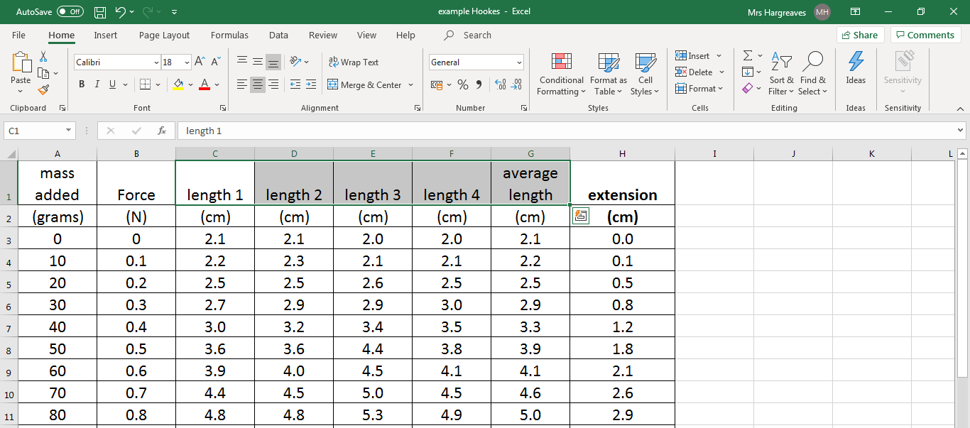
Merging will only leave the top left cell title so you’ll need to add in the units and change the units in the cells below to the readings, see my effort below. If you type in an apostrophe before the number then you wont be able to accidentally plot this in your graph as it indicates that this is a word and not data. Don’t forget to add your average title back in.
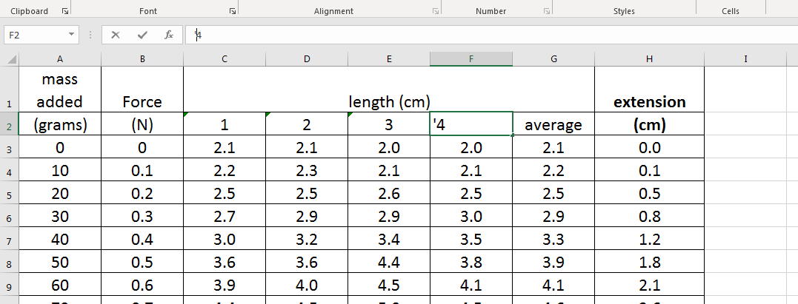

mass added | Force | length (cm) |  |  |  |  | extension
(grams) | (N) | 1 | 2 | 3 | 4 | average | (cm)
0 | 0.0 | 2.1 | 2.1 | 2.0 | 2.0 | 2.1 | 0.0
10 | 0.1 | 2.2 | 2.3 | 2.1 | 2.1 | 2.2 | 0.1
20 | 0.2 | 2.5 | 2.5 | 2.6 | 2.5 | 2.5 | 0.5
30 | 0.3 | 2.7 | 2.9 | 2.9 | 3.0 | 2.9 | 0.8
40 | 0.4 | 3.0 | 3.2 | 3.4 | 3.5 | 3.3 | 1.2
50 | 0.5 | 3.6 | 3.6 | 4.4 | 3.8 | 3.9 | 1.8
60 | 0.6 | 3.9 | 4.0 | 4.5 | 4.1 | 4.1 | 2.1
70 | 0.7 | 4.4 | 4.5 | 5.0 | 4.5 | 4.6 | 2.6
80 | 0.8 | 4.8 | 4.8 | 5.3 | 4.9 | 5.0 | 2.9
90 | 0.9 | 5.0 | 5.6 | 5.6 | 5.1 | 5.3 | 3.3
100 | 1.0 | 5.5 | 6.0 | 6.0 | 5.7 | 5.8 | 3.8

Fitting your table on to one page
If your table is too big to print on one page then make sure first that it won’t fit on a landscape page. Go to PAGE LAYOUT on the ribbon bar, then orientation and click to change it to landscape. This will make the page print landscape. If the table won’t still fit on one page try reducing the font size and make sure that the headings have been wrapped so that the columns are not too wide.

Add your name to the table, either by adding it under the table or if you can add it in the header or footer.

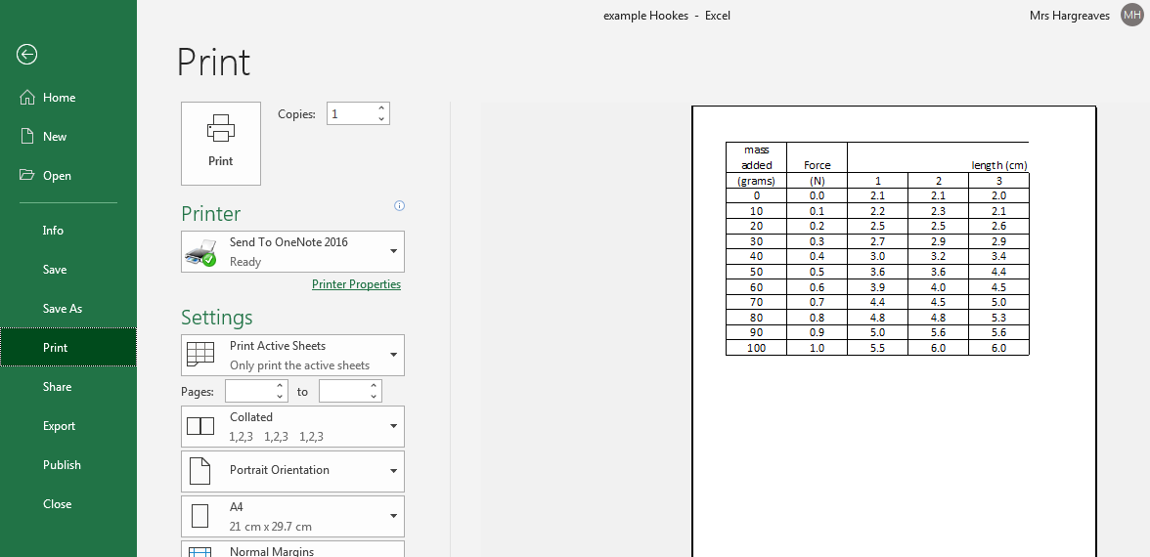
When you go to the print menu does your table fit on one page? If it doesn’t the best thing to do it to set up the page as a landscape page
For this go to the PAGE tab on the top formula bar. Click on orientation and click LANDSCAPE. You will know if it fits on a page as there is a dotted line down the edge of the page. This indicates the page break
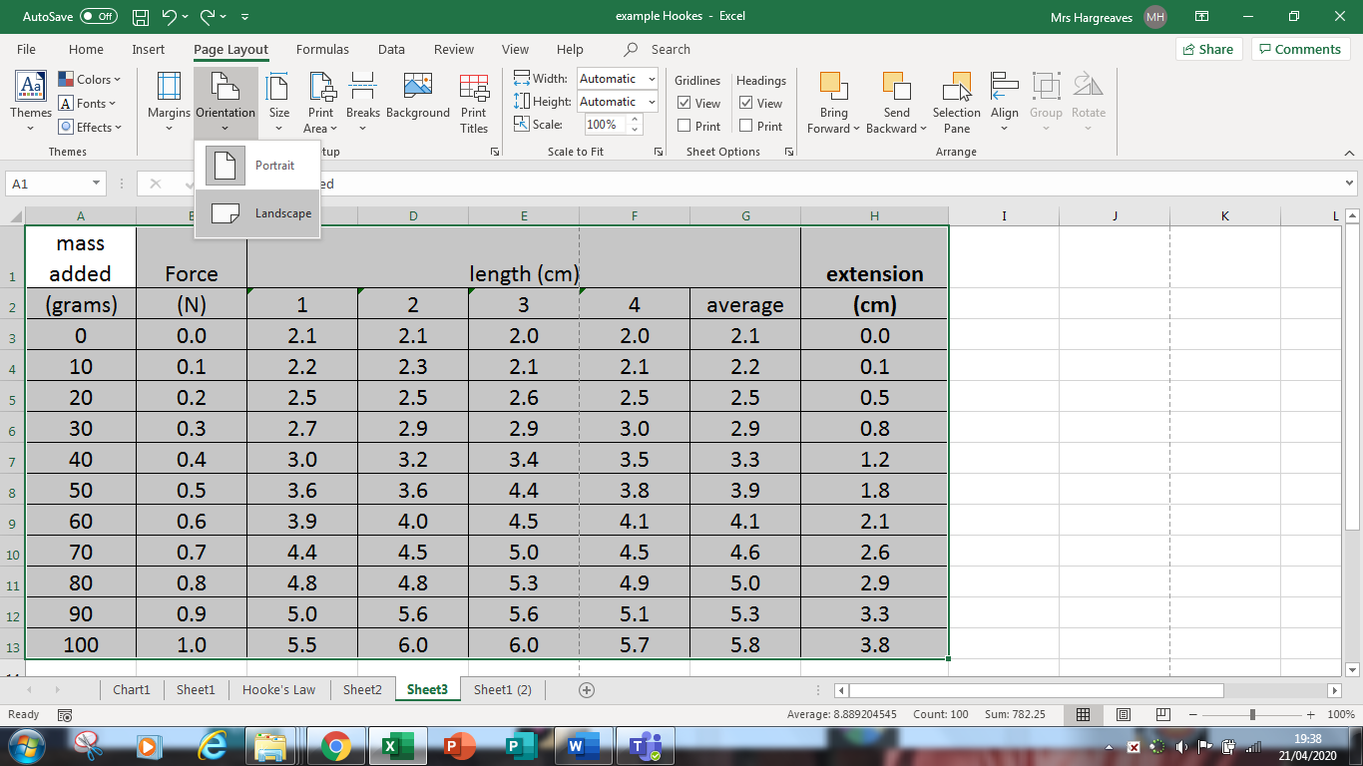

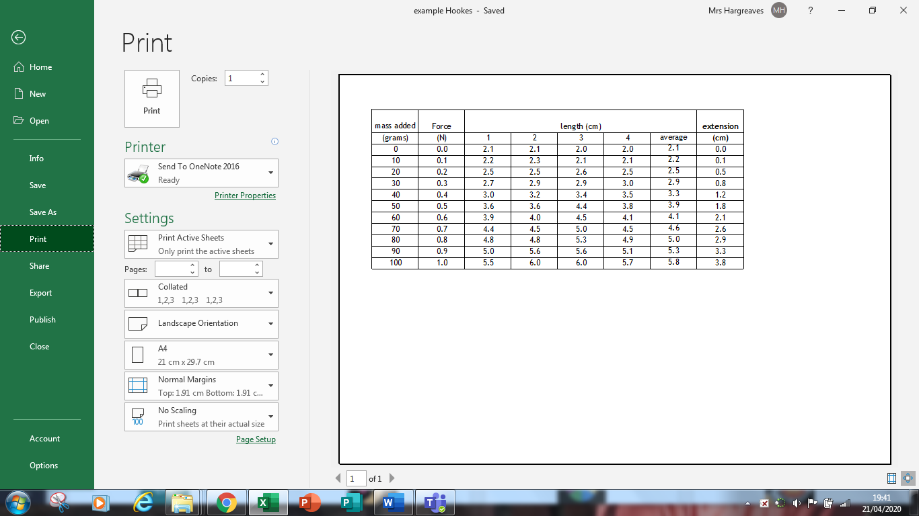

Adding a Header
Now we just need a header.
Go to the page tab at the top and click on Print titles, you then get a page set up menu come up like in the box on the right. Click custom header and you’ll get the second box come up, the one on the left.
Type in YOUR NAME, the title (HOOKES LAW) and your Physics Class. If you prefer you can add this to your footer. You wont see this until you go to print so look at your print preview again.
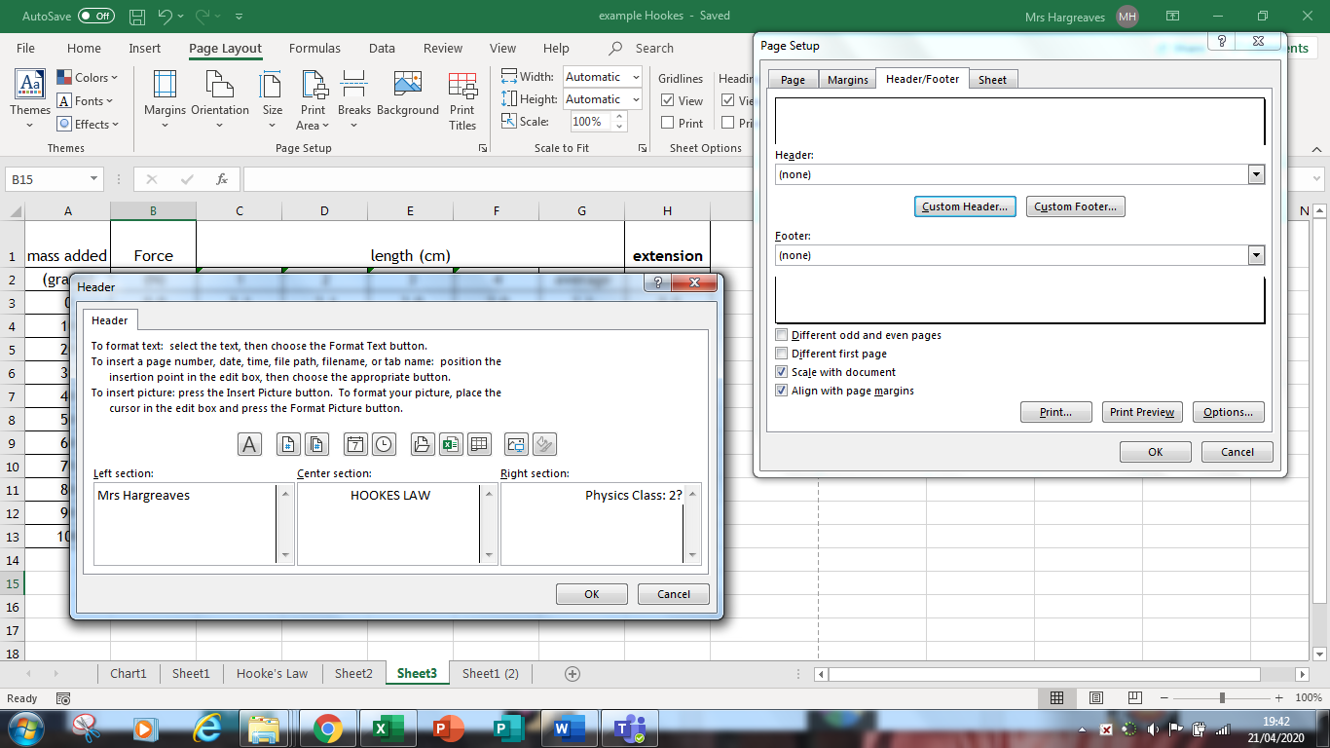

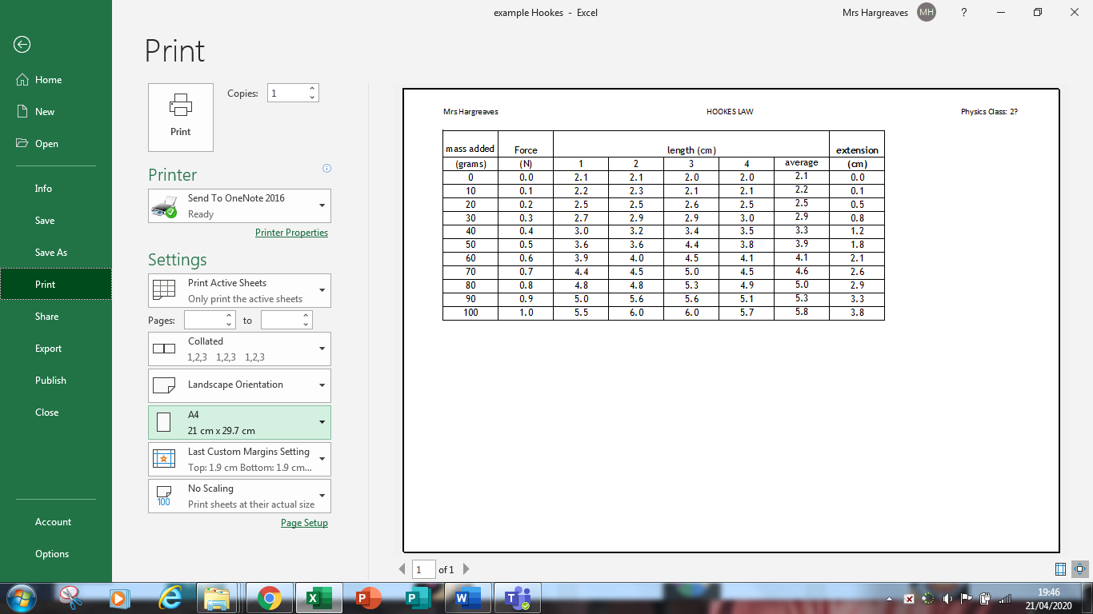
Now you are ready to plot your graph. SAVE YOUR FILE with the name YOURNAME TITLE and the date or your class.

Extension
length of thread | Time for three swings (s) |  |  |  |  |  |  | average 3T (s) | a.r.u in 3T | Period (T) | Period (T)²
m | (1) | (2) | (3) | (4) | (5) | (6) | (7) | (av) | (s) | (s) | (s²)
0.250 | 3.04 | 2.99 | 2.93 | 3.08 | 2.99 | 2.99 | 3.00 | 3.00
0.500 | 3.26 | 4.36 | 4.96 | 4.34 | 4.46 | 4.38 | 4.59 | 4.34
0.750 | 4.99 | 5.06 | 5.06 | 5.06 | 5.06 | 5.06 | 5.06 | 5.05
1.000 | 6.24 | 6.22 | 6.08 | 6.06 | 6.18 | 6.10 | 6.14 | 6.15
1.100 | 6.59 | 6.40 | 6.55 | 6.47 | 6.47 | 6.51 | 6.54 | 6.50
1.200 | 6.39 | 6.68 | 6.56 | 6.44 | 6.86 | 6.45 | 6.46 | 6.55
1.300 | 6.32 | 6.38 | 6.40 | 6.64 | 6.59 | 6.63 | 6.39 | 6.48
1.500 | 7.45 | 7.62 | 7.32 | 7.31 | 7.55 | 7.52 | 7.27 | 7.43
1.750 | 7.93 | 7.93 | 8.11 | 7.63 | 7.63 | 7.68 | 7.69 | 7.80
2.000 | 9.01 | 8.59 | 8.55 | 8.41 | 8.41 | 8.60 | 8.82 | 8.63

Let’s type in the formula to find the approximate random uncertainty. Remember this is $$R=\frac{R_{max}-R_{min}}{n}$$
Where ΔR= uncertainty, Rmax is the maximum value measured and Rmin is the minimum value measured and n is the number of measurements taken. This formula works best for between 6 and 12 repeats.
This equation in Excel would be given below.
=(MAX (B3:H3)-MIN(B3:H3))/COUNTA(B3:H3)
Where B3:H3 is the range of cells to find the uncertainty in. If the cells aren’t next to one another you can either hold the control and click on the cells containing repeats or use the , between cells containing measurements.
The statement COUNTA(cells) counts the filled cells in the range of cells you recorded. So if for example you missed one of the results out, or felt it was an odd result then blank cells in the range would not be added up.
You can then drag the formula down using the black cross. Don’t forget to set up the cells for the same d.p. as the answers. Do not round up at this stage.
You then need to work out the period (the time for one swing). You have recorded the time for 3, 5, 10 or more swings so you need to put in the formula to find this.

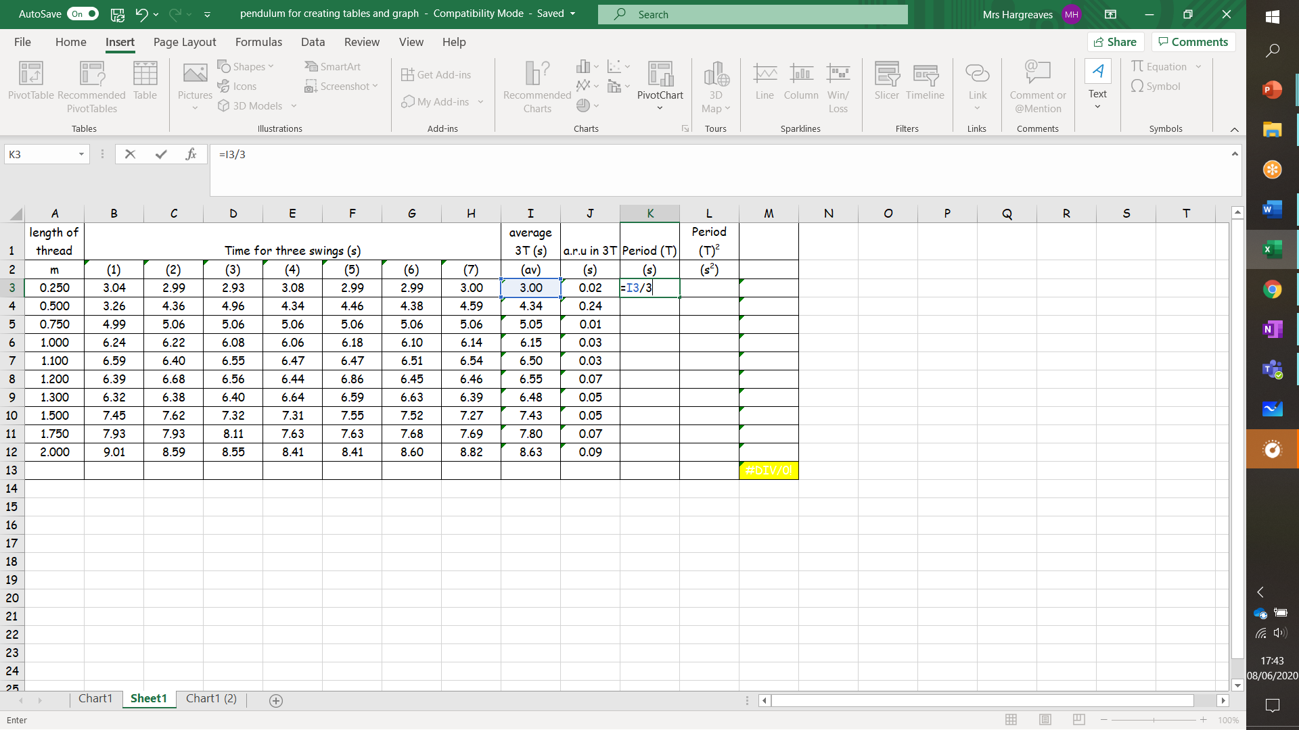
Formula
=cell/(no.of swings)

Drag the formula with the “magic black cross.”
It is highly recommended that you check one of your results with a calculator to check that you have entered the formula correctly.

Finding the period squared, T²
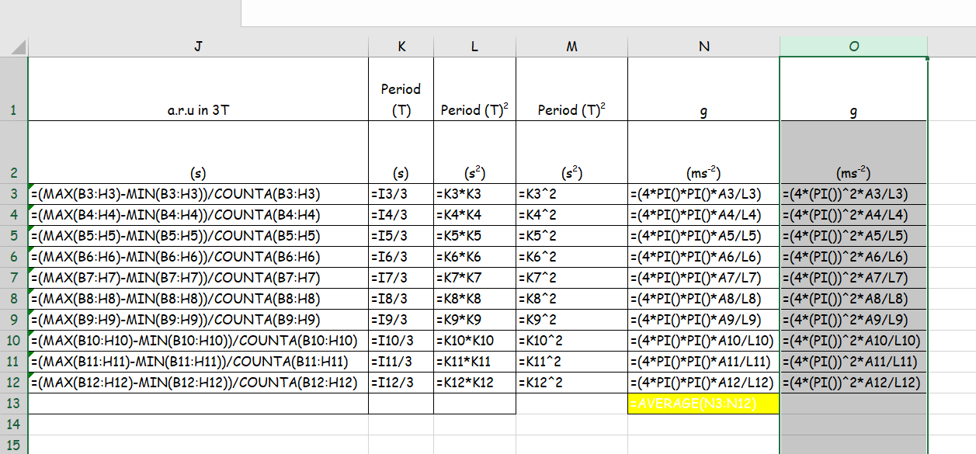
There are two ways that you can find T2 in your results. You are needed to square the value for T, you can do this by multiplying the cell for T by itself, eg K11*K11 where * stands for multiply. Or you can find the way to raise a value to a power using the ^ symbol (caret circumflex) eg K11^2, where 2 is the power to which the number in the cell is raised.

It is incorrect to calculate g using these values as the uncertainties are too large in one point. Instead a graph should be drawn. However, you may wish you check that your values are getting reasonable results. Again there are two ways to enter the formula which is
$$T^{2}={4π}^{2}\frac{l}{g}$$
$$g={4π}^{2}\frac{l}{T^{2}}$$

4 × π × π×l(cell A3)/T² (cell L3) | 4 × π ²× l(cell A3) /T² (cell L3)
=(4*PI()*PI()*A3/L3) | =(4*(PI())^2*A3/L3)

Uncertainties
We’ve already shown you how to determine the approximate random uncertainty in a measurement, don’t forget that both your independent and dependent variables will be prone to uncertainties. Often a scale reading uncertainty will be the same for each measurement so can be copied down the row. This might also be the same for the calibration uncertainty. Sometimes the calibration uncertainty is given as a percentage of the measurement with an additional value.
Figure 1AH Physics Staff guide uncertainties norman fancey and gemmell millar
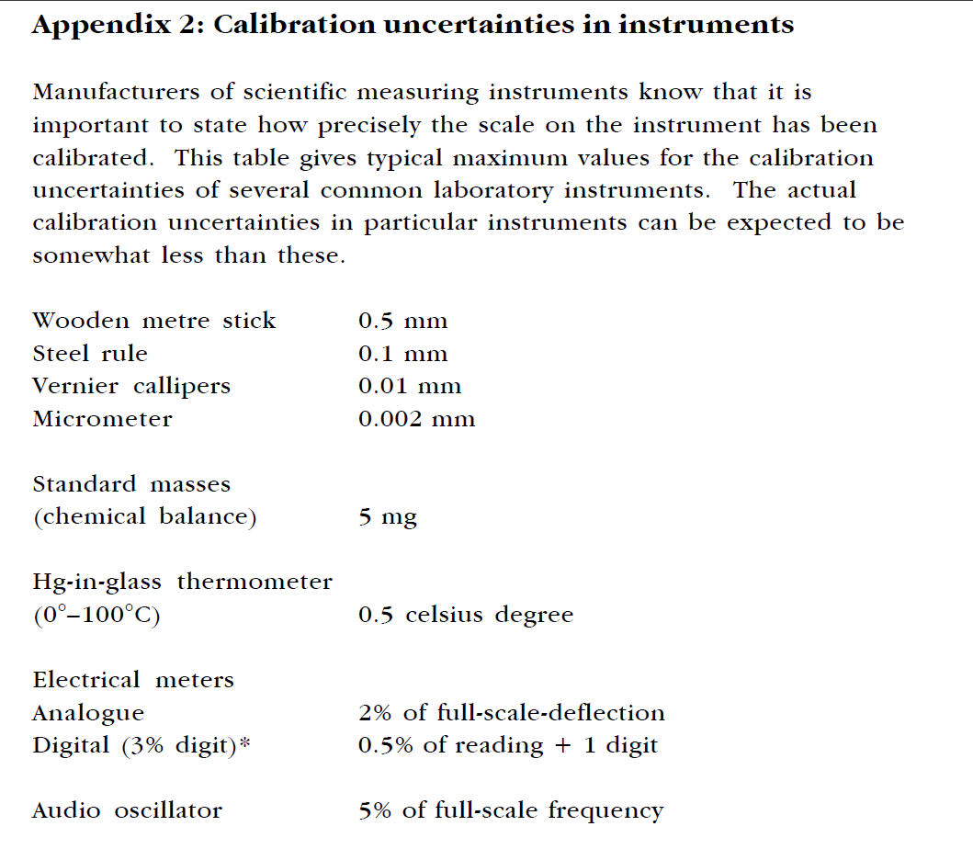

So for our pendulum example we probably have a calibration uncertainty in the metre stick of 0.5 mm or 0.0005 m and in the time 0.5% of the reading + 1 digit. We will need a formula for the calibration uncertainty in the timer.
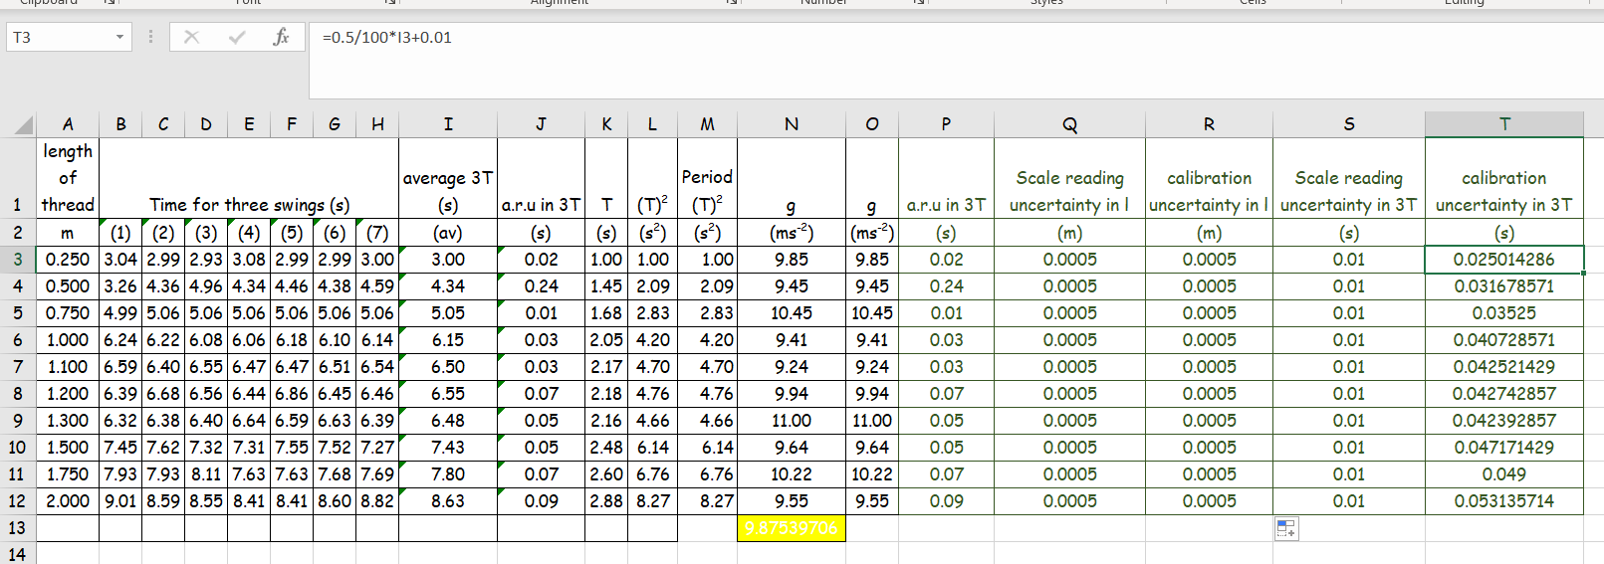
The formula for the calibration uncertainty has been entered as
=0.5/100*(cell)+0.01
= (for the formula)
0.5/100 *(cell) gives 0.5% of the measurement (notice this is the measurement not the calculated value of T)
+0.01 this represents the one digit. The smallest reading our stopwatch can make is 1/100th of a second or 0.01 s

Notice for this purpose I have rounded the calibration uncertainty to 3 sig fig as in the measurements. Do not round up too early or additional rounding errors will occur. Also note that Excel displays the rounded values but the original values are still in the cell and these non-rounded numbers are what is used should you try to combine your uncertainties.

