Moffat’s O.S. Benchmarks (Flush Brackets)
Ordnance Survey Bench marks (BMs) are survey marks made by Ordnance Survey to record height above sea level. There are approximately 500,000 BMs still remaining; but this number is reducing as they have not been maintained for 30 years.

Moffat has 5 flush plate benchmarks.

Can you use the clues to find them around town ?
(Start with any clue but if you do them in the order marked it is the shortest distance to walk).
- The railway is long gone but this isn't that “hidden”.
- From one park to the other the river takes you along the straightest route. You will find this plate on the bridge whose “new” name isn't very appropriate.
- You used to learn so much here, but now it's just a bit flat, although luxurious.
- You can still post a letter near here, but give your eyes a chance to find this one.
- Off to the city by an old road or straight on for Selkirk, the decision is yours if you look behind the sign.

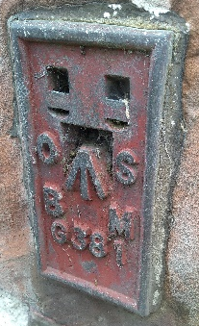 | 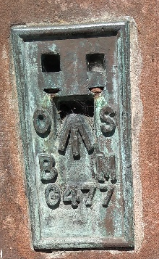 | 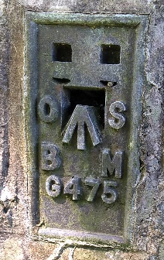 | 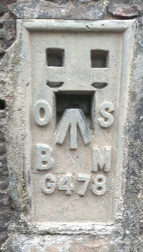 | 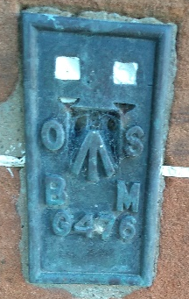

Care must be taken when looking for OS Benchmarks. Some are near water and others are on major roads. Remain on the pavement and paths, find safe places to cross. Follow the Green Cross Code and the Water Safety Code.
There are approximately 190 Fundamental benchmarks, FBMs, are high-accuracy BMs and still maintained and are used by Ordnance Survey.  NT 06390866 This is on the A701 near the bridge over Holehouse Linn  Visiting the fundamental benchmark is not suitable for young children due to the busy road, narrow entrance to the bridge and tight turn off the bridge There is a layby nearby, just before the bridge for parking. | 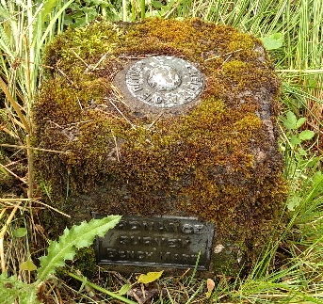
Answers: Find the answers at

