LO RADIATION ANSWERS

Quantities for the Radiation Unit
For this unit copy and complete the table.
Quantity | Symbol | Unit | Unit Symbol | Scalar / Vector
Time | t | second | s |  | S
Activity | A | Becquerel | Bq |  | S
Equivalent Dose | H | Sievert | Sv |  | S
Absorbed Dose | D | Gray | Gy |  | S
Absorbed Dose Rate | $$\dot{D}$$ | Gray/day Gray/year | Gy/h, Gy/y |  | S
Equivalent Dose Rate | $$\dot{H}$$ | Sieverts/ hour, Sieverts/day, Sieverts/ year | Sv/h, Sv/d |  | S
Radiation weighting factor | w_{R} | ___________ | __ |  | S
Energy | E | Joule |  |  | S
Mass | m | Kilogram | kg |  | S
Number of radioactive nuclei decaying | N | ______________ | __ |  | S

The RADIATION unit in numbers
Quantity | Value
State the charge on an alpha particle | (+2) , +3.2×10⁻¹⁹ C
State the charge on a beta particle | (-1) , -1.6×10⁻¹⁹ C
State the mass of an alpha particle | 6.64 ×10⁻²⁷ kg
State the mass of a beta particle | 9.11×10⁻³¹ kg
State the average annual background radiation in the UK | 2.2 mSv
State the average annual effective dose limit for a member of the public in the UK | 1 mSv
State the average annual effective dose limit for radiation workers in the UK. | 20 mSv
State the radiation weighting factor of an alpha particle | 20
State the radiation weighting factor of a beta particle | 1
State the radiation weighting factor of a gamma particle | 1
State the radiation weighting factor of a fast neutron | 10
State the radiation weighting factor of a slow neutron | 3
State the speed of a gamma wave in air | 3 × 10⁸ ms⁻¹

No. | CONTENT
Nuclear Radiation
20.1 |  | I understand the nature of alpha, beta and gamma radiation: including the relative effect of ionization, their relative penetration.
20.1.1 |  | Copy the simple diagram of an atom and label the nucleus, proton, neutron and electron. State the charge on each particle.
  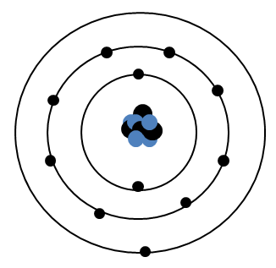 | Electron (-1), -1.6 × 10⁻¹⁹ C  Proton (+1), +1.6 × 10⁻¹⁹ C  Neutron (0) 0  Nucleus  Energy Shell
20.1.2 |  | Define the term ionisation (repeat)
 |  | Ionisation is the gaining or losing of electrons from atoms
20.1.3 |  | State from where all ionizing radiations originate.
 |  | The nucleus
20.1.4 |  | Describe the following in as much detail as you can  - Alpha particle  - Beta particle  - Gamma radiation
Alpha |  | Symbol = α, He nucleus, 2 protons and 2 neutrons, highly ionising, travels very short distances in air (a few cm), stopped by paper and anything more dense, charge +2 or 3.2 × 10⁻¹⁹ C. Radiation weighting factor of 20
Beta |  | Symbol β, fast moving electron, produced when neutron is converted to a proton, and the process creates an electron and an electron antineutrino, charge -1 or or -1.6 × 10⁻¹⁹ C. Travels a few cm in air and stopped by a few mm of aluminium or anything denser. Radiation weighting factor of 1
Gamma |  | Symbol γ: a transverse high energy wave travelling at 3 ×10⁸ ms⁻¹, which has no charge and no mass. It travels through air and is partially stopped by a few cm of lead or several metres of concrete. It has a radiation weighting factor of 1. It is the least ionising radiation and can travel many km in air.
20.1.5 |  | State what happens to radiation energy as it passes through the medium.
 |  | Radiation energy is absorbed as it passes through the medium
20.1.6 |  | State the approximate range through air, and absorption of alpha, beta and gamma radiation.
Radiation | Range in air | Minimum absorbing material
Alpha, α | A few cm | A sheet of paper
Beta, β | A few m | A few mm of Al
Gamma, γ | Many km | A few cm of lead or several m of concrete.

20.1.7 |  | Describe how one of the effects of radiation is used in a detector of radiation. The following web address might help.  http://www.darvill.clara.net/nucrad/detect.htm
Detectors of Radiation | Effect on which they work
Geiger Muller | GM tubes work by ionisation. Best at detecting alpha particles, because -particles ionise strongly.  The tube is filled with Argon gas, and a high voltage is applied to the thin wire. When a particle enters the tube, it pulls an electron from an Argon atom. The electron is attracted to the central wire, and as it rushes towards the wire, the electron will knock other electrons from Argon atoms, causing an "avalanche". Thus one single incoming particle will cause many electrons to arrive at the wire, creating a pulse which can be amplified and counted.
Photographic Film | Radioactivity will darken ("fog") photographic film,  Workers in the nuclear industry USED TO wear "film badges" which are sent to a laboratory to be developed, just like your photographs. This allows us to measure the dose that each worker has received different “windows” with different thickness and materials allowing the type of radiation to be identified.
Gold leaf electroscope | This uses ionisation. When an electroscope is charged, the gold leaf sticks out, because the charges on the gold repel the charges on the metal stalk.  When a radioactive source comes near, the air is ionised, and starts to conduct electricity. This means that the charge can "leak" away, the electroscope discharges and the gold leaf falls.
Spark Counter | This works a little like the GM tube. A high voltage is applied between the gauze and the wire.  When a radioactive source is brought close, the air between the gauze and the wire is ionised, and sparks jump where particles pass
Cloud Chamber | These work by ionisation. Alpha or beta particles leave trails in the vapour in the chamber.  The chamber contains a supersaturated vapour (e.g. methylated spirits), which condenses into droplets when disturbed and ionised by the passage of a particle
Bubble Chamber | Particles leave trails of tiny bubbles in a liquid.  The chamber would be surrounded by powerful magnets, so any charged particles passing though the chamber would move in curved paths. The shapes of the curves tell us about the charge, mass and speed of each particle, so we can work out what they are.

20.1.8 |  | In an experiment, radiation from a sample of radium is passed through an electric field.  It is split into three different components (as shown in the diagram below).  - Name the radiations labelled (i), (ii) and (iii).  - Which radiation is deflected most by the electrostatic field?  Beta  - What is the function of the lead shield?  To absorb the radiation not travelling in the right direction and to prevent particles from the outside getting in  - Why is the experiment carried out in an evacuated chamber?  So the radiation travel as far as the photographic film and do not ionise the air.  - What is the purpose of the photographic film?  To detect the radiation
  (i) | Alpha | It is positively charged so is attracted towards the negatively charged plate
  (ii) | Gamma | It is not charged so continues in a straight line
  (iii) | Beta | Is negatively charged so is attracted towards the positively charged plate
20.1.9  OEQ |  | Alpha, beta and gamma are types of nuclear radiation, which have a range of properties and effects. Using your knowledge of physics, comment on the similarities and/or differences between these types of nuclear radiation.
See previous questions. Talk about some of the following and use previous questions to fill in details. You’d need to specify things like mass, charge, structure:
Similarities | Difference (you need to state these in more detail)
All originate from atomic nucleus | Charge, mass,
All can kill or cause damage to cells | range in air,
D=E/m | structure
H=Dw_{R} | Ionising properties, Ionising density
 | Different dose equivalents and radiation weighting factors, so different biological harms
Here is a possible answer. NO idea if I’d get the full 3 marks!
Alpha, Beta and Gamma are all forms of ionising radiation that originate in the nucleus. They can all cause damage to tissue and kill and change the nature of cells as they pass through them.
Alpha is a He nucleus, so has a charge of +3.2 x 10⁻¹⁹ C so it is highly ionising and is absorbed by a few cm of air or a sheet of paper.
Beta is a fast moving electron and is formed by a neutron changing to a proton and emitting a beta particle and an antineutrino. It has a negative charge of -1.6 x 10⁻¹⁹ C. It is much less massive than an Alpha particle by 5 orders of magnitude (9.11 x 10⁻³¹ kg, cf 6.64 x 10⁻²⁷ kg) but can travel a few metres in air.
Gamma is a transverse electromagnetic wave with no mass and no charge and can travel many kilometres in air. It is the least ionising so the most penetrating.
Due to the difference is charge, mass and other properties each radiation type is given a separate radiation weighting factor, which takes account of the biological harm of the radiation. Alpha has a w_{R} of 20, Beta w_{R} of 1 and gamma a w_{R} of 1
20.2 |  | I can explain the term ‘ionisation’.
20.2.1 |  | Explain the term ionisation.
 |  | Ionisation is the gaining or losing of electrons from atoms
20.1.2 |  | State what remains after an atom has been ionised.
 |  | The atom has become an ion.
20.3 |  | I can state that which nuclear radiation is most ionising, and which is the least ionising.
20.3.1 |  | From the list of alpha, beta and gamma radiation,  - state which is least ionising. Gamma  - state which is most ionising Alpha
20.3.2 |  | Give a piece of evidence to show that your answer to 20.3.1 is correct.
 |  | This can be seen from the tracks in a bubble chamber or cloud chamber, see 20.1.8
20.3.3 |  | State the effect radiation can have on living cells
Radiation can kill living cells or change the nature of living cells.
The biological effect of radiation depends on the absorbing tissue and the nature of the radiation
Equivalent dose, measured in Sieverts, takes account of the type and energy of radiation.
20.4 |  | I can state the distances alpha, beta and gamma radiation can travel in air and the penetration through different materials.
20.4.1 |  | State the approximate distance (range) travelled in air by:  - alpha particles : a few cm in air  - beta particles: a few m in air  - gamma rays many km in air
20.4.2 |  | State the minimum object, and the thickness that can stop:  - alpha particles a single sheet of paper  - beta particles a few mm of aluminium  - gamma rays partly absorbed by a few cm of lead or several metres of concrete.
20.4.3 |  | Copy and complete the table below to show if each type of radiation passes or is absorbed by each type of material.
  Type of radiation | Range in air | Effect of passing radiation through
  Type of radiation | Range in air | 0.1 mm paper | 3 mm aluminium | 3 mm lead | 10 m concrete
  Alpha | Few cm | Absorbed | absorbed | absorbed | Absorbed
  Beta | Few m | None | absorbed | absorbed | Absorbed
  Gamma | Many km | None | none | Partly absorbed | Absorbed
  X-rays | Many km | None | none | Partly absorbed | Absorbed
20.4.4 |  | Describe one use of radiation based on the fact that radiation is easy to detect.
Detectors of Radiation | Effect on which they work
Geiger Muller | GM tubes work by ionisation. best at detecting alpha particles, because -particles ionise strongly.  The tube is filled with Argon gas, and a high voltage is applied to the thin wire. When a particle enters the tube, it pulls an electron from an Argon atom. The electron is attracted to the central wire, and as it rushes towards the wire, the electron will knock other electrons from Argon atoms, causing an "avalanche". Thus one single incoming particle will cause many electrons to arrive at the wire, creating a pulse which can be amplified and counted.
Photographic Film | Radioactivity will darken ("fog") photographic film,  Workers in the nuclear industry USED TO wear "film badges" which are sent to a laboratory to be developed, just like your photographs. This allows us to measure the dose that each worker has received different “windows” with different thickness and materials allowing the type of radiation to be identified.
Gold leaf electroscope | This uses ionisation. When an electroscope is charged, the gold leaf sticks out, because the charges on the gold repel the charges on the metal stalk.  When a radioactive source comes near, the air is ionised, and starts to conduct electricity. This means that the charge can "leak" away, the electroscope discharges and the gold leaf falls.

Spark Counter | This works a little like the GM tube. A high voltage is applied between the gauze and the wire.  When a radioactive source is brought close, the air between the gauze and the wire is ionised, and sparks jump where particles pass
Cloud Chamber | These work by ionisation. Alpha or beta particles leave trails in the vapour in the chamber.  The chamber contains a supersaturated vapour (e.g. methylated spirits), which condenses into droplets when disturbed and ionised by the passage of a particle
Bubble Chamber | Particles leave trails of tiny bubbles in a liquid.  The chamber would be surrounded by powerful magnets, so any charged particles passing though the chamber would move in curved paths. The shapes of the curves tell us about the charge, mass and speed of each particle, so we can work out what they are.

20.4.5 |  | The table below represents data obtained from an absorption experiment using three separate radioactive sources (background count = 20 counts per minute).  (a) What effect did paper have on each of the three sources?  (b) Use the data in the table to try to identify the type of radiation from each source.
  Type of radiation | Count rate (per minute)
  Type of radiation | Source A | Source B | Source C
  Air | 3125 | 900 | 420
  Paper | 3130 | 880 | 38
  1mm Aluminium | 3000 | 380 | 20
  10 mm lead | 1900 | 20 | 21
- The paper had no effect on sources A and B but significant effect on source C
- Source C is therefore Alpha, Source B is reduced by aluminium and totally absorbed by 10 mm of lead so is a Beta source, Source A is unaffected by paper and 1mm of alumimium and is reduced by 10 mm of lead so is a gamma source
20.5 |  | I can state that Activity is the number of nuclear disintegrations per second.
20.5.1 |  | Explain the term activity of a radioactive source.
 |  | Activity is the number of decays / disintegrations per second
20.5.2 |  | State what happens to the Activity of a source with time.
 |  | Activity decreases with time
20.5.3 |  | Describe an experiment to find the activity of a radioactive source using the following equipment:  Stopwatch, Geiger-Muller Tube, Counter.
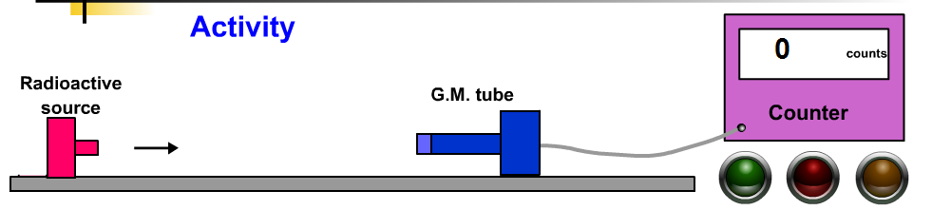
NB This will not give you the total activity of the source as the GM tube and counter will only count the particles that arrive at the detector, many radioactive particles will not be detected.
Use the GM tube and counter to detect the background radiation (no source).
Then place the radioactive source close to the GM tube and switch on the counter. Note the count in one minute (60 seconds). Record the number of counts on the counter. Find the Activity using A=N/t where A is the activity in Becquerels, N is the count, t is the time in seconds.
20.6 |  | I can state the units of activity.
20.6.1 |  | State the units of the Activity of a source.
 |  | Activity is measured in Becquerels, symbol Bq (but Bq alone wouldn’t get you a mark)
20.7 |  | I can use A=N/t to solve problems involving activity, number of nuclear disintegrations and time.
20.7.1 |  | Copy this table and calculate the missing numbers, there is no need to complete the table, just show the working underneath using IESSUU.
   | Activity / Bq | Number of Decays | Time / s | Working
  (a) | 12 Bq | 720 | 60 | $$A=\frac{N}{t}=\frac{720}{60}=12 Bq$$
  (b) | $$25 Bq$$ | 4500 | 180 | $$A=\frac{N}{t}=\frac{4500}{180}=25 Bq$$
  (c) | 1000 | $$1×{10}^{5} Bq$$ | 100 | $$N=A×t=1000×10=1×{10}^{5} Bq$$
  (d) | 12 500 | $$6.3×{10}^{6} Bq$$ | 500 | $$N=A×t=12500×500=6.3×{10}^{6} Bq$$
  (e) | 40 000 | 3.0 x 10⁷ | $$750 s$$ | $$t=\frac{N}{A}=\frac{3.0×{10}^{7}}{40000}= 750 s$$
  (f) | 2.5 x 10⁶ | 5.0 x 10⁸ | $$200 s$$ | $$t=\frac{N}{A}=\frac{5.0×{10}^{8}}{2.5.×{10}^{6}}= 200 s$$
20.7.2 |  | Move to later in the question group.  In a laboratory, the background activity is measured as 1.5 Bq. A Geiger-Muller tube is used to measure the activity of a source in the laboratory. In three minutes, 1440 counts are recorded. Calculate the activity of the source.
$$A=\frac{N}{t}=\frac{1440}{3×60}=\frac{1440}{180}= 8 Bq$$
$$Asource= 8-1.5 \left(due to Background\right)=6.5 Bq$$
20.7.3 |  | Calculate the activity of a source that has 210 decays in a minute.
 |  | $$A=\frac{N}{t}=\frac{210}{60}= 3.5 Bq$$
20.7.4 |  | A source has an activity of 2.0 kBq. Calculate the number of counts recorded from the source by a Geiger-Muller tube (and counter) in 30 seconds.
2.0 kBq = 2.0 ×10³ Bq
$$A=\frac{N}{t}$$
$$2.0 {10}^{3}=\frac{N}{30}$$
$$N=2.0 {10}^{3}×30=6.0 {10}^{4}$$

20.7.5 |  | Calculate the time it takes a source with an activity of 1.8 MBq to have 8.1 x 10⁸ radioactive decays.
1.8 MBq = 1.8 ×10⁶ Bq

$$A=\frac{N}{t}$$
$$1.8 {10}^{6}=\frac{8.1 {10}^{8}}{t}$$

$$t=\frac{8.1 {10}^{8}}{1.8 {10}^{6}}=506 s$$
20.7.6 |  | In an experiment, the number of decays from a radioactive source is recorded. The background count is then taken away. The results of this are shown.  Draw a line graph of these results, and use the gradient of the straight line to calculate the activity of the source.
  Time / minutes | Corrected Number of Decays
  0 | 0
  1 | 1800
  2 | 3600
  3 | 5400
  4 | 7200
  5 | 9000
Now remember the gradient is given in corrected counts per minute and Activity in counts per second. A gradient of 1800 must be divided by 60 to get an Activity in Becquerels. This would give an Activity of 30 Bq
 | Time / minutes | Time / s | Corrected Number of Decays
0 |  | 0 | 0
1 |  | 60 | 1800
2 |  | 120 | 3600
3 |  | 180 | 5400
4 |  | 240 | 7200
5 |  | 300 | 9000
Or you could add an additional column in the table and plot time in seconds against corrected decays. This is still using the data in the table and would give a gradient equal to the Activity- which is a much better way of answering the question
20.8 |  | I can identify background sources of radiation.
20.8.1 |  | State what is meant by the term background radiation.
Background radiation is ionizing radiation present in the environment at a particular location (which is not due to deliberate introduction of radiation sources).
Many people don't realise that your radiation dose from cosmic rays is increased considerably if you fly a great deal. This is because our atmosphere provides some protection against cosmic rays, so the higher you fly the more you get. This only tends to be a problem if you're an airline pilot or an astronaut.
20.8.2 |  | Identify background sources of radiation.
 |  | 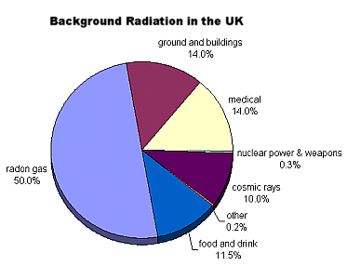
20.8.3 |  | State three natural sources that contribute to background radiation.
Source | Annual Equivalent dose  /mSv
Cosmic Radiation (sea Level)* | 0.25
Inhaled radioactive gas (radon) | 1.0
Radioactivity from rocks, soil, buildings | 0.3
Radioactivity in human body | 0.4
Inhaled Radon and daughter products | 1.0

20.8.4 |  | State three artificial sources (manmade) that contribute to background radiation.
Source
Medical
Such as
- X-rays,
- Radiotherapy,
- PET scans,
- CAT Scans
Nuclear Power Stations which emit next to nothing
If you live within a 50 mile radius of a working Nuclear Plant your average annual dose
(releases due to incidents major and small),
and weapon release (Hiroshima and Nagasaki)
Nuclear weapons tests carried out by 0.02%
- United States of America.
- Soviet Union.
- United Kingdom.
- France.
- China.
- India.
- Pakistan.
- North Korea.

20.9 |  | Knowledge of the dangers of ionising radiation to living cells and of the need to measure exposure to radiation
20.9.1 |  | State how the equivalent dose a person receives can be reduced.
Monitor: Do not go near a source unless totally necessary and limit any exposure
Distance: Keep as far away from the source as possible, handle with tongs or remote arms, as this increases the distance to the source.
Shield: put layers of shielding between the source and the user, such as gloves and lab coat (for alpha only) and aluminium for beta lead for gamma.
Do not choose two answers from the same group, choose one from each section in a question.
20.9.2 |  | Explain why airline pilots and crews receive higher doses of radiation than the ground crew working in the airport.
 |  | Gamma radiation is absorbed by the atmosphere. As aircraft pilots are higher in the sky there is less atmosphere to absorb this harmful radiation.
20.9.3 |  | State three factors that can affect the biological harm of radiation.
The biological effect of radiation depends on:
- The absorbed dose
- the type of radiation (alpha, beta, gamma or x-rays) and
- the type of tissue absorbing the radiation
20.9.4 |  | State three ways to reduce the biological harm on a person due to radiation.
 |  | 1.Keep your distance, 2 Limit exposure time, 3 Use shielding.
20.9.5 |  | Several people have been poisoned by Polonium-210. Describe their symptoms prior to death.
Symptoms would depend on the strength of polonium used.
They would likely include:
- nausea and vomiting
- anorexia
- hair loss
- lowered white blood cell count, or lymphopenia
- diarrhoea
- damage to bone marrow
The higher the dose, the faster the effect will be.
- After these acute symptoms, the patient may appear to recover, but bone marrow damage will continue, resulting in lower white blood cell and platelet counts.
- Next, various body organs will be affected, including the bone marrow, the gastrointestinal system, and the cardiovascular and central nervous system (CNS).
- If the CNS is affected, this is irreversible and leads to death. At high doses, this can lead to confusion, convulsion, and coma within minutes of the poisoning.
- Finally, the person will either die or recover.
20.10 |  | I can use appropriate relationships to solve problems involving absorbed dose and equivalent dose energy, mass and radiation weighting factor.  ($H = Dw_{R}$, $D= \frac{E}{m}$ )
20.10.1 |  | State the difference between and absorbed dose and an equivalent dose.
Absorbed dose, D is equal to $D=\frac{E}{m}$ and takes into account the energy of the radiation and the mass of the absorbing tissue. Equivalent Dose takes into account the biological harm done by the radiation and is $H=D { w}_{R}$ or
$$H=\frac{E}{m}{ w}_{R}$$
20.10.2 |  | State what is indicated by the radiation weighting factor for each radiation.
 |  | The radiation weighting factor takes account of the biological harm done by each type of radiation.
20.10.3 |  | Copy this table and calculate the missing numbers, there is no need to complete the table, just show the working underneath. Show all the working using IESSUU.
   | Absorbed Dose / Gy | Energy/ J | Mass / kg | working
  (a) | 1.2 x 10⁻⁵ | 6 x 10⁻⁶ | 0.5 | $$D=\frac{E}{m}$$  $$D=\frac{6×{10}^{-6}}{0.5}$$
  (b) | 1.4 x 10⁻⁴ | 3.5 x 10⁻⁵ | 0.25 | $$D=\frac{E}{m}$$  $$D=\frac{3.5×{10}^{-5}}{0.25}$$
  (c) | 8.8 x 10⁻⁵ | 4.4 x 10⁻⁶ | 0.05 | $$D=\frac{E}{m}$$  $$8.8×{10}^{-5}=\frac{E}{0.05}$$  $$E=8.8×{10}^{-5}×0.05$$
  (d) | 6.5 x 10⁻⁵ | 1.7 x 10⁻⁵ | 0.26 | $$D=\frac{E}{m}$$  $$6.5×{10}^{-5}=\frac{E}{0.26}$$  $$E=6.5×{10}^{-5}×0.26$$
  (e) | 1.1 x 10⁻⁵ | 3.3 x 10⁻⁶ | 0.30 | $$D=\frac{E}{m}$$  $$1.1 × {10}^{-5}=\frac{3.3×{10}^{-6}}{m}$$  $$m=\frac{3.3×{10}^{-6}}{1.1 × {10}^{-5}}$$
  (f) | 1.2 x 10⁻⁵ | 1.8 x 10⁻⁶ | 0.15 | $$D=\frac{E}{m}$$  $$1.2 × {10}^{-5}=\frac{1.8×{10}^{-6}}{m}$$  $$m=\frac{1.8×{10}^{-6}}{1.2 × {10}^{-5}}$$
20.10.4 |  | Calculate the equivalent dose absorbed by a person exposed to 5 mGy of radiation with a radiation weighting factor of 6.
$$H=Dw_{R}$$
$$H=5×{10}^{-3}×6$$
$$H=0.03 Sv$$
OR
$$H=Dw_{R}$$
$$H=5×6=30 mSv$$
Here I’ve kept the dose in mGy which will give an answer in mSv. BEWARE if you use this that you check your sig fig and numbers.
20.10.5 |  | The absorbed dose to a mass of skin is 10 μGy. Calculate the mass of skin exposed if the energy of the radiation is 4.2 μJ.
  $$D=\frac{E}{m}$$  $$10=\frac{4.2}{m}$$  $$m=\frac{4.2}{10}=0.42 kg$$ | $$D=\frac{E}{m}$$  $$10×{10}^{-6}=\frac{4.2×{10}^{-6}}{m}$$  $$m=\frac{4.2×{10}^{-6}}{10×{10}^{-6}}=0.42 kg$$
20.10.6 |  | An equivalent dose of 4µSv is received by a patient from radiation with a radiation weighting factor of 20, calculate the absorbed dose.
$$H=Dw_{R}$$
$$4×{10}^{-6}=D×20$$
$$\frac{4×{10}^{-6}}{20}=D=2.0×{10}^{-6} Gy$$
20.10.7 |  |  |  | Visitors to a nuclear reprocessing plant are informed that they have absorbed an equivalent dose of 2.0 µSv from a measured absorbed dose of 2.0 µGy.  - Calculate the radiation weighting factor of the radiation they were exposed to.  - Using tables in the notes identify possible types of radiation.
(i)
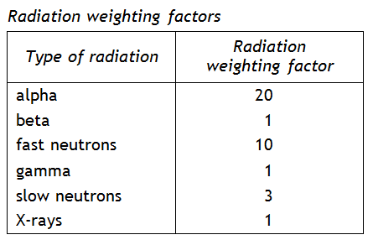
$H=Dw_{R}$
$$2×{10}^{-6}=2×{10}^{-6}×w_{R}$$
$$\frac{2×{10}^{-6}}{2×{10}^{-6}}=w_{R}=1$$
This could be due to beta, gamma or X-rays
20.10.8 |  |  |  | In the course of his work an industrial worker receives an equivalent dose of 200 μSv. Determine the absorbed dose if he is exposed to alpha particles, with a radiation weighting factor of 20.
$$H=Dw_{R}$$
$$200×{10}^{-6}=D×20$$
$$\frac{200×{10}^{-6}}{20}=D=1.0×{10}^{-5} Gy$$
OR
$$H=Dw_{R}$$
$$200=D×20$$
$$\frac{200}{20}=D=10 Gy$$
20.10.9 |  |  |  | Calculate the absorbed dose of a 400 g hand that absorbs 7 μJ of alpha particles.
m=400 g, this must be converted to kg = 0.4 kg. NB The fact that they are alpha particles doesn’t affect the absorbed dose!
$$D=\frac{E}{m}$$
$$D=\frac{7×{10}^{-6}}{0.4}$$
$$D=1.8×{10}^{-5} Gy=18 Gy$$
20.10.10 |  |  |  | A tumour of mass 150 g is exposed to gamma rays. The absorbed dose from this exposure is 5.1 x 10⁻⁵ μGy. What is the energy of the gamma rays absorbed by the tumour?
$$D=\frac{E}{m}$$
$$5.1×{10}^{-5}=\frac{E}{0.150}$$
$$E=5.1×{10}^{-5} ×0.150=7.6×{10}^{-6} J=7.6J$$
20.10.11 |  |  |  | A sample of tissue is exposed to 15 μGy of alpha radiation and 20 μGy of gamma radiation. Calculate the total equivalent dose received by the tissue is
Work out the two doses and add them as scalar quantities

$$H=Dw_{R}$$  $$H=15×20=300Sv$$ | $$H=Dw_{R}$$  $$H=20×1=20Sv$$
$$H_{Total} =H+ H=300+20=320 Sv$$
or 0.32 mSv
20.10.12 |  |  |  | A worker spends some time in an area where she is exposed to the following  radiations:  thermal neutrons = 8 mGy radiation weighting factor = 3  fast neutrons = 40 μGy radiation weighting factor = 10  (a) Calculate the equivalent dose for each type of neutron.  (b) Calculate the total equivalent dose for the exposure.
Work out the two doses individually and add them as they are scalar quantities.
Be careful you cannot just add milli Sieverts and micro Sieverts so you might want to put them all into scientific notation if you cannot convert between the two.
a)+ b)

$$H=Dw_{R}$$  $$H=8m×3=24 mSv$$ | $$H=Dw_{R}$$  $$H=40×10=400Sv=0.4 mSv$$
H _{total} = 24.4 mSv

$$H=Dw_{R}$$  $$H=8×{10}^{-3}×3=24 ×{10}^{-3}Sv$$ | $$H=Dw_{R}$$  $$H=40×{10}^{-6}×10=400×{10}^{-6}Sv$$
$$H_{total}=24 ×{10}^{-3}+ 400×{10}^{-6}=24.4×{10}^{-3}Sv$$

20.10.13 |  |  |  | An unknown radioactive material has an absorbed dose of 500 μGy and gives a dose equivalent of 1.0 mSv. Calculate the radiation weighting factor of the material.
When the prefixes are different it is best to convert everything to base units
$$H=Dw_{R}$$
$$1.0×{10}^{-3}=500×{10}^{-6}×w_{R}$$
$$\frac{1.0×{10}^{-3}}{500×{10}^{-6}}=w_{R}=2$$
20.10.14 |  |  |  | A patient receives a chest X-ray with an equivalent dose of 2.0 mSv. If the radiation weighting factor of the X-ray is 1, calculate the absorbed dose of the patient.
$$H=Dw_{R}$$
$$2.0×{10}^{-3}=D×1$$
$$\frac{2.0×{10}^{-3}}{1}=D=2.0×{10}^{-3}Gy=2.0 mGy$$
20.10.15 |  |  |  | A lady has a dental X-ray which produces an absorbed dose of 0.3 mGy. Calculate the equivalent dose of this X-ray.
$$H=Dw_{R}$$
$$H=0.3×{10}^{-3}×1$$
$$H=0.3×{10}^{-3}Sv=0.3 mSv$$
20.10.16 |  |  |  | A nuclear worker is exposed to a radioactive material producing an absorbed dose of 10 mGy. She finds that the material emits particles with a radiation weighting factor of 3. Calculate the equivalent dose for this exposure.
$$H=Dw_{R}$$
$$H=10×{10}^{-3}×3$$
$$H=30×{10}^{-3}Sv=30 mSv$$
20.10.17 |  |  |  | A physics teacher uses a gamma source in an experimental demonstration on absorption. The teacher receives an absorbed equivalent dose of 0.5 μSv. Calculate her absorbed dose if the radiation weighting factor for gamma radiation is 1.
$$H=Dw_{R}$$
$$0.5×{10}^{-6}=D×1$$
$$\frac{0.5×{10}^{-6}}{1}=D=0.5×{10}^{-6}Gy=0.5 Gy$$
20.10.18 |  |  |  | - Alpha particles produce an equivalent dose of 50 mSv from an absorbed dose of 2.5 mGy. Calculate the radiation weighting factor of the alpha particles.  - Explain why exposure to alpha radiation increases the risk of cancer more than X-rays or gamma rays.
$$H=Dw_{R}$$
$$50×{10}^{-3}=2.5×{10}^{-3}×w_{R}$$
$$\frac{50×{10}^{-3}}{2.5×{10}^{-3}}=w_{R}=20$$
Alpha particles are more ionising so causes more biological harm to cells that X rays or gamma rays
20.10.19 |  |  |  | The unit for absorbed dose is the gray, Gy. Explain this term and give an equivalent unit for absorbed dose.
 |  |  |  | Absorbed dose is the energy from the radiation per kilogram of absorbing tissue, so its alternative units for Gy must be Jkg⁻¹
20.11 |  | I can state that the unit for absorbed dose, the unit for equivalent dose is the Sievert (Sv) and the radiation weighting factor has no unit
20.11.1 |  | State the symbol, unit, and unit symbol for the following  - Absorbed dose D Grays, Gy  - Equivalent dose H Sieverts Sv  - Radiation weighting factor w_{R} no units
20.11.2 |  | Write out the relationships for the dosimetry formula and for each one write them in words and symbols. Use the relationships sheet to help you
$$H=Dw_{R}$$
Equivalent dose = Absorbed Dose x radiation weighting factor.
$$D=\frac{E}{m}$$
Absorbed Dose =Energy of radiation divided by mass of the absorbing tissue.
Combining these gives
$$H=\frac{E}{m}w_{R}$$
20.12 |  | I can use (H dot) =H/t to solve problems involving equivalent dose and time to calculate an equivalent dose rate.
20.12.1 |  | A sample of tissue receives an equivalent dose rate of 0·40 mSv h⁻¹ from a source of alpha radiation. Calculate the equivalent dose received by the sample in 30 minutes.
NB Beware there is a conflict of units here! The equivalent dose is given in mSvh⁻¹, the time in minutes so this needs to be converted to hours
$$t=30mins=0.5 h$$

$$\dot{H}=\frac{H}{t}$$
$$0.40=\frac{H}{0.5}$$
$$0.40×0.5=H=0.2 mSv$$

20.12.2 |  | A worker in a nuclear power plant is receives an annual equivalent dose of 6.10 mSv. Calculate the worker’s equivalent dose rate, in μSvh⁻¹
For this question we need to find hours in a year.
We’ll just take an ordinary year!
365 day= 365 × 24 = 8760 hour
Put the milli sieverts into sieverts to make changing to microsieverts easier.

$$\dot{H}=\frac{H}{t}$$
$$\dot{H}=\frac{6.10×{10}^{-3}}{8760}=0.70 Svh^{-1}$$

20.12.3 |  | Radiation workers can receive an average equivalent dose rate of 2.2μSvh⁻¹ to still be within limits for radiation workers. Calculate the annual equivalent dose a radiation worker can receive.
$$\dot{H}=\frac{H}{t}$$
$$2.2×{10}^{-6}=\frac{H}{8760}$$
$$2.2×{10}^{-6}×8760=H=19 mSv$$

20.12.4 |  | SQA N5 2014  An airport worker passes suitcases through an X-ray machine.  (a) The worker has a mass of 80·0 kg and on a particular day absorbs 7·2 mJ of energy from the X-ray machine.  (i) Calculate the absorbed dose received by the worker.  (ii) Calculate the equivalent dose received by the worker.  - If this equivalent dose rate is received over a period of 10 hours, calculate the equivalent dose rate received by the worker.
$$\dot{H}=\frac{H}{t}$$

$$\dot{H}=\frac{9.0×{10}^{-5}}{10}$$

$$\dot{H}=9.0 μSvh^{-1}$$

20.12.5 |  | As a part of his job, an airport security guard has to expose her hand to X-rays  (w_{R} = 1) as she removes blockages from a baggage scanner. On average, each time she does this, the absorbed dose of her hand is 0.03 μGy.  - Calculate the equivalent dose of her hand each time she removes a blockage.  - The safety rules in the airport state that the maximum equivalent dose for his hand in one hour is 0.6 μSv. Determine how many times can the airport security guard safely put her hand in the scanner in an hour.  - If the security guard works for an 8 hour shift over a 24 hour period and puts her hand through the scanner 25 times during one shift, calculate the security guard’s equivalent dose rate per day.
a)
$$H=Dw_{R}$$

$$H=0.03 ×1=0.03 Sv$$

b)
If we take the equivalent dose we are allowed and divide that by the equivalent dose for one blockage clearance we can find the total number of blockages she can perform in this time and be within the limits

$$n=\frac{H}{H_{1}}=\frac{0.6}{0.03}=20$$

c) So here the length of a shift isn’t important as it is over a 24 hour period. It is a red herring. Yes the worker gets a higher dose during this time but for the other 16 hours she gets very little so we average it out.

So her equivalent dose is
$$H=H_{1}×n=0.03×25=0.75 Sv$$

$$\dot{H}=\frac{H}{t}$$

$$\dot{H}=\frac{0.75×{10}^{-6}}{24}$$

$$\dot{H}=0.031 μSvh^{-1}=31 nSvh^{-1}$$

20.12.6 |  | It is found that a radiation worker has received an equivalent dose of 500 μSv in the course of a 25-hour working week. Calculate the equivalent dose rate in μSv h⁻¹. I think this question is ambiguous and wouldn’t be in an exam paper so I will adapt it for the second version
For the working week  $$\dot{H}=\frac{H}{t}$$  $$\dot{H}=\frac{500×{10}^{-6}}{5×24}$$  $$\dot{H}=4.2 μSvh^{-1}$$  For the whole week  $$\dot{H}=\frac{H}{t}$$  $$\dot{H}=\frac{500×{10}^{-6}}{7×24}$$  $$\dot{H}=3 μSvh^{-1}$$ |  |  |  |  |  | For the hours worked  $$\dot{H}=\frac{H}{t}$$  $$\dot{H}=\frac{500×{10}^{-6}}{25}$$  $$\dot{H}=20 μSvh^{-1}$$  $$during the working week but we take$$  $$it over the whole week$$
20.12.7 |  | The cosmic ray detector on board an aircraft indicates an equivalent dose rate of 15 μSvh⁻¹.  - Calculate the equivalent dose to those on board during a 4-hour flight.  - Calculate the number of these flights would a crew member have to make in a year to receive the maximum permissible equivalent dose of 5.0 mSv in a year?
$$\dot{H}=\frac{H}{t}$$
$$15 =\frac{H}{4}$$

$$15 ×4=H=60 Sv or 0.06 mSv$$

No. of flights per year is the total equivalent dose ÷equivalent dose for 1 flight
$$n=\frac{H}{H_{1}}=\frac{5.0}{0.06}=83$$
20.12.8 |  | A worker receives the following absorbed doses:  - γ–radiation 150 μGy  - Thermal slow neutrons 240 μGy  - Fast neutrons 90 μGy.  - What is the equivalent dose for each radiation?  - Find the total equivalent dose.  - If the doses were received in 6 hours, calculate the equivalent dose rate in μSv h⁻¹.
For this question you need to find the radiation weighting factor for each radiation. This will be given in the data sheet.
Radiation weighting factors
Type of radiation | Radiation weighting factor
alpha | 20
beta | 1
fast neutrons | 10
gamma | 1
slow neutrons | 3
X-rays | 1

γ–radiation 150 μGy w_{R} = 1
slow neutrons 240 μGy w_{R} = 3
Fast neutrons 90 μGy. w_{R} = 10

$$H=Dw_{R}$$
$$H=150 ×1=150 Sv$$
$$H=240 ×3=720 Sv$$
$$H=90 ×10=900 Sv$$
b) Total equivalent dose = sum of equivalent doses
$$H=150 Sv+720 Sv+900 Sv=1.8 mSv$$
c)
$$\dot{H}=\frac{H}{t}$$

$$\dot{H}=\frac{1.8×{10}^{-3}}{6}$$

$$\dot{H}=0.3 mSvh^{-1}$$

20.12.9 |  | SQA Exam Questions  - A patient’s thyroid gland is to receive an absorbed does of 500 Gy from a source so that the gland absorbs 15 J of energy. From this information what is the mass of the thyroid gland?
$$D=\frac{E}{m}$$
$$500=\frac{15}{m}$$
$$m=\frac{15}{500}=0.03 kg$$
20.12.10 |  | The following graph shows how the effective equivalent dose rate due to background radiation varies with height above sea level.  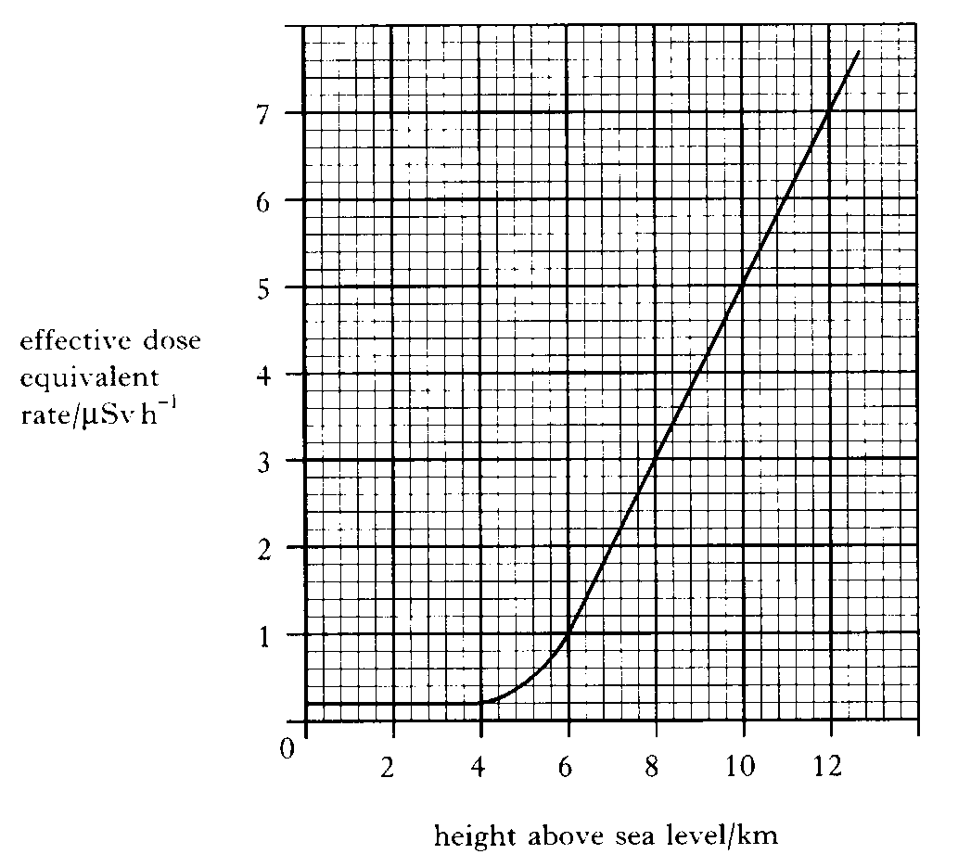  Effective equivalent dose rate /μSvh⁻¹  - Name two sources of background radiation 1  - The graph shows that there is an increase in effective equivalent dose rate at altitudes greater than 4 km. Suggest a reason for this increase. 1  - An aircraft makes a 7 hour flight at a cruising altitude of 10 km.  - Calculate the effective equivalent dose received by a passenger during this flight.  - A regular traveller makes 40 similar flights in one year and spends the rest of the year at sea level.  Calculate the effective equivalent dose of background radiation received by this traveller in that year.
a)

Source | - The atmosphere absorbs cosmic radiation. There is less radiation arriving at lover levels as more has been absorbed by the atmosphere. For gamma rays with an energy of 1 MeV half will be absorbed every 90 metres  Reading from the graph at an altitude on 10 km the effective equivalent dose rate is 5 μSvh⁻¹ so for a 7 hour flight  $$\dot{H}=\frac{H}{t}$$  $$5=\frac{H}{7}$$  $$H=5×7=35 Sv$$
Cosmic Radiation (sea Level)*
Radon Gas
Radioactivity from rocks, soil, buildings
Radioactivity in human body from organic matter
Medical radiation
  - $Total flight equivalent dose=No of flights × equivalent dose per flight$
$$Total flight equivalent dose=40 ×35=1400 Sv$$
Hours in 1 year = 365 × 24 = 8760 hours
Flying hours = 40 × 7 = 280 hours
Hours in the year at ground level = 8760 – 280 = 8480

$$\dot{H}=\frac{H}{t}$$
$$0.2=\frac{H}{8480}$$
$$H=0.2×8480=1696 Sv$$

Total background radiation = ground level background + flight background
Total annual background equivalent dose = 1696 + 1400 = 3096 $Sv$

Total annual background equivalent dose = 3 mSv

NB You could also have done this as
Hour at ground level equivalent dose rate at ground level + Hour at 10 km × equivalent dose rate at 10 km

(280 ×5) + (8480 ×0.2) = 3096 $Sv$

Total annual background equivalent dose = 3 mSv

20.12.11 |  | The radiology department in a hospital uses radioactive iodine to examine the functioning of the thyroid gland in a patient. The thyroid gland of the patient receives an absorbed dose of 750 μGy of radiation from the radioactive iodine.  - Calculate the total energy absorbed if the gland has a mass of 0.04 kg.  - The average equivalent dose rate for the gland is 12.5 μSv h⁻¹. The radioactive iodine is present in the gland of the patient for 120 hours. Determine the quality radiation weighting factor of the radiation.
$$D=\frac{E}{m}$$
$$750=\frac{E}{0.04}$$
$$750 ×0.04=E=30 J$$

ii) We need to find the Equivalent dose as the value is given as an equivalent dose rate. So this is a two calculation question

$$\dot{H}=\frac{H}{t}$$
$$12.5=\frac{H}{120}$$

$$12.5 ×120=H=1500 Sv$$

$$H=Dw_{R}$$

$$1500 =750 ×w_{R}$$

$$\frac{1500 }{750}=w_{R}=2$$
20.12.12 |  | Smoke detectors are important in giving early warning of fire starting in the home.  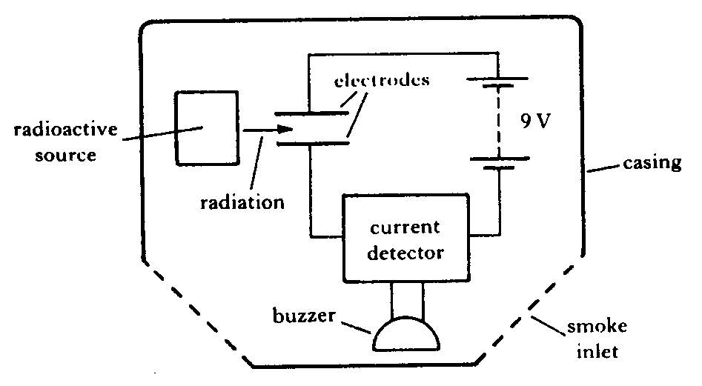  - The simplified layout of one type of smoke detector is illustrated below.  The following is an extract from the manufacturer’s data sheet.  ”The detector uses a low energy source of ionising radiation, 30 kBq Americium 241, which causes ionisation of the air molecules and hence a small current between the electrodes. When smoke particles enter the space between the electrodes they impede the flow of ions and the current is reduced. When the current falls below a certain value the buzzer sounds.”  - The symbol for the radioactive source used is .  What information is given by the numbers 95 and 241?  95 is the atomic number/ no. of protons in the atom  241 is the mass number/ no. of protons + neutrons in the atom  - What is meant by “30 kBq”?  30 kBq means 30 000 disintegrations per second.  - Explain what is meant by ionising radiation.  Ionising radiation passes through matter and can dislodge outer electrons from atoms causing them to become ions.  - The equation for decay of this source is  Identify the type of radiation emitted in this decay and explain why this particular type of radiation is used in the smoke detector.  The half-life of Americium 241 is 458 years.  Discuss the advantage of using this source compared to one with a half-life of 5 years.
  LHS | RHS
  Mass number = 241  Atomic Number = 95 | 241- 237= 4  95-93=2
  So the radiation must be alpha as it has 4 nucleons and 2 protons, which is a helium nucleus or alpha particle. This radiation is used as it is highly ionising travels only a short distance in air and is easily absorbed by the plastic casing.
 |  | If it had a long half-life then it wouldn’t have to be replaced very often.
20.13 |  | I can state the units of H dot.
20.13.1 |  | State the quantity, unit, and unit symbol for the term $\dot{H}$
 |  | $\dot{H}$ is equivalent dose rate and measured in units of Svh⁻¹ or Svy⁻¹
20.14 |  | I can compare equivalent dose due to a variety of natural and artificial sources.
20.14.1 |  | A pie chart indicating the exposure of the Public to ionizing radiation is given below.  From data given in the pie chart create  - State the main source of public exposure to ionizing radiation  - create a table indicating sources originate naturally sources and which are artificial sources of radiation.  - Calculate the percentage exposure due to artificial sources.  - State the percentage exposure from naturally occurring sources.  As an aside…  Other sources <1% includes  - Occupational – 0.3%  - Fallout - <0.3%  - Nuclear fuel cycle – 0.1%  - Miscellaneous – 0.1%
- The main source of public exposure is due to radon gas.

Natural Sources | Artificial sources
Radon Gas | Medical X-rays
Terrestrial | Consumer Products
Cosmic | Medical
Internal (Food)

- The artificial sources are medical (4%) consumer products (3%) and medical (11%) which is a total of 18%
- The natural sources are radon (55%) cosmic (8%) and internal (11%) and terrestrial (8%) which is a total of 82%
Remember that these numbers are rounded to 1 sig fig which is why there are other sources listed below
20.14.2 |  | State if you are more likely to receive a more uniform dose of radiation from naturally occurring or man-made sources of radiation. You must justify your answer.
 |  | Uniform dose from naturally occurring radiation as spread across rocks and food etc. Fabricated sources are designed to be intense, high doses over a short time, eg radiotheraphy etc.
20.14.3 |  | SQA N5 2014  A sample of tissue is irradiated using a radioactive source.  A student makes the following statements about the sample.  I The equivalent dose received by the sample is reduced by shielding the sample with a lead screen.  II The equivalent dose received by the sample is increased as the distance from the source to the sample is increased.  III The equivalent dose received by the sample is increased by increasing the time of exposure of the sample to the radiation.
20.14.4 |  | SQA N5 2015  A sample of tissue is irradiated using a radioactive source.  A student makes the following statements.  The equivalent dose received by the tissue is  I reduced by shielding the tissue with a lead screen  II increased as the distance from the source to the tissue is increased  III increased by increasing the time of exposure of the tissue to the radiation.  Yes this question really was on 2 years running!
20.14.5 |  | SQA N5 2015  A paper mill uses a radioactive source in a system to monitor the thickness of paper.  Radiation passing through the paper is detected by the Geiger-Müller tube.  The count rate is displayed on the counter as shown. The radioactive source has a half-life that allows the system to run continuously.  - State what happens to the count rate if the thickness of the paper decreases.  - The following radioactive sources are available. State which radioactive source should be used. You must explain your answer.
  Radioactive Source | Half-life | Radiation emitted
  W | 600 years | alpha
  X | 50 years | beta
  Y | 4 hours | beta
  Z | 350 years | gamma
20.15 |  | I know the average annual background radiation in the UK.
20.15.1 |  | State the average annual background radiation in the UK. 2.2 mSv
20.16 |  | I know the average annual effective dose limit for a member of the public in the UK.
20.16.1 |  | State the average annual effective dose limit for a member of the public in the UK. 1mSv
20.17 |  | I know that the average annual effective dose limit for radiation workers.
20.17.1 |  | State the average annual effective dose limit for radiation workers. 20 mSv
20.18 |  | I can give some applications of nuclear radiation.
20.18.1 |  | State some medical applications of nuclear radiation.
- Diagnosis of organ function
- Treatment for cancer
- Sterilization of medical equipment
- PET scanners
- Improving contrast in X-rays
- Radiosurgery
This is more detailed information on the above from https://world-nuclear.org/information-library/non-power-nuclear-applications/radioisotopes-research/radioisotopes-in-medicine.aspx#:~:text=Nuclear%20medicine%20uses%20radiation%20to%20provide%20diagnostic%20information,radiation%20to%20weaken%20or%20destroy%20particular%20targeted%20cells. You will not need this much detail to answer an exam question but it gives some idea of things you could write about.
- Nuclear medicine uses radiation to provide diagnostic information about the functioning of a person's specific organs.
- Radiotherapy can be used to treat some medical conditions, especially cancer, using radiation to weaken or destroy particular targeted cells.
- Sterilization of medical equipment is an important use of radioisotopes.
- Technetium injections are used to improve contrast on a spinal x ray.
- PET scanners (positron emission tomography) detect the precise position and extent of cancers.
- Diagnostic radiopharmaceuticals can be used to examine blood flow to the brain, functioning of the liver, lungs, heart, or kidneys, and to assess bone growth and to predict the effects of surgery and assess changes since treatment.
- An external radiation procedure is known as gamma knife radiosurgery, and involves focusing gamma radiation on a precise area of the brain with a cancerous tumour. This external irradiation (sometimes called teletherapy) can be carried out using a gamma beam from a radioactive cobalt-60 source.
- Internal radionuclide therapy is administered by planting a small radiation source, usually a gamma or beta emitter, in the target area to kill cancer/ tumour cells.
- Short-range radiotherapy is known as brachytherapy, Iodine-131 is commonly used to treat thyroid cancer. It is also used to treat non-malignant thyroid disorders. Iridium-192 implants are used especially in the head and breast.
- Permanent implant seeds are used in brachytherapy for early stage prostate cancer.
- Brachytherapy procedures give less overall radiation to the body, are more localized to the target tumour, and are cost-effective.
- Treating leukaemia may involve a bone marrow transplant. The defective bone marrow will first be killed off with a massive (and otherwise lethal) dose of radiation before being replaced with healthy bone marrow from a donor.
- Many therapeutic procedures are palliative, usually to relieve pain.
- A new field is targeted alpha therapy (TAT) or alpha radioimmunotherapy, especially for the control of dispersed cancers. The short range of very energetic alpha emissions in tissue means that a large fraction of that radiative energy goes into the targeted cancer cells, Clinical trials for leukaemia, cystic glioma, and melanoma are underway.
- TAT is increasingly important for treating pancreatic, ovarian, and melanoma cancers.
- Neutron Capture Enhanced Particle Therapy (NCEPT) involves injecting a patient with a neutron capture agent shortly before irradiation with protons or heavy ions. This approach boosts the target dose without increasing the dose to healthy tissue and delivers a significant dose to secondary lesions outside the primary treatment area. It uses boron-10 or gadolinium-157 which concentrate in malignant brain tumours. The patient is then irradiated with thermal neutrons or protons which are strongly absorbed by the boron, producing high-energy alpha particles which kill the cancer. This requires the patient to be brought to a nuclear reactor, rather than the radioisotopes being taken to the patient.
- The doses per therapeutic procedure are typically 20-60 Gy.
- Sterilisation by radiation has several benefits. It is safer and cheaper because it can be done after the item is packaged. The sterile shelf-life of the item is then practically indefinite provided the seal is not broken. Apart from syringes, medical products sterilised by radiation include cotton wool, burn dressings, surgical gloves, heart valves, bandages, plastic, and rubber sheets and surgical instruments.
- NB A radioisotope used for diagnosis must emit gamma rays of sufficient energy to escape from the body and it must have a half-life short enough for it to decay away soon after imaging is completed.
20.18.2 |  | Describe how electrical energy can be obtained from nuclear radiation.
In a nuclear power station nuclear fuel undergoes a controlled chain reaction in the reactor to produce heat energy (nuclear to heat). In a chain reaction a slow moving neutron is bombarded at an unstable nucleus, splitting the nucleus and producing more neutrons.
Heat is used to change water into steam in the heat exchanger. (heat in the reactor to heat in the steam)
The steam drives the turbine (heat to kinetic energy).
This drives the generator to produce electricity – (kinetic to electrical energy).
20.18.3 |  | A nuclear reactor produces waste that emits nuclear radiation. State a use of nuclear radiation.
any suitable use e.g. treating cancer/tracers/sterilisation/smoke detectors/measuring thickness of paper.
Must be a use of nuclear radiation
20.19 |  | I can define half-life.
20.19.1 |  | Sketch a graph showing how the activity of a radioactive source varies with time.
0 Activity
0 Time

20.19.2 |  | State what is meant by the term half-life.
time taken for half of the radioactive atoms to decay OR
time taken for the activity to decrease by half
20.19.3 |  | State the units of half-life.
 |  | The units of half-life are units of time, eg seconds, minutes, hours, days or years etc
20.20 |  | I can use graphical and numerical data to determine the half-life.
20.20.1 |  | A radioactive material has a half-life of 5 days. If the original activity is 120 Bq, calculate the activity after 20 days.
$$No.=\frac{T_{total}}{t_{\frac{1}{2}}}$$
$$No.=\frac{20}{5}=4$$
Either ½ four times  120→60→30→15→7.5 Bq | Or multiple by $\frac{1}{2^{4}}$  $$120 ×\frac{1}{2^{4}}=7.5 Bq$$

$$No. of half lives=\frac{T_{total}}{t_{\frac{1}{2}}}$$
$$No.=\frac{20}{5}=4$$
Keep halving 5 times (remember count the arrows, not the numbers)  120→60→30→15→7.5 | Or  $$A_{final}=\frac{A_{o}}{2^{no. of t\frac{1}{2}}}$$  $$A_{final}=\frac{120}{2^{4}}=7.5 Bq$$
Final Activity = 7.5 Bq

20.20.2 |  | If a radioactive material has a half-life of 600 years. If the original activity was 80 Bq calculate the time it takes for the activity to fall to 10 Bq.
Keep halving until you get to the final value
80→40→20→10
Count the arrows (3)
$$No. of half lives=\frac{T_{total}}{t_{\frac{1}{2}}}$$
$$3=\frac{T_{total}}{600}$$
$$3×600=T_{total}=1800 years$$

20.20.3 |  | A radioactive substance has a half-life of 4 hours. Calculate the fraction of the original activity left after one day.
1 day = 24 hours (all times must be in the same units)
$$No. of half lives=\frac{T_{total}}{t_{\frac{1}{2}}}$$
$$No. of half lives=\frac{24}{4}=6$$
$$Fraction remaining = \frac{1}{2^{6}}=\frac{1}{64}$$
20.20.4 |  | The activity of a source starts at 100 MBq. After 20 days it has fallen to 6.25 MBq. Calculate the half-life of the source.
Keep halving until you get to the final value
100M→50→25→12.5→6.25M
Count the arrows (4)
$$No. of half lives=\frac{T_{total}}{t_{\frac{1}{2}}}$$
$$4=\frac{20}{t_{\frac{1}{2}}}$$
$$t_{\frac{1}{2}}=\frac{20}{4}=5 days$$
20.20.5 |  | A radioactive source has an activity of 3072Bq. After 64 days its activity is measured again, and is found to be 48Bq. Calculate its half-life.
Keep halving until you get to the final value
3072→1536→768→384→192→96→48
Count the arrows (6)
$$No. of half lives=\frac{T_{total}}{t_{\frac{1}{2}}}$$
$$6=\frac{64}{t_{\frac{1}{2}}}$$
$$t_{\frac{1}{2}}=\frac{64}{6}=10.7 days or 256 hours ≅11 days or 260 hours$$
20.20.6 |  | Calculate the half-life of a radioactive source if the activity falls from 4000 kBq to 125 kBq in 40 days.
keep halving until you get to the final value
3072→1536→768→384→192→96→48
Count the arrows (6)
$$No. of half lives=\frac{T_{total}}{t_{\frac{1}{2}}}$$
$$6=\frac{64}{t_{\frac{1}{2}}}$$
$$t_{\frac{1}{2}}=\frac{64}{6}=10.7 days or 256 hours ≅11 days or 260 hours$$
20.20.7 |  | The half-life of Cobalt-60 is 5 years. If the source, 25 years ago, had an activity of 500kBq, calculate the new activity.
$$No. of half lives=\frac{T_{total}}{t_{\frac{1}{2}}}$$
$$No.=\frac{25}{5}=5$$
Keep halving 5 times (remember count the arrows, not the numbers)  500→250→125→62.5→31.25→15.625 | Or  $$A_{final}=\frac{A_{o}}{2^{no. of t\frac{1}{2}}}$$  $$A_{final}=\frac{500}{2^{5}}=15.625 kBq$$
Final Activity = 16 kBq

20.20.8 |  | A radioactive material has a half-life of 5 days. If the original activity is 120 Bq, calculate the activity after 20 days. Repeat
$$No. of half lives=\frac{T_{total}}{t_{\frac{1}{2}}}$$
$$No.=\frac{20}{5}=4$$
Keep halving 5 times (remember count the arrows, not the numbers)  120→60→30→15→7.5 | Or  $$A_{final}=\frac{A_{o}}{2^{no. of t\frac{1}{2}}}$$  $$A_{final}=\frac{120}{2^{4}}=7.5 Bq$$
Final Activity = 7.5 Bq

20.20.9  Repeat |  | If a radioactive material has a half-life of 600 years. If the original activity was 80 Bq calculate the time it takes for the activity to fall to 10 Bq.
Keep halving until you get to the final value
80→40→20→10
Count the arrows (3)
$$No. of half lives=\frac{T_{total}}{t_{\frac{1}{2}}}$$
$$3=\frac{T_{total}}{600}$$
$$3×600=T_{total}=1800 years$$

20.20.10  Repeat |  |  | A radioactive substance has a half-life of 4 hours. Calculate the fraction of the original activity left after one day.
1 day = 24 hours (all times must be in the same units)
$$No. of half lives=\frac{T_{total}}{t_{\frac{1}{2}}}$$
$$No. of half lives=\frac{24}{4}=6$$
$$Fraction remaining = \frac{1}{2^{6}}=\frac{1}{64}$$
20.20.11 |  |  | The data above was obtained from an experiment to determine the half-life of a radioactive source:  Is this the corrected count rate?  (a) Describe how you could carry out this experiment.  (b) Determine the half-life of the radioactive source.
  Time | (mins) | 0 | 20 | 40 | 60 | 80
  Count rate | (c.p.m.) | 100 | 60 | 45 | 30 | 20
source
- Use the Geiger-Muller tube and scaler counter to measure the background count rate.
- Record this value.
- Set up the apparatus shown in the diagram.
- Measure and record values of count rate and time interval for a suitable time period.
- Correct all your measurements for background by taking the background count off all other measured count rates..
- Plot a graph of COUNT RATE or ACTIVITY against TIME.
- Find the half-life from the graph

Time when count rate = 80 cpm = 9 mins | Time when count rate = 60 cpm = 24.5 mins
Time when count rate = 40 cpm = 44.5 mins | Time when count rate = 30 cpm = 60 mins
Half life = 44.5 - 9 = 36 mins | Half life = 60 - 24.5 = 36 mins

20.20.12 |  |  | The table of results below show how the count rate for a radioactive source varies with time. The background count was 60 counts per minute.  - Copy out the table and find the corrected count rate.  - Plot a graph of corrected count against time.  - Determine the half-life of the source from your graph.
  Time | (mins) | 0 | 5 | 10 | 15 | 20
  Count rate | (c.p.m.) | 1660 | 1100 | 750 | 510 | 350
Time | (mins) | 0 | 5 | 10 | 15 | 20
Count rate | (c.p.m.) | 1660 | 1100 | 750 | 510 | 350
Corrected count rate | (c.p.m.) | 1600 | 1040 | 690 | 450 | 390

Time when count rate = 1400 cpm = 1.6 mins | Time when count rate = 1000 cpm = 5.6 mins
Time when count rate = 700 cpm = 9.6 mins | Time when count rate = 50 cpm = 13.8 mins
Half life = 9.6 – 1.6 = 8 mins | Half life = 13.8 -5.6 = 8 mins

20.20.13 |  | SQA H5 2018  A technician carries out an experiment, using the apparatus shown, to determine the half-life of a gamma radiation source.  (a) Before carrying out the experiment the technician measures the background count rate.  (i) Explain why this measurement is made.  (ii) State a source of background radiation.  - The technician’s results are shown in the table.  - Produce a graph of these results.  - Use your graph to determine the half-life of the gamma radiation source.  - The technician repeats the experiment with an alpha radiation source.  Suggest a change the technician must make to the experimental set-up to determine the half-life of the alpha radiation source. Justify your answer.
  Time  (minutes) | Corrected count rate  (counts per minute)
  0 | 680
  20 | 428
  40 | 270
  60 | 170
  80 | 107
  100 | 68
Background could include radon gas, medical procedures, food, rocks and soil, weapons testing, nuclear releases from power station accidents.
Time when count rate = 600 cpm = 5.5 mins | Time when count rate = 400 cpm = 23mins
Time when count rate = 300 cpm = 36 mins | Time when count rate = 200 cpm = 53 mins
Half life = 36 – 5.5 = 30 mins | Half life = 53-23 = 30 mins

20.21 |  | I can describe an experiment to determine the half-life of a radioactive material.
20.21.1 |  | Describe an experiment to measure half-life. Make sure you include how you take background radiation into account, how you measure the activity and the time, and how you use the graph to calculate the half-life.
- Measure the count in a set time interval (1)
- Repeat at (regular) intervals (1)
- Measure background (count) and subtract (1)
Put the source next to a Geiger Muller tube and counter, and repeatedly measure the activity at regular time intervals, until it is a small fraction of its initial value. Now remove the source and measure the background activity. Subtract the background activity from the previous readings, and plot a graph of the corrected activity against time. Use the graph to find how long it takes the activity to half - this is the half-life.
20.21.2 |  | An experiment is carried out in a laboratory to determine the half-life of a radioactive source. A Geiger-Müller tube and counter are used to measure the background radiation over a period of 10 seconds. This is repeated several times and an average value of 4 counts in 10 seconds is recorded.  The apparatus shown is used to measure the count rate over a period of time.  The readings are corrected for background radiation.  (a) Name two factors that affect the background count rate.  (b) Calculate the activity of the background radiation. ???? (the GM tube and counter wouldn’t detect all particles)  (c) Calculate the half-life of the radioactive source.
  Time (minutes) | Corrected count rate  (c.p.10s)
  0 | 168
  2 | 120
  4 | 84
  6 | 60
  8 | 42
  10 | 30
  12 | 21
- Background count is affected by the height above sea level and the natural rock around where the count is being taken.

$$A=\frac{N}{t}=\frac{4}{10}=0.4 Bq$$
Time when count rate = 160 cp10s = 0.3mins | Time when count rate = 80 cpm = 4.3 mins
Time when count rate = 80 cpm = 4.3 mins | Time when count rate = 40 cpm = 8.3 mins
Half life = 4.3 - 0.3 = 4 mins | Half life = 8.3 - 4.3 = 4 mins

20.21.3 |  | A technician carries out an experiment to determine the half-life of a radioactive source.  - Use information from the graph to determine the half-life of the radioactive source.  - Determine the corrected count rate after 40 minutes.
t when corrected count rate = 80 cpm = 1 min
t when corrected count rate = 40 cpm = 11 min
t when corrected count rate = 20 cpm = 21 min
t_{½} = t₄₀ - t₈₀ =11- 1 = 10 min
t_{½} = t₂₀ – t₄₀ =21- 11 = 10 min
The half life is 10 minutes
    - The corrected count rate at 40 mins will be approximately 5 cpm

6. (a) | The time taken for the activity / corrected count rate (of a radioactive source) to half. | 1 Do not accept: Time for radiation / radioactivity / count rate to half.
(b) | (i) Measure the count in a set time interval (1)  Repeat at (regular) intervals (1)  Measure background (count) and subtract (1) | independent marks. Description must refer to the apparatus shown. If candidate response makes reference to using a rate meter then MAX (2) marks.
(b) | (ii) (Half-life =) 10 minutes (1) | 1 Unit required (accept mins) +/- half box tolerance
 | (iii) 88 → 44 → 22 → 11 → 5·5 (1) mark for evidence of halving  Count rate = 5·5 counts per minute (1)  Or answer consistent with 6(b)(ii) | Accept 5 or 6 counts per minute Accept calculation based on one halving of 11 counts per minute Unit required (accept c.p.m.) Alternative method: Accept calculation using division by 24 (equivalent to halving)

20.22 |  | I can provide a qualitative (info) description of fission chain reactions and their role in the generation of energy.
20.22.1 |  | Explain what is meant by the term nuclear fission.
 |  | Nuclear fission is the splitting of a large atomic nucleus such as uranium into smaller nuclei with the release of energy.
20.22.2 |  | Nuclear fission can be spontanteous or induced.  - State the difference between these two types of fission  - State whether a nuclear reactor would use an isotope that undergoes spontanseously or induced fission, you must justify your answer.
    - Induced fission is when fission occurs due to collision with a neutron
Spontaneous fission is the breaking up of a large nucleus into smaller nuclei without being struck by a neutron.
    - A nuclear reactor in a power station must use an isotope that undergoes induced fission or it cannot be controlled/ stopped. If the neutrons are absorbed in a reactor the fission reaction which stop.
In spontaneous fission the reaction cannot be controlled.
20.22.3 |  | Explain what is meant by the term chain reaction.
 |  | neutrons can go on to cause further (fission) reactions/split more (uranium) nuclei (1) causing a chain reaction/this process repeats (1)
20.22.4 |  | Describe the function of the following parts of a nuclear reactor  - Containment vessel  - Fuel rods  - Moderator  - Control Rods  - Coolant.
- The containment vessel prevents/reduces release of radiations OR radioactive gases OR radioactive substances etc.
- Contains the nuclear fuel used in a nuclear reactor The nuclear fuel rods are sealed ,narrow metal tubes.
- The moderator slows neutrons.
- The control rods absorb neutrons
- The propose of the coolant is to removed heat from the reactor core and take it to the place of its utilisation eg. steam turbine.
20.22.5 |  | State the common element used in nuclear fission to generate energy.
 |  | Uranium (although Plutonium can be used)
20.22.6 |  | SQA Int 2 2013  A student is researching information on nuclear reactors. The following diagram is found on a website. It illustrates a type of reaction that takes place in a reactor.  - State the type of nuclear reaction shown in the diagram.  (induced) fission  (ii) The labels have been omitted at positions P, Q, R and S on the diagram.  Copy out the diagram and correctly name the parts labelled P,Q,R and S.  - Name the part of the reactor whose function is to prevent release of radiation beyond the reactor.  Containment vessel  (c) Disposal of some types of radioactive waste from nuclear reactors is  particularly difficult.  Give a reason for this difficulty.  It remains radioactivity for hundreds or thousands of years.  (d) Electricity can be generated using fossil fuels or nuclear fuel.  State one advantage of using nuclear fuel.  It generates lots of energy per kilogram of fuel  (The energy produced is very predicatable)
  P | (slow) NEUTRON
  Q | (fissionable) NUCLEUS
  R | (fast) NEUTRON
  S | FISSION Fragments / DAUGHTER PRODUCT NUCLEI
20.22.7 |  | 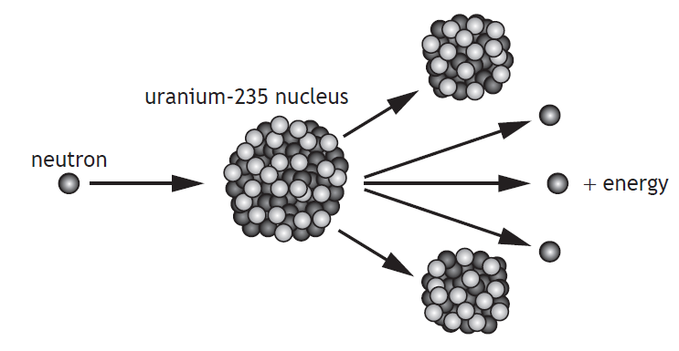  Explain how a single reaction can lead to the continuous generation of energy.
neutrons can go on to cause further (fission) reactions/split more (uranium) nuclei (1)
causing a chain reaction/this process repeats (1)
20.22.8 |  | The nuclear reactor produces waste that emits nuclear radiation.  State a use of nuclear radiation.
 |  | any suitable use (eg treating cancer/tracers/ sterilisation/smoke detectors/ measuring thickness of paper), generating energy.
20.22.9 |  | SQA Int 2 2010  Many countries use nuclear reactors to produce energy. A diagram of the core of a nuclear reactor is shown.  (a) State the purpose of:  (i) the moderator; the moderator slows neutron  (ii) the control rods. absorbs neutrons  - One nuclear fission reaction produces 2·9 × 10⁻¹¹J of energy. The power output of the reactor is 1·4 GW. Determine the number of fission reactions produced in one hour.  $$E= Pt$$  $$E =1·4 × {10}^{9} × 3600= 5·04 × {10}^{12}J$$  $$No. of reactions = \frac{total energy}{energy for one reaction}$$  $$No. of reactions = \frac{{ E}_{total}}{{E }_{reaction}}=\frac{ 5·04 × {10}^{12}}{2·9 × {10}^{-11}}=1.7 × {10}^{20}$$  (c) State one advantage and one disadvantage of using nuclear power for the generation of electricity.  Advantages  - Nuclear fuels do not produce carbon dioxide or sulfur dioxide, unlike fossil fuels.  Disadvantages  - Like the fossil fuels, nuclear fuels are non-renewable energy resources. They will run out one day if we keep on using them.  - If there is an accident, large amounts of radioactive material could be released into the environment.  - Nuclear waste remains dangerously radioactive and harmful to health for thousands of years. It must be stored safely.
  Advantages | Disadvantages
  No release of carbon dioxide (CO₂ ) – greenhouse gas | Non-renewable source – will eventually run out
  No release of sulphur dioxide (SO₂ ) – acid rain | Expensive to commission and decommission power stations
  1 kg of uranium produces millions times more energy than 1 kg of coal | Hazardous radioactive waste produced
   | Danger of release of radioactive materials into the environment
20.23 |  | I can provide a qualitative description of fusion, plasma containment, and their role in the generation of energy.
20.23.1 |  | Explain the term nuclear fusion.
 |  | Fusion is a nuclear reaction in which small atomic nuclei of (low atomic number) fuse to form a heavier nucleus with the release of energy.
20.23.2 |  | Nuclear fusion reactors are in the development stage.  - State an advantage of nuclear fusion over nuclear fission as a way of generating electrical energy.  - State a major difficulty with building fusion reactors  - State why this type of generator is not currently in use commercially.
- 1) No dangerous radioactive waste
2) More energy is produced per reaction
- Extremely high temperatures are required to start the reaction.
- More energy is needed to start the reaction than is obtained from the reaction, (i.e. it is a net consumer of energy)
20.23.3 |  | Nuclear fusion is the main way energy is generated in the Sun. State the simplified equation that shows this reaction.
Inside the Sun, the process begins with protons (a lone hydrogen nucleus) and through a series of steps, these protons fuse together and are turned into helium.
2(p + p + p)-> Helium nucleus + 2 p

2(Hydrogen + Hydrogen + Hygrogen)-> Helium + 2 Hydrogen
- Two protons within the Sun fuse. Most of the time the pair breaks apart again, but sometimes one of the protons transforms into a neutron via the weak nuclear force. Along with the transformation into a neutron, a positron and neutrino are formed. This resulting proton-neutron pair that forms sometimes is known as deuterium.
- A third proton collides with the formed deuterium. This collision results in the formation of a helium-3 nucleus and a gamma ray. These gamma rays work their way out from the core of the Sun and are released as sunlight.
- Two helium-3 nuclei collide, creating a helium-4 nucleus plus two extra protons that escape as two hydrogen. Technically, a beryllium-6 nuclei forms first but is unstable and thus disintegrates into the helium-4 nucleus.
20.23.4 |  | 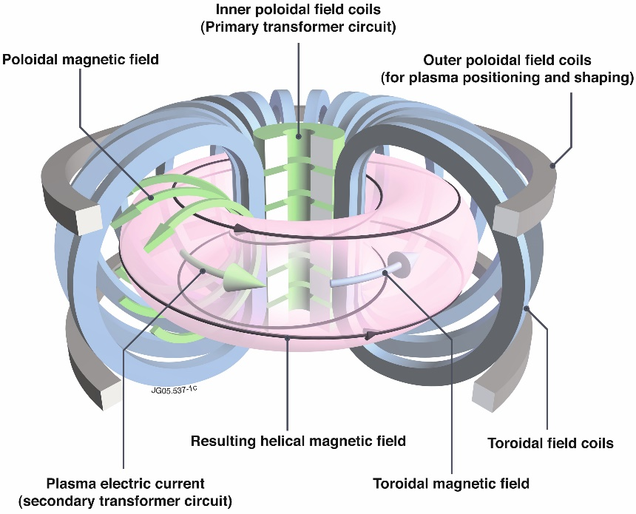  The diagram below shows a functioning nuclear fusion reactor.  - State the temperatures in the nuclear reactor required to allow fusion.  - Explain the term plasma and  - State the material in the reactor which is a plasma.
Fusion requires temperatures about 100 million Kelvin (approximately six times hotter than the sun's core).
At these temperatures, hydrogen is a plasma, not a gas. Plasma is a high-energy state of matter in which all the electrons are stripped from atoms and move freely about.
20.23.5 |  | State the potential advantages of nuclear fusion over nuclear fission.
Advantages of nuclear fusion process over nuclear fission to generate electricity are:
1. More energy is produced for the mass. Hence fusion of a very small mass generates large amount of energy.
2. Unlike fission the products of fusion reactions are not radio-active (which are highly hazardous and need to be stored safely for long periods).. They are harmless and can be replaced easily.
Figure 1: ITER tokamak
https://science.howstuffworks.com/fusion-reactor4.htm
Image courtesy of ITER
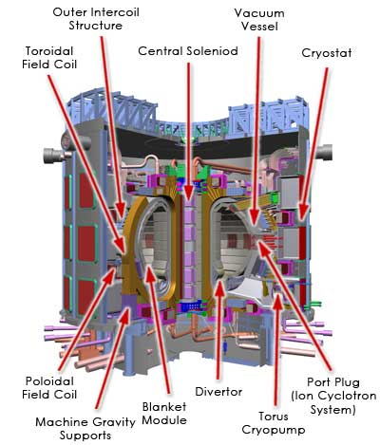 | How Nuclear Fusion Reactors Work  BY CRAIG FREUDENRICH, Ph.D.  Magnetic Confinement: The ITER Example  The main parts of the ITER tokamak reactor are:  - Vacuum vessel - holds the plasma and keeps the reaction chamber in a vacuum  - Neutral beam injector (ion cyclotron system) - injects particle beams from the accelerator into the plasma to help heat the plasma to critical temperature
- Magnetic field coils (poloidal, toroidal) - super-conducting magnets that confine, shape and contain the plasma using magnetic fields
- Transformers/Central solenoid - supply electricity to the magnetic field coils
- Cooling equipment (crostat, cryopump) - cool the magnets
- Blanket modules - made of lithium; absorb heat and high-energy neutrons from the fusion reaction
- Divertors - exhaust the helium products of the fusion reaction

Here's how the process will work:
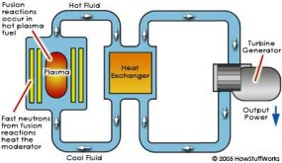

Magnetic-confinement fusion process
- The fusion reactor will heat a stream of deuterium and tritium fuel to form high-temperature plasma. It will squeeze the plasma so that fusion can take place. The power needed to start the fusion reaction will be about 70 megawatts, but the power yield from the reaction will be about 500 megawatts. The fusion reaction will last from 300 to 500 seconds. (Eventually, there will be a sustained fusion reaction.)
- The lithium blankets outside the plasma reaction chamber will absorb high-energy neutrons from the fusion reaction to make more tritium fuel. The blankets will also get heated by the neutrons.
- The heat will be transferred by a water-cooling loop to a heat exchanger to make steam.
- The steam will drive electrical turbines to produce electricity.
- The steam will be condensed back into water to absorb more heat from the reactor in the heat exchanger.
- Initially, the ITER tokamak will test whether a sustained fusion reactor is feasible and eventually will become a test fusion power plant.
20.23.6 |  | Summarise the video clip below, using bullet points. https://www.bbc.co.uk/bitesize/clips/z4nwmp3
- JET project Oxford hottest place on Earth 10 x hotter than sun
- Centre of the sun 15 million degrees Celsius
- Cheap, safe form of E releasing no harmful gases or dangerous waste.
- Sun releases E by FUSION in the plasma (4th state of matter)
- T so high electrons don’t stay attached to atoms, atoms don’t exist
- e- ,p+, n exist alone moving fast,
- p normally repel as same charge, but in plasma, with high T can fuse.
- Fused p form He nuclei
- Sun process on Earth could create great energy, but need to create high temperatures
- Problems- working with high temperatures, keeping particles from sides prevents particles cooling, do this with magnetic field.
- Very safe, if something goes wrong, it cools and the reaction stops.
20.23.7 |  | Copy and complete  Nuclear fission is the process by which energy is released when a large nucleus is hit by a neutron, becomes unstable and splits into two or three smaller pieces, called fission fragments or daughter nuclei plus two or three neutrons.  When fission occurs, some of the mass of the reactants is 'lost' – it has been converted directly into energy This energy is in the form of heat which can be harnessed and used to generate electricity/ electrical energy in a nuclear power station.
20.23.8 |  | Copy and complete the following  Nuclear fusion is the process by which energy can be released when two small nuclei fuse together to form a larger nucleus.
20.23.9 |  | Copy and complete the following passage..  During a nuclear fusion reaction two nuclei of smaller mass number combine to produce a nucleus of larger mass number. During a nuclear fission reaction a nucleus of larger mass number splits into two nuclei of smaller mass number. Both of these reactions are important because these processes can release energy .
20.23.10 |  | State the requirements for a containment vessel used to contain a nuclear fusion reaction.
The containment vessel needs to cope with high temperatures and high pressures.
Do this with Magnetic confinement which uses magnetic and electric fields to heat and squeeze the hydrogen plasma.
Or Inertial confinement uses laser beams or ion beams to squeeze and heat the hydrogen plasma.

Notes

PHYSICS IN NUMBERS
Find the correct number from your notes, learn these numbers. Your syllabus could have many of the answers, so use it! Don’t forget to include relevant units or your answer is meaningless.
e.g State the height above the Earth of a satellite if placed in geostationary orbit. 36 000 km
- State the number of milliamps in an amp. | 1000
- State the number of metres in a kilometre. | 1000
- State the number of ohms in a megaohm. | 1 000 000
- State the number of centimetres in a metre. | 100
- State the number of Joules in a gigajoule. | 1 000 000 000
- State the number of seconds in a minute. | 60 s
- State the number of seconds in an hour. | 3600 s
- State the voltage of the mains supply in the UK. | 230 V
- State the frequency of the mains supply in the UK. | 50 Hz
- State the speed at which a electrical signals is transmitted along a wire at a speed. | Almost 3.0 × 10⁸ ms⁻¹
- State the speed of light in air. | 3.0 × 10⁸ ms⁻¹
- State the speed of light in glass, eg in a fibre optic cable. | 2.0 × 10⁸ ms⁻¹
- State the speed of microwaves in air. | 3.0 × 10⁸ ms⁻¹
- State the speed of a television signal in air. | 3.0 × 10⁸ ms⁻¹
- State the speed of a radio signals in air. | 3.0 × 10⁸ ms⁻¹
- State the value of the gravitational field strength on the Earth. | 9.8 Nkg⁻¹
- State the speed of X-rays in air. | 3.0 × 10⁸ ms⁻¹
- State the speed gamma radiation travels in air. | 3.0 × 10⁸ ms⁻¹
- State the two usual size of fuse that are usually fitted in a 13A plug. | 3A, 13A
- State the number of joules of energy in 1 kWh. | 3 600 000
- State the initial acceleration of all objects when initially falling to Earth. | 9.8 ms⁻²
- State the weight of a 1kg object on the Earth | 9.8 N
- State the mass of the 1kg object in space | 1 kg
- State the approximate speed of sound in air. | 3.0 × 10⁸ ms⁻¹
- State the approximate speed of ultrasound in air. | 3.0 × 10⁸ ms⁻¹
- State if sound travels faster or slower in solids than in air. | Faster in solids

Variables & Exam Questions
Paper | Question
SQA  2018 | The energy of a water wave can be calculated using  $$E=\frac{ρgA^{2}}{2}$$  where:  E is the energy of the wave in J  ρ is the density of the water in kg m⁻³  g is the gravitational field strength in Nkg⁻¹  A is the amplitude of the wave in m.  A wave out at sea has an amplitude of 3·5 m. The density of the sea water is 1·02 × 10³ kgm⁻³ . Calculate the energy of the wave.
Answer: 6·1 ⋅ 10⁴ J
$$E=\frac{ρgA^{2}}{2}$$
$$E=\frac{1.03×{10}^{3}×9.8{×3.5}^{2}}{2}=6.1×{10}^{4} J$$

SQA N5  2019 | The table gives the distance from Earth, the approximate surface temperature and the age of five stars.  A student makes the following statements based on this information.  I As the distance from Earth increases, the age of a star decreases.  II As the age of a star increases, the approximate surface temperature of the star increases.  III There is no apparent relationship between the distance from Earth and the approximate surface temperature of a star.  Copy out the table and the correct statements.
SQA  N5 2018 | A rain sensor is attached to the glass windscreen of a vehicle to automatically control the windscreen wipers. raindrop  LEDs rain sensor infrared detectors glass windscreen refracted light  Infrared light is emitted from LEDs and is received by infrared detectors.  The graph shows how the number of raindrops affects the percentage of  infrared light received by the infrared detectors.  The percentage of infrared light received by the infrared detectors from the LEDs controls the frequency with which the windscreen wipers move back and forth.  The table shows how the number of times the windscreen wipers move back and forth per minute relates to the number of raindrops.  At one point in time the infrared detectors receive 70% of the infrared light emitted from the LEDs. Show that the frequency of the windscreen wipers at this time is 0·90Hz
For alternative methods calculating N or t, there must be a final statement to show the calculated value of N or t is the same as the value stated in the question.
SQA N5  2014 | Catapults are used by anglers to project fish bait into water.  A technician designs a catapult for this use. Pieces of elastic of different thickness are used to provide a force on the ball.  Each piece of elastic is the same length.  The amount of stretch given to each elastic is the same each time.  The force exerted on the ball increases as the thickness of the elastic increases.  Which row in the table shows the combination of the thickness of elastic and mass of ball that produces the greatest acceleration?
  Thickness of elastic | Mass of ball
  (mm) | (kg)
  5 | 0.01
  10 | 0.01
  10 | 0.02
  15 | 0.01
  15 | 0.02
SEB O Level 1976 | Fig 1 shows a pendulum in its rest position A. The pendulum, bob has a mass of 0.3 kg. The bob is pulled to one side as shown in Figure 2 and held in position A which is 0.8 m above the rest position  The bob is released from position B and swings to and fro until it comes to rest.  - Find the gain in potential energy of the bob when it is moved from position A to position B.  - State the position of the bob when it has its greatest kinetic energy.  - Estimate the maximum speed of the bob.  - Describe the energy changes which take place from the time the bob is released until it eventually comes to rest.
(a)
$$E_{p}=mgh$$
$$E_{p}=0.3×9.8×0.8=2.4 J$$
- The bob has the greatest Ek when it is at the bottom of the swing

$$E_{k gained}=E_{p lost}=\frac{1}{2}mv^{2}$$
$$2.4=\frac{1}{2}×0.3×v^{2}$$

$$\frac{2×2.4}{0.3}=v^{2}$$

$$v=\sqrt{\frac{2×2.4}{0.3}}=4.0 {ms}^{-1}$$
- Ep stored at the top of the swing is converted to Ek with the maximum Ek at the bottom of the swing. Some energy is transferred to heat in the air due to frictional forces, ie air resistance/ drag between the bob/string and air.
SQA Int2 2012 | A resistor is labelled: “10 Ω ± 10%, 3 W”.  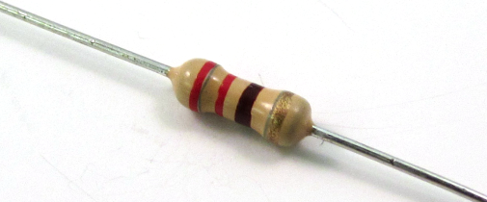  This means that the resistance value could actually be between 9 Ω and 11 Ω.  (a) A student decides to check the value of the resistance.  Draw a circuit diagram, including a 6 V battery, a voltmeter and an ammeter, for a circuit that could be used to determine the resistance.  (b) Readings from the circuit give the voltage across the resistor as 5·7 V and the current in the resistor as 0·60 A.  Use these values to calculate the resistance.  (c) During this experiment, the resistor becomes very hot and gives off smoke.  Explain why this happens.  You must include a calculation as part of your answer.  (d) The student states that two of these resistors would not have overheated if they were connected together in parallel with the battery.  Is the student correct? Explain your answer.
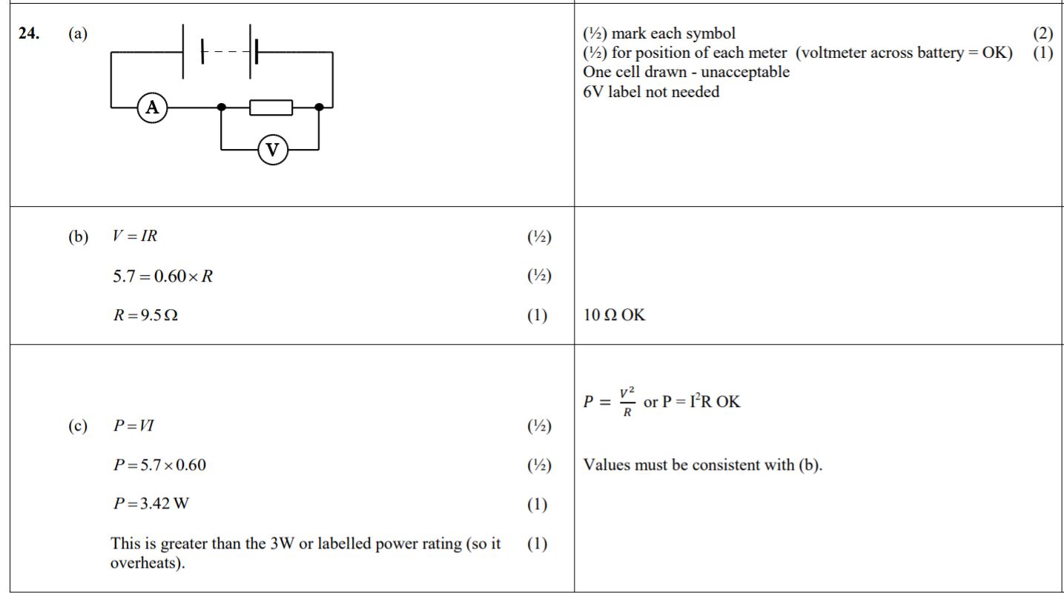
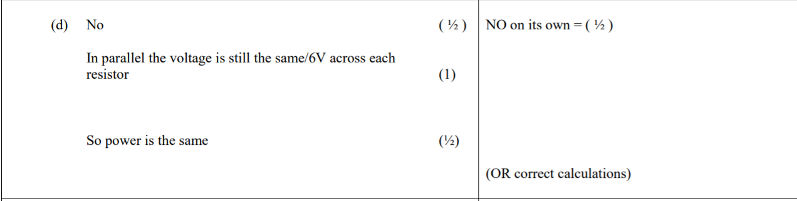

SQA N5 2015 | Craters on the Moon are caused by meteors striking its surface.  A student investigates how a crater is formed by dropping a marble into a tray of sand.  - Describe the energy change that takes place as the marble hits the sand.  The student drops the marble from different heights and measures the diameter of each crater that is formed.  The table shows the student’s results.  - Using the graph paper below, draw a graph of these results.  - Use your graph to predict the diameter of the crater that is formed when the marble is dropped from a height of 0·25 m.  - Suggest two improvements that the student could make to this investigation.  - Suggest another variable, which could be investigated, that may affect the diameter of a crater.
  height (m) | diameter (m)
  0·05 | 0·030
  0·10 | 0·044
  0·15 | 0·053
  0·35 | 0·074
  0·40 | 0·076
  0·45 | 0·076

