Speed, Distance and Time Calculations
- A runner completes a 200 m race in 25 s. What is his average speed in ms⁻¹?
- A friend asks you to measure his average cycling speed along flat road. Describe which measurements you would take and the measuring instruments you would use.
- An athlete takes 4 minutes 20 s to complete a 1500 m race. What is the average speed?
- On a fun run, a competitor runs 10 km in 1 hour. What is her average speed in
  - kmh⁻¹ b) ms⁻¹?
- Describe how you could measure the average speed of a car as it passes along the road outside your school/college.
- Concorde can travel at 680 ms⁻¹ (twice the speed of sound). How far will it travel in 25 s at this speed?
- A girl can walk at an average speed of 2 ms⁻¹. How far will she walk in 20 minutes?
- How long will it take a cyclist to travel 40 km at an average speed of 5 ms⁻¹?
- How long (to the nearest minute) will the Glasgow to London shuttle take if it flies at an average speed of 220 ms⁻¹ for the 750 km flight?
- How long, to the nearest minute, will a car take to travel 50 km if its average speed is 20 ms⁻¹?
- Look at this timetable for a train between Edinburgh and Glasgow:
Station | Time | Distance from Glasgow
Glasgow | 08:00 | 0 km
Falkirk | 08:20 | 34 km
Linlithgow | 08:28 | 46 km
Edinburgh | 08:50 | 73 km
a) What was the average speed for the whole journey in ms⁻¹?
b) What was the average speed in ms⁻¹ between Glasgow and Falkirk?
c) Explain the difference in average speeds in a) and b).
- Describe how you would measure the instantaneous speed of a vehicle as it reached the bottom of a slope.
- In an experiment to measure instantaneous speed, these measurements were obtained:-
Reading on timer | = | 0.125 | s
Length of car | = | 5 cm
Calculate the instantaneous speed of the vehicle in ms⁻¹.
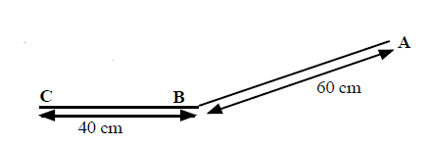
- A trolley with a 10 cm card attached to it is released from A and runs down the slope, passing through a light gate at B, and stopping at C.
Time from A to B = 0.8 s.
Time on light gate timer = 0.067 s
a) What is the average speed between A and B?
b) What is the instantaneous speed at B?

Speed Questions
1. A top class sprinter covers the 100m in a time of 10 seconds. Calculate the sprinter's average speed.
2. How long will it take a Formula 1 car to travel one lap around a 5 km long circuit if it is travelling at an average speed of 180 kmh⁻¹?
3. A physics pupil tries to calculate his friend’s instantaneous speed when running by timing how long it takes her to cross a line. He uses a stopclock to measure the time.
(a) Explain why this method will give poor results for the instantaneous speed.
(b) Suggest the equipment needed to make the experiment more accurate.
4. Read this passage on Thinking and Braking and then answer the questions that follow it.
You are travelling at 30 mph in a car in good road conditions when you suddenly see children crossing the road. By the time you react and apply the brakes, the car has travelled a total distance of 23 m. If the car had been travelling at 60 mph the stopping distance would have been 73 m.
The stopping distance consists of two parts: the thinking distance and the braking distance. The thinking distance is the distance travelled in the time between seeing a hazard on the road and pressing the brake pedal. This time is called the reaction time.
thinking distance = speed x reaction time
Reaction times vary from person to person. An average driver has a reaction time of about 0.8 seconds. A professional racing driver has a reaction time of about 0.2 seconds. Your reaction time is likely to be much longer if you have taken drugs or alcohol. Even a small amount of alcohol can greatly increase your reaction time.
(a) What is meant by the term ' thinking distance'?
(b) What will happen to the thinking distance if the car is going faster?
(c) If a car is going faster will the reaction time alter? Explain your answer.

Vectors and Scalars Tutorials

  - How would you define a scalar quantity?
  - Give three examples of scalar quantities

  - How would you define a vector quantity?
  - Give three examples of vector quantities.
- Explain the terms speed and velocity.
- Explain the difference between a vector quantity and a scalar quantity.
- Use your answer to the questions above to explain the difference between distance and displacement.
- A man walks from X to Y along a winding road.
a) State his displacement at the end of his walk.
b) State the distance has he walked.
If the walker in the previous question took 40 minutes for his walk, determine
c) his average speed
d) his average velocity?
- One complete lap of a running track is 400m.
An athlete completes one lap in 48 s in the 400 m race. State his
- distance travelled
- displacement
c) determine her average speed
d) determine her average velocity.
- Repeat Q8 for a runner in the 800 m race whose winning time was 1 min 54s.

- A car travels 40 km north, then turns back south for 10 km. The journey takes 1 hour.
Detemine
a) the displacement of the car
b) the distance the car has travelled
c) the average velocity of the car in km h⁻¹
d) the average speed of the car.

- A car drives 60 km north, then 80 km east, as shown in the diagram. The journey takes 2 hours. Calculate the
a) distance travelled
b) displacement
c) average speed
d) average velocity.

- During an orienteering exercise, a student walks from point A to point B.

The student travels 400 m north and then 300 m east to reach point B as shown.
(a) The student takes 400 s to walk from point A to point B.
Calculate his average speed.
(b) By scale diagram or otherwise determine the student’s displacement at point B from point A.

ACCELERATION QUESTIONS
- A Jaguar can reach 27 ms⁻¹ from rest in 9.0 s. What is its acceleration?
- The space shuttle reaches 1000 ms⁻¹, 45 s after launch. What is its acceleration?
- A car reaches 30 ms⁻¹ from a speed of 18 ms⁻¹ in 6 s. What is its acceleration?
- A train moving at 10 ms⁻¹ increases its speed to 45 ms⁻¹ in 10 s. What is its acceleration?
- A bullet travelling at 240 ms⁻¹ hits a wall and stops in 0.2 s. What is its acceleration?
- A car travelling at 20 ms⁻¹ brakes and slows to a halt in 8 s.
  - What is the acceleration of the car?
  - What is the deceleration of the car?
- Describe how you would measure the acceleration of a small vehicle as it runs down a slope in the laboratory.
- On approaching the speed limit signs, a car slows from 30 ms⁻¹ to 12 ms⁻¹ in 5 s. What is its deceleration?
- A bowling ball is accelerated from rest at 3 ms⁻² for 1.2 s. What final speed will it reach?
- How long will it take a car to increase its speed from 8 ms⁻¹ to 20 ms⁻¹ if it accelerates at 3 ms⁻²?
- A cyclist can accelerate at 0.5 ms⁻² when cycling at 4 ms⁻¹. How long will she take to reach 5.5 ms⁻¹?
- The maximum deceleration a car’s brakes can safely produce is 8 ms⁻². What will be the minimum stopping time if the driver applies the brakes when travelling at 60 mph (27 ms⁻¹).

- The table below gives some performance figures for cars.
Car | Time for 0 - 60 mph | max. speed in mph
Porsche 918 Spyder | 2.2 s | 217
Tesla Model S P100D w/Ludicrous+ Update | 2.5 s | 155
smart EQ fortwo | 9.5 s | 90
Ford Mondeo TDCi | 7.6 | 140
VW Polo | 10.8 | 110
- Which car has the smallest acceleration?
- Which car has the largest acceleration?
- Assuming that the acceleration remained constant, how long would it take for the following cars to reach their top speed?
i) Mondeo ii) Porsche
14. Calculate a car’s acceleration if its speed increases by 12 ms⁻¹ in a time of 3 s.
15. A physics pupil running away from a wasp accelerates from rest to 5 ms⁻¹ in a time of 1.25 s. Calculate the pupil’s acceleration.
16. A electromagnetic gun can produce an acceleration of 2500 ms⁻². If the bullet starts at rest, and acceleration for 0.03s. What will be the final velocity of the bullet?

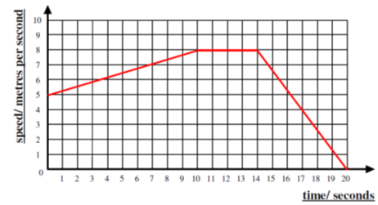
VELCOCITY TIME GRAPHS
For each question below, copy the graph into your jotter and complete the description.
- Copy and complete the description of the velocity time graphs above.
0-10s ___________ _______ from ____ ms⁻¹ to ____ ms⁻¹.
(Constant/ uniform _____________).
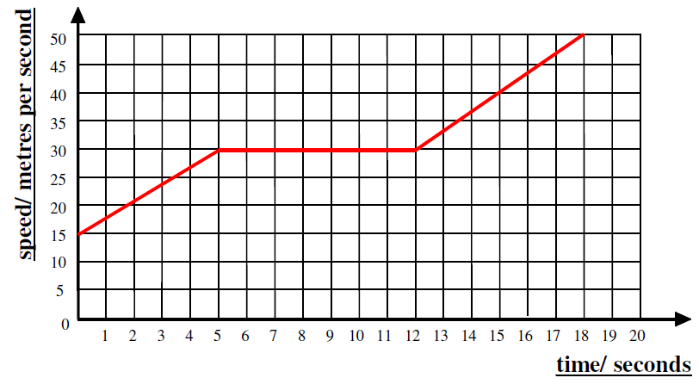
10-14 s _____________ ___________ of ____ ms⁻¹.
14-20s _______________ ______ from ___ ms⁻¹ to ms⁻¹ (constant/ uniform ____________)

- 0-5s ___________ _______ from ___ ms⁻¹ to ____ ms⁻¹. (Constant/ uniform _____________).
5-12 s _____________ ___________ of ____ ms⁻¹.
- -17 s _______________ ______ from ___ ms⁻¹ to ms⁻¹ (constant/ uniform _____________)

- On graph paper draw graphs representing the following motion of a vehicle travelling in a straight line.

- From
  - s: speeding up from rest to 10 ms⁻¹. Constant /uniform acceleration.
5-15 s: steady velocity of 10 ms⁻¹
15-20 s: slowing down from 10 ms⁻¹ to rest (constant / uniform negative acceleration)
- A cyclist travels at a steady speed of 9 ms⁻¹ for 6 s before accelerating constantly / uniformly to a speed of 2 ms⁻¹ in 7 s. She then travels at this steady speed for a further 5 s.

- A racing car travels at a steady speed of 10 ms⁻¹ for 2 s before accelerating constantly/ uniformly for 12 s to a speed of 90 ms⁻¹. The car then immediately decelerates constantly / uniformly for 6s to a speed of 70 ms⁻¹
MORE VELOCITY TIME GRAPHS
            - Copy the velocity-time graphs below and find the accelerations for each part of the journey.

Homework ACCELERATION
Time (s) | Speed (m/s)
0 | 0
2 | 6
4 | 12
6 | 18
8 | 24
10 | 30
1. A car's speed is recorded over a period and the results are show in the table below:
(a) Plot a graph of the car's motion over this 10-second period.
(b) From the graph, find the car's speed 5 seconds into its journey.
(c) Describe the car’s motion over the 10 seconds.

            - Look at the graph. This shows the speed of a car over a short journey. Use the graph to answer these questions.
(a) Describe the car’s motion between:

B

C

D
Speed/ m/s
Time/s
10
20
30
40
50
40
30
20
10

A
A and B;
B and C;
C and D.
(b) Estimate the car’s speed after 10 seconds.

            - A hot air balloon is released and it accelerates upwards.
Speed/ ms⁻¹
Time/s
10
20
30
40
50
8
6
4
2
During the ascent, some sandbags are released and the acceleration increases. The graph shows its vertical motion during the first 50 seconds of its flight.
(a) Calculate the acceleration after the sandbags are released. (2)
(b) How high had the balloon risen after the 50 seconds had passed?

VELOCITY TIME GRAPHS (WITH DISPLACEMENT)
- The graph below shows how the velocity of a car varies over a 40 s period.
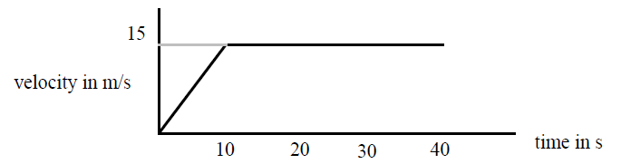

a) Describe the motion of the car during this 40 s period.
b) Calculate the acceleration of the vehicle.
c) How far does the car travel while accelerating?
d) What is the total distance travelled by the car?

- Use the graph below to answer the following questions.
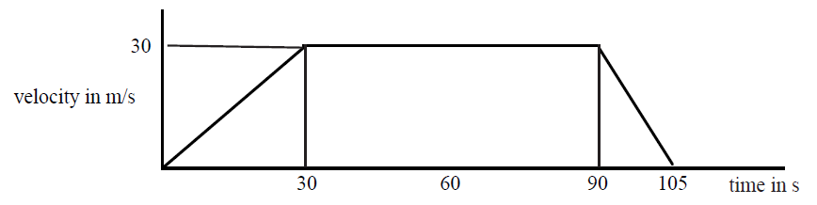
  - State the time during which time is the vehicle travelling at a constant velocity.
  - Calculate the values of
    - the initial acceleration
    - the final deceleration
  - Determine the braking distance of the car.
  - Calculate the total distance travelled.
  - Determine the average velocity of the car.

- Draw a velocity-time graph to describe the following motion:-
A car accelerates from rest at 2 ms⁻¹ for 8 s, then travels at a constant velocity for 12s, finally slowing steadily to a halt in 4 s.

- For the vehicle in the previous question, determine the
  - maximum velocity
  - distance travelled
  - average velocity

- The graph below describes the motion of a cyclist.
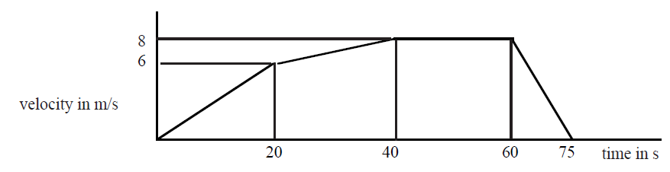
  - Calculate the maximum positive acceleration of the cyclist.
  - Show by calculation whether the cyclist travels farther while accelerating, or while cycling at the maximum velocity.

- For each of the graphs below, calculate:
  - The acceleration for each part of the journey
  - The total distance travelled for the vehicle.
Speed/ ms⁻¹
Time/s
10
20
30
40
50
8
6
4
2

B

C

D
v / ms⁻¹
t/s
10
20
30
40
50
40
30
20
10

A

Homework
- This graph shows the motion of a car.
    - Describe how the car is moving,
    - How far does the car travel in the time shown on the graph?
2. The graph shows the speed of a runner during a race.
- Describe the motion of the runner.
- What distance does she cover in the first eight seconds?
- What was the distance she ran in the last four seconds?
- What was the length of the race?
3. A hot air balloon is released and accelerates upwards. During the lift, some sand bags are released, and the acceleration increases. The graph shows the vertical motion of the balloon during the first 50s of its flight.
(a) Calculate the height of the balloon when the sandbags are released.
(b) Calculate the height of the balloon after 50 s.
4.During a test run of a TACV (tracked air-cushioned vehicle or hovertain), its speed along a straight level track was recorded as shown in the table below.
    - Draw a graph of the train’s motion during the test run.
    - Calculate the distance travelled during the test run.
Time (s) | Speed (ms⁻¹)
0 | 0
20 | 10
40 | 40
60 | 70
80 | 100
100 | 100
120 | 50
140 | 0

More motion graph questions
Use your knowledge of velocity time graphs, and equations to answer these questions
- A car travels between two sets of traffic lights. Its speed changes as shown in the graph.
        - Calculate the car’s acceleration over the first 5 seconds.
        - Calculate the acceleration of the car when it brakes.
        - Calculate the distance moved by the car.
        - Determine the car’s average speed between the traffic lights.
- A girl cycles along a road and down a hill. Her speed changes as shown in the graph.
    - At what time dis she start to travel down the hill?
    - For what distance did she cycle downhill?
    - What was her acceleration as she went down the hill?
    - What total distance did she travel?
    - What was her average?

- A train arrives at the start of the platform of Lockerbie Station at 4.5 ms⁻¹, slows down and comes to rest 15 s later.
- Calculate the acceleration of the train.
- Sketch a velocity time graph showing the motion.
- Use your graph to calculate the stopping distance of the train.
- While driving along a road, a driver sees a brick fall off the lorry 100 metres in front of her. The graph shows the motion of the car from the instant she sees the brick fall.
    - Why is there a delay between the driver seeing the brick fall, and the car decelerating?
    - What is the acceleration of the car?
    - What is the distance travelled by the car before it comes to rest?
    - Explain if the car will hit the brick or not.
- A glider, cruising at 20 ms⁻¹ goes into a shallow dive and increases its speed in a straight line. The graph shows its motion starting a few seconds before its dive.
          - At what time did the dive start?
          - Wat was the time taken during the dive?
          - What was the acceleration during the dive?
          - How far did the glider travel during the dive?

DYNAMICS PROBLEMS
Assume the questions refer to the Earth unless otherwise stated
1. What is the weight of a 10 kg bag of potatoes?
2. What is the weight of a 250 g bag of sweets?
3. What is the mass of a 450 N girl?
4. What is the weight of a 10,000 kg spacecraft on
a) Earth b) Mars c) Venus?
5. What would a 60 kg man weigh on Jupiter?
6. Which planet’s gravity is closest to our own?
7. An astronaut who weighs 700 N on Earth goes to a planet where he weighs 266 N.
- A boy of mass 45 kg slides down a chute at a leisure centre. His acceleration is initially 2 ms⁻². Calculate the force acting on him.
- A car's engine applies a force of 3000 N, and this accelerates it at 4 ms⁻². Calculate the mass of the car.
- Explain, using the theory of forces, how a seat belt can prevent injury in a car crash.
- Explain the term balanced forces.
- State the equivalent of balanced forces.
- State Newton’s First Law.
- The diagram below illustrates the forces acting on a motorbike. The combined mass of the bike and rider is 125 kg.
200 N
700 N

(a) Calculate the resultant force acting on the bike.
(b) Calculate the acceleration of the bike.
8. . Look at the pairs of forces acting on the objects below. In each case, state the resultant force and the direction in which it is acting.
10 N
5 N
12 N
20 N
(a) (b)

Balanced Forces and Newton’s First Law Questions
- The diagram below shows the forces acting on a car moving at constant velocity.
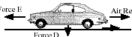
Other friction = 450 N
Force E
Force D
Normal reaction = 10 000 N
Air resistance = 400 N

- Make a statement about the forces acting on this car.
- Calculate the magnitude of the engine force E.
c) Calculate the weight of the car.

- The diagram shows the forces acting on a balloon as it rises.
Buoyancy force = 2000 N
Balloon rising at a constant velocity

Force A
- Calculate the size of force A.
- If the balloon was falling at a constant velocity, determine the size of force A.

- State Newton’s First Law.
- Explain, using Newton’s First Law, why passengers without seat belts in a moving car appear to be “thrown forwards” in the car, when the car stops suddenly
- Explain how a parachutist reaches a terminal velocity.

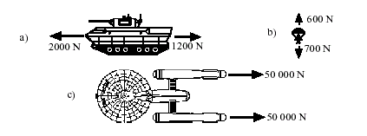
Resultant Forces Tutorials
- What is meant by the resultant force on an object?
- What are the resultants of the following forces?

- By using a scale diagram or otherwise, find the resultant of the following pairs of forces. Remember to draw the vectors “tip to tail”.
a) b)
5 N
15 N
5 N
12 N

c) d)
N
8 N
10 N
24 N
18 N

Newton’s Second Law Questions
- Calculate the force needed to accelerate a 5 kg mass at 3 ms⁻².
- Calculate the acceleration produced on a 12 kg mass acted on by a force of 30 N.
- Calculate the mass when a Force of 12 N acts to produce an acceleration of 2 ms⁻².
- Calculate the force which will accelerate 250 g at 2 ms⁻²?
- Calculate the force required to accelerate a 10 tonne lorry at 1.5 ms⁻²
(1 tonne = 1000 kg)
- State two reasons why a car will have a smaller acceleration in similar conditions when a roof rack is added.
- Describe an experiment to investigate the effect of varying the unbalanced force acting on a fixed mass.
- A car of mass 1200 kg experiences friction equal to 500 N when travelling at a certain speed. If the engine force is 1400 N, determine the car’s acceleration.
- A car of mass 2000 kg has a total engine force of 4500 N. The frictional drag force acting against the car is 1700 N. Calculate the acceleration of the car.
- Two girls push a car of mass 1000 kg. Each pushes with a force of 100 N and the force of friction is 120 N. Calculate the acceleration of the car.
- A boat engine produces a force of 10000 N and the friction and water resistance total 3500 N. If the mass of the boat is 2000 kg, calculate its acceleration.
- A careless driver tries to start his car with the hand brake still on. The engine exerts a force of 2500 N and the hand brake exerts a force of 1300 N. The car moves off with an acceleration of 1.2 ms⁻². calculate the mass of the car.
- A car of mass 1200 kg can accelerate at 2 ms⁻² with an engine force of 3000 N. Determine the total frictional force acting on the car.
- A helicopter winches an injured climber up from a mountainside. The climber’s mass is 65 kg.
- Calculate the weight of the climber.
- If he is accelerated upwards at 1.0 ms⁻², determine the unbalanced force required.
c) Calculate the total upwards force produced by the helicopter.
- An 800 kg car is accelerated from 0 to 18 ms⁻¹ in 12 seconds.
- Calculate the resultant force acting on the car.
- At the end of the 12 s period the brakes are operated and the car comes to rest in a time of 5 s. calculate the average braking force acting on the car.

Homework WEIGHT
            - Calculate the weight of a girl who has a mass of 40kg.
            - What is the gravitational force acting on a 30g rock on the Earth’s surface?
            - Find the mass of a boy who weighs 550N.
            - During the Apollo 11 expedition to the Moon, 21kg of soil samples were brought from the Moon to the Earth. The gravitational field strength was not constant throughout the journey
              - What is meant by gravitational field strength?
              - Copy and complete the table to show the mass and weight of the soil samples at various stages of the journey
Stage | Gravitational field strength (N kg⁻¹) | Mass (kg) | Weight (N)
On the Moon | 1.6 | 21
At a point during the journey | 0
On the Earth | 9.8

- An astronaut on the Moon uses a newton balance to measure the weight of a 20kg rock. If the reading on the balance is 32N, calculate the gravitational field strength on the Moon
- The gravitational field strength on Venus is 8.8Nkg⁻¹. If a robot probe of mass 270kg lands on Venus, how much will it weigh?
- If a man weighs 700N on Earth, how much would he weigh on Jupiter which has a gravitational field strength of 26Nkg⁻¹?

FRICTION
Answer the following questions in your jotter.
- Describe two methods of
a) increasing friction b) decreasing friction.
2) Where, in a bicycle, is friction deliberately
a) increased b) decreased?

Friction
- Define what friction is.
- Give two examples where friction slows things down.
- Give two examples of where friction helps things move.
- Describe two methods of increasing friction.
- Describe three methods of decreasing friction.
- Where in a bicycle is friction deliberately
- increased
- decreased?
- What is friction commonly called when the one of the surfaces involved is air?
- What is friction commonly called when the one of the surfaces involved is water?

Homework NEWTON’S SECOND LAW
1. Find the unbalanced force required to accelerate a 6kg mass at 3ms⁻².
2. Find the acceleration of a 200kg rock, rolling down a hill, if the unbalanced force acting on it is 1kN.
3. What is the mass of a trolley if an unbalanced force of 12N causes it to accelerate at 4ms⁻²?
4. The forces acting on a car of mass 1000kg are shown below.
2kN
6kN
Engine force
Friction
- Find the unbalanced force acting on the car.
- Calculate the acceleration of the car.
- A model motor boat of mass 4 kg is initially at rest on a pond. The boat’s motor, which provides a constant force of 5 N, is switched on. As the boat accelerates, the force of friction acting on it increases. A graph of the force of friction acting on the boat against time is shown.

    - State the force of friction acting on the boat 2 s after the motor is switched on.
    - Calculate the acceleration of the boat at this time.
  - Describe and explain the movement of the boat after 7 s
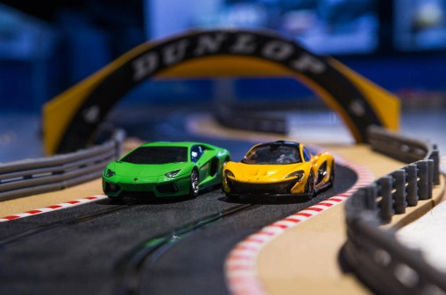
- Stephen and Jack are invited along to ‘Techno toys’ workshop to try out a new remote control car. They line the car up to race along the 200 m track and then start it off.

(a) Describe how the designers could work out the car’s instantaneous speed as it goes round the corner of the track. Your answer must include:
any apparatus they would need
any measurements they would take
any calculations they would do.
- The speed time graph below represents the motion of the car during part of the race.
(b) Calculate the acceleration of the car during the first 6 seconds.
(c) Determine the distance travelled by the car during the 18 seconds represented by the graph.
(d) During the period 6 s to 14 s the car exerted an engine force of 450 N. State the magnitude of the frictional forces acting on the car during this time.
(e) State how the designers reduce the frictional forces acting on the car.
(f) Draw the graph that would have been produced if the race had taken place on a wet day.

WORK DONE
- A shopper pushes a supermarket trolley a distance of 600m with a force of 70 N. How much work is done?
- A locomotive pulls a carriage a distance of 1.6 km with a force of 28000 N. How much work is done?
- The brakes of a car exert a force of 500 N to stop the car. If the braking distance is 67m how much work is done by the brakes to stop the car?
- A lift moves a 45kg girls up 9 m from the ground floor to the top floor. What is her gain in gravitational potential energy?
- A boy lifts a 3.8 kg school bag up to 0.92m from the floor to the bench. What is the gain in the gravitational potential energy of the bag?

Work Tutorial
$$E_{w}=Fd$$
- A locomotive exerts a pull of 10 000 N to pull a train of loaded wagons a distance of 300 m. How much work is done?
- A gardener pushes a lawnmower with a force of 150N for a distance of 220m. How much work is done?
- If a girl uses 1200 J of energy pushing a trolley a distance of 60m, how big is the force she exerts?
- The brakes on a car do 900 000 J of work when bringing it to a halt. If the stopping distance is 125 m, how much force do the brakes exert?
- If the force produced by the brakes was only 1000N in question 4, and the brakes still do 900 000 J of work, what would be the new stopping distance?
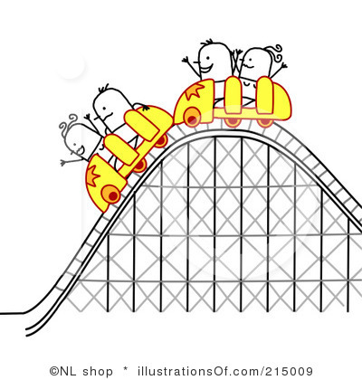
- The force of friction between a pencil and paper is 0.12N. How far would you have to push a pencil to do 5 J of work?
- A mountain rescue helicopter winches up an injured climber of mass 65 kg a distance of 30m from a rock edge. What is the gain in gravitational potential energy?
30m
- What is the gain in gravitational potential energy when a 50 kg sack of potatoes is lifted 0.85m up onto a lorry?
- Estimate how much gravitational potential energy you would gain if you were winched up 30m to the top of a funfair ride.
- A fork lift truck is to be used to load a crate of mass 200kg onto a lorry .
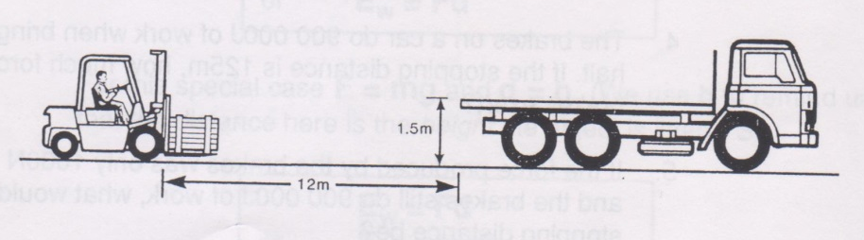
It has to drive 12m to the lorry and then lift the crate up 1.5m onto the lorry. The driving force is 500N and the energy available to complete the operation is 8000 J. Will the fork-lift truck be able to load the crate onto the lorry? Justify your answer by calculations.

Energy Transformations
- Copy and complete these examples of energy transformations.
a) Car moving at a steady speed along level road: chemical energy -> ________
b) Car accelerating along level road: chemical energy -> ________ + _______
c) Car braking: kinetic energy -> ________
d) Car freewheeling downhill (engine switched off): ________ -> ________ + _______

- A locomotive exerts a pull of 10000 N to pull a train a distance of 400 m.
How much work is done?

- A gardener does 1200 J pushing a wheelbarrow with a force of 100 N.
How far did she push the barrow?

- A man uses up 1000 J by pulling a heavy load for 20 m. What force did he use?

- A girl is pushing her bike with a force of 80 N and uses up 4000 J of energy.
How far did she push the bike?

- A man weighing 600 N climbs stairs in an office block which are 40 m high.
How much work does he do?

- A worker pushes a 4 kg crate along the ground for 3 m using a force of 20 N, then lifts the crate up to a ledge 1 m high. How much work does he do altogether?

Gravitational potential energy Questions
- A chairlift raises a skier of mass 60 kg to a height of 250 m. How much potential energy does the skier gain?
- A brick of mass 3 kg rests on a platform 25 m above the ground on a building site.
  - How much potential energy is stored in the brick?
  - If the brick falls 25 m to the ground, how much potential energy will it lose?
  - What form of energy will the brick gain?
- Estimate how much gravitational potential energy you would gain if you were lifted 30m up to the top of a fun-ride.
- An apple, mass 100 g, has 300 J of potential energy at the top of the Eiffel Tower.
What is the height of the Eiffel Tower?
- An astronaut of mass 70 kg climbs to a height of 5 m on the moon and gains 560 J of gravitational potential energy. What must be the gravitational field strength on the moon?

Work, Power and Time
- A man pushes a wheelbarrow for 60 m using a 50 N force. If he takes 10 s, what is his average power?
- The man’s son pushes the wheelbarrow for 60 m using the same force as his father, but he takes 13 s to do it.
- How does a) his work b) his power compare to his father’s?
- A machine lifts a load of 4000 N to a height of 5 m in 20 s. What is its power?
- A boy who weighs 600 N can run upstairs of vertical height 8 m in 12 s.
  - What is his power?
  - A girl who weighs 500 N takes 10 s to run up the stairs. What is her power?
  - Do they do equal amounts of work?
- Describe how you could estimate the average power of a student who is running up a flight of stairs. List measurements you would take, how you would obtain these, and indicate how you would calculate the result.
- A lift can raise a total mass of 800 kg up 10 m in 40 s. What is its power?
- A weight lifter lifts a mass of 250 kg from the ground to a height of 1.5 m in a time of 2 seconds. What was his average power during the lift?
- A lift in a building can take a maximum of 10 people of average mass 70 kg. The mass of the lift is 500 kg.
  - What is the total weight of a full lift?
  - What is the power needed to raise the lift up 30 m in 10 s?
- A bucket of water of weight 250 N is to be lifted up a 30 m well by a 500 W motor.
How long will it take to raise the bucket?
  - What will be the power of the electric motor of a lift which can raise a load of 4000 N at a steady speed of 2 ms⁻¹?
  - What is the energy transformation?

Gravitational potential energy
- A chairlift raises a skier of mass 60 kg to a height of 250 m. How much potential energy does the skier gain?
- A brick of mass 3 kg rests on a platform 25 m above the ground on a building site.
  - How much potential energy is stored in the brick?
  - If the brick falls 25 m to the ground, how much potential energy will it lose?
  - What form of energy will the brick gain?
- Estimate how much gravitational potential energy you would gain if you were lifted 30m up to the top of a fun-ride.
- An apple, mass 100 g, has 300 J of potential energy at the top of the Eiffel Tower.
What is the height of the Eiffel Tower?
- An astronaut of mass 70 kg climbs to a height of 5 m on the moon and gains 560 J of gravitational potential energy. What must be the gravitational field strength on the moon?

Kinetic energy Questions
            - You are provided with an air track and vehicles, a light gate and timer and some elastic bands. Describe how you could use this apparatus to establish how kinetic energy depends on velocity. Include details of any measurements you would take and any additional measuring equipment needed.
- Calculate the kinetic energy of the following:
  - a 5 kg bowling ball moving at 4 ms⁻¹
  - a 50 kg skier moving at 20 ms⁻¹
  - a 0.02 kg bullet moving at 100 ms⁻¹.

  - Calculate the kinetic energy of a 800 kg car travelling at a speed of 10 ms⁻¹?
  - If it doubles its speed to 20 ms⁻¹, calculate its new kinetic energy.
- A cyclist who is pedalling down a slope reaches a speed of 15 ms⁻¹. The cyclist and her cycle together have a mass of 80 kg.
  - Calculate the total kinetic energy.
  - Name two sources of this kinetic energy.
- Calculate an approximate value for the kinetic energy of an Olympic 100 m sprinter as he crosses the line (time for race is about 10 s).
- What is the speed of a stone of mass 2 kg if it has 36 J of kinetic energy?
- Calculate the speed of a motor cyclist and his bike if they have a total mass of 360 kg and kinetic energy of 87120J.
- The apple of mass 100g is dropped from the top of the Eiffel Tower.
  - How much kinetic energy would it have just before hitting the ground?
  - What will be its velocity as it hits the ground?
- A car of mass 1000 kg is travelling at 20 ms⁻¹.
  - How much kinetic energy does it have?
  - If the maximum braking force is 5 kN, what will be the minimum braking distance?
  - If the driver has a reaction time of 0.7 s, how far will the car travel during this ‘thinking time’?
  - What will the total stopping distance be?

Ep
1. Calculate the gravitational potential energy of a student of mass 50kg that has climbed 7 metres.
2. If an object has a mass of 10kg and a gravitational potential energy of 45,000J how high is it?
3. An object at a height of 25m has a gravitational potential energy of 100J, calculate its mass
4. A car travelling at 10 m/s has a mass of 1,500 kg calculate its kinetic energy.
5. A bullet of mass 4.2 g has a kinetic energy of 2,000J, calculate its speed.
6. A bumblebee is flying at 6 m/s and has a kinetic energy of 1.8 mJ, calculate it’s mass.
7. State and explain the principle of the conservation of energy.
8. A stone falls from a cliff, which is 80 m high
a. If air resistance can be ignored, calculate the speed at which it enters the water at the bottom of the cliff
b. If air resistance cannot be ignored, what effect will this have on the speed of the stone as it enters the water?
c. In practice, not all of the initial gravitational energy is transformed into kinetic energy. Other than kinetic energy, what is the main form of energy produced?
9. a. What type of energy does a spacecraft have because of its movement?
b. What is this energy changed into when the spacecraft re-enters the Earth’s atmosphere from space?
c What causes this energy transformation?
10. Show that, if air resistance can be ignored, the speed of a falling object is independent of its mass and depends only on the height through which it moves.

Conservation of energy
- 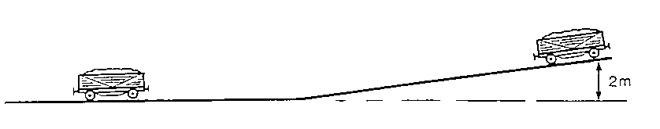In a railway shunting yard, wagons are allowed to run down a slope as shown below. A wagon of mass 900 kg starts from rest and runs down the slope.
- Calculate the amount of gravitational potential energy it loses as it runs down the slope.
- Ignoring any energy losses due to friction, state its total gain in kinetic energy as it runs down to the bottom of the slope.
- Calculate its speed at the bottom of the slope.
- When the wagon is moving along the level part of the yard frictional forces slow it down. How much work will have to be done by friction to stop it?
- The wagon applies its brakes so that the total frictional force applied to it is 200 N. Calculate the distance required to stop the wagon.
- If frictional forces, such as air resistance, had not been ignored in parts (b) and (c) what would the effect be on the speed of the wagon at the bottom of the slope? Explain your answer.

- In a TV advert to demonstrate the safety features of a car, the manufacturers drive it off the top of a building at a speed of 5 m s⁻¹, as shown in the diagram below. The mass of the car is 1000 kg and the height of the building is 11.55 m.
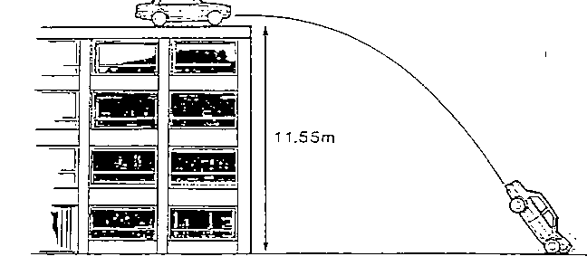

- Calculate the kinetic energy of the car as it drives off the roof.
- Calculate the gravitational potential energy that the car loses as it falls to the ground.
- What then will be its total kinetic energy as it hits the ground?

- A 900 kg car is parked on a hill when its handbrake starts to slip. The car runs down the hill, crashing into a wall at 6 m s⁻¹.
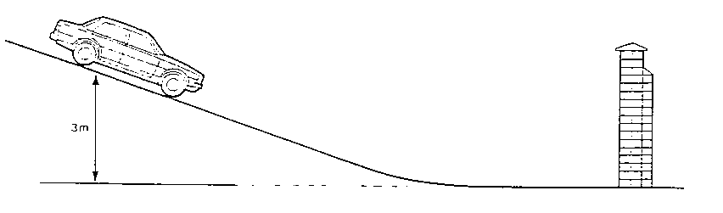
3 m

- How much gravitational potential energy did the car lose as it ran down the hill?
- What was the car's kinetic energy as it hit the wall?
- The slipping brake heated up as the car ran down the hill. How much heat energy was produced at the brake pads?

- A part falls off a helicopter, at a height of 720 m. With what speed will it hit the ground?
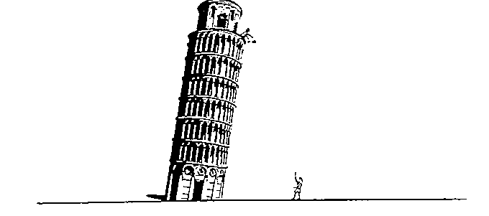
- When Galileo dropped metal spheres of different mass from the leaning tower of Pisa, he found that they hit the ground at the same time. How can his discovery be explained in terms of conservation of energy?

- A 50 kg girl on a 15 kg bicycle is moving at a constant speed of 5 m s⁻¹. She applies her brakes and comes to rest in 2 seconds.
- What is the kinetic energy of the girl plus her bicycle before she brakes?
- What becomes of this kinetic energy during the braking?
- Calculate the power of the brakes in watts.

- A fun ride is being designed so that a carriage with 20 people in it will be raised to a height of y metres, be released and then will go round a loop and stop going up another slope. The carriage has to reach a speed of 7.07 m s⁻¹ at the top of the 10 m high loop. The carriage and passengers are expected to have a total mass of 2500 kg.
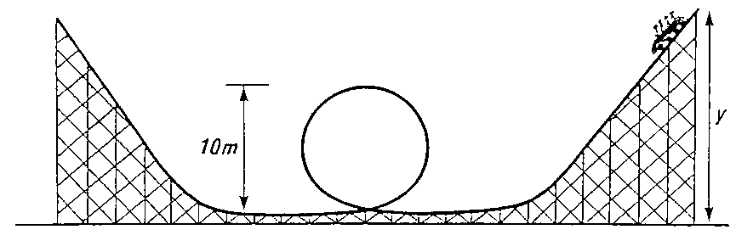

- Calculate the kinetic energy of the full carriage at the top of the loop.
- Calculate its gravitational potential energy at the top of the loop.
- What will be its total kinetic energy as it enters the loop?
- What will be its total gravitational potential energy at height y?
- Calculate the height y.
- Calculate the maximum speed the carriage will reach during the ride.

PROJECTILE QUESTIONS
- What is a projectile?
- What is special about its motion?
- A projectile is fired horizontally at 100 ms⁻¹.
  - How long will it take it to travel a horizontal distance of 50m?
  - What will be its vertical velocity when it hits the ground?
  - What will be its average vertical speed?
  - How far will it fall in the 50m?
- A ball rolls along a flat roof at 2ms⁻¹ and rolls off the edge.
  - If it takes 1.5s to fall to the ground what is the speed on landing?
  - How high is the roof?
  - How far away from the base of the building will it land?
- Jordan the goalkeeper punches a football which has been kicked across his goal mouth. The football leaves his glove with a horizontal velocity of 11.5 ms⁻¹ to the right and takes 0.80s to land on the pitch.
(a) Describe the horizontal velocity of the football from the instant it is punched to the instant it lands.
(b) Show, by calculation involving horizontal motion, that the horizontal displacement travelled by the football during the 0.8 s is 9.2 m to the right.
(c) At the instant the football leaves Jordan's hand, the downward vertical velocity of the football is 0 ms⁻¹. Calculate the downward vertical velocity of the football as it lands.
(d) From what height was the ball pitched?
6. The Physics Department's pet cat jumps horizontally to the right from a window ledge. The cat lands on the floor 0.36 s later. Its horizontal displacement is 1.8 m to the right.
(a) During the jump, does the horizontal velocity of the cat increase, decrease or remain constant?
(b) Show, by calculation involving horizontal motion, that the horizontal velocity of the cat just before landing is 5 ms⁻¹to the right.
(c) What was the height of the window ledge?
(d) At the instant the cat jumps from the window ledge, its downward vertical velocity is 0 ms⁻¹. Calculate the downward vertical velocity of the cat as it lands.

7. Ellen's hand hits a volleyball from a point directly above the central net.
The volleyball leaves Ellen's hand with a horizontal velocity of 8.4 ms⁻¹ to the right.
On leaving her hand, the volleyball follows a curved path, hitting the floor when its horizontal displacement is 6.3 m to the right.
(a) Show, by calculation involving horizontal motion, that the time taken for the volleyball to travel from Ellen's hand to the floor is 0.75 s.
(b) At the instant the volleyball leaves Ellen's hand, the downward vertical velocity of the volleyball is 0 ms⁻¹. Calculate the downward vertical velocity of the volleyball as it reaches the floor.
(c) From what vertical height was the volleyball punched?

8. A rocket is fired horizontally from a cliff top at 40 ms⁻¹ to the right. The rocket hits the sea below after 4 s.
(a) What will be the rocket's horizontal component of velocity just before it hits the sea?
(b) What will be the rocket's range (horizontal displacement)?
(c) What will be the rocket's vertical component of velocity just before it hits the sea?
(d) Sketch the velocity-time graph for the rocket's vertical motion.
(e) Use the graph to determine the rocket's vertical displacement (the height of the cliff).

9. Fred kicks a football off a cliff with a horizontal velocity of 5 ms⁻¹ to the right. The football lands on ground below the cliff 2.5 s later.
(a) What will be the ball's horizontal component of velocity just before it hits the ground?
(b) What will be the ball's range (horizontal displacement)?
(c) What will be the ball's vertical component of velocity just before it hits the ground?
(d) Sketch the velocity-time graph for the ball's vertical motion.
(e) Use the graph to determine the ball's vertical displacement (the height of the cliff).

10. Barney pushes a coin off a staircase. The coin's initial horizontal velocity is 0.5 ms⁻¹ to the right. It hits the floor after 1.2 s.
(a) What will be the coin's horizontal component of velocity just before it hits the floor?
(b) What will be the coin's range (horizontal displacement)?
(c) What will be the coin's vertical component of velocity just before it hits the floor?
(d) Sketch the velocity-time graph for the coin's vertical motion.
(e) Use the graph to determine the coin's vertical displacement (the height of the staircase).
11. Wilma throws a dart horizontally at 8 ms⁻¹ to the right.
The dart hits the floor after 0.6 s.
(a) What will be the dart's horizontal component of velocity just before it hits the floor?
(b) What will be the dart's range (horizontal displacement)?
(c) What will be the dart's vertical component of velocity just before it hits the floor?
(d) Sketch the velocity-time graph for the dart's vertical motion.
(e) Use the graph to determine the dart's vertical displacement (the height it was thrown from).

11. Betty fires an arrow horizontally at 25 ms⁻¹ to the right. The arrow hits the ground after 0.4s
(a) What will be the arrow's horizontal component of velocity just before it hits the ground?
(b) What will be the arrow's range (horizontal displacement)?
(c) What will be the arrow's vertical component of velocity just before it hits the ground?
(d) Sketch the velocity-time graph for the arrow's vertical motion.
(e) Use the graph to determine the arrow's vertical displacement (the height it was fired from).
12. A stone thrown horizontally from a cliff lands 24 m out from the cliff afte r 3s. Find:
a) the horizontal speed of the stone
b) the vertical speed at impact.

13. A ball is thrown horizontally from a high window at 6 ms⁻¹ and reaches the ground after 2 s. Calculate:
a) the horizontal distance travelled
b) the vertical speed at impact.

- An aircraft flying horizontally at 150 ms⁻¹, drops a bomb which hits the target after 8 s.
Find:
a) the distance travelled horizontally by the bomb
b) the vertical speed of the bomb at impact
c) the distance travelled horizontally by the aircraft as the bomb fell
d) the position of the aircraft relative to the bomb at impact.

- A ball is projected horizontally at 15 ms⁻¹ from the top of a vertical cliff. It reaches the ground 5 s later. For the period between projection until it hits the ground, draw graphs with numerical values on the scales of the ball’s
a) horizontal velocity against time
b) vertical velocity against time
c) From the graphs calculate the horizontal and vertical distances travelled.

- In the experimental set-up shown below, the arrow is lined up towards the target.
As it is fired, the arrow breaks the circuit supplying the electromagnet, and the target falls downwards from A to B.
a) Explain why the arrow will hit the target.
b) Suggest one set of circumstances when the arrow would fail to hit the target (you must assume it is always lined up correctly).

- An osprey flying horizontally at a speed of 15 ms⁻¹ drops the fish it is carrying in to the lake. The fish hits the water 2 seconds later.
- sketch the path the fish took
- at what height was the osprey flying when it dropped the fish?
- Assuming the osprey does not change its speed or direction, where is it in relation to the fish when it hits the water.

