NATIONAL QUALIFICATIONS CURRICULUM SUPPORT

Physics

Stellar Physics

Support Material

[ADVANCED HIGHER]
J Hargreaves



The Scottish Qualifications Authority regularly reviews the arrangements for National Qualifications. Users of all NQ support materials, whether published by Learning and Teaching Scotland or others, are reminded that it is their responsibility to check that the support materials correspond to the requirements of the current arrangements.

Acknowledgement
Learning and Teaching Scotland gratefully acknowledges this contribution to the National Qualifications support programme for Physics.

I gratefully acknowledge ********.

© Learning and Teaching Scotland 2012

This resource may be reproduced in whole or in part for educational purposes by educational establishments in Scotland provided that no profit accrues at any stage.

Contents

Background 4

Properties of Stars 6
Fusion in Stars 7
The Structure of the Sun 1*4
Size of Stars 1*6
Surface Temperature 1*4
Mass 1*5
Luminosity 1*7
Detecting Astronomical Objects 188
Stellar Classification 1*8
Solar Activity and Sunspots 2*0

Stellar Evolution 2*1
Nucleosynthesis 2*1
Hertzsprung-Russell Diagrams 2*2
Neutron Stars, Black Holes and SUpernovae
References

Further Reading

Note this document gives hyperlinks to the glossary at the back and then clicking on the heading will take you back to the original place in the document.

6. STELLAR PHYSICS

Background
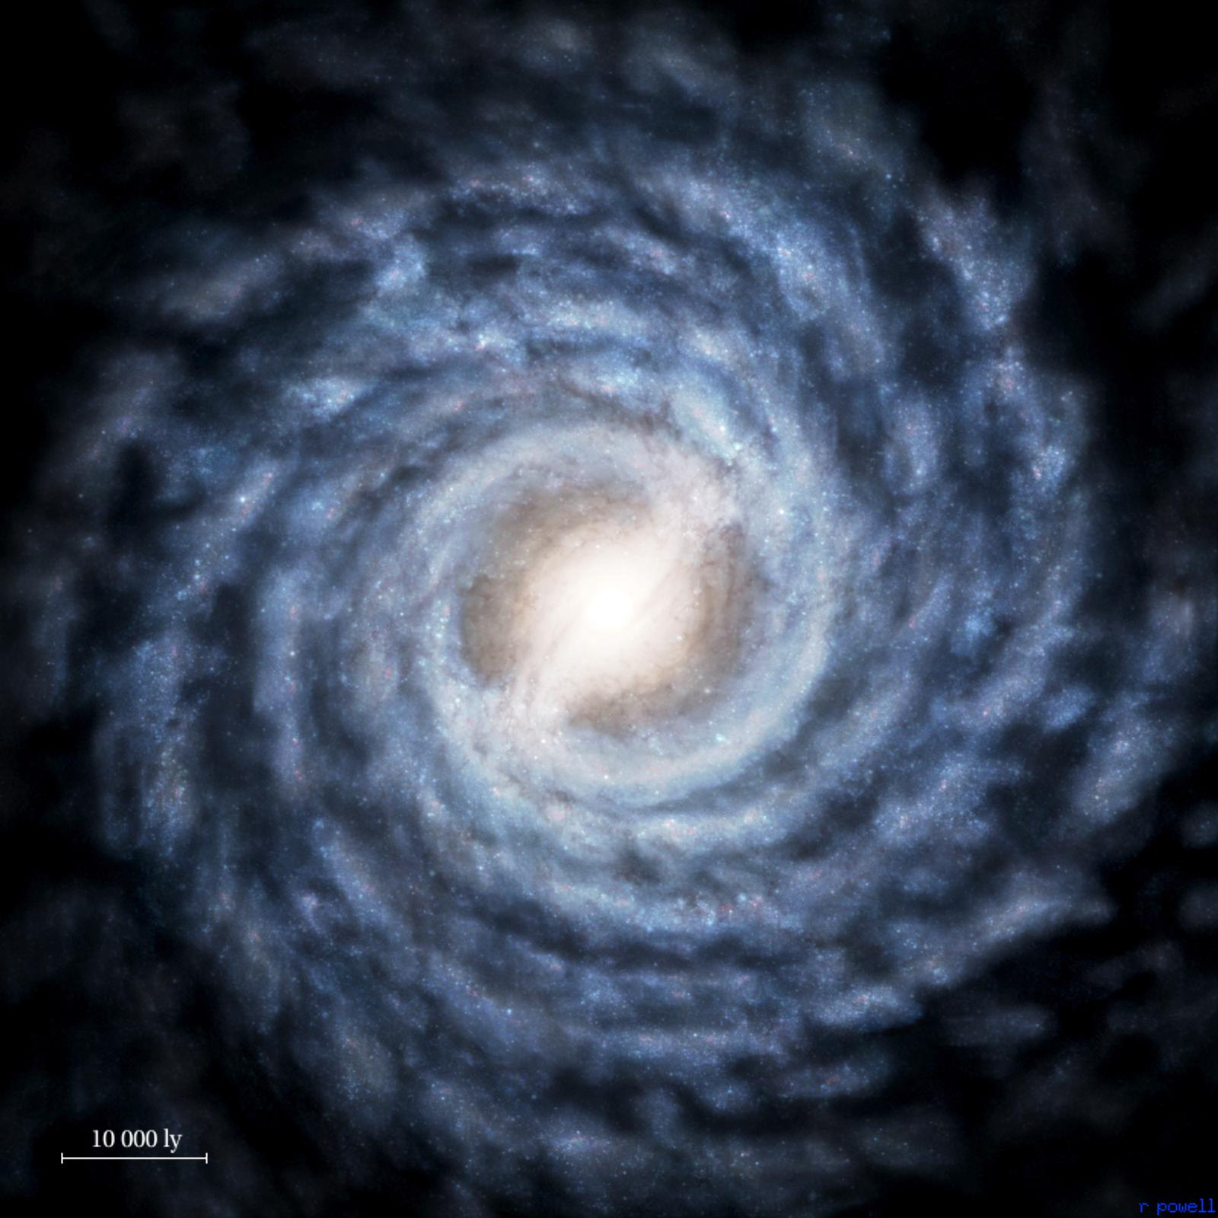Stellar Physics is the study of stars throughout their birth, life-cycle and death. It aims to understand the processes which determine a star’s ultimate fate.
Figure 1. An example of a spiral galaxy

Throughout the Universe there are estimated to be something like 100 billion (10¹¹) galaxies, each consisting of perhaps 10¹¹ stars, meaning that there are in the order of 10²² stars in the observable Universe. Naked-eye observation from Earth reveals just a few thousand of these.

Our closest star is, of course, the Sun, approximately 150 million kilometres from Earth. After that the closest is Alpha Centauri at 4.4 light years (42 trillion km). The most distant stars are beyond 13 billion light years (10²³ km) away. This means that travelling at the speed of light of 3.0×10⁸ m s⁻¹, light would take 13 billion years to arrive. As the Universe is believed to be 13.7 billion years old some of this light set off soon after the Universe was created at the big bang.

In this part of the course we will explore the processes, properties and life-cycle of the major stellar classes.

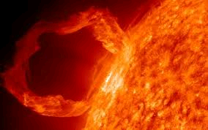
Properties of Stars
Figure 2: Solar Flare

Until the beginning of the 20th century, the process by which our Sun produced heat and light was not established. Early theories, developed before the size and distance of the Sun was known, involved chemical production, just like burning wood or coal.

However, by the mid-19th century when the Sun’s size and distance were estimated, it became clear that the Sun simply couldn’t sustain its power output from any sort of chemical process. The next suggestion was that heat was produced by the force of gravity producing extremely high pressures in the core of the Sun in much the same way that pressurising a gas at constant volume causes its temperature to rise; a similar process to the way in which a pressure cooker works. It was estimated that the Sun could produce heat and light for perhaps 25 million years if this were the source of the energy.

At around this time it became apparent from geological studies that the Earth (and therefore the Sun) were very much older than 25 million years so a new theory was required. This new theory emerged in the early years of the 20th century with Einstein’s famous E=mc² equation establishing an equivalence between mass and energy. Here at last was a mechanism which could explain a large, sustained energy output by converting mass to energy.

We now know that an active star produces heat by the process of nuclear fusion. At each stage of a fusion reaction a small amount of mass is converted to energy. The process involves fusing two protons together to produce a deuterium nucleus, a positron, a neutrino and energy. The positron is annihilated by an electron producing further energy in the form of gamma rays. The deuterium nucleus then combines with a further proton to produce a helium-3 nucleus, gamma rays and energy. Two helium-3 nuclei then combine to produce a single helium-4 nucleus, two protons and energy. The whole process is summarized in diagrams one to three.
proton
deuterium H-2
positron
neutrino
proton
helium He-3
gamma
γ
proton
deuterium H-2
helium He-4
helium He-3
helium He-3
2 protons
Diagram 1: Two protons fuses, converting one to a neutron to form deuterium H-2. Energy is released.
Diagram 2: The deuterium, H-2, captures another proton to form Helium-3, He-3. Energy is released as γ.
Diagram 3: Two Helium -3 nuclei fuse, giving Helium 4, He-4 and freeing two protons.
Fusion in the Sun
+Energy

+Energy

This whole sequence is known as the proton-proton chain reaction and may be summarised as

4 (¹H) ------> ⁴He + 2 e⁺ + 2 neutrinos + energy.

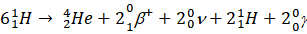

Two protons, being positively charged, will repel each other as they approach. Forcing two protons close enough together so that they will fuse can only occur at extremely high temperature and pressure, capable of overcoming the inter-nuclei repulsive forces. Conditions in the core of the Sun meet the requirements of nuclear fusion with a temperature of around 15 million Kelvin and a pressure of 200 billion atmospheres.

One of the methods by which the proton-proton chain reaction could be confirmed to be the source of the Sun’s energy was to predict the number of neutrinos which could be expected to arrive at the Earth if the reaction was proceeding at a rate which was consistent with the rate of energy production observed. Neutrinos are very difficult to detect as they rarely interact with other particles, but because so many are produced by the sun it is possible, with a sufficiently large detector, to measure these interactions.

The first neutrino detector consisted of an underground reservoir containing 400,000 litres of dry-cleaning fluid. Chlorine nuclei within this fluid occasionally interacted with neutrinos to produce argon, so the quantity of argon accumulated within the reservoir allowed the number of neutrinos arriving at the Earth’s surface to be estimated.

Unfortunately, the quantity of neutrinos detected was only about one third the number that theory predicted, suggesting either that the proton-proton chain reaction was not the source of the Sun’s energy or that the experiment was for some reason failing to detect two thirds of the neutrinos. This problem remained unsolved for over thirty years and became known as the solar neutrino problem.

It was known that the proton-proton chain reaction produced only electron neutrinos but the existence of two other types, the muon neutrino and the tau neutrino was also known. Until recently neutrino detectors were only able to detect electron neutrinos, but with the introduction of a detector which could detect all three types it rapidly became apparent that the number arriving on Earth did, indeed, match the expected output from the proton-proton chain reaction, but that all three types were present. It is now believed that some of the electron neutrinos are converted to the other two types during their passage from the core to the surface of the Sun. Thus, after three decades of observations, it was possible to be confident that the models which predicted the source of the Sun’s energy were correct.

Nuclear fusion is the focus of much applied research on Earth as a way of producing power, allowing our reliance on fossil fuels to be reduced. Progress has been slow because the engineering required to contain plasma at high temperatures and pressures is very challenging. The ITER project (ITER, 2011) based in the south of France hopes by 2019 to produce the first reactor capable of giving out more power (500 MW) than it takes to contain the plasma (50 MW).

please can someone confirm this schematic thanks
neutron
deuterium H-2
tritium H-3
helium He-4
lithium Li-6
neutron
tritium H-3
helium He-4
Diagram 4: Deuterium and tritium are heated to a very high temperature. The neutrons from their fusion fuse with lithium around the hot gases. This gives rise to more tritium.
Diagram 4: A method of Fusion used on Earth

For life to have evolved on Earth, it is reasonable to suppose that the output of the Sun has been fairly stable for a long time. This stability can be attributed to gravitational equilibrium where the inward force of gravity is repelled by the thermal pressure produced by the fusion reactions in the core. If, for any reason, the output from the fusion reaction were to decrease, then the outward thermal pressure would decrease, and hence the pressure due to gravity in the core would rise leading to a rise in thermal output thus restoring the equilibrium. A similar feedback would prevent thermal output from increasing. This is shown in Figure 3.

Figure 3: The solar thermostat

Solar Thermostat:
Gravitational Equilibrium
A slight rise in core temperature
A slight drop in core temperature
decrease fusion
increase fusion
increase in core pressure
decrease in core pressure
core expands and cools
core contracts and heats up

The Structure of the Sun
Core
Radiation Zone
Convection Zone
Photosphere
Chromosphere
Corona
Figure 4: The Solar Zones
Moving outwards from the core of the Sun (Figure 4) there is first the radiation zone where heat transfers radiatively outwards, followed by the convection zone where pressures are low enough to allow heat transfer by convection. The “surface” of the Sun (i.e. the boundary between the plasma and gas) is the photosphere above which is the “atmosphere” consisting first of the chromosphere then the corona. Typical temperatures of each layer are given in Table 1.

Table 1: Temperature of Solar Regions
Region | Typical Temperature (K)
Core | 15 × 10⁶
Radiation Zone | 10 × 10⁶
Convection Zone | 10 × 10⁶ to 6000
Photosphere | 5800
Chromosphere | 10000
Corona | 1 × 10⁶

Although the corona is at around one million Kelvin, the surface temperature we perceive from Earth is that of the photosphere because this is a relatively dense region compared to the corona.

Since most of the energy is released in the core in the form of photons, these must radiate and convect outwards through the extremely dense inner layers of the Sun. This high density means that a photon takes hundreds of thousands of years to reach the surface of the sun, then just a little over eight minutes to reach the Earth.

So far we have considered data relating just to our Sun since that is the star about which we know the most. From here on we will consider stars in general.

Size.

There is a large range of stars and each star is placed into a “spectral class” (which we will look at later in the notes) partly depending on the star’s size. Our Sun, a main-sequence star, has a radius, R_{sun}, of approximately 696,000,km (109 times that of Earth) (Philip’s, 2002). White dwarfs (small, dense stars nearing the end of their lives) may have a radius of around 0.01R_{sun}, whilst at the other extreme supergiants may typically be 500R_{sun}.

Surface Temperature

The surface temperature of a star is, in general, the temperature of the photosphere and depends on many factors, not least the amount of energy the star is producing and the radius of the star.

When viewing the night sky it is quickly apparent that stars are not a uniform white colour. There are red stars such as Betelgeuse in the Orion constellation, and blue ones like Spica in Virgo. A dramatic contrast in star colours can be seen by observing the double star Albireo in Cygnus using a small telescope. Here the contrast between an orange and blue-green star is striking.

The reason why stars appear in a wide range of colours is directly related to their surface temperature. The hotter the star the more blue or white it appears. The surface temperature is shown to be directly linked to the irradiance (power per unit area). The energy radiated by the hot surface of a star can be calculated using a modified Stefan-Boltzman Law,
where
σ is the Stefan-Boltzman constant (5.67 x 10⁻⁸ W m⁻² K⁻⁴) and
T is the absolute temperature (K)
(Monteith, 1973).
For example the Power per unit area of our sun would be calculated as follows.

As the formula is proportional to T⁴ it shows that as temperature rises the quantity of radiation emitted per unit area increases very rapidly. However, radiation is not emitted at a single wavelength but over a characteristic waveband shown in Figure 5. This diagram is called a Black body radiation diagram. Black body radiation is the heat radiation emitted by an ideal object and has a characteristic shape related to its temperature. Many astronomical objects radiate with a spectrum that closely approximates to a black body. Figure 5 shows this black body pattern for our Sun with a surface temperature of 5800 K. The visible part of the spectrum has been plotted to put the graph in context and to demonstrate the relatively small proportion of total energy emitted in the visible waveband.


Figure 5: Black-body radiation from the Sun.

This curve is given by the Planck radiation law (Young & Freedman, 1996):
where
I(λ) is the radiation intensity per unit wavelength,
h is Planck’s constant,
c the speed of light and
k the Boltzman constant.

The maximum intensity in Figure 5 occurs at a wavelength of:
(Wien’s Law)

and gives a value of 500 nm for the light from our Sun, a value towards the middle of the visible spectrum (400 to 700 nm). Evolution has resulted in humans having eyesight most sensitive to light having the greatest energy per unit wavelength.
Figure 6: Black-body radiation from stars with 2500K, 5800K and 15000 K surface temperatures

If the emission spectra of stars of different temperatures are plotted (Figure 6) the emission curves show the same general shape but different values for their peak radiation. By measuring λ_{max} from a particular star we can therefore calculate its surface temperature. An alternative approach using just the visible part of the spectrum is to measure the ratio of red:violet intensity and use that
to predict λ_{max} using the Planck radiation law.

Mass

Our Sun has a mass, M_{Sun,} of 1.989 x 10³⁰ kg (Philip’s, 2002) or roughly 330,000 times that of the Earth. Other stars range in size from roughly 0.08M_{Sun} to 150M_{Sun}. The most numerous stars are the smallest, with only a (relatively) few high mass stars in existence. No stars with masses outside this range have been found. Why should this be?

Stars with a mass greater than 150M_{Sun} produce so much energy that, in addition to the thermal pressure which normally opposes the inward gravitational pressure, an outward pressure caused by photons (and known as radiation pressure) overcomes the gravitational pressure and causes the extra mass to be driven off into space.

Stars with a mass less than 0.08M_{Sun} are unable to achieve a core temperature high enough to sustain fusion. This arises because of another outward pressure, called degeneracy pressure which occurs in stars of this size. This pressure is explained in terms of quantum mechanics which we don’t propose to cover here, but the outcome is that this outward pressure prevents the star from collapsing enough to raise the core temperature and pressure enough to sustain nuclear fusion.

Small stars which fail to initiate fusion become Brown Dwarfs, slowly dissipate their stored thermal energy and cool down. To give an idea of scale, a star with a mass of 0.08M_{Sun} is approximately 80 times the mass of Jupiter, so brown dwarfs occupy a middle ground between the largest planets and the smallest stars.

Luminosity

The luminosity of a star is a measure of the total power the star emits. The Sun has a luminosity, L_{sun} , of 3.839 × 10²⁶ W, and the range of luminosities found throughout the universe is from around 10⁻³ L_{sun} to 10⁵ L_{sun}.

Because the range of luminosities covers 8 to 9 orders of magnitude, the luminosity can also be described using the Absolute Magnitude scale. The concept of using a range of magnitudes to measure the brightness of stars was introduced by the Greek astronomer, Hipparchus, in the second century BC. His scale had the brightest stars as magnitude 1 whilst the faintest were magnitude 6.

The modern definition uses the same principle, but describes what the visual magnitude of a particular star would be when viewed from a distance of 10 parsecs (3.26 light years). The definition of luminosity has changed slightly over the years, but the modern scale can be obtained using:

where L₀ is the luminosity of our Sun, M is the absolute magnitude of the star and L the luminosity of the star (Wolfram Alpha, 2011).

The form of this equation makes it easy to see that the scale is not linear. In fact, a difference of 5 in magnitude corresponds to a 100-fold difference in luminosity. It is also apparent from the equation that as the magnitude increases, the luminosity decreases. In fact, the most luminous stars have negative magnitudes eg. Sirius has an absolute magnitude –3.6, our Sun +4.83.

Apparent Brightness

When viewed from Earth, the brightness of stars does not necessarily reflect their absolute magnitude, it is quite possible that a high-luminosity star a long way from earth could appear to be less bright than a low-luminosity star nearby. The brightness of any star when viewed from Earth is its Apparent Brightness and is a measure of the radiation flux density (W m⁻²) at the surface of an imaginary sphere with a radius equal to the star-earth distance. The radiation flux density is calculated using the inverse square law such that

where d is the distance from the star to Earth.
To apply this to our Sun gives

and is the value of the solar constant at the top of Earth’s atmosphere. In the UK, measurements of solar radiation at the Earth’s surface give a value around 1000 W m⁻² at midday in midsummer – the difference in values being caused by atmospheric absorption and scattering.

Just as luminosity has acquired the absolute magnitude scale to make it easier to understand, apparent brightness may also be described by the apparent magnitude scale. This uses the apparent brightness of the star Vega in the constellation Lyra to define a apparent magnitude of 0. Prior to this Polaris was used to define a apparent magnitude of 2, but was subsequently found to be a variable star (i.e. its luminosity is not constant, varying between magnitudes 2.1 and 2.2 every 4 days) and so the definition was dropped in favour of Vega. Just as in the case of absolute magnitude a difference of 5 in apparent magnitude corresponds to a 100-fold difference in apparent brightness.

From this it will be clear that when a star is described as having a particular magnitude, it is important to clarify whether this is an apparent or absolute magnitude. For example, Sirius has an absolute magnitude of –3.6 but an apparent magnitude of –1.44. As a guide, the faintest stars detectable by naked eye on a clear night are of around apparent magnitude 5, although the threshold will vary from person to person. The moon has a apparent magnitude of –10.6 and the sun is -26.72.

Detecting Astronomical Objects

When recording images of distant stellar objects in order to measure their apparent brightness, people used to use film cameras. These worked by photons of light reacting with chemically treated rolls of plastic film. Nowadays, digital cameras produce images using a CCD (charge-coupled device) chip positioned directly behind the camera lens (where the film used to be located in a film camera).

A CCD is a doped semiconductor chip based on silicon, containing millions of light sensitive squares or pixels. A single pixel in a CCD is approximately 10,μm in diameter. When a photon of light falls within the area defined by one of the pixels it is converted into one (or more) electrons and the number of electrons collected will be directly proportional to the intensity of the radiation at each pixel. The CCD measures how much light is arriving at each pixel and converts this information into a number, stored in memory inside the camera. Each number describes, in terms of brightness and colour, one pixel in the image.

Not all of the photons falling on one pixel will be converted into an electrical impulse. The number of photons detected is known as the Quantum Efficiency (QE) and is wavelength dependent. For example, the QE of the human eye is approximately 20%, photographic film has a QE of around 10%, and the best CCDs can achieve a QE of over 70%.

Some CCDs detect over a very short waveband to produce several black and white images which are then coloured during image processing. This is how the Hubble Telescope and the Faulkes’ Telescopes produce their images. Certainly some of the Hubble images give details that would never be observed by the human eye.

CCDs have several advantages over film. The advantages are a high quantum efficiency, broad range of wavelengths detectable and the ability to view bright as well as dim images. CCD’s have the advantage over the eye as their response is generally linear, ie if the QE is 100% efficient 100 photons would generate 100 electrons. The human eye does not observe linearly over a large range of intensities and has a logarithmic response. This makes the eye poor at astrophotometry (the determination of the brightness of stars).

Another of the major advantages of using CCDs in imaging stellar objects is the ability to use software to “stack” images. Several images of the same object can be taken and easily superimposed to produce depth and detail that would not be observed from a single image.

Stellar Classification
Initial attempts to classify stars in the mid-19th century were based on colour and spectral absorption lines. The most commonly used scheme was that devised by Angelo Secchi and is summarised in Table 2 (Philip’s, 2002).

Table 2: The Secchi Stellar Classification

Classification Type | Colour | Absorption Lines | Examples
I | Blue-white. | Strong hydrogen | Sirius, Vega
II | Yellow, Orange. | Dense metallic species. | Sun, Arcturus, Capella
III | Orange-red | Titanium oxide | Betelgeuse, Antares
IV | Deep red | Carbon
V |  | Strong emission lines.

In the late 19th century a different approach was based on looking at hydrogen absorption line spectra and classifying them alphabetically from A to Q with Class A having the strongest absorption lines. However, it was eventually realised that such a system was slightly flawed and a clearer sequence studying absorption lines of many chemical species was established. This retained the lettering classification but moved some classes around and removed some altogether. Eventually the classification became the one used today (Table 3, source Bennett et al, 2008) and is a result of correcting previous errors or omissions in the classification.

Table 3: Modern Stellar Classification

Spectral Type | Temperature (K) | Examples
O | > 30,000 | Orion’s Belt stars
B | 30,000 to 10,000 | Rigel
A | 10,000 to 7,500 | Sirius
F | 7,500 to 6000 | Polaris
G | 6000 to 5000 | Sun
K | 5000 to 3,500 | Arcturus
M | < 3,500 | Proxima Centauri, Betelgeuse

This work was carried out at the Harvard Observatory by (mostly female) “computers”. These individuals had educated themselves in Physics and Astronomy, but the social pressures of the time meant they could not become undergraduates or have a formal position at the Observatory so this was the only type of work they could do within this field. Eventually, one of their number, Annie Jump Cannon, who led the work described above was recognised with an honorary degree from Oxford University almost 20 years after the scheme was adopted.

The spectral types listed in Table 3 cover quite large temperature ranges, so within each type a numbering system is used eg. A0, A1, A2 etc. The smaller the number the hotter the star will be. The Sun is a star of spectral type G2 with a surface temperature of 5800 K.

Solar Activity and Sunspots
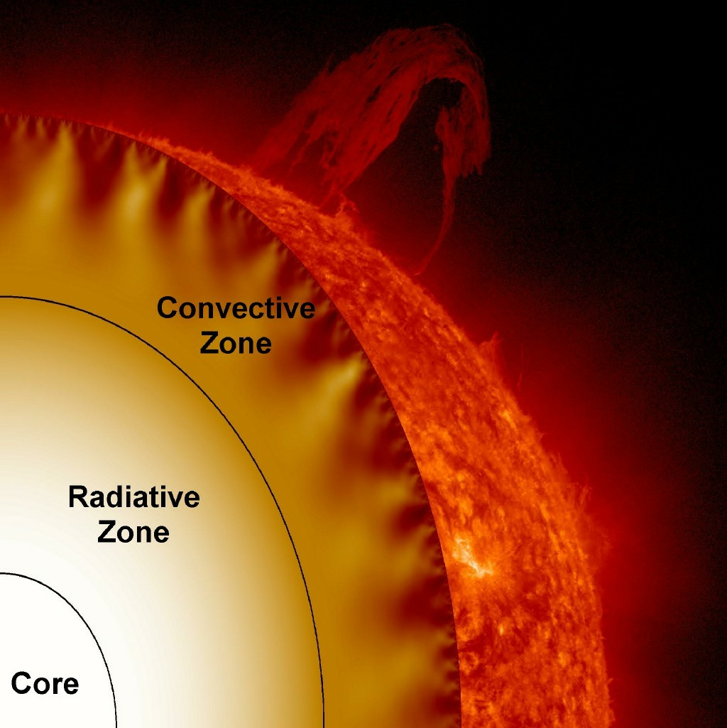We saw in the first section that the interior of the sun has distinct zones or Regions and that the zone closest to the surface is the convective zone, where heat is transferred towards the surface by convection of the plasma. Photographs of the sun clearly show these areas of convection (Figures 7 and 8) with the bright areas being regions where hotter plasma is welling up from below and dark regions those where cooler plasma is sinking.
Figure 7: The effects of convection seen at the surface
http://solarscience.msfc.nasa.gov/images/cutaway.jpg
From time to time, larger dark areas appear, ranging in size from 1000 km to 1,000,000 km in diameter. These are sunspots, usually occurring in pairs are thought to arise when strong magnetic field lines emerge from the surface of the sun, curve out into space and then back into the sun. Sometimes loops of plasma can become established in this loop and give rise to a solar prominence. These strong magnetic fields reduce the convective flow of plasma from below and therefore reduce the surface temperature within the sunspot to around 4000 K. Sunspots may last for anything from a few hours to a few months depending on the stability of the magnetic fields.
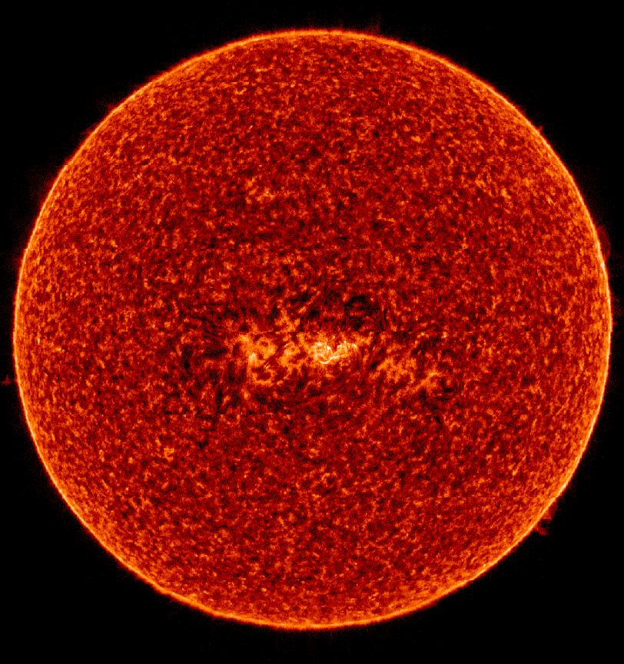
Figure 8: http://solarscience.msfc.nasa.gov/images/sumer_S_VI.jpg
The regions surrounding sunspots are associated with several aspects of solar “weather”. The first of these is the solar flare. The mechanism is believed to be associated with sudden breakdowns of twisted magnetic fields that occur in the vicinity of sunspots. Solar flares last from a few minutes to a few hours and release large quantities of radiation, predominantly X-rays and a stream of fast-moving charged particles. Figure 9 shows a time-sequence of a flare taken in August 2002 showing the movement of the flare away from the region of a sunspot.
For reasons which are not yet fully understood, the total number of sunspots present follow a cyclical pattern known as the sunspot cycle. Since sunspots have been observed for several centuries it is possible to trace this cycle back for an extended period and this confirms that sunspot numbers peak (at solar maximum) and trough (at solar minimum) approximately every 11 years but that the total number of sunspots at each peak vary considerably (Figure 10) SIDC (2011).
Figure 9: Time sequence of a solar flare

The historic data also show that total sunspot number is quite variable from cycle to cycle and that this cyclical behaviour was suspended between about 1645 and 1715. This period is known as the Maunder Minimum and coincided with the onset of the “Little Ice Age”, although the extent to which the latter was brought on by the former is uncertain. In fact, although the changes in x-ray and ultraviolet emission are quite pronounced throughout the sunspot cycle, the total energy output of the Sun changes very little. Research into the effects of solar “weather” on Earth’s climate and weather is still at a relatively early stage.
Interestingly, the Sun’s magnetic field reverses completely at each solar maximum so that it takes 22 years for the magnetic field to go from one state to another then back to the original state. This is known as the solar cycle.
Earlier on we saw that the temperatures of the sun’s chromosphere and corona are much higher than that of the photosphere, although the surface temperature that we observe from Earth is that of the photosphere. This arises because the density of the chromosphere and corona is very small. The reasons for the occurrence of these high temperatures are imperfectly understood, but it is thought that they are produced by energy transferred via the movement of loops of magnetic field lines which are, in turn, caused by strong currents within the convection zone.

The high temperatures of the chromosphere and corona cause them to emit x-ray radiation. X-ray images of the sun reveal that the hottest areas of the corona are related to areas with sunspots and that the polar regions of the sun have relatively cool areas of corona. These areas are known as coronal holes and are characterised by having magnetic field lines that do not loop back into the photosphere, but trail out into space allowing streams of charged particles to escape along them. This stream of particles travels outwards from the sun at around 500 km s⁻¹ and is known as the solar wind.

Coronal Mass Ejections (CMEs) are a more violent form of solar flare or storm. Massive quantities (far in excess of the quantity associated with the solar wind) of charged particles are ejected from the sun. These pulses of particles have very strong magnetic fields which can, if they happen to be ejected in the direction of Earth, cause geomagnetic storms.
During a geomagnetic storm, the effects on Earth are potentially serious. Bright auroras (Northern and Southern Lights) may be observed but the main problem is that the strong magnetic fields cause currents to be induced in conductors. Thus electrical and electronic devices may malfunction or cease to work entirely affecting communications and power distribution. If a CME is observed to be heading towards Earth, then we have some warning of the event as it takes around 3 days for the CME to reach us.

In recent years there have been several CME warnings, the most serious outcomes being: a) in late 2003, a series of CMEs close together destroyed a satellite, disrupted others and caused problems with aircraft navigation systems; b) in 1989, parts of the Canadian power distribution grid failed for nine hours and communications were lost with over 2000 military satellites. The total cost of this latter event was estimated to be around $100 million, emphasising how damaging a CME can be. Our almost total reliance on electronic and electrical devices nowadays mean that any threat of a CME hitting Earth must be taken seriously.

Stellar Evolution

We have now explored the structure of stars and explained how they produce energy. In this section we are going to look back to the beginning of a star’s life and explore the processes it goes through as it ages.
Star formation.
Stars are formed in what are often called interstellar nurseries. These are volumes of space containing (relatively) high densities of molecules, although it should be emphasised that densities are of the order of 300 million molecules per cubic metre. This may sound like a large number but must be considered against the density of air at sea level on Earth which is of the order of 25 x 1024 molecules per cubic metre.
Viewed from Earth these molecular clouds appear as areas in the sky which block the light from stars beyond them and are called nebulae. One of the best known groups of nebulae are found in the constellation of Orion lying below the belt and forming the sword. They are easily observed with binoculars or small telescopes. Although appearing greenish to the naked eye, the nebulae are in fact a reddish-orange colour. This apparent contradiction arises because the human eye is more sensitive to light in the middle of the visible spectrum. Closer to Orion’s belt is the famous Horsehead Nebula (Figure 11) where a cloud of dark dust lies in front of a faint nebula.
Figure 11: The Horsehead Nebula. Bright stars can be seen shining through the dust clouds.

The molecular clouds are formed mostly from hydrogen, with lesser quantities of other molecules such as carbon monoxide, ammonia, water and ethanol. In addition, small quantities of dust are commonly found consisting of carbon, iron, oxygen and silicon. It should be noted that the first stars formed after the Big Bang arose from clouds containing only hydrogen and helium, the other elements arose as a result of nuclear fusion in these first stars.

Areas of space away from molecular clouds and stars are called the interstellar medium and contain low densities of molecules and dust. In these areas gravitational attraction between molecules is relatively weak because the molecules are widely spaced apart and this attraction is not enough to overcome the thermal pressure which arises as gravity brings the molecules closer together. Star formation is therefore not possible in the interstellar medium. However, in molecular clouds the molecules are close enough together that, given suitable circumstances, gravitational attraction overcomes the thermal pressure and progressively the molecules compress into a core. The process steadily heats the core until it reaches a temperature where nuclear fusion can be sustained at which point a star has been formed. The processes by which energy production and transfer within the star are covered in the previous section, “Properties of Stars”.

Nucleosynthesis
The process of nucleosynthesis was first postulated (Singh, 2004) by the British astronomer, Fred Hoyle, in the late 1940s when he was trying to understand how elements heavier then hydrogen and helium could have arisen in the Universe. The production of these heavier elements by nuclear fusion in a star of mass 25 M₀ is summarised in Table 4 showing that progressively higher temperatures and densities are required to produce the heavier elements.
Stage | Temperature (K) | Density (g cm⁻³) | Duration
Hydrogen → Helium | 4 × 10⁷ | 5 | 10⁷ years
Helium → Carbon | 2 × 10⁸ | 7 × 10² | 10⁶ years
Carbon → Neon + Magnesium | 6 × 10⁸ | 2 × 10⁵ | 600 years
Neon → Oxygen + Magnesium | 1.2 ×10⁹ | 5 × 10⁵ | 1 year
Oxygen → Sulphur + Silicon | 1.5 ×109 | 1 × 10⁷ | 6 months
Silicon → Iron | 2.7 × 10⁹ | 3 ×10⁷ | 1 day

Table 4: Summary of nucleosynthesis occurring in a star of mass 25 M₀
(Singh, 2004).
Hoyle’s work was interesting not just for what he discovered, but also the way in which he achieved it. All the reactions in Table 4 were explainable with the exception of the helium to carbon step where the pathway required an intermediate reaction product that had never been observed and was not believed to exist. Hoyle adopted what is known as the anthropic principle reasoning that since he was partly made of carbon-12 and lived in the universe he was investigating, then such a pathway must exist otherwise he, Fred Hoyle, could not exist. He predicted the energy level of this intermediate product and then pressed Willy Fowler (an American astrophysicist) to search for this specific product. It was discovered within a few days and thus confirmed the process by which nucleosynthesis occurs.

Thus, all the elements present in our universe have been created by nucleosynthesis in many generations of stars, either due to the reactions described above or by the formation of heavier elements during a supernova explosion. Everything around us is made of stellar material, including ourselves. As Simon Singh states:

“Romantics might like to think of themselves as being composed of stardust. Cynics might prefer to think of themselves as nuclear waste.” (Singh, 2004).

Hertzsprung-Russell Diagrams.
The characteristics, lifetime and ultimate fate of a particular star depend solely on its mass, which in turn is constrained by the quantity of material available during the star’s formation.
We have seen in an earlier section that stellar masses are confined to a range 0.08M₀ to 150M₀ because outwith this range gravitational equilibrium is not possible. We will shortly discuss the evolution of low-mass and high-mass stars. However, to understand the processes of evolution it is necessary to understand how mass influences the basic characteristics of a star.
In the early 20th century, a Danish astronomer, Ejnar Hertzsprung was exploring how a star’s spectrum might be related to its apparent magnitude. The graphs he produced of apparent magnitude versus spectral class showed distinct patterns and clusters of stars. Working independently, Henry Norris Russell in the USA did a similar thing but using absolute magnitude and found the same features as Hertzsprung.
Plots of luminosity versus temperature are now known as Hertzsprung-Russell Diagrams (H-R Diagrams) (Figure 12) and understanding one is vital to explaining the lifetimes of various types of star. Note that both axes are logarithmic and that the x-axis is reversed so that the hottest stars are at the left hand side of the diagram.
As we saw earlier, the spectral type sequence for classifying stars is;
O, B, A, F, G, K, M

A mnemonic to aid in remembering the order of stellar class is
"Oh, Be A Friendly Girl/Guy, Kiss Me"! or
“Oh Be A Fantastic Goalie Kick Magnificently”
Figure 12: The Basic Hertzsprung-Russell Diagram

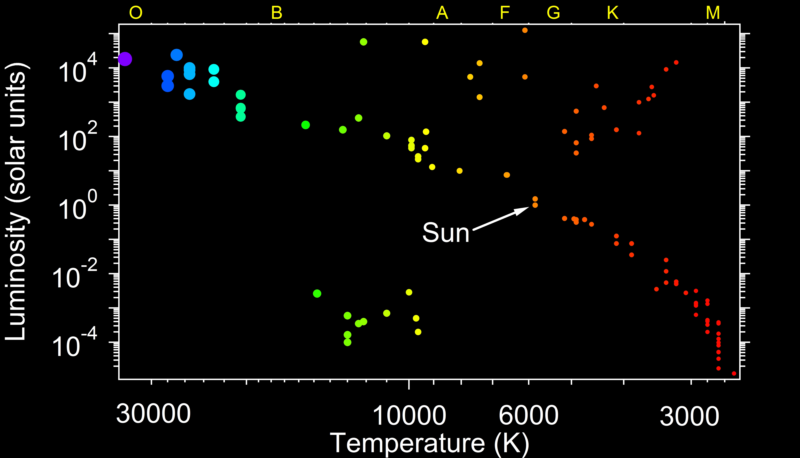
There are four main groups of stars to highlight, each group containing stars at different stages of their life-cycle: Main sequence, Giants, Supergiants and White Dwarfs (Figure 13)

Figure 13: The principal star groups

Main Sequence
Once a star has formed and established hydrogen fusion it will occupy a position somewhere along the Main Sequence, a band of stars lying from the upper left to the lower right of the H-R diagram. The position within the main sequence is determined by the mass of the star with the most massive at the upper left and the least massive at the lower right.

The mass of the star also directly influences its surface temperature. High-mass stars have a large gravitational pressure and correspondingly high core temperatures and pressures. This leads to high mass stars having high surface temperatures in the region of 25000 K whilst low mass stars may have surface temperatures as low as 2000 K. As described earlier, this leads to cool, low-mass stars having a red colouration whilst massive stars appear blue-white.

A further consequence of the very high temperatures and pressures in massive stars is that, despite having much larger reserves of hydrogen than smaller stars, they consume their hydrogen supply at such a rate that they are (relatively speaking) very short-lived. Those at the upper left of the diagram have lifetimes of the order of several million years, whilst the smallest, coolest, stars have lifetimes in excess of 300 billion years, or more than 20 times longer than the universe has so far existed for. Our own sun was formed around 4.5 billion years ago and will have a main sequence lifetime of 10 billion years, so it is roughly halfway through its main sequence phase.

Low-Mass Stars

Subgiants & Giants
Towards the end of a low-mass star’s life (such as our sun), it begins to run out of the hydrogen fuelling the fusion reaction. This causes the stellar pressure to decrease which in turn causes the gravitational pressure to compress the core leading to a higher temperature. At this higher temperature helium nuclei begin to fuse to form carbon. The star’s luminosity increases but because the star also expands in volume the surface temperature is lower than would be expected it were still on the main sequence. The star expands and the surface temperature cools passing through the subgiant region and eventually becoming a red giant.

Depending on the mass of the original star, once the helium is exhausted a further contraction raises the core temperature again, carbon atoms begin to fuse to produce neon and magnesium and star expands further.

This process of core compression followed by star expansion occurs for each of the fusion stages in Table 4, but low to medium mass stars are not able to produce elements heavier than carbon and oxygen.

White Dwarfs

As a red giant continues to expand it eventually reaches a size where the outer layers of the star can no longer be retained by gravitational attraction and the star enters the final phase of its lifetime. In terms of the H-R diagram the star moves left and downwards out of the giant region, the outer layers steadily disperse as a planetary nebulae (Figure 14) leaving behind the stellar core. Since fusion no longer occurs in this dead core it steadily cools, moving down the H-R diagram until it becomes an inert white dwarf consisting mostly of carbon and oxygen.

The death of a sun-like star, from the point at which the hydrogen runs out until it becomes a white dwarf is of the order of one billion years, compared with a 10 billion year main sequence lifetime.

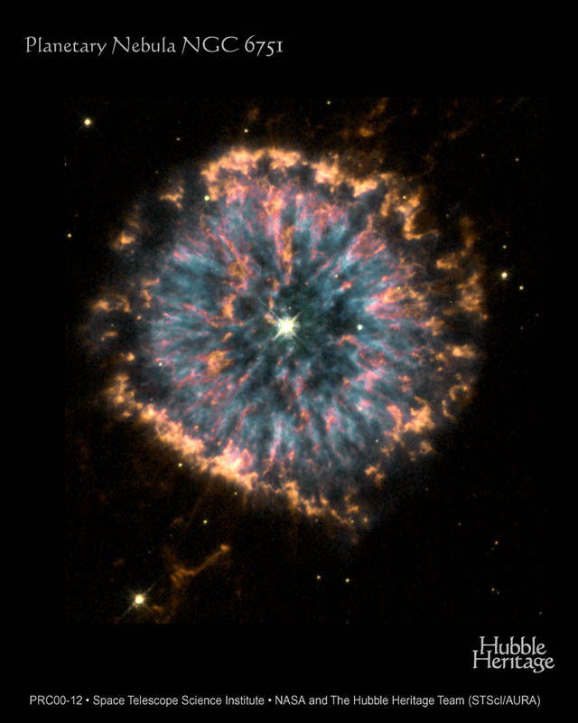High-Mass Stars
Figure 14: The Glowing Eye of Planetary Nebula NGC6751
NASA, The Hubble Heritage Team (STScI/AURA)
Supergiants
The evolution of a high-mass star is similar to that of a low-mass star in the early stages when hydrogen is fused to form helium. However, as the hydrogen runs out and helium fusion begins the process of expansion is much greater then a low-mass star and the star becomes a supergiant. In addition, the high mass means that fusion proceeds through all the stages listed in Table 4.

Neutron Stars, Black Holes and Supernovae
No fusion pathways possible within a star exist beyond iron so ultimately the star accumulates iron in its core. This process proceeds up to the point where the mass and density of the core are so large that gravitational forces cause the core to collapse in on itself.
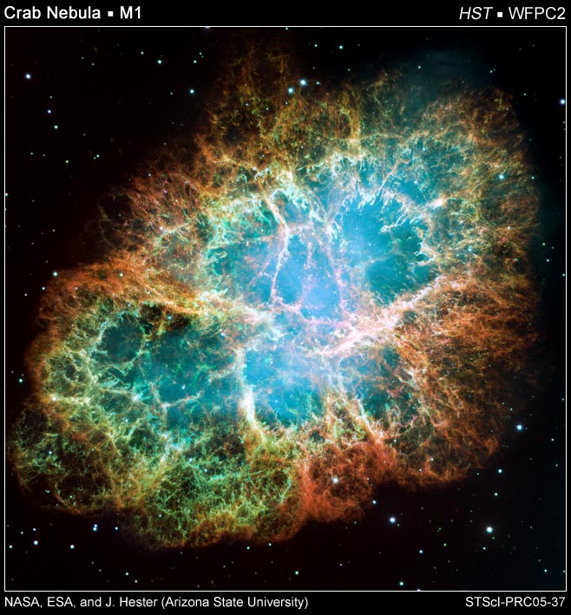Protons and electrons combine to form neutrons and the core collapses to diameter of perhaps a few kilometres, becoming a neutron star. In some cases, where the mass is large enough, the collapse produces an object so small and dense that its gravitational field is too strong even to let light escape from the object. These objects are known as black holes.
Figure 15: Crab Nebula
NASA, ESA, J. Hester and A. Loll (Arizona State University)

This collapse is a sudden and very rapid event, lasting a fraction of a second and releasing enormous amounts of energy. This energy release blows away the outer layers of the star into space and releases a massive burst of radiation known as a supernova. From Earth, the brightest supernovae are seen as a sudden brightening of a star, which lasts from several days to months before gradually fading away. However, the debris from such explosions can remain visible for much longer. An example of this is found in the Crab Nebula (Figure 15). This nebula arose from a supernova observed in China in 1054 A.D. and modern observation confirm that there is a neutron star at the centre of the nebula surrounded by clouds of stellar material expanding at thousands of kilometres per second.

The closest red supergiant to Earth at 310 ly is Betelgeuse in the constellation of Orion. It is not possible to know exactly where it is in its life-cycle but if it happens to have gone supernova during the 18th century you may yet see the visible evidence arriving on Earth.

The death of a high-mass star, from the point at which the hydrogen runs out until it goes supernova is of the order of 1 million years, compared with a 5 million year main sequence lifetime. This is roughly three orders of magnitude shorter than the lifetime of a sun-like star.

Material ejected during a supernova includes all the elements formed by the fusion processes so that when, ultimately, this material condenses to form a new star it will already have some of the heavier elements present within it. However, the quantity of energy available in a supernova is sufficient to bring about the formation of elements heavier than iron.

Cited References

Bennett, J., Donahue, M., Schneider, N. & Voit, M. (2008). The Cosmic Perspective. Fifth Edition. Pearson Addison-Wesley, San Francisco, CA

ITER (2011). http://www.iter.org/ accessed 2011-11-17.

Monteith, J.L. (1973). Principles of Environmental Physics. Edward Arnold, London.

Philip’s (2002). Astronomy Encyclopedia. ed. Moore, P. Philip’s, London.

SIDC (2011). SIDC-team, World Data Center for the Sunspot Index, Royal Observatory of Belgium, Monthly Report on the International Sunspot Number, online catalogue of the sunspot index: http://www.sidc.be/sunspot-data/, 1700-2010. Accessed 2011-11-18.

Singh (2004). Big Bang. Fourth Estate, London.

Wolfram Alpha (2011).
http://www.wolframalpha.com/entities/calculators/luminosity-absolute_magnitude_formula/7m/06/j3/ accessed 2011-11-17.

Young, H.D. & Freedman, R.A. (1996).University Physics, 9th Edition. Addison-Wesley, Reading, MA.

Further Reading

More about The HR Diagram
http://www.astro.ubc.ca/~scharein/a311/Sim/hr/HRdiagram.html

Background to early models and measurements of our Universe.
http://www.splung.com/content/sid/7/page/earlymodels

Further information on fusion.
http://www.splung.com/content/sid/5/page/fusion
but need to check authenticity )

The Big Bang Time Machine
http://resources.schoolscience.co.uk/STFC/bang/bang.htm

More about Brown Dwarfs
http://starchild.gsfc.nasa.gov/docs/StarChild/questions/question62.html
More about Sunspots
http://solarscience.msfc.nasa.gov/feature1.shtml#Sunspots
http://www.eaas.co.uk/news/solar_features.html

More about CCDs
http://www.mssl.ucl.ac.uk/www_detector/optheory/ccdoperation.html#basics
http://www.britastro.org/vss/ccd_photometry.htm
http://www.explainthatstuff.com/howccdswork.html
http://www.maths.qmul.ac.uk/~svv/MTH725U/Lecture2.htm
http://www.opticstar.com/Run/Astronomy/Astro-Editorial-Articles-General.asp?p=0_10_19_1_6_200_30
Neutrinos
http://imagine.gsfc.nasa.gov/docs/science/know_l2/stars.html

Luminosity and Brightness
http://buildingblocksoftware.com/AlbertForrester/Dr_Albert_Forrester/ClassContentCosmologyForEngineers/Entries/2011/11/29_Lecture_2_Notes_files/211_notes_lec_2.pdf

http://www.frankswebspace.org.uk/ScienceAndMaths/physics/physicsGCE/astrophysics2.htm
GLOSSARY of TERMS

Absolute brightness
The absolute brightness is the brightness a celestial body would have were it to be placed at a distance of 10 parsecs from Earth.
http://buildingblocksoftware.com/AlbertForrester/Dr_Albert_Forrester/ClassContentCosmologyForEngineers/Entries/2011/11/29_Lecture_2_Notes_files/211_notes_lec_2.pdf

http://www.frankswebspace.org.uk/ScienceAndMaths/physics/physicsGCE/astrophysics2.htm

Absolute magnitude
This term is used to allow for direct comparison of actual luminosities as it ranks stars by their brightness as if placed 10 pc (32.6 ly) from the earth. There are no units.

Apparent Magnitude
The apparent magnitude of a celestial body is another measure of how bright it is as seen by an observer on Earth. There are no units.

Apparent Brightness
The apparent brightness of a celestial body is how much energy is coming from the body per unit area per unit time, as measured on Earth. The units are watts per square metre (Wm⁻²).

anthropic principle
http://www.allancrossman.com/ap/anthropic.html
http://www.np.ph.bham.ac.uk/history/nucleosynthesis

astronomical unit (AU)
149,597,870 km; the average distance from the Earth to the Sun.

Big Bang
A theory of cosmology in which the expansion of the universe is presumed to have begun with an explosion hence the term "Big Bang".

Brown Dwarfs
An object too small to become a star, although similar but which is not massive enough to burn Hydrogen in its core. Brown dwarfs have a mass less than 0.08M_{sun}, and usually give off infra red radiation.

Chemical species
Chemical species are atoms, molecules, molecular fragments, ions, etc., being subjected to a chemical process or to a measurement.

corona (plural: coronae)
The outer layer of a star's atmosphere. In the Sun, the corona has a temperature > 1,000,000 Kelvin and a low density.

deuterium
An isotope of hydrogen containing one proton and one neutron.

Luminosity
This is a measure of the total power output of a star (W).

neutrino
A fundamental particle produced by the nuclear reactions in stars. They are therefore produced in huge numbers. They are very hard to detect because the majority of them pass through the Earth without interacting making them extremely difficult to detect.
All neutrinos are part of the lepton family of particles. There are three types of neutrino: the electron neutrino (νe), the muon neutrino (νμ) and the tau neutrino (ντ), plus their associated antiparticles, making a total of six.

Nucleosynthesis
The process by which elements heavier than helium are created by nuclear fusion. http://helios.gsfc.nasa.gov/nucleo.html

parsec
A common distance unit used in astronomy which is short for parallax of one arc second. One parsec equals 3.26 light-years, or 3.1 x 10¹⁶ m
http://www.splung.com/content/sid/7/page/magnitude
parallax
The apparent motion of a relatively close object compared to a more distant background as the location of the observer changes. Astronomically, it is half the angle which a star appears to move as the earth moves from one side of the sun to the other.

plasma
Often referred to as the fourth state of matter. A low density gas in which the individual atoms are ionized (and therefore charged) The overall electric charge on the plasma is neutral as the total number of positive and negative charges is equal.

positron
The antiparticle to the electron. The positron has the majority of identical characteristics as an electron but is positively charged.

scientific notation
A method of displaying very large or very small numbers often used by Scientist. This method requires one digit to be written before the decimal point and the rest as a decimal fraction. The remainder of the number is displayed as a power of 10.

solar flares
A solar flare is an intense change in brightness on the surface of the Sun due to violent eruptions the Sun's surface. The flare ejects clouds of electrons, ions, and atoms and electromagnetic radiation across the whole spectrum into space. Flares occur in active regions around sunspots, where intense magnetic fields infiltrate the photosphere.

Solar Neutrino Problem
The problem facing Scientists astrophysicists and nuclear physicists alike for more than 30 years, in that the number of solar neutrinos predicted did not match with the number predicted from the theories of how the sun produced its energy. This was resolved when more sensitive ways of measuring all three types of neutrinos were produced.

Stefan-Boltzmann constant; σ (sigma)
The constant of proportionality present in the Stefan-Boltzmann law. It is equal to 5.6697 x 10⁻⁸ Watts per square meter per Kelvin to the fourth power
(Wm⁻² K⁴)

Stefan-Boltzmann law
The radiated power P (rate of emission of electromagnetic energy) of a hot body is proportional to the radiating surface area, A, and the fourth power of the thermodynamic temperature, T. The constant of proportionality is the Stefan-Boltzmann constant.

stellar classification
Stars are given a designation consisting of a letter and a number roughly dependent on their surface temperature. The main classes are: O, B, A, F, G, K, and M; O stars are the hottest; M the coolest. Stars are further subdivided into numbers in each of the major classes., for example the Sun is classified as G2. The classes are oddly sequenced because they were assigned long ago before the Science behind the concept was fully understood. O and B stars are rare but very bright; M stars are numerous but dim.

sunspots
Are visible dark regions on the photosphere of the Sun. These are cooler regions on the sun where the magnetic field loops up out of the solar surface.

We cannot observe the universe beyond approx. 14 billion light year as light has not had time to reach us and looking beyond this would be looking back beyond the time when the universe existed.

