Space terms
Planet | An object that does not undergo nuclear fusion but orbits a star/sun.
Dwarf planet | An object that orbits a star and is similar to a planet but is not large enough to clear its orbital path of debris.
Moon | A natural satellite that orbits a planet
Star | A large ball of hot gases that is undergoing nuclear fusion and emitting electromagnetic radiation.
Sun | A star at the centre of a solar system
Asteroid | An object that orbits the sun that does not fulfil planetary criteria
Solar system | A central star orbited by planets
Exoplanet | A planet outside our solar system that orbits a star
Galaxy | A cluster of gravitationally bound stars, gas and dust clouds.
Universe | Consists of many galaxies separated by empty space.

Note you are not weightless in space. The gravitational field strength at the height of the ISS is approx. 8.7 N kg⁻¹. You feel weightless as you are continually falling and have no reaction force pushing you up. Astronauts lose bone density on long trips and have to exercise (but not weight lifting!) to prevent this, eg rowing machines, resistance bands. |  | 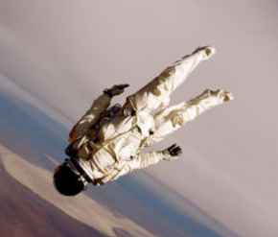
Satellites  A satellite is an object that orbits a planet. There are two types of satellite: natural and artificial- an example of a natural satellite is the moon.  A geostationary satellite is a satellite that has a period of 24 hours and orbits the Earth’s equator at an altitude of 36 000 km. It remains above the same point on the Earth’s surface. Beneficial as ground based tracking satellites don’t need to keep moving to remain aligned. It has a greater speed than the planet as it is travelling a greater distance in the 24 hours.  Satellites can be used for many things: GPS, weather forecasting, communications, scientific discovery and space exploration (eg Hubble telescope, ISS) The period of a satellite is the time taken to orbit the planet. The period of a satellite increases as height of orbit increases, @36 000 km a period of 24hours, < 36 000 km less than 24 hours, >36 000 km >24 hours!  A satellite must be accelerating as its direction is continually changing. Satellites are kept in orbit as they have a high horizontal velocity as well as an acceleration due to gravity downwards. As the satellite falls the Earth falls away |  |  |  |  |  |  |  | 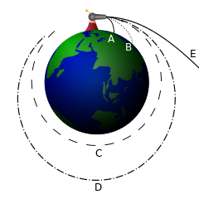  Newton’s Thought Experiment  A satellite can be put into space if it is given a horizontal velocity great enough. Too great and the object would move out of orbit.
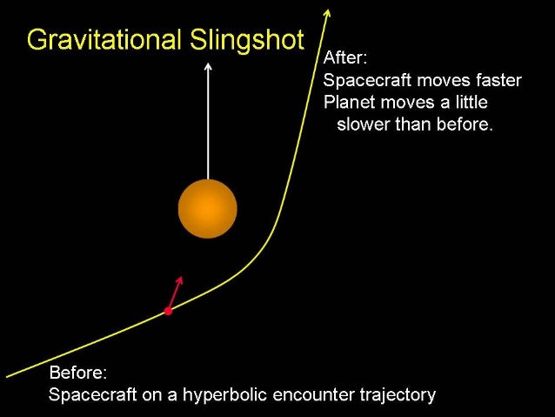 |  |  |  | Catapult/Gravity Assist /Gravity Slingshot  - Gravity assist manoeuvres an object close to a planet/large asteroid so it accelerates towards them but misses it  - When travelling close to planet/asteroid, object will accelerate due to force of gravity. The acceleration increases the velocity, meaning it flies past the asteroid/planet at a greater velocity than before.  Travelling large distances through space using a ‘catapult’ is possible. The spacecraft receives a gravitational slingshot/boost/catapult from a fast moving asteroid, moon or planet. The spacecraft gains kinetic energy/ speed and a change in direction, the celestial object is slowed (but not noticeably due to the massive size of the celestial object compared to the spacecraft)
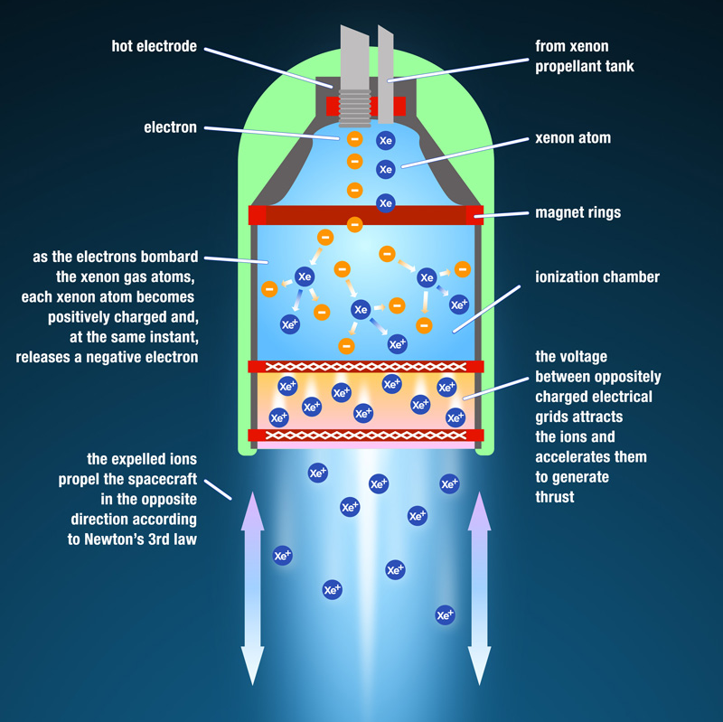 |  |  |  |  |  |  | Ion Drive  Ion drives accelerate Xenon ions between two metal plates.  These ions are ejected at a very high velocity  This provides a small but constant thrust (Newtons third law)  Challenges of Space Travel:  - High levels of radiation / cosmic rays can affect astronauts.  - Fuel load on take off  - Pressure differentials  - Sheer size of space  - Great amount of fuel required  - Huge amounts of energy required to get into orbit  - Docking  - Being hit by fast moving objects.  - Extremes of temperature (hot in sun, cold in shade)  - Expensive  - Very high temperatures during re-entry  - Potentially a one way trip!
Ion drives allow potential space travel across large distances by attaining high velocity by using ion drive which produces a small unbalanced force over an extended period of time. Not much mass needs to be carried and they work without the need to burn oxygen.
Benefits of Space Exploration  - Development of new technology not just used in Space – water filters, smoke detectors, enriched baby food  - Satellites have improved communication worldwide  - Understanding of Nature/Universe  - Innovation/Culture/Curiosity |  |  |  |  |  |  | Light Year  A light year is the distance light can travel in one year.  $$d = vt$$  d = 3x10⁸ x 365 x 24 x 60 x 60  d = 9.47x10¹⁵m  d ≈ 9.5x10¹⁵m
When we are looking at stars we are looking back in time. The light from our second nearest star set off about 4.3 years ago (it is 4.3 ly away). So if you are around 16 years it set off when you were 11 or 12 years old.
Weight
W
m
g
Use W = mg and data sheet to calculate weight on other planets $W=mg$
W = Weight (N)
m = mass (kg)
g = gravitational field strength (N/kg)
Check out the data sheet on P2 of the exam paper for the values
Why doesn’t a spacecraft need its engines on?  There is zero friction in space so no force of friction to overcome. The spaceship will travel at constant velocity/ speed in a straight line, unless acted on by an unbalanced force.  Very little fuel is required to maintain motion and only small energies are needed to change direction. Slowing down needs to be done carefully with small forces produced in the opposite direction to the motion. |  |  |  |  | The Big Bang Theory  The Big Bang Theory suggests that the universe was formed by a rapid expansion from a very hot single point of matter, and continues to expand and cool to this day.  Evidence for the Big Bang Theory comes from the presence of Cosmic Microwave Background Radiation and Redshift.  Redshift shows the galaxies are moving away from each other which would suggest at one point they were all at the same point.  The current estimated age of the Universe is 13.8 billion years old
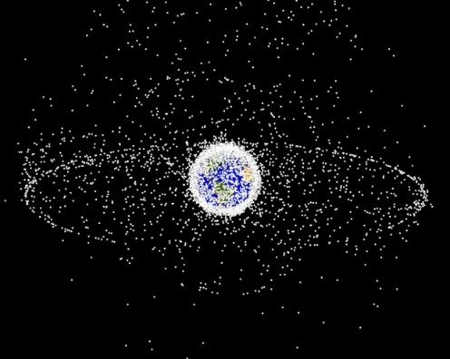 |  |  | Images of satellites and redundant satellites and space junk above the Earth. Notice the geostationary orbut that looks pretty full
Telescopes  Astronomers use telescopes that detect different parts of the electromagnetic spectrum. Each type of telescope can only detect one part of the electromagnetic spectrum. There are radio telescopes, infrared telescopes, optical (visible light) telescopes and so on. Stellar Spectroscopy is the study of the spectra of starlight. It is a very powerful tool that enables astrophysicists to infer many physical and chemical properties of stars and classify them into a logical sequence. e.g temperature, ages, size, life cycle |  |  |  |  | 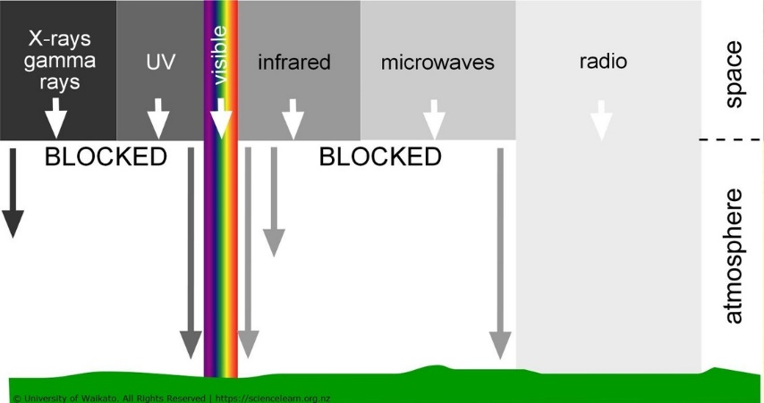
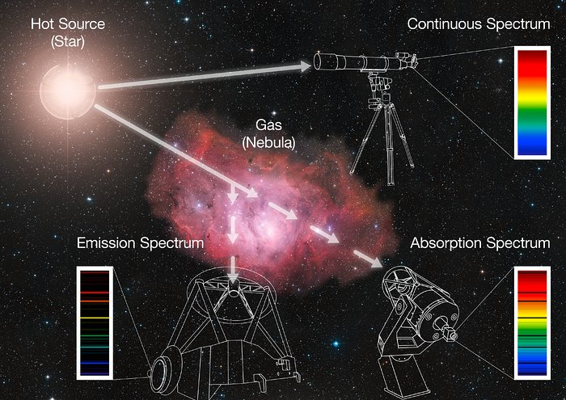
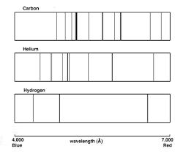
Spectra
Spectra can be used to identify elements present in stars.
By comparing the line spectra of different elements with the line spectra of stars, the elements present within stars can be identified.
Energy supply in Space  Sufficient energy to operate life support systems in a spacecraft is usually solved with using solar cells. The more energy and the further from the Sun the great the area of solar cells required. | Line emission spectrum  Continuous Spectrum  Absorption Spectrum |  |  |  | 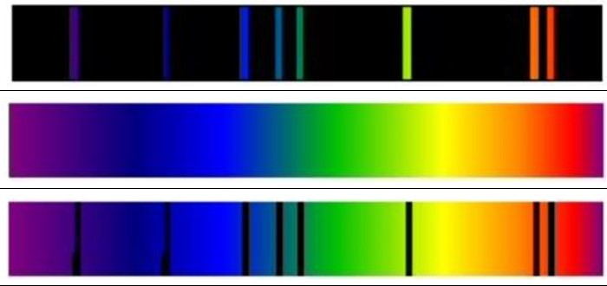
Solar cells should be adjusted to face the Sun directly or a greater area of solar cells is required.
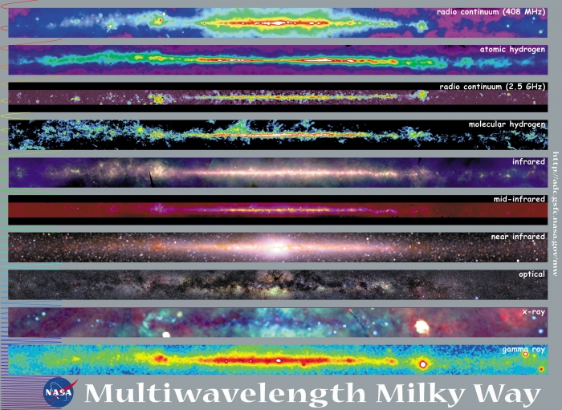
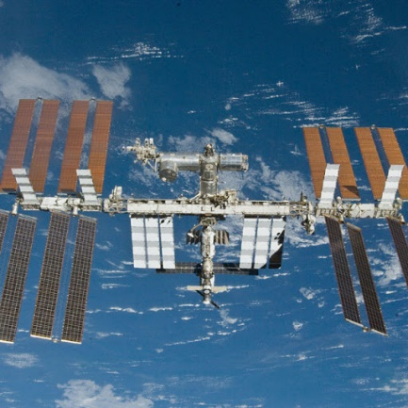
The ISS, the size of a large football pitch.

The view of our galaxy, the Milky way in different wavebands

