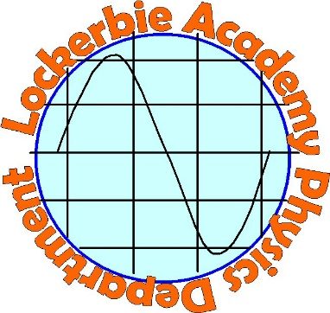
  S3 ReNEWABLES  A COURSE DESIGNED TO IMPROVE SKILLS AFTER COVID. | Abstract  Upskilling students with Physics Skills, covering Think Like a Physicist, Variable, Referencing and Renewable Investigations including presenting your findings  Mrs Hargreaves  [Course title]

Referencing

3. Referencing
In Science you will often be asked to reference your work. This is so that others can find your source of information and check it.
https://www.youtube.com/watch?v=-JV9cLDCgas
https://www.youtube.com/watch?v=rNf8HMsuxyM
https://secondary.oslis.org/

Referencing Questions
https://www.youtube.com/watch?v=rNf8HMsuxyM
- Where have you seen referencing before?
- What is Wikipedia’s way of saying “How do you know this?”
- Give 3 reasons why referencing is important.
- What is plagiarism?
- List situations where you need to reference.
- List situations where you do not need to reference.

Plagiarism happens when a student submits an assignment that contains work that is not their own, without acknowledging their sources in the form of references.
There are many different types of reference styles and when you go on to further studies it is important to use the ones they give you. We will concentrate on
- HARVARD
- VANCOUVER
As these are the ones used in Physics by the SQA.

WHAT SHOULD I REFERENCE?
You should include a reference for all the sources of information that you use when writing
or creating a piece of your own work.

WHAT IS A CITATION?
When you use another person’s work in your own work, either by referring to their ideas,
or by including a direct quotation, you must acknowledge this in the text of your work.
This acknowledgement is called a citation

HARVARD REFERENCING
Also known as 'author-date' style. In Harvard style the in-text citation can be in brackets in the body of the text or in footnotes, and uses the author's surname and the date of publication, with the page number if it is a reference to a particular page. Full details are only listed in the bibliography or reference list.

VANCOUVER REFERENCING
In Vancouver referencing, which is a numeric referencing style, each source is given a number which corresponds to the order in which it appears in the text. If the same source is referred to again in the text, the same number is used. The reference list comprises a single numbered list of citations with full details. You may also include a separate bibliography, alphabetically ordered by author, which lists works that you have used as part of your research for your assignment but not cited in the text.
Let’s take a look at this

HARVARD

https://www.youtube.com/watch?v=iueqJ78iAwk
https://www.youtube.com/watch?v=NDgqqPvMn0U
https://www.imperial.ac.uk/media/imperial-college/administration-and-support-services/library/public/vancouver.pdf

A quick guide to Harvard referencing
Published on 14 February 2020 by Jack Caulfield. Revised on 22 June 2020.
Referencing is an important part of academic writing. It tells your readers what sources you’ve used and how to find them.
Harvard is the most common referencing style used in UK. In Harvard style, the author and year are cited in-text, and full details of the source are given in a reference list.
In-text citation | Referencing is an essential academic skill (Pears and Shields, 2019).
Reference list entry | Pears, R. and Shields, G. (2019) Cite them right: The essential referencing guide. 11th edn. London: MacMillan.
This quick guide presents the most common rules for referencing in Harvard style.

Harvard in-text citation
A Harvard in-text citation appears in brackets beside any quotation or paraphrase of a source. It gives the last name of the author(s) and the year of publication, as well as a page number or range locating the passage referenced, if applicable:
The novel begins with the grim image of the train passengers’ faces, which are described as ‘pale yellow, the colour of the fog’ (Dostoyevsky, 2004, p. 5).
Note that ‘p.’ is used for a single page, ‘pp.’ for multiple pages (e.g. ‘pp. 1–5’).
An in-text citation usually appears immediately after the quotation or paraphrase in question. It may also appear at the end of the relevant sentence, as long as it’s clear what it refers to.
When your sentence already mentions the name of the author, it should not be repeated in the citation:
Woolf introduces the essay’s topic as ‘women and fiction’ (2000, p. 5), going on to discuss the various connotations of the phrase.

Sources with multiple authors
When you cite a source with up to three authors, cite all authors’ names. For four or more authors, list only the first name, followed by ‘et al.’:
Number of authors | In-text citation example
1 author | (Davis, 2019)
2 authors | (Davis and Barrett, 2019)
3 authors | (Davis, Barrett and McLachlan, 2019)
4+ authors | (Davis et al., 2019)

Sources with no page numbers
Some sources, such as websites, often don’t have page numbers. If the source is a short text, you can simply leave out the page number. With longer sources, you can use an alternate locator such as a subheading or paragraph number if you need to specify where to find the quote:
(Scribbr, para. 4)

Multiple citations at the same point
When you need multiple citations to appear at the same point in your text – for example, when you refer to several sources with one phrase – you can present them in the same set of brackets, separated by semicolons. List them in order of publication date:
Several in-depth studies have investigated this phenomenon during the last decade (Singh, 2011; Davidson, 2015; Harding, 2018).

Multiple sources with the same author and date
If you cite multiple sources by the same author which were published in the same year, it’s important to distinguish between them in your citations. To do this, insert an ‘a’ after the year in the first one you reference, a ‘b’ in the second, and so on:
The results of the first study (Woodhouse, 2018a) were inconclusive, but a follow up study (Woodhouse, 2018b) achieved a clearer outcome.

Creating a Harvard reference list
A bibliography or reference list appears at the end of your text. It lists all your sources in alphabetical order by the author’s last name, giving complete information so that the reader can look them up if necessary.
The reference entry starts with the author’s last name followed by initial(s). Only the first word of the title is capitalised (as well as any proper nouns).
Harvard reference list example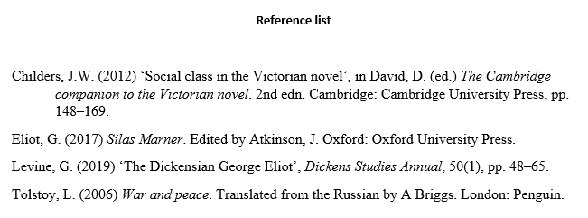

Using an online reference generator
https://www.mybib.com/tools/harvard-referencing-generator
https://www.citethisforme.com/uk/referencing-generator/harvard
https://www.uwslondon.ac.uk/free-harvard-referencing-generator/
https://www.ukessays.com/referencing/harvard/generator/website.php
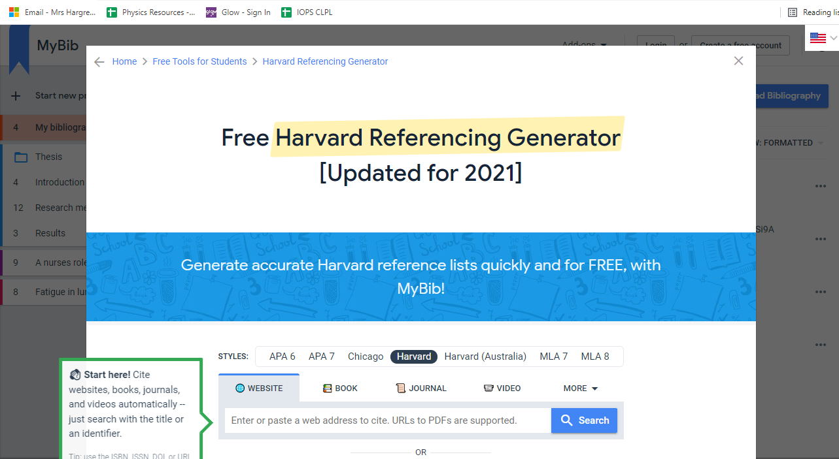

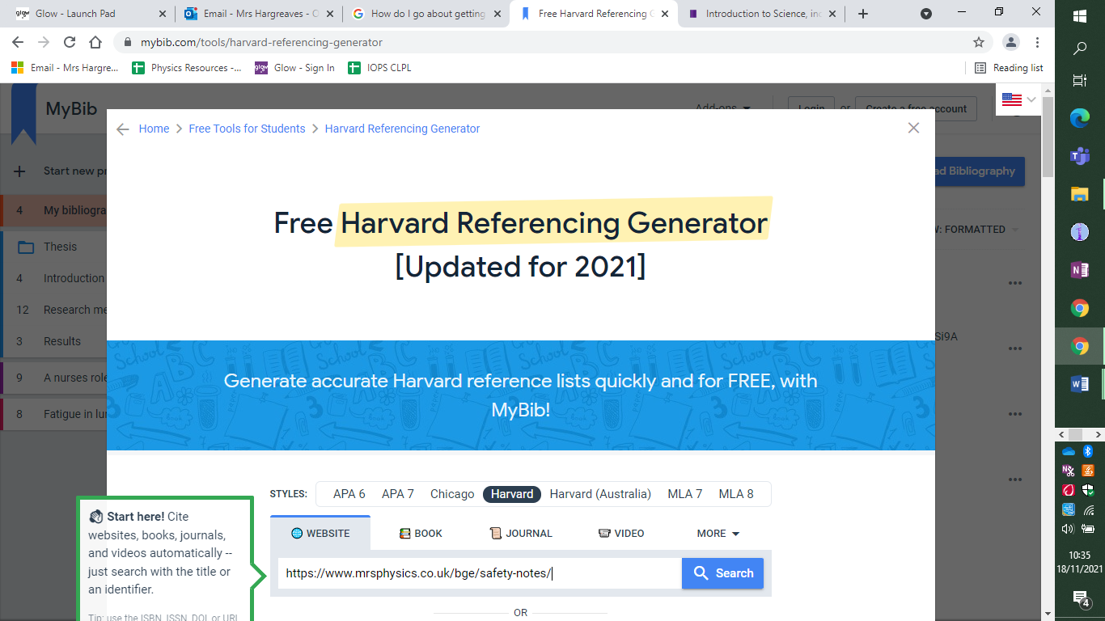

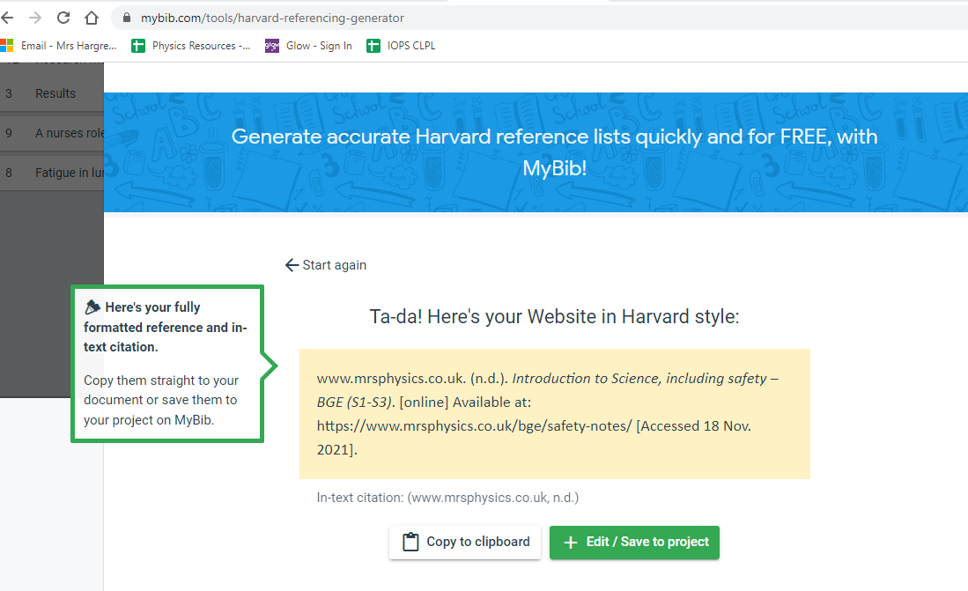Here is the final reference and how I’d use it
The SAL’s passport has all the skills that you need to acquire for a good score in your BGE Science (www.mrsphysics.co.uk, 2018.)
References
www.mrsphysics.co.uk. (2018.). Introduction to Science, including safety – BGE (S1-S3). [online] Available at: https://www.mrsphysics.co.uk/bge/safety-notes/.
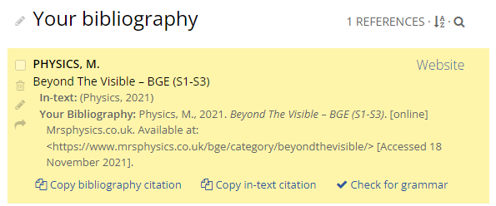

Task
- Find 4 different websites about Challenges of Space Travel, find a paragraph or sentence on each and use the Harvard Referencing System to properly reference your paragraphs.
- Use one of the reference sites below to properly make up your Reference Section.

https://www.mybib.com/tools/harvard-referencing-generator
https://www.citethisforme.com/harvard/source-type

Vancouver
https://www.youtube.com/watch?v=o-YB6JNbIzI
https://www.youtube.com/watch?v=06eWNDs6Mck
https://www.imperial.ac.uk/media/imperial-college/administration-and-support-services/library/public/vancouver.pdf
http://medevent.vn/vie/Assets/Congress/INC%202014/Docs/vancouver%20reference.pdf

https://www.scribbr.co.uk/referencing/vancouver-style/
Vancouver is a system of referencing commonly used in biomedicine, among other scientific disciplines. In Vancouver style, you place a reference number in the text wherever a source is cited:
Davies et al. state that the data is ‘unreliable’ (1, p. 15).
This number corresponds to an entry in your reference list – a numbered list of all the sources cited in your text, giving complete information on each:
1. Davies B, Jameson P. Advanced economics. Oxford: Oxford University Press; 2013.
This quick guide presents the most common rules for Vancouver style referencing.

Vancouver in-text citations
In Vancouver style, citations are marked in your text with numbers. These numbers appear either in brackets or in superscript – choose one option and stick to it consistently:
Brackets numbering Superscript numbering
Levitt (2) argues that … Levitt² argues that …
The numbers usually appear after the name of the author or after a direct quote. They may also appear at the end of the sentence:
This phenomenon is increasingly relevant to the discipline (3).

Naming authors
You will often need to mention the author when referring to a work or introducing a quote. Only use the author’s last name in your text. If a source has multiple authors, name only the first author followed by ‘et al.’:
Davies et al. (1) argue that …
It’s not always necessary to mention the author’s name in your text – but always include the reference number when you refer to a source:
Another study (13) explores the concept of …

Numbering references
Sources are numbered based on the order in which they are cited in the text: the first source you cite is 1, the second 2, and so on.
If the same source is cited again, use the same number to refer to it throughout your paper. This means that the numbers might not appear in consecutive order in your text:
Collins et al. (1) argue that this technique is highly effective. However, another study (2) conducted into the technique has raised doubts about the replicability of these results. Collins et al.’s conclusion that the technique is ready for ‘large-scale application’ (1, p. 15) in medical practice should therefore not be accepted without further investigation.

Citing multiple sources
You can also cite multiple sources in the same place:
Several studies (8, 12) indicate a similar effect.
To cite several sources that appear consecutively in your numbered list, you can use an en dash to mark the range.
There is a large body of research (1, 4–7) exploring this phenomenon.
In this case, the citation refers the reader to sources 1, 4, 5, 6, and 7.

Citing page numbers
You must specify a page number or range when you directly quote a text, and it can be helpful to do so when you are paraphrasing a particular passage.
Place the page number after the reference number inside the same parentheses, preceded by ‘p.’:
Bute refers to his project as ‘a madcap journey through America’s disciplinary institutions’ (4, p. 499).
If you’re using superscript numbers, the page number also appears in superscript, in brackets after the reference number:
… ‘a madcap journey through America’s disciplinary institutions’.⁴ (p. 499)

Creating a Vancouver reference list
Your reference list is where you provide the information your readers will need in order to look up the sources cited in your text. It consists of a numbered list of all your sources, providing key information including the author, title and publication date of each source.
The list appears in numerical order at the end of your paper. Each entry ends with a full stop, unless the last element is a DOI or URL.

Vancouver reference list example
Author names
Each entry starts with the author’s last name and initials.
When a source has more than one author, their names are separated by commas. If a source has more than six authors, list the first six followed by ‘et al.’
1 author Shields G.
2–6 authors Johnson FH, Singh J.
7+ authors James F, Pieters J, Deptford G, Harrison R, Bregman E, Empson A, et al.
Source titles
Only the first word of the title and subtitle, along with any proper nouns, are capitalised:
The Cambridge companion to the philosophy of biology.
Titles in Vancouver referencing are consistently written in plain text. Do not use italics or quotation marks.

Vancouver reference examples
The information you provide differs according to the type of source you’re citing, since different details are relevant in different cases. Formats and examples for the most commonly cited source types are given below.
Format x. Author(s). Title. Edition. Place of publication: Publisher; Year.
Example 1. Wilkinson IB, Raine T, Wiles K, Goodhart A, Hall C, O’Neill H. Oxford handbook of clinical medicine. 10th ed. Oxford: Oxford University Press; 2017.
Notes
Editions are given (in abbreviated form) only when referring to an edition other than the first.
Missing information in Vancouver references
Some sources will be missing some of the information needed for a complete reference. See below for how to handle missing elements.
No author
As shown in the website example above, when no individual author is named, you can usually name the organisation that produced the source as the author.
If there is no clear corporate author – for example, a wiki that is created and updated collaboratively by users – you can begin your reference with the title instead:
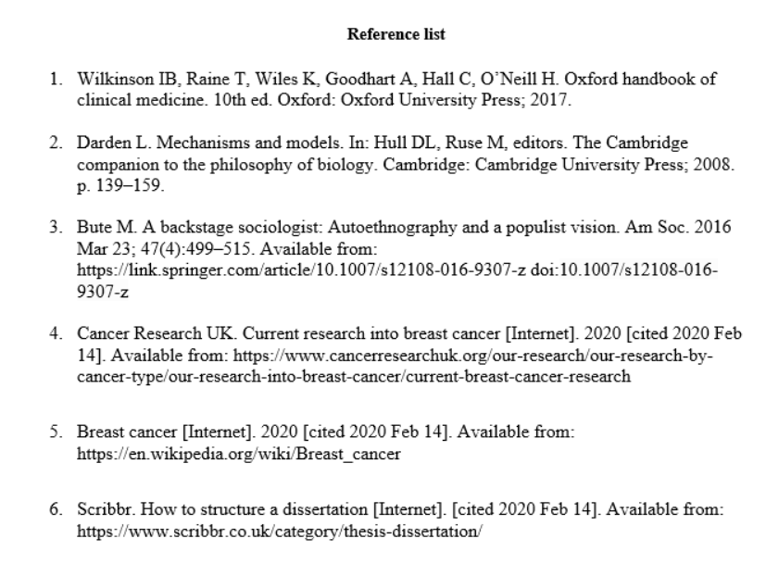No page numbers
You may want to show the location of a direct quote from a source without page numbers, such as a website. When the source is short, you can often just omit this, but where you feel it’s necessary you can use an alternate locator like a heading or paragraph number:

NASA calls the telescope ‘the most significant advance in astronomy since Galileo’s telescope’ (5, para. 5).

Vancouver Reference Generator
https://www.citethisforme.com/vancouver
https://www.citethisforme.com/citation-generator/vancouver-referencing-generator
https://app.bibguru.com/p/1e7d9670-2f38-40bc-bba2-dcb11a9a018d
https://www.ukessays.com/referencing/vancouver/generator/

TASK
Do some research about fossil fuels, you can give a broad outline of something that interests you, or choose something from the list below:
- What are fossil fuels?
- How are fossil fuels formed?
- Why should we reduce our use of fossil fuels
- What happens when we use fossil fuels.
Reference your work with at least 4 sources of information in the Vancouver style.
You can use one of the Vancouver style reference generators
Will I do the same work as everyone else in my class?
What about teamwork?

