
2025
Mrs Hargreaves
2/3/2025


N5: Dynamics 2024
Gravitational field strengths
Gravitational field strength
on the surface in N kg⁻¹
Earth | 9·8 |  |  | Specific heat capacity of materials
Jupiter | 23 |  |  | Material |  | Specific heat capacity in J kg⁻¹ ºC⁻¹
Mars | 3·7
Mercury | 3·7 |  |  | Alcohol |  | 2350
Moon | 1·6 |  |  | Aluminium |  | 902
Neptune | 11 |  |  | Copper |  | 386
Saturn | 9·0 |  |  | Glass |  | 500
Sun | 270 |  |  | Ice |  | 2100
Uranus | 8·7 |  |  | Iron |  | 480
Venus | 8·9 |  |  | Lead |  | 128
 |  |  |  | Oil |  | 2130
 |  |  |  | Sea water |  | 3900
Specific latent heat of fusion of materials |  |  |  | Water |  | 4180
Material |  | Specific latent heat  of fusion in J kg⁻¹
 |  | Specific latent heat  of fusion in J kg⁻¹ |  | Melting and boiling points of materials
Alcohol |  | 0·99 × 10⁵ |  | Material | Melting point in ºC |  | Boiling point in ºC
Aluminium |  | 3·95 × 10⁵
Carbon dioxide |  | 1·80 × 10⁵ |  | Alcohol | −98 |  | 65
Copper |  | 2·05 × 10⁵ |  | Aluminium | 660 |  | 2470
Iron |  | 2·67 × 10⁵ |  | Copper | 1077 |  | 2567
Lead |  | 0·25 × 10⁵ |  | Glycerol | 18 |  | 290
Water |  | 3·34 × 10⁵ |  | Lead | 328 |  | 1737
 |  |  |  | Iron | 1537 |  | 2737
Specific latent heat of vaporisation of materials
Material |  | Specific latent heat of vaporisation in J kg⁻¹
Alcohol |  | 11·2 × 10⁵
Carbon dioxide |  | 3·77 × 10⁵
Glycerol |  | 8·30 × 10⁵
Turpentine |  | 2·90 × 10⁵
Water |  | 22·6 × 10⁵

N5 PHYSICS DATA SHEET

Relationships Sheet
The formulae highlighted are those that are required for this unit.

Contents
Units, Prefixes and Scientific Notation 5
Summary 7
Speed 7
Average Speed 8
Instantaneous Speed 9
Required Experiments for National 5 10
Summary 14
Scalars & Vectors 15
Vector Addition 17
Summary 25
Acceleration 25
Prescribed Pratical 3 29
Summary 31
Velocity-Time Graphs 32
Summary 48
Newton’s Laws 48
Contact and Non-Contact Forces 49
Mass and Weight 49
My Weight on other planets 50
Forces and the Newton Balance 52
Hooke’s Law 53
Newton’s Laws of Motion 54
Homework 57
Difference between Newton’s first and third laws 60
Gravitational Field Strength and Acceleration Due to Gravity 61
Friction 63
Questions 66
Summary 71
Energy 72
Conservation of Energy 72
Work Done and Energy 73
Work Tutorial 76
Kinetic energy Questions 82
Summary 86
Power 87
Projectile Motion 89
Projectiles 94
Useful Resources 101

Units, Prefixes and Scientific Notation

Contents Statements
0.1 | I know the units for all of the physical quantities used in this unit.
0.2 | I can use the prefixes: micro ( μ ), milli (m), kilo (k), mega (M) and Giga (G)
0.3 | I can give an appropriate number of significant figures when carrying out calculations (This means that the final answer can have no more significant figures than the value with least number of significant figures used in the calculation).
0.4 | I can use scientific notation when large and small numbers are used in calculations.

SI Units
In Physics we always use the International System of Units (SI Units for Système International d'Unités) which is the standard across the globe (aside from the United States because they have to be special –see the story about the time NASA lost a billion dollar Mars orbiter because a contractor used Imperial units instead of SI units).
There are only 7 base units/quantities in SI units. All other units are derived from these base units, which are as follows.
Quantity | Quantity Symbol | Unit | Unit Symbol
Length | d | metre | M
Mass | m | kilogram | kg
Time | t | second | s
Electric Current | I | Ampere | A
Temperature | T | Kelvin or Celsius | K or ºC
Luminous Intensity |  | candela | cd
Amount of Substance |  | mole | mol
These SI units can be used in conjunction with the prefixes and scientific notation to express very big or very small values.

Prefixes & Scientific Notation
Throughout the course, attention should be given to units, prefixes and scientific notation.
Prefix | Symbol | Power | Multiplier
Tera | T | 10¹² | x 1,000,000,000,000
Giga | G | 10⁹ | x 1,000,000,000
Mega | M | 10⁶ | x 1,000,000
Kilo | k | 10³ | x 1,000
Centi | c | 10² | /100
Milli | m | 10⁻³ | /1,000
Micro | µ | 10⁻⁶ | /1,000,000
Nano | n | 10⁻⁹ | /1,000,000,000
Pico | p | 10⁻¹² | /1,000,000,000,000

In this section the prefixes you will use most often are milli (m), micro (µ), kilo (k), mega (M) and giga (G). It is essential that you use these correctly in calculations.
In Physics, the standard unit for time is the second (s) and therefore if time is given in milliseconds (ms) or microseconds (µs) it must be converted to seconds. Do not confuse milliseconds (ms) with the unit of speed (ms⁻¹)!.. and remember there are no SECS in Physics.

Examples
1 A car takes 2 ms to pass a point in the road. Express this in seconds.
Solution: 2 ms = 2 milliseconds = $2×10$⁻³ s = 2/1000 = 0.002 seconds.
In Physics, the standard unit for distance is the metre (m) and therefore if distance is given in kilometres (km) it must be converted to metres.

2. A car travels 15.6 km in ten minutes. Determine the distance in metres. Solution: 15.6 km = 15.6 kilometres = $15.6×{10}^{3}$ m = $15.6×1000$= 15 600 metres.
b) What is this time expressed in seconds?
Solution: 10 mins = 10 $×60$ s = 600 = 600 seconds.

3. An object experiences a force of 15 kN. Express this in Newtons.
Solution: 15 kN = 15 kiloNewtons = $15×{10}^{3}$ N = $15×1000$ = 15 000 Newton

Practice
Convert the following numbers into their prefixes.
 | 4x10⁷ m |  | 3.2 x10⁷ ms⁻¹
 | 7.25 x10⁻¹⁰ kg |  | 9.356x10² V
 | 23500000 Hz |  | 0.000234 s
 | 0.0304 m |  | 6.9 x10⁻⁶ A
It is OK (in Physics) to write numbers as 45 ×10³ kg. You do not need to convert it to 4.5×10⁴ kg as you would have to in Maths, although it is probably better if you do. Your calculators can do this for you. Check that you know how using the SCI menu.
Convert the following to 3 significant figures.
- 23 760 000 V | e. | 78 945 379.97 Hz
- 7 600 043.7 ms⁻¹ | f.
- 1 254 879 V | g.
- 67 593 268.0076 m | h. | 1 214 687 A

Summary
The following are the outcomes that you ought to have covered in this section.
I know the units for all of the physical quantities used in this unit.
I can use the prefixes: micro ( μ ), milli (m), kilo (k), mega (M) and Giga (G)
I can give an appropriate number of significant figures when carrying out calculations (This means that the final answer can have no more significant figures than the value with least number of significant figures used in the calculation).
I can use scientific notation when large and small numbers are used in calculations.

Speed

Content Statements
1.6 | I can perform calculations involving the relationship between speed, distance and time (d=vt)
1.8 | I can determine average and instantaneous speed.
1.9 | I can describe experiments to measure average and instantaneous speed.

Speed =distance ÷ time
Speed is described by the equation below.
Speed is the distance travelled in unit time (distance travelled per second)
$$speed=\frac{distance}{time} v= \frac{d}{t}$$

Symbol | Definition | Unit | Unit Symbol
v | speed | metres per second | ms⁻¹
d | distance | metre | m
t | time | second | s

We use the letter v to represent speed as it is used for the similar term velocity, although these terms are different. s is also used for the quantity displacement, which we will meet later.
d
$$t$$
$$\overline{v}$$
But don’t use the triangle unless you absolutely have to.
To rearrange, you can use the following triangle:

Average Speed
The average speed of an object is defined as the total distance travelled divided by the time for the journey, or the rate of covering a distance.
This is shown by the equation:$$\overline{v}=\frac{d}{t}$$
The bar over any quantity in Physics denotes that it is an average value.

Examples
Tony walks 40m in 30s what is his average speed?
$\overline{v}= ?$ $\overline{v}=\frac{d}{t}$
$d=40m$ $\overline{v}=\frac{40}{30}$
$t=30s$ $\overline{v}=1$ms⁻¹
You could write 1.3ms⁻¹ or 1.33ms⁻¹ or 1.333ms⁻¹ and get the mark. If you write 1.33. ms⁻¹ or 1 $\frac{1}{3}$ ms⁻¹ or 1.333333 ms⁻¹ you lose the mark for the answer! This is because you have used too many significant figures. Mrs H calls this “calculator diarrhoea” and you can fix it by always ensuring that the number of significant figures you have are no more than the number of sigfig in the quantities you calculated the answer from.

Measuring Average Speed
To measure the average speed you need to measure the distance for the whole journey and measure the time taken for the whole journey. The distance can be measured with a trundle wheel, tape measure etc., and the time can be measured with a stop watch. Use the formula:$$\overline{v}=\frac{d}{t}$$
…to calculate the average speed for the journey.
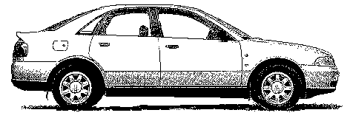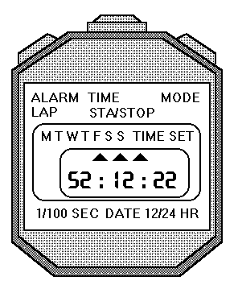
distance
Measure the distance travelled by the car using a trundle wheel/tape measure etc. Measure the time for the journey with a stopwatch. Use
speed=distance/time

Instantaneous Speed
The instantaneous speed of a vehicle at a given point can be measured by finding the average speed during a very short time as the vehicle passes that point. Average speed and instantaneous speed often have very different magnitudes (size) e.g. the average speed of a runner during a race will be less than the instantaneous speed as the winning line is crossed, due to the need to accelerate at the beginning of the race, or if you are on a car journey and need the services, your instantaneous speed when parked up, will be different from your average speed for the whole journey.
$$v=\frac{∆d}{∆t}$$
The symbol Δ is used in physics to denote a small change in. For example, the change in time is very short as is the distance measured. Or use the symbol l to represent the length of the vehicle, and Δt as the time to pass a point.
$v=\frac{l}{∆t}$
The instantaneous speed of an object is defined as the length of the vehicle divide by the time to pass a point.

Measuring Instantaneous Speed
To measure instantaneous speed, it is necessary to be able to measure very short times. With an ordinary stopclock, human reaction time introduces large errors. These can be avoided by using electronic timers. The most usual is a light gate.
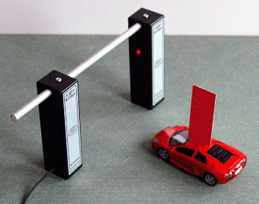
A light gate consists of a light source aimed at a photocell. The photocell is connected to an electronic timer or computer. The timer measures how long an object takes to cut the light beam. The distance travelled is the length of the object which passes through the beam. Often a card is attached so that the card passes through the beam. The length of the card is easy to measure using a rule. The instantaneous speed as the vehicle passes through the light gate is then calculated using:
$$v=\frac{d}{t}$$
Definition | Symbol | Unit | Unit symbol
speed of vehicle | $$v$$ | metre per second | ms⁻¹
length of card | $$d$$ | metre | m
time | t | second | s

Example
A vehicle moves through a light gate as shown in the diagram. Using the data from the diagram, calculate the instantaneous speed of the vehicle as it passes the light gate.
Solution
$$v=\frac{d}{t}$$
$$v=\frac{0.025}{0.25}$$
$$v=0.1 ms^{-1}$$

Light gate connected to interface & computer
0.25 s
2.5 cm

Required Experiments for National 5

Measuring the Average Speed of a Vehicle
Aim: Measurement of average speed of a trolley
Apparatus: Runway, trolley with single mask, light gate, computer timer, metre rule
Instructions
- Measure distance, d, between the two light gates.
- Set the computer to measure the time between the trolley passing through the light gates.
- Release the trolley and record the time, t.
- Calculate average speed ṽ = d / t
- Repeat several times and calculate an average.
Evaluation
Look over your results and comment on the accuracy and precision

Measuring the Instantaneous Speed of a Vehicle
Aim: Measuring the instantaneous speed of a vehicle
Apparatus Runway, trolley with single mask, light gate, computer timer, ruler.
Instructions
- Measure distance, d, between the two light gates.
- Set the computer to measure the time between the trolley passing through the light gates.
- Release the trolley and record the time, t.
- Calculate average speed ṽ = d / t
- Repeat several times and calculate an average.
Evaluation
Look over your results and comment on the accuracy and precision

Speed, Distance and Time Calculations
- A runner completes a 200 m race in 25 s. What is his average speed in ms⁻¹?
- A friend asks you to measure his average cycling speed along flat road. Describe which measurements you would take and the measuring instruments you would use.
- An athlete takes 4 minutes 20 s to complete a 1500 m race. What is the average speed?
- On a fun run, a competitor runs 10 km in 1 hour. What is her average speed in
  - kmh⁻¹ b) ms⁻¹?
- Describe how you could measure the average speed of a car as it passes along the road outside your school/college.
- Concorde can travel at 680 ms⁻¹ (twice the speed of sound). How far will it travel in 25 s at this speed?
- A girl can walk at an average speed of 2 ms⁻¹. How far will she walk in 20 minutes?
- How long will it take a cyclist to travel 40 km at an average speed of 5 ms⁻¹?
- How long (to the nearest minute) will the Glasgow to London shuttle take if it flies at an average speed of 220 ms⁻¹ for the 750 km flight?
- How long, to the nearest minute, will a car take to travel 50 km if its average speed is 20 ms⁻¹?
- Look at this timetable for a train between Edinburgh and Glasgow:
Station | Time | Distance from Glasgow
Glasgow | 08:00 | 0 km
Falkirk | 08:20 | 34 km
Linlithgow | 08:28 | 46 km
Edinburgh | 08:50 | 73 km
a) What was the average speed for the whole journey in ms⁻¹?
b) What was the average speed in ms⁻¹ between Glasgow and Falkirk?
c) Explain the difference in average speeds in a) and b).
- Describe how you would measure the instantaneous speed of a vehicle as it reached the bottom of a slope.
- In an experiment to measure instantaneous speed, these measurements were obtained:-
Reading on timer | = | 0.125 | s
Length of car | = | 5 cm
Calculate the instantaneous speed of the vehicle in ms⁻¹.
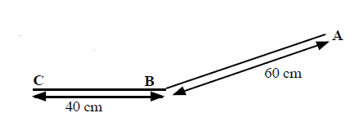
- A trolley with a 10 cm card attached to it is released from A and runs down the slope, passing through a light gate at B, and stopping at C.
Time from A to B = 0.8 s.
Time on light gate timer = 0.067 s
a) What is the average speed between A and B?
b) What is the instantaneous speed at B?

Speed Homework
1. A top class sprinter covers the 100m in a time of 10 seconds. Calculate the sprinter's average speed.
2. How long will it take a Formula 1 car to travel one lap around a 5 km long circuit if it is travelling at an average speed of 180 kmh⁻¹?
3. A physics pupil tries to calculate his friend’s instantaneous speed when running by timing how long it takes her to cross a line. He uses a stopclock to measure the time.
(a) Explain why this method will give poor results for the instantaneous speed.
(b) Suggest the equipment needed to make the experiment more accurate.
4. Read this passage on Thinking and Braking and then answer the questions that follow it.
You are travelling at 30 mph in a car in good road conditions when you suddenly see children crossing the road. By the time you react and apply the brakes, the car has travelled a total distance of 23 m. If the car had been travelling at 60 mph the stopping distance would have been 73 m.
The stopping distance consists of two parts: the thinking distance and the braking distance. The thinking distance is the distance travelled in the time between seeing a hazard on the road and pressing the brake pedal. This time is called the reaction time.
thinking distance = speed x reaction time
Reaction times vary from person to person. An average driver has a reaction time of about 0.8 seconds. A professional racing driver has a reaction time of about 0.2 seconds. Your reaction time is likely to be much longer if you have taken drugs or alcohol. Even a small amount of alcohol can greatly increase your reaction time.
(a) What is meant by the term ' thinking distance'?
(b) What will happen to the thinking distance if the car is going faster?
(c) If a car is going faster will the reaction time alter? Explain your answer.

Summary
The following are the outcomes that you ought to have covered in this section. We’ve also covered quite a few from other sections too.
I can perform calculations involving the relationship between speed, distance and time (d=vt)
I can determine average and instantaneous speed.
I can describe experiments to measure average and instantaneous speed.

Scalars & Vectors

Content Statements
1.1 | I can define the terms scalars and vectors
1.2 | I can identify vector and scalar quantities such as: force, speed, velocity, distance, displacement, acceleration, mass, time and energy.
1.3 | I can calculate the resultant of two vector quantities in one dimension or at right angles.
1.4 | I can determine displacement and/or distance using scale diagram or calculation.
1.6 | I can make use of appropriate relationships to calculate velocity in one dimension (s=vt).

What are Scalars & Vectors?
Physical quantities can be divided into two groups:Scalars and Vectors.
a scalar quantity is completely described by stating its magnitude (size) & unit.
a vector quantity is completely described by stating its magnitude, unit and direction

The following is a list of scalar and vector quantities. Try to guess which is which
Acceleration | Area | Current | Displacement | Distance
Energy | Force | Frequency | Gravitational field strength | Mass
Momentum | Pressure | Resistance | Weight/ friction etc | Temperature
Time | Velocity | Voltage | Volume | Speed
The table lists some of the scalars and the vectors quantities that will be encountered in this course.
Scalars | Vectors
Energy | Velocity
Temperature | Acceleration
Pressure | Displacement
Time | (Momentum)- not required
Mass | Force
Current | (Weight/ friction etc)
Speed | Gravitational field strength
Volume
Voltage
Distance
Area
Resistance
Frequency

Distance = “how far we’ve travelled”
- symbol d
B
A
- units metres, m
- scalar quantity

Displacement = “how far we’ve travelled in a straight
line (from A to B)” (include your direction)
- symbol s
- units, metres, m
- Vector quantity
- Must quote the direction
Speed is a scalar quantity
$$\overline{v}=\frac{d}{t}=\frac{d}{t}$$
Velocity is a vector quantity so quote a direction.
$$\overline{v}=\frac{s}{t}$$

Distance = 50 m
quantity magnitude unit direction
Velocity = 50 ms⁻¹ East
Displacement = 50 m South
Speed = 50 ms⁻¹
quantity magnitude unit direction

Vector Addition
A vector is often drawn with an arrow to indicate its size and direction.Drawing vectors as arrows allows us to add vectors and allows us to find the resultant (the single vector that has the same effect as the vectors acting) The starting point of the arrow is called the “tail” and the arrow end is called the “head”.
head
tail

Resultant Forces
When several forces act on one object, they can be replaced by one force which has the same effect. This single force is called the resultant or unbalanced force.

Combining forces in a straight line
To find the resultant force on objects in straight lines, follow the rules below. (NB this works for any vector quantity).
Draw a diagram of the object and mark in all the forces acting, using an arrow to represent each force. (Do not forget weight, which is often not specifically mentioned in the question).
Use arithmetic to find the resultant:
• add together forces which act in the same direction
12 N
8 N
e.g F₁ + F₂ = F_{u}
F_{u} =12 + 8 = 20 N
• subtract forces which act in the opposite direction
12 N
8 N
e.g F₁ + F₂ = F_{u}
F_{u} 12 + -8 = 4 N
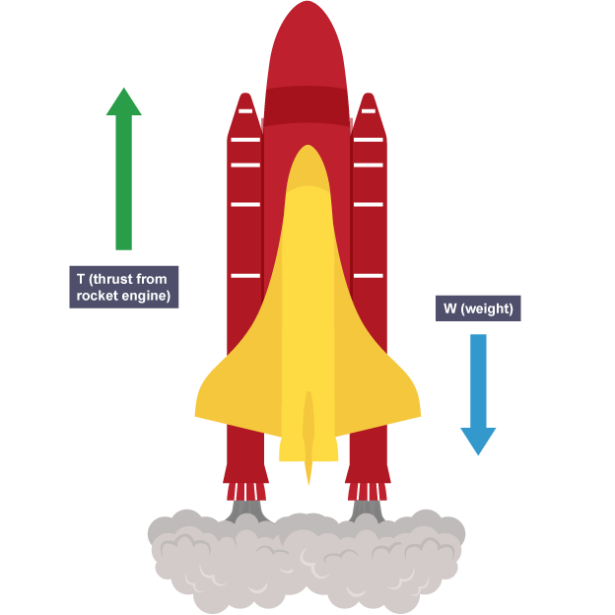
A diagram like this is called a free body diagram.
air resistance
30 000 N

weight
98 000 N

thrust
350000 N

Example
A short time after take-off, a rocket of mass 10 000 kg has a thrust of 350 000 N and experiences air resistance of 30 000 N. Draw a free body diagram and find the resultant force acting on the rocket.
Total upward force = 350 000 N
Total downward force = 98 000 N + 30 000 N
= 128 000 N
Resultant force upwards = 350 000 – 128 000 = 220 000 N

Combining forces at right angles
There are two possible methods for finding the size and direction of the resultant of two vectors, such as forces acting at right angles to each other.
• Draw a scale diagram:
• Use Pythagoras and trig functions.

Example
What is the resultant force produced by two forces of 10 N and 30 N which act on an object as shown in the diagram?

Method 1: Scale Diagram
Choose Scale and record it on the paper: 1 cm = 5 N
Draw vectors head to tail, complete triangle, then measure resultant size and direction.
Resultant measures 6.3 cm angle is measured as 72°
Resultant = 6.3 × 5 = 31.5 N at an angle of 72° to the 10 N force.
Example 2
Two forces are acting on a sledge (see diagram below) then calculate the resultant force acting on the sledge.
20 N
15 N
N
sledge

Solution:
Step 1:Select a scale, that fits on the page, record this value. (1cm = 2N)
Redraw the diagram with the vectors ‘tip to tail’. The ways to do this are given below. Note it doesn’t matter which order you draw the vectors as you should get the same answer.
15 N
Resultant force
S
20 N
F
x
15 N
20 N
S
F
x
S = Start
F = Finish
Resultant force
OR

Step 2: Using a ruler join the start to finish by drawing a line, and measure the length of this line.
Step 3: Using the scale find the magnitude of this vector.
Length of line = 12.5 cm Scale: 1cm = 2 Newton
Resultant Vector: = length x scale 12.5 × 2 = 25 N
Step 4: Measure the angle at the start to the resultant line to indicate the direction of the vector. Use a protractor to do this.
Angle measured as 37° from the vertical.
Step 5: Record your final answer with a quantity, magnitude, unit and direction.
Force= 25 N @ 37° from the vertical
Rules for Drawing A Scale Diagram
- Select a scale which will allow you to draw a diagram that fits on about half a page.
- Mark North (if appropriate) and the starting point.
- Draw the two vectors and the resultant.
- Measure the angle between the first vector and the displacement.
This is the direction.

Method 2 Using trigonometry. We will use the same question above.
15 N
Resultant force
20 N
x
15 N
20 N
x
Resultant force
Step 1: Sketch a diagram like the one above but there is no need to make it an accurate scale diagram like the previous method.
Step 2: Do the calculation using Pythagoras to find the resultant force.
$$c^{2}=a^{2}+b^{2}$$
$${c^{2}=15}^{2} + {20}^{2}$$
Resultant = √ (15² + 20² ) = √ (225 + 400 ) = 25 N
Step 3 Find the angle using trigonometry
$$\tan{x}=\frac{opp}{adj}$$
$$\tan{x}=\frac{4}{3}$$
$$x = \tan^{-1}\left(\frac{4}{3}\right)= 53.1°$$
Angle x = 53⁰
Displacement is 5 m in a direction of 53 º East of North or at a bearing of 053º.
Step 4: Write down the full answer.
Resultant force is 25 N at 53⁰ North of East or at a bearing of (037).
Example 3.
A strong wind blows at 30 ms⁻¹ Eastward. What is the resultant velocity of a plane flying due North at 10 ms⁻¹?
10 ms⁻¹
30 ms⁻¹
becomes
10 ms⁻¹
30 ms⁻¹
Solution 3: Scale Diagram,
N
10 ms⁻¹
30 ms⁻¹
x
Velocity = 31.6 m/s 18⁰ north of east or at bearing of (072).
Trigonometry
Velocity = √(30² + 10²) = 31.6 ms⁻¹
tan x = 10/30 => x = tan⁻¹(10/30) = 18⁰ => direction is 18⁰ north of east or at a bearing = (072)
Velocity = 31.6 ms⁻¹ at bearing of (072) or 18⁰ north of east
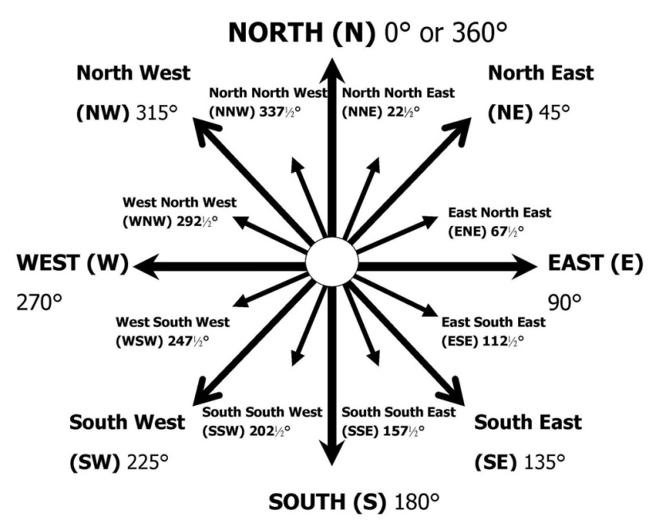
NB A vector direction of NE is a specific angle of 45° E of N. You cannot just refere to something between N and E as NE! It is as much a comass point as
N or E!

Method 2: Draw sketch of vector diagram, but not to scale.
Using Pythagoras
$$R^{2}=a^{2}+b^{2}$$
$$R^{2}={30}^{2}+{10}^{2}$$
$$R=31.6 N$$
$$tanθ=\frac{opp}{adj}, tanθ=\frac{30}{10}$$
$$\tan^{-1}θ=3,θ =72°$$

In some cases that means that the two vectors have to be redrawn so that they are being added “head to tail”. See example below.
becomes
Then join a line from the tail of the first vector to the head of the second vector. This is the resultant vector.
resultant

Examples
            - Two forces are applied to a box as shown below:
12 N
8 N
Solution: Resultant = 12 – 8 = 4 N to the right

Displacement and Distance
Distance is a measure of how far a body has actually travelled in any direction.
Distance is a scalar as it only requires a magnitude and unit.
Displacement is the measurement of how far an object has travelled in a straight line from the start to the finish of its journey.
Displacement is a vector and so a magnitude, unit and direction is required.

Example
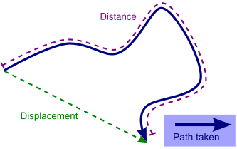
1.
A walker has followed a path through a forest as shown. The distance travelled is much larger than their displacement from the starting position.

            - A skateboarder travels 3 m due North, then turns and travels due East for 4 m
They have travelled a distance of 3 + 4 = 7 m

3 m
4 m
displacement
X
The displacement is calculated as follows:
(Displacement)² = 3² + 4² = 25 ⇒ displacement = √25 = 5 m
BUT displacement must have a direction. This can be found by drawing a scale diagram.
Angle x = 53⁰
Trigonometry can also be used
tan x = 4/3 ⇒ x = tan⁻¹(4/3) = 53.1º
Displacement is 5 m in a direction of 53 º East of North or at a bearing of 053º.

Velocity $s=vt$
Velocity is described by the equation below. Velocity is a vector quantity. The direction of the velocity will be the same as the direction of the displacement.
$$velocity=\frac{displacement}{time}$$
$$v= \frac{s}{t}$$
definition | symbol | Unit | unit symbol
velocity | $$v$$ | metre per second | ms⁻¹
average velocity | $$\overline{v}$$ | metre per second | ms⁻¹
displacement | $$s$$ | metre | m
time | t | second | s

If the velocity is measured over the whole journey then it is known as average velocity, with the symbol $\overline{v}$.
$$\overline{v}=\frac{s}{t}$$

Example
1. A remote control toy car goes 6 m due South and then 8 m due East. It takes two minutes to do this journey.
a) Find the distance it travelled and its displacement.
b) Calculate its average speed and velocity.

Solution
First draw a diagram to help.
6 m
8 m
displacement
X
- Distance = 6 + 8 = 14 m
(Displacement)² = 6² + 8² = 100 ⇒ displacement = √100 = 10 m
Direction: Angle x can be calculated using trigonometry
tan x = 8/6 => x = tan⁻¹(8/6) = 53 ⁰
or by scale diagram
Displacement is 10 m in a direction of 53º East of South or at a bearing of (127)

  - Average Speed
d = 14m  t = 2 minutes = 2 x 60= 120s  v = ? | $$v=d/t \\ v=14/120 \\ v=0.1166 \\ v=0.12 ms^{-1}$$
  - Velocity
s = 10m  t = 2 minutes = 2 x 60 =120s  v = ? | $$v =s/t \\ v =10/120$$  $$v =0.08 ms^{-1}$$

Vectors and Scalars Tutorials

  - How would you define a scalar quantity?
  - Give three examples of scalar quantities

  - How would you define a vector quantity?
  - Give three examples of vector quantities.
- Explain the terms speed and velocity.
- Explain the difference between a vector quantity and a scalar quantity.
- Use your answer to the questions above to explain the difference between distance and displacement.
- A man walks from X to Y along a winding road.
a) State his displacement at the end of his walk.
b) State the distance has he walked.
If the walker in the previous question took 40 minutes for his walk, determine
c) his average speed
d) his average velocity?
- One complete lap of a running track is 400m.
An athlete completes one lap in 48 s in the 400 m race. State his
- distance travelleddisplacement
c) determine her average speed
d) determine her average velocity.
- Repeat Q8 for a runner in the 800 m race whose winning time was 1 min 54s.

- A car travels 40 km north, then turns back south for 10 km. The journey takes 1 hour.
Detemine
a) the displacement of the car
b) the distance the car has travelled
c) the average velocity of the car in km h⁻¹
d) the average speed of the car.

- A car drives 60 km north, then 80 km east, as shown in the diagram. The journey takes 2 hours. Calculate the
a) distance travelled
b) displacement
c) average speed
d) average velocity.

- During an orienteering exercise, a student walks from point A to point B.

The student travels 400 m north and then 300 m east to reach point B as shown.
(a) The student takes 400 s to walk from point A to point B.
Calculate his average speed.
(b) By scale diagram or otherwise determine the student’s displacement at point B from point A.

Summary
The following are the outcomes that you ought to have covered in this section.
I can define the terms scalars and vectors
I can identify vector and scalar quantities such as: force, speed, velocity, distance, displacement, acceleration, mass, time and energy.
I can calculate the resultant of two vector quantities in one dimension or at right angles.
I can determine displacement and/or distance using scale diagram or calculation.
I can make use of appropriate relationships to calculate velocity in one dimension (s=vt).

Acceleration

Content Statements
3.1 | I can define acceleration as the final velocity subtract the initial velocity divided by the time for the change, or change in velocity divide by the time for the change.
3.1 | I can define the acceleration as rate of change of velocity.
3.2 | I can use the relationship involving acceleration, change in speed and time (a = ∆v/t).
3.3 | I can use appropriate relationships to solve problems involving acceleration, initial velocity (or speed) final velocity (or speed) and time of change (a = (v – u)/t ).
3.5 | I can describe an experiment to measure acceleration

Introduction to Acceleration
Have you ever looked closely at advertisements for cars? Most of them will say something like this: 0 – 60 mph in 8 seconds. What does this tell you?
It’s not how fast the car can go – cars can manage more than 60 miles per hour. It’s not how fast the car can go – cars can manage more than 60 miles per hour.
It’s how quickly the car gains speed – the car’s acceleration. The less time a car takes to gain speed, the greater its acceleration.
When a driver of a car puts her foot down on the accelerator (throttle or right pedal), the car goes faster - it accelerates!
Imagine two drivers side by side at a set of traffic lights, the lights are on red. Hollie is in a very fast sports car, and Callum is sitting in his lorry. The lights turn green and both vehicles set off. Both vehicles accelerate; the speed of both vehicles increases.
After a while both vehicles reach the same velocity. But we can tell that the sports car will have a greater acceleration than the lorry. Acceleration is not just about the increase in your velocity, it takes account of how quickly your velocity changes. The time it takes your velocity to change must be in the equation.

Acceleration describes how quickly velocity changes. Acceleration is a vector quantity. Only the acceleration of vehicles travelling in straight lines will be considered in this course. Because in Physics at National 5 we talk about accelerations in straight lines then we can be a little lax about using the term speed to mean velocity as their magnitudes would be the same in a straight line. Acceleration is really the rate of change of velocity and not speed.

Red car takes 20s to go from 0mph to 60mph.
Blue car takes 6s to go from 0mph to 60mph.
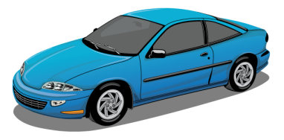
Both the red car and the blue car have the same change in velocity but not the same acceleration as the blue car makes this change in less time, so it has a greater acceleration.
Red car acceleration is (60-0)/20=3mph/s
Blue car acceleration is (60-0)/6=10mph/s
Acceleration is the change in velocity in unit time.
The units of acceleration are the units of velocity (metres per second) divided by the units of time (seconds). The result is metres per second per second. This is usually called metres per second squared and is written ms⁻².
Acceleration is the change in velocity per unit time.
An acceleration of 2 ms⁻² means the velocity increases by 2 ms⁻¹ every second

$$a=\frac{v-u}{t}=\frac{∆v}{t}$$

$$∆v=v-u$$
Note
If a vehicle is slowing down, the final velocity will be smaller than the initial velocity, and so the acceleration will be negative. A negative acceleration is a deceleration. Most vehicles do not travel at the same velocity all the time. If their velocity increases, they are said to accelerate. If they slow down, they decelerate or have a negative acceleration.
An acceleration of 2 ms⁻² means the velocity increases by 2 ms⁻¹ every second. If the vehicle was at rest when the clock is started, then after the first second it will be going at 2 ms⁻¹, after the second second it will be travelling at 4 ms⁻¹, and after ten seconds the car will be travelling at 20 ms⁻¹. What will be the speed of the car after sixty seconds?
Definition | Symbol | Unit | Unit symbol
change in velocity | $$∆v$$ | metre per second | ms⁻¹
final velocity | $$v$$ | metre per second | ms⁻¹
initial velocity | $$u$$ | metre per second | ms⁻¹
acceleration | $$a$$ | metre per second squared | ms-²
time | t | second | s

Examples
- A train accelerates from rest to 40 ms⁻¹ in a time of 60 s. Calculate the acceleration.
a | = | $$\frac{\text{v} \text{-} \text{u}}{\text{t}}$$
a | = | $$\frac{\text{40-0}}{\text{60}}$$
a | = | 0.67 ms⁻²
u = 0 ms⁻¹
v = 40 ms⁻¹
t = 60 s

- A car is moving at 15 ms⁻¹, when it starts to accelerate at 2 ms⁻¹. What will be its speed after accelerating at this rate for 4 seconds?
u = 15 ms⁻¹
2 | = | $$\frac{\text{v} \text{-} \text{15}}{\text{4}}$$
v | = | 8 + 15
v | = | 23 ms⁻¹
a = 2 ms⁻²
t = 4 s

- A car, travelling along a straight road, speeds up from 6 ms⁻¹ to 24 ms⁻¹ in a time of 32s. What is its acceleration?
- A car slows down from 16 ms⁻¹ to 0 ms⁻¹ in 8s. Find the acceleration
the negative signs tells us the car is slowing down

Formula for Acceleration
$$acceleration=\frac{change of velocity}{time for the change}$$ | where  $$∆ =change in$$  $$v is the change of velocity = (v-u)$$
$$a=\frac{∆v}{t}$$ | $$a=acceleration \left({ms}^{-2}\right)$$  $v=final velocity$ (ms⁻¹)  $u=starting velocity$(ms⁻¹)
$$a=\frac{final velocity-starting velocity }{time}$$ | $$t=time for change in velocity(s)$$
$$a=\frac{v-u}{t}$$
where
$$a=\frac{v-u}{t}=\frac{∆v}{t}$$
$$∆v=v-u$$
Acceleration is the “rate of change of velocity”, that is how quickly you change your velocity Or change of velocity per second

Measuring Acceleration
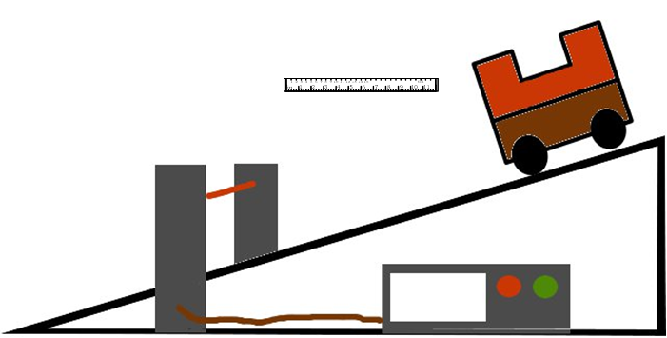
You can measure acceleration in the lab with EITHER one single mask and two light gates OR a double mask and one light gate.
Whichever way the experiment is conducted the measurements that need to be made are:
- Width of the mask or masks.
- Time for first light beam to be broken.
- Time for second light beam to be broken.
- Time between the breaks in the light beam to be measured.
The formula to use is:
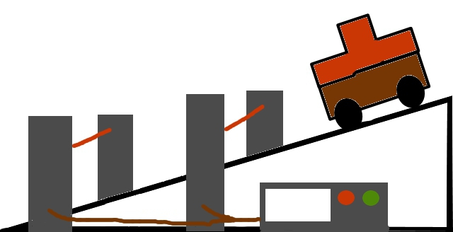
where;
u = starting velocity
v = final velocity
t = time for change in velocity.
To find the velocity
Measurements | Calculations
t₁ time to pass first light gate
t₂ time to pass second light gate
t₃ time between light gate
Length of mask | l
$$a=\frac{v-u}{t}=\frac{∆v}{t}$$
$$∆v=v-u$$

Prescribed Pratical 3

Measuring the Acceleration of a Vehicle
Aim: Measuring the acceleration of a vehicle
Apparatus: Runway, trolley with double mask, light gate, computer timer, ruler
Use either a single mask and two light gates, or a single light gate and a double mask
Instructions for double mask method
- Measure the length of the two parts of the double mask, d.
- Set the computer to measure acceleration, and input d.
- Release the trolley and record the acceleration, a.
- The computer measures the time for each part of the double mask to pass through
- the light gate, and the time between the two parts. It then uses these to calculate acceleration a = (v – u) / t.
- Repeat several times and calculate an average.
Instructions for single mask method
- Measure the length of the mask, d.
- Set the computer to measure acceleration, and input d.
- Release the trolley and record the acceleration, a.
- The computer measures the time for each for the mask to pass through each light gate
- the light gate, and the time between the two light gates. It then uses these to calculate acceleration a = (v – u) / t.
- Repeat several times and calculate an average.
Evaluation
Look over your results and comment on the accuracy and precision.
Is there any benefit to using one of the methods rather than the other? Construct a table giving the positive and negatives of each method.
Does it matter where you put the two light gates as the final velocity will be greater if the light gates are further apart.
.

Questions
- A Jaguar can reach 27 ms⁻¹ from rest in 9.0 s. What is its acceleration?
- The space shuttle reaches 1000 ms⁻¹, 45 s after launch. What is its acceleration?
- A car reaches 30 ms⁻¹ from a speed of 18 ms⁻¹ in 6 s. What is its acceleration?
- A train moving at 10 ms⁻¹ increases its speed to 45 ms⁻¹ in 10 s. What is its acceleration?
- A bullet travelling at 240 ms⁻¹ hits a wall and stops in 0.2 s. What is its acceleration?
- A car travelling at 20 ms⁻¹ brakes and slows to a halt in 8 s.
  - What is the acceleration of the car?
  - What is the deceleration of the car?
- Describe how you would measure the acceleration of a small vehicle as it runs down a slope in the laboratory.
- On approaching the speed limit signs, a car slows from 30 ms⁻¹ to 12 ms⁻¹ in 5 s. What is its deceleration?
- A bowling ball is accelerated from rest at 3 ms⁻² for 1.2 s. What final speed will it reach?
- How long will it take a car to increase its speed from 8 ms⁻¹ to 20 ms⁻¹ if it accelerates at 3 ms⁻²?
- A cyclist can accelerate at 0.5 ms⁻² when cycling at 4 ms⁻¹. How long will she take to reach 5.5 ms⁻¹?
- The maximum deceleration a car’s brakes can safely produce is 8 ms⁻². What will be the minimum stopping time if the driver applies the brakes when travelling at 60 mph (27 ms⁻¹).
- The table below gives some performance figures for cars.
Car | Time for 0 - 60 mph | max. speed in mph
Porsche 918 Spyder | 2.2 s | 217
Tesla Model S P100D w/Ludicrous+ Update | 2.5 s | 155
smart EQ fortwo | 9.5 s | 90
Ford Mondeo TDCi | 7.6 | 140
VW Polo | 10.8 | 110
- Which car has the smallest acceleration?
- Which car has the largest acceleration?
- Assuming that the acceleration remained constant, how long would it take for the following cars to reach their top speed?
i) Mondeo ii) Porsche
14. Calculate a car’s acceleration if its speed increases by 12 ms⁻¹ in a time of 3 s.
15. A physics pupil running away from a wasp accelerates from rest to 5 ms⁻¹ in a time of 1.25 s. Calculate the pupil’s acceleration.
16. A electromagnetic gun can produce an acceleration of 2500 ms⁻². If the bullet starts at rest, and acceleration for 0.03s. What will be the final velocity of the bullet?

Summary
The following are the outcomes that you ought to have covered in this section.
I can calculate acceleration as the final velocity subtract the initial velocity divided by the time for the change, or change in velocity divide by the time for the change.
I can define the acceleration as rate of change of velocity.
I can use the relationship involving acceleration, change in speed and time (a = ∆v/t), when the vehicle travels in a straight line.
I can use appropriate relationships to solve problems involving acceleration, initial velocity (or speed) final velocity (or speed) and time of change (a = (v – u)/t ).
I can describe an experiment to measure acceleration

Velocity-Time Graphs

Content Statements
2.1 | I can draw velocity–time graphs for objects from recorded or experimental data.
2.2 | I can interpret velocity–time graphs to describe the motion of an object.
2.3 | I can find displacement from a velocity–time graph.
3.4 | I can find the acceleration as the gradient of a velocity–time graph.

Velocity-Time Graphs
The motion of any object can be represented by a line drawn on a speed-time or velocity-time graph. This gives a visual indication of how objects are moving.
A velocity-time graph is a useful way to describe the motion of an object. Time is always plotted along the x-axis, and velocity is plotted along the y-axis.
The shape of the graph indicates whether the vehicle is accelerating, decelerating or moving at a constant velocity.

speeding up | uniform/ steady speed | slowing down
increasing velocity | (constant speed) | negative acceleration
(accelerating) | constant velocity | (decelerating)
0
0
0
Constant velocity
Increasing velocity
(acceleration)
Decreasing velocity
(deceleration)
time
velocity
time
velocity
time
velocity

Example
A
B
C
D
E
Velocity (m/s)
Time (s)
The graph describes the motion of a vehicle. Describe in words the motion of the vehicle during each of the lettered stages.

Solution
A: Vehicle starts from rest and accelerates uniformly to its maximum velocity.
B: Vehicles travels at a constant velocity
C: Vehicle decelerates uniformly to its new lower velocity.
D: Vehicle travels at this new (lower) constant velocity.
E: Vehicle decelerates uniformly to rest.
The gradient of a velocity-time graph (steepness) tells us the acceleration of the object. The acceleration is equal to the gradient of the slope. The steeper the line of the graph, (greater gradient) the greater the acceleration.
- While the slope is steady, the acceleration is constant.
- If the line gets steeper, the acceleration (or deceleration) increases.
- If the slope has zero gradient, and the line is flat, then the acceleration is zero and the velocity is constant.
Time (s)
Velocity (m/s)
u
v
0
Gradient= rise/run
Or v/h
In our case that is
vertical = (v-u)
horizontal = t
gradient =(v-u)/t
gradient = acceleration

Questions
- State which line on the graph shows the vehicle reaching the highest velocity. Justify your answer.
Time (s)
Velocity (m/s)
A
B
C
D
0
- State which line on the graph shows the vehicle with the largest acceleration. Justify your answer.
- State which two lines indicate the same acceleration. Justify your answer.

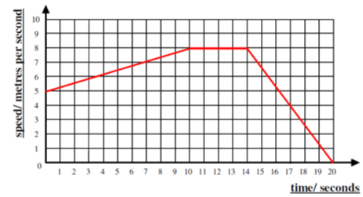
questions
For each question below, copy the graph into your jotter and complete the description.
- Copy and complete the description of the velocity time graphs above.
0-10s ___________ _______ from ____ ms⁻¹ to ____ ms⁻¹.
(Constant/ uniform _____________).
10-14 s _____________ ___________ of ____ ms⁻¹.
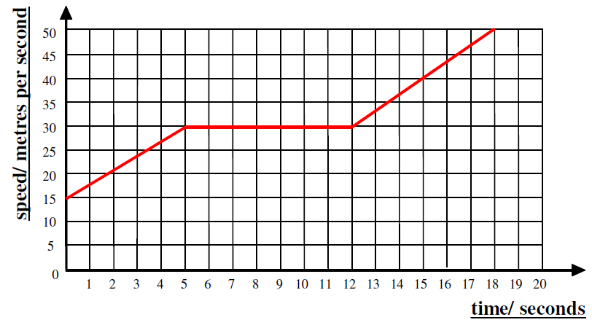
14-20s _______________ ______ from ___ ms⁻¹ to ms⁻¹ (constant/ uniform ____________)

- 0-5s ___________ _______ from ___ ms⁻¹ to ____ ms⁻¹. (Constant/ uniform _____________).
5-12 s _____________ ___________ of ____ ms⁻¹.
12 -17 s _______________ ______ from ___ ms⁻¹ to ms⁻¹ (constant/ uniform _____________)
- On graph paper draw graphs representing the following motion of a vehicle travelling in a straight line.

- From
  - s: speeding up from rest to 10 ms⁻¹. Constant /uniform acceleration.
5-15 s: steady velocity of 10 ms⁻¹
15-20 s: slowing down from 10 ms⁻¹ to rest (constant / uniform negative acceleration)
- A cyclist travels at a steady speed of 9 ms⁻¹ for 6 s before accelerating constantly / uniformly to a speed of 2 ms⁻¹ in 7 s. She then travels at this steady speed for a further 5 s.

- A racing car travels at a steady speed of 10 ms⁻¹ for 2 s before accelerating constantly/ uniformly for 12 s to a speed of 90 ms⁻¹. The car then immediately decelerates constantly / uniformly for 6s to a speed of 70 ms⁻¹

Finding the acceleration from a velocity time graph.

Example 1-

Solution using gradient
$$m=\frac{y_{2}-y_{1}}{x_{2}-x_{2}}$$
$$m=a=\frac{18-6 }{10-0}=1.2 ms^{-2}$$
6
18
10
time (s)
velocity (ms⁻¹)

Solution
v=18; u=6; t=10
$$a=\frac{v-u }{t}$$
$$a=\frac{18-6 }{10}=1.2 ms^{-2}$$

Calculate the acceleration shown in the graph below:

Example 2
A train leaves the station and takes 30 s to accelerate in a straight line to a speed of 15 ms⁻¹. It remains at this velocity for a further 15 s. As it approaches the next station it slows to 5 ms⁻¹. It takes 20 s to decelerate to this speed.
As it finally pulls into the next station it slows to a stop in 15 seconds.
Find the accelerations of the train during this journey.
$$m=\frac{y_{2}-y_{1}}{x_{2}-x_{2}}$$
$$m=a=\frac{15-0 }{30-0}=0.5 ms^{-2}$$
$$m=a=\frac{15-15 }{45-30}=0 ms^{-2}$$

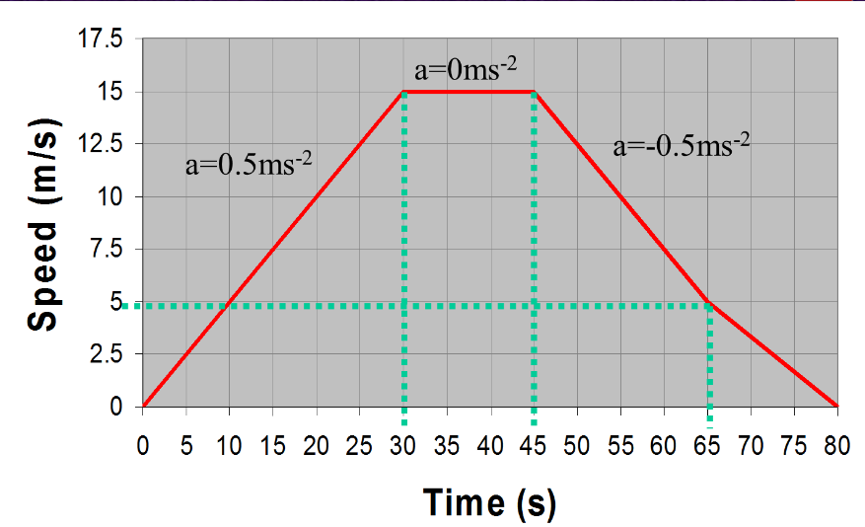

$$m=\frac{y_{2}-y_{1}}{x_{2}-x_{2}}$$
$$m=a=\frac{5-15 }{65-45}=-0.5 ms^{-2}$$
$$m=a=\frac{0-5 }{80-65}=-0.3 ms^{-2}$$
Questions-
            - Copy the velocity-time graphs below and find the accelerations for each part of the journey.

Homework
Time (s) | Speed (m/s)
0 | 0
2 | 6
4 | 12
6 | 18
8 | 24
10 | 30
1. A car's speed is recorded over a period and the results are show in the table below:
(a) Plot a graph of the car's motion over this 10-second period.
(b) From the graph, find the car's speed 5 seconds into its journey.
(c) Describe the car’s motion over the 10 seconds.

            - Look at the graph. This shows the speed of a car over a short journey. Use the graph to answer these questions.
(a) Describe the car’s motion between:

B

C

D
Speed/ m/s
Time/s
10
20
30
40
50
40
30
20
10

A
A and B;
B and C;
C and D.
(b) Estimate the car’s speed after 10 seconds.

            - A hot air balloon is released and it accelerates upwards.
Speed/ ms⁻¹
Time/s
10
20
30
40
50
8
6
4
2
During the ascent, some sandbags are released and the acceleration increases. The graph shows its vertical motion during the first 50 seconds of its flight.
(a) Calculate the acceleration after the sandbags are released. (2)
(b) How high had the balloon risen after the 50 seconds had passed?

Displacement from a Velocity-Time Graph
t/s
v /ms⁻¹
100
300
0
Velocity and speed time graphs can be used to give you information on the distance and displacement a vehicle has travelled. The AREA under a speed time graph tells us HOW FAR we have travelled (DISTANCE). In the diagram shown
the object is travelling very fast. It is travelling at constant speed, its instantaneous speed is constant. It’s acceleration is zero.
The area under the graph is a rectangle, and has been shaded in to make it more obvious. To find the area we multiply the length by the breath. The area is 300 units long and 100 units high.
Its area is 100 ×300 = 30 000. This is the distance travelled as shown.

To find the distance travelled, d, we’d use the formula;

d = 100x 300= 30 000m
Here is another graph. It shows a vehicle accelerating from 0 ms⁻¹ to 10 ms⁻¹ in 30 seconds. The area under the graph is a triangle as shown in the shading.
The area of the triangle is half the length of its base multiplied by its height. The triangle is 30 units long by 10 units high, so its area is
½ ×30×10= 150
t(s)
v/ ms⁻¹
10
30
0
Find the average speed for this journey.
The area of the triangle is exactly the same as the area of the rectangle with a speed exactly half way between the two values, u & v
the area of the pink shape is the same as the area of the yellow triangle. Both give you the distance travelled
v/ ms⁻¹
This stripy area is the same as the lightly shaded area
10
Average
speed
₃₀
t(s)
0

Example
If a toy car travels at a speed of 4ms⁻¹ for a period of 6s, the speed-time graph looks like this:
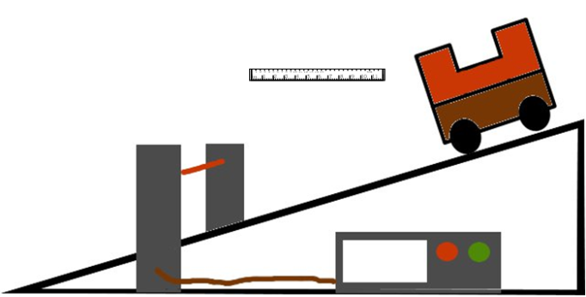
0
4
6
Speed
(ms⁻¹)
Time
(s)
If an object is accelerating it is often not possible to easily find its average speed. This in turn prevents the use of the equation distance = average speed x time to find the distance travelled.
Thankfully there is another way - we can use a velocity time graph
To find displacement travelled the area under the velocity time graph is calculated.
v/ ms⁻¹
10
5
0
6 t(s)
This graphs shows a vehicle accelerating from 5 ms-1 to 10 ms-1 in 6s. TO find the area under more complicated graphs we split the area into rectangles and triangles as shown by the shading. The triangle is 6 units long by 5 units high.
7.5
area triangle= ½ bh= ½ ×5 ×6= 15m
The rectangle is 6 units long by 5 units high.
area rectangle= bh= 5 ×6 = 30 m Distance travelled is 15m + 30 m =45 m
This can be checked using the average speed= $$\overline{v}=\frac{(v+u)}{2}=\frac{10+5}{2}=7.5{ms}^{-1}$$
$$\overline{v}×t=d=7.5×6=45m$$
HELPSHEET for finding the area under a v-t graph
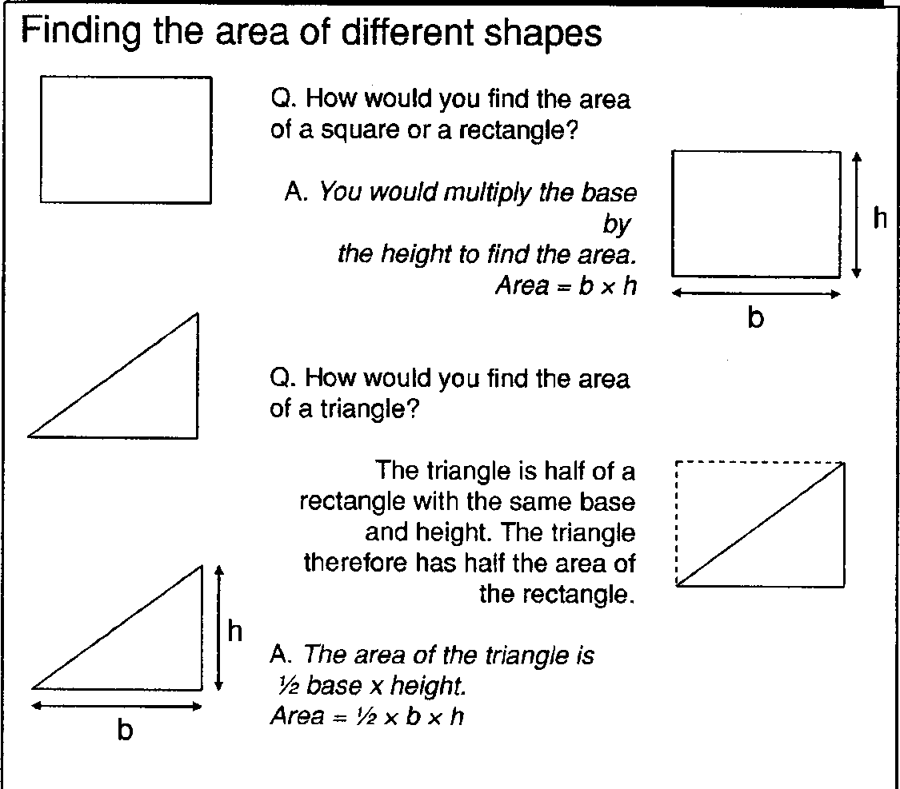

Remember that displacement and distance are not the same thing. However, if the object is travelling in a straight line then they will have the same magnitude.
This rule applies to any shape of graph.
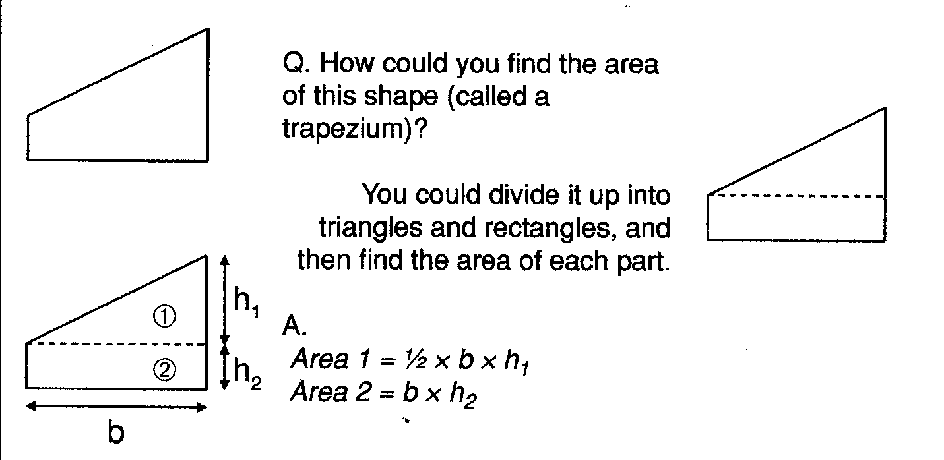

Practice:
If you need additional practica at finding the area try these questions
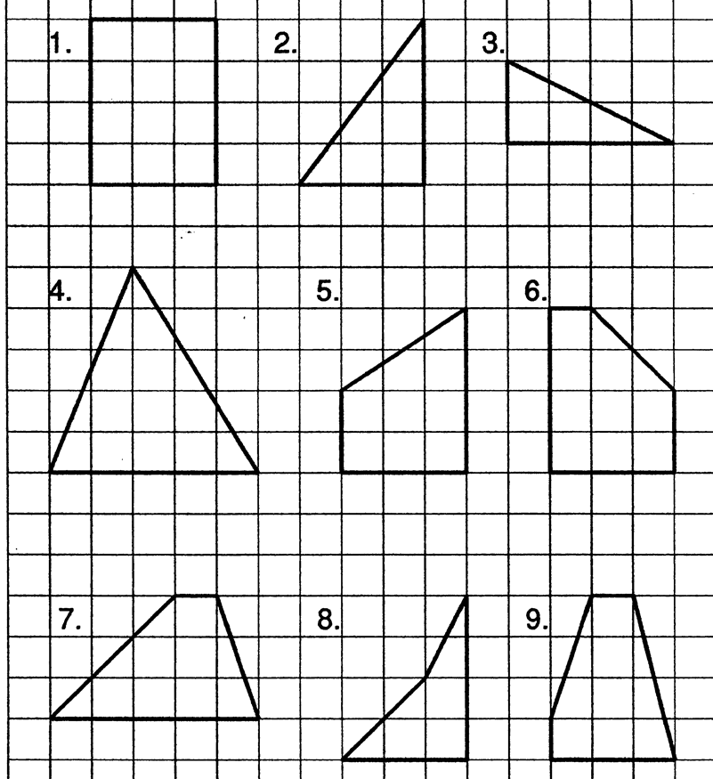
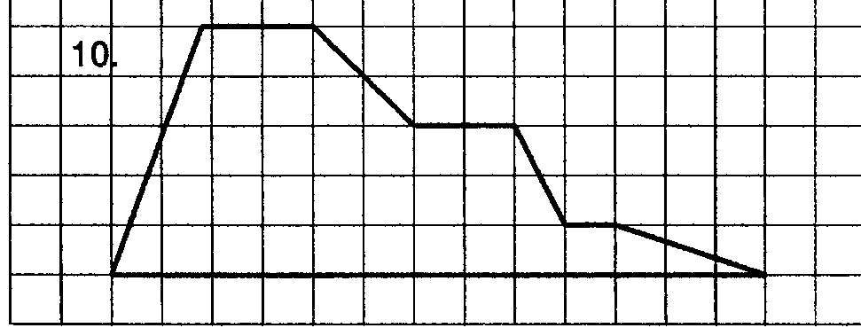

No matter what the shape of the graph….
Total distance covered = Area under a velocity- time graph

Often, to find the area, the graph will need to be split into standard geometrical shapes like triangles and rectangles
Time (s)
Speed (m/s)

- The gradient of a velocity time graph gives the acceleration of an object the area under a velocity time graph gives the total distance travelled
- Increasing or decreasing gradient gives the rate at which the acceleration is increasing or decreasing
- Zero gradient means the object is travelling at constant speed

Example
Speed (m/s)
16
4
10
0
12
Time
(s)
1
2
3

It is best to split the area under the graph into rectangles and triangles. Calculate the area of each and then add them together. [Area of a triangle is ½ base x height]
Distance travelled = area 1 + area 2 + area 3
Distance travelled = (½ × 12 × 4) + (12 × 6) + (½× 6 ×12)
Distance travelled =24 + 72 + 36 = 132 m
QUESTION
- The graph below shows how the velocity of a car varies over a 40 s period.
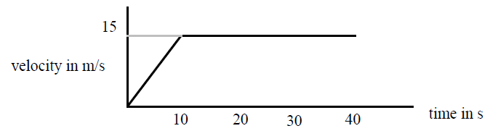

a) Describe the motion of the car during this 40 s period.
b) Calculate the acceleration of the vehicle.
c) How far does the car travel while accelerating?
d) What is the total distance travelled by the car?

- Use the graph below to answer the following questions.
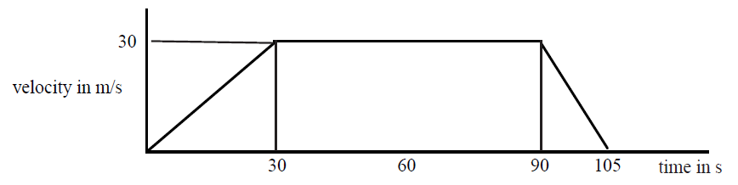
  - State the time during which time is the vehicle travelling at a constant velocity.
  - Calculate the values of
    - the initial acceleration
    - the final deceleration
  - Determine the braking distance of the car.
  - Calculate the total distance travelled.
  - Determine the average velocity of the car.

- Draw a velocity-time graph to describe the following motion:-
A car accelerates from rest at 2 ms⁻¹ for 8 s, then travels at a constant velocity for 12s, finally slowing steadily to a halt in 4 s.

- For the vehicle in the previous question, determine the
  - maximum velocity
  - distance travelled
  - average velocity

- The graph below describes the motion of a cyclist.
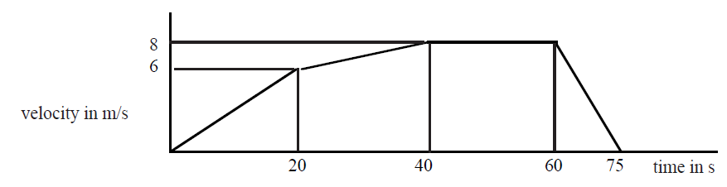
  - Calculate the maximum positive acceleration of the cyclist.
  - Show by calculation whether the cyclist travels farther while accelerating, or while cycling at the maximum velocity.
- For each of the graphs below, calculate:
  - The acceleration for each part of the journey
  - The total distance travelled for the vehicle.
Speed/ ms⁻¹
Time/s
10
20
30
40
50
8
6
4
2

B

C

D
v / ms⁻¹
t/s
10
20
30
40
50
40
30
20
10

A

Homework
- This graph shows the motion of a car.
    - Describe how the car is moving,
    - How far does the car travel in the time shown on the graph?
2. The graph shows the speed of a runner during a race.
- Describe the motion of the runner.
- What distance does she cover in the first eight seconds?
- What was the distance she ran in the last four seconds?
- What was the length of the race?
3. A hot air balloon is released and accelerates upwards. During the lift, some sand bags are released, and the acceleration increases. The graph shows the vertical motion of the balloon during the first 50s of its flight.
(a) Calculate the height of the balloon when the sandbags are released.
(b) Calculate the height of the balloon after 50 s.
4.During a test run of a TACV (tracked air-cushioned vehicle or hovertain), its speed along a straight level track was recorded as shown in the table below.
    - Draw a graph of the train’s motion during the test run.
    - Calculate the distance travelled during the test run.
Time (s) | Speed (ms⁻¹)
0 | 0
20 | 10
40 | 40
60 | 70
80 | 100
100 | 100
120 | 50
140 | 0

More motion graph questions
Use your knowledge of velocity time graphs, and equations to answer these questions
- A car travels between two sets of traffic lights. Its speed changes as shown in the graph.
        - Calculate the car’s acceleration over the first 5 seconds.
        - Calculate the acceleration of the car when it brakes.
        - Calculate the distance moved by the car.
        - Determine the car’s average speed between the traffic lights.
- A girl cycles along a road and down a hill. Her speed changes as shown in the graph.
    - At what time dis she start to travel down the hill?
    - For what distance did she cycle downhill?
    - What was her acceleration as she went down the hill?
    - What total distance did she travel?
    - What was her average?

- A train arrives at the start of the platform of Lockerbie Station at 4.5 ms⁻¹, slows down and comes to rest 15 s later.
- Calculate the acceleration of the train.
- Sketch a velocity time graph showing the motion.
- Use your graph to calculate the stopping distance of the train.
- While driving along a road, a driver sees a brick fall off the lorry 100 metres in front of her. The graph shows the motion of the car from the instant she sees the brick fall.
    - Why is there a delay between the driver seeing the brick fall, and the car decelerating?
    - What is the acceleration of the car?
    - What is the distance travelled by the car before it comes to rest?
    - Explain if the car will hit the brick or not.
- A glider, cruising at 20 ms⁻¹ goes into a shallow dive and increases its speed in a straight line. The graph shows its motion starting a few seconds before its dive.
          - At what time did the dive start?
          - Wat was the time taken during the dive?
          - What was the acceleration during the dive?
          - How far did the glider travel during the dive?

Summary
In this section you ought to have understood the following
I can draw velocity–time graphs for objects from recorded or experimental data.
I can interpret velocity–time graphs to describe the motion of an object.
I can find displacement from a velocity–time graph.
I can find the acceleration as the gradient of a velocity–time graph.

Newton’s Laws

Content Statements

4.1 I can give applications and use Newton’s laws and balanced forces to explain constant velocity (or speed), making reference to the frictional forces of the object.

4.2 I can give applications of Newton’s laws and balanced forces to explain and or determine acceleration for situations where more than one force is acting, (F=ma)

4.3 I can use F=ma to solve problems involving unbalanced force, mass and acceleration for situations where more than one force is acting, in one dimension or at right angles.

4.4 I can use W=mg to solve problems involving weight mass and gravitational field strength, including on different planets (where g is given on page 2 of section1)

4.5 I can use Newton’s 3rd law and its application to explain motion resulting from a ‘reaction’ force.

4.6 I can use Newton’s laws to explain free-fall and terminal velocity.

FORCES AND THEIR EFFECTS
A force can be described as a push or a pull. As they are invisible we recognise a force by noting the effects it causes.
changing the direction of motion
- a steering wheel turns and causes the car to turn (via a long process)
hitting a foil against A force can change an object’s:
- direction of motion (an acceleration)
- shape
- speed (cause an acceleration)
- start a mass moving (cause an acceleration)
eg
- another foil
- wind blowing in the trees
changing the shape
- clicking a pen
- plastercine
- hitting a bat against a ball
changing the speed (causing an acceleration) including starting motion.
- accelerating in a car
- kicking a ball
- driving a car into a wall

Contact and Non-Contact Forces
We can divide forces into 2 groups
Contact Forces | Non-contact Forces | 
Friction | Weight
Tension | Electrical force
Srping |   Magnetic Force
Torque / Twist/ Turn
Applied Force
Mass (g) | Predicted weight (N) | Weight (N)
100
200
300
400
500
600
700
800
900
1000 (1kg)
5000 (5kg)

Mass and Weight
What is the difference between mass and weight?
Mass is a measure of the amount of matter (stuff) in an object. It is measured in kilograms (kg). Weight is a force and it is the pull of gravity acting on an object. It is measured in Newtons.

Is there a link between mass and weight?
Conclusion
From our experiment we have found out that the Earth pulls every 1kg with a force of approximately 10N (or 9.8N)
Formula:
Weight =mass × 9.8
(N) (kg) (N kg⁻¹)
This value of 9.8 Newtons per kilogram is called the GRAVITATIONAL FIELD STRENGTH, g
$$Weight =mass gravitational field strength$$
$$W = m g$$
“g” is the gravitational field strength. It is measured in NEWTONS PER KILOGRAM. It is the WEIGHT PER UNIT MASS (force of gravity on every kilogram)
Symbol | Definition | Unit | Unit symbol
$$W$$ | Weight | newton | N
$$m$$ | Mass | kilograms | kg
g | gravitational field strength | newtons per kilogram | Nkg⁻¹, N/kg

Answer the following questions in your jotters, don’t forget to use IESSUU
Object | Mass (kg) | Weight (N)
A bag of sugar | 1 | 9.8
A bag of tatties | 5
A loaf of bread | 0.5
An apple |  | 1
A small car |  | 7840
A small pupil |  | 441
ME
Bag of crisps | 23g

A bag of crisps has a mass of 23 g, what is its weight?
Change 23g into kg =23 x 1/1000 = 0.023kg
g=9.8 N/kg
W=mg
W=0.023 x 9.8= 0.23N

My Weight on other planets
As the weight depends on what you are attracted to it would suggest that your weight on other planets will be different to your weight on Earth.

Task:
Copy the table. Calculate your own weight on each of the planets. If you do not want to use your own mass take m=50kg
Planet | g (N/kg) | m (kg) | W (N) =m x g
Mercury | 3.7
Venus | 8.8
Earth | 9.8
(Moon) | 1.6
Mars | 3.8
Jupiter | 26.4
Saturn | 11.5
Uranus | 11.7
Neptune | 11.8
Pluto | 4.2

i) Find out the distance of each of the planets from the Sun.

ii) Present the above information of ‘g’ on a drawing of the Solar System.

Example
A landing specialist working at NASA is given the following information about a space craft landing on to Mars. He does some initial calculations and knows how to ensure that the space craft approaches the surface of the planet at the correct velocity.
However he must now calculate the size of the force that the rocket engines must apply in order to maintain the constant velocity.
He uses the following information:
Mass of rocket 15 000 kg.
Gravitational field strength = 3.8 Nkg⁻¹
Draw a free body diagram and calculate the size of the force that the rocket engines must produce.
Constant velocity means that there are no unbalanced forces acting on the space craft.
Centre of mass
Engine force -
to be calculated
Weight = (15000x 3.8) N
Free Body Diagram
Total downward force = weight
W | = | mg
W | = | 15 000 x 3.8
W | = | 57 000 N
m = 15000 kg
g = 3.8 Nkg⁻¹
Upwards force = weight

Force applied by rocket engines = 57 000 N upwards

Example 2: Calculate the weight on Mars of a component for the Mar’s Rover, if its mass on Earth is 5.6 kg. Gravitational field strength on Mars is 3.8 Nkg⁻¹
m = 5.6 kg
W | = | mg
W | = | 5.6 x 3.8
W | = | 21.28
W | = | 21 N

DYNAMICS PROBLEMS
Assume the questions refer to the Earth unless otherwise stated
1. What is the weight of a 10 kg bag of potatoes?
2. What is the weight of a 250 g bag of sweets?
3. What is the mass of a 450 N girl?
4. What is the weight of a 10,000 kg spacecraft on
a) Earth b) Mars c) Venus?
5. What would a 60 kg man weigh on Jupiter?
6. Which planet’s gravity is closest to our own?
7. An astronaut who weighs 700 N on Earth goes to a planet where he weighs 266 N.

Forces and the Newton Balance
Aim: To use the newton balance to pull and lift various known masses.
Apparatus: Newton balance
Selection of masses of known size

Instructions for experiment 1
• Use the newton balance as in Diagram 1 to pull each mass across the top of your desk.
• Compare the force required to
a) start the mass moving
b) keep the mass moving slowly at a steady speed
c) keep the mass moving quickly at a steady speed.
Explain how the newton balance is used to measure force.

Instructions for experiment 2
• Use the newton balance as in Diagram 2 to lift each mass.
• Compare the force required to
a) support the mass so that it is not moving
b) move the mass upwards at a steady speed
c) move the mass downwards at a steady speed.
Record your results in a table, recording the mass in kilograms (kg).
Extend your table, calculate the ratio of weight to mass; ie.

Hooke’s Law
INVESTIGATION
You are going to investigate how increasing the force on a spring changes its length. You can also try a similar experiment with an elastic band. We want to know if doubling the force changes the length of a spring. We call this Hooke’s Law
For the experiment write down the following:-
- an AIM, (what you are trying to do),
- your PREDICTION,HYPOTHESIS (what you think will happen),
- use the METHOD to show you how to carry out the experiment,
- DO the experiment
- RECORD your RESULTS
- make your CONCLUSION
- Evaluate your experiment.

READ THE METHOD BELOW AND MAKE SURE THAT YOU UNDERSTAND IT. Then set up the apparatus as shown in the diagram below.
            - Draw a table in your jotter like the one below.
            - Hang a spring vertically from a clamp stand and make sure it cannot fly off.

MASS  (kg) | Force (N) | LENGTH  (mm)  1 | LENGTH  (mm)  2 | LENGTH  (mm)  3 | Average  LENGTH  (mm) | INCREASE IN LENGTH  (EXTENSION) (mm)  (Length - start length)
0 | 0 |  |  |  |  | 0.0

            - Record the length of the spring without any load on the end.
            - Clamp the metre stick or rule vertically in the clamp, alongside the spring.
            - Record the metre stick or rule reading level with the bottom of the spring. The number of masses hanging from the spring is 0 and the extension of the spring is 0 cm.
            - Hang a mass hanger from the bottom of the spring. Record the new metre stick reading, the mass and the extension of the spring.
            - Add another load or hanger onto the spring.
            - Record the new length of the spring in your table.
            - Work out how much the spring has stretched. This is found by subtracting the length at the start of the experiment from the stretched spring length.(or Excel can work it out for you when you record your results into a spreadsheet.
            - Repeat stages 4 to 7.
            - BEWARE DO NOT STRETCH THE SPRING SO MUCH THAT IT DOESN'T GO BACK TO ITS ORIGINAL SHAPE.
            - On a piece of graph paper plot a graph of the results. The extension of the spring is the output (or dependent) variable and you should plot it on the vertical axis. Extension (y-axis) against weight force (x-axis) as below.

Newton’s Laws of Motion

NEWTONS THREE LAWS OF MOTION
Newton’s First Law : A body will remain at rest or travel at a constant speed in a straight line, unless acted upon by an unbalanced force.
A body will remain at rest or travel at constant velocity, unless acted upon by an unbalanced force.

Newton’s Second Law we normally write as a formula:
Newton’s Third Law states: For every action there is an equal but opposite reaction.
or
If A exerts a force on B, B exerts an equal but opposite force on A.

Newton’s First Law
Two forces which are equal in size but which act in opposite directions are called balanced forces.
30 N
30 N

Balanced forces have the same effect as no force at all. When the forces on an object are balanced (or when there are no forces at all), then neither the speed nor direction of movement will change.
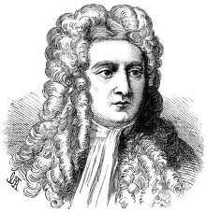
philvaz.com

Newton said :
If balanced forces are applied to a body that has velocity, the object will remain moving at that velocity.

If balanced forces are applied to a body that is not moving, the object will remain at rest.

If there are no forces acting on an object or the forces are balanced then the object will remain at rest or travel at a constant speed in a straight line (constant velocity).
This is why a passenger in a bus (not wearing a seat belt) will continue to move forward after the bus has applied its brakes. The force was applied to the bus and not to the passenger. Therefore the passenger will continue moving forwards until a force stops them (usually the backrest from the seat in front of them).
In everyday life it is hard to sometimes understand this as the force of friction acts against motion. If a pencil is pushed along a desk. Once the pushing force is removed, the pencil will come to a stop, as the force of friction acts against the motion.

Examples of balanced forces
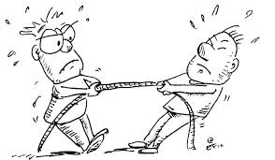
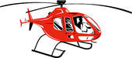

Newton’s Second Law

Force, Mass and Acceleration
Newton followed up his first law about balanced forces with a second law that describes how an object will accelerate if there is an unbalanced or resultant force acting on it. When the forces are balanced an object will remain at rest or travel at a constant speed in a straight line. But when the forces are not balanced the velocity cannot remain constant. It will change. The acceleration tells you how quickly the velocity is changing.
The acceleration of an object (produced by an unbalanced force) is:
- directly proportional to the magnitude of the unbalanced force,
- in the same direction as the unbalanced force
- inversely proportional to the mass of the object.

$$F=m a$$

Symbol | Definition | Unit | Unit symbol
$$F$$ | force | newton | N
$$m$$ | mass | kilograms | kg
$$a$$ | acceleration | metres per second squared | m/s²
This formula defines the newton.
One newton is defined as the force that makes a mass of 1 kg accelerate at 1 ms⁻²

Example
            - A car of mass 1 000 kg has an unbalanced force of 1 600 N acting on it. what will be its acceleration?
F | = | ma
1600 | = | 1000 x a
a | = | $$\frac{\text{1600}}{\text{1000}}$$
$$a$$ | = | 1.6 ms⁻²

Resultant Forces
When several forces act on one object, they can be replaced by one force, which has the same effect. This single force is called the resultant or unbalanced force.

Calculations Using F = ma For More Than One Force
If there is more than one applied force in a problem then draw a free body diagram and mark on all the known forces.
Use this to calculate the resultant force (F in the equation) before using the equation F = ma.
When adding more than one vector they must be added “tip to tail”. That means that the tip of the first vector must point at the tail of the next vector.

Examples
- A car of mass 1 000 kg experiences friction equal to 500 N. If the engine force is 1 300 N, what will be the car’s acceleration?
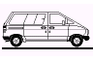
Engine force = 1300 N
Friction = 500 N

Resultant or unbalanced force = 1300 – 500 = 800 N

F | = | ma
800 | = | 1000 x a
a | = | $$\frac{\text{800}}{\text{1000}}$$
a | = | 0.8 ms⁻²
F = 800 N
m = 1 000 kg

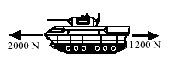
- Given that the tank below has a mass of 6000 kg, calculate its acceleration.
F | = | ma
800 | = | 6000 x a
a | = | $$\frac{\text{800}}{\text{6000}}$$
a | = | 0.8 ms⁻²
Resultant force = 2000 – 1200 =
F_{UN} = 800 N
m = 6 000 kg

Homework
- A boy of mass 45 kg slides down a chute at a leisure centre. His acceleration is initially 2 ms⁻². Calculate the force acting on him.
- A car's engine applies a force of 3000 N, and this accelerates it at 4 ms⁻². Calculate the mass of the car.
- Explain, using the theory of forces, how a seat belt can prevent injury in a car crash.
- Explain the term balanced forces.
- State the equivalent of balanced forces.
- State Newton’s First Law.
- The diagram below illustrates the forces acting on a motorbike. The combined mass of the bike and rider is 125 kg.
200 N
700 N

(a) Calculate the resultant force acting on the bike.
(b) Calculate the acceleration of the bike.
8. . Look at the pairs of forces acting on the objects below. In each case, state the resultant force and the direction in which it is acting.
10 N
5 N
12 N
20 N
(a) (b)

Balanced Forces and Newton’s First Law Questions
- The diagram below shows the forces acting on a car moving at constant velocity.
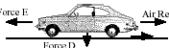
Other friction = 450 N
Force E
Force D
Normal reaction = 10 000 N
Air resistance = 400 N

- Make a statement about the forces acting on this car.
- Calculate the magnitude of the engine force E.
c) Calculate the weight of the car.
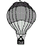
- The diagram shows the forces acting on a balloon as it rises.
Buoyancy force = 2000 N
Balloon rising at a constant velocity

Force A
- Calculate the size of force A.
- If the balloon was falling at a constant velocity, determine the size of force A.

- State Newton’s First Law.
- Explain, using Newton’s First Law, why passengers without seat belts in a moving car appear to be “thrown forwards” in the car, when the car stops suddenly
- Explain how a parachutist reaches a terminal velocity.

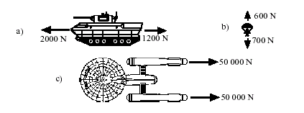
Resultant Forces Questions
- What is meant by the resultant force on an object?
- What are the resultants of the following forces?

- By using a scale diagram or otherwise, find the resultant of the following pairs of forces. Remember to draw the vectors “tip to tail”.
a) b)
5 N
15 N
5 N
12 N

c) d)
N
8 N
10 N
24 N
18 N

Newton’s Second Law Questions
- Calculate the force needed to accelerate a 5 kg mass at 3 ms⁻².
- Calculate the acceleration produced on a 12 kg mass acted on by a force of 30 N.
- Calculate the mass when a Force of 12 N acts to produce an acceleration of 2 ms⁻².
- Calculate the force which will accelerate 250g at 2 ms⁻²?
- Calculate the force required to accelerate a 10 tonne lorry at 1.5 ms⁻²
(1 tonne = 1000 kg)
- State two reasons why a car will have a smaller acceleration in similar conditions when a roof rack is added.
- Describe an experiment to investigate the effect of varying the unbalanced force acting on a fixed mass.
- A car of mass 1200 kg experiences friction equal to 500 N when travelling at a certain speed. If the engine force is 1400 N, determine the car’s acceleration.
- A car of mass 2000 kg has a total engine force of 4500 N. The frictional drag force acting against the car is 1700 N. Calculate the acceleration of the car.
- Two girls push a car of mass 1000 kg. Each pushes with a force of 100 N and the force of friction is 120 N. Calculate the acceleration of the car.
- A boat engine produces a force of 10000 N and the friction and water resistance total 3500 N. If the mass of the boat is 2000 kg, calculate its acceleration.
- A careless driver tries to start his car with the hand brake still on. The engine exerts a force of 2500 N and the hand brake exerts a force of 1300 N. The car moves off with an acceleration of 1.2 ms⁻². calculate the mass of the car.
- A car of mass 1200 kg can accelerate at 2 ms⁻² with an engine force of 3000 N. Determine the total frictional force acting on the car.
- A helicopter winches an injured climber up from a mountainside. The climber’s mass is 65 kg.
- Calculate the weight of the climber.
- If he is accelerated upwards at 1.0 ms⁻², determine the unbalanced force required.
c) Calculate the total upwards force produced by the helicopter.
- An 800 kg car is accelerated from 0 to 18 ms⁻¹ in 12 seconds.
- Calculate the resultant force acting on the car.
- At the end of the 12 s period the brakes are operated and the car comes to rest in a time of 5 s. calculate the average braking force acting on the car.

Newton’s Third Law
Newton noticed that forces occur in pairs. He called one force the action and the other the reaction. These two forces are always equal in size, but opposite in direction. They do not both act on the same object. Newton’s Third Law can be stated as:
If an object A exerts a force (the action) on object B, then object B will exert an equal, but opposite force (the reaction) on object A.

Examples
A footballer heading a ball.
Object A is the head. Object B is the ball. When the player heads the ball, the head exerts a force to the right on the ball. The ball exerts a force on the head that is equal in size and opposite in direction.
Please note the deformation of the shape of the ball


Watch
http://www.youtube.com/watch?v=seg7eLmw5pY
for slow motion kicking of a rugby ball
http://www.youtube.com/watch?v=lBMA2wWuqh8
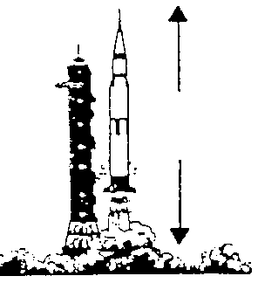
for slow motion kicking of a football
Object A is the rocket. Object B is the exhaust gases from the fuel. When the rocket takes off, the rocket exerts a force downwards on the exhaust gases. The exhaust gases exerts a force on the rocket that is equal in size and opposite in direction.

Difference between Newton’s first and third laws
This can sometimes lead to a lot of confusion and occasionally there is some overlap between the two. Newton’s first law refers to the forces on one object and Newton’s third law relates to force on two objects.
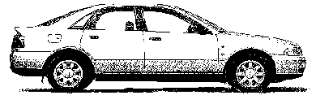
For example
Frictional forces
30 m s⁻¹
m = 1500 kg
Engine force

If a car is driving along the road at constance speed the forces on the car are balanced. The frictional forces on the car balance the engine forces pushing the car forward.
But each of those forces would have a Newton pair. For example, the frictional force is partly due to the force acting between the road and the tyre. This is a Newton Pair- the tyre exerts a force on the road and the road pushes back with an equal but opposite force on the tyre. Also drag acts on the car, but the newton pair would be the air passing over the car, but the car exerts an equal but opposite force on the air.
Sometimes Newton pairs can result in balanced forces. For example in our car example, the car is travelling along the road at equal height to something must balance the weight that obviously acts down. This is actually a Newton Pair, as the car pushes down on the road (weight) but the road must provide an equal but opposite force on the car (reaction force). This is a Newton Pair!

Gravitational Field Strength and Acceleration Due to Gravity
The force of gravity pulls every object near or on the Earth's surface down towards the centre of the Earth with a force of 9.8 Newtons for every kilogram of mass.
This downwards force (weight) per kilogram of mass is called the gravitational field strength. (Symbol g ).
Near the Earth's surface, g = 9.8 Newtons per kilogram (Nkg⁻¹)
$$acceleration = \frac{Force}{ mass }$$
The force of gravity acting on all objects with mass which are close to the Earth's surface, causes the objects to accelerate towards the Earth's surface - The objects have "acceleration due to gravity". The objects all have the same value of acceleration (if the effects of air resistance are negligible [very small]):
acceleration due to gravity, g, = 9.8 ms⁻²

Explanation
Weight is the force which causes an object to accelerate downwards.
$$W = mg$$
where g is the gravitational field strength.
The value of the acceleration caused by weight can be calculated from Newton’s second law, using the equation
$$F = ma$$
where F is now the weight W, and $$W = mg$$
(This assumes that friction is negligible).
$$Acceleration due to gravity =a$$
Using Newton’s Second Law:
$$a=\frac{F}{m}$$
In this case the force is weight so:
$$a=\frac{W}{m}$$
W = mg giving:
$$a=\frac{mg}{m}=g where g is in m s^{-2}$$
The numerical values of the acceleration due to gravity and gravitational field strength are equal. Their units, Nkg⁻¹ and ms⁻² are also equivalent.

Example
On the moon, where the gravitational field strength is 1.6 Nkg⁻¹, a stone falls and takes 1.5 s to reach the surface. What is its velocity as it hits the surface of the moon?
(There is no atmosphere to cause any air resistance on the moon).

a = g | = | $$\frac{\text{v - u}}{\text{t}}$$
1.6 | = | $$\frac{\text{v - 0}}{\text{1.5}}$$
v | = | 1.6 x 1.5
v | = | 2.4 ms⁻¹
u = 0 ms⁻¹
g = 1.6 Nkg⁻¹ (=1.6 ms⁻²)
t = 1.5 s

GRAVITATIONAL FIELD STRENGTH and ACCELERATION DUE TO GRAVITY are

"EQUIVALENT TERMS".
Weight is a force
the same
so a and g must be the equivalent

Homework
            - Calculate the weight of a girl who has a mass of 40kg.
            - What is the gravitational force acting on a 30g rock on the Earth’s surface?
            - Find the mass of a boy who weighs 550N.
            - During the Apollo 11 expedition to the Moon, 21kg of soil samples were brought from the Moon to the Earth. The gravitational field strength was not constant throughout the journey
              - What is meant by gravitational field strength?
              - Copy and complete the table to show the mass and weight of the soil samples at various stages of the journey
Stage | Gravitational field strength (N kg⁻¹) | Mass (kg) | Weight (N)
On the Moon | 1.6 | 21
At a point during the journey | 0
On the Earth | 9.8

- An astronaut on the Moon uses a newton balance to measure the weight of a 20kg rock. If the reading on the balance is 32N, calculate the gravitational field strength on the Moon
- The gravitational field strength on Venus is 8.8Nkg⁻¹. If a robot probe of mass 270kg lands on Venus, how much will it weigh?
- If a man weighs 700N on Earth, how much would he weigh on Jupiter which has a gravitational field strength of 26Nkg⁻¹?

Friction
Friction is a resistive force, which opposes the motion of two solid surfaces in contact, meaning it acts in the opposite direction to the movement of the surfaces.
Friction acts between any two surfaces in contact. When one surface moves over another, the force of friction acts between the surfaces and the size of the force depends on the surfaces, e.g. a rough surface will give a lot of friction.
Friction is a very common force.
Friction between two solid surfaces depends on two factors:
- how rough the two surfaces are
- the size of the force between the two surfaces [how hard they are pressed together and how fast they are moving relative to one another.]
Friction increases the rougher the two surfaces are and the bigger the force between them.
If there is no or little friction between surfaces then the surfaces can move easily over each other. This can nearly be achieved by placing a layer of a different material between the surfaces, called a lubricant.
An example of this is air being used in an air puck.
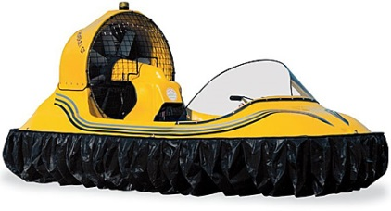
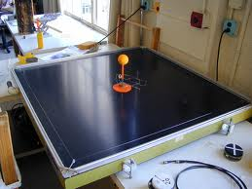

tsgphysics.mit.edufuncrate.com
Friction is a force which tries to stop things moving. Friction occurs between two solid surfaces. Friction can be good or a nuisance

Friction good | Friction bad
braking | shooting (drag slows the bullet)
walking | putting on clothes (chaffing)
space craft re-entry | wears down tyres
running | engines wear away
writing | F1 racing !!!!
sky-diving (drag) | in space things don’t stop easily
opening bottles | rotating machinery slowed down and wears away
steering wheel
striking matches
cats using to drink
sharpening knives
grip for tyres/shoes

Streamlining
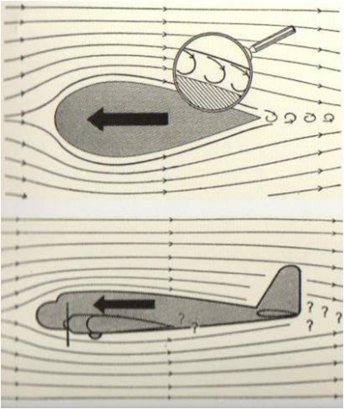
A teardrop is a very streamlined shape. Air can flow over it without producing turbulence (little winds!) To reduce fuel consumption cars and lorries are made as close to this shape as possible, but with wheels, doors, mirrors etc the shape is compromised.

The force of air resistance can also be called DRAG. Drag is a force like friction which opposes motion. Drag occurs when a solid moves through a liquid or gas.

Ways of changing friction
Sometimes we want large frictional forces but usually we want to reduce the force of friction on an object. NB Friction really only refers to two solid surfaces in contact, drag, air resistance etc refer to fluids in contact with a solid or another fluid, which is why it is often better to refer to frictional forces.
Increasing Friction | Decreasing Friction
less aerodynamic | lubrication eg oil, wax, grease, soap
greater surface area | streamlining
increase mass | more aerodynamic
surface rough eg sand | reduce mass
gritting roads | Rollers
stickier surface | layer of air
rougher tyres | polystyrene beads
 | smooth surface

Title: Friction and Movement
Aim: To investigate the force of friction between various surfaces.
Apparatus:
- Newton balance
- Block of wood
- Different surface materials
- A range of masses from 1 kg upwards.
Instructions
• Set up the apparatus as shown above using one of the surface materials.
• Using the newton balance, pull the block along the board at a steady speed.
• Record the reading on the balance in a table.
• Repeat the above for different surface materials.
• Repeat the above increasing the mass on top of the block.
Results
• List the surfaces in order of increasing friction with the wooden block.
• For each of the surfaces, plot a graph of the mass on block against the pulling force.

Questions
Answer the following questions in your jotter.
- Describe two methods of
a) increasing friction b) decreasing friction.
2) Where, in a bicycle, is friction deliberately
a) increased b) decreased?

PARACHUTES

Free-Fall & Terminal Velocity
Newton's First Law applies particularly well under freefall conditions.
Sky divers who jump from a plane do not continue to accelerate to the ground at ever increasing speeds As the skydiver's speed increases the frictional force due to air resistance also increases. There comes a point when the skydiver's upward frictional force equals the skydiver's downward weight. The forces are now balanced.
If the vertical forces on the skydiver are balanced then according to Newton's First Law, the skydiver will continue downwards at a constant speed. This constant speed (or velocity) is known as the terminal velocity.
If an object is falling as described above and the only two forces acting on it are weight and air resistance then the object is said to be in free fall.
http://www.physicsclassroom.com/mmedia/newtlaws/sd.cfm
  W | The instant the parachutist leaves the plane her vertical speed is zero!  - Friction is zero  - There is a force acting downwards -WEIGHT  - The parachutist accelerates downwards according to Fw=ma.  - The weight is an unbalanced force on the parachutist  - The parachutist accelerates at 9.8 ms⁻²
F  W  F_{un}  F  W | As the parachutist falls his speed increase  - AIR RESISTANCE/ DRAG increases  - WEIGHT remains constant  - There is still an unbalanced force on the parachutists but this is less than before.  - The parachutist accelerates downwards but the acceleration is much less than 9.8 ms⁻²  - The parachutist does not slow down but speeds up slower!
Finally the magnitude of the AIR RESISTANCE is equal to WEIGHT
- The forces on the parachutist are now BALANCED (overall effect ZERO)
- The parachutist travels at CONSTANT VELOCITY (acceleration is zero)
- The parachutist travels at TERMINAL VELOCITY
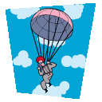  F  W  F_{un} | As the parachute opens AIR RESISTANCE/ DRAG INCREASES  - WEIGHT remains constant  - AIR RESISTANCE>>WEIGHT  - There is an unbalanced force on the parachutist upwards  - The parachutist decelerates (slows down very quickly)  - the parachutist is still failing and does not suddenly float upwards, but they slow down rapidly.
F  W | As the parachutist slows down  AIR RESISTANCE DECREASES until is equal to the weight  The forces on the parachutist are now BALANCED (overall effect ZERO). They are the same magnitude as the were at the previous terminal velocity.  The parachutist travels at CONSTANT SPEED  (acceleration is zero)  The parachutist travels at a new TERMINAL VELOCITY  (Obviously less than before but  still enough to break a leg on impact!)
  R  W  F_{un} | As the parachutist lands  - WEIGHT remains constant  - but there is a very big force from the ground  - There is an unbalanced force on the parachutist upwards  - The parachutist decelerates to a stop!  - PHEW!  This can be represented in the velocity time graph above, which gives details of the velocity at various parts of the journey..

Parachute opens
V/m s⁻¹
Terminal velocity
acceleration decreases as velocity increases
New terminal velocity
t /s
Landing
http://www.darvill.clara.net/enforcemot/friction.htm
http://www.physicsclassroom.com/mmedia/newtlaws/sd.cfm

NB The parachutist never flies upwards as appears in films. This is just the camera being tilted by the camera operator who is also falling from the plane and who pulls their parachute cord later than the person being filmed! Honest!

Friction Questions
- Define what friction is.
- Give two examples where friction slows things down.
- Give two examples of where friction helps things move.
- Describe two methods of increasing friction.
- Describe three methods of decreasing friction.
- Where in a bicycle is friction deliberately
- increased
- decreased?
- What is friction commonly called when the one of the surfaces involved is air?
- What is friction commonly called when the one of the surfaces involved is water?

Unbalanced Force, Mass & Acceleration (F = ma expanded)
'Changing motion' includes movement where the body is speeding up or slowing down. It also includes motion where the direction in which the body moves is changing, ie the body is moving in a curved path. 'Changing motion' is caused by unbalanced forces.
Unbalanced forces are generally due to a forward force (or thrust) and a frictional force working against each other.
Friction is a force that opposes motion. It is present whenever two surfaces rub over each other, such as when you rub your hands together, or when you apply the brakes on a bike or in a car. Friction also prevents an object from starting to move, such as a shoe placed on a ramp. When friction acts between two surfaces that are moving over each other, some kinetic energy is transformed into thermal (heat) energy.
Friction can sometimes be useful. For example, we rely on the soles of our shoes to not slip over the ground that we are walking on, and the friction between a car tyre and the road surface helps cars to speed up, slow down and turn corners. Sometimes though, friction can be a nuisance. For example, the friction between a wheel and the axle that it rotates on wastes energy, so we try to minimise the friction using bearings and lubricants.

Homework 2
1. Find the unbalanced force required to accelerate a 6kg mass at 3ms⁻².
2. Find the acceleration of a 200kg rock, rolling down a hill, if the unbalanced force acting on it is 1kN.
3. What is the mass of a trolley if an unbalanced force of 12N causes it to accelerate at 4ms⁻²?
4. The forces acting on a car of mass 1000kg are shown below.
2kN
6kN
Engine force
Friction
- Find the unbalanced force acting on the car.
- Calculate the acceleration of the car.
- A model motor boat of mass 4 kg is initially at rest on a pond. The boat’s motor, which provides a constant force of 5 N, is switched on. As the boat accelerates, the force of friction acting on it increases. A graph of the force of friction acting on the boat against time is shown.

    - State the force of friction acting on the boat 2 s after the motor is switched on.
    - Calculate the acceleration of the boat at this time.
  - Describe and explain the movement of the boat after 7 s

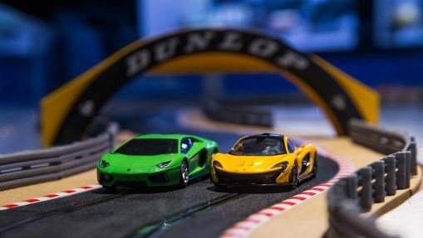
- Stephen and Jack are invited along to ‘Techno toys’ workshop to try out a new remote control car. They line the car up to race along the 200 m track and then start it off.
(a) Describe how the designers could work out the car’s instantaneous speed as it goes round the corner of the track. Your answer must include:
any apparatus they would need
any measurements they would take
any calculations they would do.
- The speed time graph below represents the motion of the car during part of the race.
(b) Calculate the acceleration of the car during the first 6 seconds.
(c) Determine the distance travelled by the car during the 18 seconds represented by the graph.
(d) During the period 6 s to 14 s the car exerted an engine force of 450 N. State the magnitude of the frictional forces acting on the car during this time.
(e) State how the designers reduce the frictional forces acting on the car.
(f) Draw the graph that would have been produced if the race had taken place on a wet day.

Summary
After this section you should understand the following
I can give applications and use Newton’s laws and balanced forces to explain constant velocity (or speed), making reference to frictional forces of this.
I can give applications of Newton’s laws and balanced forces to explain and or determine acceleration for situations where more than one force is acting, (F=ma)
I can use F=ma to solve problems involving unbalanced force, mass and acceleration for situations where more than one force is acting, in one dimension or at right angles.
I can use W=mg to solve problems involving weight mass and gravitational field strength, including on different planets (where g is given on page 2 of section1)
I can use Newton’s 3rd law and its application to explain motion resulting from a ‘reaction’ force.
I can use Newton’s laws to explain free-fall and terminal velocity.

Energy
5.1 | I can state that energy is never created or destroyed, it is conserved.
5.2 | I can identify and explain energy conversions and transfer.
5.3 | I can apply the principle of ‘conservation of energy’ to examples where energy is transferred between stores.
5.4 | I can use Ew=Fd to solve problems involving work done, unbalanced force, and distance or displacement.
5.5 | I can identify and explain ‘loss’ of energy where energy is transferred.
5.6 | I can define gravitational potential energy. Ep is the energy an object has because of its position above the Earth’s surface and its mass
5.7 | I can use Ep=mgh to solve problems on involving gravitational potential energy, mass, gravitational field strength and height
5.8 | I can define kinetic energy as the energy an object has because of its speed.
5.9 | I can use Ek= ½ mv² to solve problems involving kinetic energy, mass and speed
5.10 | I can use Ew=Fd, Ep=mgh, Ek= ½ mv² to solve problems involving conservation of energy

Conservation of Energy
The principle of the Conservation of Energy states that energy cannot be created or destroyed – it can only change from one form of energy to another. Energy is conserved – the total amount of energy present stays the same before and after any changes

It is difficult to state what energy actually is. We know that we need energy to do things, and we know that energy is changed from one type to another.
The law of conservation of energy states that energy cannot be created or destroyed, only transformed from one form to another.
In order to increase the amount of one type of energy, we must transform it from a different type.
A battery in a circuit stores chemical energy which is transformed in a circuit into electrical energy.
Energy is measured in joules (J). No energy can disappear in the change – all energy in a system is conserved. This means that if we start with 100 J, we must have 100 J of total energy after any change has taken place.

Energy ‘loss’
We often talk about energy loss. As we have already discussed, energy cannot be destroyed but it can be changed. The problem is that it doesn’t always change the way we want. A perfect example is a filament lamp. When we turn it on, the desired transformation is from electrical energy to light energy. This is the main transformation, but the lamp gets very warm when it is switched on. This transformation from electrical to heat energy is undesired.
  This Sankey diagram shows the energy transformation in a filament lamp.  100 J  Electrical  Energy  90 J  ‘lost’ Heat  Energy  10 J  Useful Light  Energy |   75 J  Useful Light  Energy  25 J  ‘lost’ Heat  Energy  100 J  Electrical  Energy  This is a similar diagram but for an energy saving lamp. Very little energy is ‘lost’ as heat.

The idea of conservation of energy can be applied to a range of energy transfers, e.g. crash barriers or footballs being kicked. In an exam you may be expected to apply this knowledge to unfamiliar situations.
We often say that the type of energy we are after is the ‘useful’ energy and that any other forms of energy that our energy store is transferred into are ‘wasted’ energy. For example, electrical energy in a light bulb is transferred into light (useful energy) and heat (wasted energy).

Work Done and Energy

At the moment you probably feel that you are doing lots of work. But in Physics work has a special meaning
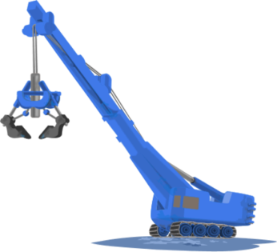
When you push something to make it move you are doing work. Work is also done when a locomotive pulls a train or when a crane lifts a load.
When work is done energy is transferred. When you push something and start it moving, you are giving it energy.
The work done, or the energy transferred, depends on the force exerted and the distance moved in the direction of the force.
$\text{work done= force × distance}$ $E_{w}=Fd$
Where the force is measured in Newtons and the distance is measured in metres, the work done is measured in joules.
Energy cannot be created or destroyed, but it can be changed from one form into another. All forms of energy are measured in the same unit: the joule (J). When a force causes movement, some energy is changed from one form to another (it is transformed) and we say that work is done. For example, the force of friction causes kinetic energy to be transformed into heat.
Work is done when a force moves through a distance.
The work done is a measure of the energy transformed. It is equal to the force multiplied by the distance the force moves. The force and distance must be measured in the same direction

.
Work is measured in the same units as energy: joules. The symbol for work is E_{W}.
$$E_{W}=F d$$
Symbol | Definition | Unit | Unit symbol
$$E_{W}$$ | Energy | joules | J
$$F$$ | Force | newtons | N
d | distance | metres | m
Example
W | = | mg
W | = | 15 x 9.8
W | = | 147 N
Calculate the work done by a gardener who uses a wheelbarrow to move 15 kg of soil a distance of 500 m.
m = 15 kg, g = 9.8 Nkg⁻¹
The weight is equivalent to the force the gardener has to apply to move the wheelbarrow of soil.
E_{W} | = | Fd
E_{W} | = | 147 x 500
E_{W} | = | 74 000 J
F = W = 147 N
d = 500 m

Questions
- A shopper pushes a supermarket trolley a distance of 600m with a force of 70 N. calculate the work done.
- A locomotive pulls a carriage a distance of 1.6 km with a force of 28000 N, calculate the work done.
- The brakes of a car exert a force of 500 N to stop the car. If the braking distance is 67 m calculate the work done by the brakes to stop the car.

A special case- Gravitational Potential energy
m
m
Force, F
height, h

When a force lifts an object, the work done by the force is stored as gravitational potential energy.
The force required to lift an object is equal to the weight of the object. However, the weight depends on the mass and the gravitational field strength.
$$\text{work done= force × distance}$$
$$E_{w}=Fd$$
For this special case, F=mg and d=h. (We use h to remind us that the distance here is the height the object is lifted) So
$$\text{work done= force × distance}$$
$$E_{w}=Fd$$
$$E_{w}=mgh$$
The symbol E_{p} is used for gravitational potential energy so,
$E_{p}=mgh$

Questions
- A lift moves a 45kg girls up 9 m from the ground floor to the top floor. Calculate her gain in gravitational potential energy.
- A boy lifts a 3.8 kg school bag up to 0.92m from the floor to the bench. Calculate the gain in the gravitational potential energy of the bag.

Work Tutorial
$$E_{w}=Fd$$
- A locomotive exerts a pull of 10 000 N to pull a train of loaded wagons a distance of 300 m, calculate the work done.
- A gardener pushes a lawnmower with a force of 150N for a distance of 220m, calculate the work done.
- If a girl uses 1200 J of energy pushing a trolley a distance of 60m, calculate the force she exerts.
- The brakes on a car do 900 000 J of work when bringing it to a halt. If the stopping distance is 125 m, determine the force the brakes exert.
- If the force produced by the brakes was only 1000N in question 4, and the brakes still do 900 000 J of work, calculate the new stopping distance.
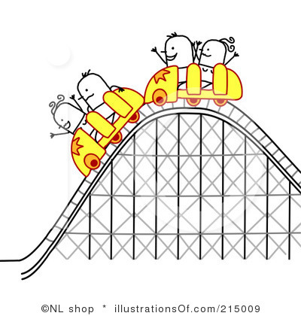
- The force of friction between a pencil and paper is 0.12N. Calculate the distance you have to push a pencil to do 5 J of work.
- A mountain rescue helicopter winches up an injured climber of mass 65 kg a distance of 30m from a rock edge. Calculate the gain in gravitational potential energy.
30m
- Calculate the gain in gravitational potential energy when a 50 kg sack of potatoes is lifted 0.85m up onto a lorry.
- Estimate how much gravitational potential energy you would gain if you were winched up 30m to the top of a funfair ride.

- A fork lift truck is to be used to load a crate of mass 200kg onto a lorry .
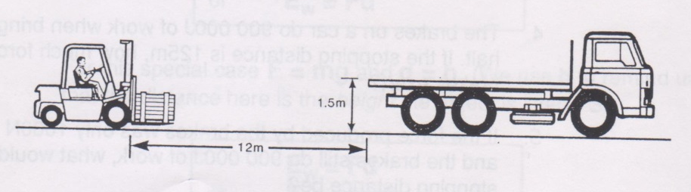
It has to drive 12m to the lorry and then lift the crate up 1.5m onto the lorry. The driving force is 500N and the energy available to complete the operation is 8000 J. Determine whether the fork-lift truck is able to load the crate onto the lorry? You must justify your answer by calculations.

Revision
We can calculate gravitational potential energy by using the following formula:
$$E_{p}= m × g × h$$
Where
E_{p} is the gravitational potential energy in Joules
m is the mass of the object in kg
g is the gravitational field strength (on Earth) = 9.8 ms⁻²
h is the height of the object in metres

Kinetic Energy
Kinetic energy is the name given to the energy an object has because it is moving. It is given the symbol E_{k}. The formula is an odd one, and some people can find it hard to rearrange, but just take it step by step and it is fine.The more massive and the greater the speed it is travelling, the greater the object’s kinetic energy.
We can calculate the kinetic energy of moving objects by using the following formula:
$E_{k} =\frac{1}{2}×m × v^{2}$
or $$E_{k} =\frac{1}{2}m v^{2}$$
Kinetic energy = ½ x mass x speed squared
where
E_{k} is the kinetic energy in Joules
m is the mass of the object in kg
v is the velocity of the object in metres per second, ms⁻¹
E_{k} is a SCALAR quantity (don’t worry if you cannot remember about this term, we will come back to it later).

A wimpy kid on an office chair, with a combined mass of 65kg is travelling at 12 ms⁻¹. Calculate E_{k}.
m=65kg, v=12 ms⁻¹

Quantity | Symbol | Unit | Unit Symbol
Kinetic Energy | E_{k} | Joules | J
Work done | E_{w} or W | Joules | J
Gravitational potential energy | E_{p} | Joules | J
Height | h | metres | m
Speed | V | metres per second | ms⁻¹

Worked example:
A crane lifts a crate of mass of 60kg to a height of 60m.
(a) calculate the gravitational potential energy gained by the crate
(b) if the cable of the crane snaps once it has completed lifting the crate , calculate the maximum velocity of the crate just as it reaches the ground (ignoring air resistance)
a) Using the equation $E_{p} = m × g × h$  E_{p} = 60 x 9.8 x 25  E_{p} = 15,000 J | Mass, m = 60 kg  Height, h = 25 m  Gravitational field strength, g = 9.8 Nkg⁻¹
b) If the crate falls, all of its potential energy will be transformed into kinetic energy. We are told to neglect air resistance – this means we can ignore any loss of energy to heat.
We can say that the gravitational potential energy, E_{p} is equal to the kinetic energy, E_{k}, therefore:
E_{p} = E_{k} = 15,000 J as worked out previously
Using the equation $E_{k} =\frac{1}{2}m × v^{2} = 15,000 J$
15,000 = ½ x 60 x v²
$$v^{2} = \frac{15,000 × 2}{60} = 500$$
v = 22.7 ms⁻¹
Energy cannot be created or destroyed we can only transfer it from one place to another. When we drop an object the GRAVITATIONAL POTENTIAL ENERGY is converted to KINETIC ENERGY, provided there are no losses due to friction.
Notice the mass of the object does not affect the speed that the object will reach as it falls. Amazing!
Now look at this example
- A car of mass 1050 kg and moving at 22.5 ms⁻¹ calculate its kinetic energy?
- The car slows to 5 ms⁻¹ calculate its new kinetic energy?
- How much work has been done heating up the brakes?
The work done is EQUAL TO the LOSS IN E_{k}
E_{w} = E_{k} (start)-E_{k} (end)
E_{w} = 266000-13125
E_{w} = 252875 J or 250000 J
- If the car travels 50m as it brakes, what is the average braking force?

Work Done, Unbalanced Force & Distance (E_{W}=Fd)
Energy is 'lost' or not used effectively when frictional forces occur. For example, when a bike applies its brakes and slows down the kinetic energy of the bike is transferred into heat energy in the brakes.
How much energy is lost depends on the frictional force (F) and the distance over which the frictional force is acting (d).
This is called the Work Done against Friction (E_{W}).

$$Work Done against Friction=Frictional Force×Distance \\ E_{W}=Fd$$
Symbol | Definition | Unit | Unit Symbol
E_{W} | Work Done | joule | J
F | Frictional Force | newton | N
d | Distance | metres | m

Example
Travelling between stops, the average frictional force on a bus was $8.2×{10}^{3}$N over a distance of 500 m.
Calculate the work done by the bus engine to overcome this frictional force.

Solution
$$E_{W}=Fd$$
$$E_{W}=8.2×{10}^{3}×500$$
$E_{W}=4.1×{10}^{6}$J

Energy Transformations
- Copy and complete these examples of energy transformations.
  - Car moving at a steady speed along level road:
chemical energy -> ________
  - Car accelerating along level road:
chemical energy -> ________ + _______
  - Car braking:
kinetic energy -> ________
  - Car freewheeling downhill (engine switched off):
________ -> ________ + _______

- A locomotive exerts a pull of 10000 N to pull a train a distance of 400 m.
Calculate the work done.

- A gardener does 1200 J pushing a wheelbarrow with a force of 100 N.
Calculate the distance she push the barrow.

- A man uses up 1000 J by pulling a heavy load for 20 m. Calculate the force used.

- A girl is pushing her bike with a force of 80 N and uses up 4000 J of energy.
Calculate the distance she pushed the bike.

- A man weighing 600 N climbs stairs in an office block which are 40 m high.
Calculate the work he does.

- A worker pushes a 4 kg crate along the ground for 3 m using a force of 20 N, then lifts the crate up to a ledge 1 m high. Determine the work done in total.

Gravitational potential energy Questions
- A chairlift raises a skier of mass 60 kg to a height of 250 m. Calculate the potential energy gained by the skier.

- A brick of mass 3 kg rests on a platform 25 m above the ground on a building site.
  - Calculate the potential energy stored in the brick.
  - If the brick falls 25 m to the ground, calculate the loss in potential energy of the brick.
  - State the form of energy gained by the brick as it falls.
- Estimate how much gravitational potential energy you would gain if you were lifted 30m up to the top of a fun-ride.
- An apple, mass 100 g, has 300 J of potential energy at the top of the Eiffel Tower. Calculate the height of the Eiffel Tower.
- An astronaut of mass 70 kg climbs to a height of 5 m on the moon and gains 560 J of gravitational potential energy. Calculate the gravitational field strength on the moon.

Kinetic energy Questions
            - You are provided with an air track and vehicles, a light gate and timer and some elastic bands. Describe how you could use this apparatus to establish how kinetic energy depends on velocity. Include details of any measurements you would take and any additional measuring equipment needed.

- Calculate the kinetic energy of the following:
  - a 5 kg bowling ball moving at 4 ms⁻¹
  - a 50 kg skier moving at 20 ms⁻¹
  - a 0.02 kg bullet moving at 100 ms⁻¹.

  - Calculate the kinetic energy of a 800 kg car travelling at a speed of 10 ms⁻¹?
  - If it doubles its speed to 20 ms⁻¹, calculate its new kinetic energy.
- A cyclist who is pedalling down a slope reaches a speed of 15 ms⁻¹. The cyclist and her cycle together have a mass of 80 kg.
  - Calculate the total kinetic energy.
  - Name two sources of this kinetic energy.
- Calculate an approximate value for the kinetic energy of an Olympic 100 m sprinter as he crosses the line (time for race is about 10 s).
- Determine the speed of a stone of mass 2 kg if it has 36 J of kinetic energy?
- Calculate the speed of a motor cyclist and his bike if they have a total mass of 360 kg and kinetic energy of 87120J.
- The apple of mass 100g is dropped from the top of the Eiffel Tower.
  - Calculate the kinetic energy of the apple just before hitting the ground?
  - Calculate the velocity of the apple as it hits the ground.
- A car of mass 1000 kg is travelling at 20 ms⁻¹.
  - Calculate the kinetic energy of the car.
  - If the maximum braking force is 5 kN, determine the minimum braking distance.
  - If the driver has a reaction time of 0.7 s, calculate the distance the car travels during this ‘thinking time’.
  - Determine the total stopping distance of the car.

Questions:
1. Calculate the gravitational potential energy of a student of mass 50 kg that has climbed 7·0 metres.
2. If an object has a mass of 10kg and a gravitational potential energy of 45,000J calculate the distance it is from the ground.
3. An object at a height of 25m has a gravitational potential energy of 100J, calculate its mass.
4. A car travelling at 10 ms⁻¹ has a mass of 1,500 kg calculate its kinetic energy.
5. A bullet of mass 4.2 g has a kinetic energy of 2,000J, calculate its speed.
6. A bumblebee is flying at 6 ms⁻¹ and has a kinetic energy of 1.8 mJ, calculate its mass.
7. State and explain the principle of the conservation of energy.
8. A stone falls from a cliff, which is 80 m high
a) If air resistance can be ignored, calculate the speed at which it enters the water at the bottom of the cliff
b) If air resistance cannot be ignored, state the effect this will have on the speed of the stone as it enters the water.
c) In practice, not all of the initial gravitational energy is transformed into kinetic energy. Other than kinetic energy, state the main form of energy produced.
9. a. State the type of energy a spacecraft has because of its movement.
b. State the energy change when the spacecraft re-enters the Earth’s atmosphere from space.
c. State the cause of this energy transformation.
10. Show that, if air resistance can be ignored, the speed of a falling object is independent of its mass and depends only on the height through which it moves.

Experiment 1 Investigate energy transfers and losses in the generation of electricity, motion down a hill, etc. using model car ‘stunt sets’.

Experiment 2
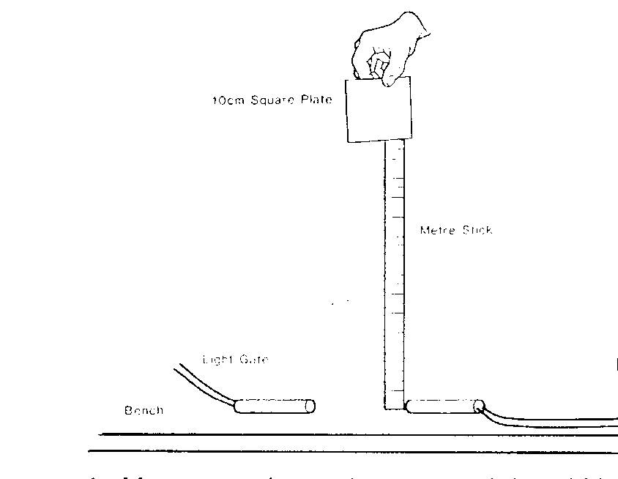
to ALBA
- Carefully cut a mask out of thick card 10cm square with a 8cm square hole cut from the middle. Make sure this is square
- Add a strip of blu tak or sellotape along the bottom (this is to help it drop squarely)
- Find the mass of the cardboard mask using scales (ensure this is in base units!)
- Set up the ALBA to measure speed with a set of light gates hanging over the edge of the bench.
- Enter the width of the BOTTOM part of the square, this ought to be 2cm
- Measure the height of the drop (start with 1 m, measured with a metre stick)
- Carefully release the mask and make sure it drops through the light gates squarely and without getting knocked
- Calculate the Ep and Ek using the data. (if possible write an excel sheet with formula to calculate these values for you)
- Repeat for different heights
- Write out your conclusions

Tutorial Questions

Conservation of energy
- 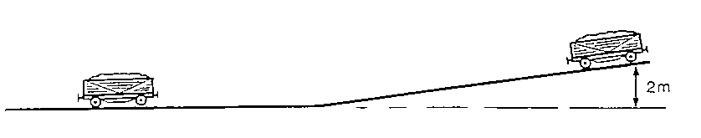In a railway shunting yard, wagons are allowed to run down a slope as shown below. A wagon of mass 900 kg starts from rest and runs down the slope.
- Calculate the amount of gravitational potential energy it loses as it runs down the slope.
- Ignoring any energy losses due to friction, state its total gain in kinetic energy as it runs down to the bottom of the slope.
- Calculate its speed at the bottom of the slope.
- When the wagon is moving along the level part of the yard frictional forces slow it down. How much work will have to be done by friction to stop it?
- The wagon applies its brakes so that the total frictional force applied to it is 200 N. Calculate the distance required to stop the wagon.
- If frictional forces, such as air resistance, had not been ignored in parts (b) and (c) what would the effect be on the speed of the wagon at the bottom of the slope? Explain your answer.

- In a TV advert to demonstrate the safety features of a car, the manufacturers drive it off the top of a building at a speed of 5 m s⁻¹, as shown in the diagram below. The mass of the car is 1000 kg and the height of the building is 11.55 m.
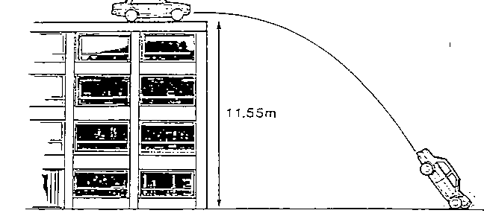

- Calculate the kinetic energy of the car as it drives off the roof.
- Calculate the gravitational potential energy that the car loses as it falls to the ground.
- What then will be its total kinetic energy as it hits the ground?

- A 900 kg car is parked on a hill when its handbrake starts to slip. The car runs down the hill, crashing into a wall at 6 m s⁻¹.
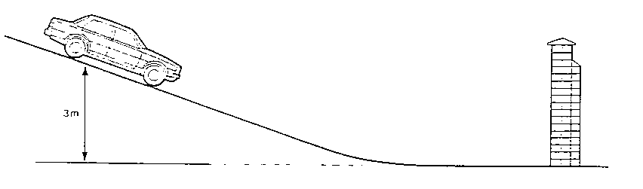
3 m

- How much gravitational potential energy did the car lose as it ran down the hill?
- What was the car's kinetic energy as it hit the wall?
- The slipping brake heated up as the car ran down the hill. How much heat energy was produced at the brake pads?

- A part falls off a helicopter, at a height of 720 m. With what speed will it hit the ground?
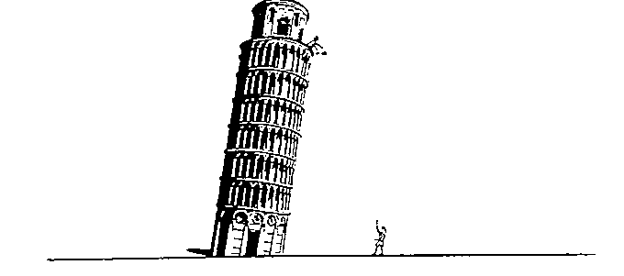
- When Galileo dropped metal spheres of different mass from the leaning tower of Pisa, he found that they hit the ground at the same time. How can his discovery be explained in terms of conservation of energy?

- A 50 kg girl on a 15 kg bicycle is moving at a constant speed of 5 m s⁻¹. She applies her brakes and comes to rest in 2 seconds.
- What is the kinetic energy of the girl plus her bicycle before she brakes?
- What becomes of this kinetic energy during the braking?
- Calculate the power of the brakes in watts.

- A fun ride is being designed so that a carriage with 20 people in it will be raised to a height of y metres, be released and then will go round a loop and stop going up another slope. The carriage has to reach a speed of 7.07 m s⁻¹ at the top of the 10 m high loop. The carriage and passengers are expected to have a total mass of 2500 kg.
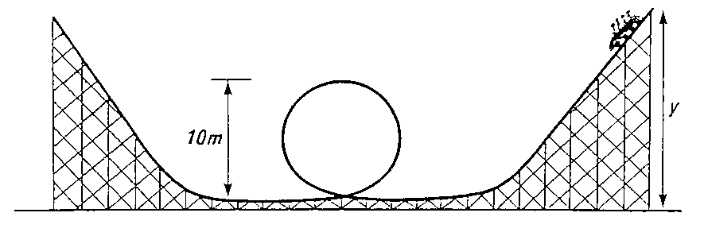

- Calculate the kinetic energy of the full carriage at the top of the loop.
- Calculate its gravitational potential energy at the top of the loop.
- What will be its total kinetic energy as it enters the loop?
- What will be its total gravitational potential energy at height y?
- Calculate the height y.
- Calculate the maximum speed the carriage will reach during the ride.

Summary
The following are the outcomes that you ought to have covered in this section. We’ve also covered quite a few from other sections too.

  - I can state that energy is never created or destroyed, it is conserved.
  - I can identify and explain energy conversions and transfer.
  - I can apply the principle of ‘conservation of energy’ to examples where energy is transferred between stores.
  - I can use appropriate relationships to solve problems involving work done, unbalanced force, and distance or displacement. (Ew=Fd)
  - I can identify and explain ‘loss’ of energy where energy is transferred.
  - I can define gravitational potential energy. Ep is the energy an object has because of its position above the Earth’s surface and its mass
  - I can use Ep=mgh to solve problems on involving gravitational potential energy, mass, gravitational field strength and height.
  - I can define kinetic energy as the energy an object has because of its speed.
  - I can use Ek= ½ mv² to solve problems involving kinetic energy, mass and speed
  - I can use Ew=Fd, Ep=mgh, Ek= ½ mv² to solve problems involving conservation of energy

It is vital that you tell your teacher if there is anything in this section that you do not understand. You will then be given additional resources to help you.

Power
You may well have heard people talking about how much Power an electrical appliance uses. It is often wrongly confused with energy although they are linked.
We can define Power as: Energy used (E) per unit time (t)
We can write this as an equation:
When we talk about power we mean how much energy is transferred every second. If the units of energy are measured in Joules and the time is measured in seconds, then we give the unit of Watts (W) for Power.
We can rearrange (change) the equation above to show that:
Energy used = Power x time
or
E = P x t
Worked Example:
How much electrical energy is converted into heat and light energy when a 60W bulb is turned on for 5 minutes?
E = P x t  = 60 x 300  = 18,000J or 18kJ | E = ?  P = 60W  t = 5 minutes = 5 x 60 = 300 seconds

Work, Power and Time
- A man pushes a wheelbarrow for 60 m using a 50 N force. If he takes 10 s, calculate his average power.

- The man’s son pushes the wheelbarrow for 60 m using the same force as his father, but he takes 13 s to do it. Determine
a) the work done by the son b) his power compare to his father’s.

- A machine lifts a load of 4000 N to a height of 5 m in 20 s. What is its power?

- A boy who weighs 600 N can run upstairs of vertical height 8 m in 12 s.
  - What is his power?
  - A girl who weighs 500 N takes 10 s to run up the stairs. What is her power?
  - Do they do equal amounts of work?

- Describe how you could estimate the average power of a student who is running up a flight of stairs. List measurements you would take, how you would obtain these, and indicate how you would calculate the result.

- A lift can raise a total mass of 800 kg up 10 m in 40 s. What is its power?

- A weight lifter lifts a mass of 250 kg from the ground to a height of 1.5 m in a time of 2 seconds. What was his average power during the lift?

- A lift in a building can take a maximum of 10 people of average mass 70 kg. The mass of the lift is 500 kg.
  - What is the total weight of a full lift?
  - What is the power needed to raise the lift up 30 m in 10 s?

- A bucket of water of weight 250 N is to be lifted up a 30 m well by a 500 W motor.
How long will it take to raise the bucket?
  - What will be the power of the electric motor of a lift which can raise a load of 4000 N at a steady speed of 2 ms⁻¹?
  - What is the energy transformation?
SUMARY

Projectile Motion
6.1 | I can explain that projectile motion occurs when an object has both a constant horizontal velocity and a constant vertical acceleration
6.2 | I can use appropriate relationships to solve problems involving projectile motion from a horizontal launch, including the use of motion graphs.
6.3 | I can state that the area under v_{h}-t graphs is equal to the horizontal range.
6.4 | I can calculate the horizontal range from the area under a v_{h}-t graphs
6.5 | I can state that the area under v_{v}-t graphs is equal to the vertical height.
6.6 | I can calculate the height, and acceleration from v_{v}-t graphs
6.7 | I can state and use the relationships  area under a v_{h}-t graphs equals the horizontal range  area under v_{v}-t graphs is equal to the vertical height.  $v_{h}=\frac{s}{t}$ where v_{h} is a constant horizontal velocity  $v_{v}=u_{v}+at$ where v_{v} is a constant vertical acceleration
6.8 | I can explain satellite orbits in terms of projectile motion, horizontal velocity and weight.

What Is Projectile Motion?
When an object is dropped it falls due to the force of gravity. This is because the object is pulled towards the Earth. The object accelerates at 9.8ms⁻². If the object is also kicked with a horizontal speed then the object is a projectile.
The object moves in a curved path. The curved path of a projectile can be treated as two independent motions.
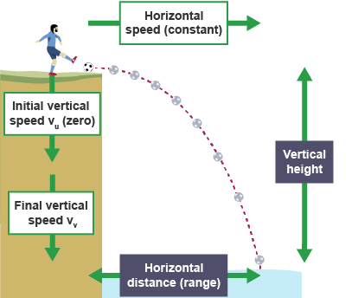
In the vertical direction, the motion is the same as an object in freefall (it accelerates downwards at 9.8 ms⁻². It has constant acceleration of 9.8ms⁻², this is provided we ignore air resistance. In the horizontal direction, the projectile moves at constant speed, providing air resistance is ignored.
The projectile follows the combined motion.
Projectile launched horizontally
At National 5, we only consider projectiles launched horizontally.

Thought Experiment
If you take two identical objects, throw one horizontally and drop one vertically at the same time from the same height, which one should hit the ground first?
They will both hit the ground at the same time as their vertical acceleration is equal.
https://www.youtube.com/watch?v=D9wQVIEdKh8 –a video showing this exact principle in action.

Calculations of Projectile Motion
To calculate projectile motion, you need to treat the vertical and horizontal motion as two independent motions, which are then combined using vector addition.
Because the vertical motion is accelerating and the horizontal motion is constant, projectiles follow an arc.

Example
A boy kicks a ball horizontally over the edge of a cliff with a speed of 6ms⁻¹ as shown in the diagram.
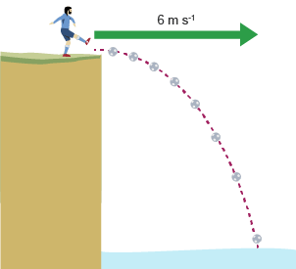
The ball hits the surface of the water 3s later.
- Calculate the vertical speed of the ball when it reaches the water's surface.
- How high is the cliff?
- How far from the foot of the cliff will the ball land?

Solution
Horizontal motion: $v_{h}=6$ms⁻¹ ; $t=3$s
Vertical motion: $u=0$ms⁻¹; $a=9.8$ms⁻²; $t=3$s; $v_{v}= ?$

- Use only the vertical information:
$$v=u+at \\ v= 0+9.8×3$$ $v=29.4$ms⁻¹
- The height of the cliff is simply the vertical distance travelled by the ball. If we draw a speed-time graph using the vertical motion, we can calculate the vertical distance travelled.
The ball has an initial vertical velocity of 0 ms⁻¹ and accelerates uniformly over 3s to reach a final vertical speed of 30ms⁻¹.
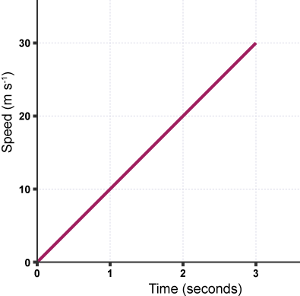
The area under the graph is the vertical distance travelled:
$$Area=0.5 ×base×height \\ Area=0.5×3×30$$ $Area=44.1$m
So the height of the cliff is 44.1m
c) The ball travels for 3s before it hits the sea. The horizontal speed of the ball is constant so we can use:
$$d=vt \\ d=6×3$$ $d=18$m
The ball is 18m from the cliff when it lands in the sea.

When an object is dropped it falls due to _____________ This is because the object is pulled towards the _____________________. The object accelerates at ____ms⁻²
If the object is also kicked with a horizontal speed then the object is a projectile.
The object moves in a curved path.
The curved path of a projectile can be treated as two independent motions.
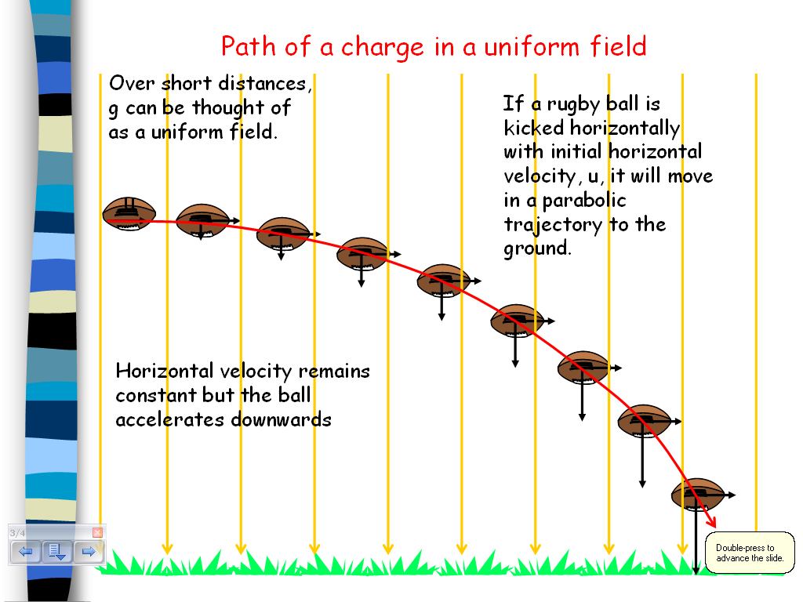
In the vertical direction, the motion is the same as an object in freefall (it accelerates downwards at 9.8 ms⁻²). It has constant acceleration of 9.8 ms⁻², this is provided we ignore air resistance.
In the horizontal direction, the projectile moves at constant speed, providing air resistance is ignored.
The projectile follows the combined motion.
(N.B. As F_{w} = mg, which is a form of F=ma then g=a,
So whatever the value of g in N/kg, it is the same value of a in ms⁻² if the object is in freefall)

Any object which is projected (fired) through the air is known as a projectile.
An object which is originally projected (fired) in a horizontal direction, follows a c _ _ _ _ _ p _ _ _ known as a t _ _ _ _ _ _ _ _ _.
The c _ _ _ _ _ p _ _ _ is due to a combination of 2 separate motions in the
h _ _ _ _ _ _ _ _ _ and v _ _ _ _ _ _ _ directions:

The diagram below shows the position of a ball projected horizontally at three different velocities. In each case, the ball takes exactly 3 seconds to reach the ground.

The greater the horizontal velocity of a projectile, the f _ _ _ _ _ _ it travels horizontally before landing. __Every second, the downward vertical distance travelled by a projectile
i _ _ _ _ _ _ _ _ because the force of g _ _ _ _ _ _ acting on it causes it to a _ _ _ _ _ _ _ _ _.
We can use this acceleration equation to calculate the downward vertical velocity of the ball in the above diagram as it lands:

$a=\frac{v-u}{t}$
downwards acceleration (a) due to gravity = 9.8 ms⁻²
initial vertical velocity (u) = 0 ms⁻¹
$$∴9.8=\frac{v-0}{3} ,$$
$$∴v=9.8 ×3=29.4 ms^{-1}$$

Projectiles
-On Earth g = 9.8 m/s²
NB If you were on a different planet the value of g would alter

vertical  ↓  a=9.8m/s² | horizontal  →  travels at constant speed
but u=0 m/s  distance or height = area under the graph.  OR  distance (height) = average speed x time  average speed =(v+u)/2  or ½ vt (if u is 0) | TIME IS THE LINK BETWEEN THE TWO MOTIONS

ANSWERING PROJECTILE QUESTIONS
- Make a table as below
Vertical | Horizontal
s_{v}= | s_{h}=
u_{v}= will = 0 m/s | v_{h}=
v_{v}= | t=
a_{v}= (on Earth=9.8m/s²)
t=

- Fill in the table, making sure vertical and horizontal are in the correct places
- Remember time is the only thing the same in both sides
- Look at what you know and what you are to find out
- Choose the correct equation
- Do the sum
- Remember units!

Exam Questions
- In 1971, a lunar module carrying two astronauts landed on the Moon’s surface. The gravitational field strength on the Moon is different from that on Earth.
(i) What is meant by “gravitational field strength”? (1)
It is the WEIGHT PER UNIT MASS on an object
(ii) The gravitational field strength at the surface of the Moon is 1.6 N/kg.
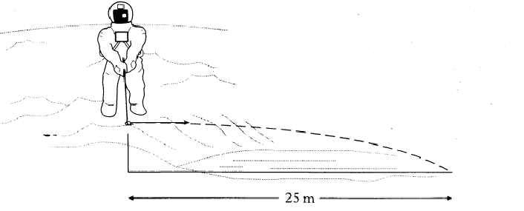
What is the value of the acceleration due to gravity at the surface of the Moon? (1) 1.6m/s²
- One of the astronauts played golf on the moon. The golf ball was struck horizontally from the edge of a steep crater. It landed 2 seconds later, 25 m away as shown in the diagram below.
(ii) Calculate the vertical speed of the ball on landing. (2)
iii) How would the horizontal distance travelled by
a ball projected with the same horizontal speed from the same height on Earth compare with that on the Moon? Explain your answer. (3)

PROJECTILE QUESTIONS
- State what is meant by the term projectile.
- State what is special about projectile motion.
- A projectile is fired horizontally at 100 ms⁻¹.
  - Determine the time it takes to travel a horizontal distance of 50 m.
  - Calculate the vertical velocity when it hits the ground.
  - Calculate its average vertical speed during the journey.
  - Calculate the height it falls in the 50 m.
- A ball rolls along a flat roof at 2ms⁻¹ and rolls off the edge.
  - If it takes 1.5s to fall to the ground determine its speed on landing.
  - Determine the height of the roof.
  - Calculate the distance from the base of the building to where it lands.
- Jordan the goalkeeper punches a football which has been kicked across his goal mouth. The football leaves his glove with a horizontal velocity of 11.5 ms⁻¹ to the right and takes 0.80 s to land on the pitch.
              - Describe the horizontal velocity of the football from the instant it is punched to the instant it lands.
              - Show, by calculation involving horizontal motion, that the horizontal displacement travelled by the football during the 0.8 s is 9.2 m to the right.
              - At the instant the football leaves Jordan's hand, the downward vertical velocity of the football is 0 ms⁻¹. Calculate the downward vertical velocity of the football as it lands.
              - Calculate the height from which the ball was pitched.
6. The Physics Department's pet cat jumps horizontally to the right from a window ledge. The cat lands on the floor 0.36 s later. Its horizontal displacement is 1.8 m to the right.
        - During the jump, state whether the horizontal velocity of the cat increase, decrease or remain constant?
        - Show, by calculation involving horizontal motion, that the horizontal velocity of the cat just before landing is 5 ms⁻¹ to the right.
        - Determine the height of the window ledge.
        - At the instant the cat jumps from the window ledge, its downward vertical velocity is 0 ms⁻¹. Calculate the downward vertical velocity of the cat as it lands.

7. Ellen's hand hits a volleyball from a point directly above the central net.
The volleyball leaves Ellen's hand with a horizontal velocity of 8.4 ms⁻¹ to the right.
On leaving her hand, the volleyball follows a curved path, hitting the floor when its horizontal displacement is 6.3 m to the right.
        - Show, by calculation involving horizontal motion, that the time taken for the volleyball to travel from Ellen's hand to the floor is 0.75 s.
        - At the instant the volleyball leaves Ellen's hand, the downward vertical velocity of the volleyball is 0 ms⁻¹. Calculate the downward vertical velocity of the volleyball as it reaches the floor.
        - Determine the vertical height from which the volleyball was punched.

8. A rocket is fired horizontally from a cliff top at 40 ms⁻¹ to the right. The rocket hits the sea below after 4 s.
        - State the rocket's horizontal component of velocity just before it hits the sea.
        - Calculate the rocket's range (horizontal displacement).
        - Calculate the rocket's vertical component of velocity just before it hits the sea.
        - Sketch the velocity-time graph for the rocket's vertical motion.
        - Use the graph to determine the rocket's vertical displacement (the height of the cliff).

9. Fred kicks a football off a cliff with a horizontal velocity of 5 ms⁻¹ to the right. The football lands on ground below the cliff 2.5 s later.
        - Calculate the ball's horizontal component of velocity just before it hits the ground.
        - Calculate the range of the ball (horizontal displacement).
        - Caluclate the vertical component of the ball's velocity just before it hits the ground.
        - Sketch the velocity-time graph for the ball's vertical motion.
        - Use the graph to determine the ball's vertical displacement (the height of the cliff).

10. Barney pushes a coin off a staircase. The coin's initial horizontal velocity is 0.5 ms⁻¹ to the right. It hits the floor after 1.2 s.
        - Calculate the coin's horizontal component of velocity just before it hits the floor.
        - Calculate the coin's range (horizontal displacement).
        - Determine the coin's vertical component of velocity just before it hits the floor.
        - Sketch the velocity-time graph for the coin's vertical motion.
        - Use the graph to determine the coin's vertical displacement (the height of the staircase).
11. Wilma throws a dart horizontally at 8 ms⁻¹ to the right. The dart hits the floor after 0.6 s.
        - Calculate the dart's horizontal component of velocity just before it hits the floor.
        - Determine the dart's range (horizontal displacement).
        - Determine the dart's vertical component of velocity just before it hits the floor.
        - Sketch the velocity-time graph for the dart's vertical motion.
        - Use the graph to determine the dart's vertical displacement (the height it was thrown from).
11. Betty fires an arrow horizontally at 25 ms⁻¹ to the right. The arrow hits the ground after 0.4s
        - State the arrow's horizontal component of velocity just before it hits the ground.
        - Calculate the range of the arrow (horizontal displacement).
        - Calculate the arrow's vertical component of velocity just before it hits the ground.
        - Sketch the velocity-time graph for the arrow's vertical motion.
        - Use the graph to determine the arrow's vertical displacement (the height it was fired from).
12. A stone thrown horizontally from a cliff lands 24 m out from the cliff after 3 s. Determine:
  - the horizontal speed of the stone
  - the vertical speed at impact.

13. A ball is thrown horizontally from a high window at 6 ms⁻¹ and reaches the ground after 2 s. Calculate:
  - the horizontal distance travelled
  - the vertical speed at impact.

- An aircraft flying horizontally at 150 ms⁻¹, drops a bomb which hits the target after 8 s. Determine:
  - the distance travelled horizontally by the bomb
  - the vertical speed of the bomb at impact
  - the distance travelled horizontally by the aircraft as the bomb fell
  - the position of the aircraft relative to the bomb at impact.

- A ball is projected horizontally at 15 ms⁻¹ from the top of a vertical cliff. It reaches the ground 5 s later. For the period between projection until it hits the ground, draw graphs with numerical values on the scales of the ball’s
  - horizontal velocity against time
  - vertical velocity against time
  - From the graphs calculate the horizontal and vertical distances travelled.

- In the experimental set-up shown below, the arrow is lined up towards the target. As it is fired, the arrow breaks the circuit supplying the electromagnet, and the target falls downwards from A to B.
  - Explain why the arrow will hit the target.
  - Suggest one set of circumstances when the arrow would fail to hit the target (you must assume it is always lined up correctly).

- An osprey flying horizontally at a speed of 15 ms⁻¹ drops the fish it is carrying in to the lake. The fish hits the water 2 seconds later.
- Sketch the path taken by the fish.
- Calculate at what height the osprey was flying when it dropped the fish.
- Assuming the osprey does not change its speed or direction, where is it in relation to the fish when it hits the water.

Projectile Motion
When an object is dropped it falls due to _____________ This is because the object is pulled towards the _____________________. The object accelerates at ____m/s²
If the object is also kicked with a horizontal speed then the object is a projectile.
The object moves in a curved path.
The curved path of a projectile can be treated as two independent motions.
In the vertical direction, the motion is the same as an object in freefall (it accelerates downwards at 9.8 m/s². It has constant acceleration of 9.8 m/s², this is provided we ignore air resistance.
In the horizontal direction, the projectile moves at constant speed, providing air resistance is ignored.
The projectile follows the combined motion.
(N.B. As F_{w} = mg, which is a form of F=ma then g=a,
So whatever the value of g in Nkg⁻¹, it is the same value of a in ms⁻² if the object is in freefall)

SUMMARY
  - I can explain that projectile motion occurs when an object has both a constant horizontal velocity and a constant vertical acceleration
  - I can use appropriate relationships to solve problems involving projectile motion from a horizontal launch, including the use of motion graphs.
  - I can state that the area under v_{h}-t graphs is equal to the horizontal range.
  - I can calculate the horizontal range from the area under a v_{h}-t graphs
  - I can state that the area under v_{v}-t graphs is equal to the vertical height.
  - I can calculate the height, and acceleration from v_{v}-t graphs
  - I can state and use the relationships
    - area under a v_{h}-t graphs equals the horizontal range
    - area under v_{v}-t graphs is equal to the vertical height.
    - v_{h}=s/t where v_{h} is a constant horizontal velocity
    - v_{v}=u_v+at where v_{v} is a constant vertical acceleration
  - I can explain satellite orbits in terms of projectile motion, horizontal velocity and weight.
Tell your teacher if there was anything in this section that you couldn’t quite understand so that your teacher can give you additional help and resources.

Useful Resources

Glossary of Terms
Term | Definition
acceleration | The rate of change of velocity, measured in metres per second squared. Acceleration = change in velocity/time taken
average speed | Average speed = distance ÷ time over a known distance and time. For example, the average speed of the bus between Edinburgh and Glasgow was 30 m s-1.
balanced force | When the total force in opposite directions are equal in magnitude. For example, with a thrust of 15 N and a frictional force of 15 N, the body experiences balanced forces.
bearing | A direction given where due North is 000 and through a circle clockwise. Eg: Due East is 090, due South is 180 and due West is 270.
constant speed | When the speed of body does not change. eg The car was travelling at a constant speed of 30 m s⁻¹.
deceleration | Slowing down or negative acceleration, e.g. the car slowed down with a deceleration of 2 m s⁻²
direction | Information to give the direction of travel or the direction of a force
displacement | Quantity describing the distance from the start of the journey to the end in a straight line with a described direction, eg the hiker ended up at the hostel 50 km due north of his original position.
distance | Numerical description of how far apart two things are. For example, the distance from Edinburgh to Glasgow is approximately 50 miles.
energy | The capacity of a system to do work. For example, electrical work. Measured in Joules (J). Eg: A signal with 0.002 J of electrical energy was received at the aerial.
final speed | The speed of a body after accelerating, e.g. after an acceleration for 5 seconds, the car's final speed was 20 ms-1
force | A push or a pull. The unit of force is the newton (N)
freefall | Falling freely in space/air, not attached to anything; e.g. the skydiver was in freefall after leaving the plane.
gravitational field strength | Force per unit mass. Measure in newtons per kg
horizontal | Parallel to the ground
initial speed | The speed of a body before accelerating, e.g. the car has an initial speed of 5ms-1
instantaneous speed | The speed at a particular point in time, e.g. the speed of the car at the corner was 5ms-1
kilometre (km) | 1000 m. A large unit for distance.
mass | The amount of matter an object contains. Mass is measured in kilograms (kg).
newton | Unit of force named after British scientist Isaac Newton (1642-1727), e.g. the frictional force on the boat is 20,000N.
projectile | An object travelling through space unaided by an engine, e.g. the cannon shot a projectile over the horizon
rest | A stationary object which has a speed of zero, e.g. the bus started from rest before it reached a speed of 8ms-1
scalar | A quantity that requires only a size, for example, distance travelled is 20m.
scale diagram | A diagram drawn where each length represents a exact magnitude in direct proportion. Eg: a scale of 1:10 in a diagram means that 1cm will represent a force of 10N.
speed | The distance travelled in a fixed time period, usually 1 second. The unit of speed is metres per second
stationary | Not moving.
temperature | How warm or cold something is, a measure of the average kinetic energy of the particles
thrust | A force used to move a body forwards or up, e.g. the rocket had a thrust of 10,000N.
time | Term that describes the order and duration of events. For example, the Physics lesson was 50 minutes long.
vacuum | A volume that contains no matter.
vector | A vector describes a movement from one point to another. A vector quantity has magnitude (size) and direction.
velocity | The speed of an object in a particular direction. The unit of velocity is metres per second
vertical | At right angles (perpendicular) to the ground or the horizontal axis)
visible | You can see this part of the spectrum.

Useful Revision Links
https://mrsphysics.co.uk/n5/ Mrs Physics
https://www.bbc.com/bitesize/subjects/z6fsgk7 BBC Bitesized National 5 Physics Dynamics Topic-
http://hyperphysics.phy-astr.gsu.edu/hbase/hframe.html Hyperphysics (be warned some sections go up to AH level) -
http://www.sqa.org.uk/sqa/45731.html SQA Nat 5 Physics Resources (Past Papers & Content Statements)
http://mrmackenzie.co.uk/national-5/ Fizzics With Mr McKenzie
http://www.physics-podcast.co.uk/

