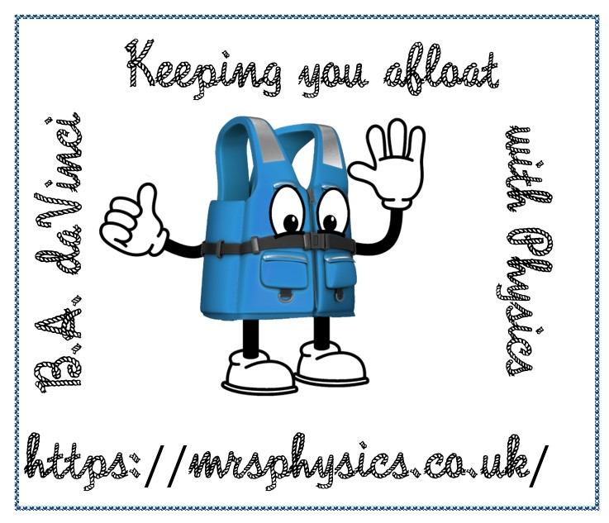
2023
J A Hargreaves
Mrs Physics
1/1/2023
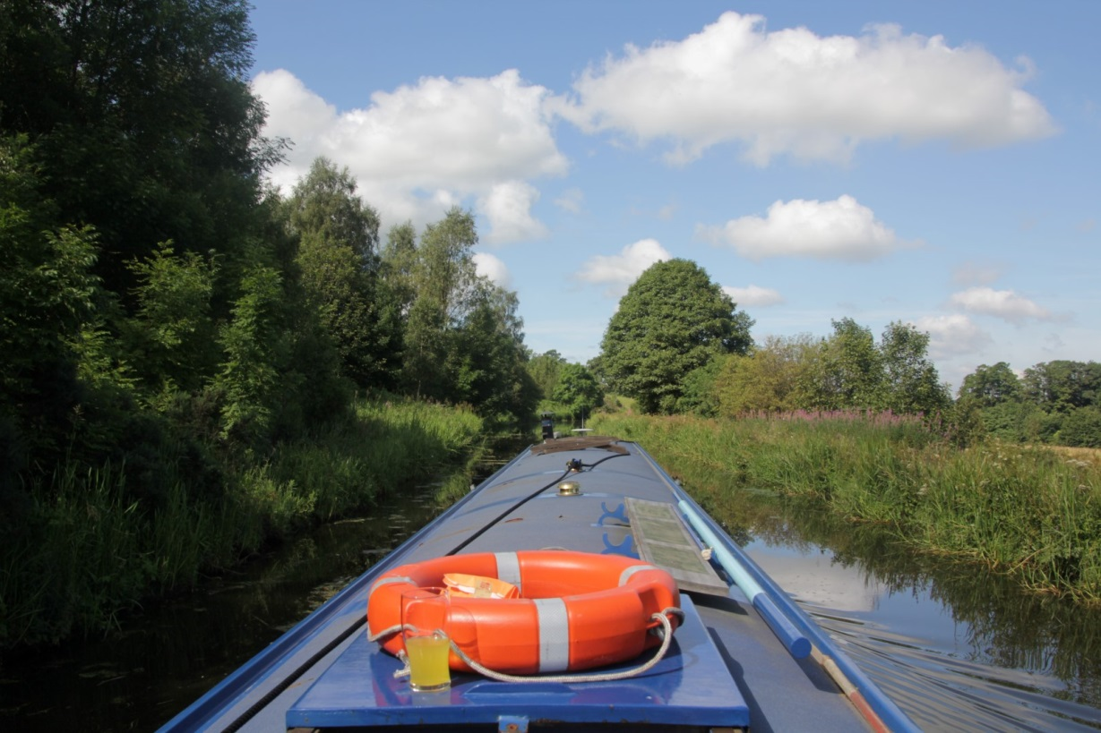
A GUIDE TO PRACTICAL SKILLS

Introduction
This guide has been written to give you some background practice at carrying out and writing up practical work in Physics, particularly in preparation for the SQA Higher Assignment. It is important that you know this material before starting your assignment in Higher Physics. This document is not for use during the assignment and must not be taken into the reporting phase as this will count as malpractice. It is provided to give you the skills required during the year before starting your assignment.

Preparation for a Practical Experiment
Your teacher will discuss with the whole group any mathematical skills required, for example the need for a straight line through the origin to verify a 'directly proportional' relationship, before starting any practical work. Your teacher may also refer to relevant equations and any manipulation of such equations in class discussions. Similarly it is expected that you have covered the relevant theory before completing any experiment undertaken.

A Guide to Practical Experiments
Preparation for your Assignment

When starting a practical make sure that you:
- Choose the aim of the activity?
- Know what experimental precautions will be taken to try to ensure a successful outcome?
- Know what measurements/observations are going to be made?
- Know how you will record the data
- Prepare a table to record the measurements before you start. Make sure it has correct headings and units.
- Know what safety measures are required to be taken?
- Know how will you repeat your measurements and how many repeats will you make?
- Practice your skills with various experiments prior to you tackling your assignment.
Make sure that you know and understand the different aspects of the practical.

Getting organised for experimental work
During practical work it is important that all students play an active part in setting up and collecting the data.
Do you understand the practical task? If not make sure that you speak to your teacher about this. If you don’t know what you are meant to be doing you are likely to be unsafe and could cause yourself or others injury.
You will change the independent variable, measure it, and record it. As you do this measure the dependant variable and record it.
Record the data in a table, ensuring the independent variable is recorded in the first column.
Read carefully and mark the Understanding Standards examples at
https://www.understandingstandards.org.uk/Subjects/Physics/Higher/Assignment
Student reminders
• Check that you are familiar with the Instructions to Candidates for writing a report. It is useful to use the headings stated to ensure there are no omissions, but using those heading is less likely to cause omissions.
https://www.sqa.org.uk/files_ccc/HigherCATPhysics.pdf
• The separate experimental instruction sheet should be read through carefully.

Underlying Physics
What sort of things do you write in your Underlying Physics?
If asked to write up underlying physics for a practical activity consider the following
- What formula(e) might you be trying to prove, don’t forget to give the formula(e) and define each term?
- Can you show how the formula is derived from first principles?
- What physics concepts and principles, e.g. momentum and impulse, internal resistance, refraction, as well as related formulae and calculations linked to your work?
Do not link your physics to the history of its discovery or the people who discovered it as a background to your investigation.
Check the underlying Physics in the Understanding Standards section of the SQA website. Think why these candidates have not been awarded full marks and what they have missed. This is as important as what the students got correct.
https://www.understandingstandards.org.uk/Subjects/Physics/Higher/Assignment
Notice one candidate has obviously written one paragraph of his own work but scored zero as he has used words that are not his own in another passage. This is plagiarism and therefore the student has not demonstrated knowledge, only copied it!

Graphing
You can either plot your graph in Microsoft excel or other graphing package or plot it by hand. With the pathetic graph paper available I’d recommend a graphing package, but remember there are some great websites where you can design your own piece of graph paper. One of the ones I like most is
https://incompetech.com/graphpaper/multicolor/
Here you can set your own grid spacing and line thicknesses and could set it up so that it had the right scale for your results. You won’t be able to print this paper out during the reporting phase so you’ll need to take three or four sheets into the reporting phase in case you make a mistake when drawing your graph. I’ve included a sheet at the end of this booklet, but it will not be as good as if you print out directly from the pdf file. I’ve uploaded several different sizes onto https://www.mrsphysics.co.uk/higher/assignment-skills/

Graphing in excel
I have taken F=ma as an example for data collection and showing how to plot graphs in Excel etc. This would not be a suitable assignment for Higher, as it covers National 5 content. I’ve used it purely for an example.
A good plan when carrying out any practical experiment is to put your results straight into an Excel spreadsheet and start graphing as you go along. (as you can set up a graph before you’ve put results into a table see below) You can then check your points as you go through the experiment and check any outliers (points that appear to be off the trendline). For your assignment you are only allowed to store your raw data, so any rough plot you have made will need to be deleted, but at least the results won’t come as a surprise when you’re in your reporting stage and you will know what to expect and hopefully have thought of a reason why your results are not as expected.
You ought to decide before plotting the graph what information this will give you.
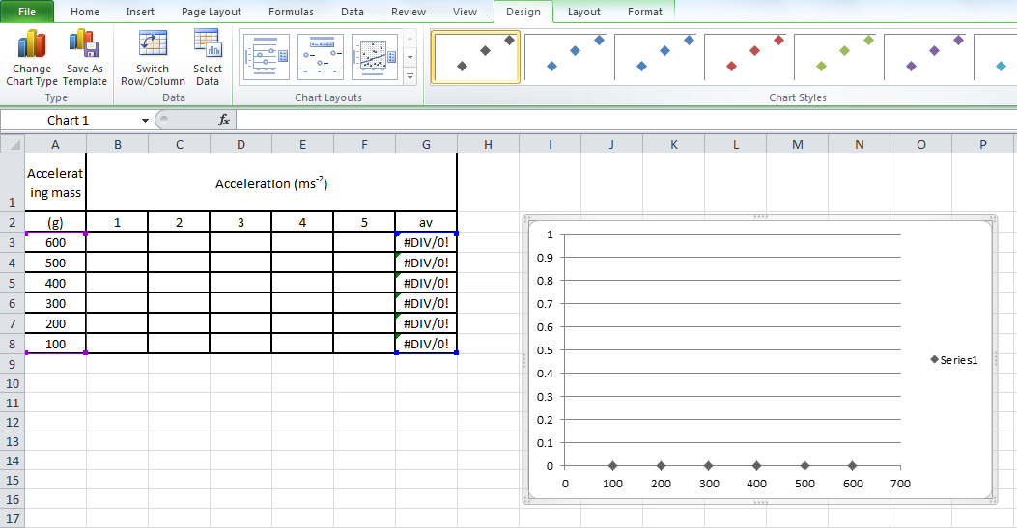
As you populate the table set up above the points will form on the graph and you can detect any point not fitting the trendline.
Your table should contain headings, with the independent variable in the first column and then subsequent dependent variables in the following columns. Many students struggle to fit everything in the table columns and leave spare columns. What you need is the WRAP TEXT box so that headings can be in more than one line.
Wrap Text in Excel
- Right click on the top left corner box or all the cells that you might wish to wrap the text for.
- In the format cells menu click on the ALIGNMENT tab.
- Tick the box marked WRAP TEXT.
- Click OK
- You can now make the columns smaller and the text should wrap around the box.
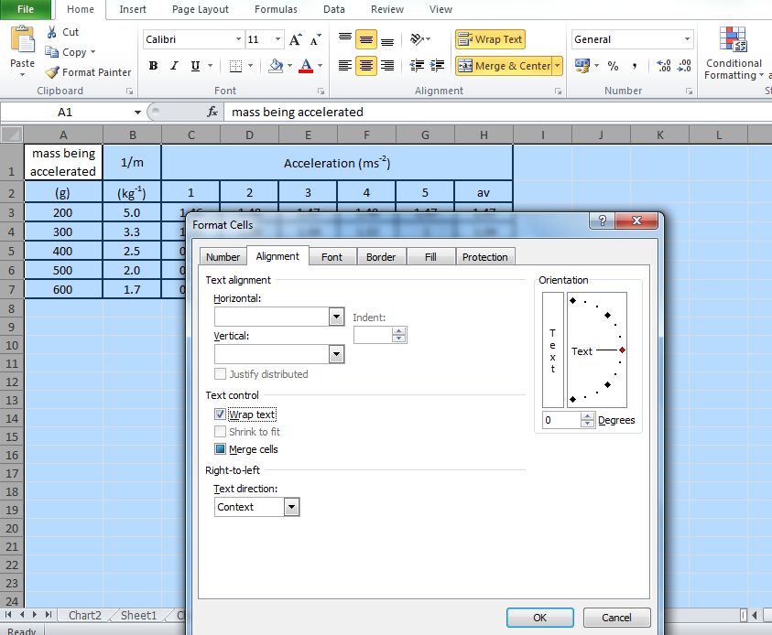
Subscript, Superscript and symbols
In Physics you might want to write units such as ms⁻², etc where you need subscript and superscript. These are found in the font menu, but you can’t always get to it without superscripting the whole cell. So to get part of the cell superscripted come out of the box after typing in the text you will want to superscript. Then go back in and highlight just the text you want to superscript. Click on the font menu on the ribbon bar and select the superscript or subscript, as in the example below. This can be done in the graph axes as well as for the table heading.
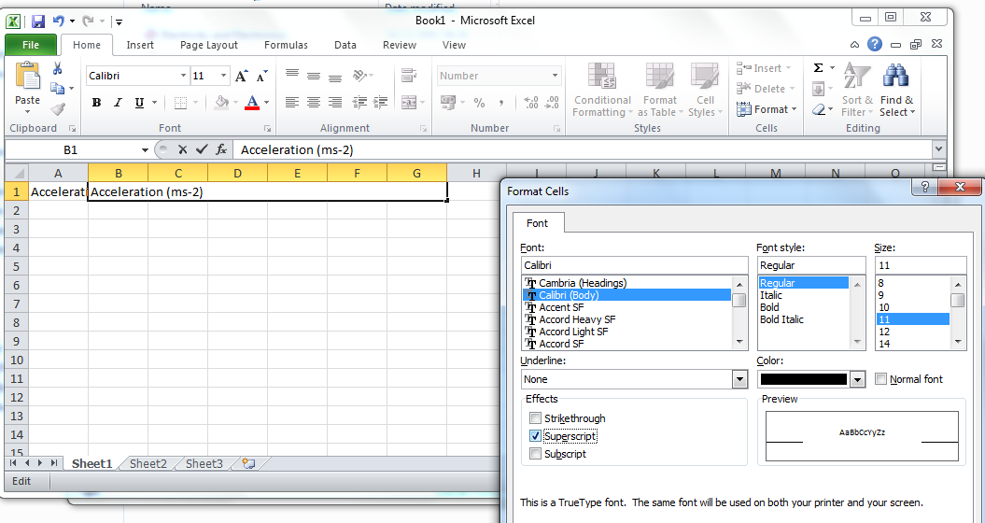
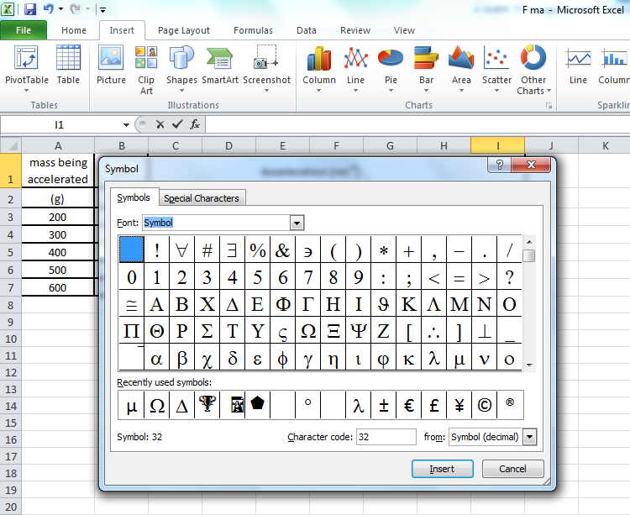
To add a symbol in a table heading you can
- click in the cell and select INSERT from the ribbon menu
- You need to select the SYMBOL font to get the GREEK alphabet up.
- Choose the symbol you wish to select.
- Beware as this might change the whole cell to symbols, so you might need to just select the text.
- If you know the symbol letter on the keyboard (for example q in symbol font equates to θ, y equates to λ)

Checking points as you go along
Make sure that you watch what you are typing in to your document. In the two highlighted cells it looks like there has been an error in typing in the text, suggesting 500g attempt 4 ought to be 1.07, and 300g attempt 4 should be 0.65. These points should be checked. If you check as you step back from entering the data you might even remember what the correct value was. It is very difficult to correct this after you’ve put away all of your apparatus.
Accelerating mass | Acceleration (ms⁻²)
(g) | 1 | 2 | 3 | 4 | 5 | av
600 | 1.28 | 1.26 | 1.28 | 1.26 | 1.26
500 | 1.06 | 1.07 | 1.08 | 1.7 | 1.08
400 | 0.84 | 0.86 | 0.85 | 0.85 | 0.85
300 | 0.65 | 0.65 | 0.63 | 65 | 0.65
200 | 0.42 | 0.44 | 0.43 | 0.43 | 0.44
100 | 0.25 | 0.27 | 0.27 | 0.26 | 0.25

CONVERTING AN ACCELERATING MASS TO WEIGHT
Remember the converting of an accelerating mass to weight will come under data processing, so for your practice graph during the data collection you can plot a graph of mass against acceleration
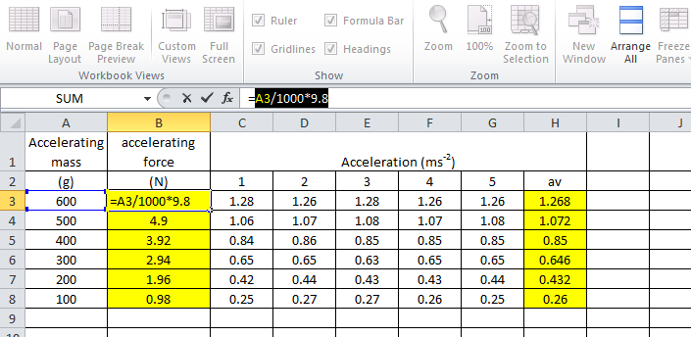
Mean average
To determine the mean average of a set of values then you can type in the formula
“=average(first cell:last cell)” or if the cells to average are not directly next to each other use “=average(cell1,cell2,cell3,cell4)” Where the cells need naming.
Remember the average should contain the same number of significant figures as the measurement that you took. However, remember that this just displays the rounded values but when you come to plot the graph the results plotted will be the unrounded values.
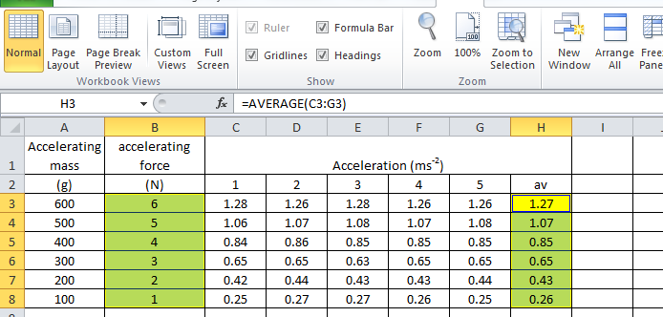
Below is the default graph that is produced in Excel. This will not meet the criteria for the graph in any way so you need to make some changes. The first thing to do is to change the points to black (to the left of the blue highlighted cells) as this will produce a clearer graph when printing (unless you are able to print off in colour). You can see this in Chart tools -> design, click on the black diamonds.
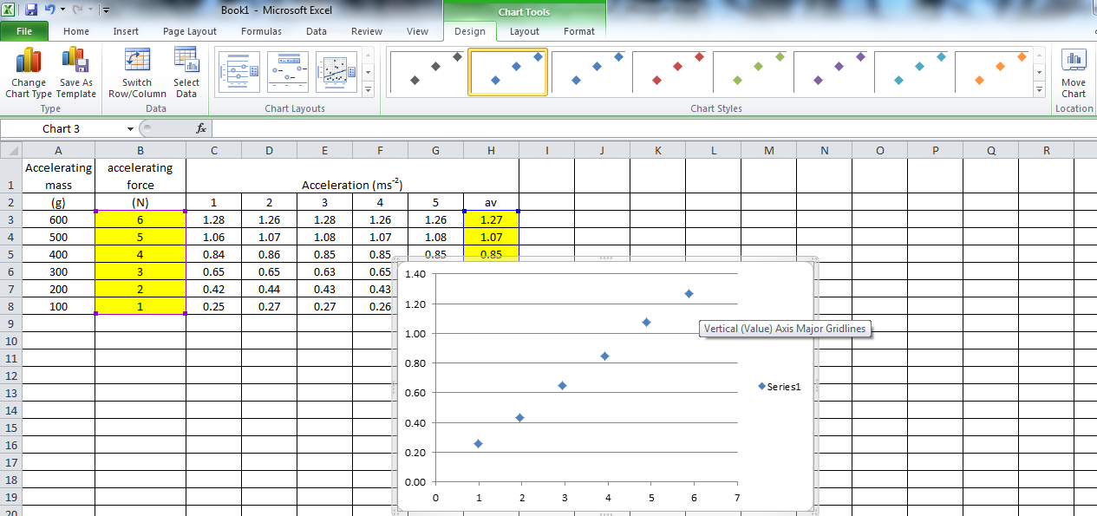
The quickest way to get the graph in a form that is likely to be acceptable is to use the design template.
Design Layout 3, will provide a great template with major and minor gridlines, axes labelled and a trendline already in place. Beware that this might not be the best fit line as we’ll discuss. Generally you’ll want to delete the side panel with series 1 and trendline label. If you then click on each of these parts you can write your own axes titles and units.
The only thing that isn’t shown is the chart title.
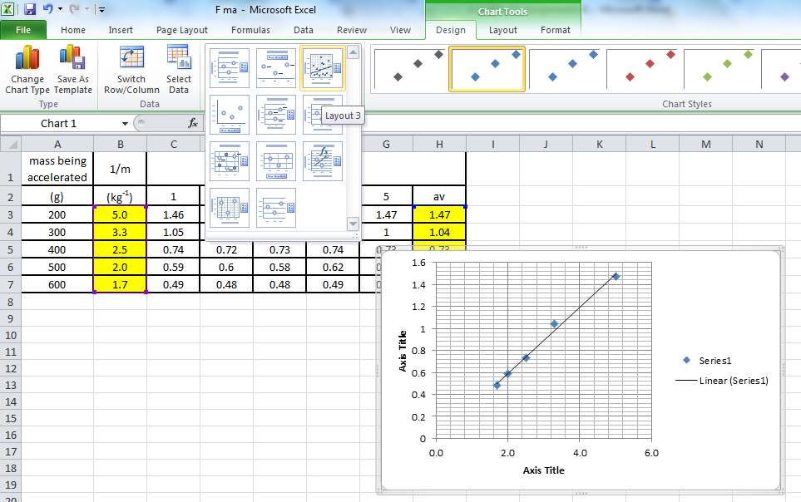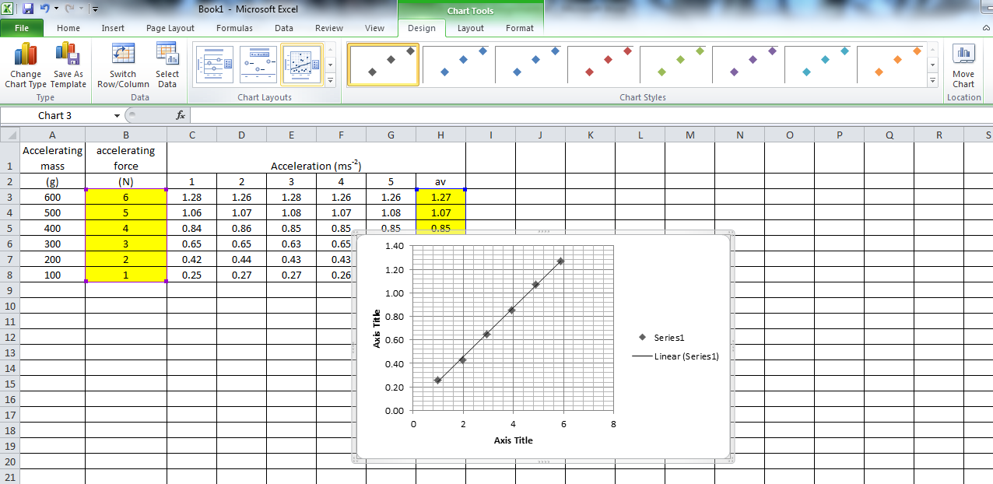

Also make sure that your graph is in a new spreadsheet. Do this by clicking on the MOVE CHART in the CHART TOOLS location.
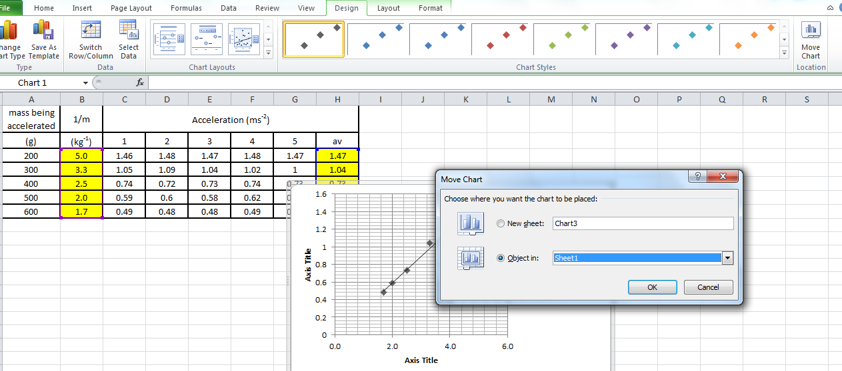
mass being accelerated | 1/m | Acceleration (ms⁻²)
(g) | (kg⁻¹) | 1 | 2 | 3 | 4 | 5 | av
200 | 5.0 | 1.46 | 1.48 | 1.47 | 1.48 | 1.47 | 1.47
300 | 3.3 | 1.05 | 1.09 | 1.04 | 1.02 | 1.00 | 1.04
400 | 2.5 | 0.74 | 0.72 | 0.73 | 0.74 | 0.73 | 0.73
500 | 2.0 | 0.59 | 0.6 | 0.58 | 0.62 | 0.55 | 0.59
600 | 1.7 | 0.49 | 0.48 | 0.48 | 0.49 | 0.48 | 0.48
Here is the final table graph. You might probably want to copy this into your main write up document. If you copy the graph from the Excel document by clicking on the outside of the graph, then when you copy it in and paste it into the word document you have access to the Excel menu and can still edit if you discover you’ve made a little mistake just prior to printing; i.e. you’re pasting it in as a excel spreadsheet not as a picture. Make the graph as large as possible, one way to do this is to select the copied graph into the document and set the selected text to print out landscape so the graph fills a full A4 sheet of paper lengthways or print the graph out directly from Excel.

My best line of fit
You could be tempted to put a straight line through these points, as in the diagram below. This is where you should use your brain and general knowledge.
You should know that
$$F=ma$$
So F ∝ a for constant mass
But 1/m ∝ a for constant F
i.e. as mass increases the acceleration of vehicle will decrease for constant Force.
This suggests that mass is INVERSELY proportional to acceleration so that the best fit line through the points should be a power trendline.


This graph above does not have the best fit line through it. You could be tempted to add this line as the default but for the equation F=ma the best fit curve is a power curve (see below for the difference)

The graph below shows the final graph for the results shown, Note
- The axes are labelled with quantity
- The axes have units
- Points are small and x and not large
- There are plenty of major and minor gridlines
- There is not a lot of wasted space.
- The axes are all given to the correct number of significant places
- The best curve of fit is shown.
- The best fit curve has the equation typed in
- The graph is titled

However, is this the best graph you should draw at Higher level? Wouldn’t it be better to get your straight line graph? As we know that
$m × a$ is a constant
then 1/m against a should produce a straight line graph through the origin.
mass being accelerated | 1/m | Acceleration (ms⁻²)
(g) | (kg⁻¹) | 1 | 2 | 3 | 4 | 5 | av
200 | 5.0 | 1.46 | 1.48 | 1.47 | 1.48 | 1.47 | 1.47
300 | 3.3 | 1.05 | 1.09 | 1.04 | 1.02 | 1.00 | 1.04
400 | 2.5 | 0.74 | 0.72 | 0.73 | 0.74 | 0.73 | 0.73
500 | 2.0 | 0.59 | 0.6 | 0.58 | 0.62 | 0.55 | 0.59
600 | 1.7 | 0.49 | 0.48 | 0.48 | 0.49 | 0.48 | 0.48

Here is the final graph of a plot of acceleration against 1/mass. The gradient of this graph should tell us the force acting on the trolley.
$$\frac{a}{\frac{1}{m}}=a ×m=gradient=F$$

Don’t be tempted to extrapolate the graph beyond your points as shown below.
 


CARRYING OUT A PRACTICAL EXPERIMENTS
If you are absent for an experiment you must not copy up results from another pupil as you will not have completed all the criteria which states that you must actively participate in the experiment. It is important that over the year you get plenty of experience of completing practical work and writing some of these up as it will develop skills in you that can be vital in your assignment and will help you should you continue to AH and have to complete a project.
Safety
Due attention must be given to safety in the laboratory. Although teachers ensure that safe working practices are observed you have a responsibility to act safely during any practical work. You should think about RISK , HAZARDS and CONTROL MEASURES.
A Hazard is a potential source of harm or adverse health effect on a person or persons’.
‘risk is the likelihood that a person may be harmed or suffers adverse health effects if exposed to a hazard.’
The terms Hazard and Risk are often used interchangeably but this simple example explains the difference between the two.
If there was a spill of water in a room then that water would present a slipping hazard to persons passing through it. If access to that area was prevented by a physical barrier then the hazard would remain though the risk would be minimised.
https://www.hsa.ie/eng/Topics/Hazards/
Repeated readings
It is expected that you will repeat readings, where feasible, without being reminded in the instruction sheet. Collection of a minimum of five repeated readings is usually expected, in order to determine the approximate random uncertainty.
Check as you go along
When carrying out any practical it is good practice to create a graph as you go along and then you can check for outlier points.
You ought to decide before plotting the graph what information this will give you.
What does the gradient of the graph represent? Do the X and Y intercepts or the area under the graph give you a quantity?
- Check for any results that are outside the range of each measurement. If they are this point should be repeated before the equipment is packed away and the original result discarded.
- If you are expecting a straight line when graphing results, you should aim to get your points equidistant
- If you are expecting a curve when graphing results more readings should be taken around the turning point of the curve as this will make drawing the correct best bit line easier.
- Find the average of each set of results.
Processing Data
• Check for any results that are outside the range of each measurement. If they are this point should be repeated before the equipment is packed away and the original result discarded.
• Finding the mean average of each set of results will count as processing in your assignment so should only be completed during the reporting phase..

PRODUCING A SCIENTIFIC REPORT OF AN EXPERIMENT
In the report you should try to use what is known as the impersonal passive voice using the past tense.
You should try to write in the form: "the light gate was connected to a computer" and not "I connected the light gate to a computer".
Sentences should be brief, clear and to the point. A lengthy description of the procedure is not required, a few short sentences are sufficient.
You should structure your report under specific headings to avoid missing out important sections. The following headings can be used:
Title
- This is to help you and the teacher / marker know what topic is contained in the report.
Aim or Objective
- A brief statement of the purpose of the experiment. This must be able to link to the conclusion. When reading the conclusion you ought to be able to correctly form the aim. If you can’t then your aim and conclusion are not linked enough, and you need to reassess the aim. If you have multiple aims then your conclusion must also have multiple parts.

- Good aims could include
  - To determine the relationship between X and Y
  - To investigate how X varies with Y
  - To establish a relationship between X and Y
  - To determine the magnitude of Z
NB Avoid “if” statements that could lead to a conclusion of “yes” or “no”
For example
‘To investigate if X is affected by Y’ or ‘To investigate if X varies with Y.’
……as the answer and conclusion to both of these aims could be Yes or No!
Apparatus
- A simple labelled line diagram of the experimental arrangement with labels is useful to avoid the need for lengthy descriptions.
- Circuit diagrams should be included for electrical circuits.
- Labelled photographs can be included if these are high quality and labelled.
Procedure
A few brief sentences describing briefly,
- what is X is and how it is measured
- what Y is and how it is measured
- how X is varied
- What you measured (the dependent and independent variables)
- What you measured with (equipment/ apparatus). Note if a quantity is derived it should be clear how this is done. For example if an interface is giving the value of speed is this because you measured the width of a mask and the interface measured the time and then calculated v as d/t.
- You do not need to state the range of the independent variable(s) or the number of repeats as this information can be seen in your table.
- How the independent variable was altered It is not sufficient for you to say what you are going to change; you must state how you are going to effect the change
- eg I will change
  - the voltage... by adding more batteries/by turning the voltage control on the power supply. (By using a power supply' on its own is insufficient as many common power supplies have a single output voltage)
  - the temperature... by heating with a Bunsen burner/water bath
- Reference can be made to a labelled diagram, but alone a diagram is not enough.
- All reports should briefly but clearly state how the independent variable was altered and how measurements were taken.
- A diagram should be labelled. However if a circuit diagram is drawn with standard symbols, it is not necessary to label those standard symbols, for example to label 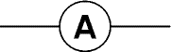 as an ammeter is unnecessary.
Readings/Results
These are usually presented in a clear table with suitable headings giving the quantity and its unit.
- All tables require suitable headings with the correct units.
- Experimental data must be tabulated.
- Every column must have a clear heading.
- Units must be indicated in the column headings rather than given after every data entry.
- It must be clear that measurements have been repeated, all mean values must be calculated correctly and tabulated.
- You may then have to use these readings to:
  - calculate other quantities which again should be given in a clear table. In some cases the same table as above can be used
  - plot a graph which should have clearly labelled axes, correctly plotted points and a line or curve of best fit.
- Any derived values required for graphing must be calculated correctly and tabulated.
Your independent variable goes in here! /with Unit | Your dependent variable goes here!  /With Unit |  |  |  |  | Average dependent variable /with unit
 | 1st set of results | 2nd set of results | 3rd set of results | 4th set of results | 5th set of results
With 5 different values

Graphs
A graph is a visual representation of a relationship between two variable, X the independent variable and Y the dependent variable. Data is best analysed by drawing a graph including a curve or line of best fit; in Physics it is never acceptable to be plotting a pie chart or bar chart.
Graphs make it easy to identify trends in data that you have collected and can be analysed in order to perform a calculation or a measurement related to addressing the aim of an experiment.
Graphs should be drawn, where possible, before the apparatus is cleared away, in case further data is required. However, during your assignment you cannot keep the graph and averaging that you might complete during your experimental procedure as this is required to be completed during the reporting stage. Good practice should be to check and plot your results as you do the experiment and then you can check and outliers or odd points as you find them on the graph.
Graphs must have correctly labelled axes and a line or curve of best fit. Straight line graphs should not be 'adjusted' to go through the origin. An appropriate scale for each axis should be chosen.
The best graph’s for Physics are usually straight line graphs and at times the data needs to be manipulated in order for the graph to produce a straight line.
This is why you also need to have done your theory prior to writing up so that you know how to manipulate the data. For example
F=ma if I want to find the relationship between mass and acceleration for a constant force the formula shows us that as m increases a must decreases, ie the two quantities are inversely proportional. Therefore if we want to show a relationship we ought to plot a graph of a against 1/m this should give a straight line best line of fit through the origin. The gradient would be equal to F
Stages of Plotting a Scientific Graph
Stage | Action | Detail
1. | Identify the variables | The independent variable is plotted on the x-axis and the dependent variable on the y-axis
2. | Determine the variable range | Decide if your graph needs to start from the origin. If you are trying to find a relationship it is usual to start at the origin. If not, subtract the lowest data value from the highest data value.
3. | Determine the scale of the graph | You can go up in multiples of 1,2,(4),5 ie 0.1,10,100 etc.  Determine a scale (the numerical value for each square) that best fits the range of each variable.  Use a scale that uses over half the graph paper. If it does not then you can double the scale.  The range and scale on each axis may be very different, but each square must represent the same difference for each square.
4. | - Label each axis  - Add units on each axis if required | Clearly label the X and Y axes, including the units of measurement. Watch if you want to use non base units, e.g. mm rather than m etc.
5. | Plot all and each data point | Plot each data value on the graph with a small x
6. | Look along the graph to identify the best line or curve of fit
7. | Plot the best line or curve of fit. |  | There are best line of fit rulers in the department. See additional notes for best line of fit graphs.  Only draw the line or curve of best fit over the range for which you have data. Do not extend your line beyond this range.  If you need to extrapolate (extend the graph along the same slope beyond the data range) you should use a dotted line to indicate that you are extrapolating.
8. | Write a descriptive title |  | Your title should clearly communicate what the graph is about.

The data analysis starts with drawing a graph and adding a curve or line of best fit. Sometimes the data needs to be manipulated in order for the graph to graph to produce a straight line so you must understand the underlyling Physics governing the equation to describe the experiment.
Why do we draw a line of best fit?
Lines of best fit are to
- Reduce the effect of systematic and random uncertainties, thus making the experiment more accurate and reliable
- Find and use the gradient of the line of best fit to determine an unknown in the experiment.
To draw the line of best fit
- Reject outliers
- Place the line through the majority of the data and not from those that differ.
- There should be equal numbers of points above and below the line and equidistant.
- Never force a graph through the origin, remember if all the points are on the line and yet it does not go through the origin when it is meant to it could indicate a systematic uncertainty.
https://d32ogoqmya1dw8.cloudfront.net/files/mathyouneed/best_fit_line_dividing.pdf
https://www.matrix.edu.au/the-beginners-guide-to-physics-practical-skills/physics-practical-skills-part-4-how-to-draw-a-line-of-best-fit/

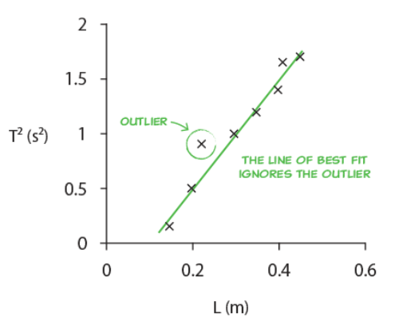 | This outlier point should have been removed from the data series when making the best line of fit. This is tricky in Excel  Problems with this graph  - No gridlines  - Not equal sig fig on the Y axis  - Points too large  - No title on the graph
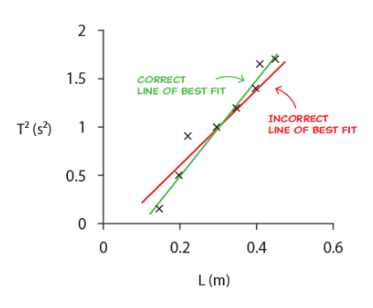 | As you can see including the outlier gives a best line of fit that is offset as the outlier has a large influence on the data set.
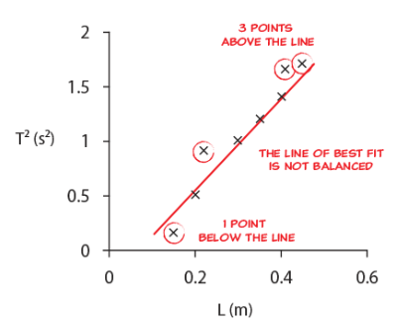 | When drawing your best fit line make sure  - you have approximately the same number of data points on each side of the line?  - Points are evenly distributed (that is, make sure there are the same number of points above and below the best fit line and are equally spaced from the line.  - your line minimizes the average distance from it to each of the data points  Note that in some cases, best-fit lines do not pass through anyof the points on the plots. It is not necessary to connect any dots when you are constructing a best-fit line.
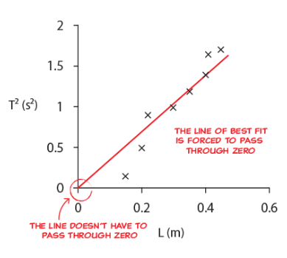 | Never force a line through the origin, even if you know that is where it ought to go!  If your data doesn’t go naturally through the origin you cannot force it through the origin and expect to be awarded points.

If your graph goes through the origin and is a straight line then you can say that the two quantities are directly proportional, If you get a straight line which doesn’t pass through the origin you can say that the two quantities are proportional, but not directly proportional, unless you can justify this by uncertainties.

Finding the gradient of a line of best fit
It is vital that you use the line and never take data points to determine the gradient of your graph. Using the data points is undoing all the effort you went to in reducing systematic and random uncertainties. Look for points from the graph that cross one of the squares on your graph paper. These are the points that are easiest to determine.

Uncertainties
Uncertainties must be stated for all the measuring instruments used. For most experiments a mean should also be calculated together with the approximate random uncertainty and a scale reading uncertainty for each meter.
Depending on the activity the following should be included as appropriate:
• uncertainties in individual readings
• mean value and approximate random uncertainties in the mean
• uncertainties expressed in absolute or percentage form.
Uncertainty | Description | Effect
Calibration | If a piece of equipment is not calibrated correctly (e.g a wooden metre stick that has had the end worn away by overuse), all measurements will be offset by the same value | Systematic effect
Zero Error | If a piece of equipment has an offset (e.g. a top pan balance which is not zero when there is nothing on the top) all measurements will be offset by the same amount | Systematic effect
Parallax Error | If you make a measurement by comparing an indicator against a scale (e.g. reading a dial on an analogue ammeter) the angle at which you view the scale will affect the reading Try to use a meter with a mirror and you are viewing correctly when you cannot see the reflection of the needle | Systematic error if you are always viewing from the same angle or random error if the dial is not always read from the same angle.
Environmental Errors | Ideally ambient readings should remain constant, eg temperature, air pressure, light levels, humidity. This is why you should take a full set of readings and then repeat readings rather than taking 3 readings of the same point at once and then moving on | This is most likely to cause random uncertainties but could result in systematic uncertainties. Try to measure these background readings
Reaction Time | You may react too early or too late so this may vary for each reading | This is likely to cause random uncertainties. Think of ways to reduce this by giving a countdown to your partner before taking the reading

You could use the table below to help you record your uncertainties.
 | Scale reading uncertainty | comment | % uncertainty  [if needed] | random uncertainty  [if needed]
(name of x) | ± (value) unit | half smallest scale division |  | see readings table,  max - min used  No. of readings
(name of y) | ± (value) unit | one in last digit |  | Not done, only two readings taken

e.g Do the random uncertainties swamp the reading uncertainty?
e.g. What is the reading uncertainty in the X measurements?
e.g. What is the reading uncertainty in the Y measurements?
e.g. Calculate the random uncertainties in both X and Y if appropriate, but at least Y?
e.g. How large are the random uncertainties? Do they swamp the reading uncertainty?
Make sure that you give an example calculation for how you arrived at your uncertainties. Remember the approximate random uncertainty is found by:
$$∆R=\frac{R_{max}-R_{min}}{no. of observations}$$

Quantifying Uncertainties
- Find the mean
This is the best estimate of the “true” value but not necessary the “true” value

- Find the approximate random uncertainty in the mean
This can be written as and it is sometimes referred to as average deviation or absolute uncertainty.
stop here and quote the result with an approx. random uncertainty
MEAN ± approx. random uncertainty (UNITS)

- Find the percentage uncertainty.

$percentage uncertainty=\frac{approximately randon uncertainty}{mean value}×100\%$=

$$percentage uncertainty=\frac{\frac{range}{n}}{mean value}×100\%$$
stop here and quote the result with a percentage uncertainty
MEAN (UNITS)± percentage uncertainty (%) (

Or (uncertainty in reading/reading )× 100%

Note Uncertainties have units unless quoted as a %. The units are the same as the measurements from which they are derived/calculated.
Systematic uncertainties shift measurements from their true value by the same amount and in the same direction all the time. These do not affect the reliability/ precision/ but affect accuracy. These usually arise from incorrectly used equipment.
Random Uncertainties will shift each measurement from its true value by a random amount and in random directions. These affect the reliability but may not affect the overall accuracy of a result.

Scale reading uncertainty
Analogue device = ±½ scale division
Digital device = ±1 in the last digit
(e.g. my digital bathroom scales measure to the nearest 0.2 kg so scale reading uncertainty is ±0.2 kg)

Overall uncertainty in an Experiment
In an experiment, where more than one physical quantity has been measured, spot the quantity with the largest percentage uncertainty. This percentage uncertainty is often a good estimate of the percentage uncertainty in the final numerical result of the experiment.
eg if one measurement has an uncertainty of 3 % and another has an uncertainty of 5 %, then the overall percentage uncertainty in this experiment should be taken as 5 %
When completing an experimental EVALUATION, always refer to the magnitude of the uncertainty giving an indication of the reliability of your results.
Analysis of Data
You are analysing the data as soon as you begin to manipulate your data, for example finding an average in a set of data, plotting a graph and calculating a gradient. You will then be looking over your results to comment on their reliability and validity.
Analysis of Data (you may wish to consider these items after the readings have been obtained)
e.g. Does X increase with Y?
e.g. Does the X decrease with Y?
e.g. What is the theoretical relationship between X and Y?
e.g. What graph should be plotted to obtain a straight line?
- Discuss the dependent, independent and control variable
- Discuss the reliability, accuracy, precision and validity of the experiment.
- Calculate the uncertainties in each measurement- both the scale reading uncertainty and approximate random uncertainty.
- Discuss the size of the uncertainties in the experiment and identify the largest one in the whole of the experiment. To improve the experiment the quantity with the greatest uncertainty is what should be measured in a better way to reduce overall uncertainties in the experiment.
- You must be able to identify the flaws and suggest improvements in reliability, accuracy, precision and validity.

 | Validity | Reliability | Accuracy
Assessment | An experiment is valid if the methods are carried out appropriately and the control variables are kept constant | An experiment if reliable and precise if you get similar results for each repeat of a measurement | An experiment is accurate if there is very little difference between the experimental results and the accepted true value.
Improvement | Suggest experimental techniques that will ensure the experiment is valid (are your procedures and materials giving you the desired result?)e.g. is your mask small enough to measure the instantaneous speed etc.Have you accounted for friction? | Check the measurements that you are taking and connections. If you wiggle the wires of a circuit does it greatly affect the meter reading? | What experimental technique will reduce this; SOMETIMES THIS CAN BE IDENTIFIED FROM THE GRAPH

Analysis of data using excel
Microsoft Excel is a powerful package if you know how to work it. A couple of useful formula are given below.
 | measurement (units) |  |  | Formula | Meaning
 | 1 | 2 | 3 | =AVERAGE(B2:D2) | To calculate a mean average
 | 1 | 2 | 3 | =COUNTA(B3:D3) | To count the number of cells that aren't blank
 | 1 | 2 | 3 | =(MAX(B4:D4)-MIN(B4:D4))/COUNTA(B4:D4) | To find ΔR of a measurement
 | 30 |  |  | =SIN(RADIANS(B5)) | To find the sin of an angle in degrees (the default is radians)
 | 1 | 2 | 3 | =B6/1000*9.8 | To convert a mass reading in gram to a Force in Newtons
 | 1 | 2 | 3 | =B7/100 | To convert a distance reading in cm to m
1 |  | 2 | 3 | =AVERAGE(A8,C8,D8) | To calculate a mean average when the values are not next to each other

Remember when recording the average you must ensure that your answer is not to more of less significant figures than the values, likewise, if the answer ends in a 0 don’t let excel miss this off.
Highlight the data you wish to HIGHLIGHT to so many decimal places
Right click -> Format Cells -> Number -> select the appropriate number of d.p.
Remember uncertainties should be given to one significant figure.
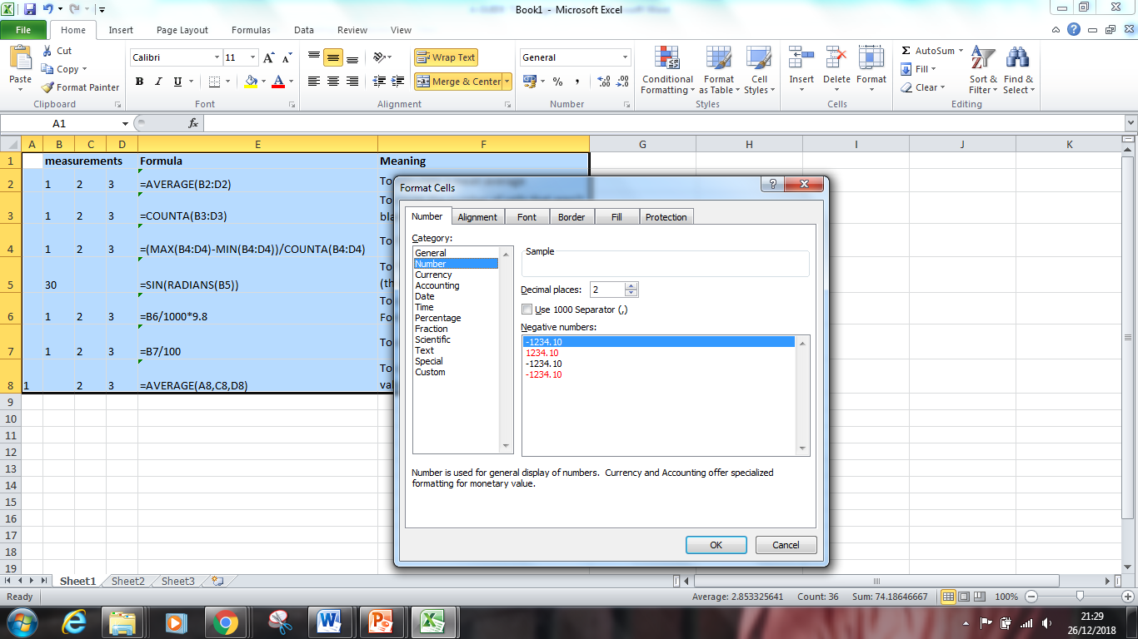

Conclusion
Conclusions must link to your aim and should contain, as appropriate, a statement of:
• overall pattern to observations
• trends in analysed information or results
• connection between variables
• measurement of a physical quantity.
The number of points given in the conclusion depends on the experiment. In some cases, a single sentence is sufficient. For example '.xx.. is directly proportional to ..yy.' with the comment that the 'graph is a straight line through the origin'.
Evaluation
- You should be able to identify the flaws and suggest improvements in reliability, accuracy, precision and validity.

https://www.matrix.edu.au/the-beginners-guide-to-physics-practical-skills/physics-practical-skills-part-1-how-to-study-for-practical-exams/
The number of points given in the evaluation will depend on the experiment selected and apparatus used. If the readings are not repeated a reason should be given. You must give a reason or justifications for each of your points.
The evaluation is likely to contain, as appropriate, a few sentences commenting on:
• possible sources of error
• control of variables
• possible improvements
• limitations of equipment.
A list of some typical phrases has been produced to help you with you evaluation. This list is not exhaustive, nor should the phrases be used without some thought. The purpose of this list is to promote discussions during the particular experiment being undertaken.
Highlighting the positive features of an experiment is all too often forgotten.
A list of typical phrases with a justification in italics is given below.
- The apparatus was satisfactory, the readings gave a good straight line graph in agreement with the theory, hence no improvements were required.
- The results obtained were as expected [details of what was expected is required]. Hence the procedures are valid.
- The percentage uncertainty in 'x' was much larger than the percentage uncertainty in 'y', and a more accurate instrument to measure 'x' would improve the experiment.
- The points on the graph show some scatter, it was difficult to ensure that [name of the variable] was always measured ‘the same way' /'From the same point'.
- The voltage of the supply must remain constant otherwise the measured value of the current might alter.
- The use of an air track would make the friction between vehicle and slope less important.
- The linear air track was used so that the friction between the vehicle and the slope was considerably reduced so that it could be neglected.
- The ruler may not be vertical, which would make the depth readings too large, giving a systematic error. (The graph must be consistent with the statement.)
- The meter was switched to a lower range to reduce the relative or % uncertainty in [name of variable].
- The graph did not go through the origin due to the systematic effect [detail of systematic effect].
- Tap the Bourdon gauge before taking a reading in case the mechanism sticks.
- A lens was used in front of the ray box to ensure the light ray(s) is(are) parallel.
Evaluation
- e.g. Was the room dark? Does it matter if there was background or reflected light?
- e.g. Is the lamp a point source? Does it matter if it is an extended source?

- You will need to comment on an experiments precision, reliability and accuracy. For this you will need to understand the difference between the three.

- Precision - this refers to the distance of the points from the line of best fit on the graph. If the majority of the points lie on or very near to the line of best fit, the experiment is said to be precise.

- Reliability - this refers to the difference in results between repeats. If a repeat has a very similar value in the experiment, the experiment is said to be reliable.

- Accuracy - this refers to the comparison of a calculated value to the accepted value. If a value that you calculate is very close to the accepted value, it is said to be accurate. An example of this would be if you calculated the earth’s gravitational field strength (g) to be 9.7 ms⁻², it is very close to the accepted value of 9.8 ms⁻². Therefore that experiment would be accurate.

- Another evaluation you might make is working out or comparing gradients and y-intercepts. For this you must know the equation
- y=mx+C

- where y and x are variables, m is the gradient and C is the y-intercept.
- All linear equations can be rearranged into this form, in order to work out certain values.

ACCURACY & PRECISION
Accuracy is how close your answer is to the true value. Precision is how repeatable a measurement is. Use the diagram below to remind you which is which.
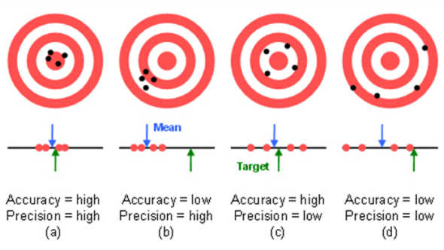
https://www.isobudgets.com/introduction-to-measurement-uncertainty/
In Physics you will often calculate an answer to a question that has a large number of significant figures or decimal places. Because it is highly unlikely that we need to know the answer that precisely. It is important to round off any answers that you find.
References
A citation is a quotation from or reference to a book, paper, or author, when referring to a Scientific work.
A citation and reference for a source of internet/literature data or information.
When writing up a scientific report or the assignment you must cite the internet/literature source within the body of the report and give the reference later in the report.
Acceptable references are given in the table below. There are many online reference generators like the ones given below. Here you add in all the information requested and then the reference generator produces a reference that you can copy and paste into your reference section at the end of a report. Do not forget to link this to where this information appears in the text.
The easiest way is to number the references in the text using [1] and then numbering the references (this is what has been used in this document.
https://www.qub.ac.uk/directorates/sgc/learning/LearningResources/Referencing/ReferencingPDFs/Filetoupload,1560650,en.pdf
https://www.mybib.com/tools/vancouver-citation-generator
Source | Reference
Website | Full URL for the page(s) with date accessed  The URL ‘www.bbc.co.uk (Feb 2018)’ is not acceptable, but https://www.bbc.co.uk/education/guides/z9499j6/revision (Feb 2018) is acceptable.
Journal | Title, author, journal title, volume and page number
Book | Title, author, page number and either edition or ISBN

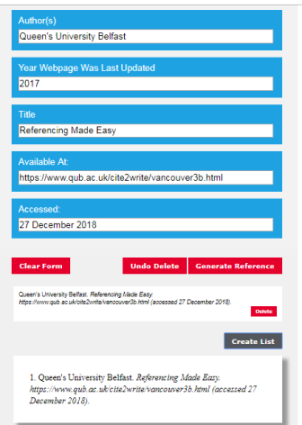
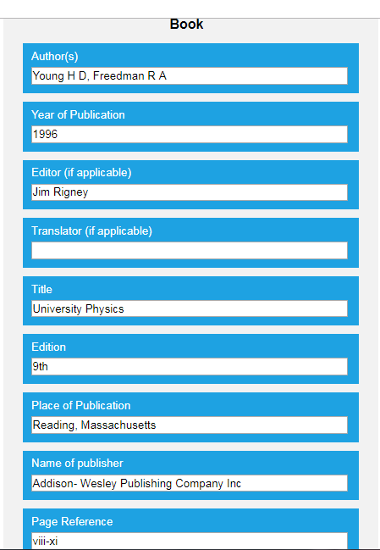
If using an online reference generator you will need to do this at the end so that you can generate one list that contains all the references and numbered. For example this is the one generated from QUB

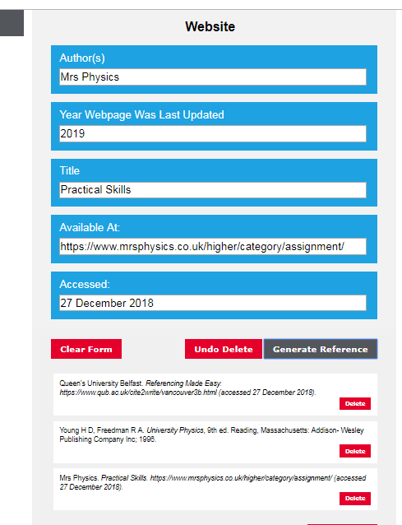

- Queen's University Belfast. Referencing Made Easy. https://www.qub.ac.uk/directorates/sgc/learning/LearningResources/Referencing/ReferencingPDFs/Filetoupload,1560650,en.pdf (accessed 4th September 2023)
- Young H D, Freedman R A. University Physics, 9th ed. Reading, Massachusetts: Addison- Wesley Publishing Company Inc; 1996. pp vi-xi
- Mrs Physics. Practical Skills. https://www.mrsphysics.co.uk/higher/category/assignment/ (accessed 27 December 2018).
- Matrix Education. How to Draw A Line of Best Fit. https://www.matrix.edu.au/the-beginners-guide-to-physics-practical-skills/physics-practical-skills-part-4-how-to-draw-a-line-of-best-fit/ (accessed 27 December 2018).
NB with the book I had to type in my own page numbers

