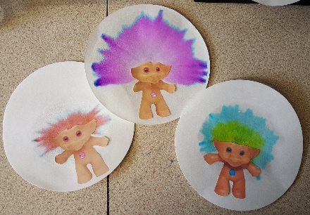
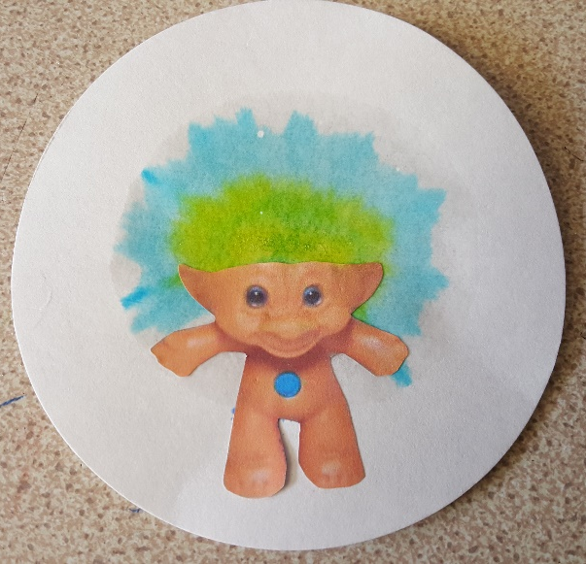
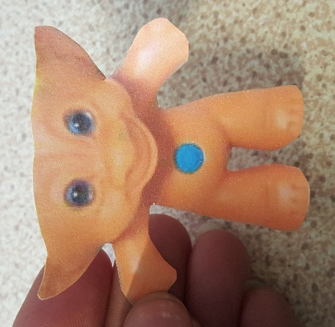
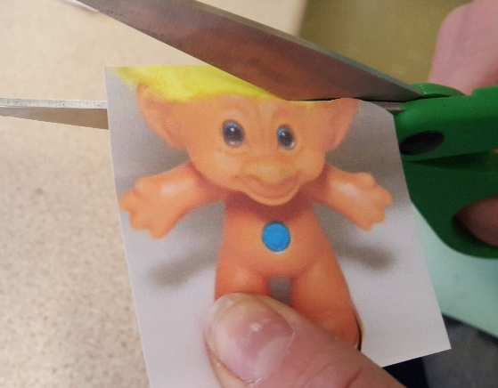
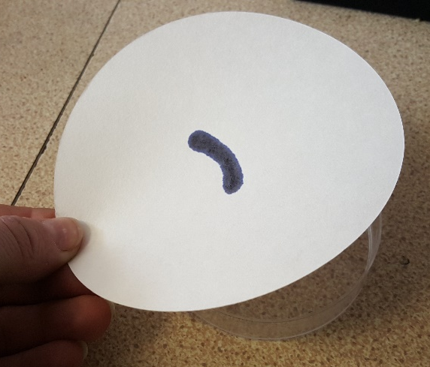
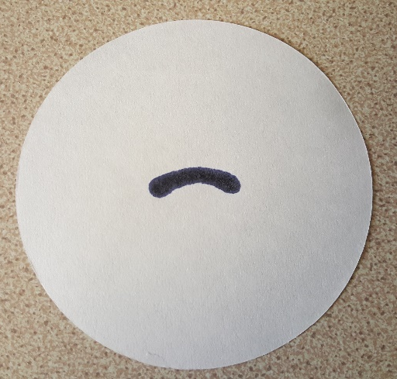
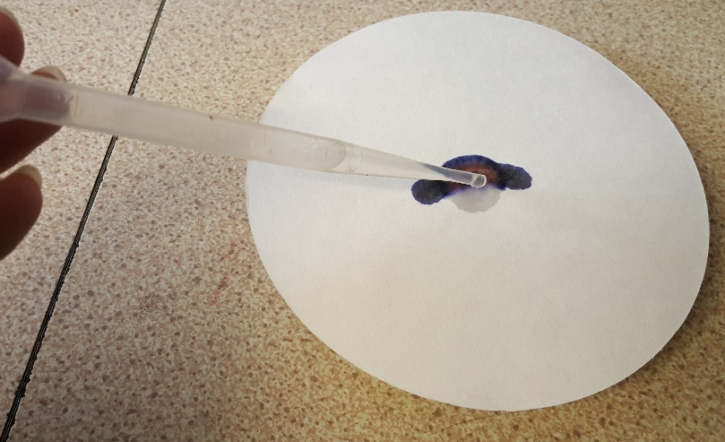
Leave your filter paper to dry (or use a hairdryer)
Use a glue stick to stick your troll body onto his new funky hair!

What next? Repeat but with a different coloured pen to see what colour hair you can create
While you are waiting for the water drops to absorb choose a troll and cut it out

Make sure you have cut around the body so it looks like this one
Chromatography Trolls
Use a felt pen to draw a line or curve in the middle of your filter paper

Place the filter paper onto the petri dish
Use a pipette to add salt water below the line, one drop at a time
Wait for all the water to be absorbed before you add the next drop

Continue doing this until the ink has spread as much as possible

