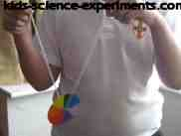
Making a Rainbow Spinner
Materials you will need:
• Pencil
• A Glass
• White Card
• Piece of Cardboard
• Scissors
• A ruler
• Coloured pencils or crayons
• Hole Punch (optional)
• Glue
• String (around 2' or 24")
This is a colour changing experiment

Steps
1. Stand the glass on a piece of white card and draw around the base of the glass to make two white circles. Then draw a circle on the piece of cardboard to make one cardboard circle.
2. Carefully cut out all three circles.
3. Divide the circle into several equal-sized sections (so that it looks like pie pieces) using a ruler for straight lines and color each pie section with a different color. Do this on both of your white circles.
4. Color in each pie section with a different color. Do this on both of you white circles.
5. Glue the two colored circles on each side of the cardboard so that the pretty colors can be seen from both sides of the cardboard circle.
6. Carefully make two small holes (use a compass tip or pencil tip) equally from the center of the card (circle) around 1/2 inch and just big enough to thread the string through the holes (use the pencil tip to guide the string in if it doesn't go through smoothly).
7. Thread the string through both holes and then tie a knot at the end.
8. Pull the string so that it is positioned evenly on either side of the spinner.
9. Place your pointer fingers inside the string at each end. Slowly make a circular motion with both hands so that you flick the spinner around in this circular motion until the string is twisted.
10. Stop the circular motion and then pull your hands apart and then back in (like you are playing an accordion but with a yoyo action) causing the spinner to spin very quickly.
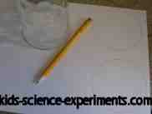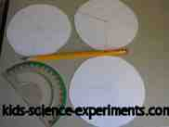
Step 1 Step 2 & 3
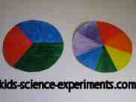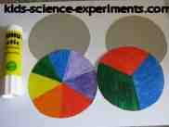
Step 4 Step 5
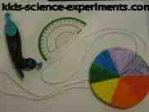
Step 6 & 7 Step 8 & 9
What colour do you see? Make lots of spinners using different combinations of colours. What colours do you see when you spin them?
When the spinner spins really fast you see light reflected from all its colours, but your brain cannot separate them. So you see a mixture of all colours, which is white. Your spinner may look grey to you because your colours are not pure.

