Teltron Tubes

Maltese Cross

1.1 🔧Setting Up
To set up the Maltese Cross Tube, you will need:
- EHT supply.
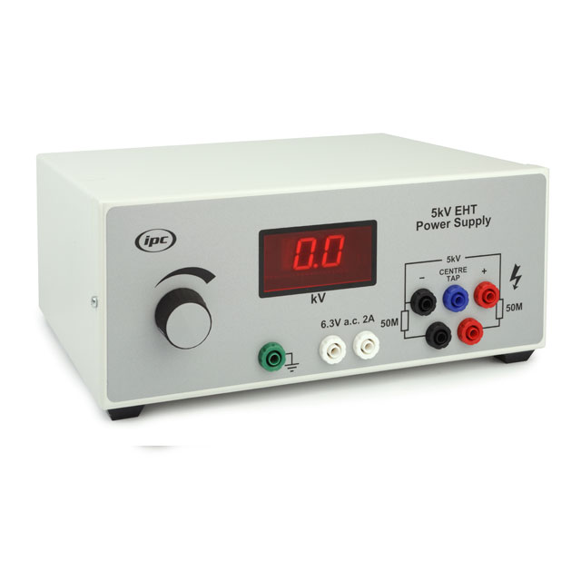
- Maltese Cross Teltron Tube with holder
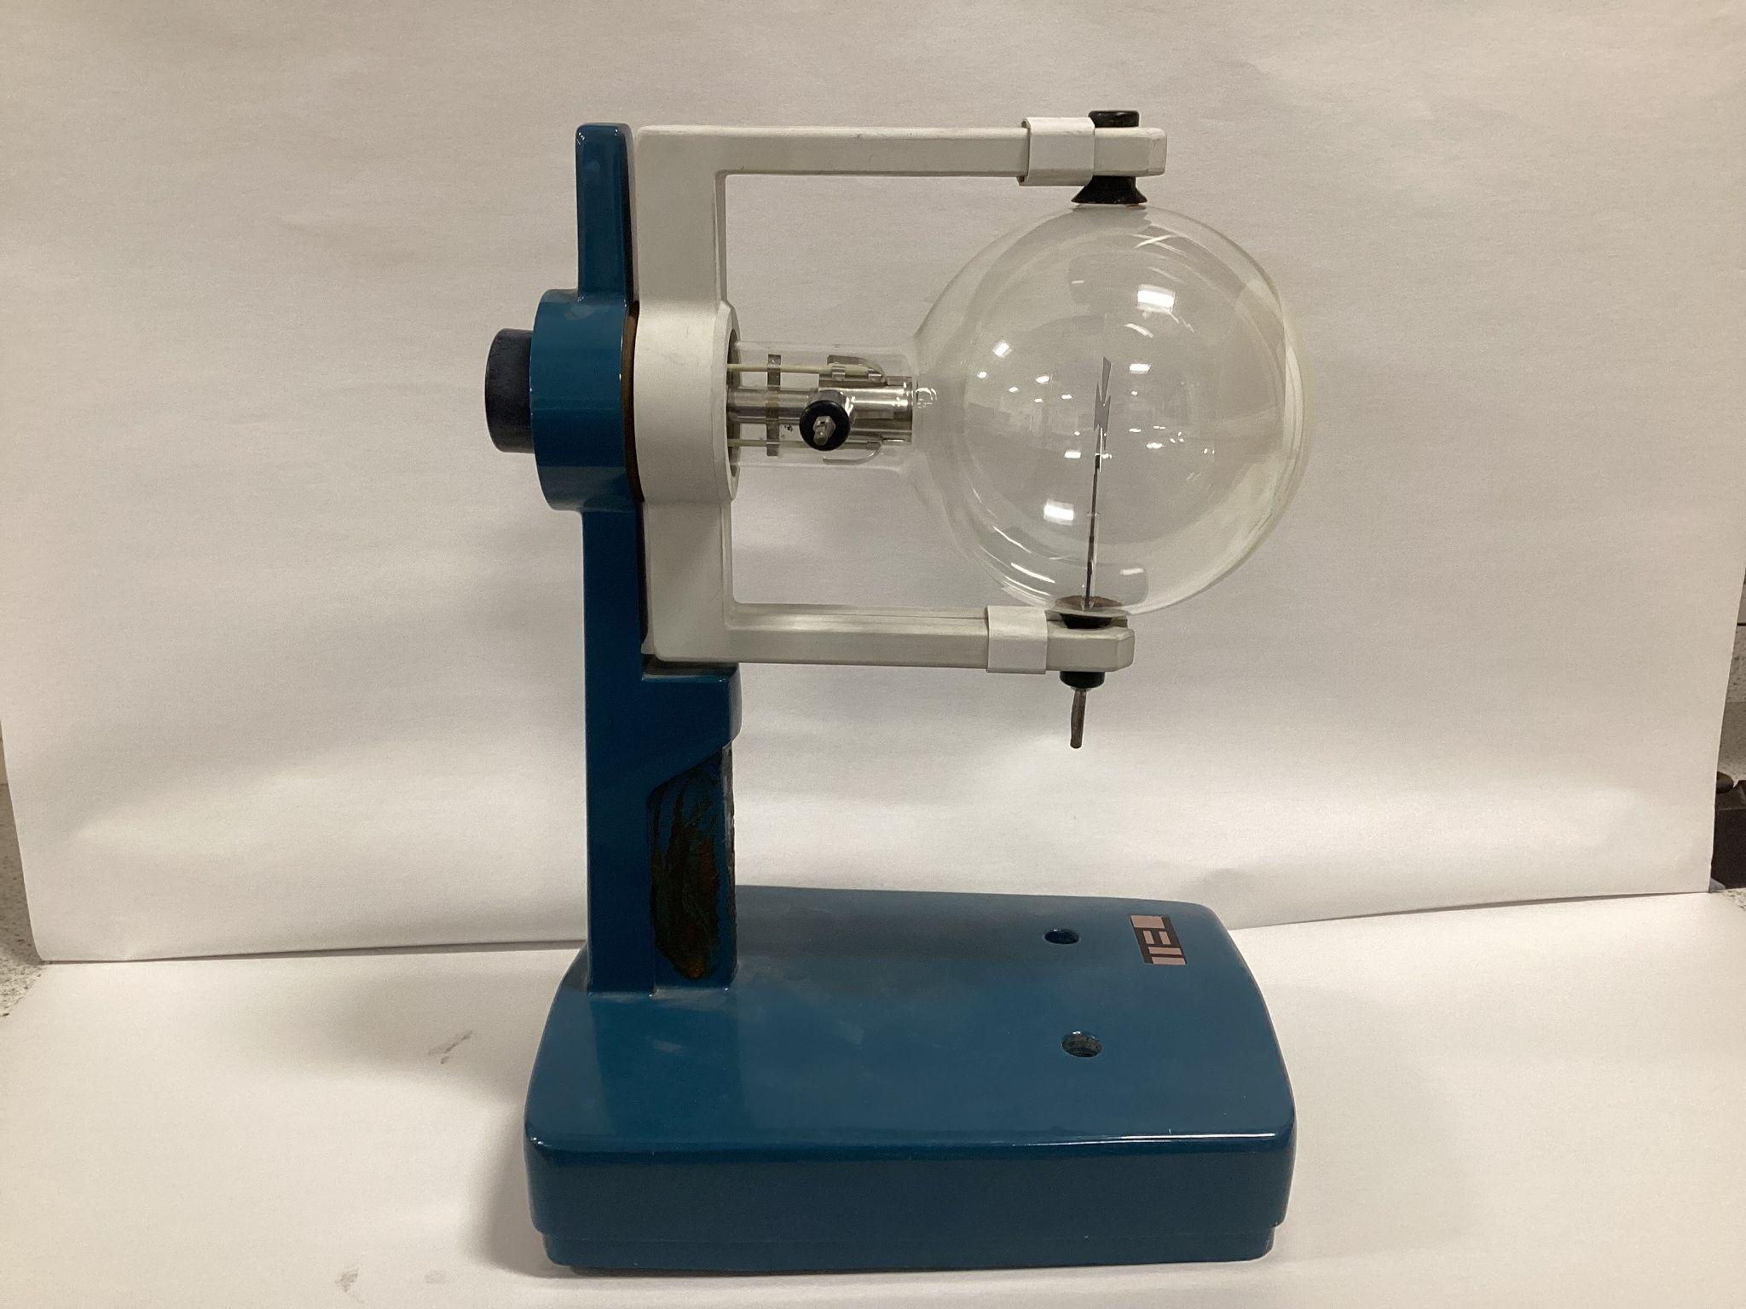
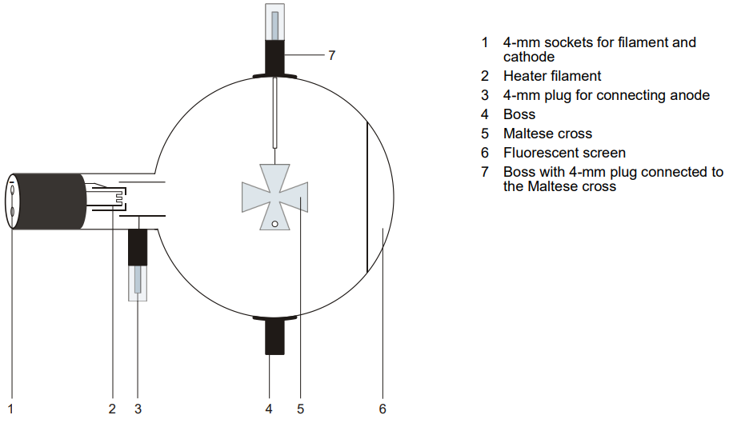
- Push the jaw clamp sliders on the stanchion of the tube holder right back so that the jaws open.
- Push the bosses of the tube into the jaws.
- Push the jaw clamps forward on the stanchions to secure the tube within the jaws.
- Only connect circuits with power supply equipment switched off.
- First connect the 6.3V a.c. Low Power Supply to the back of the tube (yellow wires).
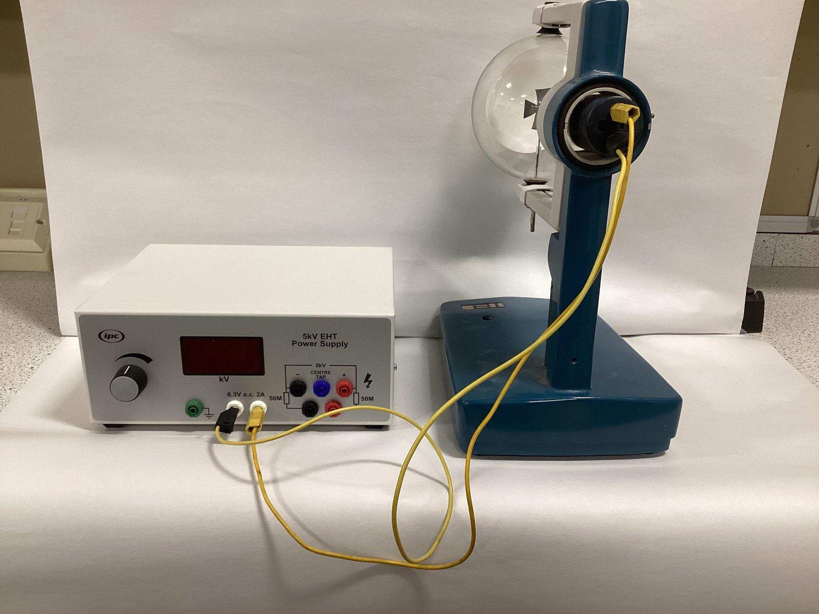

- Connect the positive end of the high voltage supply to the anode with a shrouded wire (red wire).
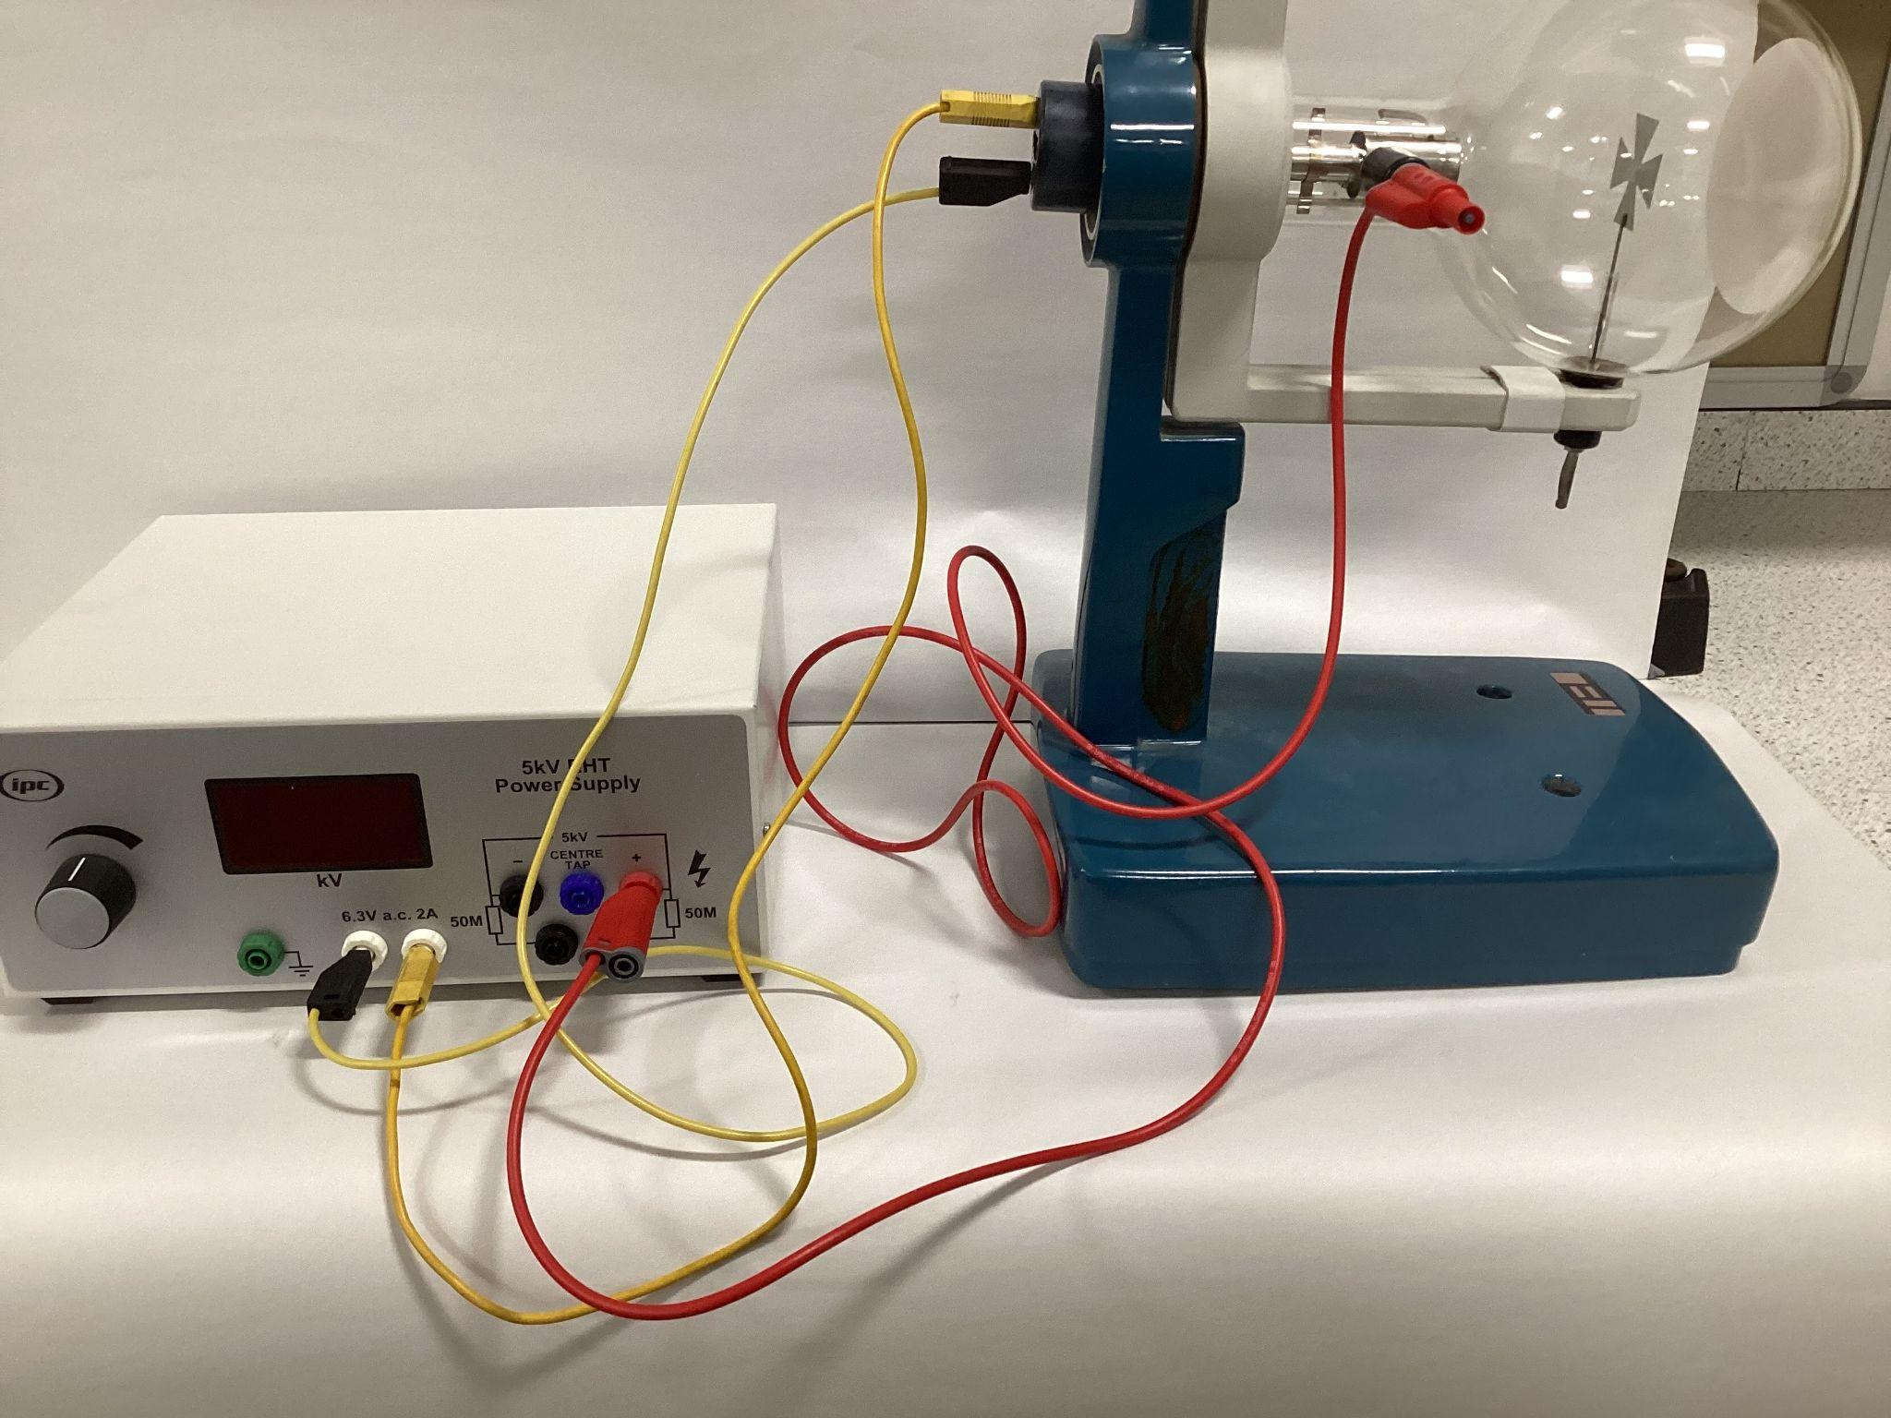
- Connect the negative end of the high voltage supply to the cathode at the back of the Teltron Tube using a shrouded wire with a connector (black wire).
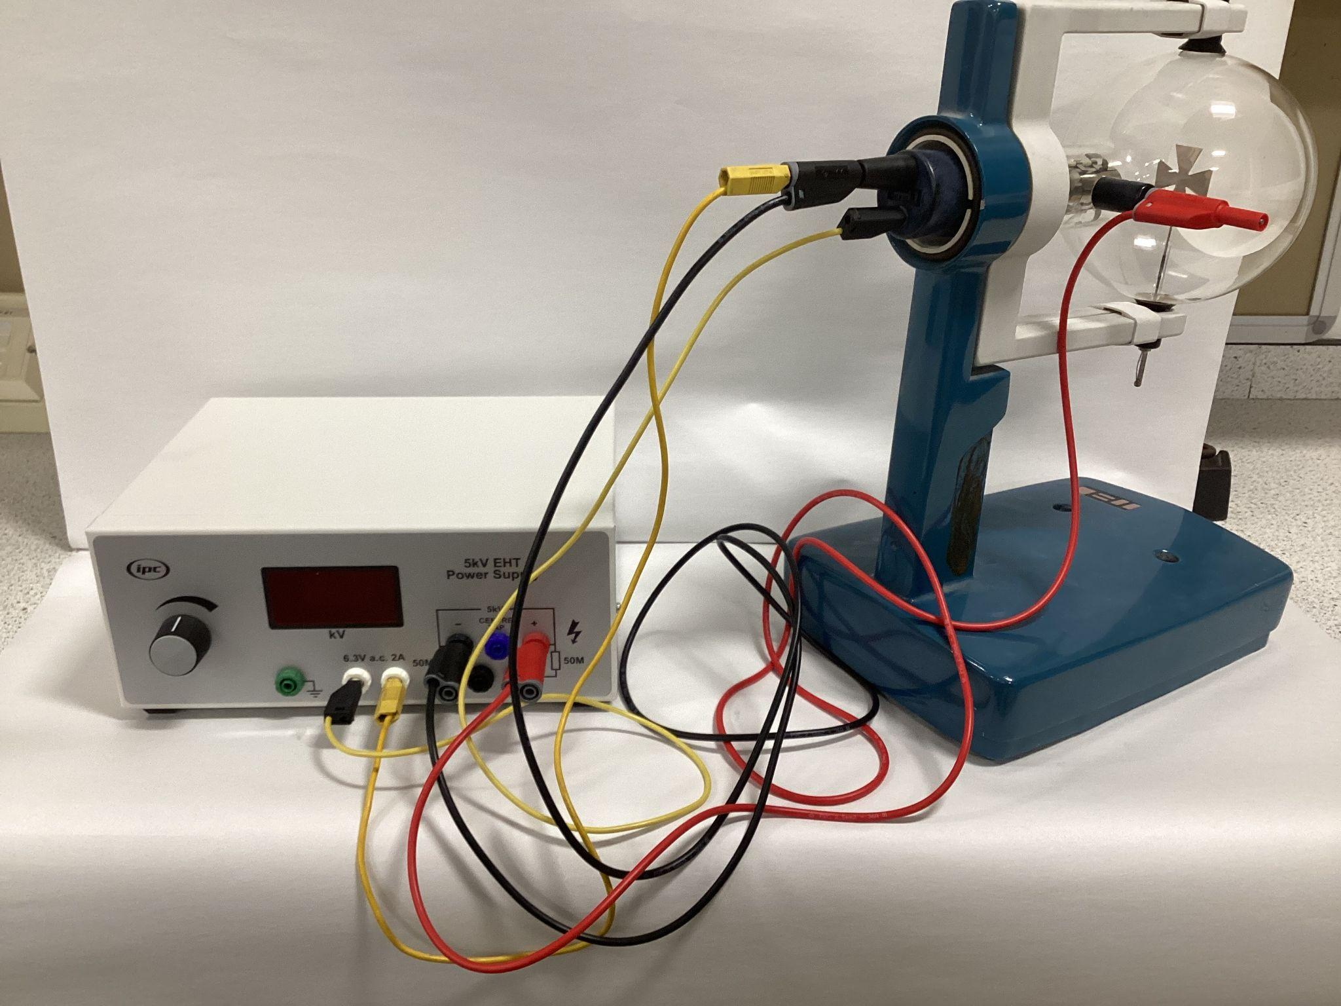

- Connect the positive end of the high voltage supply to the Maltese Cross (green wire).
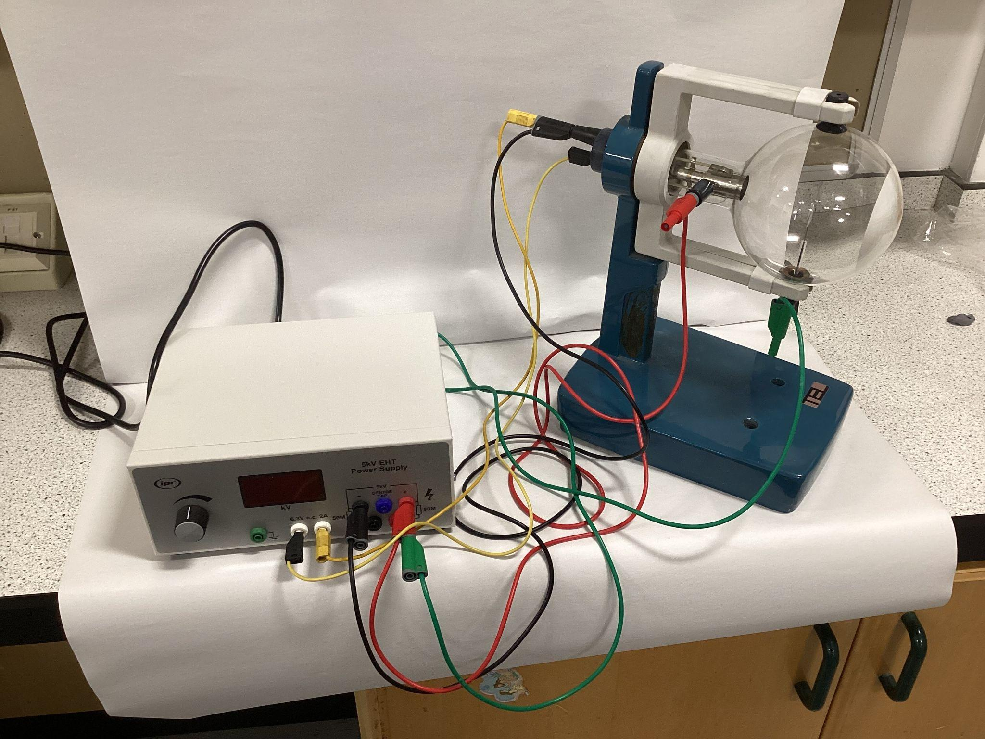
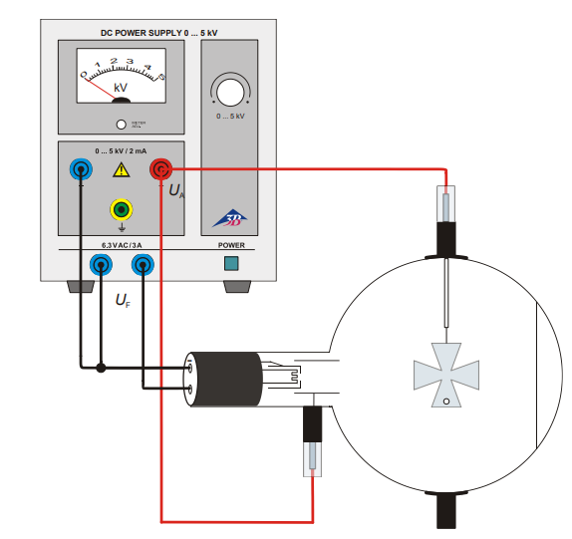

1.2 Experiment 1: Linear propagation of cathode rays
- Switch ON the EHT supply. A voltage will be applied to the heater filament.
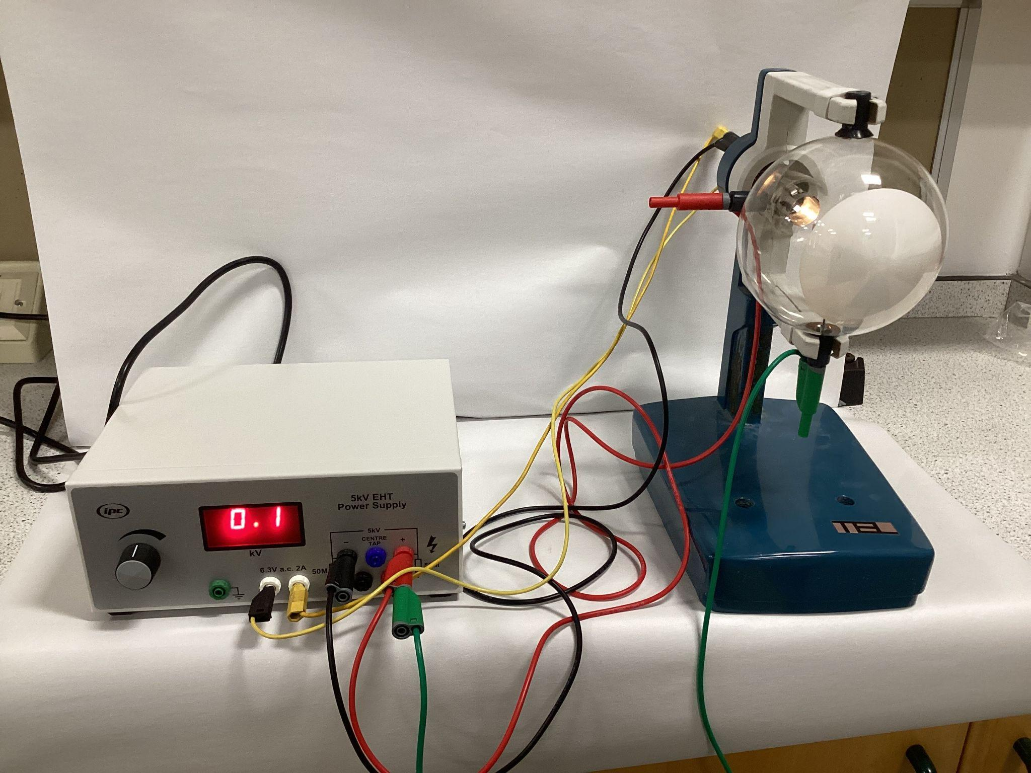
- Observe that the Maltese cross casts a sharp shadow on the luminescent screen in the visible light emitted by the glowing cathode.
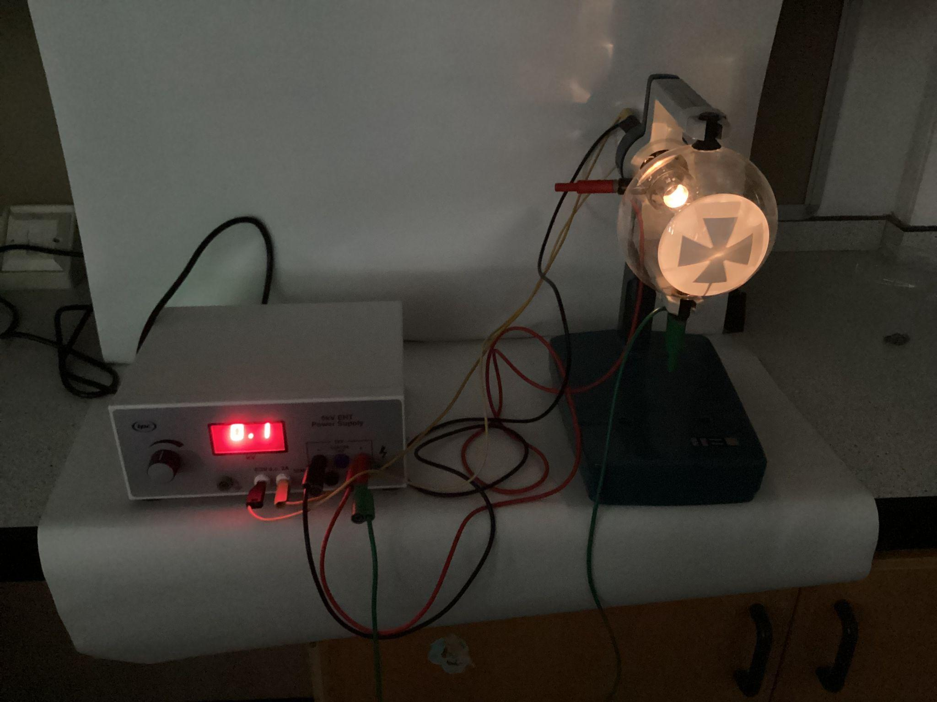

- Turn on the high-tension supply to the anode by slowing increasing EHT supply to 3kV.
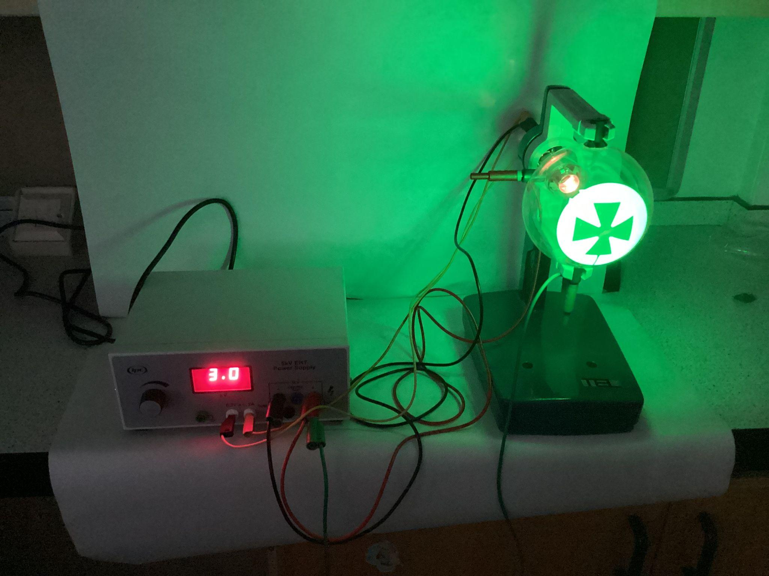
👁️Observe that an equally sharp and exactly overlapping shadow is cast on the screen by the charged particles. The experiment demonstrates that the charges, cathode rays, are propagated linearly and produce shadows in exactly the same manner as visible light.
Allow the tube to cool before dismantling.

1.3 Experiment 2: Electrostatic charging effect
- 🔧Set up circuit as in 1.1
- Isolate the metal cross from the anode potential (remove green wire).
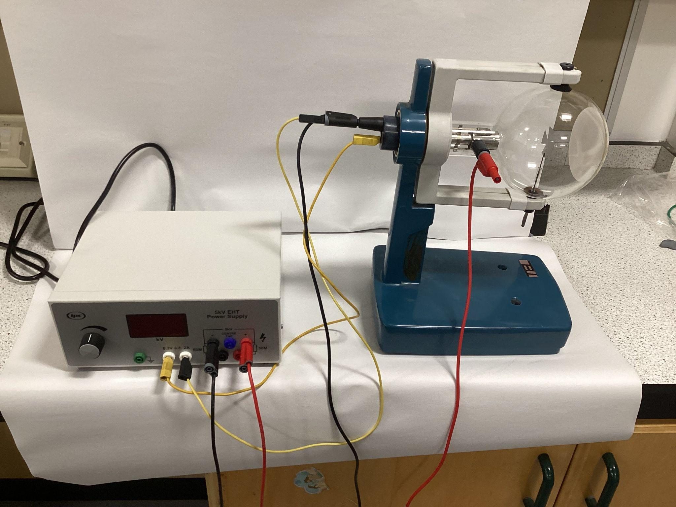

- Switch ON the EHT supply. A voltage will be applied to the heater filament.
- Turn on the high-tension supply to the anode by slowing increasing EHT supply to 3kV.
👁️Negative charges accumulate on the cross and when equilibrium is reached, they oppose the collection of any further charge. Cathode rays passing close to this opposing field are deflected and produce a distortion of the luminescent shadow.
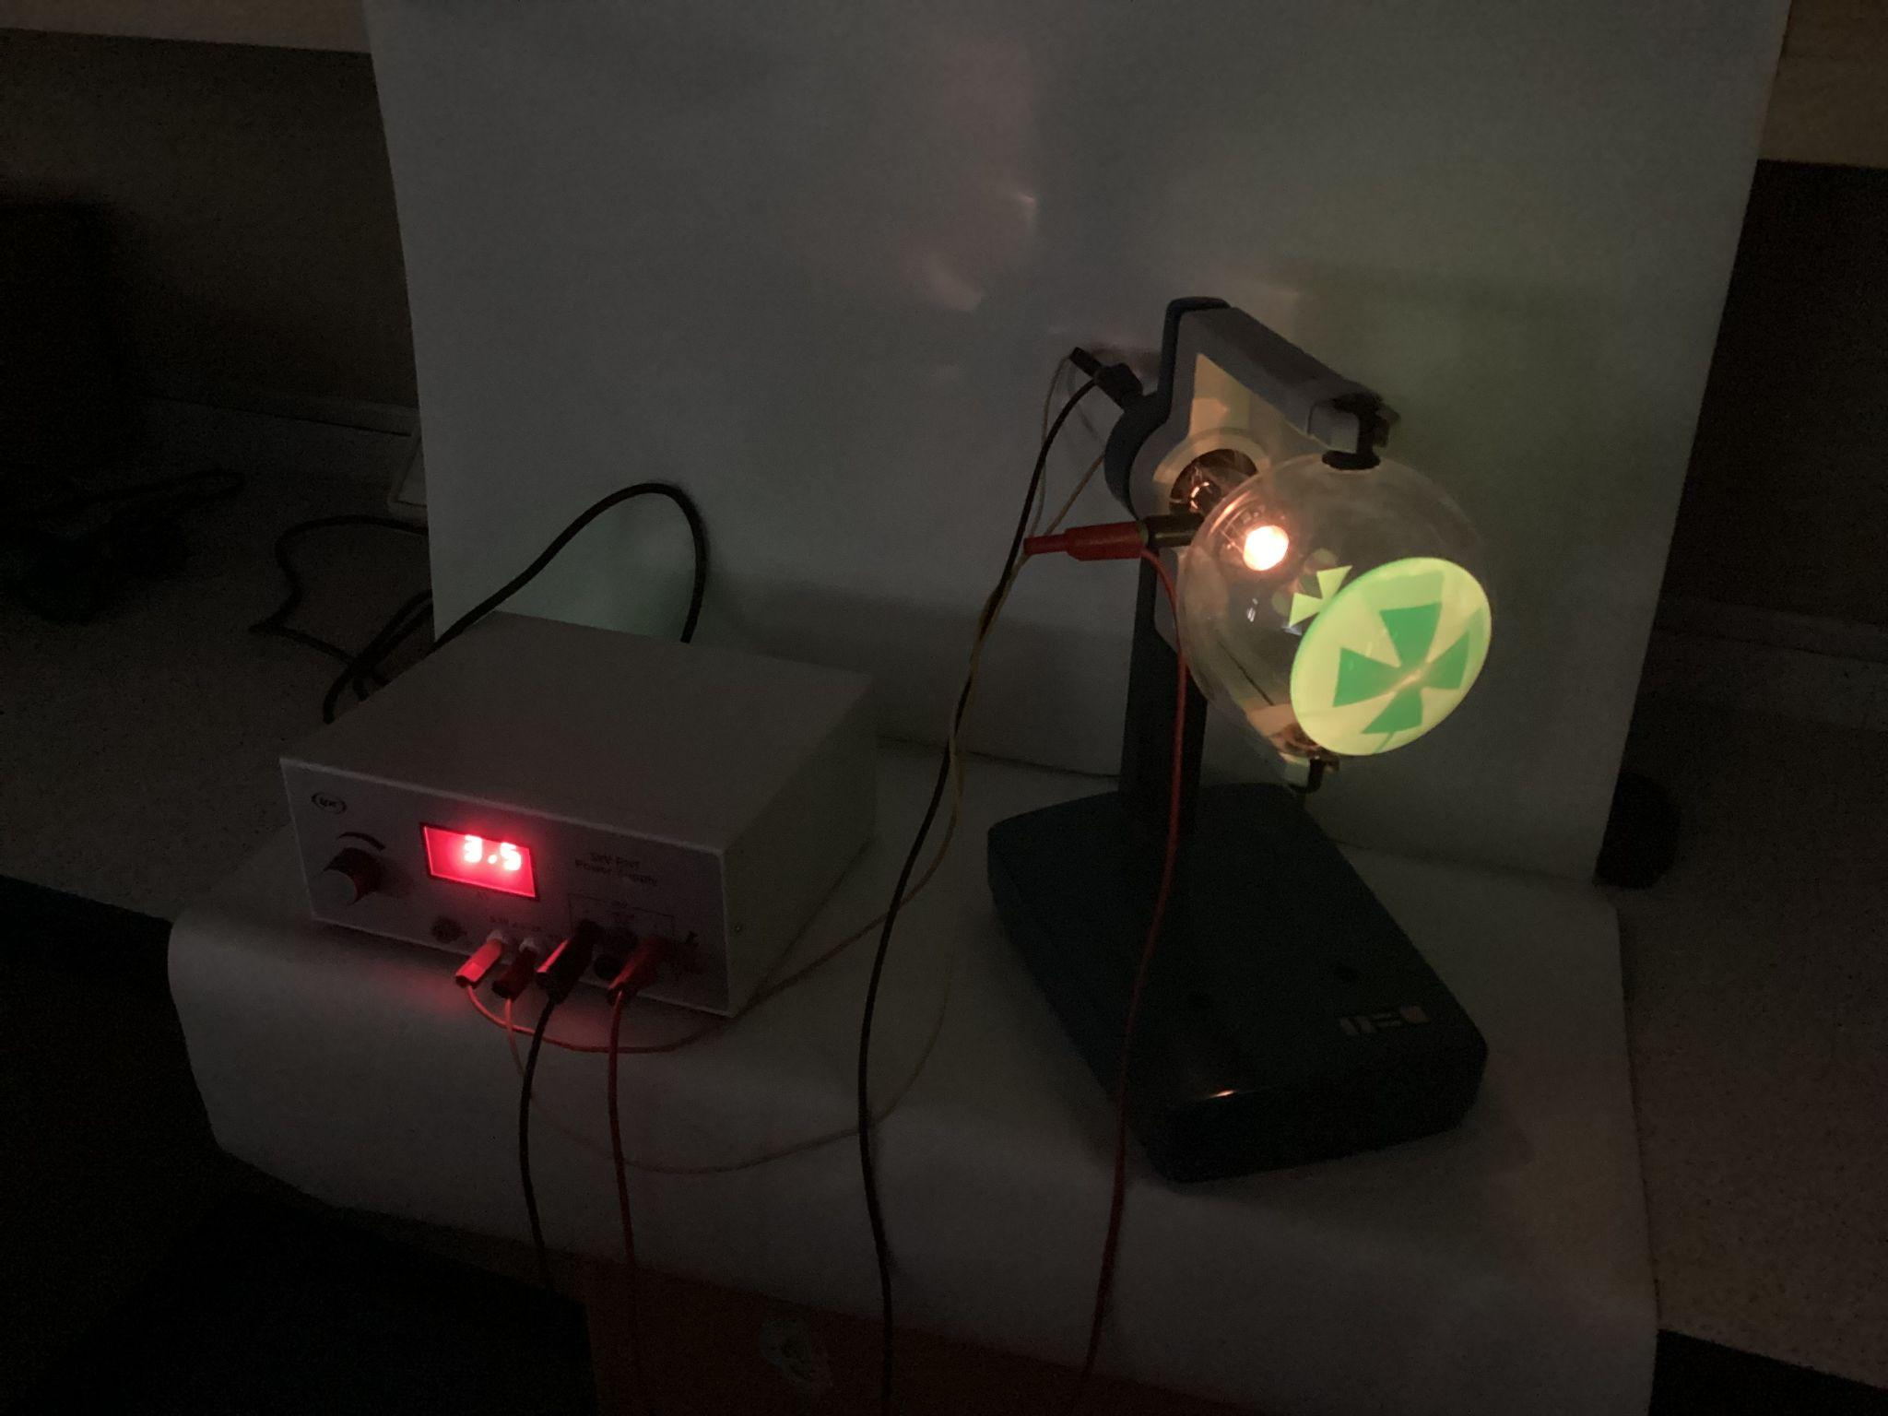

Connecting the cross to the cathode potential (connecting the green wire between Maltese Cross and negative end of EHT supply) results in such a distortion that the image is magnified beyond the limits of the fluorescent screen.
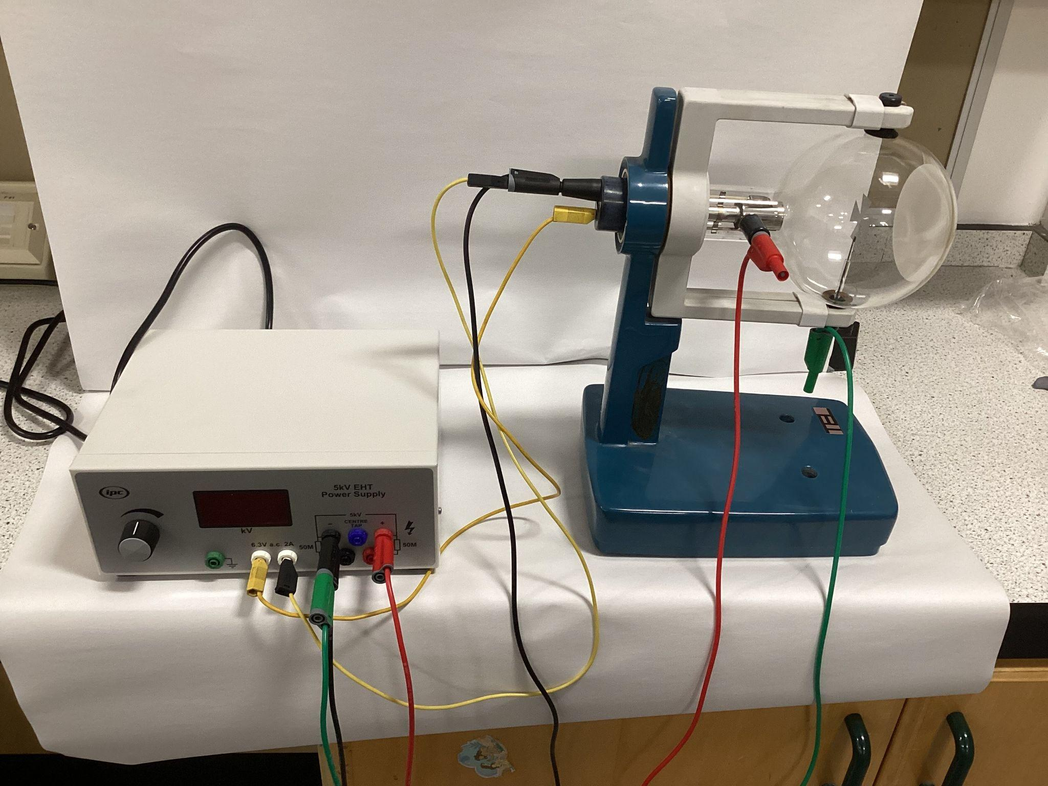
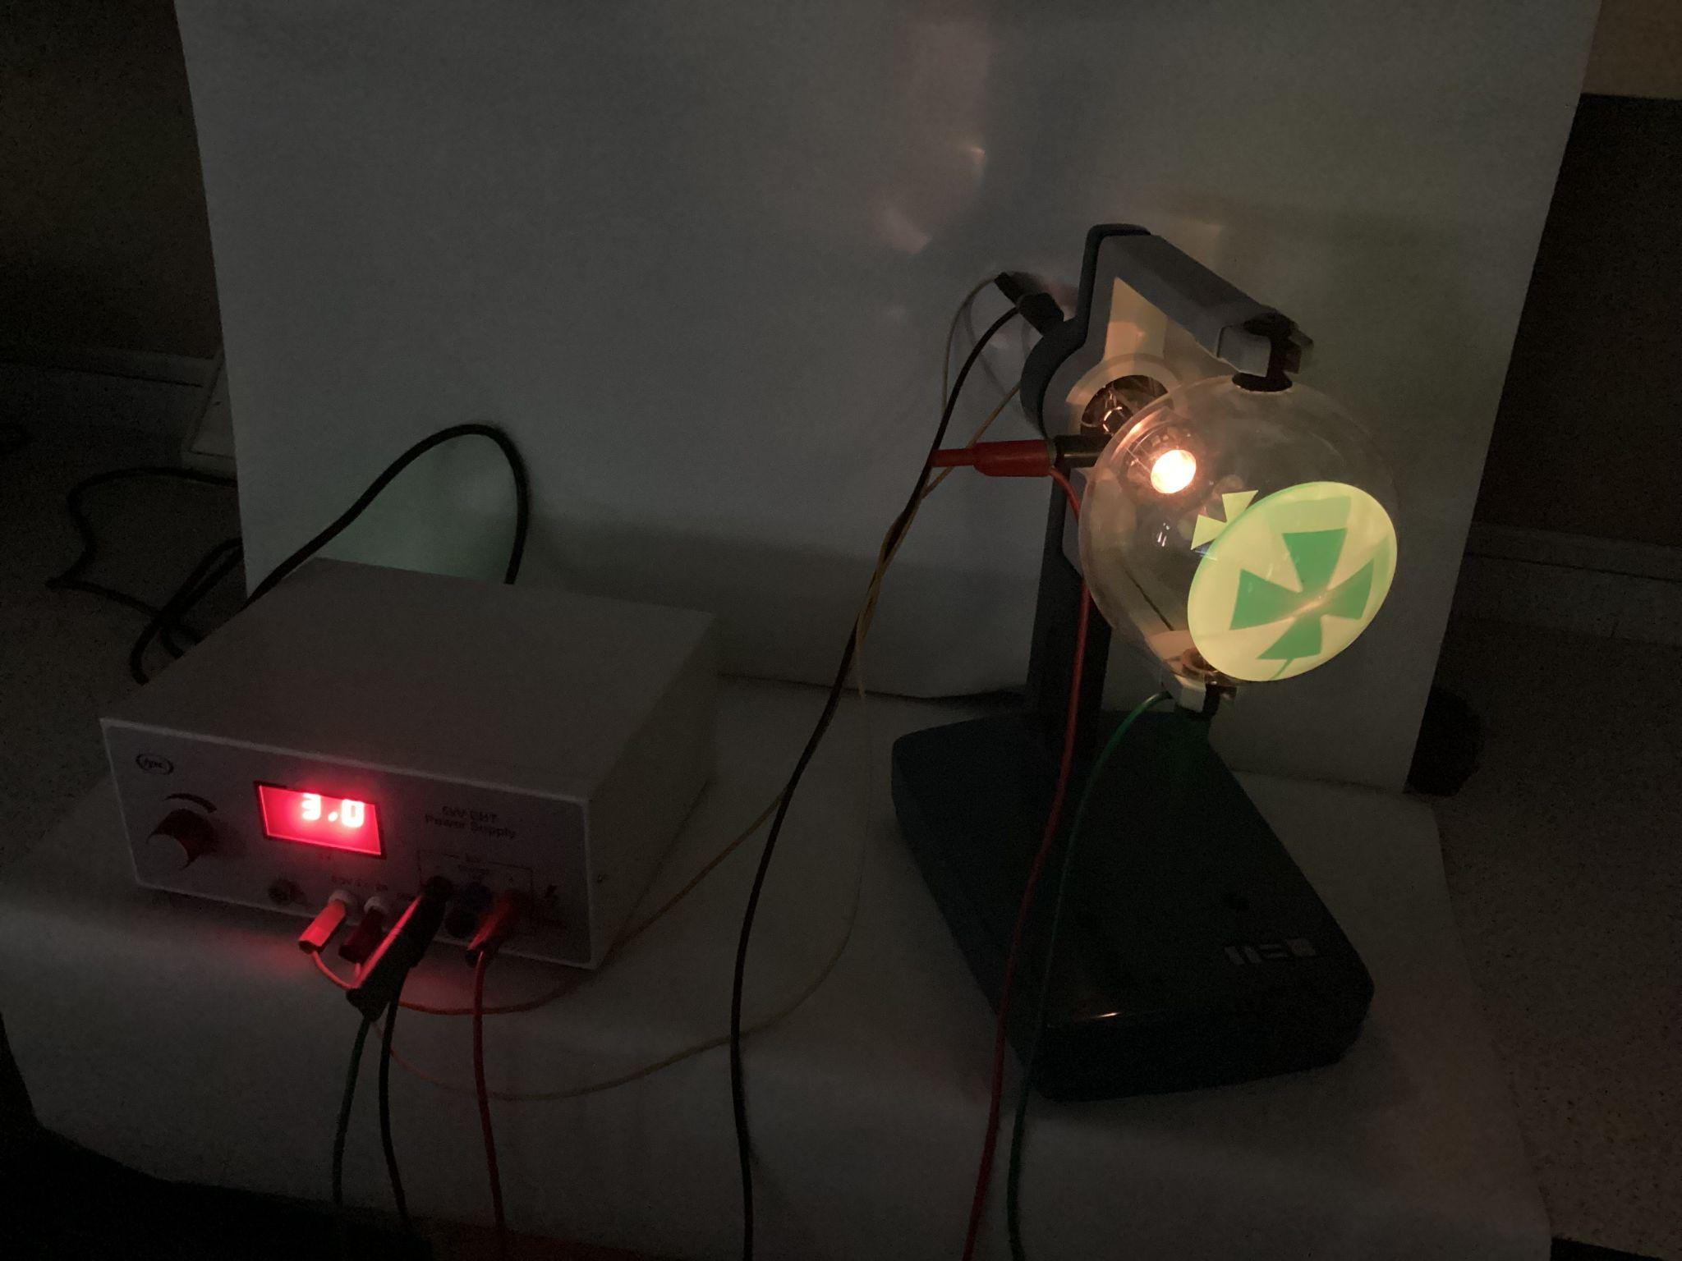
Allow the tube to cool before dismantling.

1.4: Experiment 3: Deflection by a magnetic field
- 🔧Set up circuit as in 1.1
- With the tube operating, bring a magnet close to the tube.
Observe that the shadow moves. The amount of deflection depends on both the strength of the magnetic field and the accelerating voltage applied to the gun. Relate the direction of deflection, the field and the motion of the charges using Fleming's law of motion (left-hand rule). Cathode rays under the influence of magnetic fields appear to behave in a similar manner to electric currents in conductors.
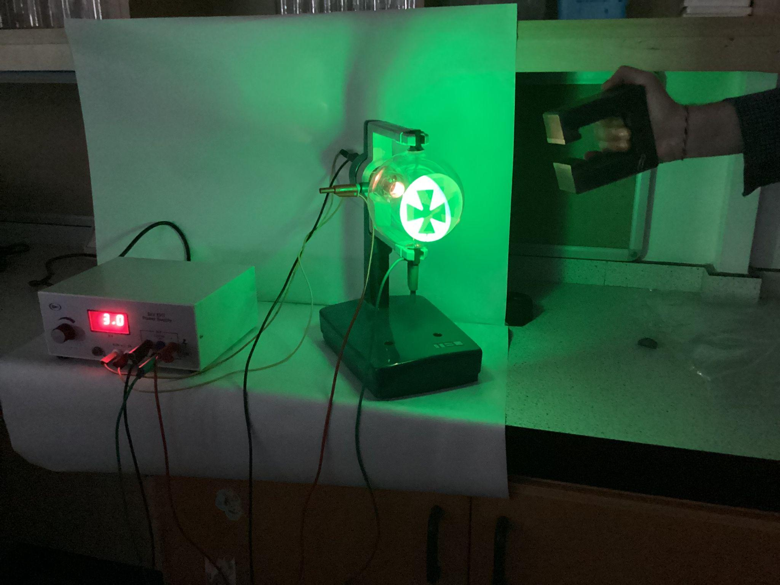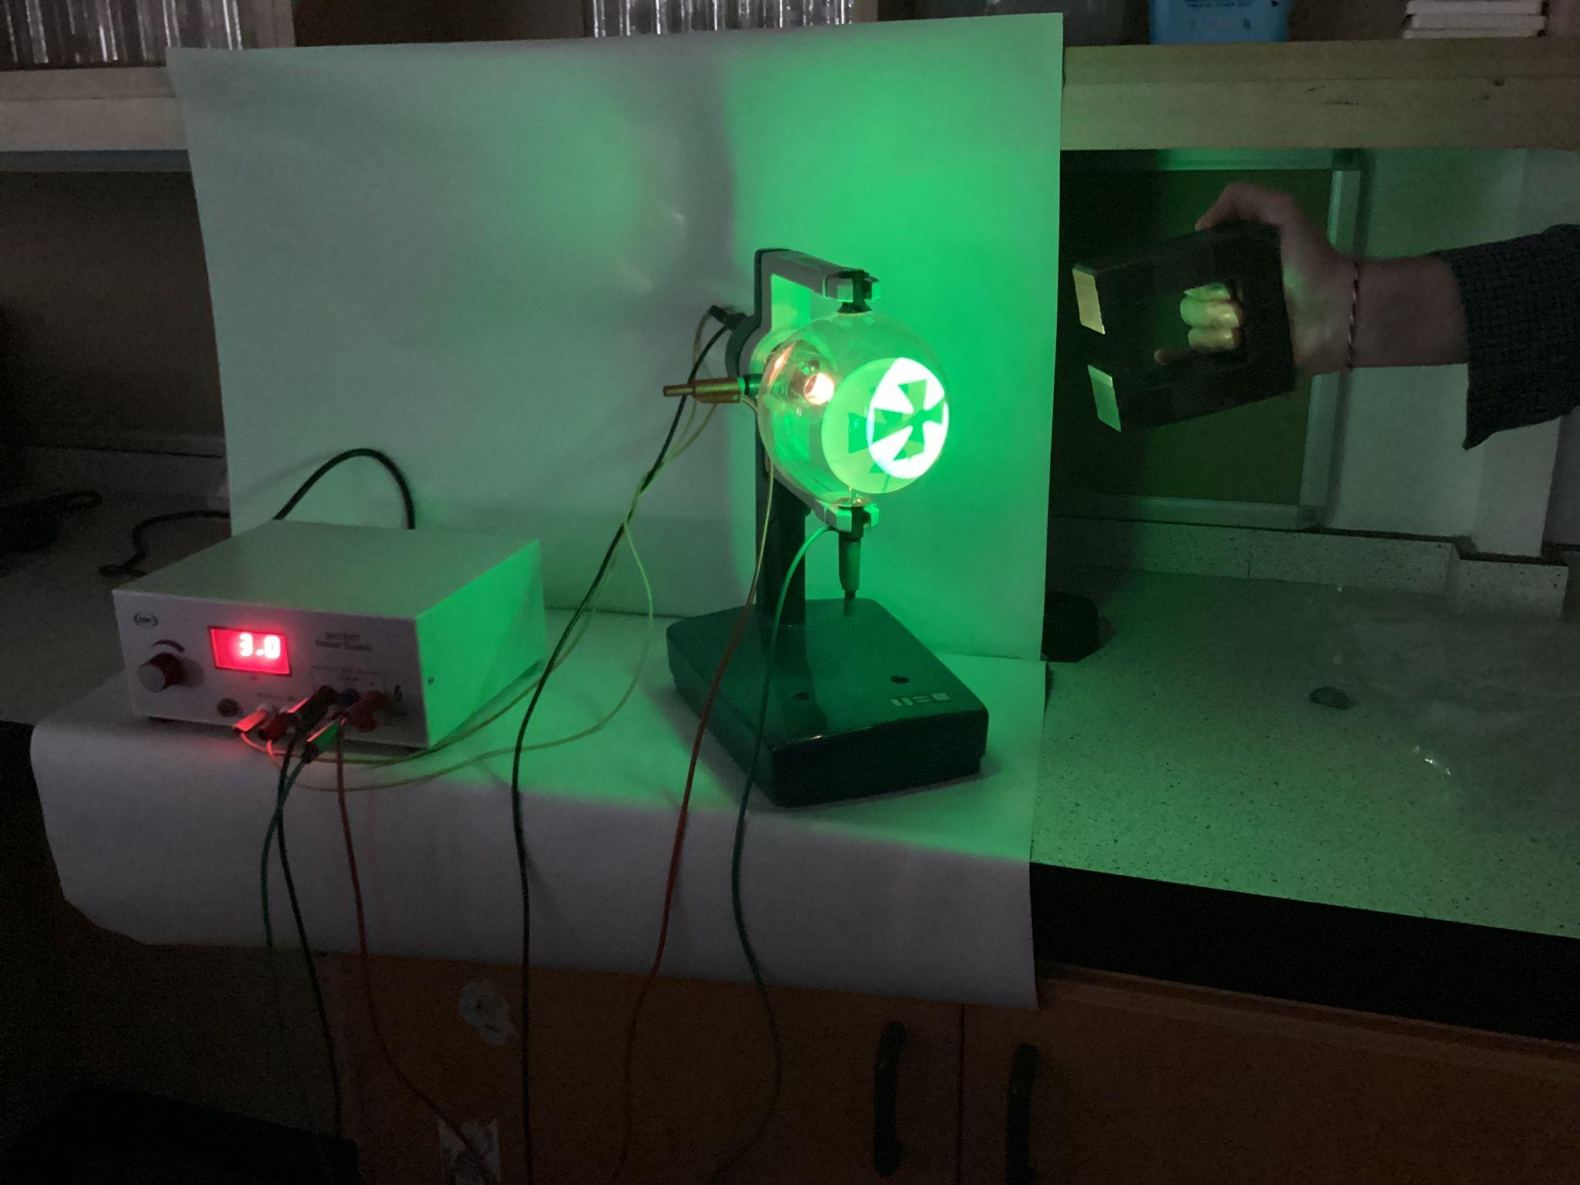
Allow the tube to cool before dismantling.

1.5: Experiment 4: Introduction to electron optics
- Place the tube in the stand at 90° to its normal alignment.
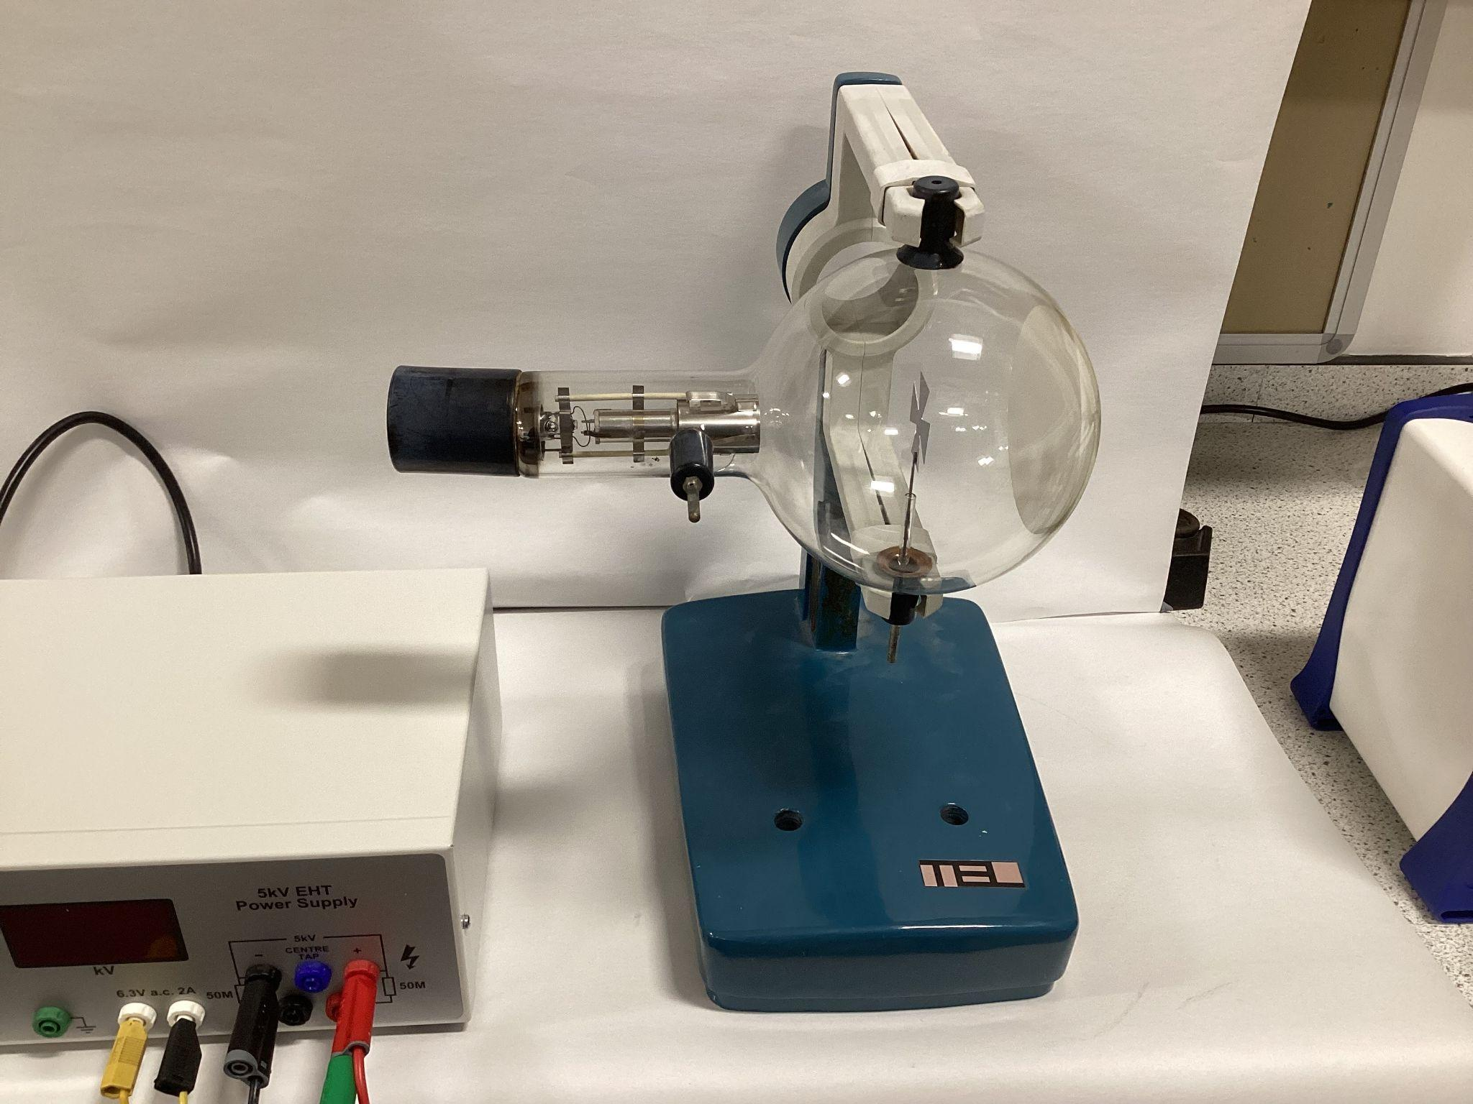
- Insert the coil in the slot of the tube holder so that the fluorescent screen is enclosed by a single Helmholtz coil.
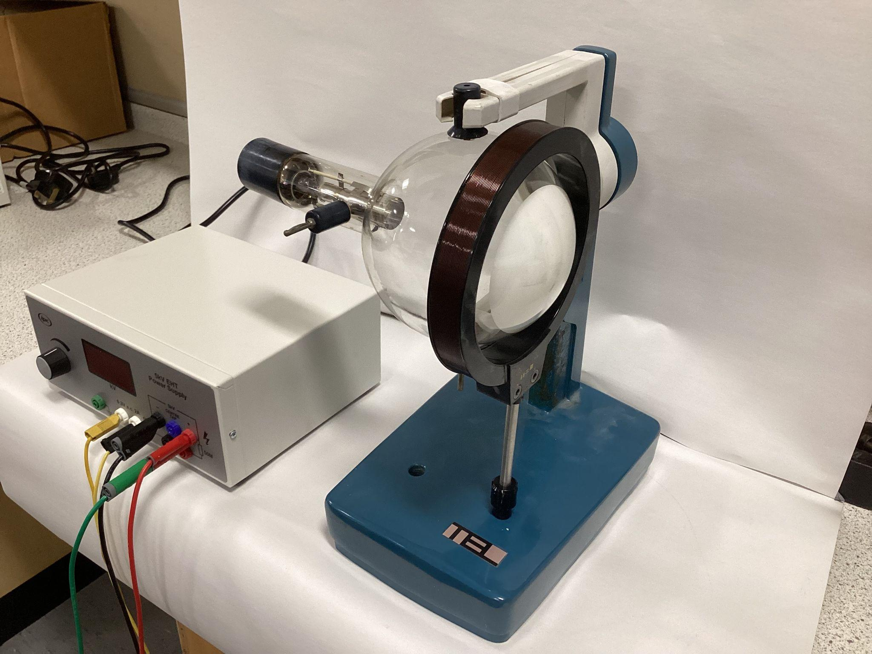

- Connect the Helmholtz Coils to a d.c. low power supply.
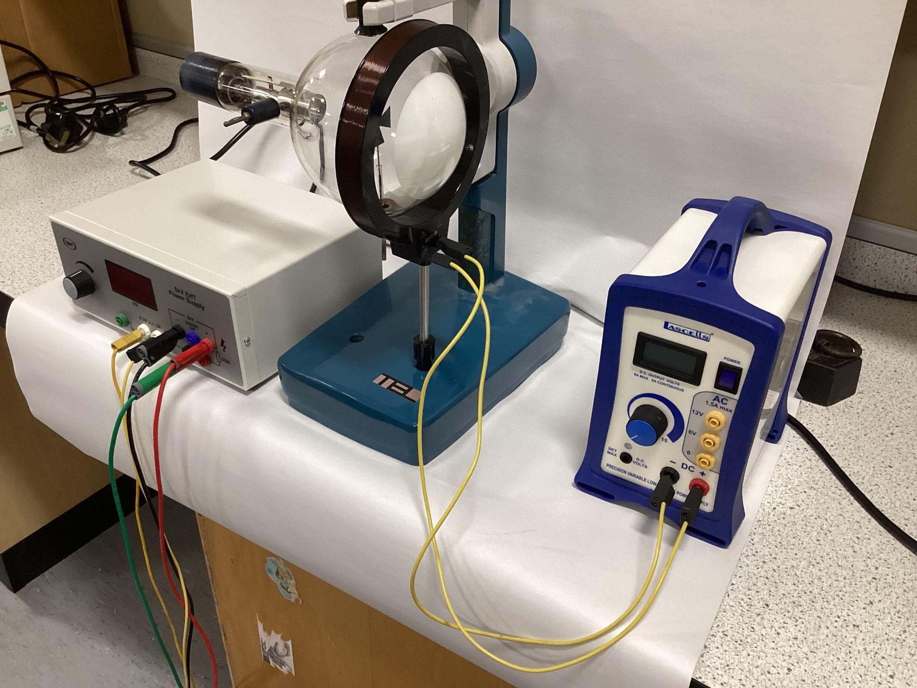
- Set up tube as in 1.1.

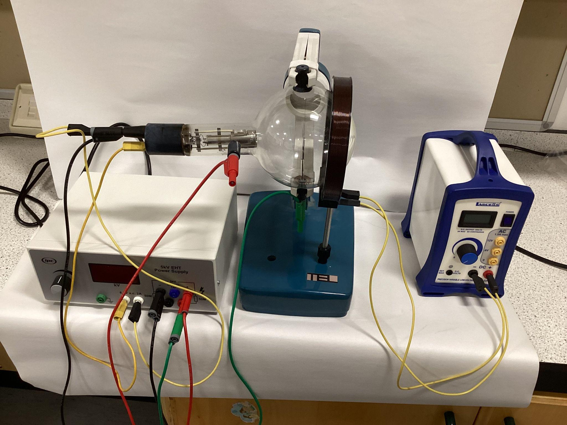

- Turn on the power supply for the tube and observe the shadow. Turn on the coil current and slowly increase it.
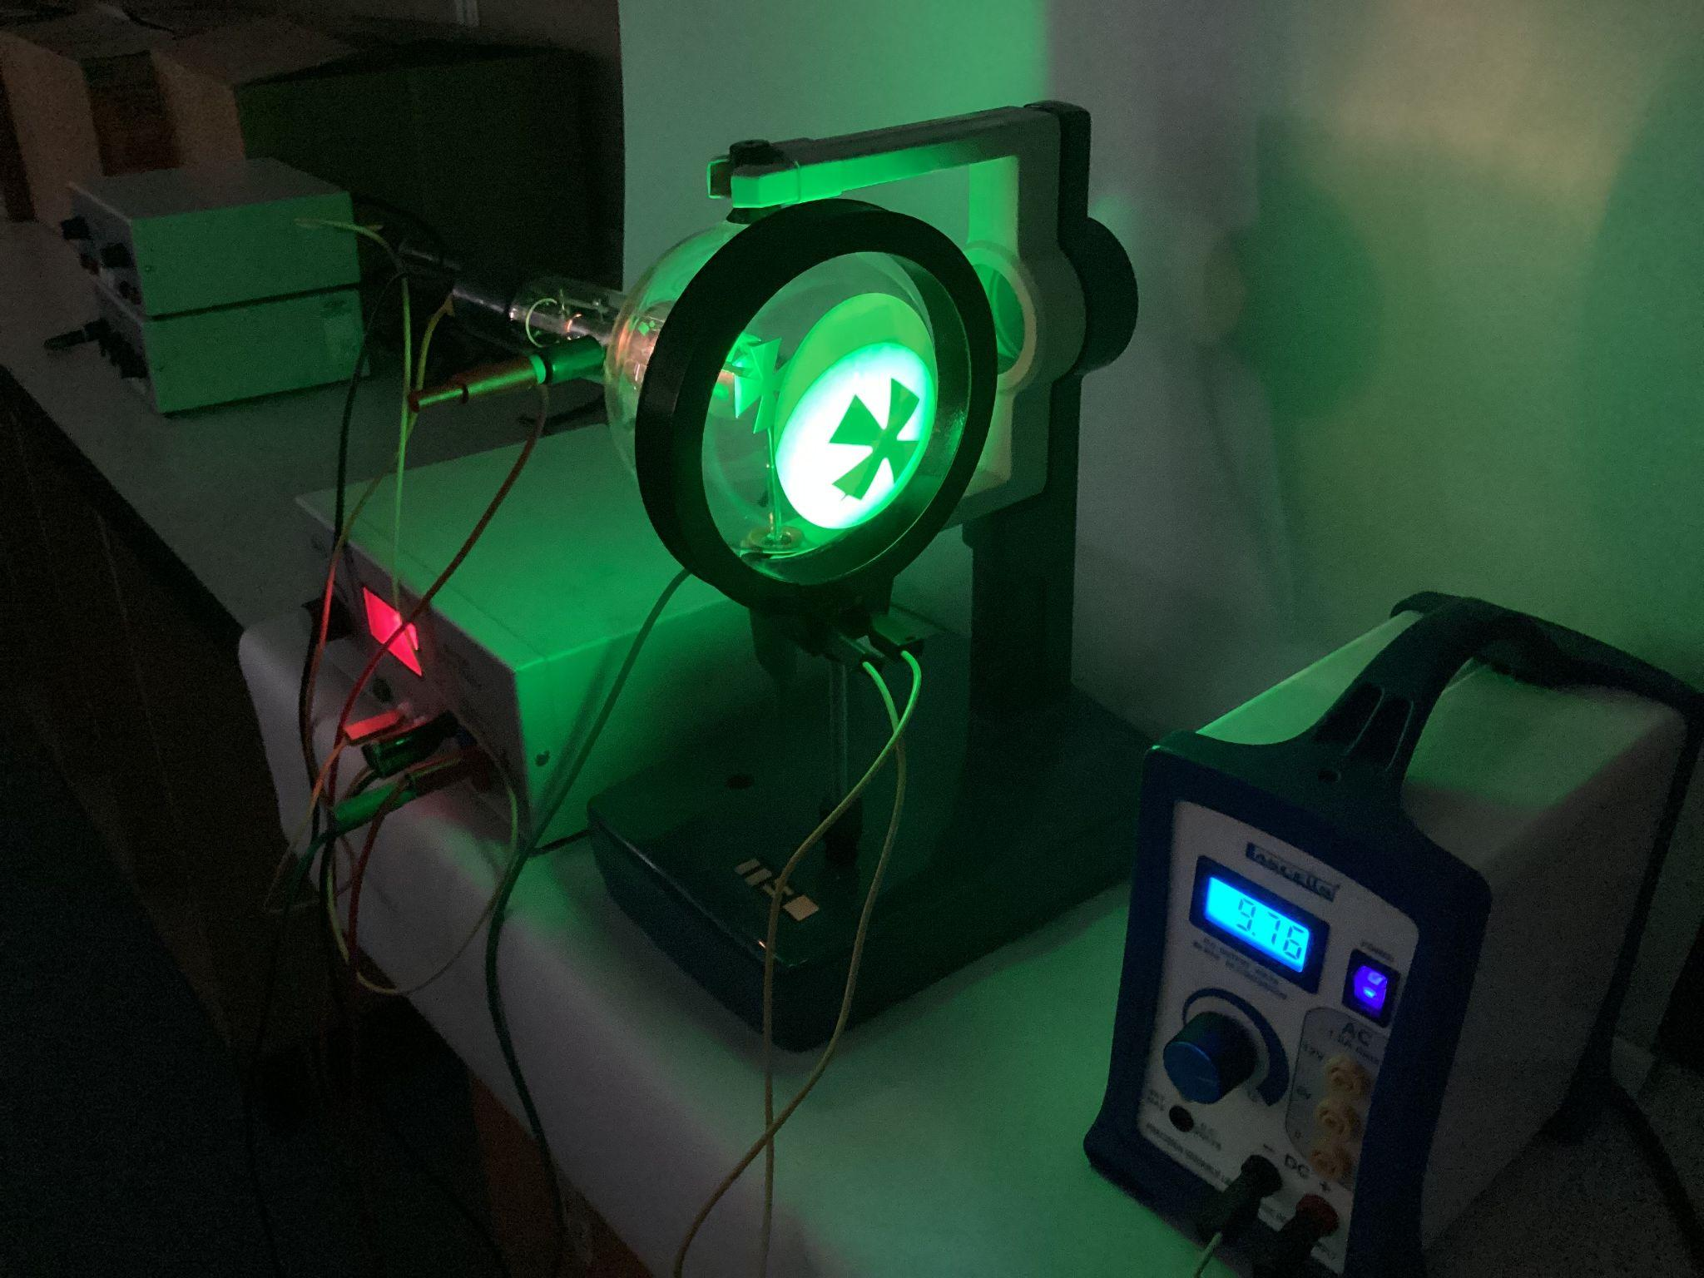

By increasing the magnetic field (raising the voltage to the coil) the image is seen to rotate, diminish to a spot and then enlarge again in inverted form.
Another cool effect is to swap the low power supply to the coil with a signal generator. The image is seen to vibrate.
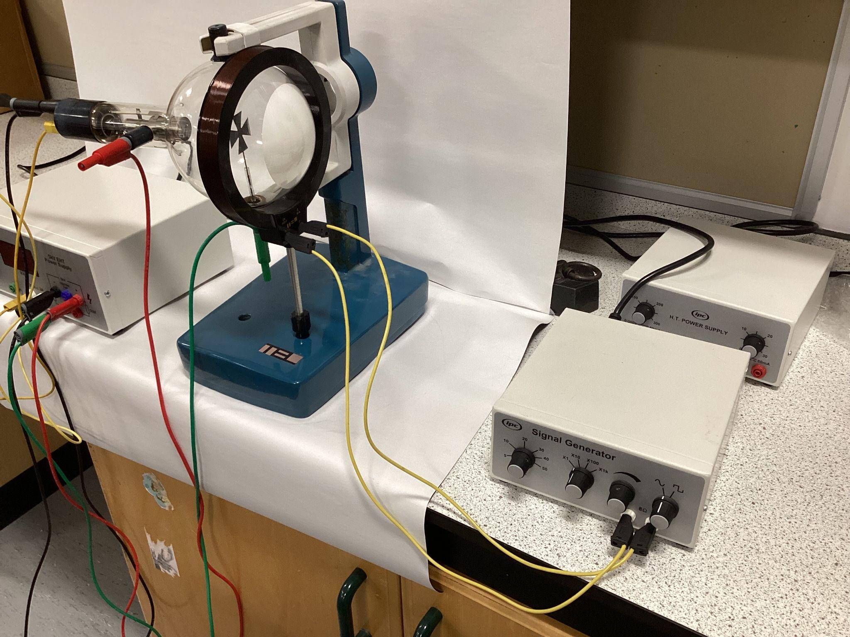

Allow the tube to cool before dismantling.

Deflection Tube

2.1 Setting Up
To set up the Deflection Tube, you will need:
- EHT supply.
- HT supply.
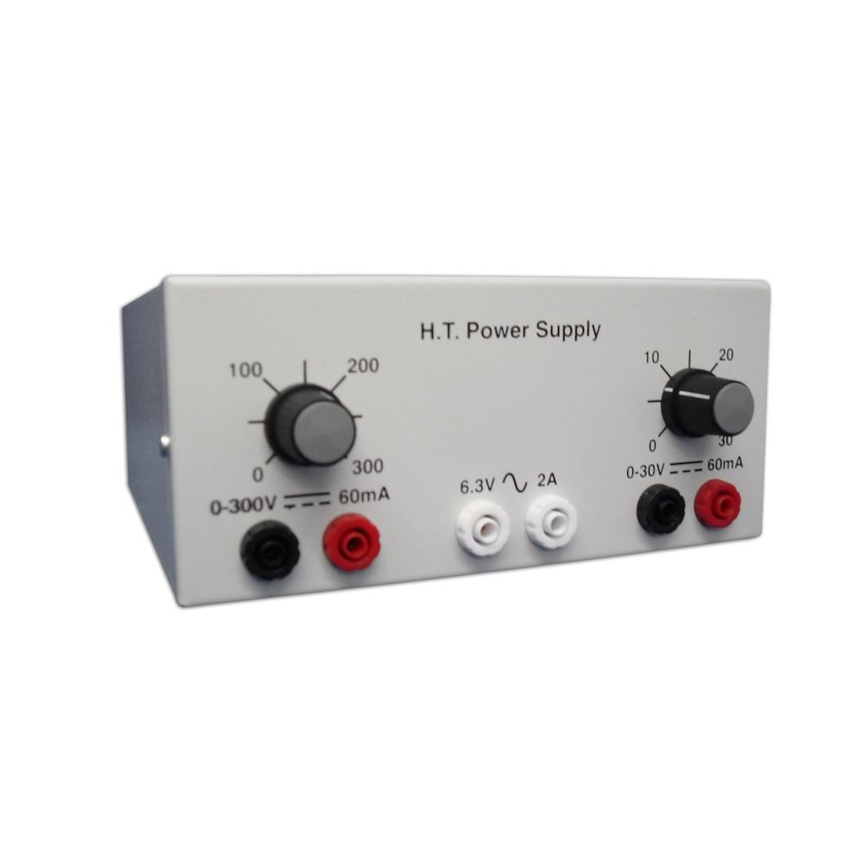
- Deflection Tube with holder
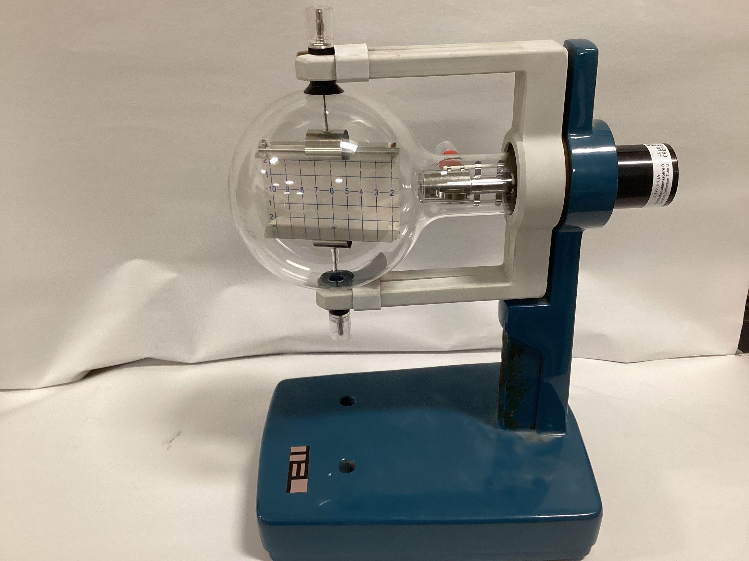
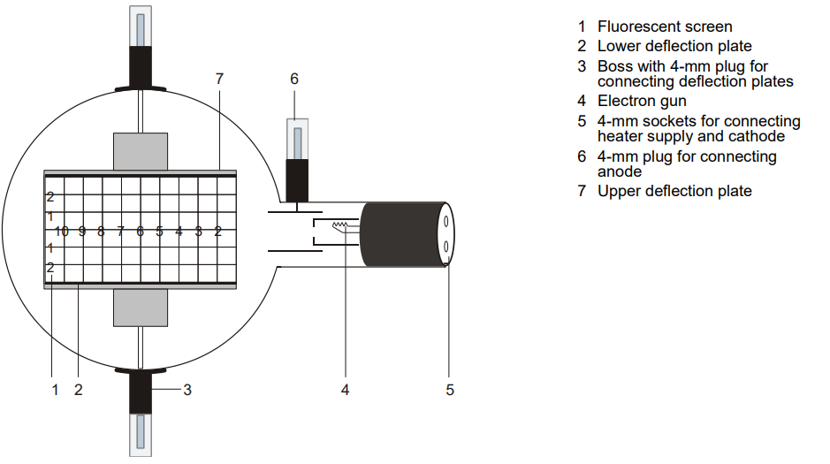
- Push the jaw clamp sliders on the stanchion of the tube holder right back so that the jaws open.
- Push the bosses of the tube into the jaws.
- Push the jaw clamps forward on the stanchions to secure the tube within the jaws.
- Only connect circuits with power supply equipment switched off.
- First connect the 6.3V a.c. Low Power Supply to the back of the tube (yellow wires).
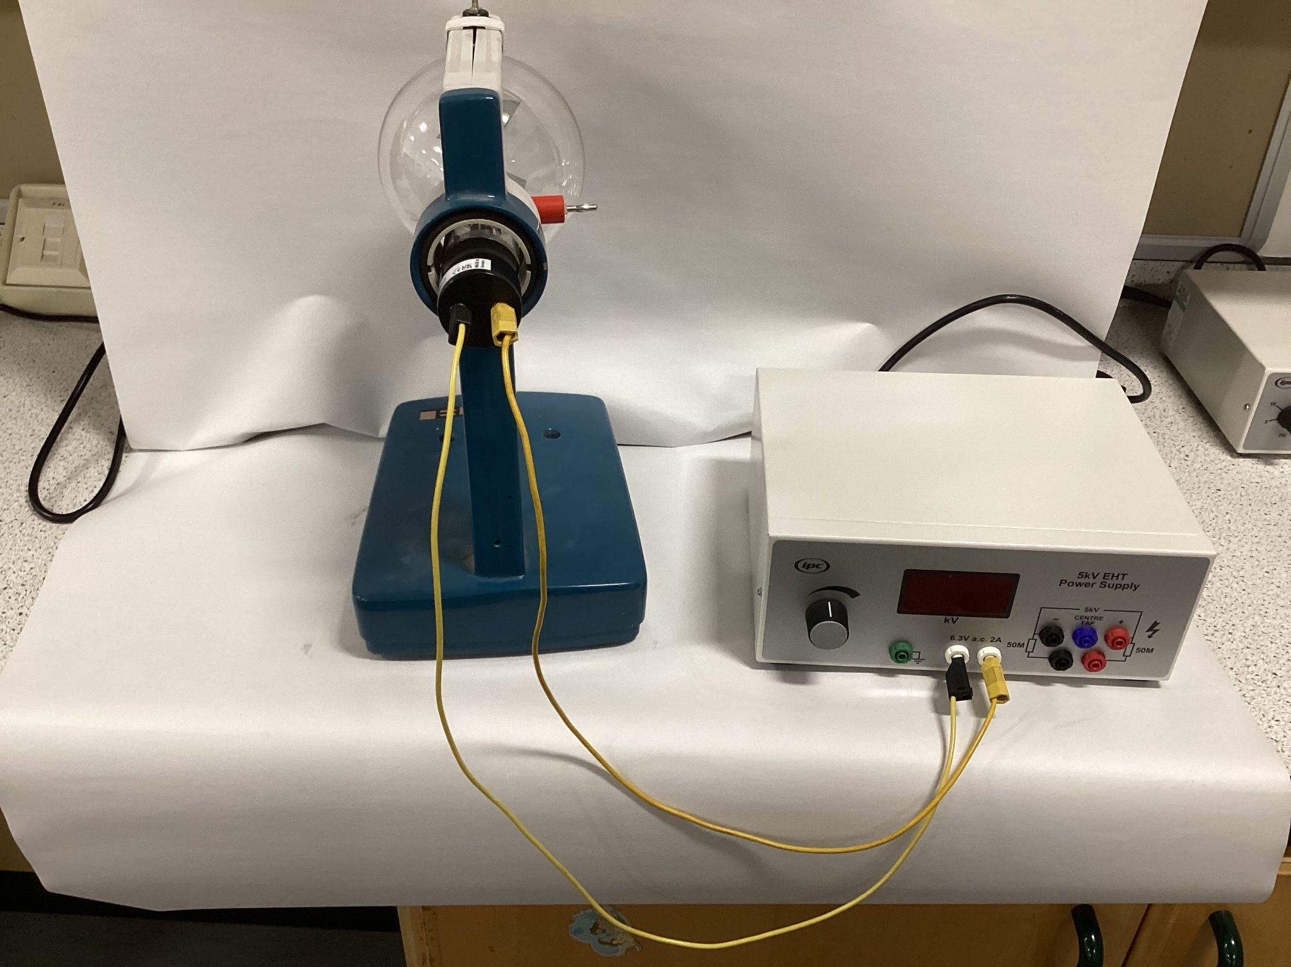
- Connect the negative end of the EHT supply to the cathode at the back of the Teltron Tube (labelled with negative sign) using a shrouded wire with a connector (black wire).
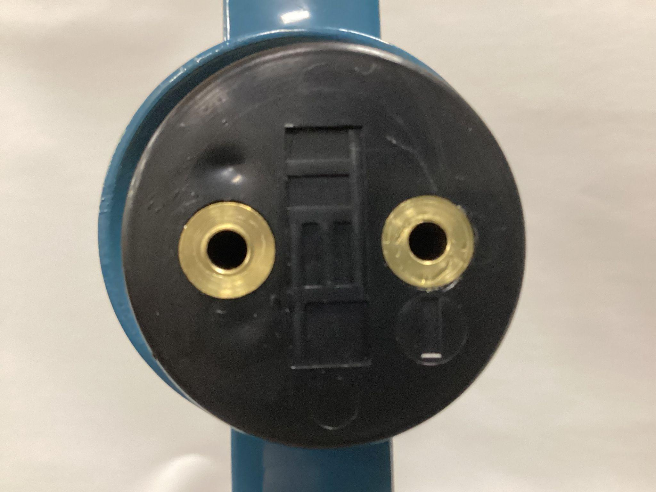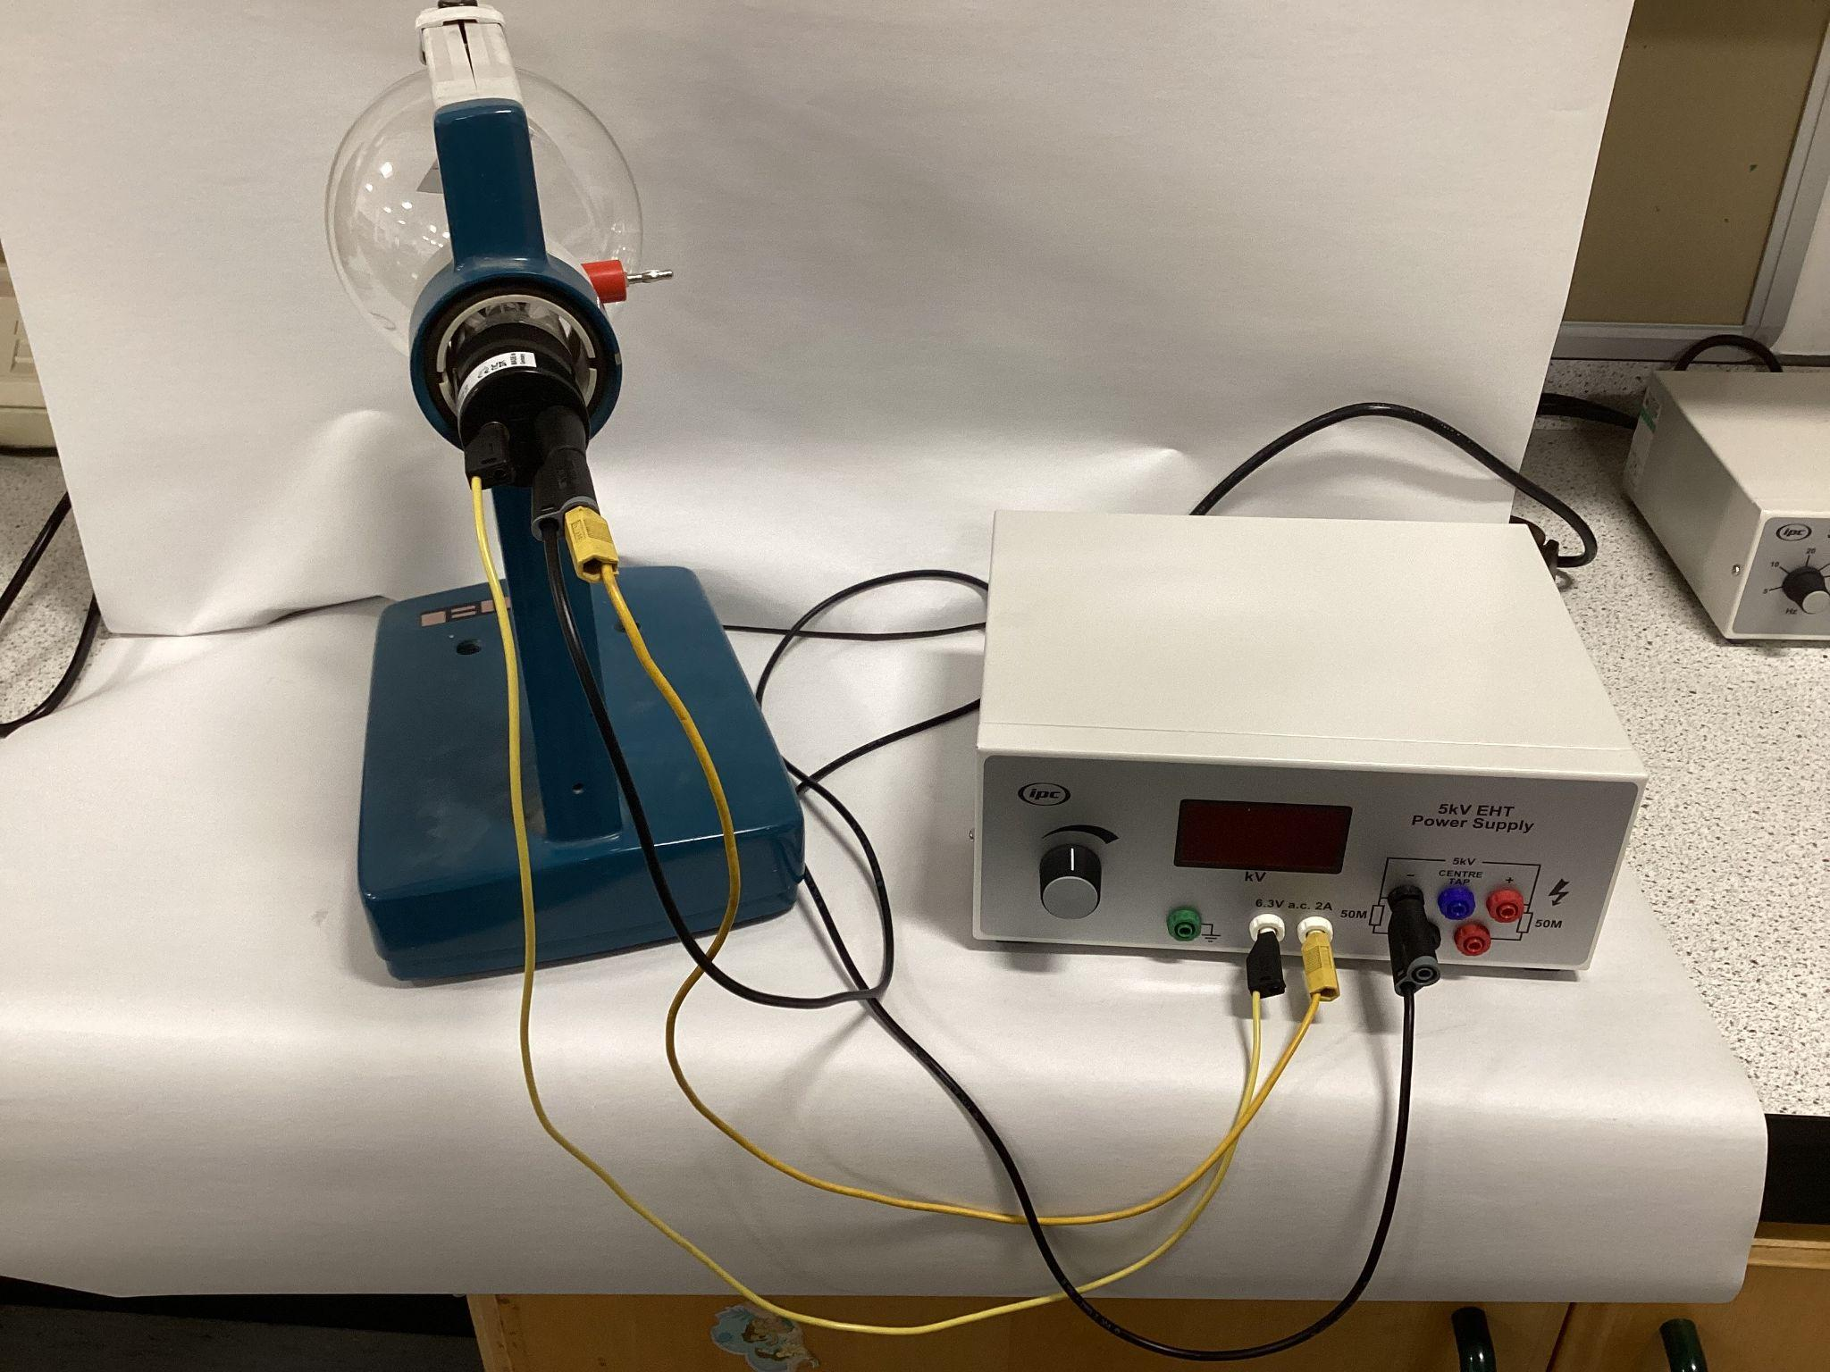
- Connect the Earth terminal 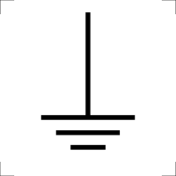of the EHT supply to the anode with a shrouded wire (red wire).
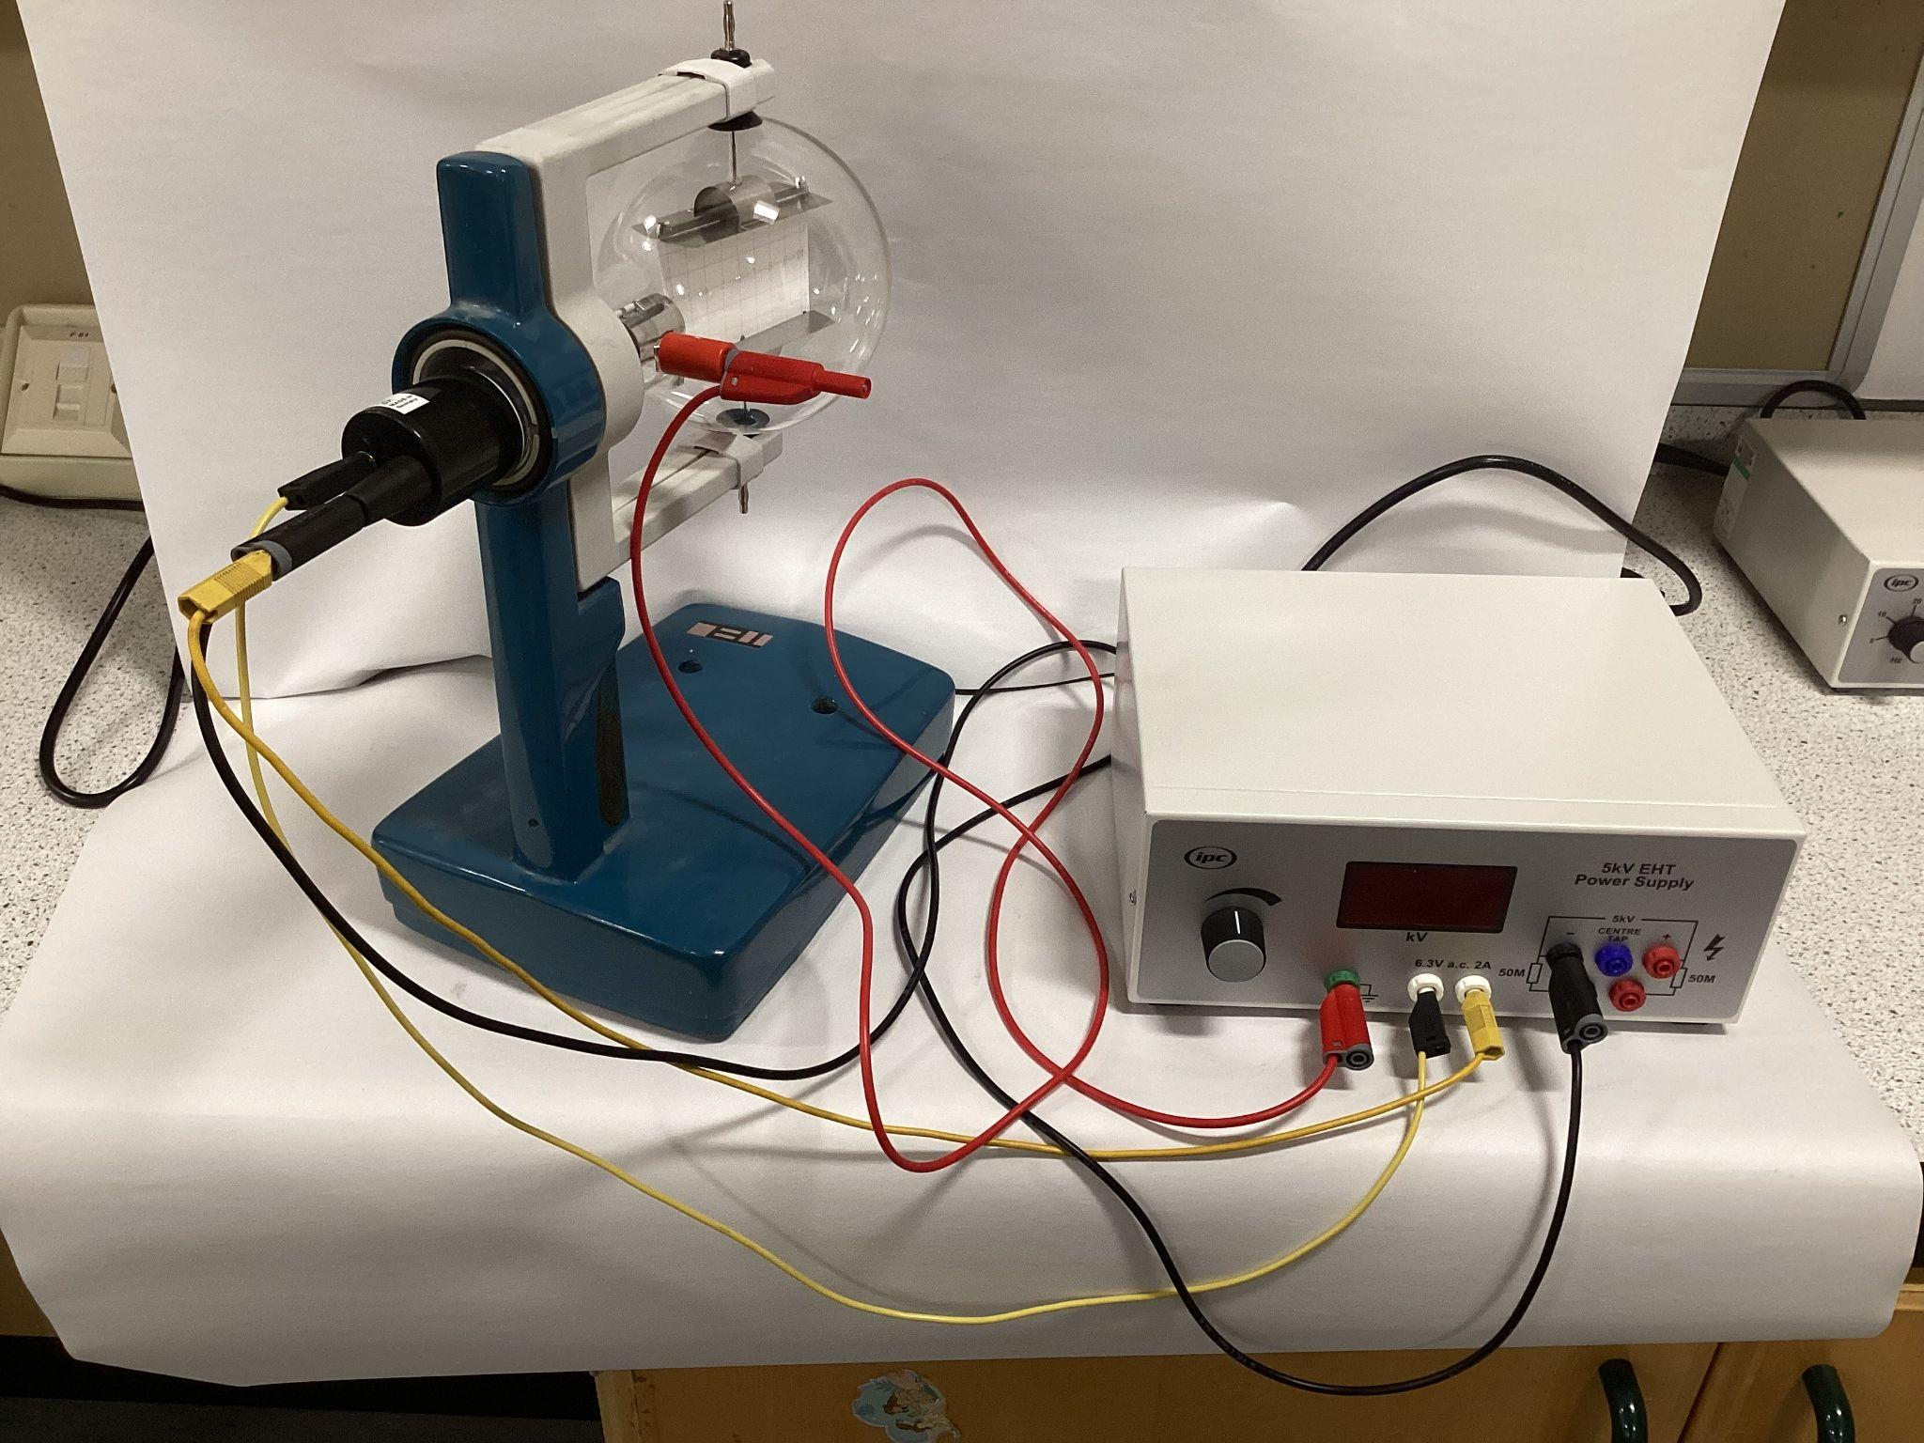

2.2 Speed of electron
The speed of the electrons can be calculated using the law of conservation of energy.
The work done can be calculated using:
$$W=QV$$
With $W$, work done by electron gun on electrons in Joules, J.
$Q$, charge of an electron, $1.6×{10}^{-19}C$
$V$, potential difference across EHT supply in Volts, V.

The kinetic energy can be calculated using:
$$E_{k}=\frac{1}{2}mv^{2}$$
With $E_{k}$, kinetic energy in Joules, J.
$m$, mass of an electron, $9.11×{10}^{-31}kg$
$v$, speed of an electron in metres per secon, $ms^{-1}$

For example is the voltage across electron gun is $3 kV$, using the law of conservation of energy:
$$W=E_{k}$$
$$QV=\frac{1}{2}mv^{2}$$
$$1.6×{10}^{-19}×3,000=\frac{1}{2}×9.11×{10}^{-31}×v^{2}$$
$$v=\sqrt{\frac{1.6×{10}^{-19}×3,000}{\frac{1}{2}×9.11×{10}^{-31}}}$$
$$v=3.25×{10}^{7}ms^{-1}$$

2.3 Experiment 1: Electric Deflection
- Connect the positive terminal from the high voltage from the HT supply to the top plate of the tube (green wire).
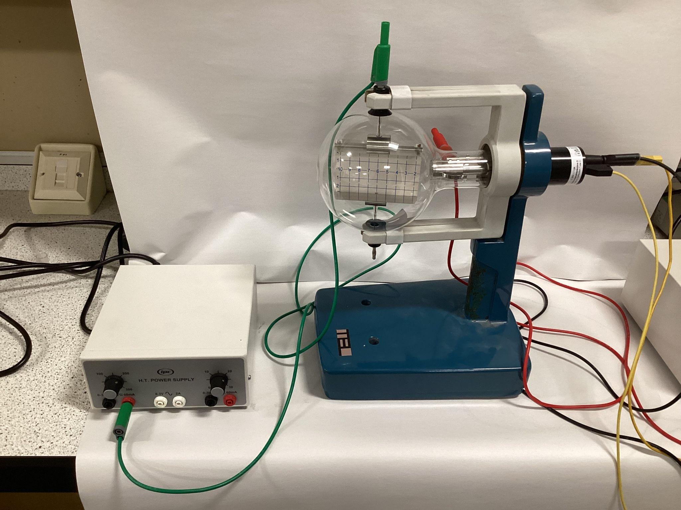
- Connect the negative terminal from the high voltage from the HT supply to the top plate of the tube (green wire).
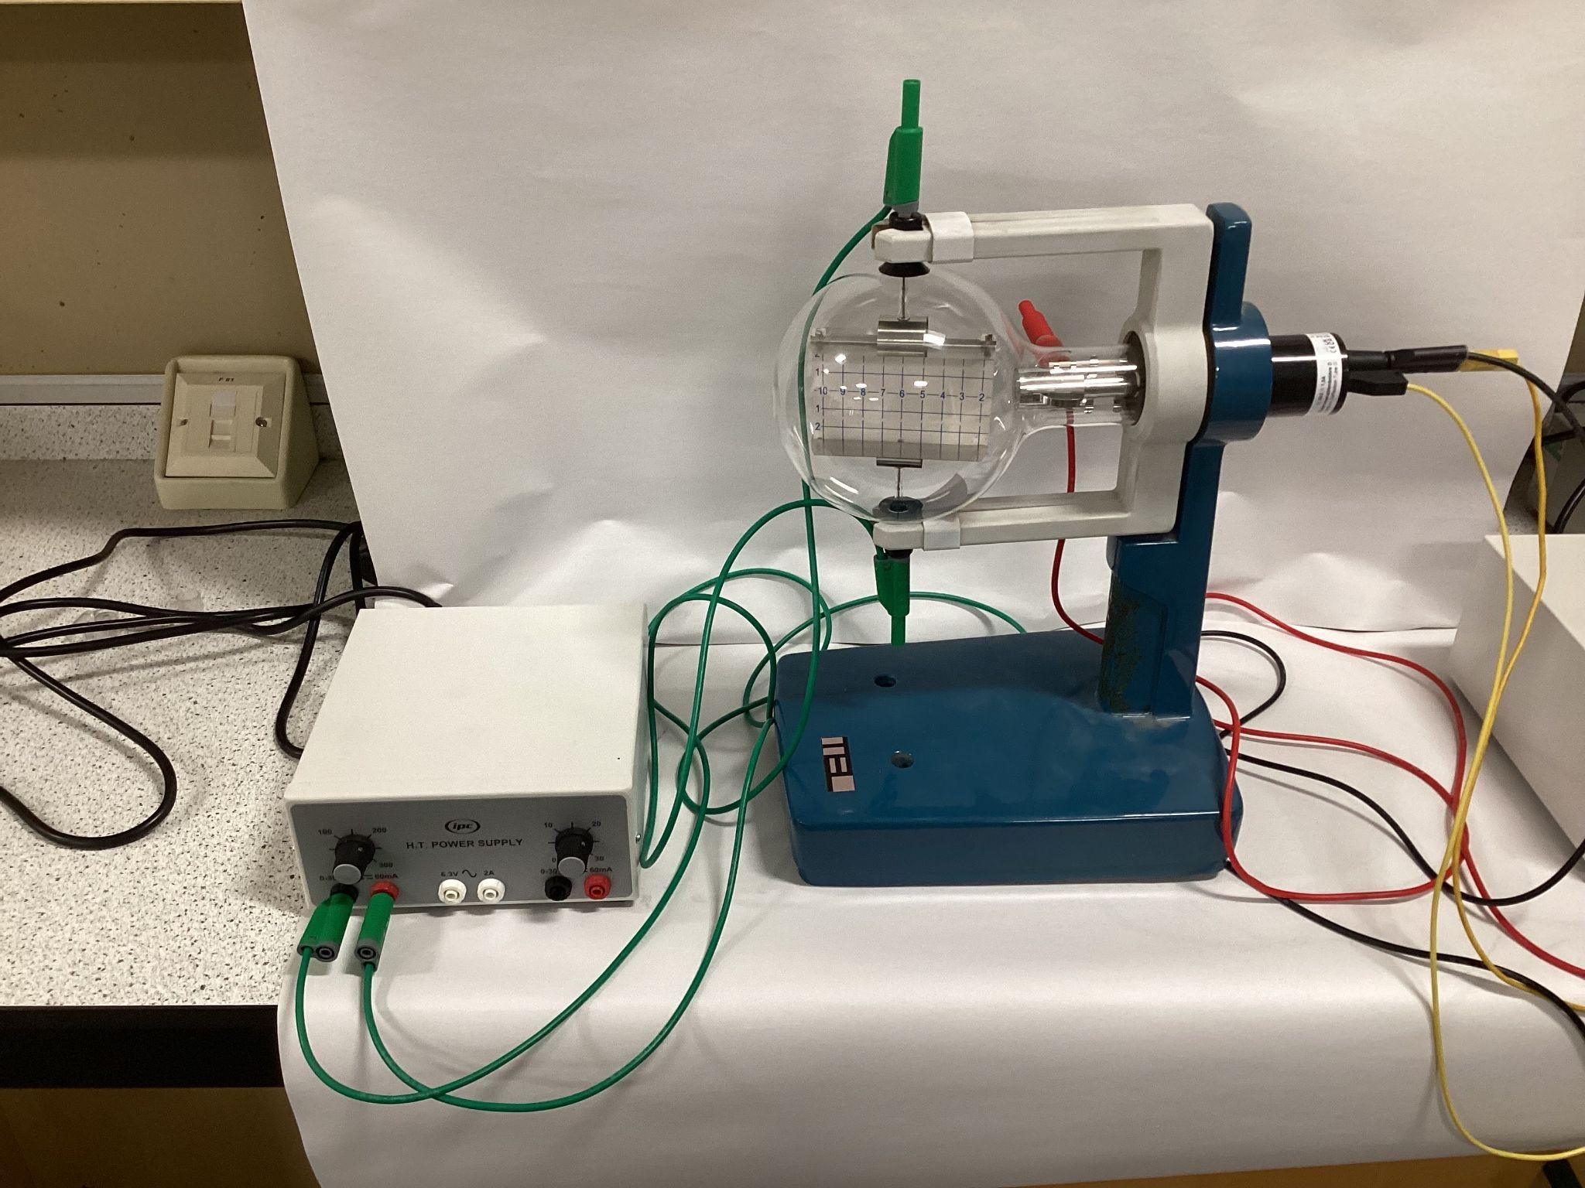
- Switch ON the EHT supply. A voltage will be applied to the heater filament.
- Increase the high voltage of the EHT supply until a horizontal blue line can be seen across the fluorescent screen.
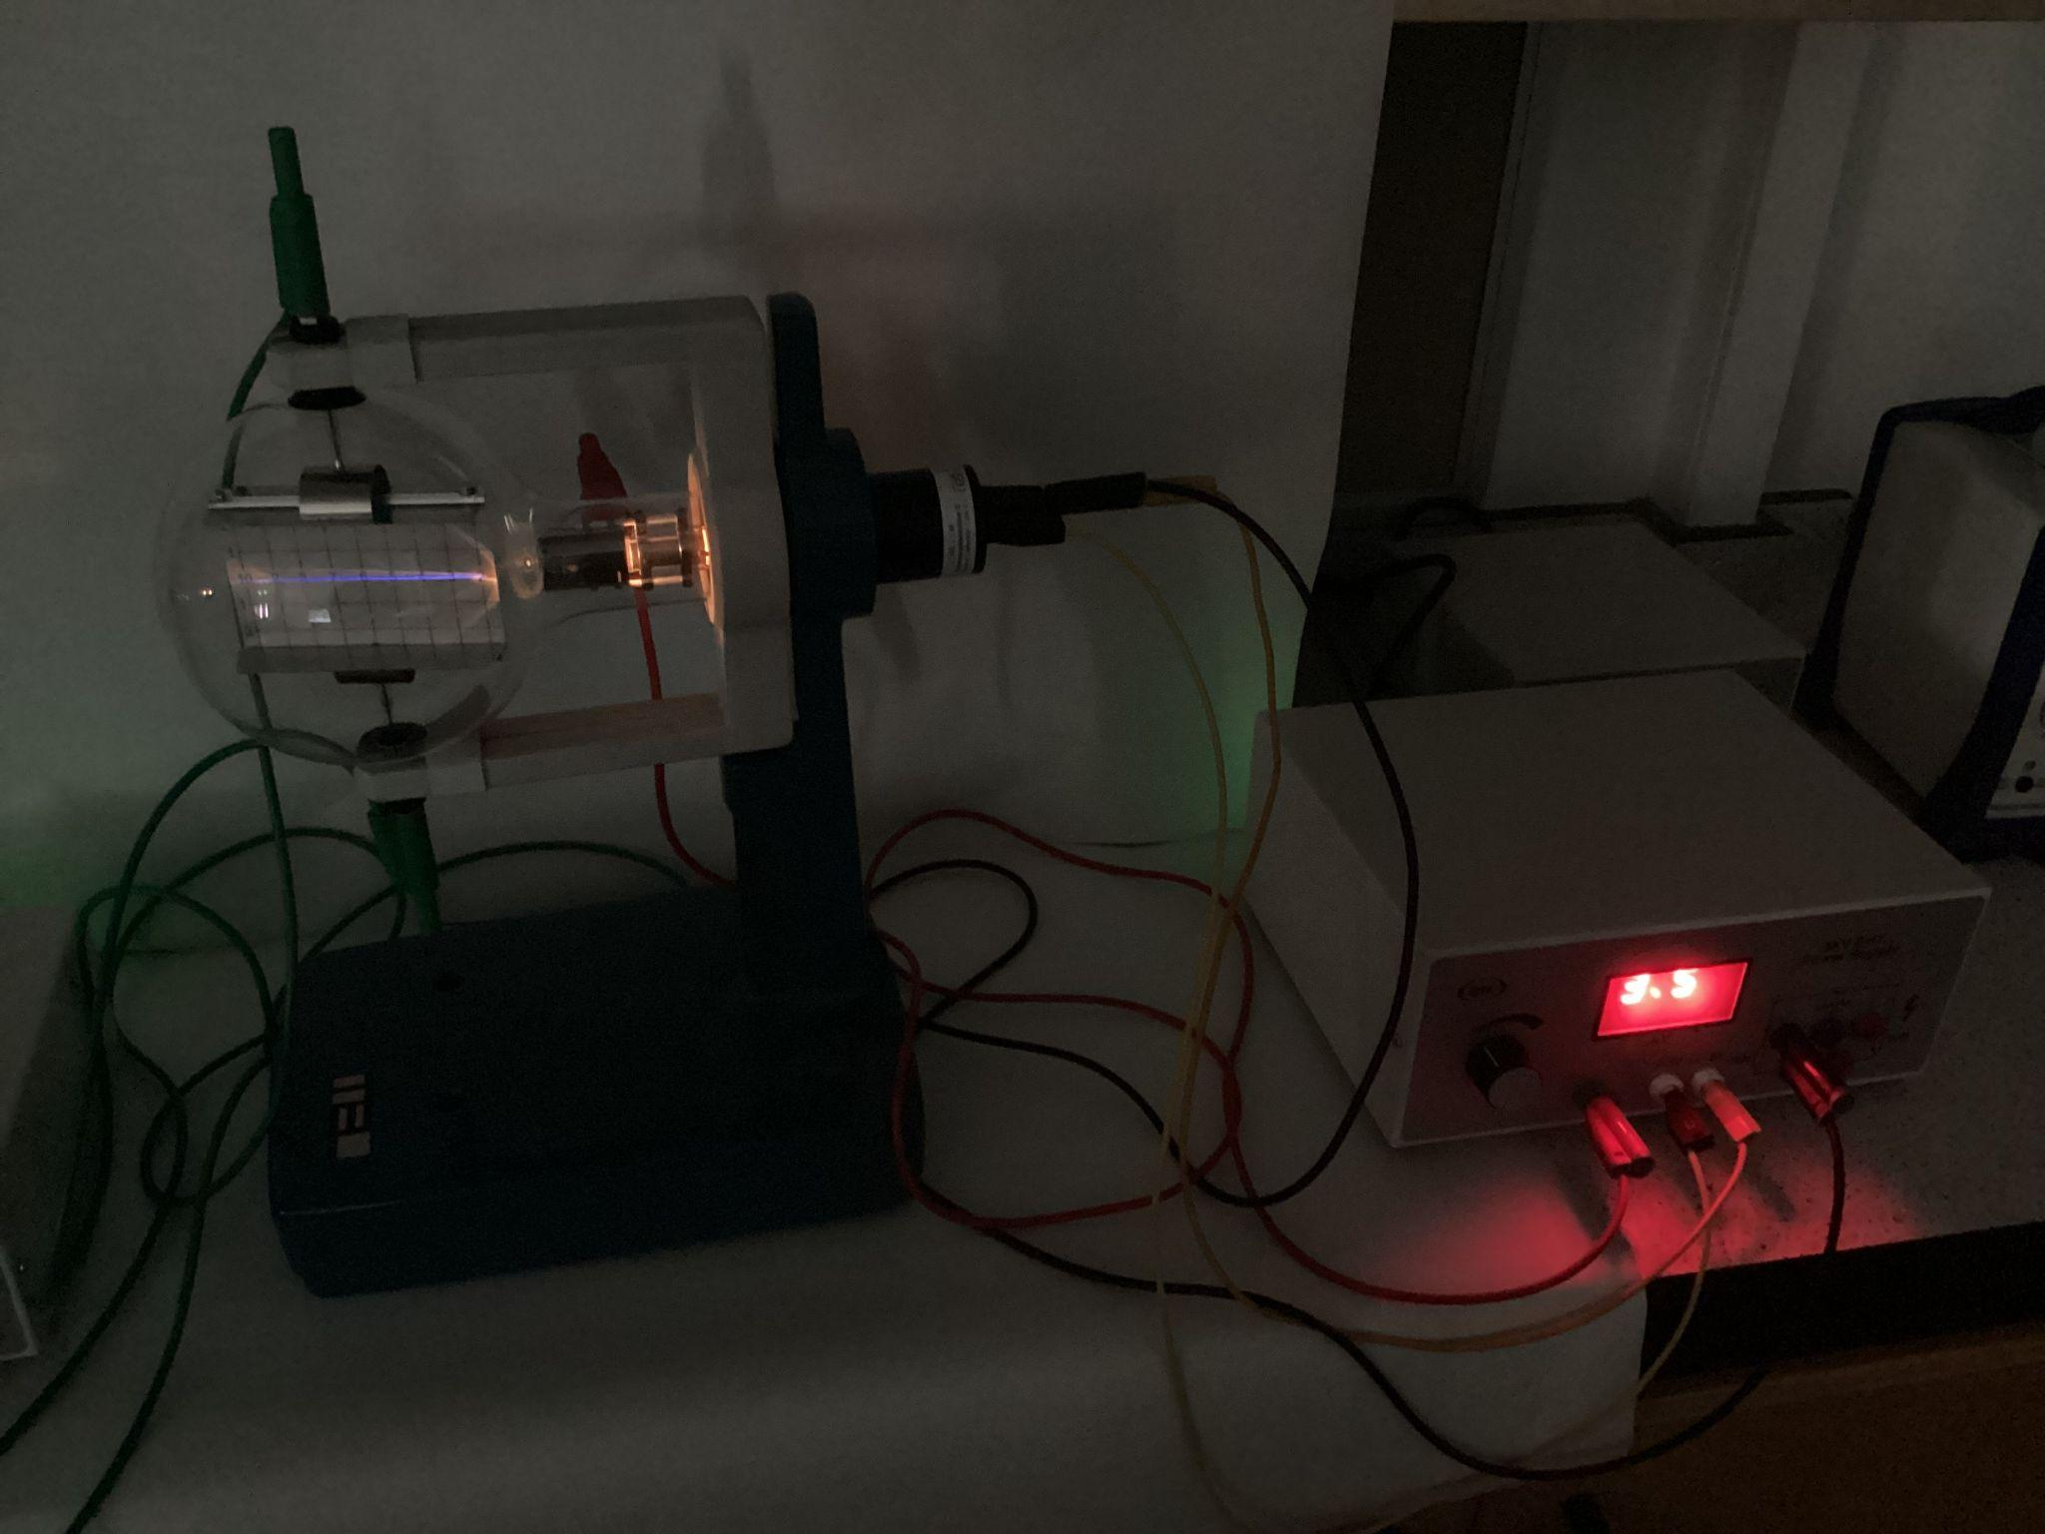
- Increase the high voltage of the HT supply across the deflection plates and observe the path of beam on fluorescent screen.
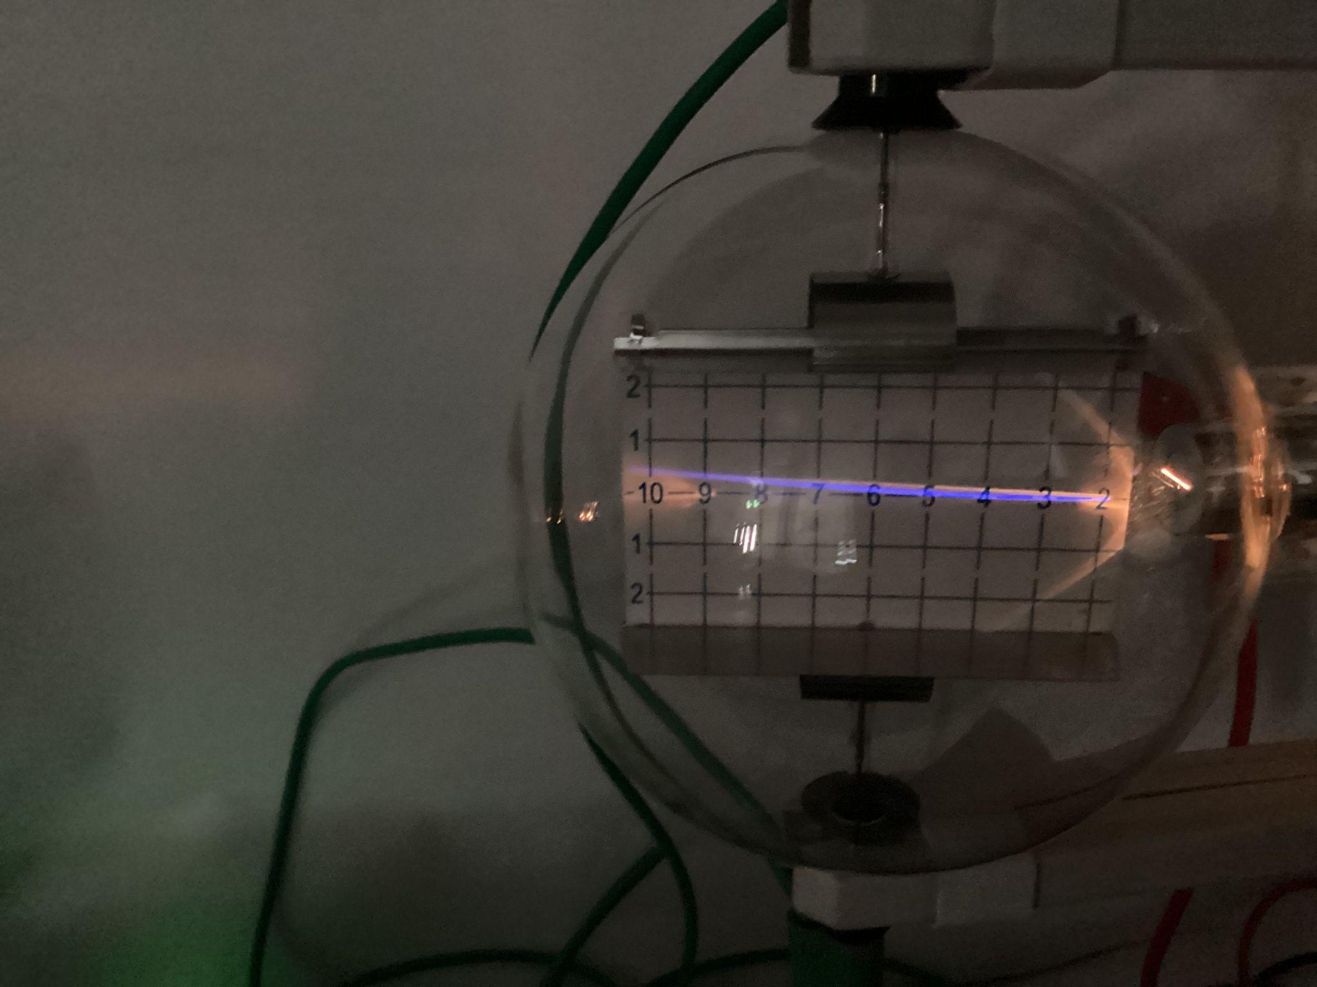
- Swap the connections on the HT supply.
- Increase the high voltage of the HT supply across the deflection plates and observe the path of beam on fluorescent screen.
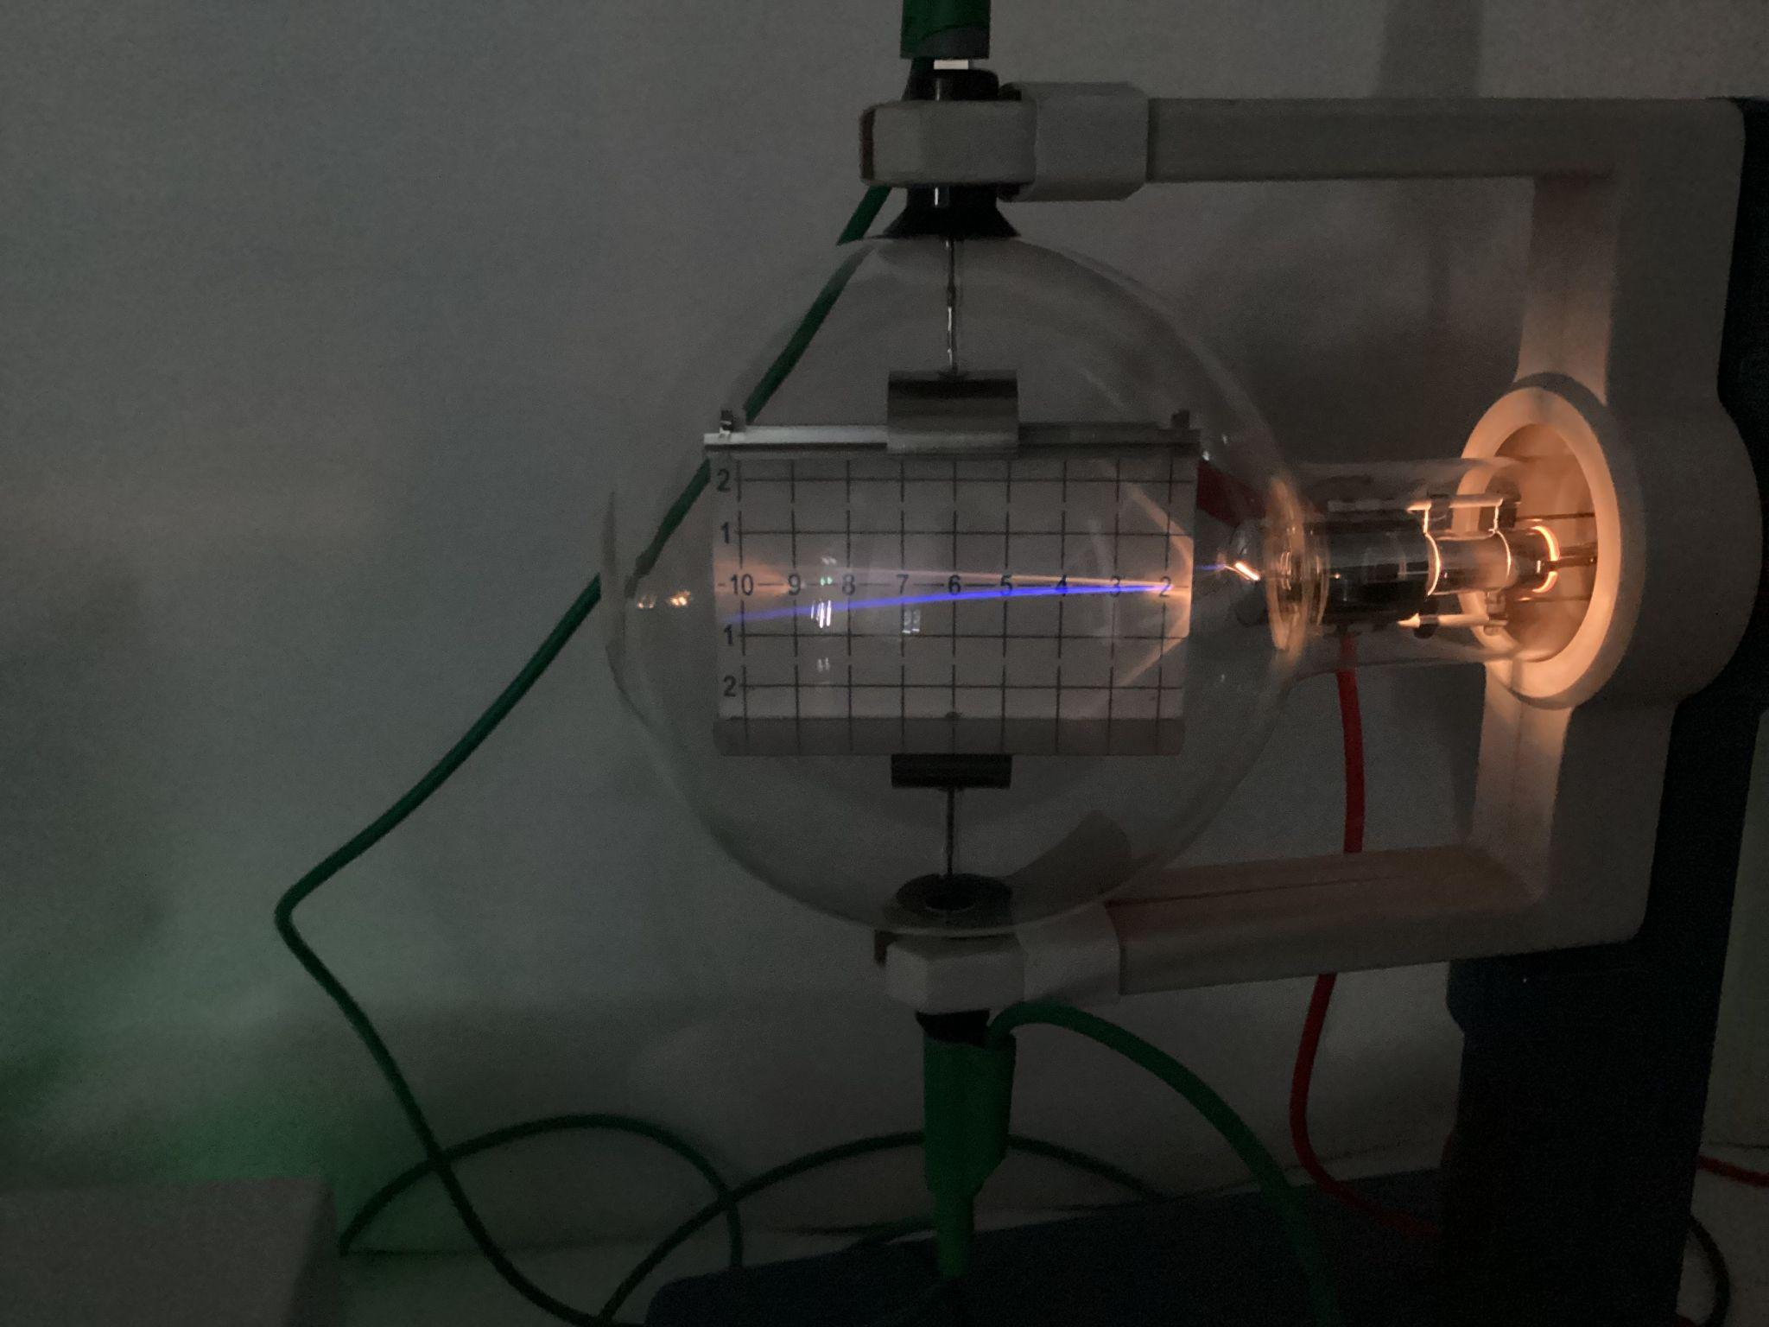

- The voltage across the deflection plate can also be supplied by using the EHT. In this case the high voltage supply from the EHT is used to both supply voltage to the anode and to the deflection plate.

2.4 Calculating vertical deflection
The vertical deflection of the beam can be predicted using equations of motion. Horizontally, the electron beam is traveling at constant speed between the deflection plates. Previously for an electron gun supply voltage of 3kV, the calculated horizontal velocity is $v=3.25×{10}^{7}ms^{-1}$.
Using a horizontal distance of 10 cm, across the plates and using equation of motion, horizontally, the time of travel between deflection plates is:
$$d=vt$$
$$0.1=3.25×{10}^{7}×t$$
$$t=\frac{0.1}{3.25×{10}^{7}}$$
$$t=3.1×{10}^{-9} s$$

Vertically, there is an acceleration due to the electric field across the deflection plates. Using $F=ma$, we can calculate the vertical acceleration of the electron beam:
$a=\frac{F}{m}$ with $F=QE$ and $V=Ed$
$$a=\frac{QV}{md}$$
If voltage across deflection plate is 300V and the distance between deflection plate is 54mm:
$$a=\frac{1.60×{10}^{-19}×300}{9.11×{10}^{-31}×54×{10}^{-3}}$$
$$a=9.75×{10}^{14}ms^{-2}$$
Using equation of motion, the vertical deflection can be calculated:
$$s=\frac{1}{2}at^{2}$$
$$s=\frac{1}{2}×9.75×{10}^{14}×{\left(3.1×{10}^{-9}\right)}^{2}$$
$$s=4.7×{10}^{-3}m$$

2.5 Calculating mass to charge ratio by electric deflection
Also the charge to mass ratio can be calculated using the equations of motion.
The vertical deflection is given by:
$y=\frac{1}{2}at^{2}$ with $y=$ vertical deflection
$a=$ vertical acceleration between deflection plates
$t=$ time between deflection plates
Substituting $a=\frac{F}{m}$ :
$y=\frac{1}{2}\frac{F}{m}t^{2}$ with $F=$ electrostatic force between plates
$m=$ mass of electron, $9.11×{10}^{-31}kg$
Substituting $F=QE$
$y=\frac{1}{2}\frac{QE}{m}t^{2}$ with $Q=$ charge of an electron, $1.60×{10}^{-19}C$
$E=$ electric field strength between deflection plates
Substituting $t=\frac{x}{v}$
$y=\frac{1}{2}\frac{QE}{m}t^{2}$ with $x=$ horizontal displacement between deflection plates
$v=$ horizontal velocity between plates (for an anode voltage of 3kV, $v=3.25×{10}^{7}ms^{-1}$, see calculation 2.2)
Substituting $E=\frac{V}{d}$
$y=\frac{1}{2}\frac{QVx^{2}}{dmv^{2}}$ with $V=$ deflection plates potential difference
$d=$ separation between plates, $54×{10}^{-3}m$
The charge to mass ratio is given by:
$$\frac{Q}{m}=\frac{2ydv^{2}}{Vx^{2}}$$
With $x=4.7×{10}^{-3}m$ and $V=300 V$:
$\frac{Q}{m}=\frac{2×4.7×{10}^{-3}×54×{10}^{-3}×{(3.25×{10}^{7})}^{2}}{300×{0.1}^{2}}$
$\frac{Q}{m}=1.76×{10}^{11}C{kg}^{-1}$

2.6 Experiment 2: Magnetic Deflection
- Set up the deflection tube as in 2.1.
- Insert the Helmholtz coils on either side of the tube.
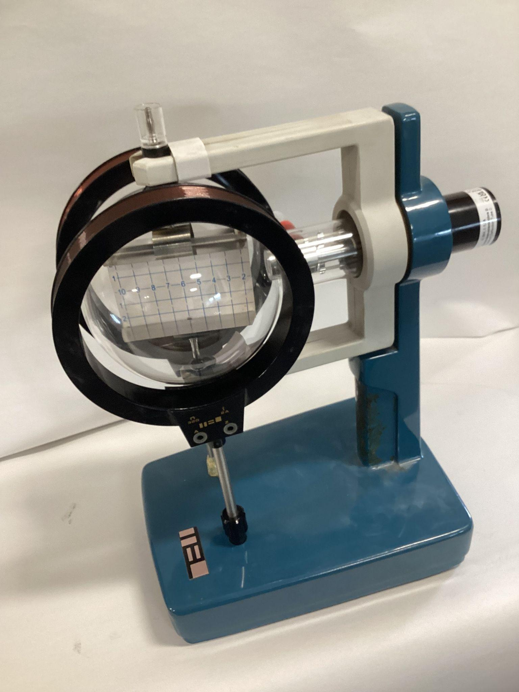
- Link connections Z from each coil with a single wire (yellow wire).
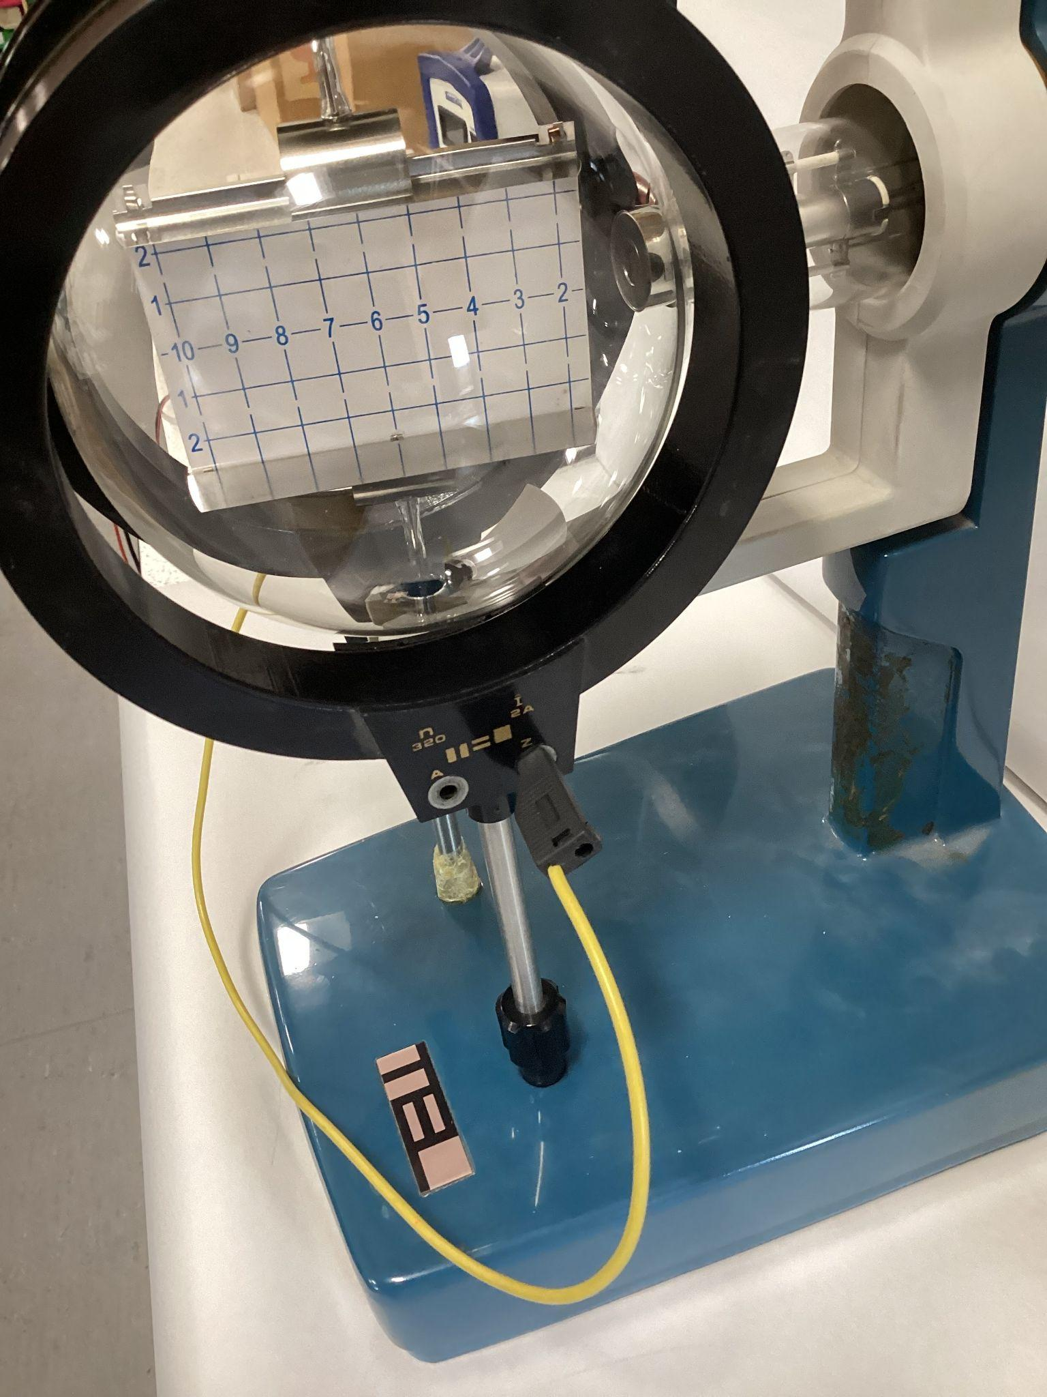
- Connect connections A from each coil to a low power d.c. supply (red and black wires)
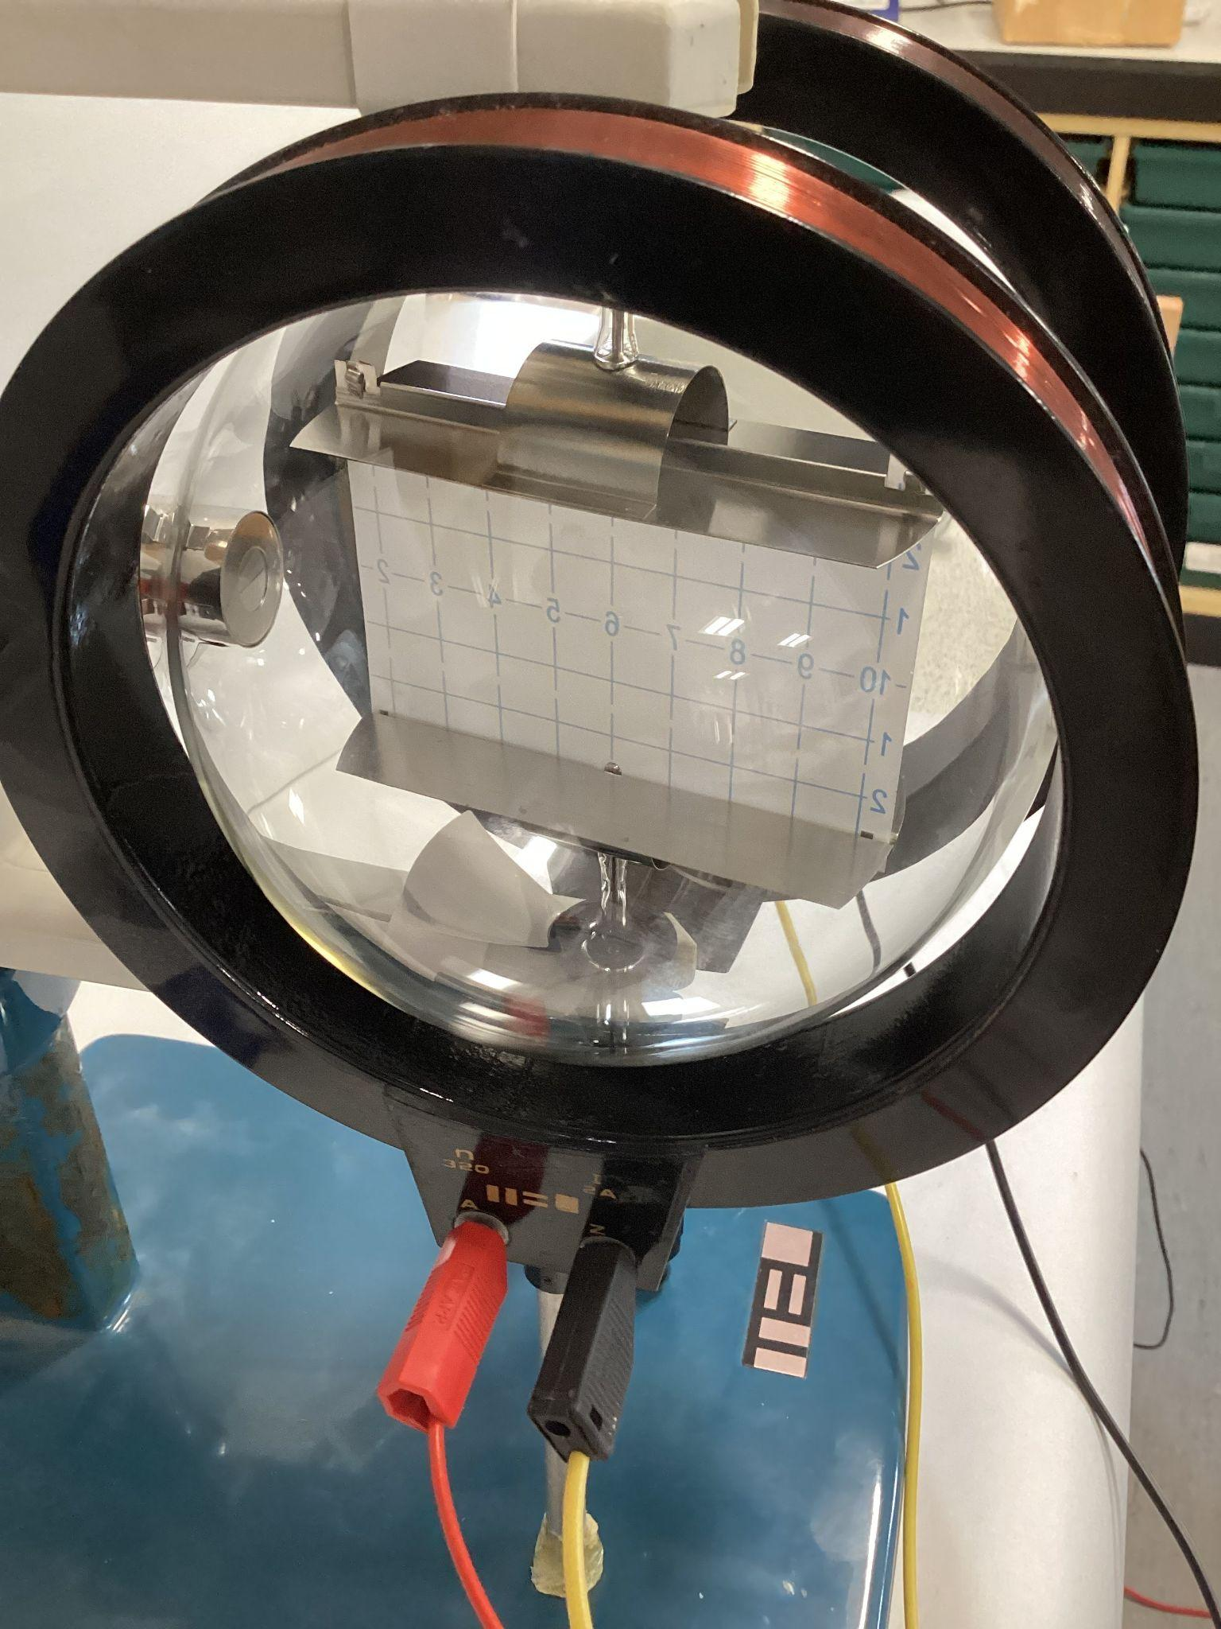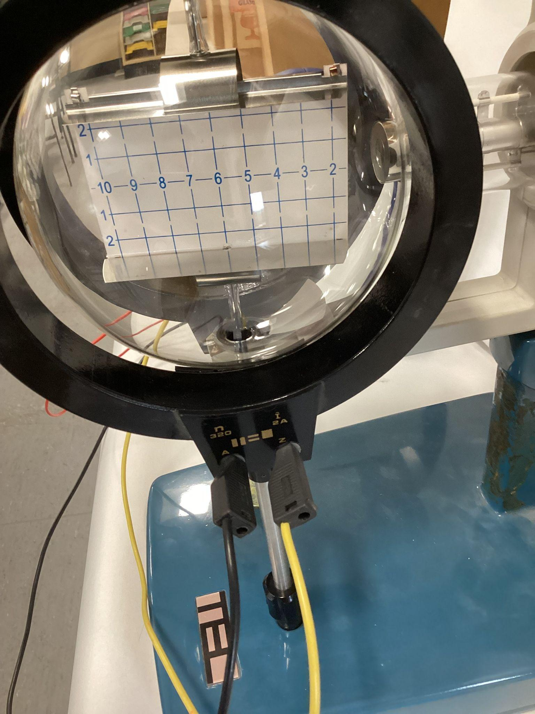
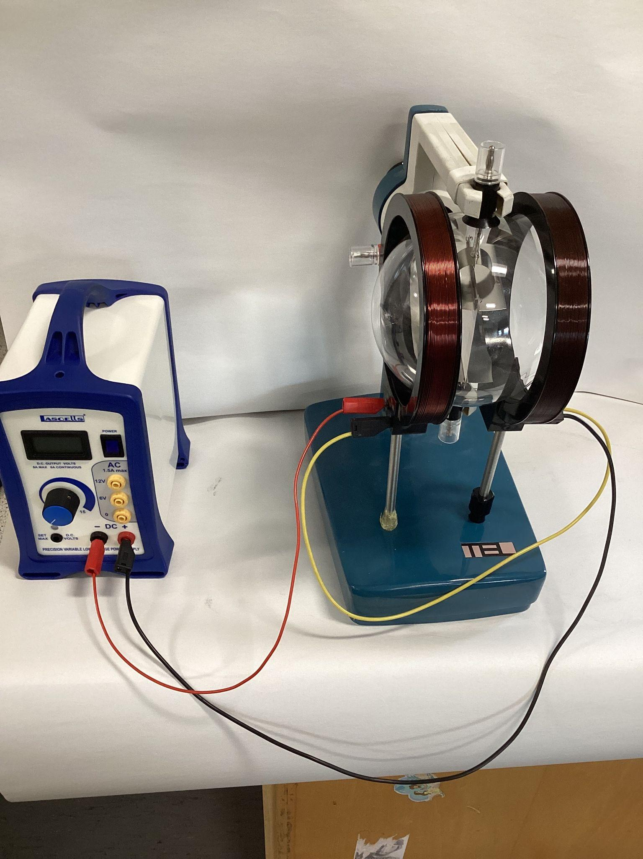
- Switch ON the EHT supply. A voltage will be applied to the heater filament.
- Increase the high voltage of the EHT supply until a horizontal blue line can be seen across the fluorescent screen.
- Energise the Helmholtz coils and observe the path of the beam.
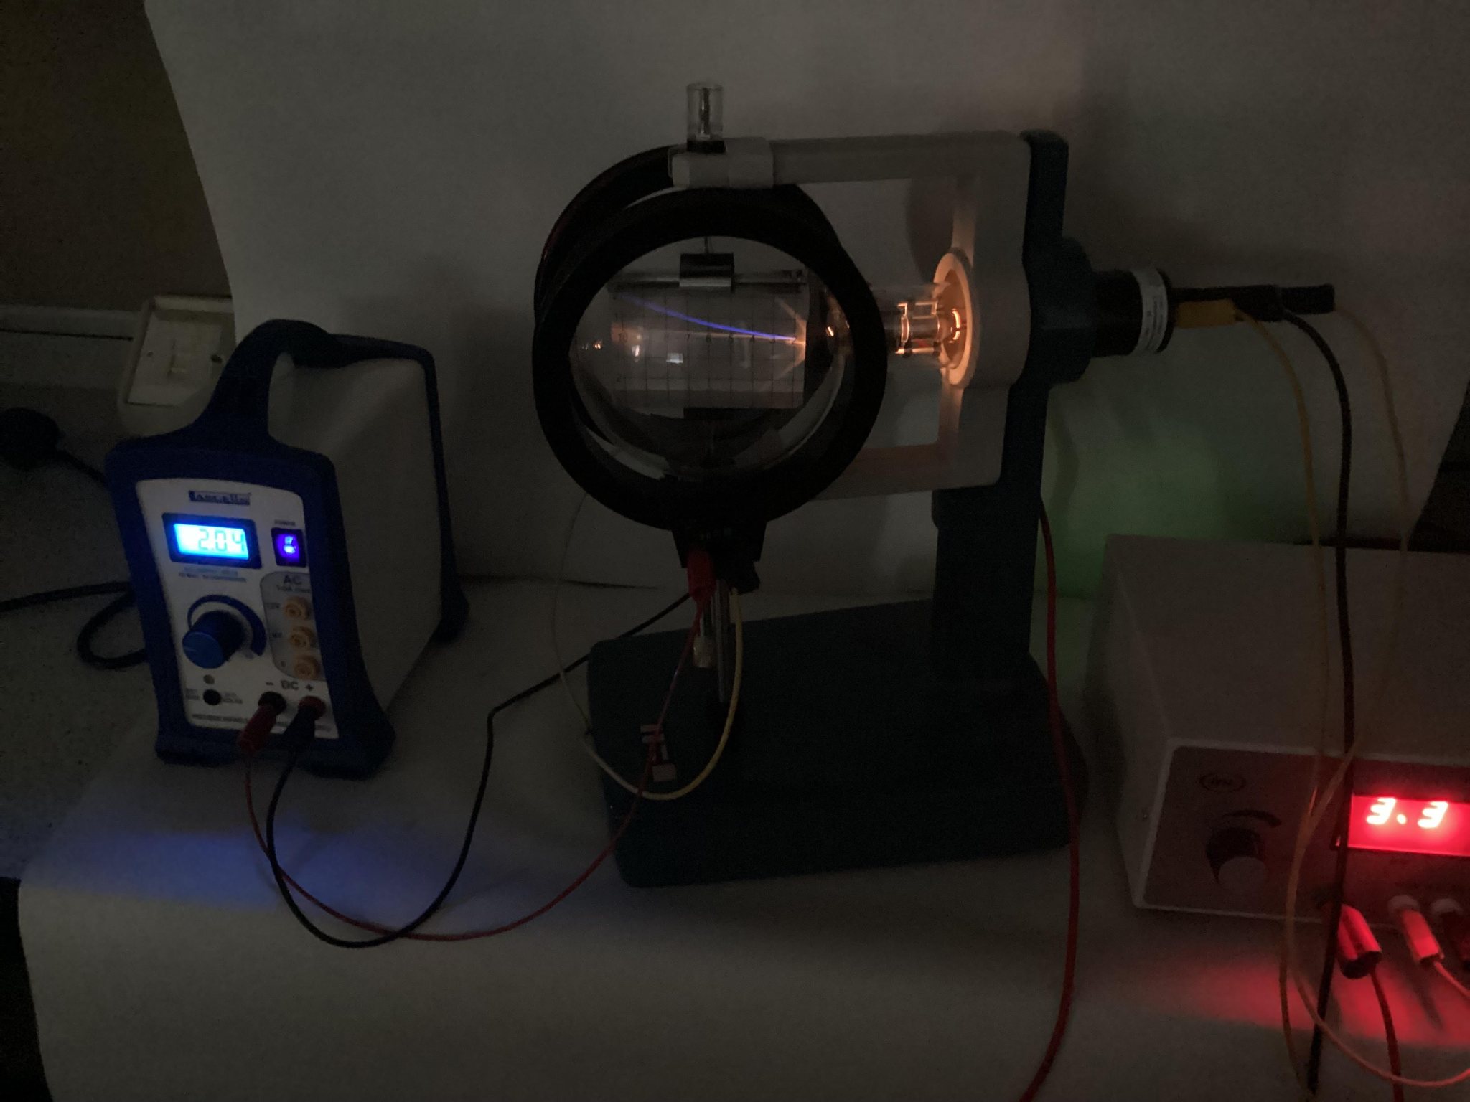
The path of the luminous beam is circular, the deflection being in a plane perpendicular to the electromagnetic field. At fixed anode voltage the radius decreases with increasing coil current. With a fixed coil current the radius increases with increasing anode potential, indicating a higher velocity.

2.7 Calculating mass to charge ratio by magnetic deflection
An electron with velocity v passing through the electric field E produced by a plate capacitor held at a voltage UP with a plate spacing d is deflected into the curved path of a parabola governed by the equation:
$F_{B}=F_{c}$ with $F_{B}=qvB$, magnetic force, with $q=1.6×{10}^{-19}C$, charge of an electron, $v=3.25×{10}^{7}ms^{-1}$, speed of electrons as they enter the magnetic field (as calculated in 2.2 for an anode voltage of $3kV$, and B, magnetic field from Helmholtz coils.
$F_{c}=\frac{mv^{2}}{r}$, centripetal force, with $m=9.11×{10}^{-31}kg$, mass of an electron and $r$, radius of curvature.

Substituting forces:
$qvB=\frac{mv^{2}}{r}$
$\frac{q}{m}=\frac{v}{Br}$

The radius of curvature r is obtained geometrically:
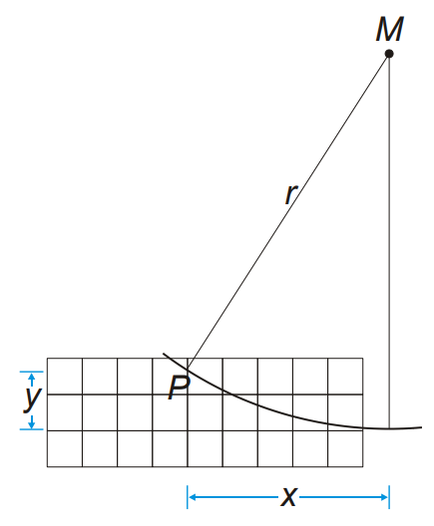
$$r^{2}=x^{2}+{\left(r-y\right)}^{2}$$
$$r=\frac{x^{2}+y^{2}}{2×y}$$
The magnetic flux B of a magnetic field generated by the Helmholtz coils in Helmholtz geometry and the coil current I can be calculated:
$B={\left(\frac{4}{5}\right)}^{\frac{3}{2}}×\frac{μ_{0}×n}{R}×I$ with $n=320$ (number of turns in coils)
$R=68 mm$ (coil radius)
$I=$ coil current
$B=k×I$ with $k=4.2mTA^{-1}$

For example with an anode voltage of 3kV: $x=0.05m$
$$y=0.01m$$
$$I=0.29A$$

$r=\frac{{0.05}^{2}+{0.01}^{2}}{2×0.01}=0.13m$
$B=4.2×{10}^{-3}×0.29=1.2×{10}^{-3}T$

$\frac{q}{m}=\frac{3.25×{10}^{7}}{1.2×{10}^{-3}×0.13}=2.1×{10}^{11}C{kg}^{-1}$

2.8 Calculating mass to charge ratio by field compensation
- Set up deflection tube as in 2.1, 2.3 and 2.6.

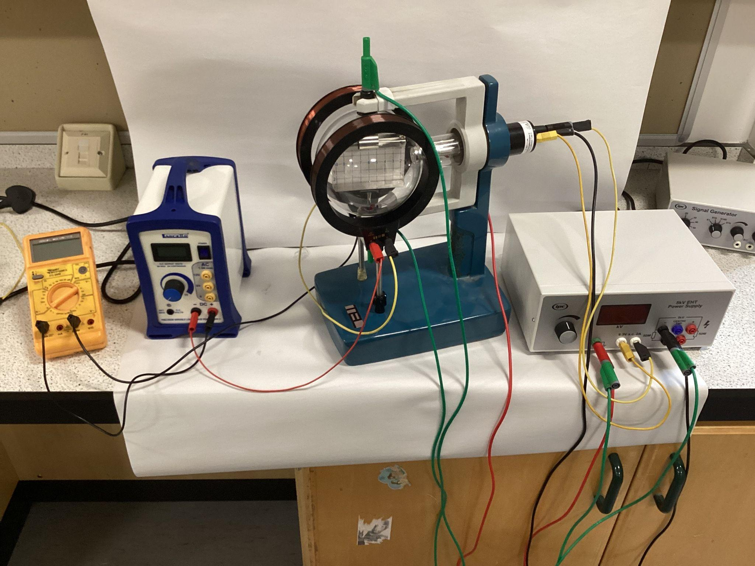
- Turn on the high-tension power supply units and deflect the beam electrically.
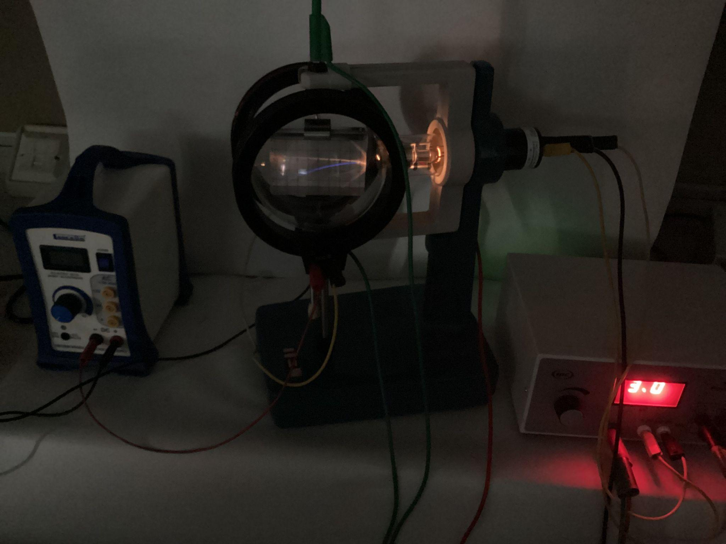
- Energise the Helmholtz coils and adjust the voltage in such a way that the magnetic field compensates the electric field and the beam is no longer deflected.
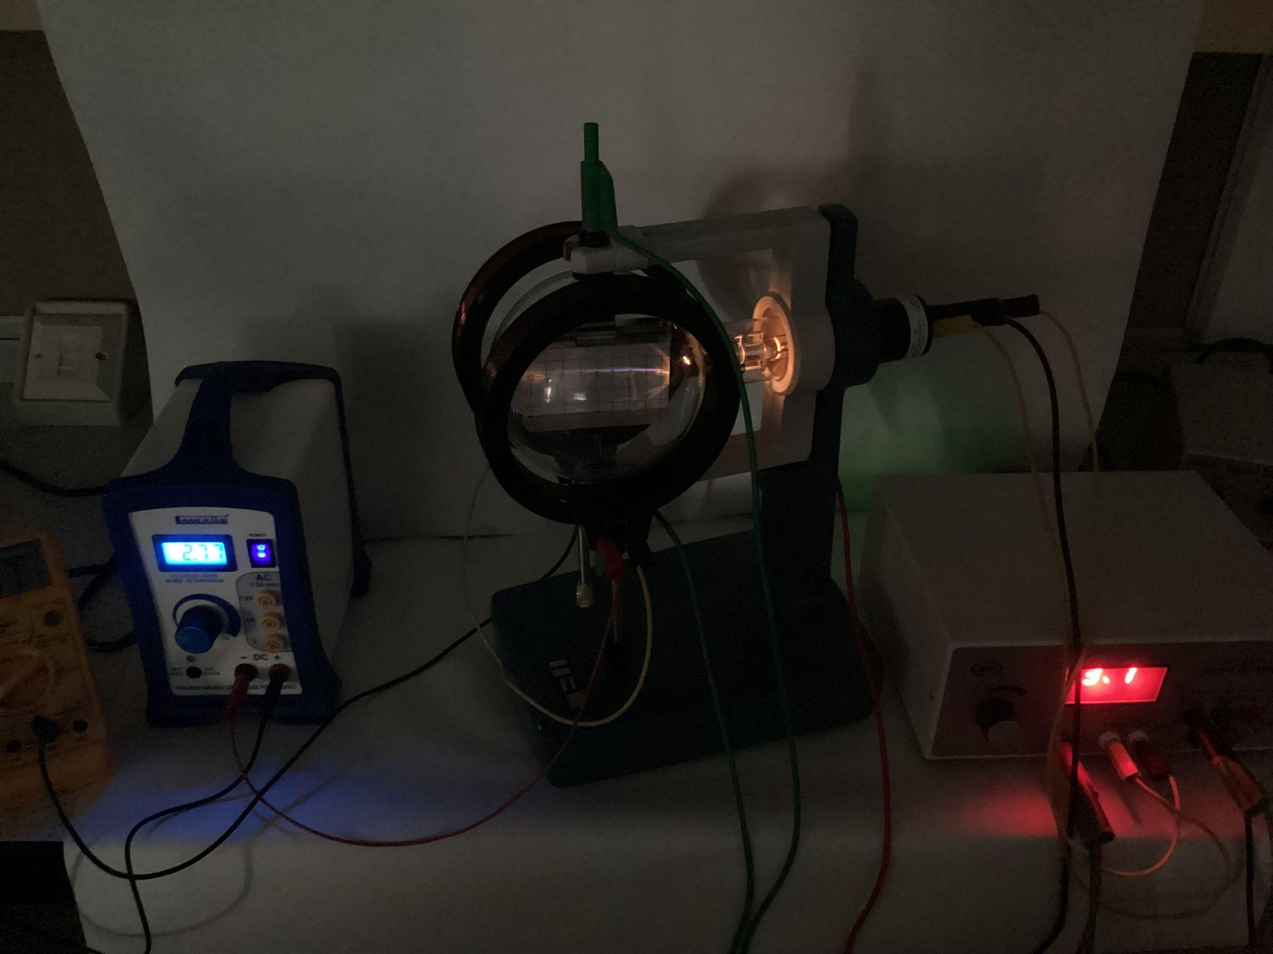
- The magnetic field compensates the deflection of the electron beam caused by the electric field:
$F_{m}=F_{e}$ with $F_{m}=qvB$, magnetic force, with $q=1.6×{10}^{-19}C$, charge of an electron, $v=3.25×{10}^{7}ms^{-1}$, speed of electrons as they enter the magnetic field (as calculated in 2.2 for an anode voltage of $3kV$, and B, magnetic field from Helmholtz coils.
$F_{e}=qE$, electrostatic force, with $E=\frac{V}{d}$, electric field strength, $V=3kV$, potential difference across deflection plates and $d=54mm$, distance between deflection plates.

$qvB=qE$
$v=\frac{E}{B}$
From conversation of energy:
$W=E_{k}$ with $W$, work done on electrons
$E_{k}$, kinetic energy gained by electrons in electric field provided by electron gun
$QV=\frac{1}{2}mv^{2}$ with $Q=1.6×{10}^{-19}C$, charge of an electron
$V=3kV$, anode voltage
$m=9.11×{10}^{-31}kg$, mass of electrons
$v$, speed gain by electron
$\frac{Q}{m}=\frac{v^{2}}{2V}$
Substituting $v=\frac{E}{B}$:
$\frac{Q}{m}=\frac{1}{2V}×{\left(\frac{E}{B}\right)}^{2}$
Substituting $E=\frac{V}{d}$:
$\frac{Q}{m}=\frac{1}{2V}×{\left(\frac{V}{dB}\right)}^{2}$

With $I=0.15A$
$B=4.2×{10}^{-3}×0.15=6.3×{10}^{-4}T$ (see 2.7)

$\frac{Q}{m}=\frac{1}{2×3000}×{\left(\frac{3000}{54×{10}^{-3}×6.3×{10}^{-4}}\right)}^{2}=1.3×{10}^{12}C{kg}^{-1}$

