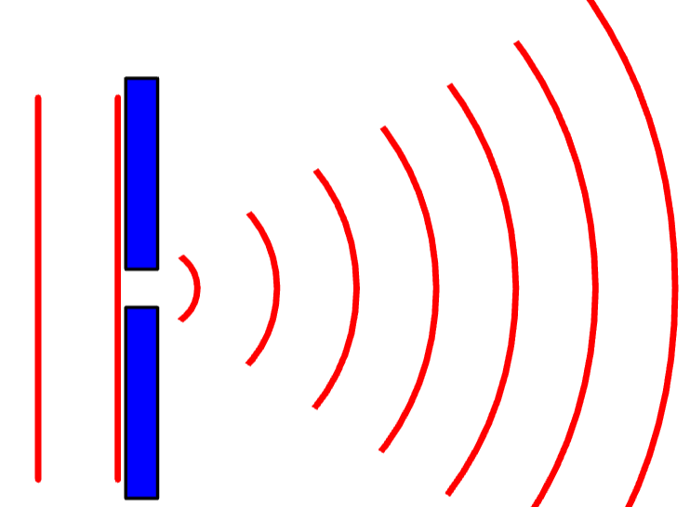
$$dsin θ= m$$

describe conditions for constructive and destructive interference in terms of the phase difference
interference
State the test for a wave. (something that only waves can do)

State how minima are produced
State how maxim are produced
coherent waves have a constant phase relationship.
Waves from coherent sources
  - have the same velocity.
  - have the same wavelength/frequency.
  - have a constant phase relationship

$$d=\frac{1}{n}$$
Where n = no. of lines per metre
Eg 300 lines per mm=
$$d=\frac{1}{n}=\frac{1}{300 000}=3.3×{10}^{-6}m$$

Decrease (squashes pattern)
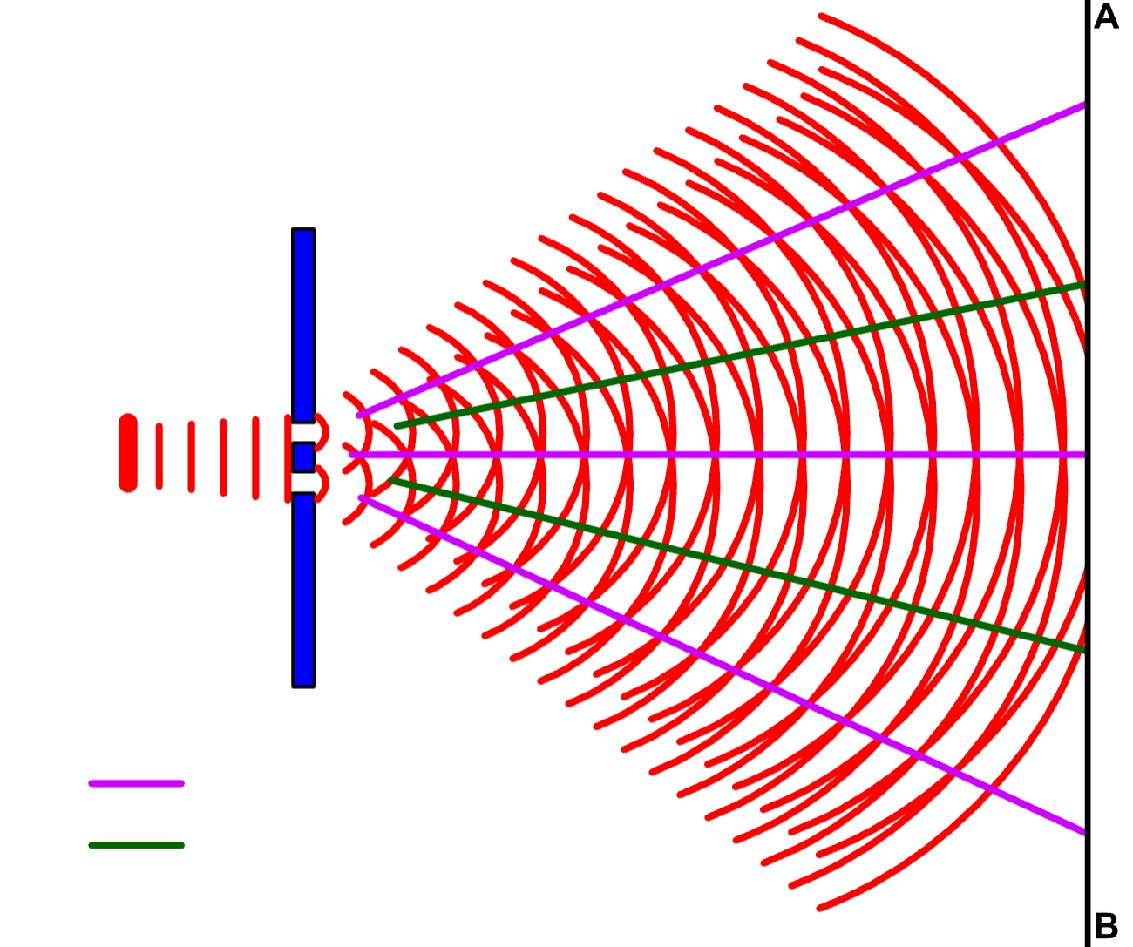
State the relationship between path difference and maxima & minima
Complete the interference pattern and mark on the no. of maxima and minima

Does increasing the distance between slits spread out or reduce the interference pattern?
Maxima
S₂P-S₁P=mλ
Minima
S₂P-S₁P=(m+½) λ

Complete the diagram to show how the waves pass through the gaps.
State the link between grating spacing and number of lines per millimeter in a grating
State the equation involving grating spacing, wavelength, order number and angle to the maximum.
State the meaning of the term diffraction.
Constructive interference
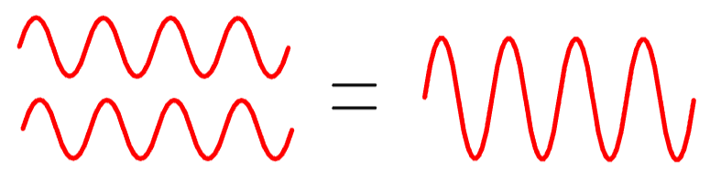


Destructive interference

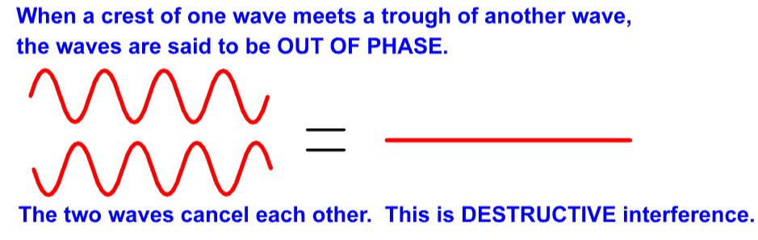
State the meaning of the term coherent
Draw diagrams to show conditions for constructive and destructive interference
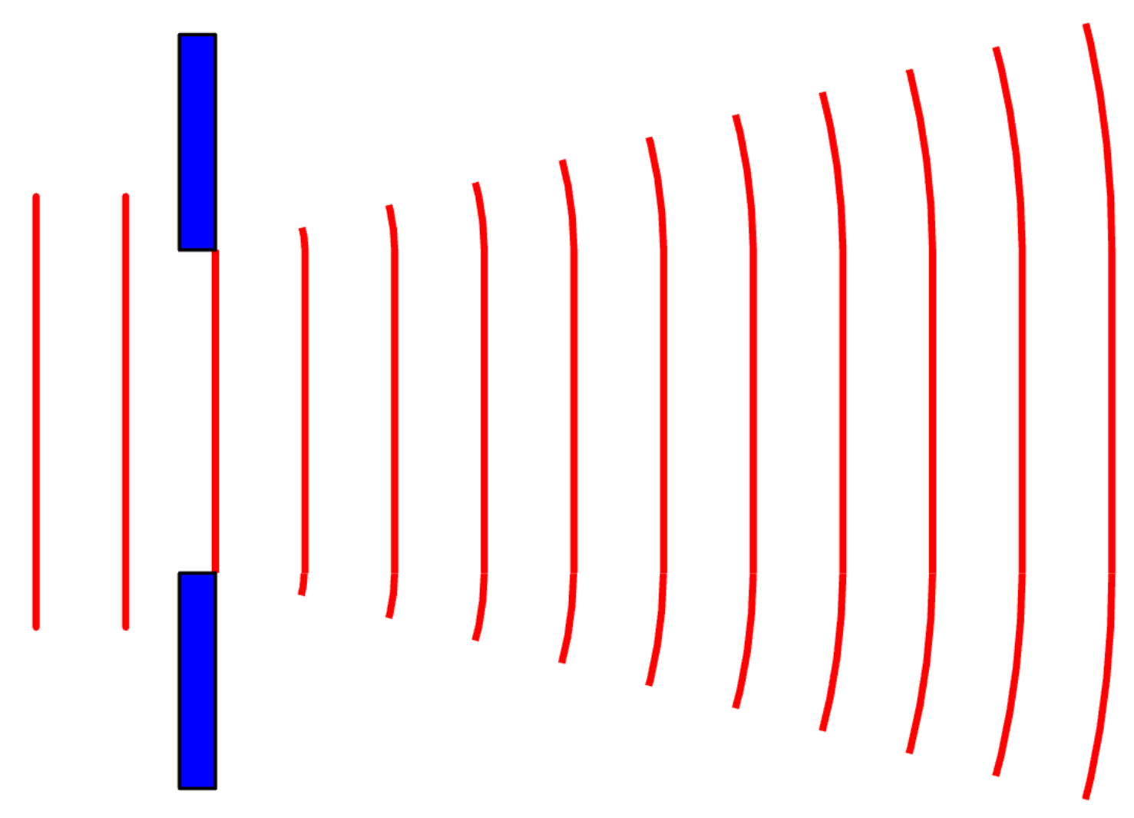

Interference
maxima are produced when the path difference between waves is a whole number of wavelengths

minima are produced when the path difference between waves is an odd number of half-wavelengths respectively
