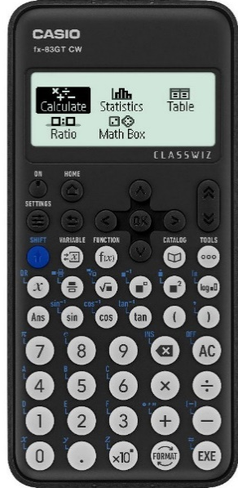
Let’s set up the calculator
Settings button  (above the blue button)  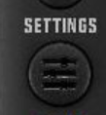 | Calculator setting click ok | Input/output | Choose MathsI/DecimalO | Choose if you want to use the MathIO (recommended MathI decimalO) which allows for the fraction button to be used or put in equations in a line format
 | Calculator setting click ok | Angle format | Choose degree | WHAT YOUR CALCULATOR MUST BE IN WHEN DOING PHYSICS USED FOR TRIG
 | Calculator setting click ok | Number format | Choose either setting
 | Calculator setting click ok | Fraction results | Choose improper fraction | Do you want vulgar fractions or full numbers and fractions
 | Calculator setting click ok | (down) Decimal mark | Choose dot | Should be set to dot, some countries use a comma instead of a dot in a number
 | Calculator setting click ok | (down) Digit separator | Choose on | (this spreads out the number so it is easier to read).
Settings button  (above the blue button) | system setting click ok | Contrast | Use the L and R arrows until the colour difference is good
Settings button  (above the blue button) | system setting click ok | Autopower off | 10 mins except for exam then 60 mins
Settings button  (above the blue button) | system setting click ok | Multiline font | Normal font, unless you’ve really great eyesight!
Catalog  (the one with a book)Ca | Catalogue->Numeric calc | Recurring decimal
 | Catalogue-> angle/coord/sexa_> rect to polar | Rect to Polar | Pol(adjacent,opposite) | FOR USE WITH VECTORS RIGHT ANGLED TRIANGLES, Converts an X and Y to resultant and angle (but not a bearing) Does your trig for you.  Enter Pol(ADJACENT,OPPOSITE) to get the comma press shift and then ). Don’t forget the ) on the end Answer gives r= hypotenuse θ = angle between adjacent and hypotenuse
 | Catalogue-> angle/coord/sexa_>down arrow-> rect to polar | Polar to Rect | Rec(hypotenuese,angle) | FOR USE WITH VECTORS RIGHT ANGLED TRIANGLES, CONVERTS A VECTOR AND ANGLE TO X,Y  Enter Rec(hypotenuse,angle) to get the comma press shift and then ). Don’t forget the ) on the end. Answer gives adjacent (X) and then opposite (Y)
 | When you have done your calculation you can decide how you want to display the answer. | And down arrow  And down arrow | Decimal | Allows you to change your answer to a decimal
 |  |  | Recurring decimal | Will give you a recurring decimal DON’T USE unless you’ve got really good light
 |  |  | Improper fraction | Can be useful if you want to hold over a value and don’t want intermediate rounding errors.
 |  |  | Mixed fraction | Not recommended
 |  |  | ENG Notation | GREAT! Puts your answer to the power of 10 to a value that can be converted to a prefix, keep clicking the eng to move up powers of 3 or shift eng to move down, or use the right and left arrows to alter between the
 |  |  | Sexagesimal

Button/ | How to get there | What is does
Sin, cos, tan | First buttons above the number keys. Mark sure calculator is in degrees | Only needs for the angle in vector questions
° ‘ “ | 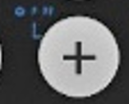 | Converts between hours, mins and second.
x10^{x} |  | Puts your answer to the power of 10, use for m, μ, k etc and the speed of light 3  8. With this calculator it is probably best to bracket powers of 10!
 |  | Fraction button RECOMMENDED to avoid problems of BODMAS and for resistance in parallel questions. BEWARE: https://www.youtube.com/watch?v=rEXWHcyMklo
Fix |  | This fixes the number of decimal places you want to display so will round up. Use this for individual questions only
Sci |  | Displays your answer in scientific notation, good when your answer requires this (lots of decimal places or a big number of sig fig etc
Norm |  | Cancels the Fix and Sci but you then select the type of input you want (see above)
Norm 1~2 |  | Selects between maths or line
pol | Catalogue-> angle/coord/sexa_> rect to polar | FOR USE WITH VECTORS RIGHT ANGLED TRIANGLES, Converts an X and Y to resultant and angle (but not a bearing) Does your trig for you.  Enter Pol(ADJACENT,OPPOSITE) to get the comma press shift and then ). Don’t forget the ) on the end
Rec | Catalogue-> angle/coord/sexa_>down arrow-> rect to polar | FOR USE WITH VECTORS RIGHT ANGLED TRIANGLES, CONVERTS A VECTOR AND ANGLE TO X,Y  Enter Rec(hypotenuse,angle) to get the comma press shift and then ). Don’t forget the ) on the end
ANS | Find it two buttons below the blue shift button | This stores the answer so you can use this for additional parts of the calculation
x⁻¹ |  | Puts your number/answer over 1 (eg in Resistance in parallel) Nowadays it is easier to use  $$\frac{}{ANS}$$
π | Shift 7 now gets you pi! | 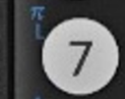  Can also get this through the catalog funtion, but why would you? It is a terrible place to get it! Catalog->down until you reacher “other”-> right arrow-> right arrow-> ok
Power button |  | For you powers, beware the shift and this button has limited use, especially when using powers of 10.
root | 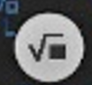 | Direct algebraic logic states that you need to use this button before putting the number in. This button is the square root, Shift and this button allows for other roots such as cube root etc.

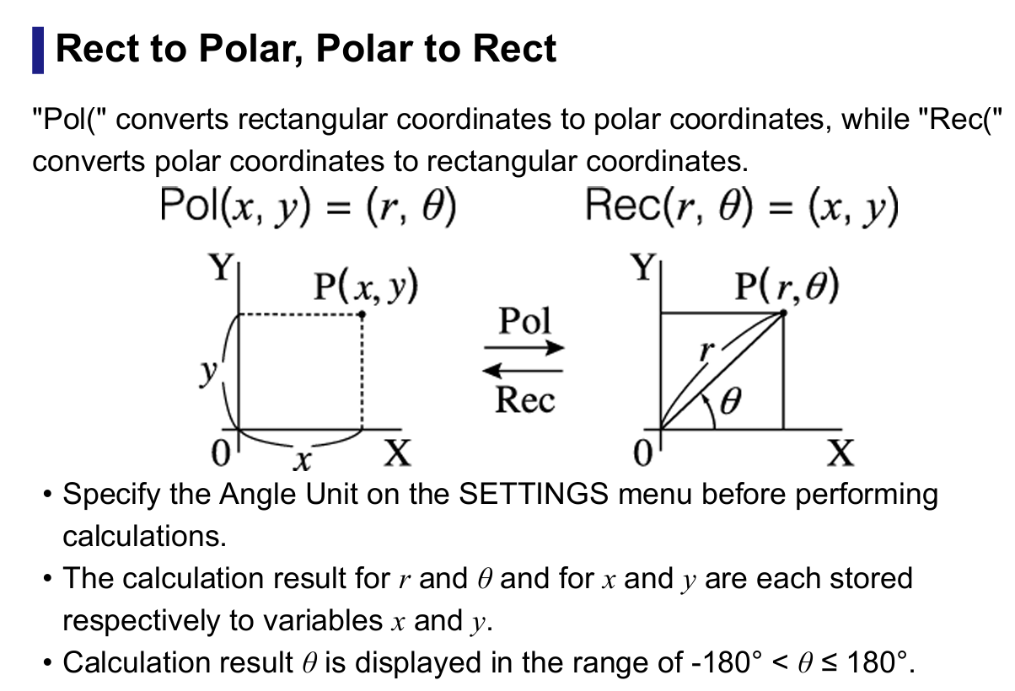

Polar to Rectangular, Rectangular to polar

This is what you can use for finding components of vectors or finding the resultant vector from its components. To explain the information on the right we do
Pol(adjacent,opposite) this gives the resultant and angle (you’ll need to decide on how this fits in with the bearing)
Rec(hypotenuse,angle) this gives the adjacent and opposite in that order.
To find these buttons on the new calculators you need the catalogue (see the table) this will generate either Pol( or Rec( . Then add in the relevant number and the comma is found by using shift+)
Eg. For a 3,4,5 triangle
Pol(3,4) = r=5 θ= 53.13, you will get a different angle if you put the Pol(4,3) so it must be the adjacent that goes first.
Let’s try it the other way
Rec(5,53) = x (adj) 3.009075, y (opp) 3.993 (which I hope you can see would round to 4)
Try finding the resultant displacement for the following journey, A dog walks 12 m west in a straight line and then 5.0 m due south.

You ought to get r=13m, θ=23° But as for this as a bearing it is 23° below the 270° line so 270-23 = (247)

Button/ | How to get there | What is does
x10^{x} |  | Puts your answer to the power of 10, use for m, μ, k etc
ENG |  | Puts your answer to the power of 10 to a value that can be converted to a prefix, keep clicking the eng to move up powers of 3 or shift eng to move down
S↔D |  | Toggles between leaving your answer as a fraction or decimal
DEG |  | WHAT YOUR CALCULATOR MUST BE IN WHEN DOING PHYSICS USED FOR TRIG
RAD/Grad |  | DON’T LET YOUR CALCULATOR BE IN EITHER OF THESE
calculate |  | To work out a sum rather than statistics, the default setting
Input/output | Shift /set up 1 | This decides if you want to use the MathIO (recommended MathI decimalO) which allows for the fraction button to be used or put in equations in a line format
Angle unit | Shift/set up 2 | For checking your calculator is set to DEGREES
Digital separator | Shift/ set up / down twice/1/on | This breaks the number into 1000’s so that it is easier to identify large and small numbers
Fix | Shift/ set up 3 /1 | This fixes the number of decimal places you want to display so will round up. Use this for individual questions only
Sci | Shift/ set up 3 /2 | Displays your answer in scientific notation, good when your answer requires this (lots of decimal places or a big number of sig fig etc
Norm | Shift/ set up 3 /3 | Cancels the Fix and Sci but you then select the type of input you want (see above)
Norm 1~2 |  | Selects between maths or line
Ab/c or d/c | Shift/ set up 4 | Do you want vulgar fractions or full numbers and fractions
Recurring decimal | Shift / down. 3 | I RECOMMEND THIS BEING OFF, IT GIVES YOU THE DOT WHICH YOU MIGHT NOT NOTICE
Decimal mark | Shift down 4 | Should be set to dot, some countries use a comma instead of a dot in a number
pol | Shift + | Shift + number comma number bracket = FOR USE WITH VECTORS RIGHT ANGLED TRIANGLES, CONVERTS A VECTOR AND ANGLE TO X,Y
Rec | Shift - | Shift – number comma number bracket = FOR USE WITH VECTORS RIGHT ANGLED TRIANGLES, Converts an X and Y to resultant and angle (but not a bearing)
ANS |  | This stores the answer so you can use this for additional parts of the calculation
x⁻¹ |  | Puts your number/answer over 1 (eg in Resistance in parallel)
Sin, cos, tan |  | Only needs for the angle in vector questions
° ‘ “ |  | Converts between hours, mins and second
 |  | Fraction button RECOMMENDED to avoid problems of BODMAS

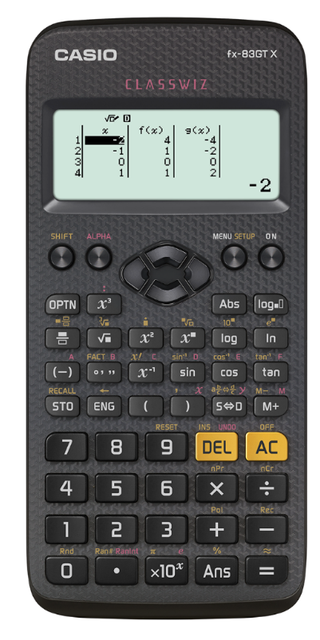
Button/ | How to get there |  | What is does
x10^{x} |  | Puts your answer to the power of 10, use for m, μ, k etc
ENG |  | Puts your answer to the power of 10 to a value that can be converted to a prefix, keep clicking the eng to move up powers of 3 or shift eng to move down
S↔D |  | Toggles between leaving your answer as a fraction or decimal
DEG | Shift/ set up 3 | WHAT YOUR CALCULATOR MUST BE IN WHEN DOING PHYSICS USED FOR TRIG
RAD/Grad | Shift/ set up 4 or 5 | DON’T LET YOUR CALCULATOR BE IN EITHER OF THESE
calculate |  | To work out a sum rather than statistics, the default setting
MthIO | Shift /set up 1 | This decides if you want to use the MathIO (recommended MathI decimalO) which allows for the fraction button to be used or put in equations in a line format
LineIO | Shift/set up 2 | For checking your calculator is set to DEGREES
Number format
Fix | Shift/ set up 6 | This fixes the number of decimal places you want to display so will round up. Use this for individual questions only
Sci | Shift/ set up 7 | Displays your answer in scientific notation, good when your answer requires this (lots of decimal places or a big number of sig fig etc
Norm | Shift/ set up 8 | Cancels the Fix and Sci but you then select the type of input you want (see above)
Norm 1~2 |  | Selects between maths or line
Ab/c or d/c | Shift/ set uo/ down 1 or 2 | Do you want vulgar fractions or full numbers and fractions
Recurring decimal | Shift / set up/down. 4 | I RECOMMEND THIS BEING OFF, IT GIVES YOU THE DOT WHICH YOU MIGHT NOT NOTICE
Decimal mark | Shift / set up/down. 5 | Should be set to dot, some countries use a comma instead of a dot in a number
pol | Shift + | Shift + number comma number bracket = FOR USE WITH VECTORS RIGHT ANGLED TRIANGLES, CONVERTS A VECTOR AND ANGLE TO X,Y
Rec | Shift - | Shift – number comma mumber bracket = FOR USE WITH VECTORS RIGHT ANGLED TRIANGLES, Converts an X and Y to resultant and angle (but not a bearing)
ANS |  | This stores the answer so you can use this for additional parts of the calculation
x⁻¹ |  | Puts your number/answer over 1 (eg in Resistance in parallel)
Sin, cos, tan |  | Only needs for the angle in vector questions
° ‘ “ |  | Converts between hours, mins and second
 |  | Fraction button RECOMMENDED to avoid problems of BODMAS
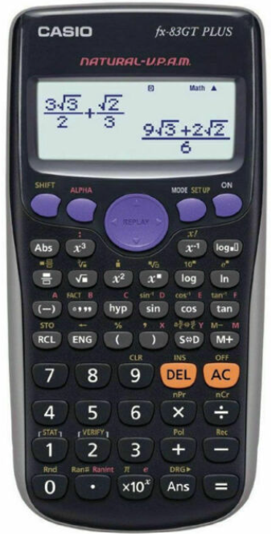

Prefix | Symbol | Multiple | Multiple in full
Tera | T | x10¹² | x1 000 000 000 000
Giga | G | x10⁹ | x1 000 000 000
Mega | M | x10⁶ | x1 000 000
Kilo | k | x10³ | x1 000
BASE UNIT | _ | _______ | ____________________
Milli | m | x10⁻³ | ÷1 000
Micro | μ | x10⁻⁶ | ÷1 000 000
Nano | n | x10⁻⁹ | ÷1 000 000 000
Pico | p | x10⁻¹² | ÷1 000 000 000 000
- (Information)- Summarise the question.
- Change any units that are not standard.
- (Equation) -Write out the formula.
- (Substitution) -Put the numbers in.
- Use the magic triangle to rearrange the formula, only if you must!
- (Solution)- Work out the answer.
- Write out the answer, but not to too many sig fig.
- (Units) -Add units to your answer.
- (Underline) Underline the answer

