2027
J. A. Hargreaves
Mostly Harmless
04 June 2026



CfE Higher Physics Compendium



NAME: ________________
CLASS: _______________

Contents
1 Contents 1
2 Data Sheet 2
3 Relationships Required For Higher Physics 3
4 Periodic Table 4
5 Summary of The Physics Course 5
5.1 Summary of Our Dynamic Universe 5
5.2 Summary of Particles and Waves 5
5.3 Summary of Electricity 5
6 Course assessment structure 6
6.1 Question papers 6
6.2 Assignment 6
7 COURSE OUTCOMES / SUCCESS CRITERIA 7
7.1 Uncertainties 7
7.2 Units Prefixes and Scientific Notation 8
7.3 Our Dynamic Universe 8
7.4 Particles and Waves 11
7.5 Electricity 15
7.6 Prescribed Practical Experiments 19
8 Annotated relationships sheet for Higher Physics 21
9 Quantity symbol unit and unit Symbol 26
9.1 Greek Alphabet 29
10 Calculator Cribsheet 30
10.1 Add Your notes 33
11 SI Units 34
12 Trigonometry 34
12.1 Pythagoras 34
a. Cosine Rule 34
12.2 Sine Rule 35
13 . Prefixes 35
14 Uncertainties 36
14.1 . Quantifying Uncertainties 36
14.2 Scale reading uncertainty 36
14.3 Overall uncertainty in an Experiment 37
14.4 Accuracy & Precision 37
15 Marking Principles 37
15.1 How many Significant Figures? 37
15.2 Example 38
15.3 From the General Marking Principles 38
16 Mark Scheme for the Assignment 40
17 Personal Notes 41

Data Sheet
Content

Relationships Required For Higher Physics
Content
$$d=\overline{v}t$$ | $$W=QV$$ | $$V_{rms}=\frac{V_{peak}}{\sqrt{2}}$$
$$s=\overline{v}t$$ | $$E=mc^{2}$$ | $$l_{rms}=\frac{I_{peak}}{\sqrt{2}}$$
$$v=u+at$$ | $$I=\frac{P}{A}$$ | $$T=\frac{1}{f}$$
$$s = ut +\frac{1}{2} at^{2}$$ | $$I=\frac{k}{d^{2}}$$ | $$V=IR$$
$$v^{2}= u^{2} + 2as$$ | $$I_{1}d_{1}^{2}=I_{2}d_{2}^{2}$$ | $$P=IV=I^{2}R=\frac{V^{2}}{R}$$
$$s=\frac{1}{2}(v+u)t$$ | $$E=hf$$ | $$R_{T}=R_{1}+R_{2}+…$$
$$F=ma$$ | $$E_{k}=hf-hf_{o}$$ | $$\frac{1}{R_{T}}=\frac{1}{R_{1}}+\frac{1}{R_{2}}+…$$
$$W=mg$$ | $$v=fλ$$ | $$V_{1}=\left(\frac{R_{1}}{R_{1}+R_{2}}\right)V_{s}$$
$E_{w}=Fd$, or $W=Fd$ | $$E_{2}-E_{1}=hf$$ | $$\frac{V_{1}}{V_{2}}=\frac{R_{1}}{R_{2}}$$
$$E_{p}=mgh$$ | $$d\sin{θ}=mλ$$ | $$E=V+Ir$$
$$E_{k}=\frac{1}{2 } m v^{2}$$ | $$n=\frac{\sin{θ_{1}}}{\sin{θ_{2}}}$$ | $$C=\frac{Q}{V}$$
$$P= \frac{E}{t}$$ | $$\frac{\sin{θ_{1}}}{\sin{θ_{2}}}=\frac{λ_{1}}{λ_{2}}=\frac{v_{1}}{v_{2}}$$ | $$Q=It$$
$$p=mv$$ | $$\sin{θ_{c}=\frac{1}{n}}$$ | $$E=\frac{1}{2}QV=\frac{1}{2}CV^{2}=\frac{1}{2}\frac{Q^{2}}{C}$$
$$Ft=mv-mu$$
$$F=G\frac{m_{1}m_{2}}{r^{2}}$$ | Content
$$t^{'}=\frac{t}{\sqrt{1-{\left(\frac{v}{c}\right)}^{2}}}$$ | $$Path difference=mλ or \left(m+\frac{1}{2}\right)λ, where m=0,1,2…$$
$$l^{'}=l\sqrt{1-{\left(\frac{v}{c}\right)}^{2}}$$ | $$Random Uncertainty=\frac{max value-\min{value}}{number of values }$$  $$or ∆R=\frac{R_{max}-R_{min}}{n}$$
$$f_{o}=f_{s} \left(\frac{v}{v\underline{+}v_{s}}\right)$$

$$z=\frac{λ_{observed }-λ_{rest}}{λ_{rest}}$$

$$z=\frac{v}{c}$$
$$v=H_{o}d$$

Periodic Table
Content

Summary of The Physics Course
Content
The following material is taken from the Higher Course Specifications version 1.0 April 2018 produced by the SQA. https://www.sqa.org.uk/sqa/47916.html

There are three units to this course and an Assignment

Summary of Our Dynamic Universe
The topics covered are:
- motion — equations and graphs
- forces, energy and power
- collisions, explosions, and impulse
- gravitation
- special relativity
- the expanding Universe

Summary of Particles and Waves
The topics covered are:
- forces on charged particles
- the Standard Model
- nuclear reactions
- inverse square law
- wave-particle duality
- interference
- spectra
- refraction of light

Summary of Electricity
The topics covered are:
- monitoring and measuring AC
- current, potential difference, power, and resistance
- electrical sources and internal resistance
- capacitors
- semiconductors and p-n junctions
There is also an assignment which must be completed.

Content

The length of time for students to complete the course is 160 hours.
There are three parts to the exam.
Component | Marks | Scaled mark | Duration & Notes
Section 1: multiple choice | 20 | 20 | 2 hours and 30 minutes
Section 2 | 110 | 110 | 2 hours and 30 minutes
Assignment | 20 | 33 | 8 hours including a max of 2 hours for the writing stage

Course assessment structure

Question papers
Section 1: multiple choice 20 marks
Section 2: extended questions 110 marks
The question papers total 130 marks, and makes up 80% of the overall marks
Section 1 contains multiple-choice questions and has 20 marks. This is not scaled.
Section 2 contains restricted-response and extended-response questions and has 110 marks. This is not scaled.
The assignment will be scaled to 33 marks giving a total of 163 marks
A data sheet and a relationships sheet are provided. The majority of the marks are awarded for applying knowledge and understanding. The other marks are awarded for applying scientific inquiry, scientific analytical thinking and problemsolving skills.

Assignment
The assignment has a total mark allocation of 20 marks. This is scaled to 30 marks by SQA. This contributes 20% to the overall marks for the course assessment.
The assignment assesses the application of skills of scientific inquiry and related physics knowledge and understanding.
It allows assessment of skills that cannot be assessed through the question paper, for example the handling and processing of data gathered from experimental work by the candidate.
The assignment is:
- an individually produced piece of work from each candidate
- started at an appropriate point in the course
- conducted under controlled conditions
Content

COURSE OUTCOMES / SUCCESS CRITERIA
NB Bold comments are straight learn statements and can be copied to make flashcards. Red typeface indicates the core experiments.
Content

Uncertainties
Content
No | CONTENT |  | Traffic Light
1. | Uncertainties
eq | or $$∆R=\frac{R_{max}-R_{min}}{n}$$
1.1 | I can identify that all measurements of physical quantities are liable to uncertainty which I can express in absolute or percentage form.
1.2 | I can quantify and recognise scale reading, random and systematic uncertainties in a measured quantity.
1.3 | I can express uncertainties in absolute or percentage form
1.4 | I know that random uncertainties arise when an experiment is repeated and slight variations occur.
1.5 | I know that to calculate the approximate random uncertainty in a measurement I use the formula,  The units will be the same as that of the measurement
1.6 | I know that scale reading uncertainty is an indication of how precisely a scale can be read.
1.7 | I can state that random uncertainties can be reduced by taking repeated measurements.
1.8 | I can explain that systematic uncertainties occur when readings taken are either all too small or all too large.
1.9 | I can recognise that systematic uncertainties can arise due to measurement techniques or experimental design.
1.10 | I know the mean of a set of repeated measurements is the best estimate of the ‘true’ value of the quantity being measured.
1.11 | I know that when systematic uncertainties are present, they offset the mean value
1.12 | I know when mean values are used, the approximate random uncertainty should be calculated.
1.13 | I can correctly calculate, use and identify uncertainties during data analysis.
1.14 | I know that when an experiment is being undertaken and more than one physical quantity is measured, the quantity with the largest percentage uncertainty should be identified and this may often be used as a good estimate of the percentage uncertainty in the final numerical result of an experiment.
1.15 | I can express the numerical result of an experiment in the form final value ±uncertainty.

Units Prefixes and Scientific Notation

No | CONTENT |  | Traffic Light
2. | Units, prefixes and scientific notation
2.1 | I know the units for all of the physical quantities used in this unit.
2.2 | I can use the prefixes: pico (p), nano (n), micro (μ), milli (m), kilo (k), mega (M), giga (G) and tera (T).
2.3 | I can give an appropriate number of significant figures when carrying out calculations. (This means that the final answer can have no more significant figures than the value with least number of significant figures used in the calculation).
2.4 | I can use scientific notation when large and small numbers are used in calculations.
Content

Our Dynamic Universe

No | CONTENT |  |  | Traffic Light
3. | Equations of Motion
Eq | $d=\overline{v}t, s=\overline{vt} ; s=\frac{1}{2}\left(u+v\right)t;$ $v=u+at s=ut+\frac{1}{2}at^{2} v^{2}\text{= }u^{2}+2as$
3.1 | I can use the equations of motion to find distance, displacement, speed, velocity, and acceleration for objects with constant acceleration in a straight line.
3.2 | I can interpret and draw motion-time graphs for motion with constant acceleration in a straight line, including graphs for bouncing objects and objects thrown vertically upwards.
3.3 | I know the interrelationship of displacement-time, velocity-time and acceleration- time graphs.
3.4 | I can calculate distance, displacement, speed, velocity, and acceleration from appropriate graphs (graphs restricted to constant acceleration in one dimension, inclusive of change of direction).
3.5 | I can give a description of an experiment to measure the acceleration of an object down a slope
4. | Forces, energy and power
Eq | W = mg F = ma E_{W} or W = Fd Ep = mgh Ek = ½ mv² E = Pt
4.1 | I can use vector addition and appropriate relationships to solve problems involving balanced and unbalanced forces, mass, acceleration and gravitational field strength.
4.2 | I know the effects of friction on a moving object (static and dynamic friction are not required)
4.3 | I can identify and explain the effects of friction on moving objects. I do not need to use reference to static and dynamic friction.
4.4 | I can identify and explain, in terms of forces an object moving with terminal velocity
4.5 | I can interpret and produce velocity-time graphs for a falling object when air resistance is taken into account.
4.6 | I can analyse motion using Newton’s first and second laws.
4.7 | I can use free body diagrams and appropriate relationships to solve problems involving friction and tension.
4.8 | I can resolve a vector into two perpendicular components.
4.9 | I can resolve the weight of an object on a slope into a component acting parallel (down the slope) and a component acting normal to the slope.
4.10 |  | I can use the principle of conservation of energy and appropriate relationships to solve problems involving work done, potential energy, kinetic energy and power.
5. | Collisions and explosions
eq | p = mv Ft = mv − mu ${E_{k}=\frac{1}{2}mv}^{2}$
5.1 | I know the law of conservation of momentum which states “total momentum before an interaction is equal to total momentum after an interaction in the absence of external forces”
5.2 | I can use the principle of conservation of momentum and an appropriate relationship to solve problems involving the momentum, mass and velocity of objects interacting in one dimension.
5.3 | I can explain the role in kinetic energy in determining whether a collision is described as elastic and inelastic collisions or in explosions.
5.4 | I can use appropriate relationships to solve problems involving the total kinetic energy of systems of interacting objects.
5.5 | I can use Newton’s third law to explain the motion of objects involved in interactions.
5.6 | I can draw and interpret force-time graphs involving interacting objects.
5.7 | I know that the impulse of a force is equal to the area under a force-time graph and is equal to the change in momentum of an object involved in the interaction.
5.8 | I can use data from a force-time graph to solve problems involving the impulse of a force, the average force and its duration.
5.9 | I can use appropriate relationships to solve problems involving mass, change in velocity, average force and duration of the force for an object involved in an interaction.
 |  |  |  | Content
6. | Gravitation |  |  | Content
Eq | $d=\overline{v}t, s=\overline{vt} ; s=\frac{1}{2}\left(u+v\right)t;$ $v=u+at s=ut+\frac{1}{2}at^{2} v^{2}\text{= }u^{2}+2as$ $F=\frac{G{m_{1}m}_{2}}{r^{2}}$
6.1 | I can use the equation $F=\frac{G{m_{1}m}_{2}}{r^{2}}$
6.2 | I can give a description of an experiment to measure the acceleration of a falling object.
6.3 | I know that the horizontal motion and the vertical motion of a projectile are independent of each other.
6.4 | I know that satellites are in free fall around a planet/star.
6.5 | I can resolve the initial velocity of a projectile into horizontal and vertical components and their use in calculations.
6.6 | I can use resolution of vectors, vector addition, and appropriate relationships to solve problems involving projectiles.
6.7 | I can use Newton’s Law of Universal Gravitation to solve problems involving force, masses and their separation.
7. | Special relativity
Eq | $l'=l\sqrt{1-\frac{v^{2}}{c^{2}}}$ $t'=\frac{t}{\sqrt{1-\frac{v^{2}}{c^{2}}}}$
7.1 | I know that the speed of light in a vacuum is the same for all observers.
7.2 | I know that measurements of space, time and distance for a moving observer are changed relative to those for a stationary observer, giving rise to time dilation and length contraction.
7.3 | I can use appropriate relationships to solve problems involving time dilation, length contraction and speed.
 |  |  |  | Content
8. | The expanding Universe
Eq | $f_{\text{observed}}=f_{source}\frac{v}{\left[v+v_{source}\right]}$ $v = H_{o}d$
8.1 | I know that the Doppler effect causes shifts in wavelengths of sound and light.
8.2 | I can use appropriate relationship to solve problems involving the observed frequency, source frequency, source speed and wave speed.
8.3 | I know that the light from objects moving away from us is shifted to longer wavelengths (redshift).
8.4 | I know that the redshift of a galaxy is the change in wavelength divided by the emitted wavelength. For slowly moving galaxies, redshift is the ratio of the recessional velocity of the galaxy to the velocity of light.
8.5 | I can use appropriate relationships to solve problems involving redshift, observed wavelength, emitted wavelength, and recessional velocity
8.6 | I can use appropriate relationship to solve problems involving the Hubble constant, the recessional velocity of a galaxy and its distance from us.
8.7 | I know that Hubble-Lemaître Laws law allows us to estimate the age of the Universe.
8.8 | I know that measurements of the velocities of galaxies and their distance from us lead to the theory of the expanding Universe.
8.9 | I know that the mass of a galaxy can be estimated by the orbital speed of stars within it.
8.10 |  | I know that evidence supporting the existence of dark matter comes from estimations of the mass of galaxies.
8.11 |  | I know that evidence supporting the existence of dark energy comes from the accelerating rate of expansion of the Universe.
8.12 |  | I know that the temperature of stellar objects is related to the distribution of emitted radiation over a wide range of wavelengths.
8.13 |  | I know that the peak wavelength of this distribution is shorter for hotter objects than for cooler objects.
8.14 |  | I know that hotter objects emit more radiation per unit surface area per unit time than cooler objects.
8.15 |  | I know of evidence supporting the big bang theory and subsequent expansion of the Universe: cosmic microwave background radiation, the abundance of the elements hydrogen and helium, the darkness of the sky (Olbers’ paradox) and the large number of galaxies showing redshift rather than blueshift.
Content

Particles and Waves

No | CONTENT |  |  | Traffic Light
9. | Forces on charged particles
Eq | $W=QV$ $E_{k}=\frac{1}{2}mv^{2}$
9.1 | I know that charged particles experience a force in an electric field.
9.2 | I know that electric fields exist around charged particles and between charged parallel plates.
9.3 | I can sketch electric field patterns for single-point charges, systems of two-point charges and between two charged parallel plates (ignore end effects).
9.4 | I can determine the direction of movement of charged particles in an electric field.
9.5 | I can define voltage (potential difference) as the work done moving unit charge between two points
9.6 | I can solve problems involving the charge, mass, speed, and energy of a charged particle in an electric field and the potential difference through which it moves.
9.7 | I know that a moving charge produces a magnetic field.
9.8 | I can determine the direction of the force on a charged particle moving in a magnetic field for negative and positive charges using the slap rule or other method.
9.9 | I know the basic operation of particle accelerators in terms of acceleration by electric fields, deflection by magnetic fields and high-energy collisions of charged particles to produce other particles.
 |  |  |  | Content
10. | Standard Model
10.1 | I know that the Standard Model is a model of fundamental particles and interactions.
10.2 | I can describe the Standard Model in terms of types of particles and groups
10.3 | I can use orders of magnitude and am aware of the range of orders of magnitude of length from the very small (sub-nuclear) to the very large (distance to furthest known celestial objects).
10.4 | I know that evidence for the existence of quarks comes from high-energy collisions between electrons and nucleons, carried out in particle accelerators.
10.5 | I know that in the Standard Model, every particle has an antiparticle.
10.6 | I know that the production of energy in the annihilation of particles is evidence for the existence of antimatter
10.7 | I know that beta decay was the first evidence for the neutrino.
10.8 | I know the equation for β- decay above (β+ decay not required) ${}_{0}^{1}n→{}_{1}^{1}p+{}_{-1}^{0}{e+\overline{ν_{e}}}$
10.9 | I know that fermions, the matter particles, consist of quarks (six types: up, down, strange, charm, top, bottom) and leptons (electron, muon and tau, together with their neutrinos).
10.10 |  | I know that hadrons are composite particles made of quarks.
10.11 |  | I know that baryons are made of three quarks.
10.12 |  | I know that mesons are made of quark–antiquark pairs.
10.13 |  | I know that the force-mediating particles are bosons: photons (electromagnetic force), W- and Z-bosons (weak force), and gluons (strong force).
11. | Nuclear reactions
Eq | $$E=mc^{2}$$
11.1 | I can use nuclear equations to describe radioactive decay, fission (spontaneous and induced), with reference to mass and energy equivalence.
11.2 | I can use nuclear equations to describe fusion reactions, with reference to mass and energy equivalence.
11.3 | Use of an appropriate relationship to solve problems involving the mass loss and the energy released by a nuclear reaction. $E=mc^{2}$
11.4 | I know that nuclear fusion reactors require charged particles at a very high temperature (plasma) which have to be contained by magnetic fields.
 |  |  | Content
12. | Inverse square law
Eq | $I=\frac{P}{A}$ $I_{1}d_{1}^{2}=I_{2}d_{2}^{2}$
12.1 | I know that irradiance is the power per unit area incident on a surface.
12.2 | I can use the equation $I=\frac{P}{A}$ to solve problems involving irradiance, the power of radiation incident on a surface and the area of the surface.
12.3 | I know that irradiance is inversely proportional to the square of the distance from a point source.
12.4 | I can describe an experiment to verify the inverse square law for a point source of light
12.5 | I can use and $I_{1}d_{1}^{2}=I_{2}d_{2}^{2}$ to solve problems involving irradiance and distance from a point source of light.
13. | Wave Particle Duality
Eq | $E=hf$ $E=\frac{hc}{λ}$ $E_{k}=hf-hf_{0} E_{k}=\frac{1}{2}mv^{2} and v=fλ$
13.1 | I know that the photoelectric effect is evidence for the particle model of light.
13.2 | I know that photons of sufficient energy can eject electrons from the surface of materials (photoemission).
13.3 | I can use $E=hf$ and $E=\frac{hc}{λ}$ to solve problems involving the frequency and energy of a photon.
13.4 | I know that the threshold frequency, f₀ is the minimum frequency of a photon required for photoemission.
13.5 | I know that the work function, W or hf₀ of a material is the minimum energy of a photon required to cause photoemission.
13.6 | I can use $E_{k}=hf-hf_{0}$ $E_{k}=\frac{1}{2}mv^{2} and v=fλ$ to solve problems involving the mass, maximum kinetic energy and speed of photoelectrons, the threshold frequency of the material, and the frequency and wavelength of the photons.
 |  |  |  | Content
14. | Interference
Eq | $path difference=mλ or \left(m+\frac{1}{2}\right)λ$ where m =0,1,2.  $d sinθ=mλ$
14.1 | I know that interference is evidence for the wave model of light.
14.2 | I know that coherent waves have a constant phase relationship.
14.3 | I can describe of the conditions for constructive and destructive interference in terms of the phase difference between two waves.
14.4 | I know that maxima are produced when the path difference between waves is a whole number of wavelengths
14.5 | I know that minima are produced when the path difference between waves is an odd number of half-wavelengths respectively.
14.6 | I can use $path difference=mλ or \left(m+\frac{1}{2}\right)λ$ where m =0,1,2...  to solve problems involving the path difference between waves, wavelength and order number.
14.7 | I can use $d sinθ=mλ$ to solve problems involving grating spacing, wavelength, order number and angle to the maximum.
 |  |  |  | Content
15. | Spectra
Eq | $E_{2}-E_{1}=hf$ and
15.1 | I have knowledge of the Bohr model of the atom.
15.2 | I can explain the Bohr model of the atom using the terms ground state, energy levels, ionisation and zero potential energy.
15.3 | I know the mechanism of production of line emission spectra, continuous emission spectra and absorption spectra in terms of electron energy level transitions.
15.4 | I can use $E_{2}-E_{1}=hf$ and to solve problems involving energy levels and the frequency of the radiation emitted/absorbed.
15.5 | I know that the absorption lines (Fraunhofer lines) in the spectrum of sunlight provide evidence for the composition of the Sun’s outer atmosphere.
 |  |  | Content
16. | Refraction
Eq | $n=\frac{\sin{θ_{1}}}{\sin{θ_{2}}}=\frac{λ_{1}}{λ_{2}}=\frac{v_{1}}{v_{2}}$ and $v=fλ$ and
16.1 | I can define absolute refractive index of a medium as the ratio of the speed of light in a vacuum to the speed of light in the medium.
16.2 | I can use $n=\frac{\sin{θ_{1}}}{\sin{θ_{2}}}$ to solve problems involving absolute refractive index, the angle of incidence and the angle of refraction.
16.3 | I can describe an experiment to determine the refractive index of a medium.
16.4 | I can use $\frac{\sin{θ_{1}}}{\sin{θ_{2}}}=\frac{λ_{1}}{λ_{2}}=\frac{v_{1}}{v_{2}}$ and $v=fλ$ to solve problems  involving the angles of incidence and refraction, the wavelength of light in each medium, the speed of light in each medium, and the frequency, including situations where light is travelling from a more dense to a less dense medium.
16.5 | I know that the refractive index of a medium increases as the frequency of incident radiation increases.
16.6 | I can define critical angle as the angle of incidence which produces an angle of refraction of 90°.
16.7 | I know that total internal reflection occurs when the angle of incidence is greater than the critical angle.
16.8 | I can use to solve problems involving critical angle and absolute refractive index.

Electricity
Content

No | CONTENT |  |  | Traffic Light
17. | Monitoring and Measuring A.C.
Eq | $T=\frac{1}{f}$ $V_{rms}=\frac{V_{peak}}{\sqrt{2}}$ $I_{rms}=\frac{I_{peak}}{\sqrt{2}}$
17.1 | I know that an A.C. is a current which changes direction and instantaneous value with time.
17.2 | I can use $V_{rms}=\frac{V_{peak}}{\sqrt{2}}$ $I_{rms}=\frac{I_{peak}}{\sqrt{2}}$ to solve problems involving peak and r.m.s. values.
17.3 | I can determine the frequency, peak voltage and r.m.s. values from graphical data.
17.4 | I can use $T=\frac{1}{f}$ to determine the frequency.
18. | Current, potential difference, power and resistance
Eq
Eq
18.1 | I can use relationships involving potential difference, current, resistance and power to analyse circuits even those that may involve several steps in the calculations.
18.2 | I can correctly use calculations involving potential dividers circuits.
19. | Electrical sources and internal resistance
Eq
19.1 | I can correctly use and explain the terms electromotive force (E.M.F), internal resistance, lost volts, terminal potential difference (t.p.d) ideal supplies, short circuits and open circuits.
19.2 | I can use $E=V+Ir$ and $V=IR$to solve problems involving EMF, lost volts, t.p.d., current, external resistance, and internal resistance.
19.3 | I can describe of an experiment to measure the EMF and internal resistance of a cell.
19.4 | I can determine electromotive force, internal resistance and short circuit current using graphical analysis.
20. | Capacitors |  |  | Content
Eq
20.1 | I know that a capacitor of 1 farad will store 1 coulomb of charge when the potential difference across it is 1 volt.
20.2 | I can use the equation C=Q/V to solve problems involving capacitance, charge and potential difference.
20.3 | I can use the equation Q = It to determine the charge stored on a capacitor for a constant charging current.
20.4 | I know the total energy stored in a charged capacitor is equal to the area under a charge-potential difference graph.
20.5 | I can use $E=\frac{1}{2}QV=\frac{1}{2}CV^{2}=\frac{1}{2}\frac{Q^{2}}{C}$ to solve problems involving energy, charge, capacitance, and potential difference.
20.6 | I know the variation of current with time for both charging and discharging cycles of a capacitor in an RC circuit (charging and discharging curves).
20.7 | I know the variation of potential difference with time for both charging and discharging cycles of a capacitor in an RC circuit (charging and discharging curves).
20.8 | I know the effect of resistance and capacitance on charging and discharging curves in an RC circuit.
20.9 | I can describe experiments to investigate the variation of current in a capacitor and voltage across a capacitor with time, for the charging and discharging of capacitors
21. | Semiconductors and p-n junctions
21.1 | I know and can explain the terms conduction band and valence band.
21.2 | I know that solids can be categorised into conductors, semiconductors or insulators by their band structure and their ability to conduct electricity. Every solid has its own characteristic energy band structure. For a solid to be conductive, both free electrons and accessible empty states must be available.
21.3 | I can explain qualitatively the electrical properties of conductors, insulators and semiconductors using the electron population of the conduction and valence bands and the energy difference between the conduction and valence bands. (Reference to Fermi levels is not required.)
21.4 | I know that the electrons in atoms are contained in energy levels. When the atoms come together to form solids, the electrons then become contained in energy bands separated by gaps.
21.5 | I know that for metals we have the situation where one or more bands are partially filled.
21.6 | I know that some metals have free electrons and partially filled valence bands, therefore they are highly conductive.
21.7 | I know that some metals have overlapping valence and conduction bands. Each band is partially filled and therefore they are conductive.
21.8 | I know that in an insulator, the highest occupied band (called the valence band) is full. The first unfilled band above the valence band is the conduction band. For an insulator, the gap between the valence band and the conduction band is large and at room temperature there is not enough energy available to move electrons from the valence band into the conduction band where they would be able to contribute to conduction. There is no electrical conduction in an insulator.  Content
21.9 | I know that in a semiconductor, the gap between the valence band and conduction band is smaller and at room temperature there is sufficient energy available to move some electrons from the valence band into the conduction band allowing some conduction to take place. An increase in temperature increases the conductivity of a semiconductor.
21.10 |  | I know that, during manufacture, semiconductors may be doped with specific impurities to increase their conductivity, resulting in two types of semiconductor: p-type and n-type.
21.11 |  | I know that, when a semiconductor contains the two types of doping (p-type and n- type) in adjacent layers, a p-n junction is formed. There is an electric field in the p-n junction. The electrical properties of this p-n junction are used in a number of devices.
21.12 |  | I know and can explain the terms forward bias and reverse bias. Forward bias reduces the electric field; reverse bias increases the electric field in the p-n junction.
21.13 |  | I know that LEDs are forward biased p-n junction diodes that emit photons. The forward bias potential difference across the junction causes electrons to move from the conduction band of the n-type semiconductor towards the conduction band of the p- type semiconductor. Photons are emitted when electrons ‘fall’ from the conduction band into the valence band either side of the junction
21.14 |  | I know that solar cells are p-n junctions designed so that a potential difference is produced when photons are absorbed. (This is known as the photovoltaic effect.) The absorption of photons provides energy to ‘raise’ electrons from the valence band of the semiconductor to the conduction band. The p-n junction causes the electrons in the conduction band to move towards the n-type semiconductor and a potential difference is produced across the solar cell.

Content

Prescribed Practical Experiments
One example of a method has been exemplified for each practical. Many more alternatives are available and just as good.
Content
1.5 | An experiment to measure the acceleration of an object down a slope
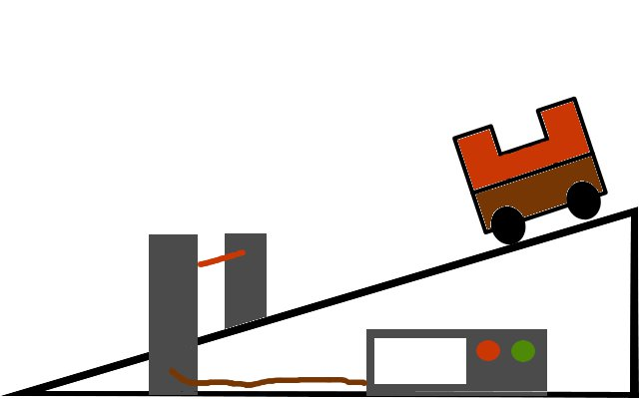

4.2 | An experiment to measure the acceleration of a falling object.
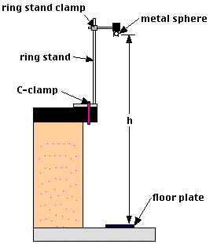

11.5 | I can describe an experiment to verify the inverse square law for a point source of light
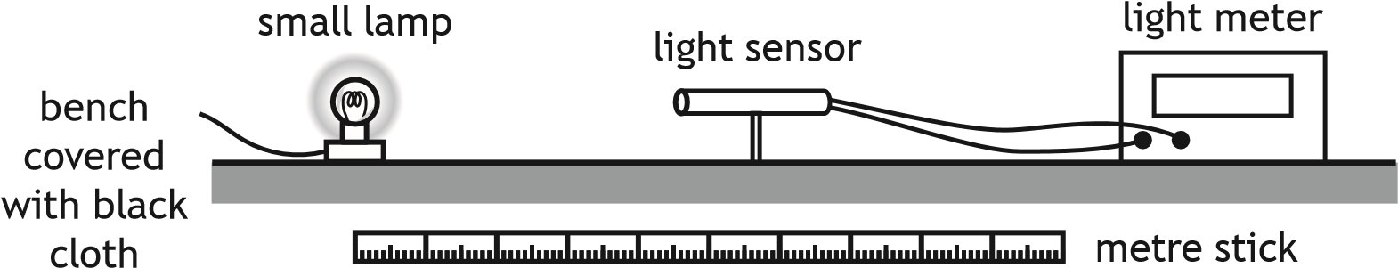

15.3 | I can describe an experiment to determine the refractive index of a medium.
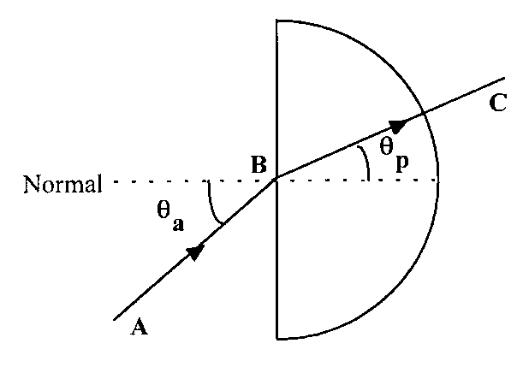
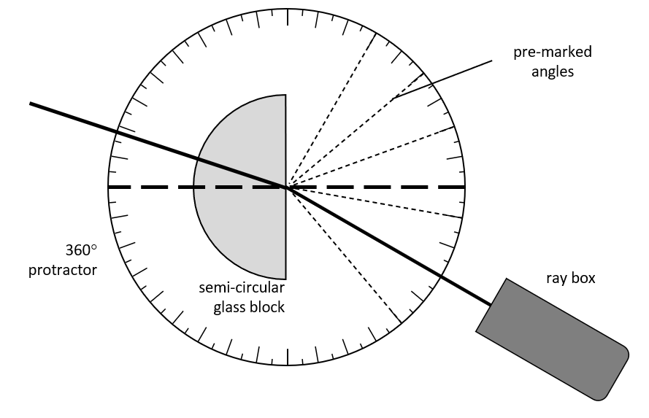
19.3 | I can describe of an experiment to measure the EMF and internal resistance of a cell.
A
V
A

20.9 | I can describe experiments to investigate the variation of current in a capacitor and voltage across a capacitor with time, for the charging and discharging of capacitors
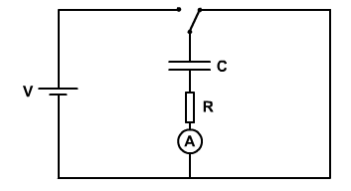

Annotated relationships sheet for Higher Physics
Content
Content
$$d=\overline{v}t$$
$$distance \left(m\right)=average speed \left(ms^{-1}\right)×time (s)$$
$$s=\overline{v}t$$
$$displacement \left(m\right)=average velocity \left(ms^{-1}\right)×time (s)$$
$$v=u+at$$
$final velocity \left(ms^{-1}\right)=initial velocity \left(ms^{-1}\right)+acceleration \left(ms^{-2}\right)×time (s)$
$$s = ut +\frac{1}{2} at^{2}$$
$$displacement=initial velocity ×time+\frac{1}{2}×acceleration \left(ms^{-2}\right)×{time}^{2} (s^{2})$$
$$v^{2}= u^{2} + 2as$$
$${final velocity }^{2 }{\left(ms^{-1}\right)}^{2}= {initial velocity }^{2}{\left(ms^{-1}\right)}^{2}+2×acceleration \left(ms^{-2}\right)×dispacement (m)$$
$$s=\frac{1}{2}(v+u)t$$
$$displacement \left(m\right)=\frac{1}{2}×\left(final velocity (ms^{-1}\right)+initial velocity (ms^{-1}))×time (s)$$
$$F=ma$$
$$force \left(N\right)=mass \left(kg\right)×acceleration (ms^{-2})$$
$$W=mg$$
$$weight \left(N\right)=mass \left(kg\right)×gravitational field strength (N {kg}^{-1})$$
$$E_{w}=Fd$$
$$work done \left(J\right)=force \left(N\right)×distance (m)$$
$$E_{p}=mgh$$
$gravitational potential energy \left(J\right)= mass \left(kg\right)×gravitational field strength \left(N {kg}^{-1}\right)×vertical height (m)$
$$E_{k}=\frac{1}{2}mv^{2}$$
$$kinetic energy \left(J\right)= \frac{1}{2}×mass \left(kg\right)×{speed}^{2}{(ms^{-1})}^{2}$$
$$P= \frac{E}{t}$$
$$power \left(W\right)= \frac{energy (J)}{time (s)}$$
$$p=mv$$
$$momentum \left(kg{ms}^{-1}\right)=mass\left(kg\right) ×velocity ({ms}^{-1})$$
$$Ft=mv-mu$$
$$Impulse \left(Ns \right)=mass \left(kg\right)×final velocity \left(ms^{-1}\right)-mass \left(kg\right)×initial velocity \left(ms^{-1}\right)$$
$$Impulse \left(Ns \right)=change in momentum (kg ms^{-1})$$
$$F=G\frac{m_{1}m_{2}}{r^{2}}$$
$$Force \left(N\right)=Universal gravitational Constant (m^{3}{kg}^{-1}s^{-2})\frac{{Mass}_{1}\left(kg\right)×{Mass}_{2}(kg)}{{separation distance}^{2} (m^{2})}$$
$${NB The Universal Gravitational Constant =6.67 {10}^{-11} m}^{3}{kg}^{-1}s^{-2}$$
Content
$$t^{'}=\frac{t}{\sqrt{1-{\left(\frac{v}{c}\right)}^{2}}}$$
$$relativistic time \left(s\right)=\frac{time (s)}{\sqrt{1-{\left(\frac{speed (ms^{-1})}{speed of light in vacuum (ms^{-1})}\right)}^{2}}}$$
NB time can be in other units as this is a ratio, but both times must be in the same unit.
c = 3.0 × 10⁸ ms⁻¹
$$l^{'}=l\sqrt{1-{\left(\frac{v}{c}\right)}^{2}}$$
$$relativistic length \left(m\right)=length (m) ×\sqrt{1-{\left(\frac{speed \left(ms^{-1}\right)}{speed of light in vacuum \left(ms^{-1}\right)}\right)}^{2}}$$
c = 3.0 × 10⁸ ms⁻¹
$$f_{o}=f_{s}\left(\frac{v}{v\underline{+}v_{s}}\right)$$
$$\begin{matrix}frequency observed \\ \left(Hz\right)\end{matrix} =\begin{matrix}frequency of source \\ (Hz)\end{matrix} ×\left(\frac{speed of sound (ms^{-1})}{\begin{matrix}speed of sound \\ \left(ms^{-1}\right)\end{matrix} \begin{matrix}± \\ 0\end{matrix} \begin{matrix}velocity of source \\ (ms^{-1})\end{matrix}}\right)$$
ADD when the object moves AWAY from the observer and
TAKE AWAY (subtract) when the object comes TOWARDS the observer

$$z=\frac{λ_{observed }-λ_{rest}}{λ_{rest}}$$
$$Redshift (no unit)= \frac{observed wavelength \left(m\right)-rest wavelength (m) }{rest wavelength (m)}$$
$$z=\frac{v}{c}$$
$$Redshift (no unit)=\frac{recessional velocity (ms^{-1})}{speed of light in vacuum (ms^{-1})}$$
$$v=H_{o}d$$
$\begin{matrix}recessional velocity \\ \left(ms^{-1}\right)\end{matrix} =\begin{matrix}Hubble’s Constant \\ (s^{-1})\end{matrix}×\begin{matrix}distance from galaxy to observer \\ (m)\end{matrix}$
NB for this course the Hubble Constant Ho is given as 2·3 x 10⁻¹⁸ s⁻¹
$$W=QV$$
$$Work done moving a charge across a p.d. \left(J\right)=electrical charge \left(C\right)×voltage (V)$$
$$E=mc^{2}$$
$$Energy \left(J\right)=mass \left(kg\right)×speed of light squared ({ms}^{-1})^{2}$$
NB the speed of light squared is equal to 9.0 × 10¹⁶ m²s⁻²

$$I=\frac{P}{A}$$
$$irradiance (Wm^{-2})=\frac{power (W)}{area (m^{2})}$$

$$I=\frac{k}{d^{2}}$$
$$irradiance \left(Wm^{-2}\right)= \frac{constant (W)}{{distance}^{2}\left(m^{2}\right)}$$
This is more easily understood as
$$irradiance\left(Wm^{-2}\right){×distance}^{2}\left(m^{2}\right)=constant value (W)$$

$$I_{1}d_{1}^{2}=I_{2}d_{2}^{2}$$
$${irradiance}_{1} \left(Wm^{-2}\right)×{initial distance }^{2}(m^{2})={Irradiance}_{2} \left(Wm^{-2}\right)×{final distance }^{2}(m^{2})$$
$$E=hf$$
$$energy \left(J\right)=Planck^{'}s Constant (Js)×frequency (Hz)$$
NB Planck’s constant = 6.63 x 10⁻³⁴ Js
$$E_{k}=hf-hf_{o}$$
$$\begin{matrix}Kinetic Energy \\ (J)\end{matrix}=\left( \begin{matrix}Planck^{'}s Constant \\ \left(Js\right)\end{matrix} ×\begin{matrix}incident frequency \\ \left(Hz\right)\end{matrix}\right)-\left(\begin{matrix}Planck^{'}s Constant \\ \left(Js\right)\end{matrix} ×\begin{matrix}threshold frequency \\ (Hz) \end{matrix}\right)$$
NB Planck’s constant = 6.63 x 10⁻³⁴ Js
hf_{o} is also known as the work function (J), hf is the energy of the incident photon (J)
$$v=fλ$$
$$speed \left(ms^{-1}\right)=frequency \left(Hz\right)×wavelength (m)$$
$$E_{2}-E_{1}=hf$$
$$most excited energy\left(J\right)-least excited energy (J)= Planck^{'}s Constant \left(Js\right)×frequency \left(Hz\right)$$
$$d\sin{θ}=mλ$$
$$Slit separation \left(m\right) sin of angle from centre to the spot = m a whole number of wavelengths (m)$$
NB This equation is for constructive interference
Content
$$n=\frac{\sin{θ_{1}}}{\sin{θ_{2}}}$$
$$Refractive index = \frac{sine of the angle in vacuum/air}{sine of the angle in the material}$$

$$\frac{\sin{θ_{1}}}{\sin{θ_{2}}}=\frac{λ_{1}}{λ_{2}}=\frac{v_{1}}{v_{2}}$$
$$Refractive index = \frac{sin of the angle in vacuum/air}{sin of the angle in the material}=\frac{wavelength \left(air\right)(m)}{wavelength (material)(m)} = \frac{speed (air) (ms^{-1})}{speed (material)(ms^{-1})}$$
$$refractive index=ratio of wavelengths in vacuum/air and material$$
$$refractive index=ratio of the speeds in\frac{vacuum}{air}and the material$$
This formula really applies to material 1 being a vacuum, but there is not much difference between the refractive indexes of air and a vacuum ∴ we assume for Higher they have the same value.

$$\sin{θ_{c}=\frac{1}{n}}$$
$$Sine of the critical angle =\frac{1}{refractive index}$$
The critical angle is the angle in the material when the angle in air is 90°
$$V_{rms}=\frac{V_{peak}}{\sqrt{2}}$$
$$root mean square A.C. voltage (V) =\frac{peak voltage (V)}{ 1.414}$$
$$l_{rms}=\frac{I_{peak}}{\sqrt{2}}$$
$$root mean square A.C. current (A) =\frac{peak current (A)}{1.414}$$
$$T=\frac{1}{f}$$
$$Period (s)=\frac{1}{Frequency (Hz)}$$
$$V=IR$$
$$Voltage\left(V\right)=Current (A)×Resistance(Ω)$$
$$P=IV=I^{2}R=\frac{V^{2}}{R}$$
$$Power \left(W\right)=current \left(A\right)×voltage\left(V\right)={current }^{2}\left(A^{2}\right)×Resistance \left(Ω\right)=\frac{{Voltage}^{2 }(V^{2})}{Resistance (Ω)}$$
For resistors in series
Content
$$R_{T}=R_{1}+R_{2}+…$$
$$total resistance (Ω)={resistance }_{1}\left(Ω\right)+{resistance }_{2}(Ω)+…$$
For resistors in parallel
$$\frac{1}{R_{T}}=\frac{1}{R_{1}}+\frac{1}{R_{2}}+…$$
$$\frac{1}{total resistance (Ω)}=\frac{1}{{resistance }_{1}(Ω)}+\frac{1}{{resistance }_{2}(Ω)}+…$$
$$V_{1}=\left(\frac{R_{1}}{R_{1}+R_{2}}\right)V_{s}$$
$$voltage across component 1 in potential divider(V)=\left(\frac{{resistance}_{1} (Ω)}{total resistance(Ω)}\right)×supply voltage (V)$$
For resistances in series (potential divider circuits)
$$\frac{V_{1}}{V_{2}}=\frac{R_{1}}{R_{2}}$$
Ratio of the voltages in series = ratio of the resistance in series
$$\frac{Voltage across resistor1 (V)}{voltageacross resistor 2 (V)}= \frac{resistance of resistor1 (Ω)}{resistance of resistor 2 (Ω)}$$
$$E=V+Ir$$
$$e.m.f \left(V \right)= terminial potential difference \left(V\right)+ current \left(A\right) internal resistance (Ω)$$
This can also be written as $$E=I\left(R+r\right) or E=IR+Ir$$
I is the total current in the circuit, r is in series with the combined circuit resistance
Content
$$C=\frac{Q}{V}$$
$$Capacitance (F)=\frac{Charge (C)}{Voltage \left(V\right)}$$
$$Q=It$$
$$Charge (C) = current (A) time (s)$$
$$This is better explained as current is the rate of flow of charge \left(I=\frac{Q}{t}\right)$$
$$E=\frac{1}{2}QV=\frac{1}{2}CV^{2}=\frac{1}{2}\frac{Q^{2}}{C}$$
$$\begin{matrix}Energy stored in capacitor \\ (J)\end{matrix} = \frac{1}{2} \begin{matrix}charge stored in capacitor \\ (C)\end{matrix} \begin{matrix}voltage across capacitor \\ (V)\end{matrix}$$
$$\begin{matrix}Energy stored in capacitor \\ (J)\end{matrix} = \frac{1}{2} \begin{matrix}capacitance \\ (F)\end{matrix} \begin{matrix}v{oltage across capacitor}^{2} \\ {(V)}^{2}\end{matrix}$$
$$\begin{matrix}Energy stored in capacitor \\ (J)\end{matrix} = \frac{1}{2} \frac{{(charge stored in capacitor)}^{2} {(C}^{2})}{voltage across capacitor\begin{matrix} \\ (V)\end{matrix}}$$
$$Path difference=mλ or \left(m+\frac{1}{2}\right)λ, where m=0,1,2…$$
$$\begin{matrix}Path difference \\ \left(m\right)\end{matrix} =\begin{matrix}whole number of wavelengths \\ (constructive interference)\end{matrix}$$
$$\begin{matrix}path difference \\ \left(m\right)\end{matrix}=\begin{matrix}whole number of wavelengths+\frac{1}{2} a wavelength \\ (destructive interference) \end{matrix}$$
$$Random Uncertainty=\frac{Max value-\min{value}}{number of values }$$

$$or ∆R=\frac{R_{max}-R_{min}}{n}$$

NB for the random uncertainty in a value the units of the random uncertainty are the same as for the quantity you are finding the uncertainty for.
$$Random Uncertainty(units of the quantity)=\frac{Max value-\min{value}}{number of values }$$

Quantity symbol unit and unit Symbol
Content
Physical Quantity | Symbol | Unit | Unit Abb.  Content
acceleration | a | metre per second per second | m s⁻²
acceleration due to gravity | g | metre per second per second | m s⁻²
amplitude | A | metre | m
angle | θ | degree | °
area | A | square metre | m²
average speed | $$\overline{v}$$ | metres per second | m s⁻¹
average velocity | $$\overline{v}$$ | metres per second | m s⁻¹
capacitance | C | farad | F
change of speed | Δv | metre per second | m s⁻¹
change of velocity | Δv | metre per second | m s⁻¹
critical angle | θc | degree | °
current | I | ampere | A
displacement | s | metre | m
distance | D | metre, light year | m , ly
distance, depth, height | d or h | metre | m
electric charge | Q | coulomb | C
electric charge | Q or q | coulomb | C
electric current | I | ampere | A
electric field strength | E | newton per coulomb  volts per metre | N C⁻¹  Vm⁻¹
electromotive force (e.m.f) | E or ε | volt | V
energy | E | joule | J
energy level | E₁, E₂ | joule | J
final velocity | v | metre per second | m s⁻¹
force | F | newton | N
force, tension, upthrust, thrust | F | newton | N
frequency | f | hertz | Hz
frequency of source | f_{s} | hertz | Hz
fringe separation | Δx | metre | m
grating to screen distance | D | metre | m
gravitational field strength | g | newton per kilogram | N kg⁻¹
gravitational potential energy | E_{p} | joule | J
heat energy | E_{h} | joule | J
height, depth | h | metre | m
impulse | Ft | newton second  kilogram metre per second | Ns  kgm s⁻¹
initial speed | u | metre per second | ms⁻¹
initial velocity | u | metre per second | m s⁻¹
internal resistance | r | ohm | Ω
irradiance | I | watt per square metre | W m⁻¹
kinetic energy | Ek | joule | J
length | l | metre | m
mass | m | kilogram | kg
momentum | p | kilogram metre per second | kg m s⁻¹
number of photons per second per cross sectional area | N | - | -
observed wavelength | λ_{observed} | metre | m
peak current | I_{peak} | ampere | A
peak voltage | V_{peak} | volt | V
period | T | second | s
Planck’s constant | h | joule second | Js
potential difference | V | volt | V
potential energy | E_{p} | joule | J
power | P | watt | W
pressure | P or p | pascal | Pa
radius | r | metre | m
Redshift | Z | - | -
refractive index | n | - | -
relativistic length | l' | metre | m
relativistic time | t' | second | s
resistance | R | ohm | Ω
rest wavelength | λ_{rest} | metre | m
root mean square current | I_{rms} | ampere | A
root mean square voltage | V_{rms} | volt | V
slit separation | d | metre | m
specific heat capacity | c | joule per kilogram per kelvin | Jkg⁻¹K ⁻¹
specific latent heat | l | joule per kilogram | Jkg⁻¹
speed of light in a vacuum | c | metre per second | m s⁻¹
speed, final speed | v | metre per second | ms⁻¹
speed, velocity, final velocity | v | metre per second | m s⁻¹
supply voltage | V_{s} | volt | V
temperature | T | degree Celsius | °C
temperature | T | kelvin | K
threshold frequency | f_{o} | hertz | Hz
time | t | second | s
total resistance | R _{t} | ohm | Ω
velocity of observer | v_{o} | metre per second | m s⁻¹
velocity of source | v_{s} | metre per second | m s⁻¹
voltage | V | volt | V
voltage, potential difference | V | volt | V
volume | V | cubic metre | m³
Wavelength | λ | metre | m
weight | W | newton | N

Greek Alphabet

Content

Calculator Cribsheet
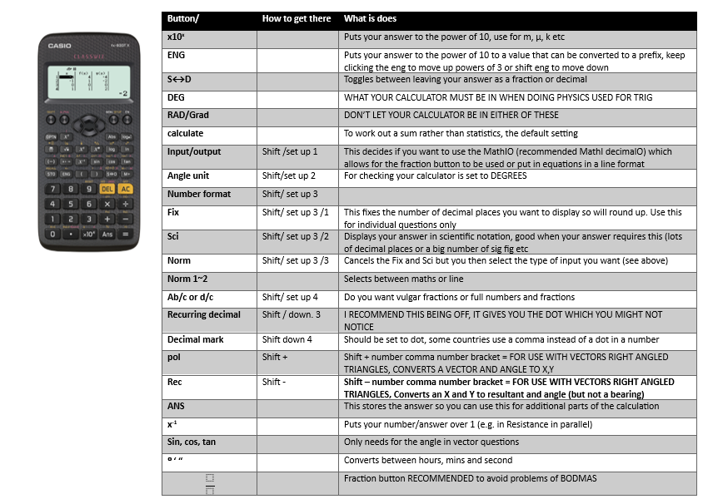
Instructions for the old style Casio are on the front page of mrsphysics in the resources table https://mrsphysics.co.uk/higher
Content

Instructions for the new round button calculator- beware this does silly things
Content

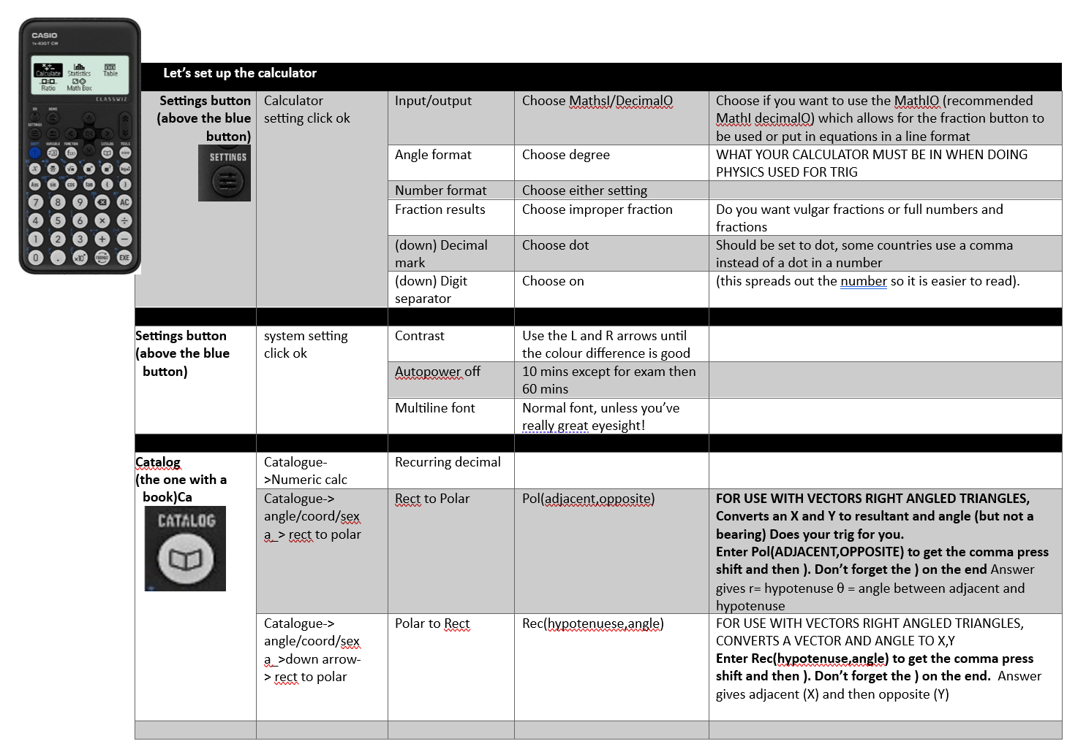

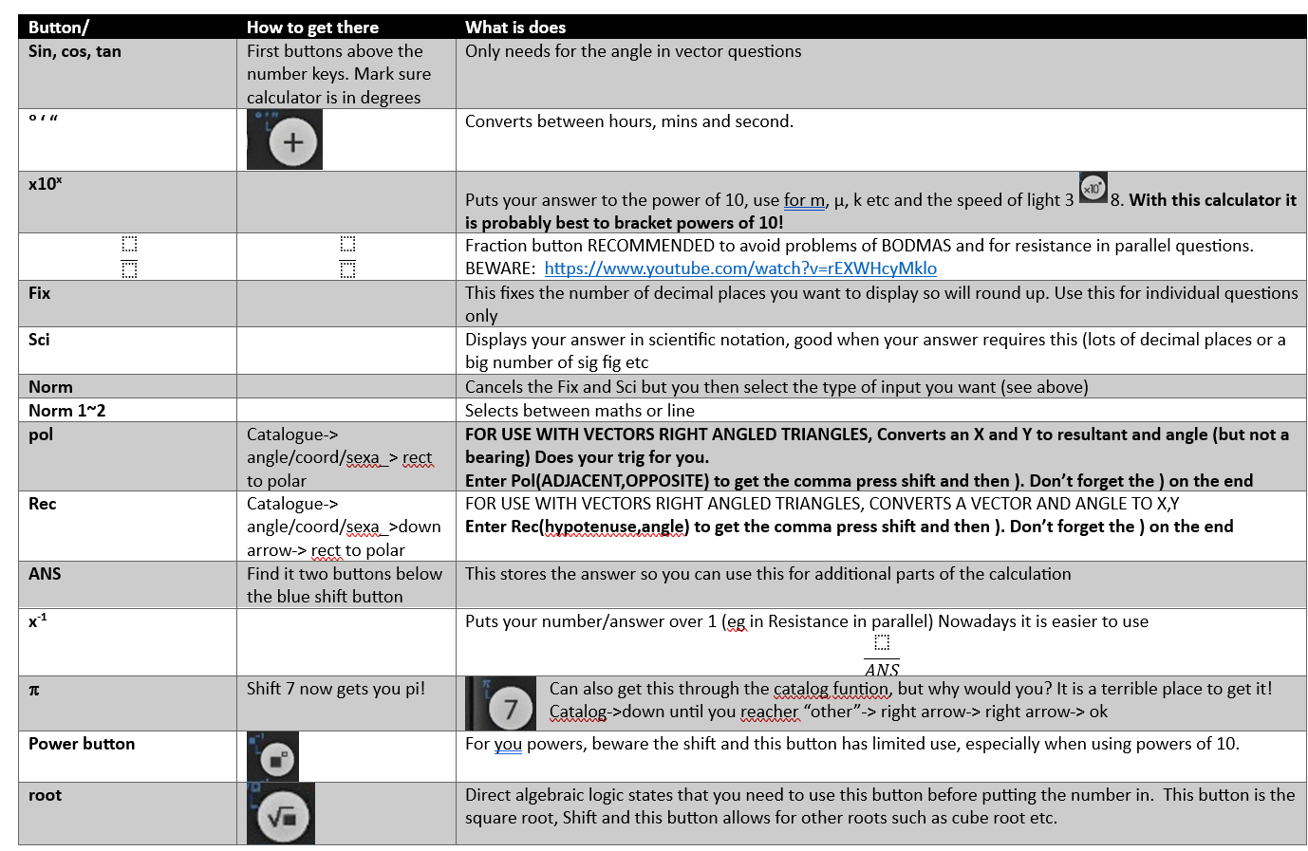

Content

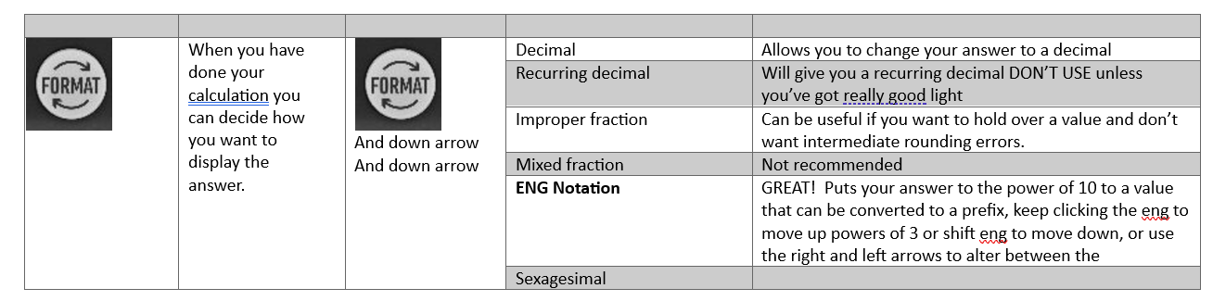

Add Your notes
Content

SI Units
Content
There is an international standard for units called the Systeme International D’Unites, SI units for short.
These consist of seven basic units, two of which we do not use in this course (the unit of luminous intensity, the candela, and the amount of substance containing a certain number of elementary particles, the mole).
The 5 basic units we use are units of mass, length, time, temperature and current. Every other unit can be expressed using a combination of these seven basic units.
Quantity | Symbol | Units
Mass | m | kilogram, kg
Length | l | metre, m
Time | t | second, s
Temperature | T | degrees Celsius, Kelvin, K
Current | I | ampere, A

e.g. Velocity is measured in metres per second, ms⁻¹

Trigonometry

Pythagoras
a
c
b
θ₂
θ₁

$$c^{2}=a^{2}+b^{2} \sin{θ_{1}}=\frac{b}{c}\cos{θ_{1}}=\frac{a}{c} \\ \sin{θ_{2}}=\frac{a}{c}\cos{θ_{2}}=\frac{b}{c} \\ ∴\sin{θ_{1}}≡\cos{θ_{2}} \\ \tan{θ_{1}}=\frac{b}{a}\tan{θ_{2}}=\frac{a}{b}$$

Cosine Rule
b
A
C
B
c
a
F
The cosine rule for a triangle states that:
$a^{2}=b^{2}+c^{2}-2bc\cos{A}$
$OR{ b }^{2}=c^{2}+a^{2}-2ca\cos{B}$ $OR c^{2}=a^{2}+b^{2}-2ab\cos{C}$

To prove these formula consider the following triangle, ABC:
Drop a line from C to form a perpendicular with AB at F.
$CF=b\sin{A}andAF=b\cos{A}$$$soBF=AB-AF=c-b\cos{A}$$
Using Pythagoras’ theorem in the triangle BFC:
Content
$BC^{2}=BF^{2}+CF^{2}$$$or a^{2}={\left(c-b\cos{A}\right)}^{2}+b^{2}\sin^{2}{A} \\ =c^{2}-2bc\cos{A}+b^{2}\left(\sin^{2}{A}+\cos^{2}{A}\right) \\ =b^{2}+c^{2}-2bc\cos{A}$$

Sine Rule
C
A
B
a
c
b
D
The sine rule for a triangle states that:
$\frac{a}{\sin{A}}=\frac{b}{\sin{B}}=\frac{c}{\sin{C}}$
To prove these formula consider
the following triangle, ABC:
Drop a line from C to form a
perpendicular with BC at D.
$AD=c\sin{B}=b\sin{C} ∴\frac{b}{\sin{B}}=\frac{c}{\sin{C}}$

. Prefixes
Prefix | Symbol | Multiple | Multiple in full
Tera | T | x10¹² | x1 000 000 000 000
Giga | G | x10⁹ | x1 000 000 000
Mega | M | x10⁶ | x1 000 000
Kilo | k | x10³ | x1 000
 |  | x1 | 1
Milli | m | x10⁻³ | ÷1 000
Micro | μ | x10⁻⁶ | ÷1 000 000
Nano | n | x10⁻⁹ | ÷1 000 000 000
Pico | p | x10⁻¹² | ÷1 000 000 000 000
Above is a table of prefixes, which you will commonly find in Higher Physics.
NB THE STANDARD UNIT FOR MASS IS THE KILOGRAM. Do not try changing it to grams!
Watch out for ms which is milli seconds not metres per second!
Content

Uncertainties

. Quantifying Uncertainties
- Find the mean
$$\text{mean value}=\frac{Σ\text{results}}{\text{no. of observation}}$$
This is the best estimate of the “true” value but not necessary the “true” value

- Find the approximate random uncertainty in the mean (absolute uncertainty)
This can be written as $=\frac{\text{range}}{\text{no. of observation}}$ and it is sometimes referred to as average deviation or absolute uncertainty.
stop here and quote the result with an approx. random uncertainty
MEAN ± approx. random uncertainty (UNITS)

- Find the percentage uncertainty.

$percentage uncertainty=\frac{approximately randon uncertainty}{mean value}×100\%$=

$$percentage uncertainty=\frac{\frac{range}{n}}{mean value}×100\%$$
stop here and quote the result with a percentage uncertainty
MEAN (UNITS)± percentage uncertainty (%) (

Or (uncertainty in reading/reading )× 100%
Content

Scale reading uncertainty
Analogue device = ±½ scale division
Digital device = ±1 in the last digit

Overall uncertainty in an Experiment
In an experiment, where more than one physical quantity has been measured, spot the quantity with the largest percentage uncertainty. This percentage uncertainty is often a good estimate of the percentage uncertainty in the final numerical result of the experiment.
eg if one measurement has an uncertainty of 3% and another has an uncertainty of 5%, then the overall percentage uncertainty in this experiment should be taken as 5%
When completing an experimental EVALUATION, always refer to the magnitude of the uncertainty to give an indication of how reliable your results are.

Accuracy & Precision
Accuracy is how close your answer is to the true value. Precision is how repeatable a measurement is. Use the diagram below to remind you which is which.
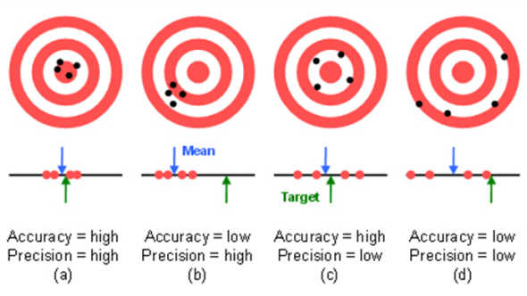
http://preview.tinyurl.com/lwanwoh
In Physics you will often calculate an answer to a question that has a large number of significant figures or decimal places. Because it is highly unlikely that we need to know the answer that precisely. It is important to round off any answers that you find.

Marking Principles
You need to refer to the document General Marking Principles for guidance on how questions are marked.
https://www.sqa.org.uk/files_ccc/general-marking-principles-physics.pdf
Before you get in to the Higher Physics Course make sure you’ve looked over this material (there are laminated sheets in the Physics Dept).

How many Significant Figures?
The simple rule is this: Your answer should have no more than the number of significant figures given in the question.
Content
If different numbers in the question are given to a different number of significant figure you should use the number of significant figures in the value given to the smallest number of significant figures.
Content

Example
Question: A rocket motor produces 4,570N of thrust to a rocket with a mass of 7.0kg.What is the acceleration of the rocket?
The calculated answer to this question would be 652.8571429 ms⁻² . However the least accurate value we are given in the question is the value of the mass. This is only given to two significant figures. Therefore our answer should also be to two significant figures: 650 ms^{–2} .

From the General Marking Principles
Question: Calculate the kinetic energy of a 0·950 kg ball travelling at 2·35 m s⁻¹.
Response
$$E_{k}=\frac{1}{2}mv^{2}$$  $$E_{k}=0.5×0.950×2{.35}^{2}$$  $$E_{k}=2.6231875$$  $$E_{k}=2.62 J$$  Award 3 marks | In rounding to an expected number of significant figures, the mark can be awarded for answers which have up to two figures more or one figure less than the number in the data with the fewest significant figures.  1 mark for selected relationship.  1 mark for correct substitution.  1 mark for the correct final answer, including unit.  (2·6 J, 2·623 J and 2·6232 J are also acceptable)
If the final answer in the Response is
3 J, 2·62319 J, 2·623188 J or 2·6231875 J
Mark for final answer is not awarded.
Award a maximum of 2 marks
Question
An unbalanced force of 4·0 N is applied to a 6·0 kg mass. Calculate the acceleration of the mass.
Response
$$F=ma$$  $$4.0=6.0×a$$  $$a=0.6\dot{6}ms^{-2}$$  Award 2 marks | 1 mark for selected relationship.  1 mark for correct substitution.  Mark for final answer is not awarded.  (Use of the recurrence dot implies an infinite number of significant figures.)

Question
In a ripple tank, a wave generator produces 9 waves in 27 seconds. The wavelength of the waves is 4·5 cm. Determine the speed of the waves.
Response

Award 4 marks | In numerical calculations involving intermediate stages, candidates should not round intermediate values. If intermediate rounding leads to a final answer which is incorrect then treat as an arithmetic error.  1 mark for selected relationship.  1 mark for correct substitution.  1 mark for selected relationship.  1 mark for correct substitution.  Mark for final answer not awarded (rounding off at an intermediate stage has resulted in an incorrect final answer). (Final answer should be 2 cm s⁻¹ rounded from 1·5 cm s⁻¹.)  Content

Mark Scheme for the Assignment

Section | Expected response | Marks
Aim. | An aim that describes clearly the purpose of the investigation | 1
Underlying physics | An account of the physics relevant to the aim of the investigation. | 3
Data collection and handling | A brief summary of an approach used to collect experimental data. | 1
Data collection and handling | Sufficient raw data from the candidate’s experiment. | 1
Data collection and handling | Data, including any mean and/or derived values, presented in correctly produced table. | 1
Data collection and handling | Data relevant to the experiment obtained from an internet/literature source or data relevant to the aim of the investigation obtained from a second experiment. | 1
Data collection and handling | A citation and reference for a source of internet/literature data or information. | 1
Graphical presentation | Axes of the graph have suitable scales. | 1
Graphical presentation | Axes of the graph have suitable labels and units. | 1
Graphical presentation | Accurately plotted data points and, where appropriate, a line of best fit. | 1
Uncertainties | Scale reading uncertainties and random uncertainties. | 2
Analysis | Analysis of experimental data. | 1
Conclusion | A valid conclusion that relates to the aim and is supported by all the data in the report. | 1
Evaluation | Evaluation of the investigation. | 3
Structure | A clear and concise report with an informative title. | 1
TOTAL |  | 20

Content

Personal Notes

Content

EXAM DATE: 29th April 2027

