2027
J. A. Hargreaves
Mostly Harmless


Mrs Physics’ Higher Physics
Compendium ANSWERS


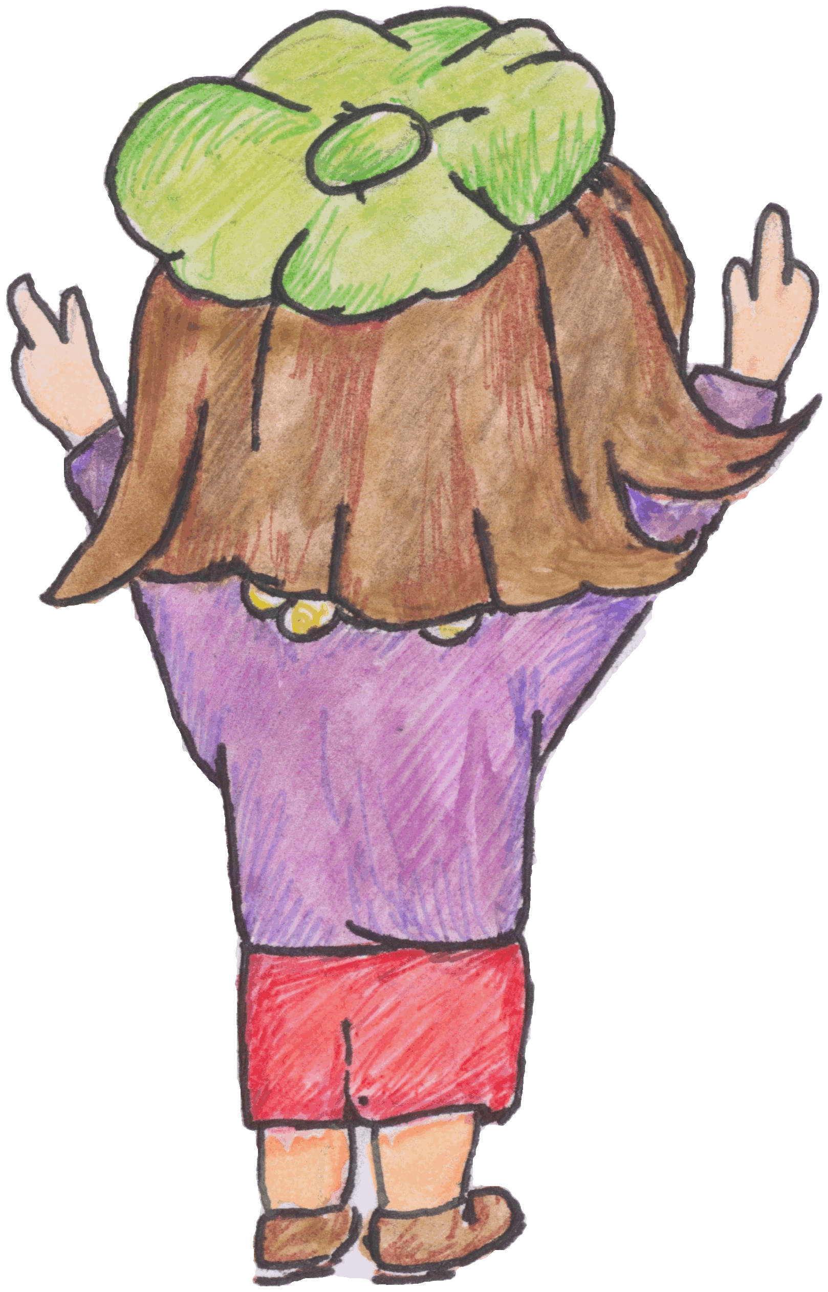

Summary of The Physics Course
The following material is taken from the Higher Course Specifications version 1.0 April 2018 produced by the SQA. https://www.sqa.org.uk/sqa/47916.html

There are three units to this course and an Assignment

Summary of Our Dynamic Universe
The topics covered are:
- motion — equations and graphs
- forces, energy and power
- collisions, explosions, and impulse
- gravitation
- special relativity
- the expanding Universe

Summary of Particles and Waves
The topics covered are:
- forces on charged particles
- the Standard Model
- nuclear reactions
- inverse square law
- wave-particle duality
- interference
- spectra
- refraction of light

Summary of Electricity
The topics covered are:
- monitoring and measuring AC
- current, potential difference, power, and resistance
- electrical sources and internal resistance
- capacitors
- semiconductors and p-n junctions
There is also an assignment which must be completed.

COURSE OUTCOMES
No | CONTENT
1. | Uncertainties
eq | or $$∆R=\frac{R_{max}-R_{min}}{n}$$
1.1 | all measurements of physical quantities are liable to uncertainty
1.2 | I can quantify and recognise scale reading, random and systematic uncertainties in a measured quantity.
1.3 | I can express uncertainties in absolute or percentage form
1.4 | random uncertainties arise when an experiment is repeated and slight variations occur.
1.5 | scale reading uncertainty is a measure of how well an instrument scale can be read.  Analogue device = ±½ scale division  Digital device = ±1 in the last digit
1.6 | scale reading uncertainty is an indication of how precisely a scale can be read.
1.7 | random uncertainties can be reduced by taking repeated measurements.
1.8 | systematic uncertainties occur when readings taken are either all too small or all too large.
1.9 | systematic uncertainties can arise due to measurement techniques or experimental design.
1.10 | the mean of a set of repeated measurements is the best estimate of the ‘true’ value of the quantity being measured.
1.11 | when systematic uncertainties are present, they offset the mean value
1.12 | when mean values are used, the approximate random uncertainty should be calculated.
1.13 | I can correctly calculate, use and identify uncertainties during data analysis.
1.14 | when an experiment is being undertaken and more than one physical quantity is measured, the quantity with the largest percentage uncertainty should be identified and this may often be used as a good estimate of the percentage uncertainty in the final numerical result of an experiment.
1.15 | I can express the numerical result of an experiment in the form final value ±uncertainty.  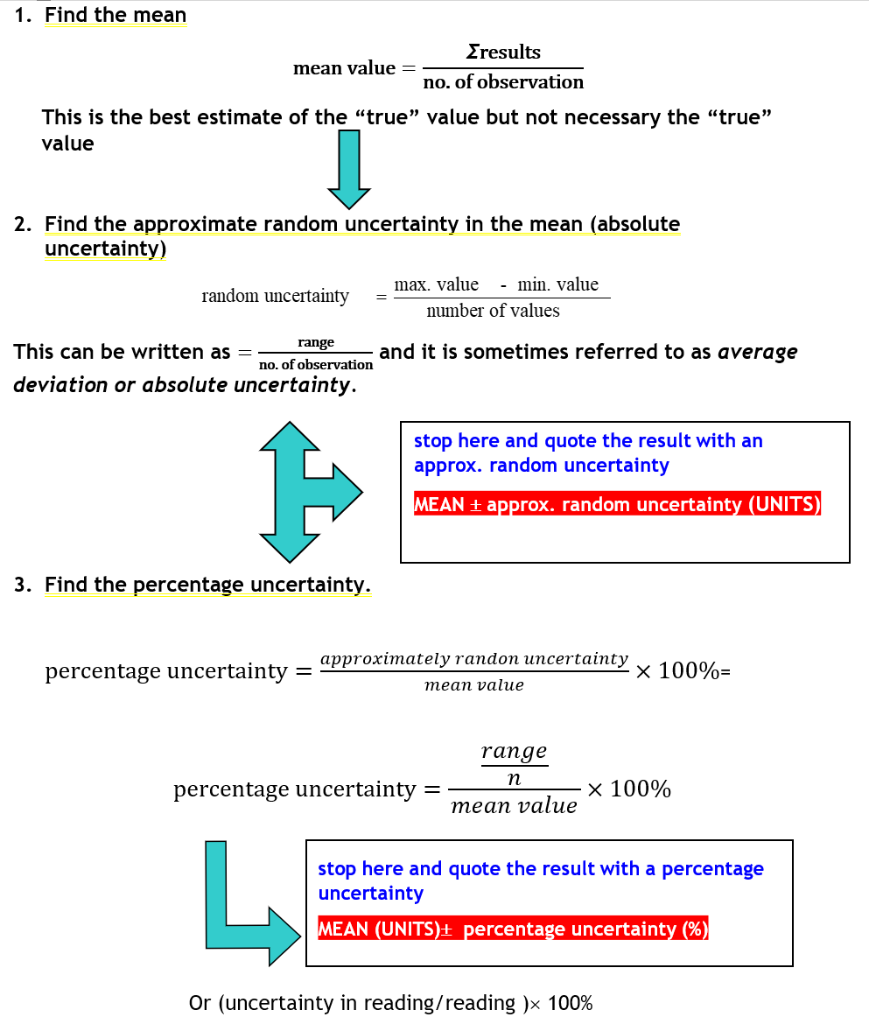

Units Prefixes and Scientific Notation

No | CONTENT
2. | Units, prefixes and scientific notation
2.1 | I know the units for all of the physical quantities used in this unit. (see annotated relationships sheet)
2.2 | I can use the prefixes: pico (p), nano (n), micro (μ), milli (m), kilo (k), mega (M), giga (G) and tera (T).  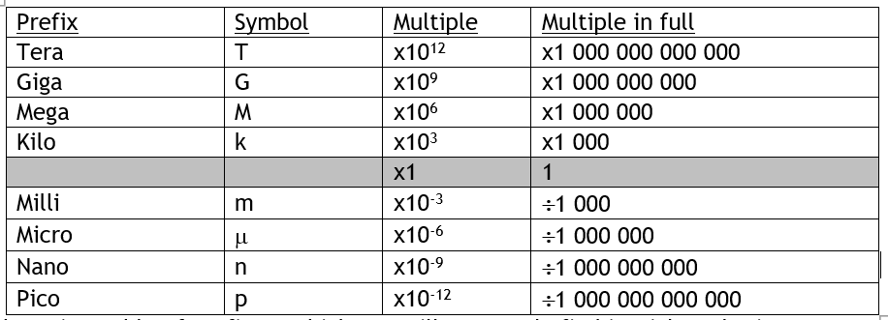  Above is a table of prefixes, which you will commonly find in Higher Physics.  NB THE STANDARD UNIT FOR MASS IS THE KILOGRAM. Do not try changing it to grams!  Watch out for ms which is milli seconds not metres per second!
2.3 | I can give an appropriate number of significant figures when carrying out calculations. (This means that the final answer can have no more significant figures than the value with least number of significant figures used in the calculation).  Find the number with the least significant figures given in the question. This should be the number of sig fig you quote in your answer. Do not round up too early. If you struggle change your calculator settings to SCI and use 3 sig fig, this usually works as a final answer.
2.4 | I can use scientific notation when large and small numbers are used in calculations.

Our Dynamic Universe

No | CONTENT |  | 
3. | Equations of Motion
Eq | $d=\overline{v}t, s=\overline{vt} ; s=\frac{1}{2}\left(u+v\right)t;$ $v=u+at s=ut+\frac{1}{2}at^{2} v^{2}\text{= }u^{2}+2as$
3.1 | I can use the equations of motion to find distance, displacement, speed, velocity, and acceleration for objects with constant acceleration in a straight line.  Remember s,v,a are vector quantities you must remember the direction, especially in the vertical component of projectile questions, that s will be negative, if a is negative and the object falls below it’s starting point.
3.2 | I can interpret and draw motion-time graphs for motion with constant acceleration in a straight line, including graphs for bouncing objects and objects thrown vertically upwards.  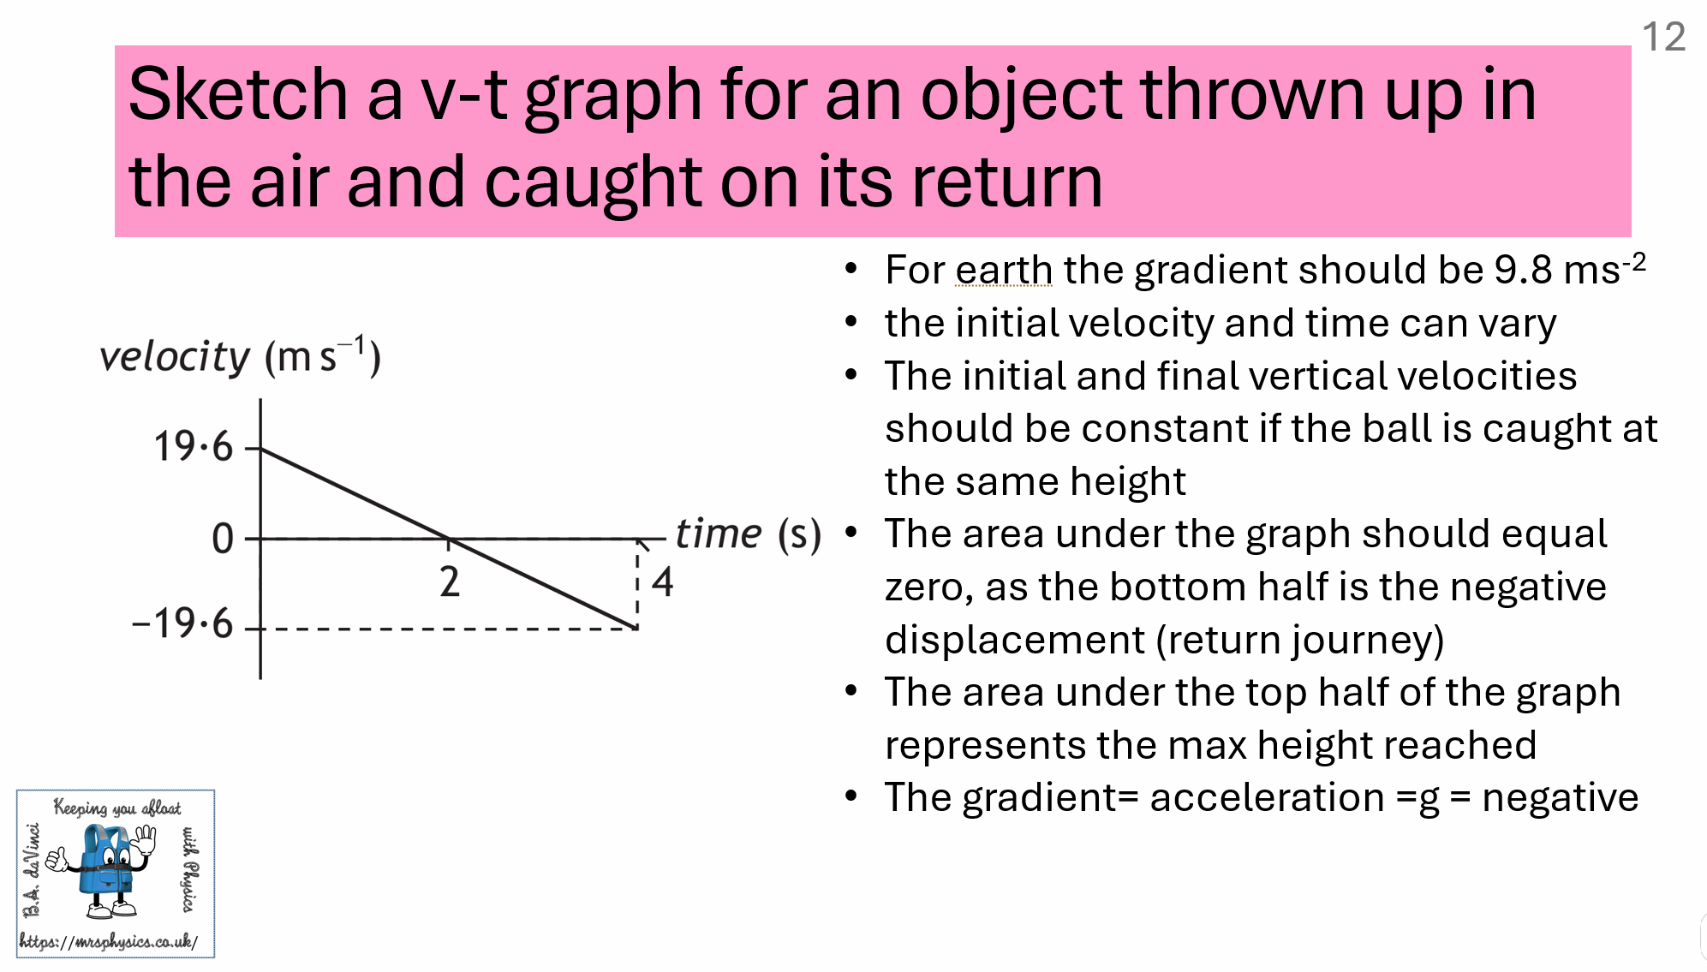  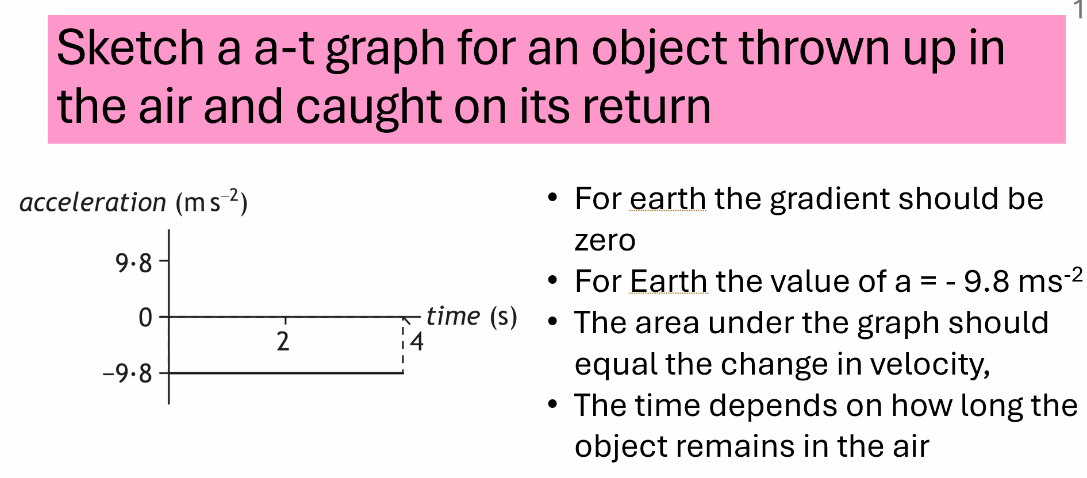  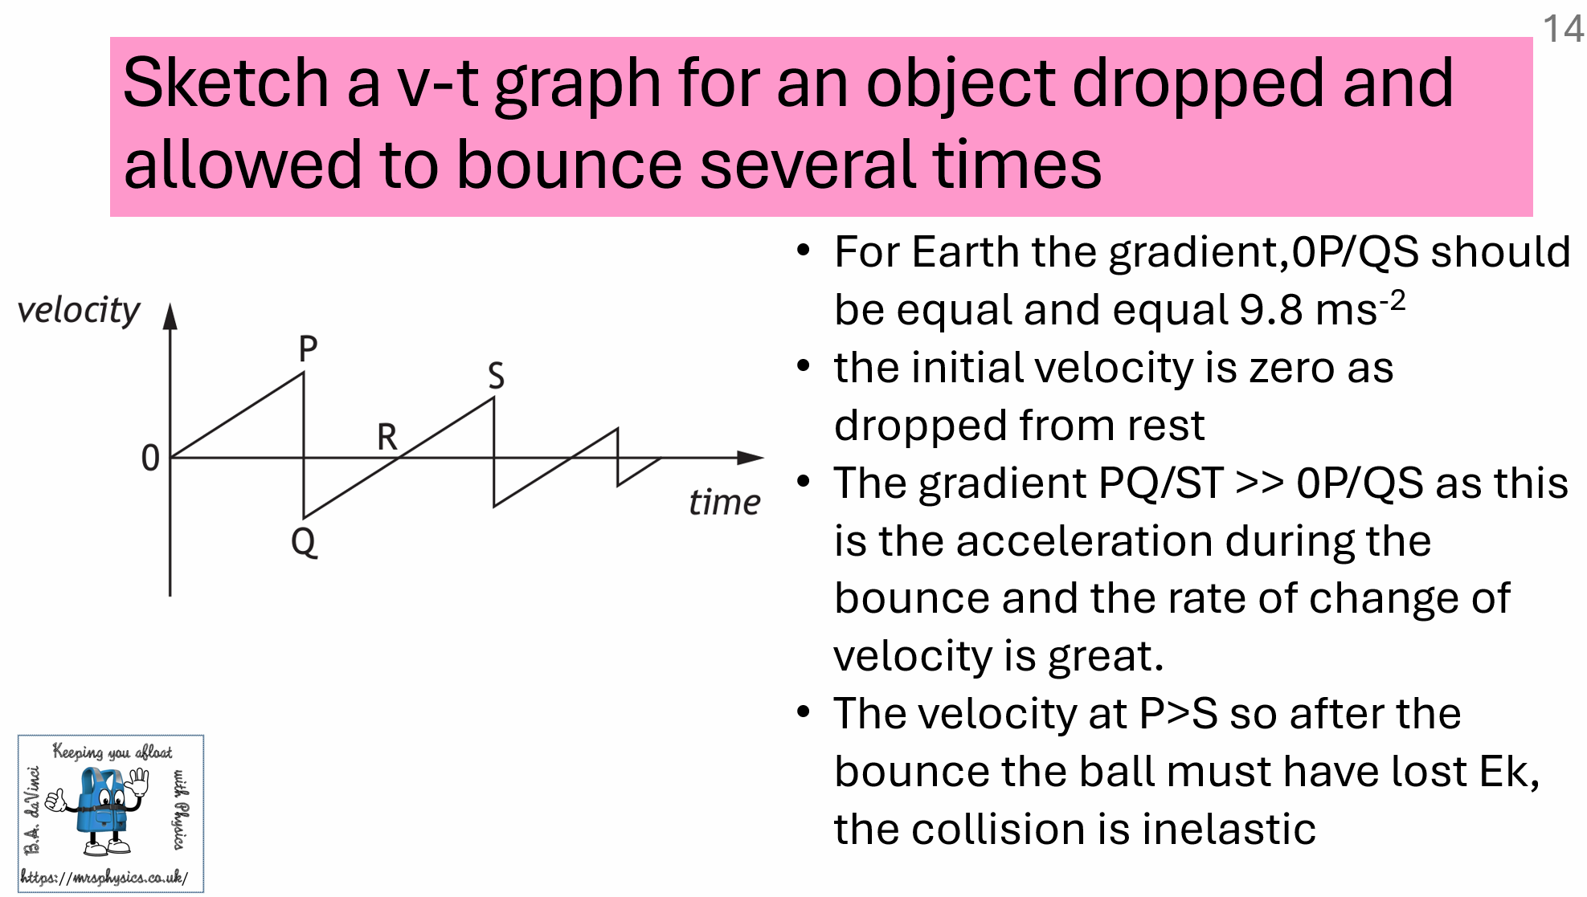
3.3 | I know the interrelationship of displacement-time, velocity-time and acceleration- time graphs.
3.4 | I can calculate distance, displacement, speed, velocity, and acceleration from appropriate graphs (graphs restricted to constant acceleration in one dimension, inclusive of change of direction).  Gradient of a v-t graph = acceleration  Area under a v-t graph = displacement (or distance if you ignore the under the y=0 is negative and just add all the areas)  Gradient of a s-t graph = velocity  Area under a a-t graph = change in velocity
 | An acceleration of XXX means the velocity increases by XXX m s ⁻¹ every second
3.5 | I can give a description of an experiment to measure the acceleration of an object down a slope  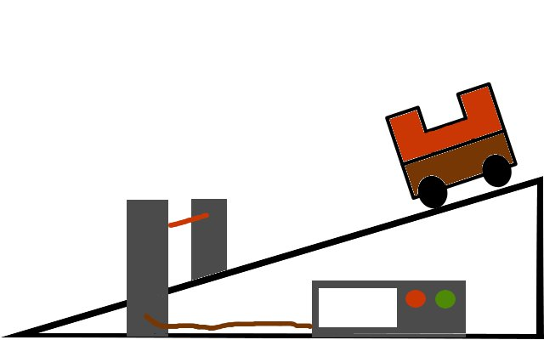  Or  use two light gates and a single mask  Or  if u=0 ms⁻¹ then measure instantaneous speed at the bottom of the slope but time for the object to roll down the slope.  To compensate for friction find the angle you have to lift the slope so that the trolley moves down the slope with 0 acceleration or at constant velocity. The rename this height zero and subtract this a=0 height from all other heights.
4. | Forces, energy and power
Eq | W = mg F = ma E_{W} or W = Fd Ep = mgh Ek = ½ mv² E = Pt
4.1 | I can use vector addition and appropriate relationships to solve problems involving balanced and unbalanced forces, mass, acceleration and gravitational field strength.
4.2 | I know the effects of friction on a moving object (static and dynamic friction are not required)  Friction always opposes motion, so is in the opposite direction to the unbalanced Force and direction of travel.
4.3 | I can identify and explain the effects of friction on moving objects. I do not need to use reference to static and dynamic friction.  Friction always opposes motion, so always works against the unbalanced force. (check).
4.4 | I can identify and explain, in terms of forces an object moving with terminal velocity  For an object travelling at terminal velocity the frictional forces balance any force causing a forward motion. The result is a constant velocity
4.5 | I can interpret and produce velocity-time graphs for a falling object when air resistance is taken into account.
4.6 | I can analyse motion using Newton’s first and second laws.
4.7 | I can use free body diagrams and appropriate relationships to solve problems involving friction and tension.  Consider Tension as the balancing Force. To get the direction cut the object under tension and the way the object moves will be in the opposite direction to the tension (when it was present)
4.8 | I can resolve a vector into two perpendicular components.  (Rec(hypotenuse,angle) X=adj, Y=opp
4.9 | I can resolve the weight of an object on a slope into a component acting parallel (down the slope) and a component acting normal to the slope.  The component of force acting down the slope is mgsinθ  The component of force acting into the slope is mgcosθ is balanced by the reaction force from the slope. If there is friction its direction opposes motion, so  If the object is travelling down the slope you have mgsinθ down the slope and friction up the slope  If the object is travelling up the slope you have mgsinθ and friction down the slope so the acceleration (-ve) will be greater than the acceleration down the slope.  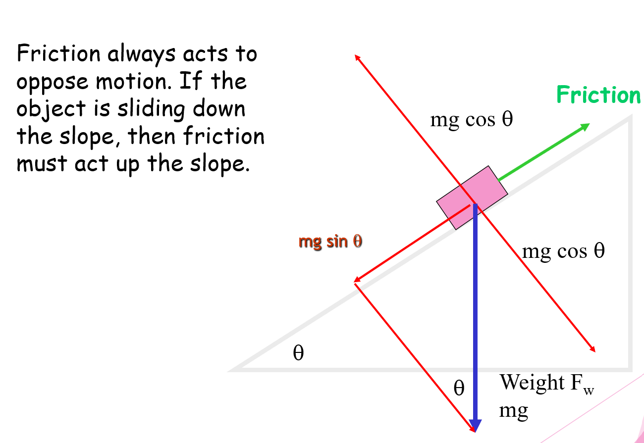  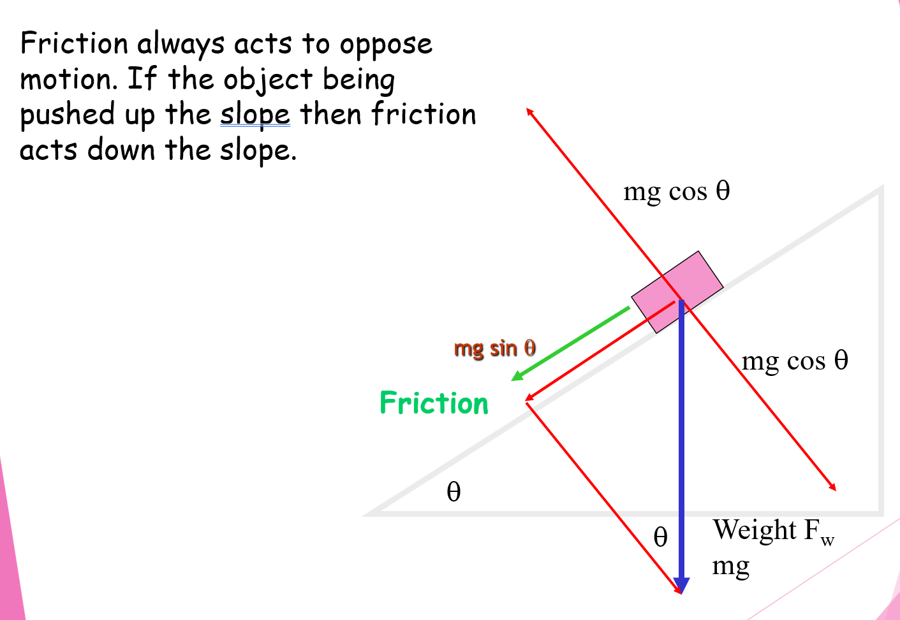
4.10 |  | I can use the principle of conservation of energy and appropriate relationships to solve problems involving work done, potential energy, kinetic energy and power.  If there are no energy losses due to friction  $$E_{w}=Fd = mgh =\frac{1}{2}mv^{2}=\frac{P}{t}$$
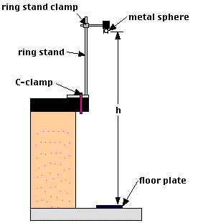
An experiment to measure the acceleration of a falling object.
5. | Collisions and explosions
Eq | p = mv Ft = mv − mu ${E_{k}=\frac{1}{2}mv}^{2}$
5.1 | I can use the principle of conservation of momentum and an appropriate relationship to solve problems involving the momentum, mass and velocity of objects interacting in one dimension.  Total momentum before (a collision) is equal to the total momentum after (a collision) in the absence of external forces.
5.2 | I can explain the role in kinetic energy in determining whether a collision is described as elastic and inelastic collisions or in explosions.  In ALL collisions TOTAL momentum is CONSERVED, TOTAL ENERGY is CONSERVED  In an ELASTIC COLLISION= Kinetic energy is conserved  In an INELASTIC COLLISION= Kinetic energy is lost
5.3 | I can use appropriate relationships to solve problems involving the total kinetic energy of systems of interacting objects.  Total momentum before = total momentum after  if they stick together  Change in p₁ = change in p₂
5.4 | I can use Newton’s third law to explain the motion of objects involved in interactions.
5.5 | I can draw and interpret force-time graphs involving interacting objects.  For force-time graphs:  area under graph  t  F  5  12  0  = Ft  = Δp (change in momentum)  = impulse  Impulse = area under the graph  = ½ x 12 x 5 = 30 N s.  Note the 12N is the peak Force and not the force you calculate which is the average Force. In reality a force-time graph is usually a bell curve.
5.6 | the impulse of a force is equal to the area under a force-time graph and is equal to the change in momentum of an object involved in the interaction.
5.7 | I can use data from a force-time graph to solve problems involving the impulse of a force, the average force and its duration.  The area under both these graphs should be the same as they equal the change in momentum.  Safety devices often use the principle of increasing the time to stop which reduces your average Force -which is what harms you.  Eg you don’t usually die every time you come off the motorway and come to a stop at the junction, you stop over a long distance. It is when you hit something and stop very quickly that there is a problem
5.8 | I can use appropriate relationships to solve problems involving mass, change in velocity, average force and duration of the force for an object involved in an interaction.  I’ve always encouraged the use of $Ft=m(v-u)$ but remember this is just a rearrangement of Newton’s second Law $F=ma$, so if you are more comfortable using that formula then do: who am I to judge!
6. | Gravitation
Eq | $d=\overline{v}t, s=\overline{vt} ; s=\frac{1}{2}\left(u+v\right)t;$ $v=u+at s=ut+\frac{1}{2}at^{2} v^{2}\text{= }u^{2}+2as$ $F=\frac{G{m_{1}m}_{2}}{r^{2}}$
6.1 | I can use the equation $F=\frac{G{m_{1}m}_{2}}{r^{2}}$  Remember r is the radius, or mean distance from the centre of an object to the centre of the other object. If the height above the planet etc is given you must add the radius of the planet, if it is the radius between two planets, or the moon and planet, or Sun and planet then the distance is measured from the centre of mass.
6.2 | I can give a description of an experiment to measure the acceleration of a falling object.
6.3 | the horizontal motion and the vertical motion of a projectile are independent of each other.
6.4 | satellites are in free fall around a planet/star.
6.5 | I can resolve the initial velocity of a projectile into horizontal and vertical components and their use in calculations.  If the angle is given to the horizonal your vertical component = R sin θ  If the angle is given to the horizonal your horizontal component = R cos θ  Or [Rec(R,angle)] gives X= horizontal, Y= vertical
6.6 | I can use resolution of vectors, vector addition, and appropriate relationships to solve problems involving projectiles.
6.7 | I can use Newton’s Law of Universal Gravitation to solve problems involving force, masses and their separation.  $$F=\frac{G{m_{1}m}_{2}}{r^{2}}$$  Beware a typical mistake is to forget the square the radius. If you are given the height of a satellite from the surface, don’t forget to add the radius of the planet on to r. If it is the mean distance between eg the Earth and Sun in the data sheet, this already has the radii included!
7. | Special relativity
Eq | $l'=l\sqrt{1-\frac{v^{2}}{c^{2}}}$ $t'=\frac{t}{\sqrt{1-\frac{v^{2}}{c^{2}}}}$
7.1 | the speed of light in a vacuum is the same for all observers.
7.2 | measurements of space, time and distance for a moving observer are changed relative to those for a stationary observer, giving rise to time dilation and length contraction.
7.3 | I can use appropriate relationships to solve problems involving time dilation, length contraction and speed.  The person with the measuring tape or watch in the same inertial frame of reference as the object being measured has the correct value. Those observing from a different inertial frame of reference are measuring t’ or l’  BTW no need to change the units of t and l into s and m as it is a ratio, the units will be the same as the original units.
8. | The expanding Universe
Eq | $f_{\text{observed}}=f_{source}\frac{v}{\left[v+v_{source}\right]}$ $v = H_{o}d$
8.1 | the Doppler effect causes shifts in wavelengths of sound and light.
Frequency increasing as an object making a sound moves toward the observer
Statement that there are more wavefronts per second (arriving at the microphone/person/detector).
OR
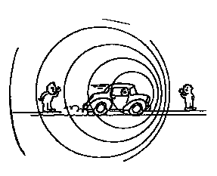
The wavefronts (arriving at the microphone/person/detector) are closer together.
OR
Diagram showing wavefronts closer together ahead of the vehicle and further apart behind it.
Don’t draw the car, just an arrow!

8.2 | I can use appropriate relationship to solve problems involving the observed frequency, source frequency, source speed and wave speed.  Start with this equation if it is moving towards or away as that gets one mark in the bag!  If the object is coming Towards, Take away, if the object is going AWAY, Add
8.3 | the light from objects moving away from us is shifted to longer wavelengths (redshift).
8.4 | The redshift of a galaxy is the change in wavelength divided by the emitted wavelength.  For slowly moving galaxies, redshift is the ratio of the recessional velocity of the galaxy to the velocity of light.
8.5 | I can use appropriate relationships to solve problems involving redshift, observed wavelength, emitted wavelength, and recessional velocity  $$z=\frac{{}_{o}-{}_{r}}{{}_{r}} or {}_{r}=\frac{{}_{o}}{z+1} or {}_{o}=(z×{}_{r})+{}_{r}$$  This equation can be hard to rearrange so you might want to learn the alternatives, well for ${}_{r}$ anyway
8.6 | I can use appropriate relationship to solve problems involving the Hubble constant, the recessional velocity of a galaxy and its distance from us.  $$z=\frac{{}_{o}-{}_{r}}{{}_{r}} =\frac{v}{c}=\frac{H_{0}d}{c}$$  This is often presented as a multi-stage problem
8.7 | Hubble-Lemaître Laws law allows us to estimate the age of the Universe.
8.8 | measurements of the velocities of galaxies and their distance from us lead to the theory of the expanding Universe.
8.9 | the mass of a galaxy can be estimated by the orbital speed of stars within it.
8.10 |  | evidence supporting the existence of dark matter comes from estimations of the mass of galaxies.
 |  | Therefore combining 8.9 and 8.10 orbital speed of stars within a galaxy supports the idea of the existence of dark matter.
8.11 |  | evidence supporting the existence of dark energy comes from the accelerating rate of expansion of the Universe.
8.12 |  | I know that the temperature of stellar objects is related to the distribution of emitted radiation over a wide range of wavelengths.  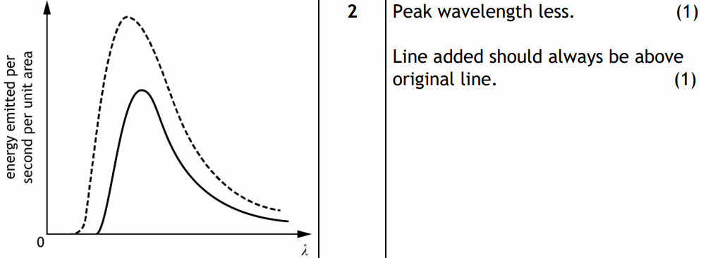
8.13 |  | the peak wavelength of this distribution is shorter for hotter objects than for cooler objects.  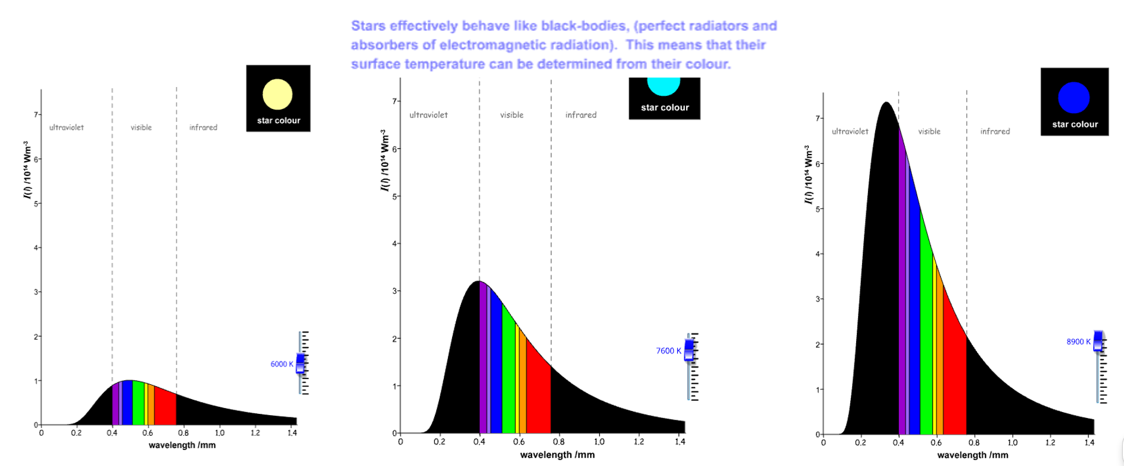  Note if the x-axis was frequency these graphs would be flipped along the vertical axis.  Please note the units of wavelength are incorrect on this graph and should be μm.
8.14 |  | hotter objects emit more radiation per unit surface area per unit time than cooler objects.  Note if the x-axis was frequency these graphs would be flipped along the vertical axis.
8.15 |  | evidence supporting the big bang theory and subsequent expansion of the Universe:  cosmic microwave background radiation,  the abundance of the elements hydrogen and helium,  the darkness of the sky (Olbers’ paradox) and  the large number of galaxies showing redshift rather than blueshift.

Particles and Waves

No | CONTENT |  | 
9. | Forces on charged particles
Eq | $W=QV$ $E_{k}=\frac{1}{2}mv^{2}$
9.1 | charged particles experience a force in an electric field.
9.2 | electric fields exist around charged particles and between charged parallel plates.
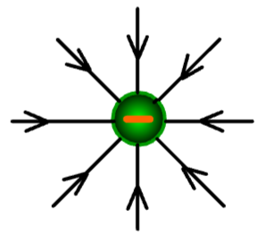  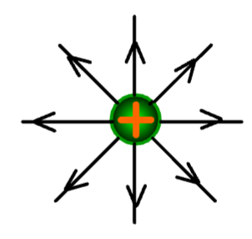  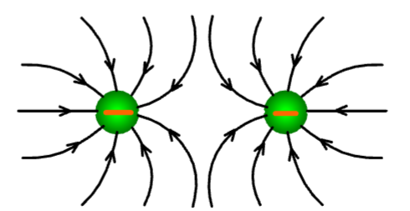  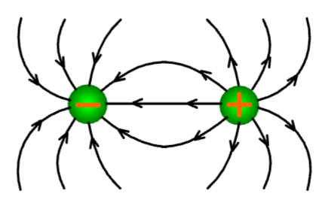  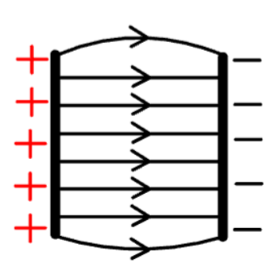  9.3 | I can sketch electric field patterns for single-point charges, systems of two-point charges and between two charged parallel plates (ignore end effects).  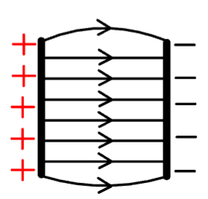
9.4 | I can determine the direction of movement of charged particles in an electric field.  A positive particle will be attracted to the negative plate  A negative particle will be attracted to the positive plate  A neutral particle will travel through an electric field undeviated.
9.5 | voltage (potential difference) is the work done moving unit charge between two points
9.6 | I can solve problems involving the charge, mass, speed, and energy of a charged particle in an electric field and the potential difference through which it moves.  $$Ew by the field=Ek gained by charged particle$$  $$QV =\frac{1}{2}m v^{2}$$
9.7 | A moving charge produces a magnetic field.
9.8 | I can determine the direction of the force on a charged particle moving in a magnetic field for negative and positive charges using the slap rule or other method.  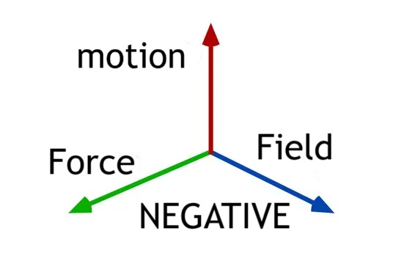  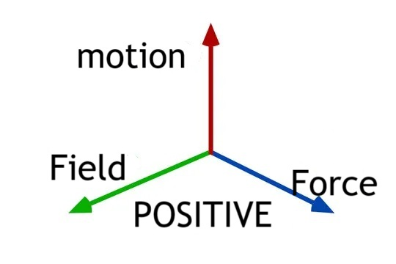  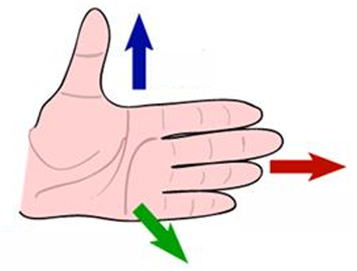  Different colour scheme sorry!  LEFT HAND  Blue= direction of the particle  Red = magnetic field (N to S)  Green is the motion of a negative particle, and the backhand is the motion of a positive particle.  Works for positive and negative and avoids arthritis in older life!
9.9 | I know the basic operation of particle accelerators in terms of acceleration by electric fields, deflection by magnetic fields and high-energy collisions of charged particles to produce other particles.  In a particle accelerator the electric field accelerates the charged particle  $$Ew by the field=Ek gained by charged particle$$  $$QV =\frac{1}{2}m v^{2}$$  In a particle accelerator the magnetic field alters the direction of the charged particle  When these particles are smashed together new particles are produced.
10. | Standard Model
10.1 | The Standard Model is a model of fundamental particles and interactions.
 | Fundamental particles are not composed of other particles.
10.2 | I can describe the Standard Model in terms of types of particles and groups  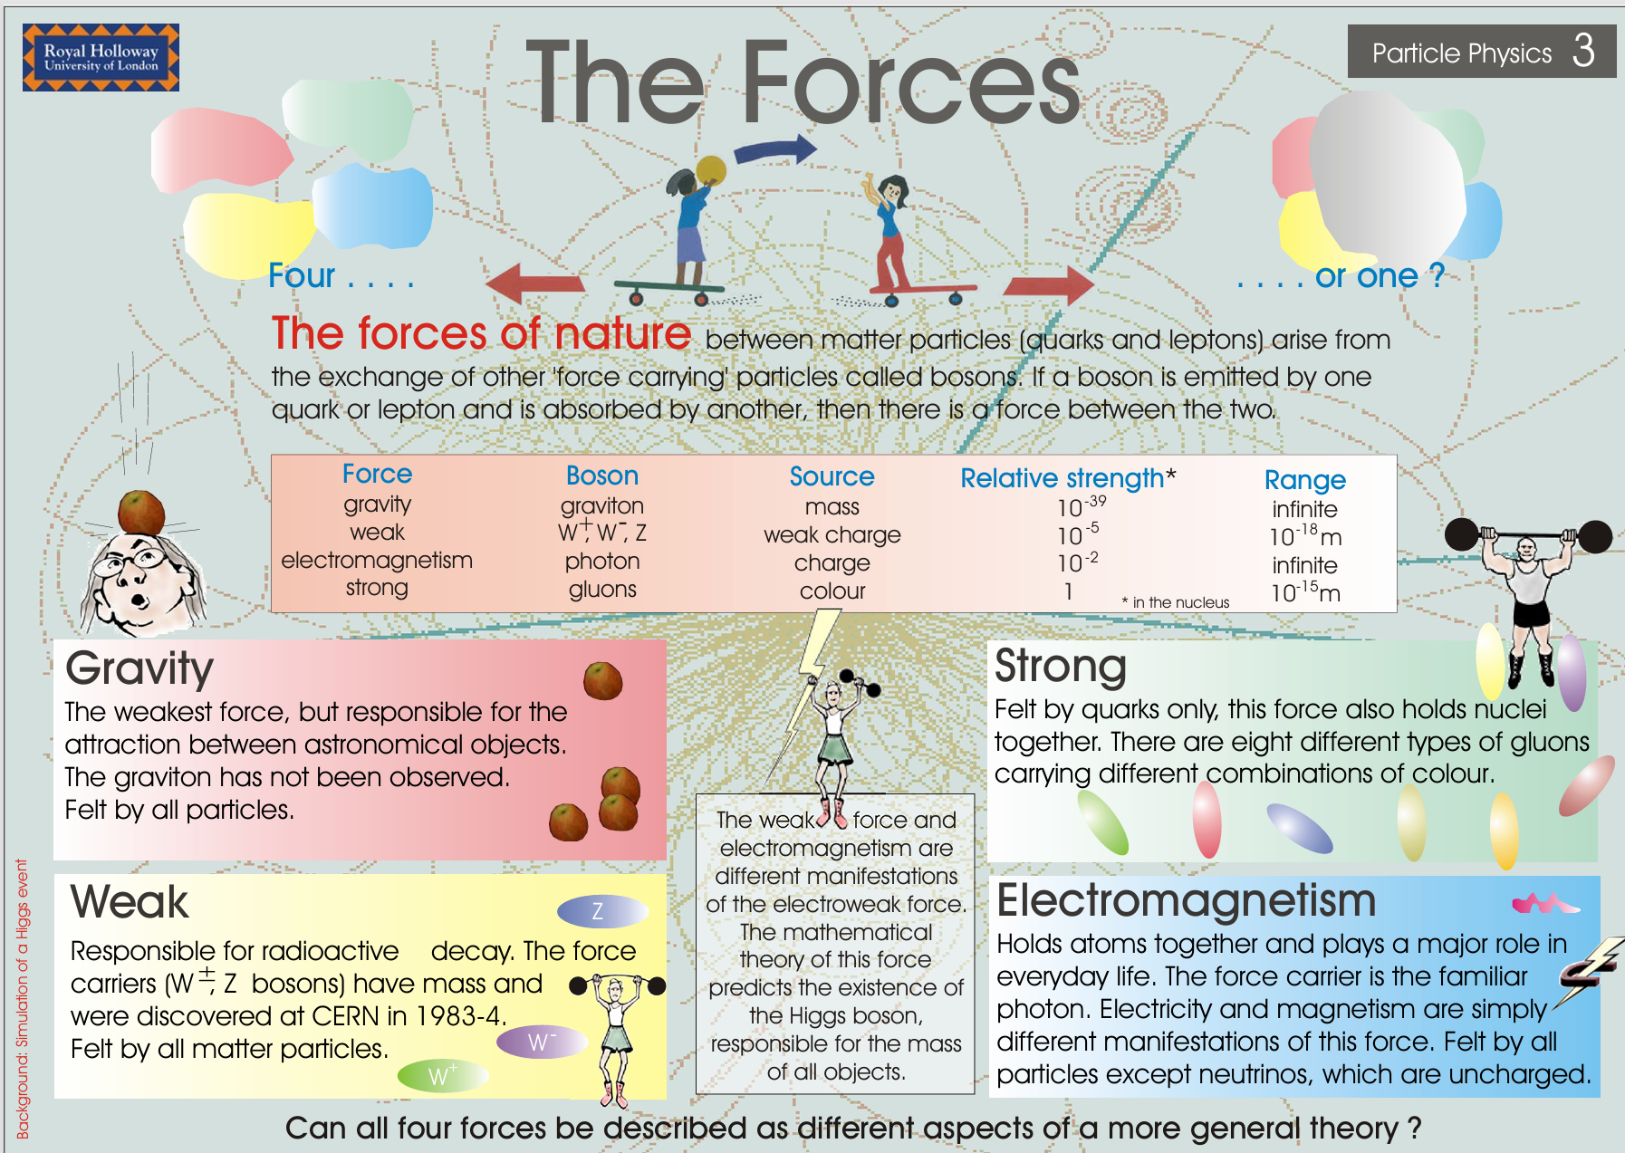  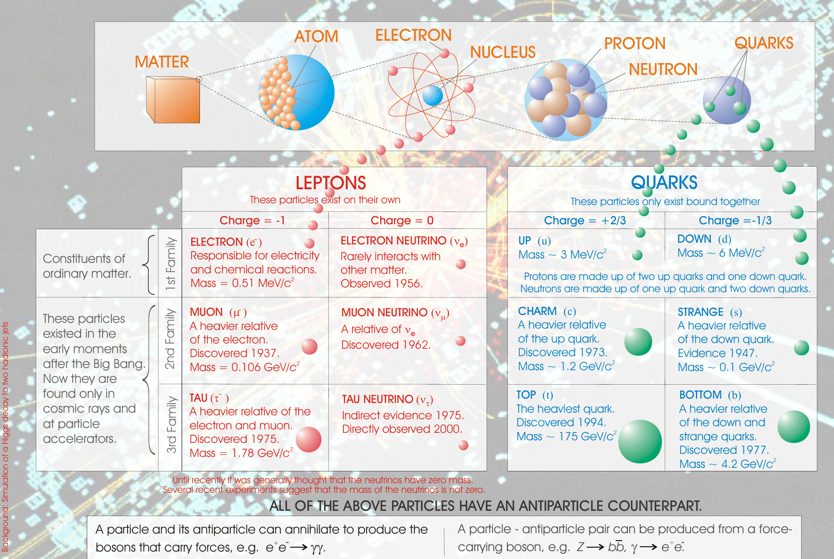
10.3 | I can use orders of magnitude and am aware of the range of orders of magnitude of length from the very small (sub-nuclear) to the very large (distance to furthest known celestial objects).  - Put both numbers in standard form  - Take the x10^{x} for the top and divide it by the x10^{x} for the bottom number and  - the orders of magnitude is the x in the x10^{x}.  - Remember you must say if it is x orders greater or smaller.
10.4 | Evidence for the existence of quarks comes from high-energy collisions between electrons and nucleons, carried out in particle accelerators.
10.5 | In the Standard Model, every particle has an antiparticle.
10.6 | The production of energy in the annihilation of particles is evidence for the existence of antimatter
10.7 | beta decay was the first evidence for the neutrino.
10.8 | I know the equation for β- decay above (β+ decay not required)  $${}_{0}^{1}n→{}_{1}^{1}p+{}_{-1}^{0}{e+\overline{ν_{e}}}$$
10.9 | fermions, the matter particles, consist of quarks (six types: up, down, strange, charm, top, bottom) and leptons (electron, muon and tau, together with their neutrinos).
10.10 |  | hadrons are composite particles made of quarks.
10.11 |  | baryons are made of three quarks.
10.12 |  | mesons are made of quark–antiquark pairs.
10.13 |  | the force-mediating particles are bosons: photons (electromagnetic force), W- and Z-bosons (weak force), and gluons (strong force).
11. | Nuclear reactions
Eq | $$E=mc^{2}$$
- a | I can use nuclear equations to describe radioactive decay, fission (spontaneous and induced), with reference to mass and energy equivalence.  Spontaneous the reaction occurs randomly but with no other input.  Induced the reaction requires a neutron to start it off  (induced reactions required in power station for control)  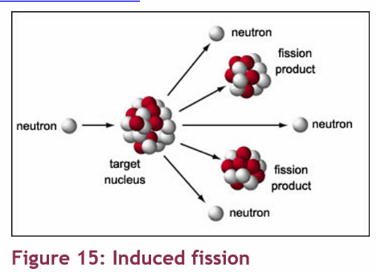  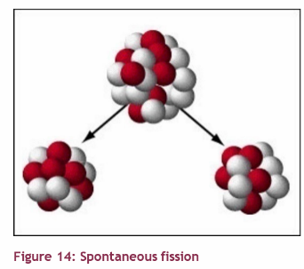  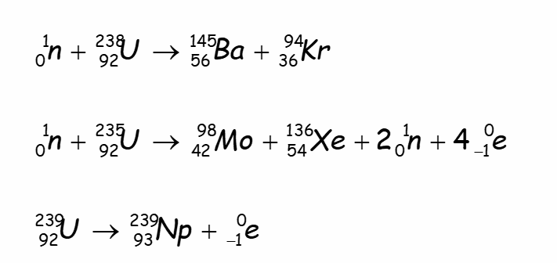  In these examples the first two equations show induced fission as a neutron is required to start the reaction  The last one shows spontaneous fission (which is also beta decay)  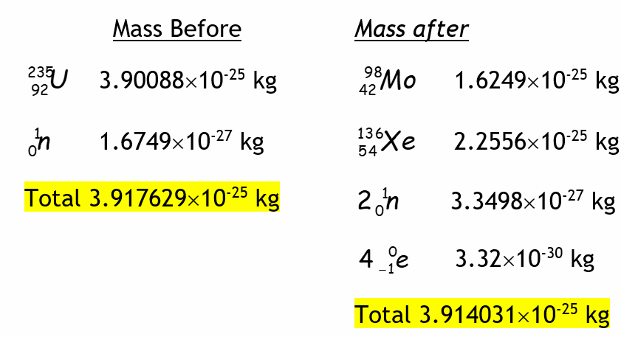  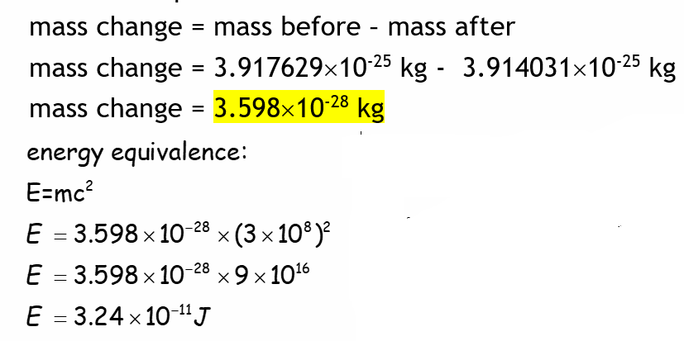
- b | I can use nuclear equations to describe fusion reactions, with reference to mass and energy equivalence.  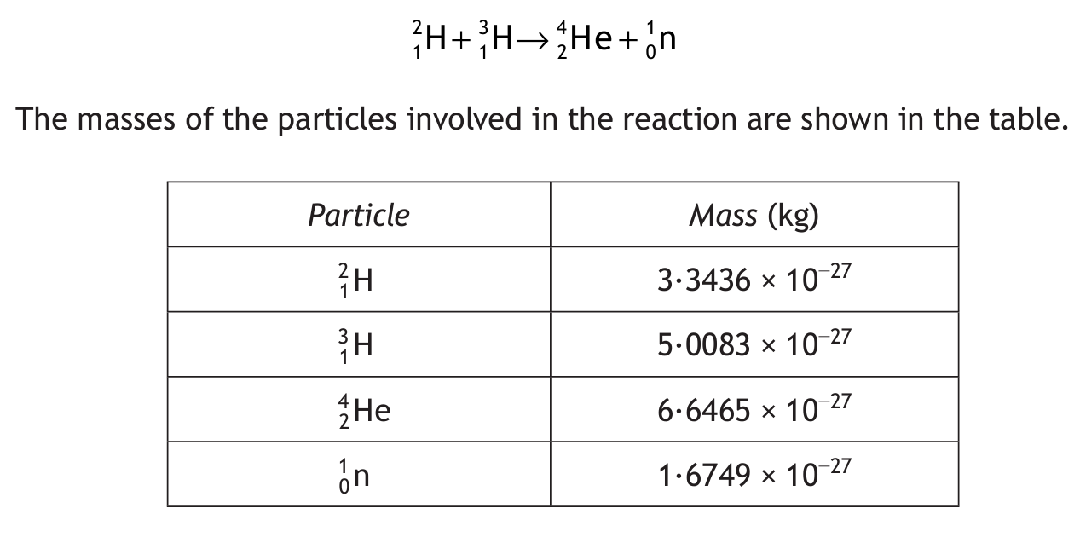  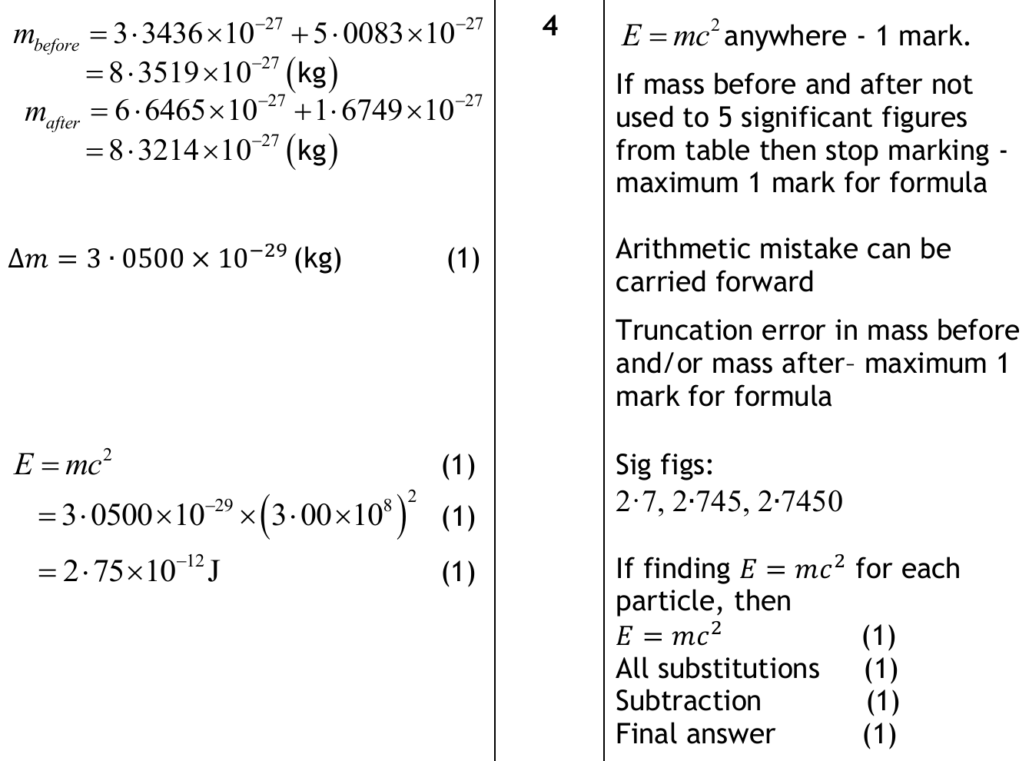
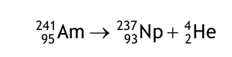
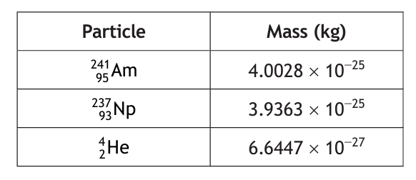
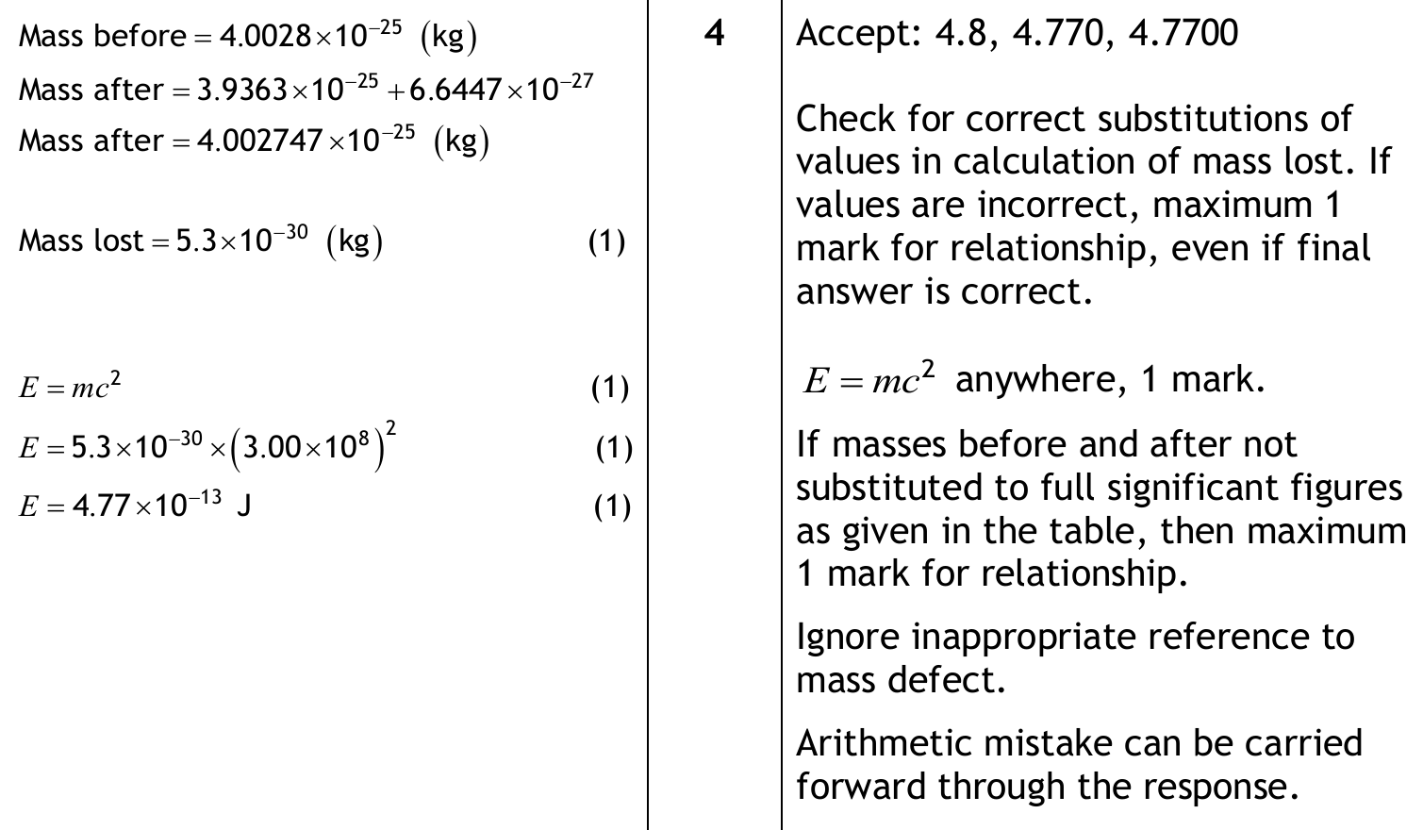

- c | Use of an appropriate relationship to solve problems involving the mass loss and the energy released by a nuclear reaction. $E=mc^{2}$  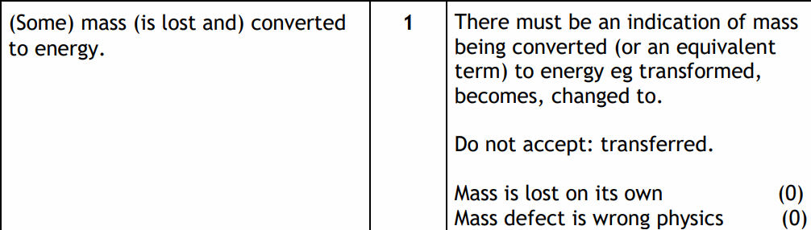
- d | nuclear fusion reactors require charged particles at a very high temperature (plasma) which have to be contained by magnetic fields.
12. | Inverse square law
Eq | $I=\frac{P}{A}$ $I_{1}d_{1}^{2}=I_{2}d_{2}^{2}$
a) | irradiance is the power per unit area incident on a surface.
b) | I can use the equation $I=\frac{P}{A}$ to solve problems involving irradiance, the power of radiation incident on a surface and the area of the surface.
c) | irradiance is inversely proportional to the square of the distance from a point source.
d) | 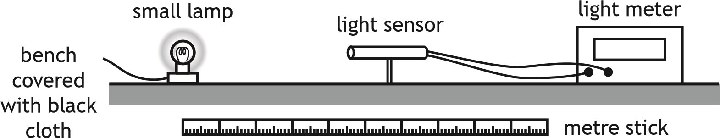  How to make this experiment better  - Smaller lamp / use point source.  - Black cloth on bench / wear black clothing.  - Greater range of distances. Smaller increments of distance.  - Account for background light level eg Subtract background light level,  - Tare/zero the light meter.  Why is a laser not suitable for this experiment  - Laser is not a point source.  - Light from the laser does not conform to the inverse square law.  - Laser beam does not diverge.
e) | I can use and $I_{1}d_{1}^{2}=I_{2}d_{2}^{2}$ to solve problems involving irradiance and distance from a point source of light.  Don’t let your 1s and 2s look like they are superscripts, you wont get any marks. Don’t forget to square d!  If the results are in a table you need to multiple the value of I by the value of d² and state that your results are all constant so that $Id^{2}=k$
13. | Wave Particle Duality
eq | $E=hf$ $E=\frac{hc}{λ}$ $E_{k}=hf-hf_{0} E_{k}=\frac{1}{2}mv^{2} and v=fλ$
a) | the photoelectric effect is evidence for the particle model of light.
b) | photons of sufficient energy can eject electrons from the surface of materials (photoemission).
c) | I can use $E=hf$ and $E=\frac{hc}{λ}$ to solve problems involving the frequency and energy of a photon.
d) | the threshold frequency, f₀ is the minimum frequency of a photon required for photoemission.
e) | The work function, W or hf₀ of a material is the minimum energy of a photon required to cause photoemission.
f) | I can use $E_{k}=hf-hf_{0}$ $E_{k}=\frac{1}{2}mv^{2} and v=fλ$ to solve problems involving the mass, maximum kinetic energy and speed of photoelectrons, the threshold frequency of the material, and the frequency and wavelength of the photons.
14. | Interference
Eq | $path difference=mλ or \left(m+\frac{1}{2}\right)λ$ where m =0,1,2. $d sinθ=mλ$
a) | interference is evidence for the wave model of light.
b) | coherent waves have a constant phase relationship.  The waves from two sources have a constant phase  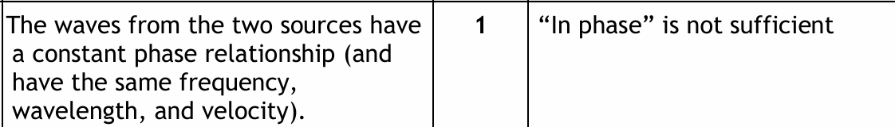
c) | I can describe of the conditions for constructive and destructive interference in terms of the phase difference between two waves.  Constructive interference- path difference is a whole no. of λ  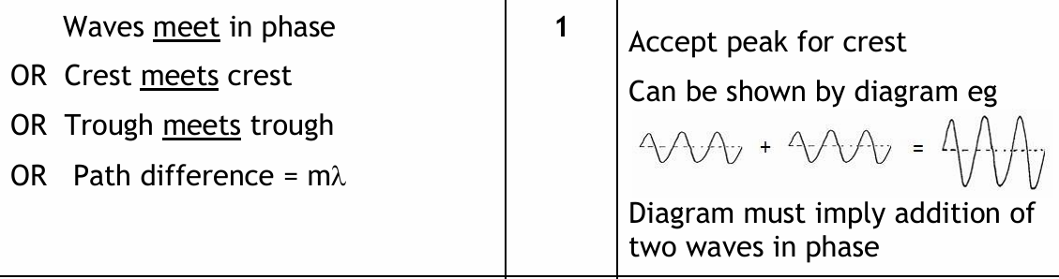  Destructive interference path difference is a ½ no. of λ  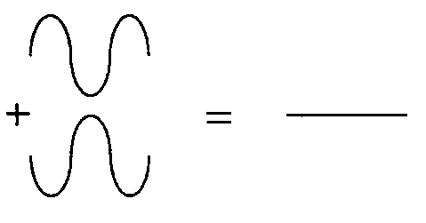  Waves meet out of phase  OR crest meets trough  OR path difference = (m+½) λ  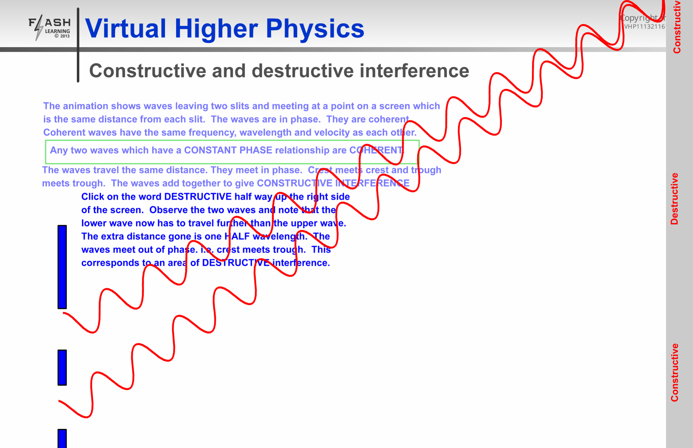  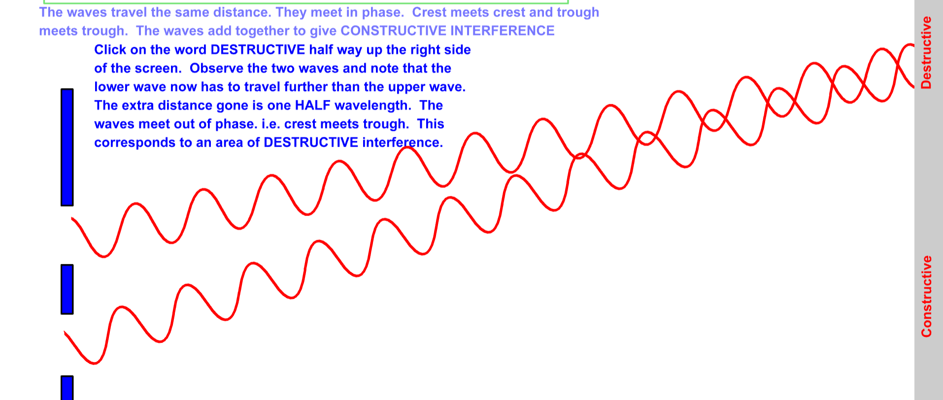
d) | maxima are produced when the path difference between waves is a whole number of wavelengths
e) | minima are produced when the path difference between waves is an odd number of half-wavelengths respectively.
f) | I can use $path difference=mλ or \left(m+\frac{1}{2}\right)λ$ where m =0,1,2...  to solve problems involving the path difference between waves, wavelength and order number.  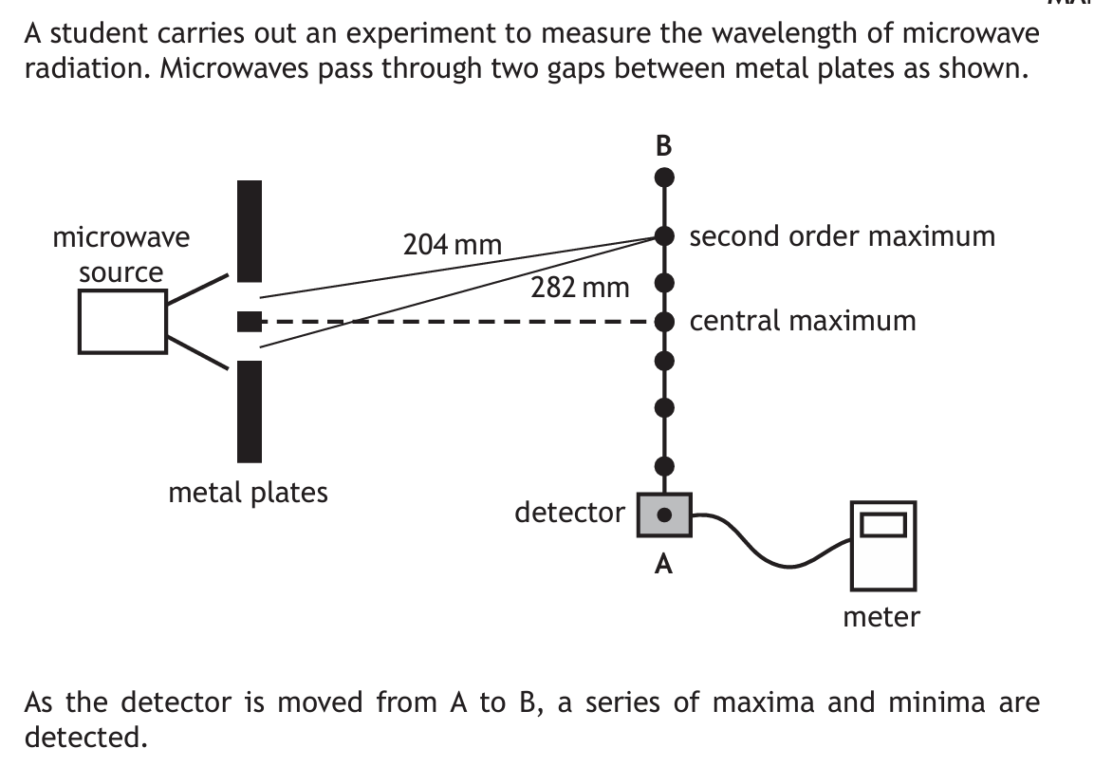  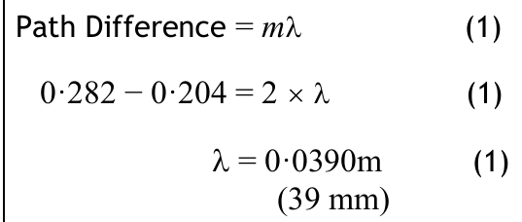
g) | I can use $d sinθ=mλ$ to solve problems involving grating spacing, wavelength, order number and angle to the maximum.  Try 2019 ppq question 10  Try 2022 ppq question 10
15. | Spectra
Eq | $E_{2}-E_{1}=hf$ and
a) | I have knowledge of the Bohr model of the atom.  A (central) positively charged nucleus.  (Negatively charged) electrons in (discrete) energy levels/shells (orbiting the nucleus, not radiating energy.)  When an electron moves from one state to another, the energy lost or gained is done so ONLY in very specific amounts of energy.  Each energy jump results in the release or absorption of energy of specific wavelengths giving line in a spectrum is produced when an electron moves from one energy level/orbit/shell to another.
b) | I can explain the Bohr model of the atom using the terms ground state, energy levels, ionisation and zero potential energy.
c) | I know the mechanism of production of line emission spectra, continuous emission spectra and absorption spectra in terms of electron energy level transitions.
d) | I can use $E_{2}-E_{1}=hf$ and to solve problems involving energy levels and the frequency of the radiation emitted/absorbed.
e) | I know that the absorption lines (Fraunhofer lines) in the spectrum of sunlight provide evidence for the composition of the Sun’s outer atmosphere.  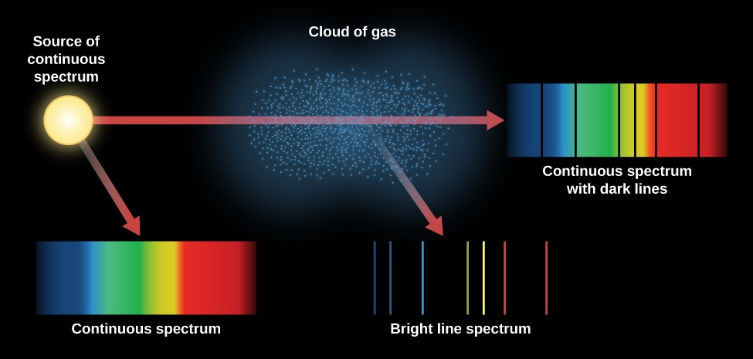  The Fraunhofer lines are a set of dark absorption lines observed in the optical spectrum of the Sun.  These lines are formed when light from the Sun’s central core (photosphere) passes through the cooler outer atmosphere (chromosphere).  The atoms and molecules in the chromosphere absorb specific wavelengths of light, resulting in the characteristic dark lines.
16. | Refraction
Eq | $n=\frac{\sin{θ_{1}}}{\sin{θ_{2}}}=\frac{λ_{1}}{λ_{2}}=\frac{v_{1}}{v_{2}}$ and $v=fλ$ and
a) | I can define absolute refractive index of a medium as the ratio of the speed of light in a vacuum to the speed of light in the medium.
b) | I can use $n=\frac{\sin{θ_{1}}}{\sin{θ_{2}}}$ to solve problems involving absolute refractive index, the angle of incidence and the angle of refraction.
c) | I can describe an experiment to determine the refractive index of a medium.
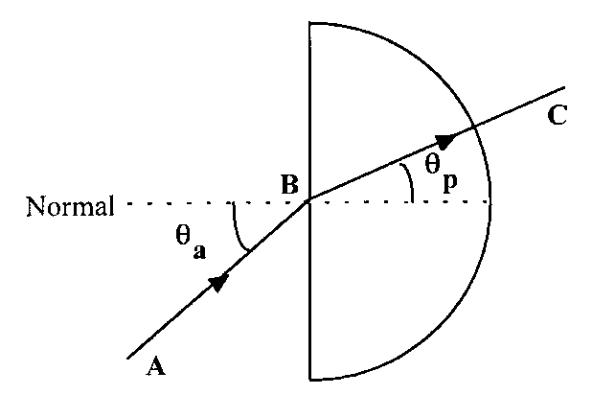
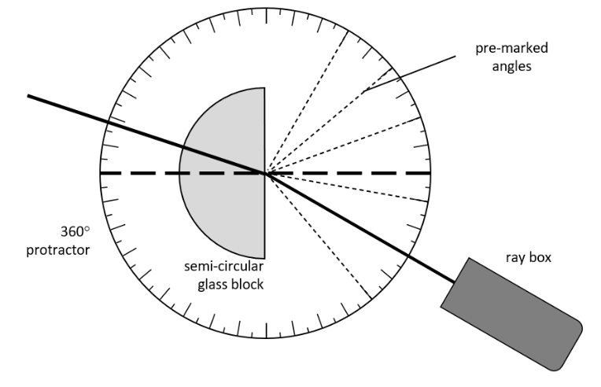
- Shine the ray into the block at the normal
- Record the angle of incidence and the angle of refraction.
- Move the ray box to a new premarked angle
- Plot a graph of sinθ air/ sinθ glass, the gradient is the refractive index.
- Taking angles either side of the normal reduces the likelihood of a systematic uncertainty due to the normal not being perpendicular to the block.
d) | I can use $\frac{\sin{θ_{1}}}{\sin{θ_{2}}}=\frac{λ_{1}}{λ_{2}}=\frac{v_{1}}{v_{2}}$ and $v=fλ$ to solve problems  involving the angles of incidence and refraction, the wavelength of light in each medium, the speed of light in each medium, and the frequency, including situations where light is travelling from a more dense to a less dense medium.  Remember frequency remains the same in the material and in the air.
e) | refractive index of a medium increases as the frequency of incident radiation increases.
f) | critical angle is the angle of incidence which produces an angle of refraction of 90°.
g) | total internal reflection occurs when the angle of incidence is greater than the critical angle.
h) | I can use to solve problems involving critical angle and absolute refractive index.

Electricity

No | CONTENT | 
17. | Monitoring and Measuring A.C.
eq | $T=\frac{1}{f}$ $V_{rms}=\frac{V_{peak}}{\sqrt{2}}$ $I_{rms}=\frac{I_{peak}}{\sqrt{2}}$
a) | an A.C. is a current which changes direction and instantaneous value with time.  D.C is a direct current the charges flow in one direction only
b) | I can use $V_{rms}=\frac{V_{peak}}{\sqrt{2}}$ $I_{rms}=\frac{I_{peak}}{\sqrt{2}}$ to solve problems involving peak and r.m.s. values.
c) | I can determine the frequency, peak voltage and r.m.s. values from graphical data.  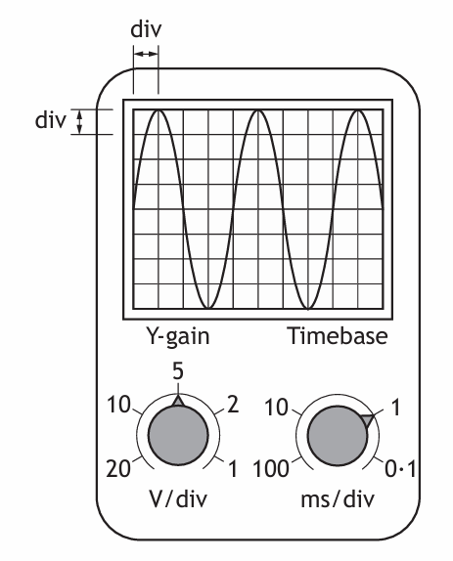  - Count the number of squares for 1 wave.  - Multiply the number of squares for 1 wave by the time base setting, giving T.  - Find frequency using $f=\frac{1}{T}$  (Time setting will be in ms or μs. DON’T FORGET TO CHANGE IT!!)  4 squares = one wave  Each wave is 1 ms (read off the timebase setting)
d) | I can use $T=\frac{1}{f}$ to determine the frequency.
18. | Current, potential difference, power and resistance
eq
Eq
a) | I can use relationships involving potential difference, current, resistance and power to analyse circuits even those that may involve several steps in the calculations.
b) | I can correctly use calculations involving potential dividers circuits.
19. | Electrical sources and internal resistance
eq
a) | I can correctly use and explain the terms electromotive force (E.M.F), internal resistance, lost volts, terminal potential difference (t.p.d) ideal supplies, short circuits and open circuits.
b) | I can use $E=V+Ir$ and $V=IR$to solve problems involving EMF, lost volts, t.p.d., current, external resistance, and internal resistance.
c) | I can describe of an experiment to measure the EMF and internal resistance of a cell.  A  V  A
d) | I can determine electromotive force, internal resistance and short circuit current using graphical analysis.  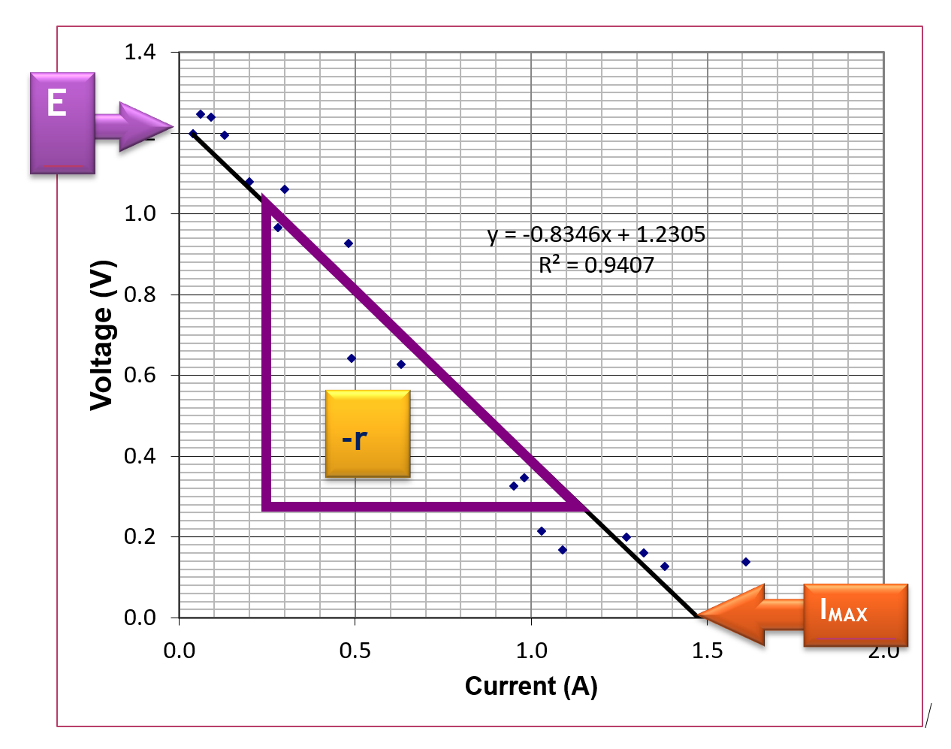  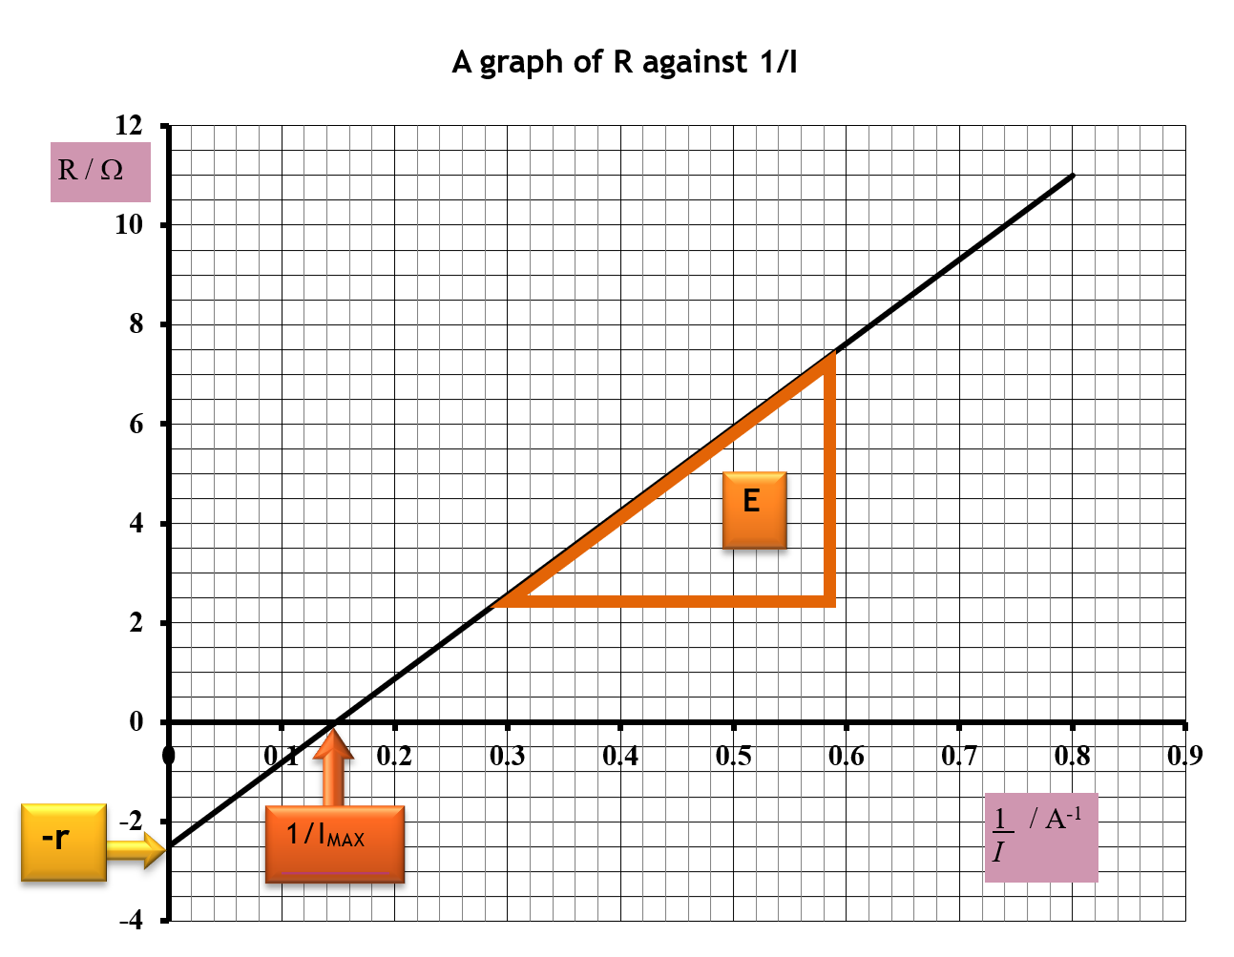  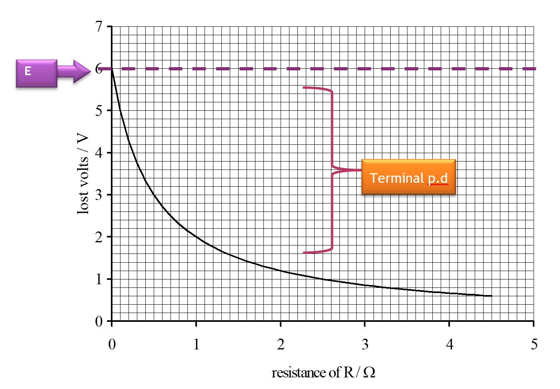  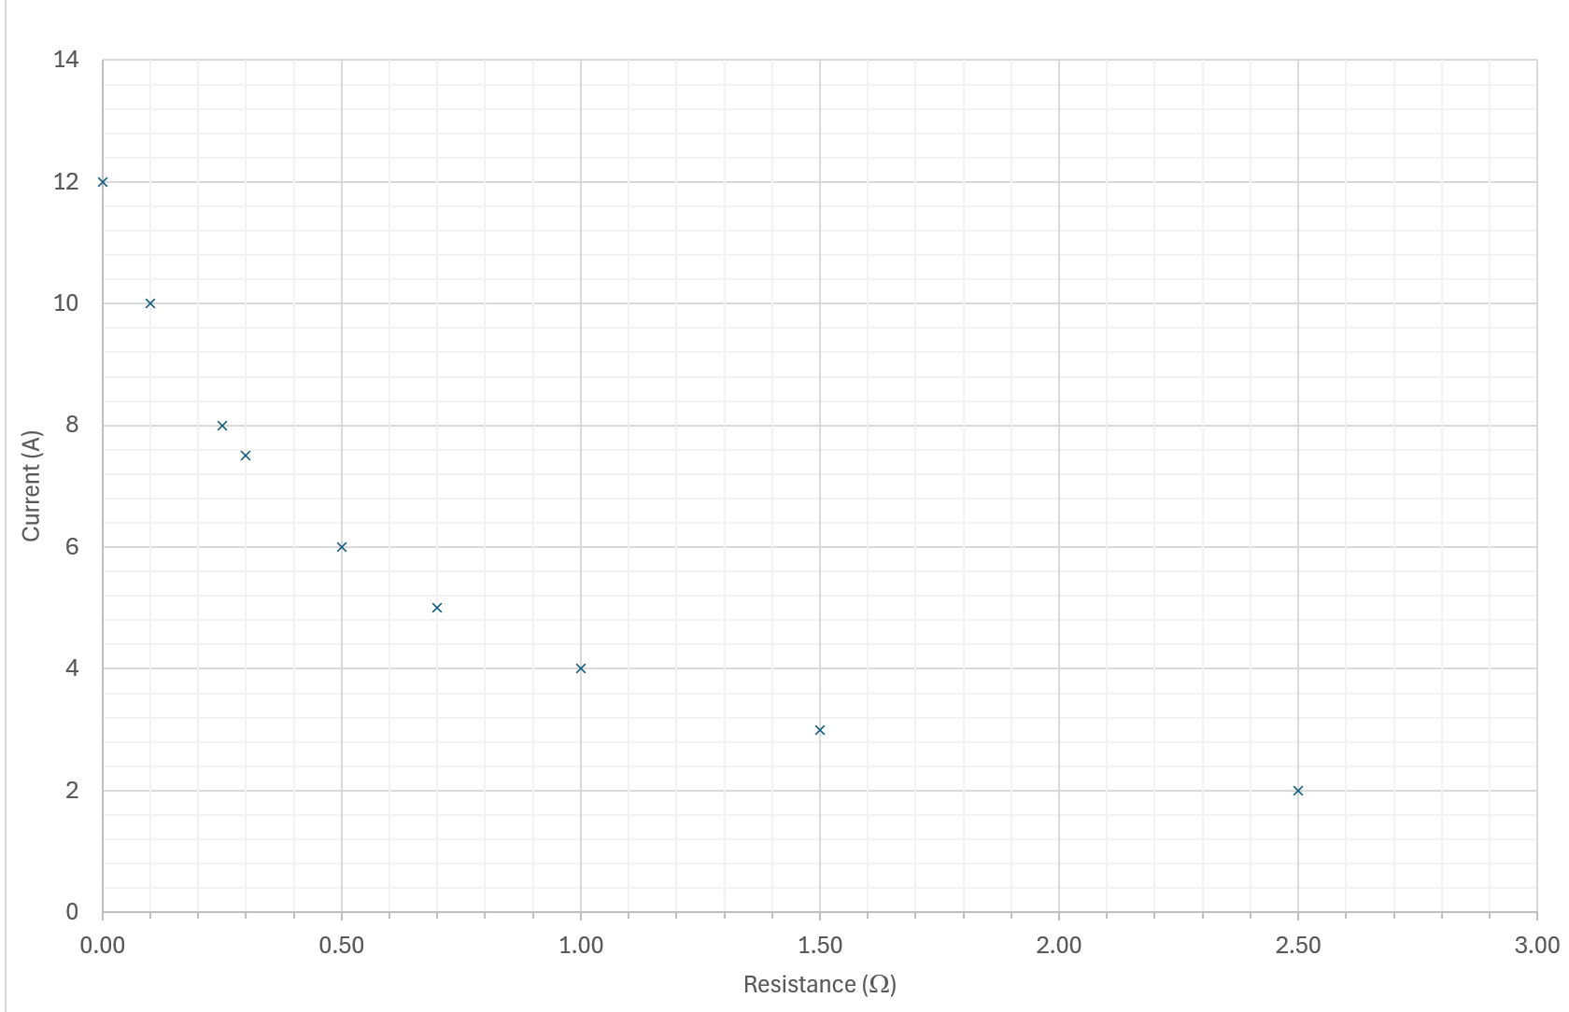  In the diagram above take a value of R and the corresponding I and that gives you the terminal p.d. The short circuit current is the value on the y-axis when R=0 Ω. For this graph the EMF needs to be given so this graph can be used to find the internal resistance only.
20. | Capacitors
eq | as soon as you are allowed in your exam, write on your relationships sheet by these equations  (for energy STORED on a capacitor only)
a) | a capacitor of 1 farad will store 1 coulomb of charge when the potential difference across it is 1 volt.
b) | I can use the equation C=Q/V to solve problems involving capacitance, charge and potential difference.
c) | I can use the equation Q = It to determine the charge stored on a capacitor for a constant charging current.
d) | the total energy stored in a charged capacitor is equal to the area under a charge-potential difference graph.
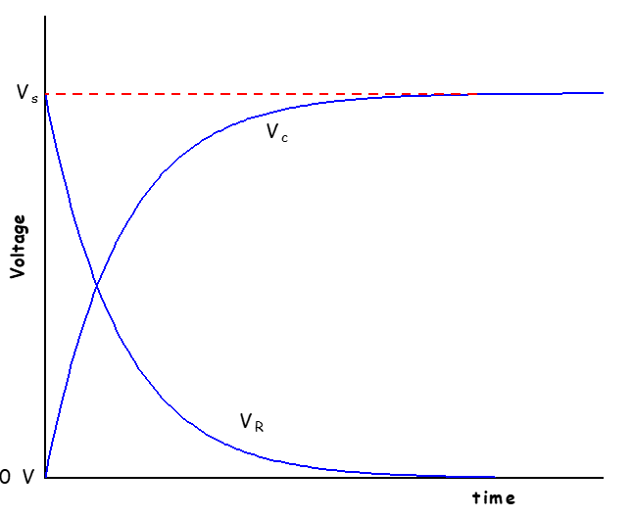
To find the V across capacitor or V across the resistor at any point in time remember Vs= V_{R}+Vc. Eg if Vs=12V and you know the voltage across one of the other components you can subtract this value from 12V to find the voltage across the other component.
e) | I can use $E=\frac{1}{2}QV=\frac{1}{2}CV^{2}=\frac{1}{2}\frac{Q^{2}}{C}$ to solve problems involving energy, charge, capacitance, and potential difference.
f) | I know the variation of current with time for both charging and discharging cycles of a capacitor in an RC circuit (charging and discharging curves).  Charging and discharging through the same resistor max current at charging is the same as max current at discharging  In the above graph the capacitor is discharging through a smaller resistance so the initial discharge current is greater than the charging current but the time for discharging is less than the time for charging
g) | I know the variation of potential difference with time for both charging and discharging cycles of a capacitor in an RC circuit (charging and discharging curves).  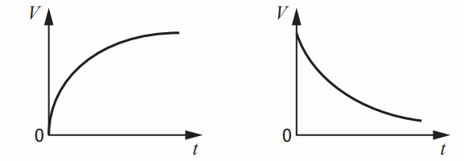  Charging (max V=Vs) Discharging (Max V=Vs)
h) | I know the effect of resistance and capacitance on charging and discharging curves in an RC circuit.  Greater the resistance  Greater the capacitance  The longer it takes for a capacitor to charge  It does not depend on the voltage of the supply.  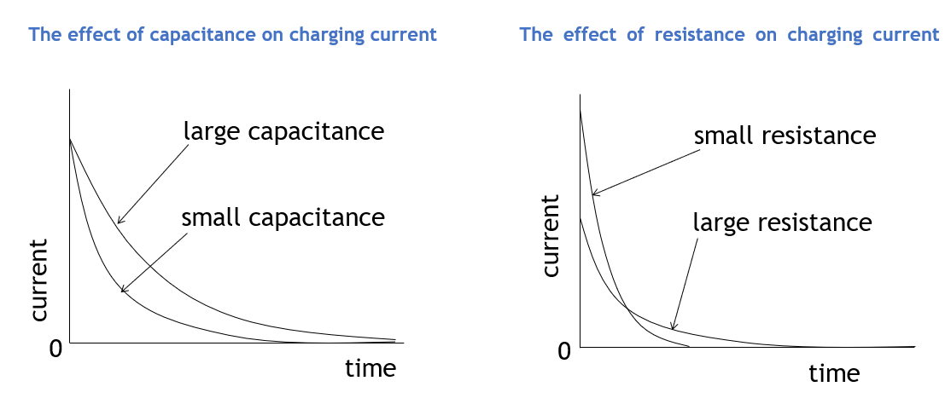  (remember the area under the graph which equals charge stored ought to be the same)  If the resistance is greater the charging time is longer but the initial current is less
i) | I can describe experiments to investigate the variation of current in a capacitor and voltage across a capacitor with time, for the charging and discharging of capacitors  For V against t  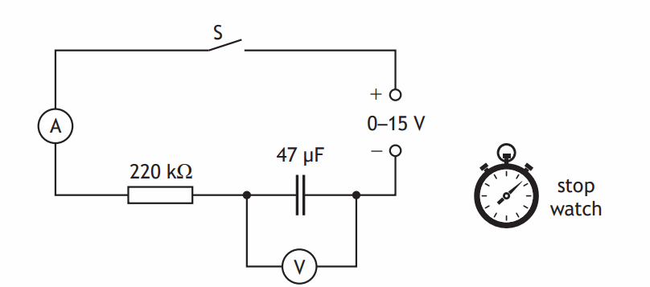  For V against t  (Close the switch and) take readings on voltmeter at (regular) time intervals (1)  Plot a graph of voltage against time (1)  For I against t  (Close the switch and) take readings on ammeter at (regular) time intervals (1)  Plot a graph of current against time (1)
21. | Semiconductors and p-n junctions
a) | I know and can explain the terms conduction band and valence band.
b) | solids can be categorised into conductors, semiconductors or insulators by their band structure and their ability to conduct electricity.  Every solid has its own characteristic energy band structure.  For a solid to be conductive, both free electrons and accessible empty states must be available. 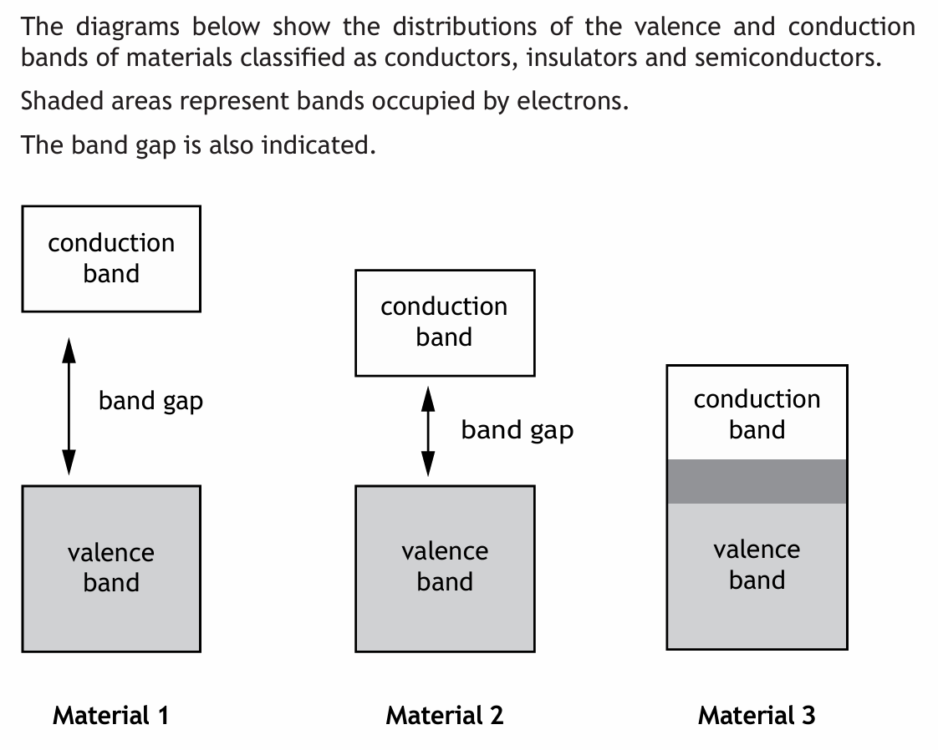  Insulator semiconductor conductor
c) | I can explain qualitatively the electrical properties of conductors, insulators and semiconductors using the electron population of the conduction and valence bands and the energy difference between the conduction and valence bands. (Reference to Fermi levels is not required.)  In an insulator the valence band is full, and there is a large band gap to the empty conduction band. Electrons don’t have the energy to move into the conduction band  In a conductor the conduction and valence bands overlap, both are partially filled, electrons can freely move between the two bands  In a semiconductor there is a band gap, the gap is small, so only small amounts of energy are required to allow electrons from the valence band into the conduction band.  - Semiconductors are like insulators in that the valence band is full. However the gap between the two bands is small and at room temperature some electrons have enough energy to jump the gap and move from the valence to the conduction band. An increase in temperature increases the conductivity of a semiconductor.
d) | the electrons in atoms are contained in energy levels. When the atoms come together to form solids, the electrons then become contained in energy bands separated by gaps.    You don’t need to understand how or why this occurs. One atom has its electron shells but when you start adding atoms then the shells blur a little, until with a solid material these shells have combined to form bands.
e) | for metals one or more bands are partially filled.
f) | some metals have free electrons and partially filled valence bands, therefore they are highly conductive.
g) | some metals have overlapping valence and conduction bands. Each band is partially filled and therefore they are conductive.
h) | In an insulator, the highest occupied band (called the valence band) is full. The first unfilled band above the valence band is the conduction band. For an insulator, the gap between the valence band and the conduction band is large and at room temperature there is not enough energy available to move electrons from the valence band into the conduction band where they would be able to contribute to conduction. There is no electrical conduction in an insulator.
i) | in a semiconductor, the gap between the valence band and conduction band is smaller (than in an insulator) and at room temperature there is sufficient energy available to move some electrons from the valence band into the conduction band allowing some conduction to take place. An increase in temperature increases the conductivity of a semiconductor.
j) | During manufacture, semiconductors may be doped with specific impurities to increase their conductivity, resulting in two types of semiconductor: p-type and n-type.  NB both n-type and p-type materials are neutrally charged as there is a proton in the nucleus for every electron in its shell.
k) | when a semiconductor contains the two types of doping (p-type and n- type) in adjacent layers, a p-n junction is formed. There is an electric field in the p-n junction. The electrical properties of this p-n junction are used in a number of devices.
l) | Forward bias reduces the electric field; reverse bias increases the electric field in the p-n junction.  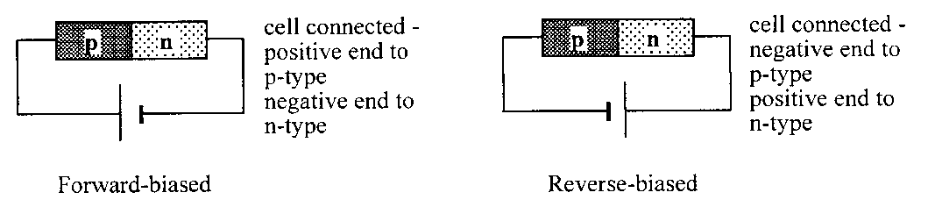  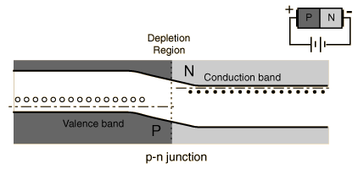  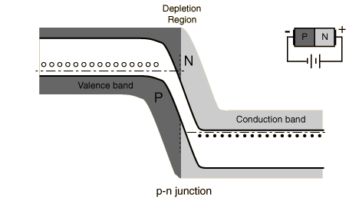
m) | 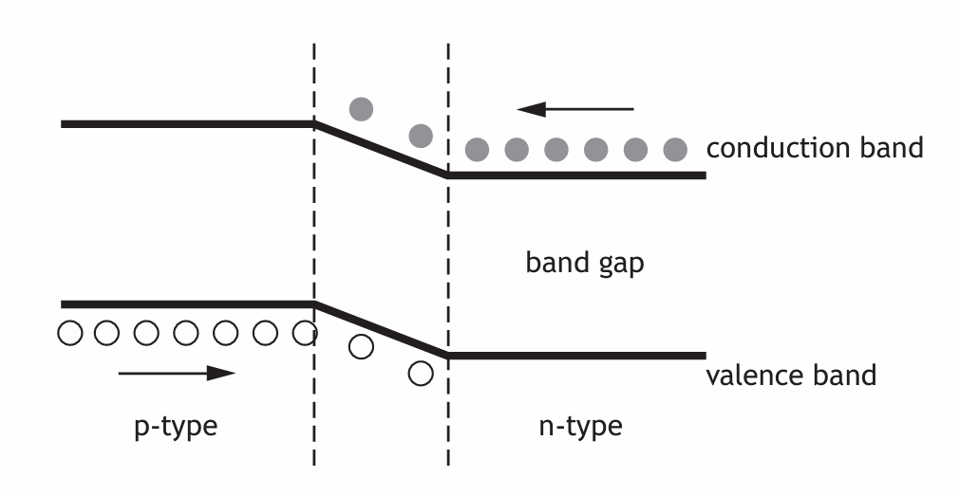  LEDs are forward biased p-n junction diodes that emit photons. The forward bias potential difference across the junction causes electrons to move from the conduction band of the n-type semiconductor towards the conduction band of the p- type semiconductor. Photons are emitted when electrons ‘fall’ from the conduction band into the valence band either side of the junction  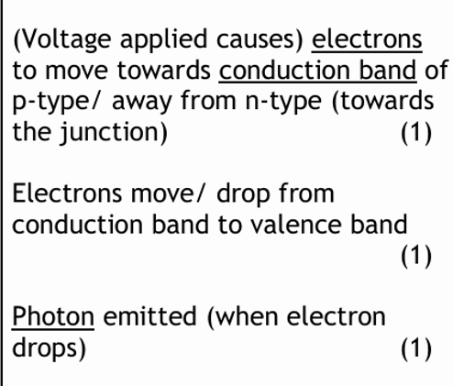
n) | solar cells are p-n junctions designed so that a potential difference is produced when photons are absorbed. (This is known as the photovoltaic effect.) The absorption of photons provides energy to ‘raise’ electrons from the valence band of the semiconductor to the conduction band. The p-n junction causes the electrons in the conduction band to move towards the n-type semiconductor and a potential difference is produced across the solar cell.  Explain how light gates produce a potential difference!  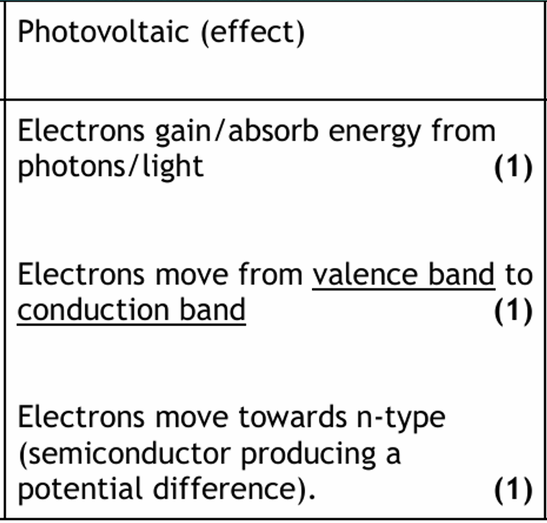

Physical Quantity | Symbol | Unit | Unit Abb.
acceleration | a | metre per second per second | m s⁻²
acceleration due to gravity | g | metre per second per second | m s⁻²
amplitude | A | metre | m
angle | θ | degree | °
area | A | square metre | m²
average speed | $$\overline{v}$$ | metres per second | m s⁻¹
average velocity | $$\overline{v}$$ | metres per second | m s⁻¹
capacitance | C | farad | F
change of speed | Δv | metre per second | m s⁻¹
change of velocity | Δv | metre per second | m s⁻¹
critical angle | θc | degree | °
current | I | ampere | A
displacement | s | metre | m
distance | D | metre, light year | m , ly
distance, depth, height | d or h | metre | m
electric charge | Q | coulomb | C
electric charge | Q or q | coulomb | C
electric current | I | ampere | A
electric field strength | E | newton per coulomb  volts per metre | N C⁻¹  Vm⁻¹
electromotive force (e.m.f) | E or ε | volt | V
energy | E | joule | J
energy level | E₁, E₂ | joule | J
final velocity | v | metre per second | m s⁻¹
force | F | newton | N
force, tension, upthrust, thrust | F | newton | N
frequency | f | hertz | Hz
frequency of source | f_{s} | hertz | Hz
fringe separation | Δx | metre | m
grating to screen distance | D | metre | m
gravitational field strength | g | newton per kilogram | N kg⁻¹
gravitational potential energy | E_{p} | joule | J
heat energy | E_{h} | joule | J
height, depth | h | metre | m
impulse | Ft | newton second  kilogram metre per second | Ns  kgm s⁻¹
initial speed | u | metre per second | ms⁻¹
initial velocity | u | metre per second | m s⁻¹
internal resistance | r | ohm | Ω
irradiance | I | watt per square metre | W m⁻¹
kinetic energy | Ek | joule | J
length | l | metre | m
mass | m | kilogram | kg
momentum | p | kilogram metre per second | kg m s⁻¹
number of photons per second per cross sectional area | N | - | -
observed wavelength | λ_{observed} | metre | m
peak current | I_{peak} | ampere | A
peak voltage | V_{peak} | volt | V
period | T | second | s
Planck’s constant | h | joule second | Js
potential difference | V | volt | V
potential energy | E_{p} | joule | J
power | P | watt | W
pressure | P or p | pascal | Pa
radius | r | metre | m
Redshift | Z | - | -
refractive index | n | - | -
relativistic length | l' | metre | m
relativistic time | t' | second | s
resistance | R | ohm | Ω
rest wavelength | λ_{rest} | metre | m
root mean square current | I_{rms} | ampere | A
root mean square voltage | V_{rms} | volt | V
slit separation | d | metre | m
specific heat capacity | c | joule per kilogram per kelvin | Jkg⁻¹K ⁻¹
specific latent heat | l | joule per kilogram | Jkg⁻¹
speed of light in a vacuum | c | metre per second | m s⁻¹
speed, final speed | v | metre per second | ms⁻¹
speed, velocity, final velocity | v | metre per second | m s⁻¹
supply voltage | V_{s} | volt | V
temperature | T | degree Celsius | °C
temperature | T | kelvin | K
threshold frequency | f_{o} | hertz | Hz
time | t | second | s
total resistance | R _{t} | ohm | Ω
velocity of observer | v_{o} | metre per second | m s⁻¹
velocity of source | v_{s} | metre per second | m s⁻¹
voltage | V | volt | V
voltage, potential difference | V | volt | V
volume | V | cubic metre | m³
Wavelength | λ | metre | m
weight | W | newton | N
GRAPHING
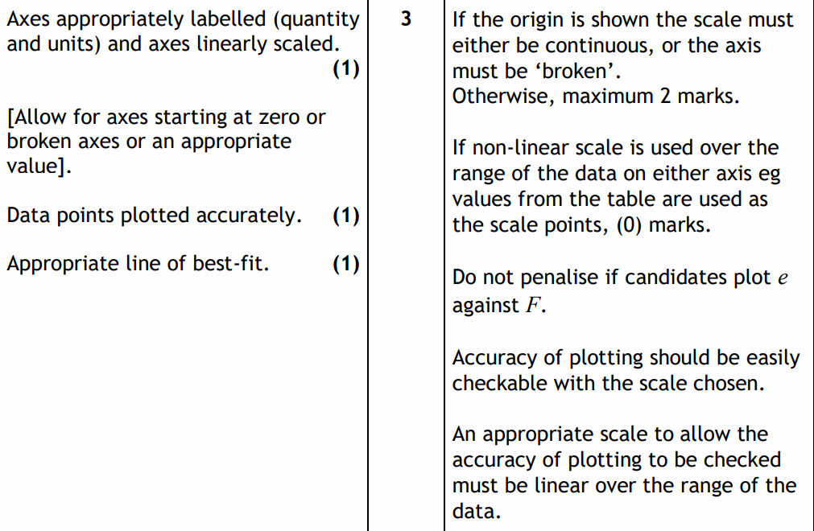

Uncertainties

Quantifying Uncertainties
- Find the mean
$$\text{mean value}=\frac{Σ\text{results}}{\text{no. of observation}}$$
This is the best estimate of the “true” value but not necessary the “true” value

- Find the approximate random uncertainty in the mean (absolute uncertainty)
This can be written as $=\frac{\text{range}}{\text{no. of observation}}$ and it is sometimes referred to as average deviation or absolute uncertainty.
stop here and quote the result with an approx. random uncertainty
MEAN ± approx. random uncertainty (UNITS)

- Find the percentage uncertainty.

$percentage uncertainty=\frac{approximately randon uncertainty}{mean value}×100\%$=

$$percentage uncertainty=\frac{\frac{range}{n}}{mean value}×100\%$$
stop here and quote the result with a percentage uncertainty
MEAN (UNITS)± percentage uncertainty (%) (

Or (uncertainty in reading/reading )× 100%
Content

Scale reading uncertainty
Analogue device = ±½ scale division
Digital device = ±1 in the last digit

Overall uncertainty in an Experiment
In an experiment, where more than one physical quantity has been measured, spot the quantity with the largest percentage uncertainty. This percentage uncertainty is often a good estimate of the percentage uncertainty in the final numerical result of the experiment.
eg if one measurement has an uncertainty of 3% and another has an uncertainty of 5%, then the overall percentage uncertainty in this experiment should be taken as 5%
When completing an experimental EVALUATION, always refer to the magnitude of the uncertainty to give an indication of how reliable your results are.

Accuracy & Precision
Accuracy is how close your answer is to the true value. Precision is how repeatable a measurement is. Use the diagram below to remind you which is which.
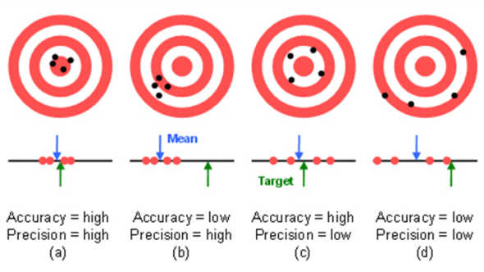
http://preview.tinyurl.com/lwanwoh
In Physics you will often calculate an answer to a question that has a large number of significant figures or decimal places. Because it is highly unlikely that we need to know the answer that precisely. It is important to round off any answers that you find.

How many Significant Figures?
The simple rule is this: Your answer should have no more than the number of significant figures given in the question.
If different numbers in the question are given to a different number of significant figure you should use the number of significant figures in the value given to the smallest number of significant figures.

Example
Question: A rocket motor produces 4,570N of thrust to a rocket with a mass of 7.0kg.What is the acceleration of the rocket?
The calculated answer to this question would be 652.8571429 ms⁻² . However the least accurate value we are given in the question is the value of the mass. This is only given Marking Principles
You need to refer to the document General Marking Principles for guidance on how questions are marked.
https://www.sqa.org.uk/files_ccc/general-marking-principles-physics.pdf
Before you get in to the Higher Physics Course make sure you’ve looked over this material (there are laminated sheets in the Physics Dept).

