

Name: ___________________
Class: _________________
NAME: _____________________

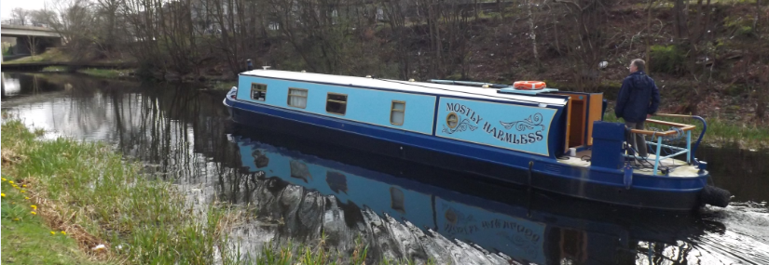
CLASS: _______
Updated for new exam structure

2027 Don’t Panic!
J A HARGREAVES | National 5 COMPENDIUM

Speed of light in materials |  |  |  | Speed of sound in materials
Material |  | Speed in m s⁻¹ |  | Material |  | Speed in m s⁻¹
Air |  | 3·0 × 10⁸ |  | Aluminium |  | 5200
Carbon dioxide |  | 3·0 × 10⁸ |  | Air |  | 340
Diamond |  | 1·2 × 10⁸ |  | Bone |  | 4100
Glass |  | 2·0 × 10⁸ |  | Carbon dioxide |  | 270
Glycerol |  | 2·1 × 10⁸ |  | Glycerol |  | 1900
Water |  | 2·3 × 10⁸ |  | Muscle |  | 1600
 |  |  |  | Steel |  | 5200
Gravitational field strengths |  |  |  | Tissue |  | 1500
 | Gravitational field strength  on the surface in N kg⁻¹ |  |  | Water |  | 1500
Earth | 9·8 |  |  | Specific heat capacity of materials
Jupiter | 23 |  |  | Material |  | Specific heat capacity in J kg⁻¹ ºC⁻¹
Mars | 3·7
Mercury | 3·7 |  |  | Alcohol |  | 2350
Moon | 1·6 |  |  | Aluminium |  | 902
Neptune | 11 |  |  | Copper |  | 386
Saturn | 9·0 |  |  | Glass |  | 500
Sun | 270 |  |  | Ice |  | 2100
Uranus | 8·7 |  |  | Iron |  | 480
Venus | 8·9 |  |  | Lead |  | 128
 |  |  |  | Oil |  | 2130
Specific latent heat of fusion of materials |  |  |  | Water |  | 4180
Material |  | Specific latent heat  of fusion in J kg⁻¹
 |  | Specific latent heat  of fusion in J kg⁻¹ |  | Melting and boiling points of materials
Alcohol |  | 0·99 × 10⁵ |  | Material | Melting point in ºC |  |  | Boiling point in ºC
Aluminium |  | 3·95 × 10⁵
Carbon dioxide |  | 1·80 × 10⁵ |  | Alcohol | −98 |  |  | 65
Copper |  | 2·05 × 10⁵ |  | Aluminium | 660 |  |  | 2470
Iron |  | 2·67 × 10⁵ |  | Copper | 1077 |  |  | 2567
Lead |  | 0·25 × 10⁵ |  | Glycerol | 18 |  |  | 290
Water |  | 3·34 × 10⁵ |  | Lead | 328 |  |  | 1737
 |  |  |  | Iron | 1537 |  |  | 2737
Specific latent heat of vaporisation of materials
Material |  | Specific latent heat of vaporisation in J kg⁻¹ |  | Radiation weighting factors
 |  | Specific latent heat of vaporisation in J kg⁻¹ |  | Type of radiation |  |  | Radiation weighting factor
Alcohol |  | 11·2 × 10⁵
Carbon dioxide |  | 3·77 × 10⁵ |  | alpha |  |  | 20
Glycerol |  | 8·30 × 10⁵ |  | beta |  |  | 1
Turpentine |  | 2·90 × 10⁵ |  | fast neutrons |  |  | 10
Water |  | 22·6 × 10⁵ |  | gamma |  |  | 1
 |  |  |  | slow neutrons |  |  | 3
 |  |  |  | X-rays |  |  | 1

Data Sheet

Periodic Table
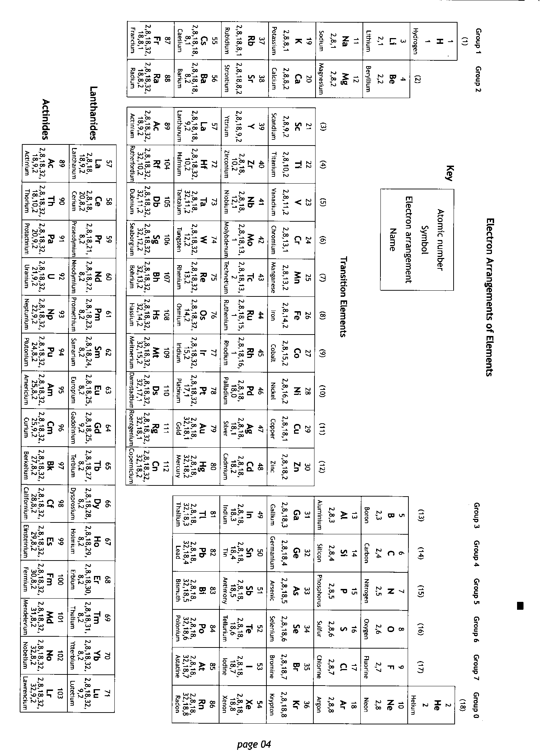

Relationships Sheet
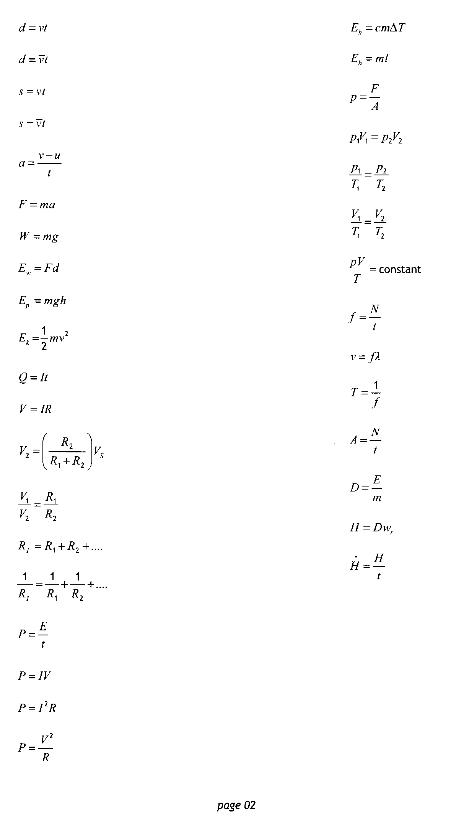

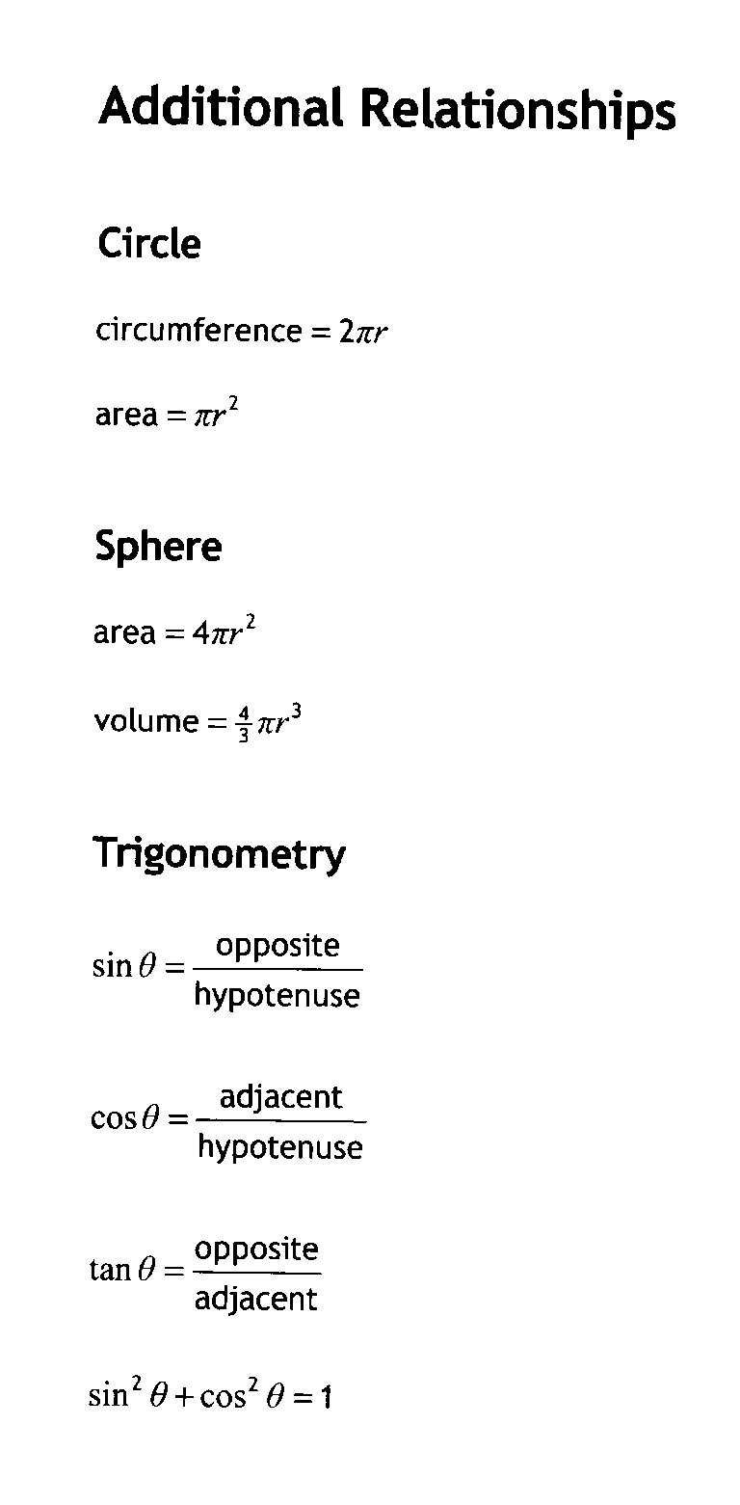

The Physics Course

There are 6 units in the National 5 Physics Course
Dynamics | Space | Electricity
Properties of Matter | Waves | Radiation

There is also an assignment which must be completed.

There are two parts to the exam

Component | Marks | Scaled mark | Duration & Notes
Part 1: question paper | 110 | 110 | 2 hours and 30 minutes  Section 1 (objective test) has 20 marks.  Section 2 contains restricted and extended response questions and has 90 marks.
Part 2: assignment | 20 | 28 | 8 hours of which a maximum of 1 hour and 30 minutes is allocated to the reporting stage  The assignment has two stages:  - research  - report

Details of the Assignment mark scheme are given at the back on pages 20 and 21.

Content
ALL UNITS
No. | CONTENT |  | Traffic Light
0.1 | I know the units for all of the physical quantities used in this course.
0.2 | I can use the prefixes: nano (n), micro(μ), milli (m), kilo(k), Mega(M) & Giga (G)
0.3 | I can give an appropriate number of significant figures when carrying out calculations (This means that the final answer can have no more significant figures than the value with least number of significant figures used in the calculation).
0.4 | I can use scientific notation when large and small numbers are used in calculations.

DYNAMICS

No. | CONTENT |  | Traffic Light
Vectors and scalars
1.1 | I can define scalar quantities and vector quantities a scalar has magnitude/size, and unit only, a vector has magnitude/size and unit + direction |  | ☺ |  | 😐 |  | ☹
1.2 | I can identify vector and scalar quantities such as: force, speed, velocity, distance, displacement, acceleration, mass, time and energy. |  | ☺ |  | 😐 |  | ☹
1.3 | I can calculate the resultant of two vector quantities in one dimension or at right angles. |  | ☺ |  | 😐 |  | ☹
1.4 | I can determine displacement and/or distance using scale diagram or calculation. |  | ☺ |  | 😐 |  | ☹
1.5 | I can determine velocity and/or speed using scale diagram or calculation. |  | ☺ |  | 😐 |  | ☹
1.6 | I can perform calculations/ solve problems involving the relationship between speed, distance and time  (d = vt, and $d=\overline{v}t$) |  | ☺ |  | 😐 |  | ☹
1.7 | I can perform calculations/ solve problems involving the relationship between velocity, displacement and time ( $s=\overline{v}t$)  in one dimension |  | ☺ |  | 😐 |  | ☹
1.8 | I can determine average and instantaneous speed. |  | ☺ |  | 😐 |  | ☹
1.9 | I can describe experiments to measure average and instantaneous speed. |  | ☺ |  | 😐 |  | ☹
Velocity- time graphs
2.1 | I can draw velocity–time graphs for objects from recorded or experimental data. |  | ☺ | 😐 |  | ☹
2.2 | I can interpret velocity–time graphs to describe the motion of an object. |  | ☺ | 😐 |  | ☹
2.3 | I can find displacement from a velocity–time graph, where s = area under the v-t graph. |  | ☺ | 😐 |  | ☹
Acceleration
3.1 | I can define acceleration as rate of change of velocity. Which is found from the final velocity subtract the initial velocity all divided by the time for the change. |  | ☺ | 😐 |  | ☹
3.2 | I can use (a = ∆v/t).to solve problems on acceleration, change in speed and time. |  | ☺ | 😐 |  | ☹
3.3 | I can use (a = (v – u)/t ).to solve problems involving acceleration, initial velocity (or speed) final velocity (or speed) and time of change. |  | ☺ | 😐 |  | ☹
3.4 | I can find the acceleration from the gradient of velocity–time graphs. |  | ☺ | 😐 |  | ☹
3.5 | I can describe an experiment to measure acceleration |  | ☺ | 😐 |  | ☹
Newton’s Laws
4.1 | I can give applications and use Newton’s laws and balanced forces to explain constant velocity (or speed), making reference to frictional forces of this. |  | ☺ | 😐 |  | ☹
4.2 | I can give applications of Newton’s laws and balanced forces to explain and or determine acceleration for situations where more than one force is acting, (F=ma) |  | ☺ | 😐 |  | ☹
4.3 | I can use F=ma to solve problems involving unbalanced force, mass and acceleration for situations where more than one force is acting, in one dimension or at right angles. |  | ☺ | 😐 |  | ☹
4.4 | I can use W=mg to solve problems involving weight mass and gravitational field strength, including on different planets (where g is given on page 2 of section1) |  | ☺ | 😐 |  | ☹
4.5 | I can use Newton’s 3rd law and its application to explain motion resulting from a ‘reaction’ force. |  | ☺ | 😐 |  | ☹
4.6 | I can use Newton’s laws to explain free-fall and terminal velocity. |  | ☺ | 😐 |  | ☹
Energy
5.1 | I can state that energy is never created or destroyed, it is conserved. |  | ☺ | 😐 |  | ☹
5.2 | I can identify and explain energy conversions and transfer. |  | ☺ | 😐 |  | ☹
5.3 | I can apply the principle of ‘conservation of energy’ to examples where energy is transferred between stores. |  | ☺ | 😐 |  | ☹
5.4 | I can use Ew=Fd to solve problems involving work done, unbalanced force, and distance or displacement. |  | ☺ | 😐 |  | ☹
5.5 | I can identify and explain ‘loss’ of energy where energy is transferred. |  | ☺ | 😐 |  | ☹
5.6 | I can define gravitational potential energy. Ep is the energy an object has because of its position above the Earth’s surface and its mass |  | ☺ | 😐 |  | ☹
5.7 | I can use Ep=mgh to solve problems on involving gravitational potential energy, mass, gravitational field strength and height |  | ☺ | 😐 |  | ☹
5.8 | I can define kinetic energy as the energy an object has because of its speed. |  | ☺ | 😐 |  | ☹
5.9 | I can use Ek= ½ mv² to solve problems involving kinetic energy, mass and speed |  | ☺ | 😐 |  | ☹
5.10 | I can use Ew=Fd, Ep=mgh, Ek= ½ mv² to solve problems involving conservation of energy |  | ☺ | 😐 |  | ☹
Projectile Motion
6.1 | I can explain that projectile motion occurs when an object has both a constant horizontal velocity and a constant vertical acceleration |  | ☺ | 😐 |  | ☹
6.2 | I can use appropriate relationships to solve problems involving projectile motion from a horizontal launch, including the use of motion graphs. |  | ☺ | 😐 |  | ☹
6.3 | I can state that the area under v_{h}-t graphs is equal to the horizontal range. |  | ☺ | 😐 |  | ☹
6.4 | I can calculate the horizontal range from the area under a v_{h}-t graphs |  | ☺ | 😐 |  | ☹
6.5 | I can state that the area under v_{v}-t graphs is equal to the vertical height. |  | ☺ | 😐 |  | ☹
6.6 | I can calculate the height, and acceleration from v_{v}-t graphs |  | ☺ | 😐 |  | ☹
6.7 | I can state and use the relationships  area under a v_{h}-t graphs equals the horizontal range  area under v_{v}-t graphs is equal to the vertical height.  $v_{h}=\frac{s}{t}$ where v_{h} is a constant horizontal velocity  $v_{v}=u_{v}+at$ where v_{v} is a constant vertical acceleration |  | ☺ | 😐 |  | ☹
6.8 | I can explain satellite orbits in terms of projectile motion, horizontal velocity and weight. |  | ☺ | 😐 |  | ☹

SPACE
No. | Content |  | Traffic Light
Space Exploration
7.1 | I have a basic understanding of the Universe https://map.gsfc.nasa.gov/universe/uni_life.html |  | ☺ | 😐 | ☹
7.2 | I can use the following terms correctly and in context: planet, dwarf planet, moon, Sun, asteroid, solar system, star, exoplanet, galaxy, and universe. |  | ☺ | 😐 | ☹
7.3 | I am aware of the benefits of satellites: for example for GPS, weather forecasting, communications, scientific discovery and space exploration (for example Hubble telescope, ISS). |  | ☺ | 😐 | ☹
7.4 | I know that geostationary satellites have a period of 24 hours and orbit at an altitude of 36 000 km above the equator on the Earth’s surface. |  | ☺ | 😐 | ☹
7.5 | I know that the period of a satellite in a high altitude orbit is greater than the period of a satellite in a lower altitude orbit. |  | ☺ | 😐 | ☹
7.6 | I am aware of the challenges of space travel. |  | ☺ | 😐 | ☹
7.7 | I am aware of potential space travel across large distances by the possible solution of attaining high velocity by using ion drive (producing a small unbalanced force over an extended period of time) |  | ☺ | 😐 | ☹
7.8 | I have a basic awareness that travelling large distances through space using a ‘catapult’ from a fast moving asteroid, moon or planet might be possible. |  | ☺ | 😐 | ☹
7.9 | I have a basic awareness of how astronauts manoeuvre a spacecraft in a zero friction environment, possibly to dock with the ISS |  | ☺ | 😐 | ☹
7.10 | I have a basic awareness of maintaining sufficient energy to operate life support systems in a spacecraft, with the possible solution of using solar cells with area that varies with distance from the Sun |  | ☺ | 😐 | ☹
7.11 | I can describe the risks associated with manned space exploration such as fuel load on take-off, potential exposure to radiation, pressure differential and re-entry through an atmosphere. |  | ☺ | 😐 | ☹
7.12 | I have knowledge of Newton’s second and third laws and their application to space travel, rocket launch and landing. |  | ☺ | 😐 | ☹
7.13 | I can use W=mg to solve problems involving weight, mass and gravitational field strength, in different locations in the universe. |  | ☺ | 😐 | ☹
Cosmology
8.1 | I can correctly use the term light year. |  | ☺ | 😐 | ☹
8.2 | I can convert between light years and metres. |  | ☺ | 😐 | ☹
8.3 | I can give a basic description of the Big Bang theory of the origin of the Universe. |  | ☺ | 😐 | ☹
8.4 | I know that the estimated age of the Universe is approximately 14 billion years or 13.8 billion years old. |  | ☺ | 😐 | ☹
8.5 | I can describe how different parts of the electromagnetic spectrum are used to obtain information about astronomical objects. |  | ☺ | 😐 | ☹
8.6 | I can identify continuous and line spectra. |  | ☺ | 😐 | ☹
8.7 | I can use spectral data for known elements, to identify the elements present in stars. |  | ☺ | 😐 | ☹

ELECTRICITY
No. | CONTENT |  | Traffic Light
Electrical Charge Carriers
9.1 | I can define electrical current as the electrical charge transferred per unit time. |  | ☺
9.2 | I can carry out calculations using Q=It where t is measured in seconds. |  | ☺
9.3 | I can explain the difference between A.C. and D.C. |  | ☺
9.4 | I can compare the traces of A.C with D.C when viewed on an oscilloscope or data logging software. |  | ☺
Potential Difference (Voltage)
10.1 | I know that a charged particle experiences a force in an electric field |  | ☺
10.2 | I can describe the effect of electric fields on a charged particle |  | ☺
10.3 | I know the path a charged particle takes between two oppositely charged parallel plate |  | ☺
10.4 | I know the path a charged particle takes near a single point charge |  | ☺
10.5 | I know the path a charged particle takes between two oppositely charged points |  | ☺
10.6 | I know the path a charged particle takes between two like charged points |  | ☺
10.7 | I can define the potential difference (voltage) of the supply as a measure of the energy given to the charge carriers in a circuit. |  | ☺
Ohm’s Law
11.1 | I can make use of a V-I graph to determine resistance. (gradient of V against I graph = resistance) |  | ☺
11.2 | I can make use of an appropriate relationship to calculate potential difference (voltage), current and resistance  V = IR $V_{2}=\left(\frac{R_{2}}{R_{1}+R_{2}}\right)V_{s}$ $\frac{V_{1}}{V_{2}}=\frac{R_{1}}{R_{2}}$ |  | ☺
11.3 | I can describe the relationship between temperature and resistance of a conductor. |  | ☺
11.4 | I can describe that increasing the temperature of a conductor increases the resistance of the conductor. Increasing the temperature does not affect the resistance of a resistor. |  | ☺
11.5 | I can describe an experiment to prove Ohm’s Law. |  | ☺
Practical Electricity and Electronics
12.1 | I can make measurements of I, V and R using appropriate meters in simple and complex circuits. |  | ☺
12.2 | I can describe the symbol, function and application of standard electrical and electronic components including cell, battery, lamp, switch, resistor, variable resistor, voltmeter, ammeter, LED, motor, microphone, loudspeaker, photovoltaic cell, fuse, diode, capacitor, thermistor, LDR, relay and transistor |  | ☺
12.3 | I can draw and identify the symbols for an npn-transistor, and an n-channel enhancement MOSFET |  | ☺
12.4 | I can explain the function of the transistors above as a switch in transistor switching circuits |  | ☺
12.5 | I can apply the current and voltage relationships in a series circuit. I_{s}=I₁=I₂=… V_{s}=V₁+V₂=… |  | ☺
12.6 | I can apply the current and voltage relationships in a parallel circuit. I_{s}=I₁+I₂=… V_{s}=V₁=V₂=… |  | ☺
12.7 | I can describe and explain practical applications of series and parallel circuits. |  | ☺
12.8 | I can use the relationship Rs=R₁+R₂+R₃ to solve problems involving total resistance of resistors in a series circuit |  | ☺
12.9 | I can perform calculations involving current and voltage relationships in a parallel circuit. |  | ☺
12.10 | I can use the relationship,  $$\frac{1}{R_{total}} = \frac{1}{R_{1}}+\frac{1}{R_{2}} +\frac{1}{R_{3}}+…$$  to calculate the resistance of resistors in parallel circuits |  | ☺
12.11 | I can use the appropriate relationships to calculate the resistance of resistors in with circuits with combinations of resistors in series and parallel |  | ☺
12.12 | I know what happens in a circuit when I increase the resistance in both series and parallel circuits. |  | ☺
Electrical Power
13.1 | I can state that electrical power is a measure of the energy transferred by an appliance every second or the energy provided by a source per second. |  | ☺
13.2 | I can used the word dissipated as it relates to power. |  | ☺
13.3 | I am able to use E = Pt to solve calculations relating to Power, Energy and time. |  | ☺
13.4 | I know the effect of potential difference (voltage) and resistance on the current in and power developed across components in a circuit. |  | ☺
13.5 | I can use appropriate relationships to solve problems involving power, potential difference (voltage), current and resistance in electrical circuits. $P = IV$ $P = I^{2}R P = \frac{V^{2}}{R}$ |  | ☺
13.6 | I know that I would use a 3A fuse for most appliances rated up to 720W and a 13A fuse for appliances rated over 720W. |  | ☺
13.7 | I could select the appropriate fuse rating given the power rating of an electrical appliance |  | ☺

PROPERTIES OF MATTER
No. | CONTENT |  |  |  |  | Traffic Light
Specific heat capacity
14.1 | I know that the same mass of different materials require different quantities of heat energy to raise their temperature by 1 degree Celsius. |  |  |  |  | ☺
14.2 | I am able to use Eh = cm∆T to carry out calculations involving: mass, heat energy, temperature change and specific heat capacity. |  |  |  |  | ☺
14.3 | I am able to explain that the temperature of a substance is a measure of the mean kinetic energy of its particles. |  |  |  |  | ☺
14.4 | I can use the principle of conservation of energy to determine heat transfer. |  |  |  |  | ☺
Specific Latent Heat
15.1 | I know that different materials require different quantities of heat to change the state of unit mass. |  |  |  |  | ☺
15.2 | I know that the same material requires different quantities of heat to change the state of unit mass from solid to liquid (fusion) and to change the state of unit mass from liquid to gas (vaporisation) |  |  |  |  | ☺
15.3 | I can use E_{h} =ml to solve problems involving mass, heat energy and specific latent heat. |  |  |  |  | ☺
Gas laws and the kinetic model
16.1 |  | I can explain that pressure is the force per unit area exerted on a surface |  |  | ☺
16.2 |  | I am able to use P=F/A to calculate pressure, force and area |  |  | ☺
16.3 |  | I can describe the kinetic model of a gas. |  |  | ☺
16.4 |  | I can describe the kinetic model of a gas and how this accounts for pressure |  |  | ☺
16.5 |  | I can convert temperatures between Kelvin and degrees Celsius and understand the term absolute zero of temperature. |  |  | ☺
16.6 |  | I know that 0 K = -273 °C |  |  | ☺
16.7 |  | I can explain the relationship between the volume, pressure and temperature of a fixed mass of gas using qualitative (info) in terms of kinetic theory. |  |  | ☺
16.8 |  | I can use appropriate relationships to calculate the volume, pressure and temperature of a fixed mass of gas  p₁V₁/T₁(K)= p₂V₂/T₂(K) .  p₁V₁ =p₂V₂ p₁/T₁(K) = p₂/T₂(K) V₁/T₁(K) = V₂/T₂(K) pV/T(K)= constant |  |  | ☺
16.9 |  | I can describe an experiment to verify Boyle’s Law (pressure and volume) |  |  | ☺
16.10 |  | I can describe an experiment to verify Gay-Lussac’s Law (pressure and temperature) |  |  | ☺
16.11 |  | I can describe an experiment to verify Charles’ Law (volume and temperature) |  |  | ☺

WAVES

No. | CONTENT |  | Traffic Light
Wave parameters and behaviours
17.1 | I can state that energy can be transferred as waves. |  | ☺
17.2 | I can define transverse waves as waves where the particles of the medium vibrate at right angles to the direction of energy travels. |  | ☺
17.3 | I can define longitudinal waves as waves where the energy travels along in the same plane as the particles vibrate. |  | ☺
17.4 | I know that sound is an example of longitudinal waves and waves in the e-m spectrum are transverse waves. |  | ☺
17.5 | I can determine the frequency, period, wavelength, amplitude and wave speed for longitudinal and transverse waves. |  | ☺
17.6 | I can make use of the relationships between wave speed, frequency, wavelength, distance, number of waves and time (v = f λ) (d = vt)(f=1/T) (f=N/t) (λ=d/N.). |  | ☺
17.7 | I can describe diffraction and associated practical limitations. |  | ☺
17.8 | I can state that long wave diffract more than short-waves. |  | ☺
17.9 | I know that diffraction occurs when waves pass through a gap or around an object. |  | ☺
17.10 | I can draw diagrams using wavefronts to show diffraction when waves pass through a gap or around an object. |  | ☺
Electromagnetic Spectrum
18.1 | I can state the relative frequency and wavelength bands of the electromagnetic spectrum. |  | ☺
18.2 | I can make reference to typical sources, detectors and applications, of the electromagnetic spectrum. |  | ☺
18.3 | I can state that all radiations in the electromagnetic spectrum are transverse. |  | ☺
18.4 | I can state that all radiations in the electromagnetic spectrum travel at the same speed of light (3x10⁸ ms⁻¹ in air) |  | ☺
Refraction
19.1 | I know that refraction occurs when waves pass from one medium to another. |  | ☺
19.2 | I can give a description of refraction in terms of change of direction (where angle of incidence is greater than 0°)for waves passing into both a more dense and a less dense medium. |  | ☺
19.3 | I can describe the qualitative (info) relationship between the frequency and the energy associated with a form of radiation. |  | ☺
19.4 | I can identify the normal, angle of incidence and angle of refraction in ray diagrams showing refraction. |  | ☺

RADIATION
No. | CONTENT |  | Traffic Light
Nuclear Radiation
20.1 | I understand the nature of alpha, beta and gamma radiation: including the relative effect of ionization, and their relative penetration. |  | ☺
20.2 | I can explain the term ‘ionisation’ as the gaining or losing of electrons from (neutral) atoms |  | ☺
20.3 | I can state that alpha is the most ionising nuclear radiation, and gamma the least ionising. |  | ☺
20.4 | I can state that alpha can travel a few cm in air and is stopped by a sheet of paper, beta can travel a few metres in air and can be stopped by a few mm of aluminium and gamma radiation can travel through air and most is stopped by several cm of lead or a few metres of concrete. |  | ☺
20.5 | I can state that Activity is the number of nuclear disintegrations per second. |  | ☺
20.6 | I can state that the activity of a source is measured in becquerels. |  | ☺
20.7 | I can use A=N/t to solve problems involving activity, number of nuclear disintegrations and time. |  | ☺
20.8 | I can identify background sources of radiation, e.g. cosmic radiation from space, radioactivity from rocks (e.g. granite) and soil of the earth, radiation from buildings e.g. radon, radiation from the human body etc. artificial sources, such as medical, fallout from weapons tests or power stations and radioactive waste. |  | ☺
20.9 | I know of the dangers of ionising radiation to living cells and of the need to measure exposure to radiation |  | ☺
20.10 | I can use H = DW_{R}, D = E / m to solve problems involving absorbed dose and equivalent dose energy, mass and radiation weighting factor. |  | ☺
20.11 | I can state that the unit for absorbed dose is the Gray (Gy), the unit for equivalent dose is the Sievert (Sv) and the radiation weighting factor has no unit |  | ☺
20.12 | I can use (H dot) =H/t to solve problems involving equivalent dose and time to calculate an equivalent dose rate. |  | ☺
20.13 | I can state the units of H dot are Sieverts per year, Sieverts per day, Sieverts per hour etc. |  | ☺
20.14 | I can compare equivalent dose due to a variety of natural and artificial sources. |  | ☺
20.15 | I know that the average annual background radiation in the UK is 2.2 mSv |  | ☺
20.16 | I know that the average annual effective dose limit for a member of the public in the UK is 1 mSv (ie 1 mSv/y) |  | ☺
20.17 | I know that the average annual effective dose limit for radiation workers is 20 mSv (ie 20 mSv/y) |  | ☺
20.18 | I can give some applications of nuclear radiation: for example electricity generation, cancer treatment and other industrial and medical uses. For example used in smoke detectors |  | ☺
20.19 | I can define half-life as the Time for activity to decrease by half or time taken for half of the radioactive atoms to decay |  | ☺
20.20 | I can use graphical and numerical data to determine the half-life |  | ☺
20.21 | I can describe an experiment to determine the half-life of a radioactive material. |  | ☺
20.22 | I can provide a qualitative (info) description of fission chain reactions and their role in the generation of energy. |  | ☺
20.23 | I can provide a qualitative description of fusion, plasma containment, and their role in the generation of energy. |  | ☺

PREFIXES
http://www.youtube.com/watch?v=N_9IBQ3Pxz0

Prefix | Symbol | Multiple | Multiple in full
Tera | T | x10¹² | x1 000 000 000 000
Giga | G | x10⁹ | x1 000 000 000
Mega | M | x10⁶ | x1 000 000
Kilo | k | x10³ | x1 000
Basic SI | UNIT | x10¹ | x1
Milli | m | x10⁻³ | ÷1 000
Micro | μ | x10⁻⁶ | ÷1 000 000
Nano | n | x10⁻⁹ | ÷1 000 000 000
Pico | p | x10⁻¹² | ÷1 000 000 000 000

Above is a table of prefixes, which you will commonly find in Physics.
NB THE STANDARD UNIT FOR MASS IS THE KILOGRAM. Do not try changing it to grammes!
Watch out for ms which is not metres per second but milli seconds

Help with the ‘Relationships sheet’

Understanding quantities, symbols and units

Symbol | Quantity | Unit & Symbol
a | acceleration | 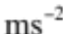 | metres per second per second
A | activity | Bq | becquerels
A | area | 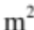 | square metres
c | specific heat capacity | 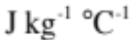 | joules per kilogram per degree Celsius
d | distance (or displacement) | m | metres
D | absorbed dose | Gy | grays
E | energy | J | joules
E_{h} | heat energy | J | joules
E_{k} | kinetic energy | J | joules
E_{p} | potential energy | J | joules
E_{W} | work done | J | joules
f | frequency | Hz | hertz
F | force | N | newtons
g | gravitational field strength | 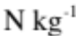 | newtons per kilogram
h | height | m | metres
H | equivalent dose | Sv | sieverts
 | equivalent dose rate | 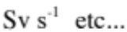 | (many possible units)
I | current | A | amps
l | specific latent heat | 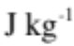 | joules per kilogram
m | mass | kg | kilograms
N | Number of radioactive nuclei decaying |  | (no units)
p | pressure | Pa | pascals
P | power | W | watts
Q | charge | C | coulombs
R | resistance | Ω | ohms
R_{T} | total resistance | Ω | ohms
s | distance (or displacement) | m | metres
t | time | s | seconds
T | period | s | seconds
T | temperature | K | kelvin
ΔT | change in temperature | ° C | degrees Celsius
u | initial velocity |  | metres per second
v | velocity (or final velocity) |  | metres per second
 | average velocity |  | metres per second
V | volume | 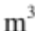 | metres cubed
V | voltage | V | volts
V_{s} | supply voltage | V | volts
W | weight | N | newtons
λ | wavelength | m | metres
ω_{R} | radiation weighting factor |  | (no units)

The next page takes each of the equations on the Relationships Sheet and writes them out in words. It is vital that you learn these if you are to succeed in the course.

Relationships sheet in words
Equation |  |  | First column Equations written in words with units
$$d=vt$$ |  |  | $$distance \left(m\right)=speed \left(m s^{-1}\right)×time (s)$$
$$d=\overline{v}t$$ |  |  | $$total distance \left(m\right)=average speed \left(m s^{-1}\right)× time (s)$$
$$s=vt$$ |  |  | $$displacement \left(m\right)=velocity \left(m s^{-1}\right)×time (s)$$
$$s=\overline{v}t$$ |  |  | $$total displacement \left(m\right)=average velocity \left(m s^{-1}\right)×time (s)$$
$$a= \frac{v-u}{t}$$ | $$acceleration \left(m s^{-2}\right)=\frac{final velocity \left(m s^{-1}\right)-initial velocity \left(m s^{-1}\right)}{time (s)}$$
$$F=ma$$ |  | $$force \left(N\right)=mass \left(kg\right)×acceleration \left(m s^{-2}\right)$$
$$W=mg$$ |  | $$weight \left(N\right)=mass \left(kg\right)×gravitational field strength\left(N kg^{-1}\right)$$
$$E_{w}=Fd$$ |  | $$work done \left(J\right)=force \left(N\right)×distance (m)$$
$$E_{p}=mgh$$ |  | $$gravitational potential$$  $$energy \left(J\right)=mass \left(kg\right)×gravitational field strength\left(N kg^{-1}\right)×vertical height (m)$$
$$E_{k}=\frac{1}{2}mv^{2}$$ |  | $$kinetic energy \left(J\right)=\frac{1}{2}×mass \left(kg\right)×speed^{2} {\left(m s^{-1}\right)}^{2}$$
$$Q=It$$ |  | $$charge \left(C\right)=current \left(A\right)× time (s)$$
$$V=IR$$ |  | $$voltage \left(V\right)=current \left(A\right)×resistance (Ω)$$
$$V_{2}=\left(\frac{R_{2}}{R_{1}+ R_{2}}\right)V_{s}$$ |  |  |  | $$For potential dividers:$$  $$voltage across second series resistor \left(V\right)=\frac{resistance of R_{2} (Ω)}{total resistance \left(Ω\right)}×voltage supply (V)$$
$$\frac{V_{1}}{V_{2}}= \frac{R_{1}}{R_{2}}$$ |  | $$\frac{voltage 1 \left(V\right)}{voltage 2 \left(V\right)}=\frac{resistance 1 \left(Ω\right)}{resistance 2 \left(Ω\right)}$$
$$R_{T}= R_{1}+ R_{2}+..$$ |  | For resistors in series:  $$total resistance \left(Ω\right)=resistance of R_{1}\left(Ω\right)+resistance of R_{2}\left(Ω\right)+...$$
$$\frac{1}{R_{T}}= \frac{1}{R_{1}}+ \frac{1}{R_{2}}$$ |  | For resistors in parallel  $$\frac{1}{total resistance \left(Ω\right)}=\frac{1}{resistance of R_{1} \left(Ω\right)}+\frac{1}{resistance of R_{2} \left(Ω\right)}+…$$
$$P= \frac{E}{t}$$ |  | $$power \left(W\right)=\frac{energy \left(J\right)}{time \left(s\right)}$$
$$P=IV$$ |  | $$power \left(W\right)=current \left(A\right)×voltage (V)$$
$$P=I^{2}R$$ |  | $$power \left(W\right)={current }^{2}{\left(A\right)}^{2}×resistance (Ω)$$
$$P=\frac{V^{2}}{R}$$ |  | $$power \left(W\right)=\frac{{voltage}^{2} {(V)}^{2}}{resistance (Ω) }$$

Equation | Second column of Equations written in words with units
$$E_{h}=cm∆T$$ | $$heat energy \left(J\right)=specific heat capacity \left(J{kg}^{-1}C^{-1} orJ{kg}^{-1}K^{-1} \right)$$  $mass \left(kg\right) change in temperature$ (°C)  Find the value of c on the data sheet
$$E_{h}=ml$$ | $heat energy \left(J\right)=mass \left(kg\right) specific latent heat$ $\left(J{kg}^{-1}\right)$  Find the value of l on the data sheet  NB there is no change in temperature just state
$$p= \frac{F}{A}$$ | $$pressure \left(Pa\right)=\frac{Force (N)}{Area \left(m^{2}\right)}$$
$$p_{1}V_{1}= p_{2}V_{2}$$ |  | $${pressure}_{1}\left(Pa\right) {volume}_{1}\left(m^{3}\right)={Pressure}_{2}(Pa)× {volume }_{2}(m^{3})$$
$$\frac{p_{1}}{T_{1}}=\frac{p_{2}}{T_{2}}$$ | $$\frac{{pressure }_{1}(Pa)}{{Temperature}_{1}(K)} =\frac{{Pressure }_{2}(Pa)}{{Temperature}_{2}(K)} Temp MUST be in Kelvin$$
$$\frac{V_{1}}{T_{1}}=\frac{V_{2}}{T_{2}}$$ | $$\frac{{volume }_{1}(m^{3})}{{Temperature}_{1}(K)}=\frac{{volume }_{2}(m^{3})}{{Temperature}_{2}(K)} Temp MUST be in Kelvin$$
$$\frac{pV}{T}=constant$$ |  |  | $$\frac{Pressure(Pa)× volume(m^{3})}{Temperature (K) }=constant value$$
$$f= \frac{N}{t}$$ | $$Frequency \left(Hz\right)=\frac{No. of waves produced or passing a point (no units)}{time\left(s\right)}$$
$$v=fλ$$ | $$wave speed \left(m s^{-1}\right)=Frequency \left(Hz\right) wavelength (m)$$
$$T= \frac{1}{f}$$ | $$Period \left(s\right)=\frac{1}{Frequency\left(Hz\right)}$$
$$A= \frac{N}{t}$$ | $$Activity (Bq)=\frac{No. of disintegrations (no units)}{time\left(s\right)}$$
$$D= \frac{E}{m}$$ | $$Absorbed Dose (Gy)=\frac{Energy (J)}{mass \left(kg\right)}$$
$$H=Dw_{R}$$ | $$Equivalent Dose \left(Sv\right)=Absorbed Dose \left(Gy\right) radiation weighting factor(no units)$$
$$\dot{H}= \frac{H}{t}$$ | $$Equivalent Dose rate \left(Svh^{-1} or Svy^{-1}\right)=\frac{Equivalent Dose (Sv)}{time (s or h or y)}$$

The Assignment
The research stage must involve an experiment which allows you to make measurements. You must also gather data from the internet, books or journals to compare against their experimental results.
You must produce a report on your research which will be sent away for marking.

The assignment is:
- an individually produced piece of work from each candidate
- started at an appropriate point in the course
- conducted under controlled conditions

Section | Expected response | Max marks
Title | The report has an informative title. | 1
Aim | A description of the purpose of the investigation. | 1
Underlying physics relevant to the aim | A description of the physics relevant to the aim which shows understanding. | 3
Data collection and handling | A brief description of the experiment  . | 1
 | Sufficient raw data from the experiment. | 1
 | Raw data presented in a table with headings and units. | 1
 | Values correctly calculated from the raw data. | 1
 | Data from an internet/literature source. | 1
 | A reference for the internet/literature source. | 1
Graphical presentation | The correct type of graph used to present the experimental data. | 1
 | Suitable scales. | 1
 | Suitable labels and units on axes. | 1
 | All points plotted accurately, with line or curve of best fit if appropriate. | 1
Analysis | Experimental data compared to data from internet/literature source. | 1
Conclusion | A conclusion related to the aim and supported by data in the report. | 1
Evaluation | A discussion of a factor affecting the reliability, accuracy or precision of the results. | 2
Structure | A report which can be easily followed. | 1
Total 20

SOME MATHS (MATHS INTRODUCTION)

The two, five , ten method of rearranging

Do not get worried about the MATHS that we use in Physics. It can easily be learned and practised.
This is about as complicated as it gets…….
e.g. Start with the formula:
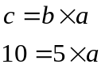
So what is a?
So a = 2.
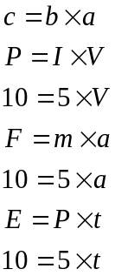This is exactly the same as we have in Physics but instead of | In each e.g. the last letter always works out to be 2. We are doing the same thing each time but with different letters. This is the maths that you’ll need in National 5 Physics!

ACCURACY & PRECISION

Accuracy is how close your answer is to the true value. Precision is how repeatable a measurement is. Use the diagram below to remind you which is which.
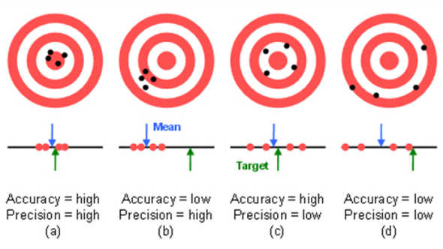
http://preview.tinyurl.com/lwanwoh
In Physics you will often calculate an answer to a question that has a large number of significant figures or decimal places. Because it is highly unlikely that we need to know the answer that precisely. It is important to round off any answers that you find.

How many Significant Figures?
The simple rule is this: Your answer should have no more than the number of significant figures given in the question.
If different numbers in the question are given to a different number of significant figure you should use the number of significant figures in the value given to the smallest number of significant figures.

Example
Question: A rocket motor produces 4,570N of thrust to a rocket with a mass of 7.0kg.What is the acceleration of the rocket?
The calculated answer to this question would be 652.8571429 ms⁻² . However the least accurate value we are given in the question is the value of the mass. This is only given to two significant figures. Therefore our answer should also be to two significant figures: 650 ms^{–2} .

Tackling Mathematical Questions
Always set out maths problems using the structure given below. It may seem to take longer but it will save time in the long run as it makes the question clearer.

USE IESSUU
http://www.youtube.com/watch?v=u7akhlAS5Ck
In short:
- (Information)- Summarise the question.
- Change any units that are not standard.
- (Equation) -Write out the formula.
- (Substitution) -Put the numbers in.
- Use the magic triangle to rearrange the formula, only if you must!
- (Solution)- Work out the answer.
- Write out the answer, but not to too many sig fig.
- (Units) -Add units to your answer.
- (Underline) Underline the answer

Look out for ADJECTIVES!
The SQA use as few words as they can, so if there is an ADJECTIVE, a describing word it means something importants
Here are a few examples to look out for, underlining with a highlighter is a good idea!
Constant speed/ velocity | The forces are balanced, there are no unbalanced forces, acceleration is zero
Frictional forces are negligible | You can ignore these.
Balanced forces | There will be no acceleration, the object will be at rest of moving with constant velocity.
Instantaneous speed | the speed at that point over such a short time any acceleration is not noticed.
Kinetic model | You need to talk about the moving particles of the gas.
Longitudinal or transverse wave | This tells you which way the particles move in relation to the direction of the wave
Horizontal speed | In a projectile this tells you this speed is constant
Vertical speed | In a projectile this tells you the speed is increasing with an acceleration of g unless air resistance is causing an effect.
The syringe was pushed slowly | So that there was no increase in temperature of the particles
Rigid object | The volume will remain constant
Send me a message of all the others you find and I can add to this list.

Using your calculators
Remember the only friend you will have in your exam is your CALCULATOR! If you know how it works, how to turn it on! It will give you great service!

Exp / x10^{x} | This is a really important button on you calculator and one YOU MUST KNOW HOW TO USE. We can deal with numbers that are too big to copy into the calculator for example can you put in this number  147 250 000 000 000  As scientists we put it in our calculators as  1.4725 Exp / x10^{x} 14  Be careful as people using this often get an extra 10  Eg. One of the most important numbers you will use is the speed of light which is 3x10⁸ m/s  Try putting this into your calculator. It should come out at 300 000 000
Sci | Sci button displays in scientific notation form. This is ONE number before the decimal point followed by the rest of the numbers after the decimal point and then the power to convert to  Eg the speed of light in air is 300 000 000 ms⁻¹ 3.0 x 10⁸ ms⁻¹ NB This can be done during a calculation
Eng | This puts your answer to the nearest prefix for example 500000 would become 0.5 x10⁶, which you should know is 0.5M (how much our Head Teacher gets paid annually!)
Fix | This can limit the number of decimal places that are displayed on the calculator.
1/x or x⁻¹ | Another vital button in Physics and possibly elsewhere. It is useful when you have worked out the bottom line of an equation and you want need to divide it INTO a number on the top. This button puts your number over 1  Eg 2 1/x or x⁻¹ becomes ½ or one half. We will use this when working out resistance in parallel.
Fraction Button |   To use this button your calculator needs to be in Maths Mode  On Casio calculators find this by doing….  Shift -> mode ->1 ->1
Powers of 10 | YOU MUST LEARN THESE. Now I encourage you to replace the power of ten by its correct form.
Degrees radians and gradians | For Physics, you must have your calculator in DEG, look for DRG or Deg, Do not have your calculator in Rad, Grad
Degrees, minutes and seconds | You can use this to change from hours and minutes and seconds into hours. You just need to find out how. It is really useful in questions about trains and things! It isn’t as useful as being able to put it in to seconds, but it is good for suggesting whether your answer is likely or not.
Intermediate rounding | If you must write down additional lines from 1) Equation 2) Substitution 3) Answer then round using the improper fraction button, there are less numbers to copy down incorrectly
Recurring fraction | Turn this OFF as it could be hard to see in the light of the exam hall and 0.26 recuring is too tempting to write as 0.26 instead of 0.27. If this is twoo hard fix your calculator to 2 d.p
Digital separator | Turn this ON. It means the speed of light can be written as 300 000 000 and not 300000000 so much easier to read!
ANS | This holds the intermediate value and is great for two stage calculations.
Pol() | Using your two vector quantities at right angles this will give you your resultant and angle. You must put in the adjacent quantity first then the opposite.
Rec() | Using the resultant vector and the angle this button gives you your opposite and adjacent quantities. Always put in the hypotenuse first and then a comma and angle. The results will give you the adjacent as quantity X and the opposite as quantity y.

Calculator Crib Sheet
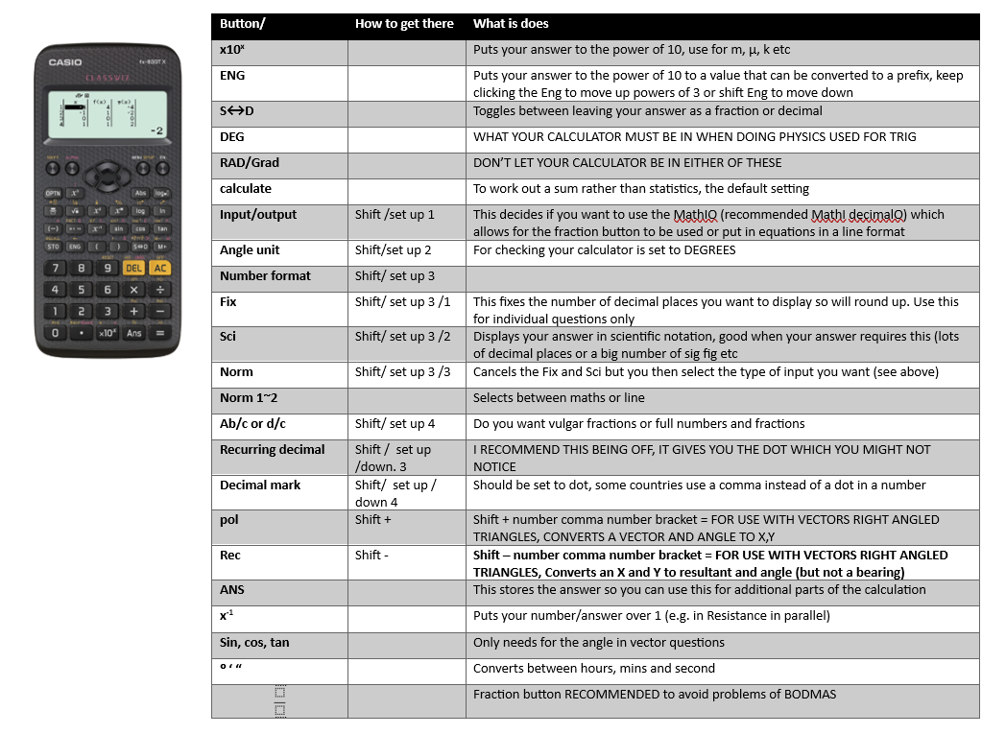

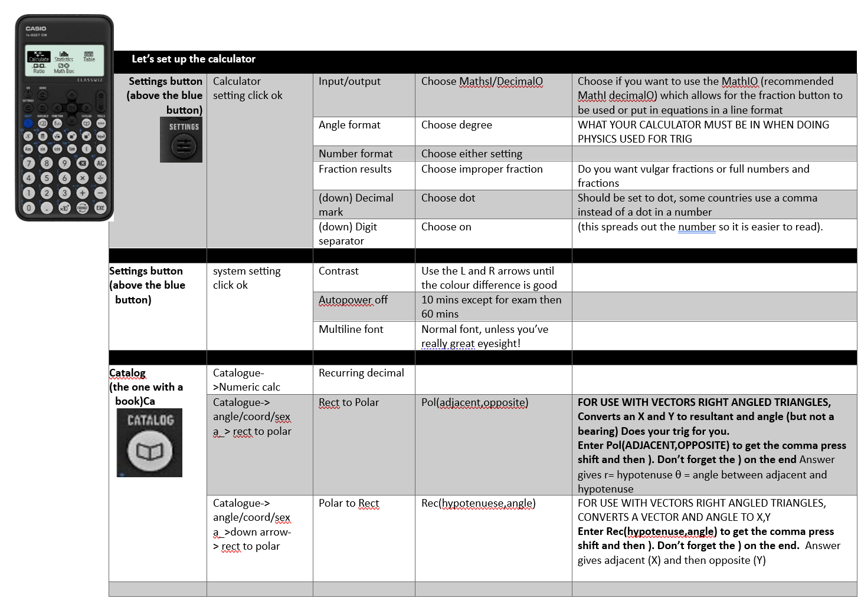
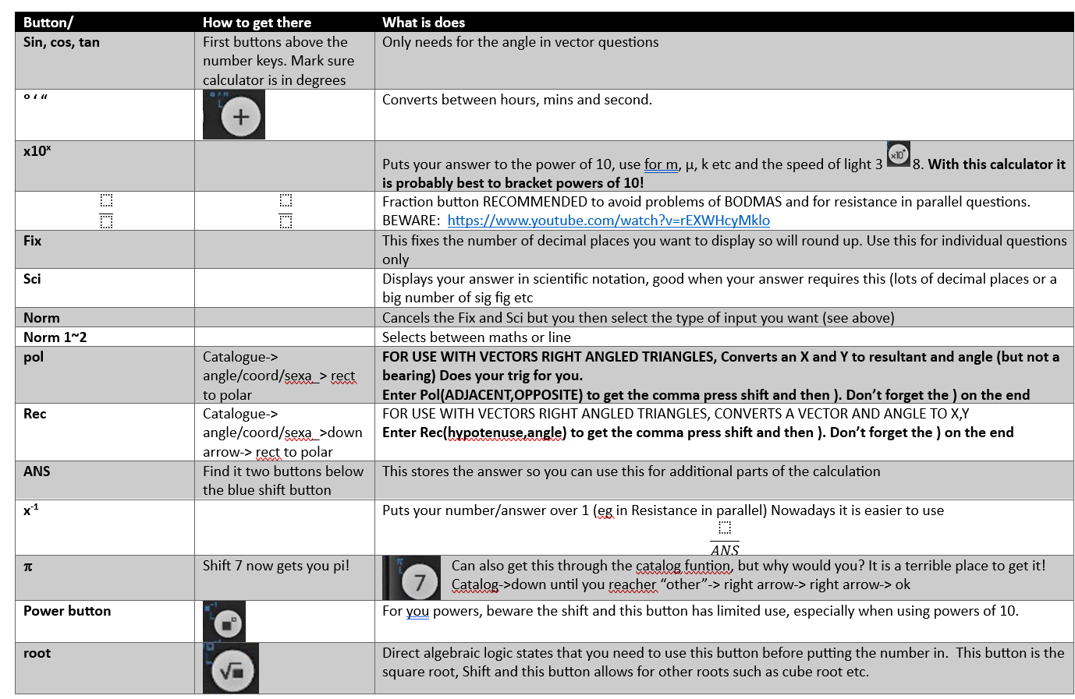
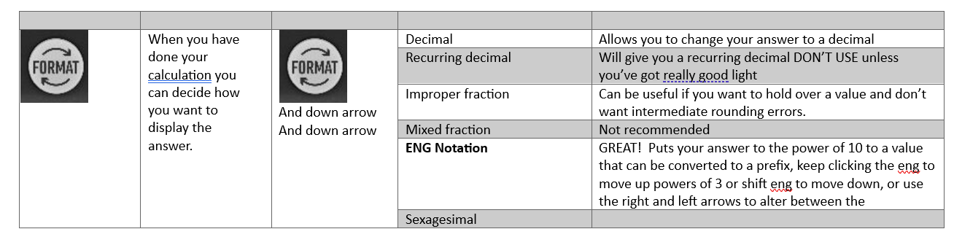

Add some notes for your calculator settings

No magic triangles use the 10,5,2 method
The first thing to note is there is NO MAGIC here!
These can help rearrange your formula, but it is much better to be able to do this without these. NEVER use these INSTEAD of FORMULA as you will not get marks!

HOW DO YOU DECIDE HOW TO MAKE A MAGIC TRIANGLE?
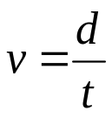 | The one on the TOP of the divide goes on the TOP of the triangle | d  v×t
Some formula come in a line and there is no divide by in the equation for example  $$F=ma$$ | If this is the case the letter ON ITS OWN on the left hand side, goes on the TOP of your triangle | F  m×a
What about this one?  $$Ep=mgh$$ | Make g=10 (as it nearly is)  Lets make m= 2, and h=5 so Ep will be 100, so you’ve 100, 10, 5,2  This will work for  $$E_{H} = mcT$$ | E_{p}  m×g×h
Lastly, lets try  $$E_{k}= ½ mv^{2}$$ | To make it easy or easier we’ll make v=2 (as we can square 2 to make 4) If we make m=10 we can halve it easier, so that gives us ½ ×10×2² which gives us an Ek value of 20 | E_{k}  ½ m×v²

Instead use the 10,5,2 method. If the equation is in a line the subject is 10 and the others are 2 and 5 (it doesn’t matter which)
$$F=ma$$
$$10=5 ×2$$
So as a= 2, how do you make 2 from 10 and 5? Divide $\frac{10}{5}$ to get 2 giving $\frac{F}{m}=a$
$$F=N/t$$
Here N=10, f and t are 5 and 2, so how do you get t which is 2, 10/5 which gives $\frac{N}{f}=t$
A couple of tricky ones,
$$E=\frac{1}{2}mv^{2}$$
Make v =2 (its easy to square) make m=10 (it’s easy to halve) giving E= 20, so it’s a 20,10,2 relationship.
$$E=\frac{1}{2}mv^{2} or 20=\frac{1}{2}×10×2^{2}$$
How do I find v? v²=2² so it is $v^{2}=\frac{E}{\frac{1}{2}m} or v^{2}=\frac{2E}{m}$ giving $v=\sqrt{\frac{E}{\frac{1}{2}m}} or v=\sqrt{\frac{2E}{m}}$
One last example that covers two equations $E=mgh and E=cmT$. For these equations it is $100=2×10×5$
$$E=mgh$$  $$100=2×10×5$$  $$To find g (=10)$$  $$g=\frac{100}{2×5}$$ | $$E=cmT$$  $$100=2×10×5$$  $$To find T=5$$  $$T=\frac{100}{2×10}$$

Have you got it?

Changing Units
Changing between cm and metres is like changing between pounds and pence as there are 100cm in a metre and 100 pence in a pound.
In your exam there wont be any cm!
For example
7.8cm is like 7.8p
7.8p is £0.078
7.8cm is 0.078m

Fuel costs 1.339 pounds per litre equal to 133.p pence per litre.

What is 16cm in metres? 0.16m

Finding the Average
When finding the mean average you add up all the values and divide by the total number of values.
$$\text{average}=\frac{\sum{x}}{n}$$
Where Σ = sum of
For example, Find the average of
600, 100, 900, 450, 50
It should be 420

Some of you might have got 2060, which I am afraid, is the WRONG answer.

Look at what an average is it is somewhere BETWEEN the highest and lowest.

This is because you never pushed the equals button on your calculator BEFORE the divide by 5 so your sum was
600+100+900+450+ 50/5
50/5 which is 10
So your sum became
600+100+900+450+10

So EITHER use brackets (600+100+900+450+50)/5
Or push the equals before the divide by symbol “ 600+100+900+450+50=/5”
Or use the fraction button.

Rounding off and decimal places.

When we use a calculator we often get an answer that has more decimal places than we need. If we write them all down we will lose 33% of the marks. We must therefore round up.

Rounding off
Suppose we have the number: 5.918504
Rounding to 1 decimal place (d.p) = look at the 2nd decimal place if it is 5 or more round up, 4 or less leave as it is
Rounding to 1 decimal place (d.p) =5.9
Rounding to 2 decimal place (d.p) =5.92
Rounding to 3 decimal place (d.p) =5.919

(5 or more round up, 4 or less ignore!)

Suppose we had the number= 5.99292
Rounding to 1 decimal place (d.p) =6.0
Rounding to 2 decimal place (d.p) =5.99
Rounding to 3 decimal place (d.p) 5.993

USE THE FIX BUTTON ON YOUR CALCULATORS!

If you have an answer leave it in your calculator, change to the fix button, decide how many dp you want and then push exe (execute) it will round up for you. You can then set it back to normal 2 for the next question.

If there is a large number or a small one with lots of decimal places or zeros before the number push the ENG button and this will change to the nearest power of 3 shift eng makes it go the other way. You can keep pushing this button. Now make sure you copy it down clearly.

Using Scientific Notation

In Physics you will be working with very large and very small numbers.
In Astronomy you will be dealing with very large distances.
For example, the distance from Earth to the nearest star Sirius is 82 000 000 000 000 000 metres.
In atomic Physics you will be dealing with very small distances.
For example, the spacing between atoms in a solid is about 0.000 000 000 1 metres.

It is not convenient to work with numbers written out in full. For this reason, it is usual when dealing with very large or very small numbers to use scientific notation.

5 000 000 can be written as 5 x 10⁶.

- x 10⁶ - 5 multiplied by 1 000 000
one million is 10 x 10 x 10 x 10 x 10 x 10 , which is 10⁶

Another way of looking at this is as follows:

Firstly insert a decimal point after the first number.

5.0 x 10⁶ - 5 0 0 0 0 0 0 . 0
the decimal point moves to the right 6 places

82 000 000 000 000 000 can be written as 8.2 x 10¹⁶.

8.2 x 10¹⁶ - 8.2 multiplied by 10 sixteen times

8.2 x 10 x 10 x 10 x 10 x 10 x 10 x 10 x 10 x 10 x 10 x 10 x 10 x 10 x 10 x 10 x 10

Instead of using powers of 10, we sometimes use prefixes.

Prefixes are used to denote multiples and sub-multiples of any unit used to measure a physical quantity.

For example:

Instead of saying 1000 metres, we can say 1 kilometre.

1 kilometre can be written as:

1 km = 1000 m = 1.0 x 10³ m

The ‘k’ before ‘m’ stands for kilo. The x 10³ is replaced by k.

Another example:

Instead of saying 0.001 metres, we can say 1 millimetre.

1 millimetre can be written as:

1 mm = 0.1 cm = 0.001 m = 1.0 x 10⁻³ m

The ‘m’ before ‘m’ stands for milli. The x 10⁻³ is replaced by m.

Your calculator can do this for you during a calculation. If your answer is in a form that you find hard to read then go to the SCI button and click that. It will ask how many d.p you want. 2 is usually fine. Your number will be made into sci notation. If you want to go back then all you need to do is go into the menu and change it to Normal 2- this puts it in the Decimal input and Line output so no need to use that S ↔ D button

GRAPHS
In Physics it is often useful to use a graph to interpret and understand experimental data or a relationship between two variables. There are several types of graph we can use and they are listed below:
• Bar graphs and charts — these are (almost) never used in Physics. You can assume that if a question asks you to draw a graph the examiner is not looking for a bar graph (and you will get no marks).
• Pie charts — these are used on occasion, typically when it is needed to represent percentages, such as showing the different energy sources used across the country.
• Line graphs — these are used sometimes in Physics, most notably in velocity/time graphs. The independent variable or time is always plotted on the x–axis. The dependant variable is always plotted on the y–axis. The points should always be plotted with an × or a +, never dots or circles. The points should be joined with straight lines. Line graphs should usually not be used for experimental data.
• Scatter graphs — the most used type of graph used in Physics. The independent variable or time is always plotted on the x–axis. The dependant variable is always plotted on the y–axis. The points should always be plotted with an × or a +, never dots or circles. If the points look like they are almost on a straight line then a line of best fit should be added. If the points do not look straight then a free hand curve or curve of best fit should be added.

An Example of a Good Graph
You ought to have checked this point before putting away the apparatus

Gradients
The gradient of a line is a measure of how steep the slope is. The larger the gradient the steeper the slope. For a straight line you can work out the gradient by taking any two points on the line and finding the difference in the y values and dividing by the difference in the x values. There are several ways of writing the formula for this
(gradient is represented be the letter m):
$$m = \frac{∆y }{∆x}= \frac{\left(y_{2} - y_{1} \right)}{\left(x_{2}- x_{1}\right)}$$
m= change in y ÷ change in x

Triangles

Describing triangles
Triangles all have three sides. A special triangle you will work with is the right angled triangle. All angles in any triangle add up to 180° In a right handed triangle as one of the sides is 90° and all angles add up to 180° then θ₁+θ₂=90°
To label the three sides you have to decide which of the angles you are taking as a reference point. In the top case I have used angle 1. We usually show a θ sign to show an angle. The adjacent side is the one next to the angle marked (but not the long side or hypotenuse) and the opposite is the side opposite the angle marked.
SideAdjacent angle θ₁

Hypotenuse
(the longest side)
Side Opposite angle θ₁
θ₁
θ₂

In the triangle below I have used angle 2 or θ2 as a reference, and although the hypotenuse is the same the adjacent and opposite sides are reverse.
$$\sin{θ=\frac{\text{opposite}}{hypotenuse}} \\ \cos{θ=\frac{\text{adjacent}}{hypotenuse}}$$
$$\tan{θ=\frac{\text{opposite}}{adjacent}}$$
Opposite θ₂

Hypotenuse
(the longest side)
Adjacent θ₂
θ₁
θ₂
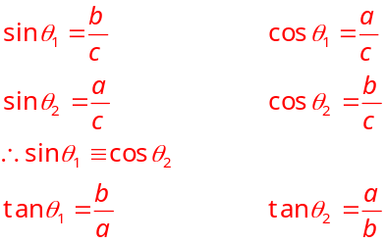

Or on your calculator
REC(hyp,angle) gives X= adj and Y= opp
POL(adj,opp) gives r= hypoténuse, θ = angle

PYTHAGORAS
Pythagoras discovered that the area of the two shorter sides of a right angled triangle is equal to the area of the hypotenuse. This gives us a way of calculating unknown sides of triangle
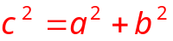
a
c
b
θ₂
θ₁

$$θ_{1}=90-θ_{2}$$

COSINE RULE
The cosine rule for a triangle states that:
b
A
C
B
c
a
F
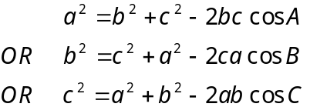

To prove these formula consider the following triangle, ABC:
Drop a line from C to form a perpendicular with AB at F.
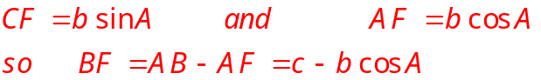
Using Pythagoras’ theorem in the triangle BFC:
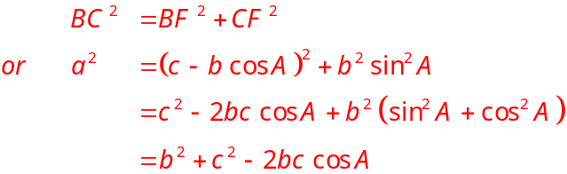

SINE RULE
The sine rule for a triangle states that:
C
A
B
a
c
b
D
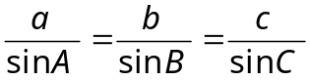
To prove these formula consider
the following triangle, ABC:
Drop a line from C to form a
perpendicular with BC at D.

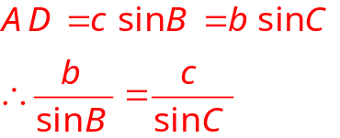

GREEK SYMBOLS
In Physics we often use greek letters as symbols for physical quantities (such as wavelength), units (such as Ohms) and prefixes (micro). Below is a handy guide to what these letters are:
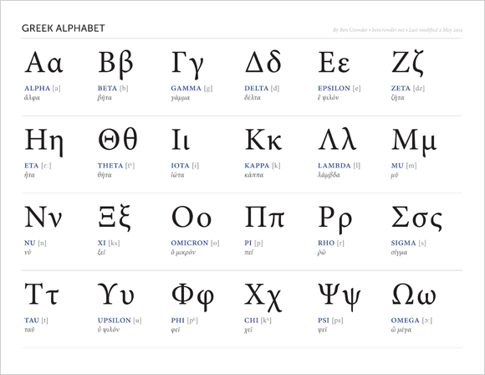

Command words
There are no questions on the Physics N5 paper 2- honestly! Instead there will be commands for you to complete. Here is a table showing the command words that are used in the exams. When you go through past paper questions you will see these terms being frequently used.
Word | What you are expected to do
describe | you must provide a statement or structure of characteristics and/or features;
determine or calculate | you must determine a number from given facts, figures or information; You should use numbers given in the question to work out the answer. You should always show your working, as it may be possible for the examiner to award some marks for the method even if the final answer is wrong. Always give the units as the final mark is for the answer and unit.
estimate | you must determine an approximate value for something;
explain | you must relate cause and effect and/or make relationships between things clear. Students should make something clear, or state the reasons for something happening. The answer should not be a simple list of reasons. This means that points in the answer must be linked coherently and logically. All of the stages/steps in an explanation must be included to gain full marks.
identify, name, give, or state | you need only name or present in brief form. Only a short answer is required, not an explanation or a description. Often it can be answered with a single word, phrase or sentence. If the question asks you to state, give, or write down one (or two etc) examples, you should write down only the specified number of answers, or you may not be given the mark for some correct examples given.
justify | you must give reasons to support their suggestions or conclusions, eg this might be by identifying an appropriate relationship and the effect of changing variables;
predict | you must suggest what may happen based on available information;
show that | you must use the appropriate formula to prove something e.g. a given value – All steps, including the stated answer and units, must be shown;
suggest | you must apply their knowledge and understanding of physics to a new situation. A number of responses are acceptable: marks will be awarded for any suggestions that are supported by knowledge and understanding of physics.
use your knowledge of physics or aspect of physics to comment on |  | you must apply your skills, knowledge and understanding to respond appropriately to the problem/situation presented (for example by making a statement of principle(s) involved and/or a relationship or equation, and applying these to respond to the problem/situation). you will be rewarded for the breadth and/or depth of their conceptual understanding.
Use the information in the passage/ diagram/ graph/ table to… |  |  | The answer must be based on the information given in the question. Unless the information given in the question is used, no marks can be given.
compare | This requires you to describe the similarities and/or differences between things, not just write about one. If you are asked to ‘compare x with y’, you need to write down something about x compared to y, using comparative words such as ‘better, ‘more than’, ‘less than’, ‘quicker’, ‘more expensive’, ‘on the other hand.’


EXAM DATE: 29th April 2027

