

National 5 Assignment

LDR distance Guide Sheet: A

Nat
5

Investigating LDR and distance from the light source

Equipment:
LDR, multi-meter (to use as an ohmmeter), light level meter, 12 V filament lamp in holder , power supply, leads/wires, black card, scissors, sellotape,

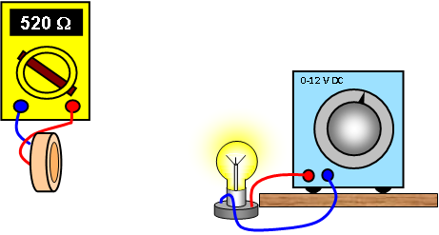

Instructions:
- Make a light box by rolling black card into a tube and seal this with Sellotape.
- Set up a 12 V lamp on the bench to act as a light source.
- Connect the multimeter to the LDR and adjust it to a suitable resistance range.
- Place the LDR and ohmmeter at one end of the black tube and the lamp and power supply at the other.
- Place the lamp into the tube and measure the distance between the lamp and the LDR. Ensure the lamp and LDR are in direct line.
- Now place the LDR at different distances from the lamp and measure the resistance of the LDR for each distance, do this by moving the LDR further into the tube.

Risk Assessment
- Check all the wires and ensure that the wires are not frayed
- The lamp being used may get hot, do not touch a hot lamp.
- Care should be taken to let it cool before packing away.
- Switch off the equipment when it is not in use.
- Do not make the black tube so tight that air cannot get in to cool the lamp
Nat
Mrsphysics takes no responsibility for any health and safety. It is the responsibility of the teacher and student to risk assess any practical activity they complete!
Sept 2023

