National 5 Assignment
Solar Cell- angle: Guide Sheet A
Nat
5



Investigating Solar Cells (Angle).
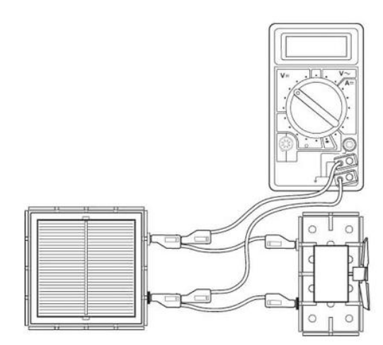
Apparatus (angle)
Solar cell unit, small motor unit (or other load), desk lamp (40 or 60 W tungsten lamp), digital multimeters (ammeter and/or voltmeter), 4 mm leads, metre rule, protractor, clamp stand

Instructions:
- Connect a solar cell to an electric motor.
- Connect a voltmeter across the solar cell also connect an ammeter in series in the circuit (not shown).
- The voltmeter and/ or ammeter can be used to get an idea about the output of the solar cell or the power can be determined.
- Shine a desk lamp onto the solar cell so that the motor turns, other loads can be used.
- Measure the angle between the lamp and the solar cell, and the corresponding current and voltage from the ammeter and voltmeter respectively.
- Adjust the angle between the lamp and solar cell, tilting the solar cell backwards and forwards ensuring you are clear about which angle you are measuring.

Risk Assessment
- Check all electrical wiring.
- Desk lamps with metal shades can get very hot. Take care when moving them.
- Be careful if considering other types of lamp such as halogen lamp and fluorescents because they can emit significant UV.

Mrsphysics takes no responsibility for any health and safety. It is the responsibility of the teacher and student to risk assess any practical activity they complete!
Sept 2023

