

National 5 Assignment

Projectile-release speed Guide Sheet: B
National 5 Assignment
LDR distance Guide Sheet: A

Nat

5

Variations in range of a projectile with launch speed
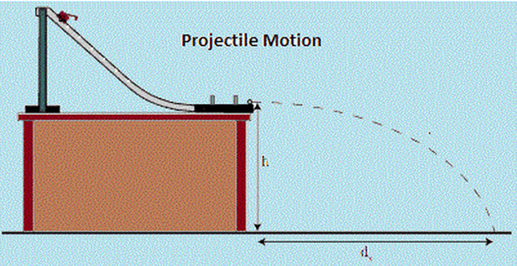
Equipment
Ball, projectile launcher, ALBA or other interface, metre stick or tape measure, sand, tray, carbon paper or timing plate, additional set of instructions for the PET timing device.
Instructions
- Set up the apparatus as shown in the diagram above.
- Clamp the track securely to the bench or piece of wood that can be raised and lowered.
- Measure the release height of the projectile track above the sand tray, or timing plate.
- Release the ball from a known position up the slope.
- Measure the height of the ball on the slope from the height the projectile is released from the desk.
- Note the time it takes for the ball to cross the two timing gates so that the release speed of the ball can be measured.
- Adjust the position of the sand tray /carbon paper or timing plate so that the ball lands in the sand / carbon paper /on the timing plate and leaves a clear mark.
- Measure the range of the ball from the release position.
- Set the projectile launcher at different heights up the slope. For each measurement of range you should have a launch height up the slope, a release time/ speed and range of the ball.
- Choose which of these variables you wish to investigate.
Risk Assessment
- Check that the launch area is free of people who could get hit.
- Ensure no projectile is left unattended where it could become a trip hazard.
- Wear safety goggles as the projectiles are likely to be smaller than the eye socket, and may not always be very well aimed!

Mrsphysics takes no responsibility for any health and safety. It is the responsibility of the teacher and student to risk assess any practical activity they complete!
Sept 2023

