Student Activity 4
The Impact of Transportation
Science Background
According to a recent study, transportation represents 23% of Canada’s greenhouse gas emissions. In this activity, you will explore what effects your transportation choices have on the environment.
Part 1: Transportation and the Environment
1. What effects do cars and other forms of transportation have on the environment?
Direct Effects | Indirect Effects
2. An average car emits 250 g of carbon dioxide per kilometre. Estimate the number of kilometres you travel by car each week. An average tree absorbs 50 g of carbon dioxide each week. How many trees are required to absorb the carbon dioxide from your personal transportation footprint weekly?

3. What are three frequent trips that you take using a car or some other type of transportation? (Walking counts as a type of transportation.)

4. What factors do you consider when deciding which mode of transportation to use? Rank them in order of importance.

Part 2: Transportation Scenarios
1. Form a group of five or six.
2. Read the Transportation Card that your teacher gives you.
3. Discuss the information on your card and fill in the table below.
My mode of transportation: ____________________
Information About My Transportation Mode
Pros | Cons | Level of Convenience | Cost | Environmental Impact
4. Form a new mixed group of five that includes an “expert” for each mode of transportation.
5. Carefully listen to the scenario that your teacher outlines. Which mode of transportation should the person take? Your group must discuss the different options and decide which mode is best based on the following criteria: environmental impact, convenience, cost, and safety concerns.
Mode of transportation chosen: ____________________________
Justification:

6. What is one regular trip you take that could be replaced with a more environmentally friendly form of transportation? Explain.

Part 3: Commercial Transportation
Commercial transportation contributes to high levels of carbon dioxide in the atmosphere. But trucks deliver goods, such as food and building materials, that people need.
1. Examine three products you are wearing or carrying. Complete the chart.
Country of Manufacture and Mass of Consumer Products
Product | Type of Product | Country of Manufacture | Estimated Mass of Product (kg)
Product 1
Product 2
Product 3
2. Using a paper or digital map, estimate how far each product travelled to reach you. Assume the products took the shortest routes. Write your answers in columns 2, 3, and 4 of the table below.
Carbon Dioxide Cost for Sea, Land, and Air Transportation
1. Product | 2. Sea Distance (km) | 3. Land Distance (km) | 4. Air Distance (km)  (Column 2 + Column 3) | 5. Amount of Carbon Dioxide, Sea + Land Travel (g) | 6. Amount of Carbon Dioxide, Air Travel (g)
Product 1
Product 2
Product 3
3. Using the information below, estimate the amount of carbon dioxide emitted in delivering the products to you by sea and land. Write your answers in column 5.
• Carbon dioxide emitted per kilometre of sea travel via container ship for every kilogram of
mass  0.0084 g
• Carbon dioxide emitted per kilometre of land travel via commercial transport truck for every
kilogram of mass  0.062 g
4. Repeat question 3, assuming the products came by air the entire way. Set the carbon dioxide emission per kilometre of air travel at 0.60 g for every kilogram of mass. Write your answers in column 6.
5. What are some ways to decrease your carbon dioxide impact related to commercial transportation?

Consolidate Your Learning
Answer the following questions to check your understanding of concepts relating to the impact of transportation on climate change.
1. What impact do cars have on the environment compared with other types of transportation? Explain.

2. What could you change to reduce your own contribution to greenhouse gas emissions?

3. How does commercial transportation contribute to climate change?

4. How have your ideas about getting around changed as a result of discussing the scenarios? What key points or arguments made you change your mind?

5. Computer navigation applications only list the travel times to a destination for particular modes of transportation (e.g., walking, biking, and driving). Outline a design for a navigation application that includes the environmental cost of each transportation mode.
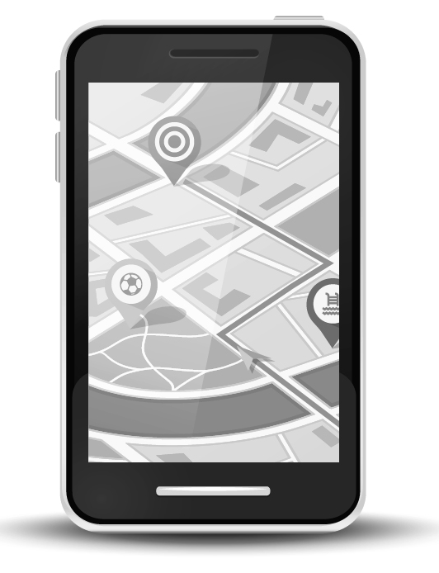
Sample screenshot of a mapping application

